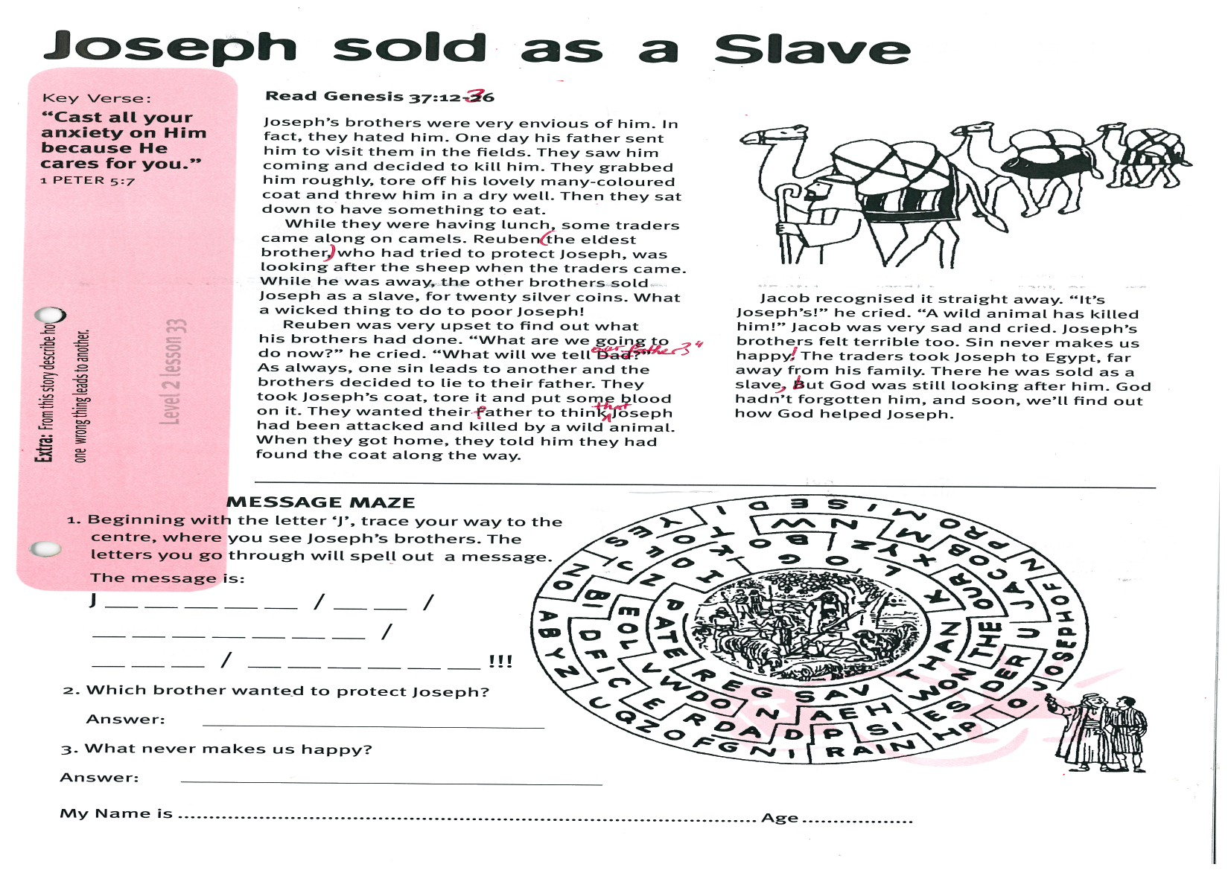

**Joseph sold as a Slave**

**Read Genesis 37:12-36**

Joseph’s brothers were very envious of him. In fact, they hated him. One day his father sent him to visit them in the fields. They saw him coming and decided to kill him. They grabbed him roughly, tore off his lovely many-coloured coat and threw him in a dry well. Then they sat down to have something to eat.

While they were having lunch, some traders came along on camels. Reuben (the eldest brother) who had tried to protect Joseph, was looking after the sheep when the traders came. While he was away, the other brothers sold Joseph as a slave, for twenty silver coins. What a wicked thing to do to poor Joseph!

Reuben was very upset to find out what his brothers had done. “What are we going to do now?” he cried. “What will we tell our father?” As always, one sin leads to another and the brothers decided to lie to their father. They took Joseph’s coat, tore it and put some blood on it.

Key Verse:  
**“Cast all your anxiety on Him because He cares for you.”**1 Peter 5:7



**Level 2 lesson 33**

**MESSAGE MAZE**

Beginning with the letter ‘J’, trace your way to   
the centre, where you see Joseph’s brothers.   
The letters you go through will spell out a   
message. The message is:

J __ __ __ __ __ / __ __ /

__ __ __ __ __ __ __ /

__ __ __ / __ __ __ __ __ __ !!!

1. Which brother wanted to protect Joseph?

Answer: _____________________________

2. What never makes us happy?

Answer: ______________________________

My Name is________________________________________ Age ______________

**Extra:** From this story describe how   
one wrong thing leads to another.

They wanted their father to think that Joseph had been attacked and killed by a wild animal. When they got home, they told him they had found the coat along the way.

Jacob recognised it straight away. “It’s Joseph’s!” he cried. “A wild animal has killed him!” Jacob was very sad and cried. Joseph’s brothers felt terrible, too.

Sin never makes us happy! The traders took Joseph to Egypt, far away from his family. There he was sold as a slave, but God was still looking after him. God hadn’t forgotten him, and soon, we’ll find out how God helped Joseph.

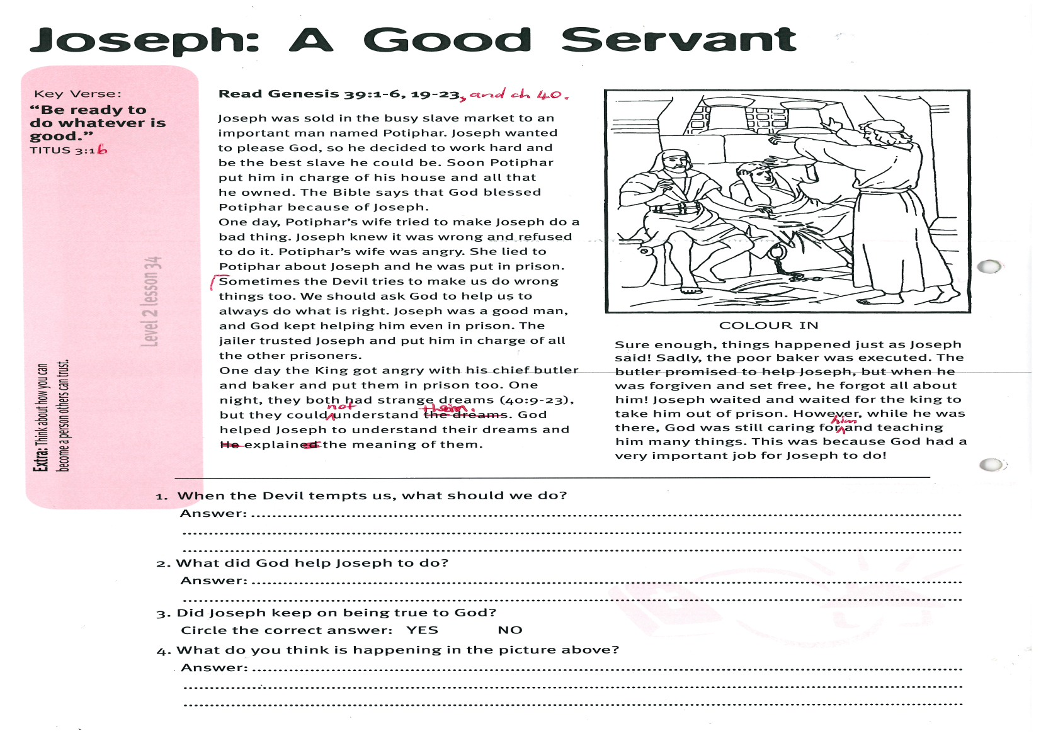

**Read Genesis 39:1-6, 19-23, and Genesis 40.**

Joseph was sold in the busy slave market to an important man named Potiphar. Joseph wanted to please God, so he decided to work hard and be the best slave he could be. Soon Potiphar put him in charge of his house and all that he owned. The Bible says that God blessed Potiphar because of Joseph.

One day, Potiphar’s wife tried to make Joseph do a bad thing. Joseph knew it was wrong and refused to do it. Potiphar’s wife was angry. She lied to Potiphar about Joseph and he was put in prison.

Sometimes the Devil tries to make us do wrong things, too. We should ask God to help us to always do what is right. Joseph was a good man, and God kept helping him even in prison. The jailer trusted Joseph and put him in charge of all the other prisoners.

One day the King got angry with his chief butler and baker and put them in prison, too.

Key Verse:  
**“Be ready to do whatever is good.”**Titus 3:1b

**Joseph: A Good Servant**

1. When the Devil tempts us, what should we do?

**Answer:** __________________________________________________________________________

___________________________________________________________________________________

2. What did God help Joseph to do?

**Answer:** __________________________________________________________________________

___________________________________________________________________________________

3. Did Joseph keep on being true to God?

**Circle the correct answer:** **YES NO**

4. What do you think is happening in the picture above?

**Answer:** __________________________________________________________________________

___________________________________________________________________________________

**Level 2 lesson 34**

**Extra:** Think about how you can   
become a person others can trust.

One night, they both had strange dreams (Genesis 40:9-23), but they could not understand them. God helped Joseph to understand their dreams and to explain the meaning of them.

Sure enough, things happened just as Joseph said! Sadly, the poor baker was executed. The butler promised to help Joseph, but when he was forgiven and set free, he forgot all about him! Joseph waited and waited for the king to take him out of prison. However, while he was there, God was still caring for him and teaching him many things. This was because God had a very important job for Joseph to do!

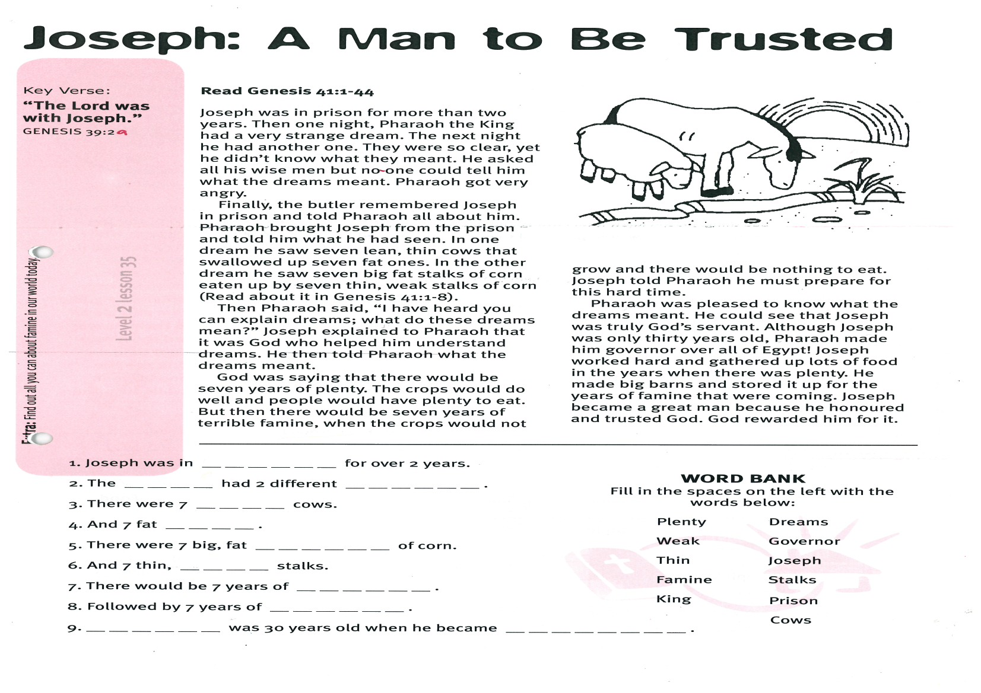

Key Verse:  
**“The Lord was with Joseph.”**Genesis 39:2a

**Joseph: A Man to Be Trusted**

**Read Genesis 41:1-44**

Joseph was in prison for more than two years. Then one night, Pharaoh the King had a very strange dream. The next night he had another one. They were so clear, yet he didn’t know what they meant. He asked all his wise men but no-one could tell him what the dreams meant. Pharaoh got very angry.

Finally, the butler remembered Joseph in prison and told Pharaoh all about him. Pharaoh brought Joseph from the prison and told him what he had seen. In one dream he saw seven lean, thin cows that swallowed up seven fat ones. In the other dream he saw seven big fat stalks of corn eaten up by seven thin, weak stalks of corn (Read about it in Genesis 41:1-8).

Then Pharaoh said, “I have heard you can explain dreams; what do these dreams mean?” Joseph explained to Pharaoh that it was God who helped him understand dreams. He then told Pharaoh what the dreams meant.

God was saying that there would be seven years of plenty. The crops would do well and people would have plenty to eat. But then there would be seven years of terrible famine, when the crops would not grow and there would be nothing to eat. Joseph told Pharaoh he must prepare for this hard time.

Pharaoh was pleased to know what the dreams meant. He could see that Joseph was truly God’s servant. Although Joseph was only thirty years old, Pharaoh made him governor over all of Egypt! Joseph worked hard and gathered up lots of food in the years when there was plenty. He made big barns and stored it up for the years of famine that were coming. Joseph became a great man because he honoured and trusted God. God rewarded him for it.

1. Joseph was in __ __ __ __ __ __ for over 2 years.

2. The __ __ __ __ had 2 different __ __ __ __ __ __ .

3. There were 7 __ __ __ __ cows.

4. And 7 fat __ __ __ __ .

5. There were 7 big, fat __ __ __ __ __ __ of corn.

6. And 7 thin, __ __ __ __ stalks.

7. There would be 7 years of __ __ __ __ __ __ .

8. Followed by 7 years of __ __ __ __ __ __ .

9. __ __ __ __ __ __ was 30 years old when he became __ __ __ __ __ __ __ __ .

**WORD BANK**

Fill in the spaces on the right using the words below:

**Plenty Dreams**

**Weak Governor**

**Thin Joseph**

**Famine Stalks**

**King Prison**

**Cows**

**Level 2 lesson 35**

**Extra:** Find out all you can about famine in our world today.

|  |  |  |  |  |  |  |  |  |  |  |  |  |
| --- | --- | --- | --- | --- | --- | --- | --- | --- | --- | --- | --- | --- |
| 1 |  |  | 2 |  |  |  |  |  |  |  |  |  |
|  |  |  |  |  |  |  |  |  |  |  |  |  |
|  |  |  | 3 |  |  |  |  |  |  | 4 |  |  |
|  |  |  |  |  |  |  |  |  |  |  |  |  |
| 5 |  |  |  |  |  |  |  |  |  |  |  |  |
|  |  |  |  |  |  |  |  |  | 6 |  |  |  |
|  |  |  |  |  |  |  |  |  |  |  |  |  |
|  |  |  |  |  |  |  |  |  |  |  |  |  |
|  |  | 7 |  | Please complete and return by post to  **PSSM, 1-2A (G2) 93 Dominion Rd, Mt Eden, Auckland 1024** or scan & email to **info@biblediscovery.org.nz** |  |  |  |  |  |  |  |  |

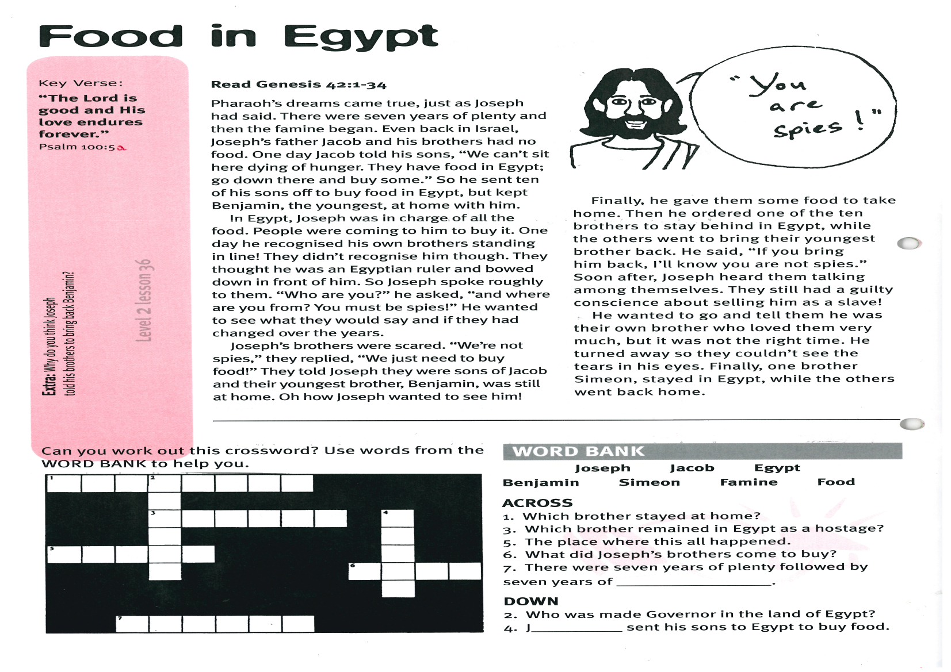

**WORD BANK** Joseph Jacob Egypt

Benjamin Simeon Famine Food

**ACROSS**1. Which brother stayed at home?  
3. Which brother remained in Egypt as a hostage?  
5. The place where this all happened.  
6. What did Joseph’s brothers come to buy?  
7. There were seven years of plenty followed by seven years of __ __ __ __ __ __.

**DOWN**2. Who was made Governor in the land of Egypt?4. J __ __ __ __ sent his sons to Egypt to buy food.

Can you work out this crossword? Use words from the **WORD BANK** to help you

**Extra:** Why do you think Joseph told his   
brothers to bring back Benjamin?

Finally, he gave them some food to take home. Then he ordered one of the ten brothers to stay behind in Egypt, while the others went to bring their youngest brother back. He said, “If you bring him back, I’ll know you are not spies.” Soon after, Joseph heard them talking among themselves. They still had a guilty conscience about selling him as a slave!

He wanted to go and tell them he was their own brother who loved them very much, but it was not the right time. He turned away so they couldn’t see the tears in his eyes. Finally, one brother Simeon, stayed in Egypt, while the others went back home.

**Level 2 lesson 36**

**Read Genesis 42:1-34**Pharaoh’s dreams came true, just as Joseph had said. There were seven years of plenty and then the famine began. Even back in Israel, Joseph’s father Jacob and his brothers had no food. One day Jacob told his sons, “We can’t sit here dying of hunger. They have food in Egypt; go down there and buy some.” So he sent ten of his sons off to buy food in Egypt, but kept Benjamin, the youngest, at home with him.

In Egypt, Joseph was in charge of all the food. People were coming to him to buy it. One day he recognised his own brothers standing in line! They didn’t recognise him though. They thought he was an Egyptian ruler and bowed down in front of him. So Joseph spoke roughly to them. “Who are you?” he asked, “and where are you from? You must be spies!” He wanted to see what they would say and if they had changed over the years.

Joseph’s brothers were scared. “We’re not spies,” they replied, “We just need to buy food!” They told Joseph they were sons of Jacob and their youngest brother, Benjamin, was still at home. Oh how Joseph wanted to see him!

**“The Lord is good and His love endures forever.”**Psalm 100:5a

**Food in Egypt**