At first Mary felt afraid, but the angel explained that her baby was the One that God had promised. He was to be the Saviour of the world. Then Mary was really happy! The angel also spoke to Joseph and told him the same thing. The baby inside Mary was God’s Holy Son, and not Joseph’s son. The angel then said, “You are to give him the name Jesus, because He will save His people from their sins.”

When it was nearly time for the baby to be born, Joseph and Mary had to go to Bethlehem. Joseph walked and Mary rode a donkey. It took them quite a while to get there. The town was so crowded they could only find a stable to sleep in! There was no room anywhere else. That very night Jesus was born.

Imagine that! Jesus came from his beautiful home in Heaven to be born in a stable. He did this because He loved us so much. I hope you have lots of room in your life for Him. Will you pray, “Oh, come into my heart Lord Jesus, save me from my sins, and make my heart new!”?

**Read Luke 1:26-38   
and Luke 2:1-7**

Last month we finished the story of Joseph. We learnt that even though his brothers had been cruel and mean to him, he loved them and forgave them. Finally, God used him to save his whole family and many other people from a terrible famine.

This month, we come to the most wonderful story of all! It tells us how God loved us and wanted to save us, not from famine, but from our sins. Over 2000 years ago, God sent Jesus to be born as a baby into this world. This was something wonderful only God could do. We call it a miracle. This is how it all happened…

A lovely young lady called Mary lived in the little town of Nazareth. She was engaged to be married to a man called Joseph. (This is a different Joseph from our lessons last month. That Joseph lived hundreds of years earlier). One day, the Angel Gabriel visited Mary. He told her she was going to have a special baby.

Key Verse:  
**“…He (Jesus) will save His people from their sins.”**Matthew 1:21b

**Jesus is Born**

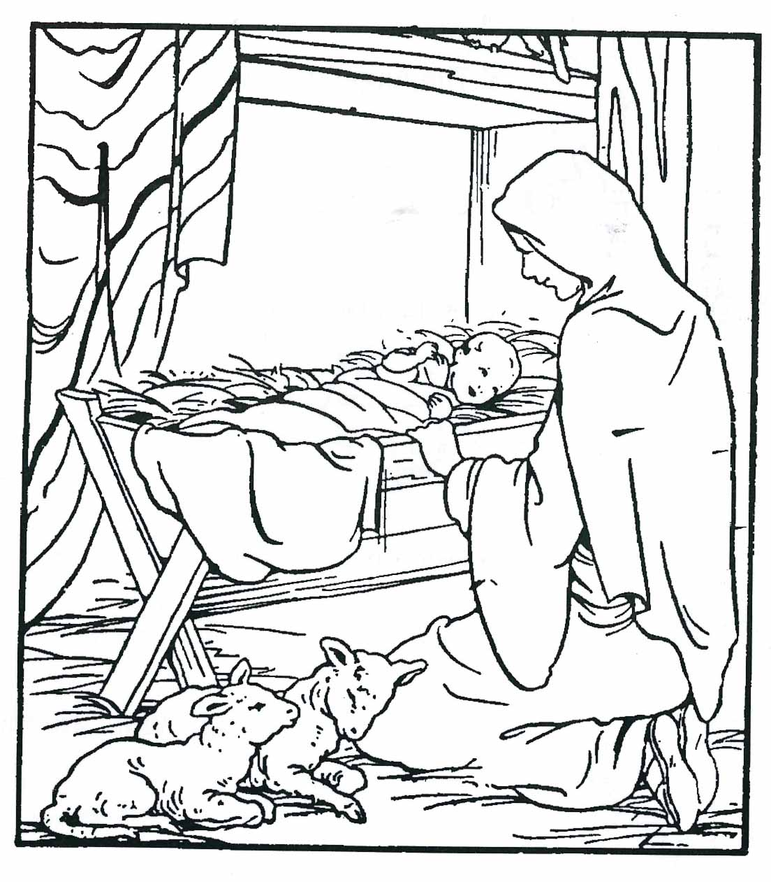

**Level 2 lesson 41**

**Extra:** What made Jesus such a ‘special’ baby?

Colour in

1. Complete this sentence from the story: At first Mary felt afraid, but the Angel explained…. Then Mary was…  
 __ __ __ __ __ __ __ __ __ __ __

2. Circle the answer: The baby was to be called…

JOSEPH JESUS GABRIEL

3. In the space below, draw a heart with Jesus’ name on it!

My Name is________________________________________ Age ______________

**Read Luke 2:8-20**

Christmas is such an exciting, happy time with lots of fun, decorations, good things to eat, and presents! Of course, while these things are all good, we should always remember what Christmas is REALLY about. That’s the BEST part! So what is it all about? Well, some angels from Heaven told us what this good news was!

One starry night, a long time ago, some shepherds were sitting in the fields near Bethlehem. They were looking after their sheep and talking together around their fire. Suddenly, they saw a very bright light, much brighter than the stars or the moon. They were scared stiff! Then from the light a shining angel spoke to them. “Don’t be afraid!” he said. “I am here with good news for you, which will bring great joy to all people. This very day, the Saviour was born in the city of Bethlehem. He is Christ the Lord!”

For a long time the Jewish people had been waiting for the Saviour, so the shepherds could hardly believe what the angel said.

“Is it really true, after all this long time, that the Saviour has come?” they wondered. The angel said, “Go into Bethlehem and there you will find the baby wrapped up in warm clothes, sleeping in a manger [this is a wooden box that holds straw].”

When he finished speaking, a great crowd of angels appeared in the sky and started to sing. It is hard to imagine how wonderful that must have been. Heavenly angels were singing in a glorious choir! “GLORY TO GOD IN THE HIGHEST HEAVEN, AND PEACE ON EARTH, GOOD WILL TOWARDS MEN.”

We may not be able to sing as well as those angels long ago. But we like to sing songs of praise and glory to God too at Christmas time! They are called Christmas carols. Many of these songs remind us of this wonderful time when Jesus came into the world as a tiny baby.

God sent Jesus to save us from our sins. That is the GOOD NEWS of Christmas - the best gift of all! The shepherds ran excitedly into Bethlehem to find the baby Jesus. They soon found Him, just where the angel had said. They bowed humbly and worshipped Jesus. Here at last was the Saviour of the world, Christ the Lord!

**The Good News of Christmas**

Key Verse:  
**“Glory to God in the highest, and on earth peace to men.”**Luke 2:14a

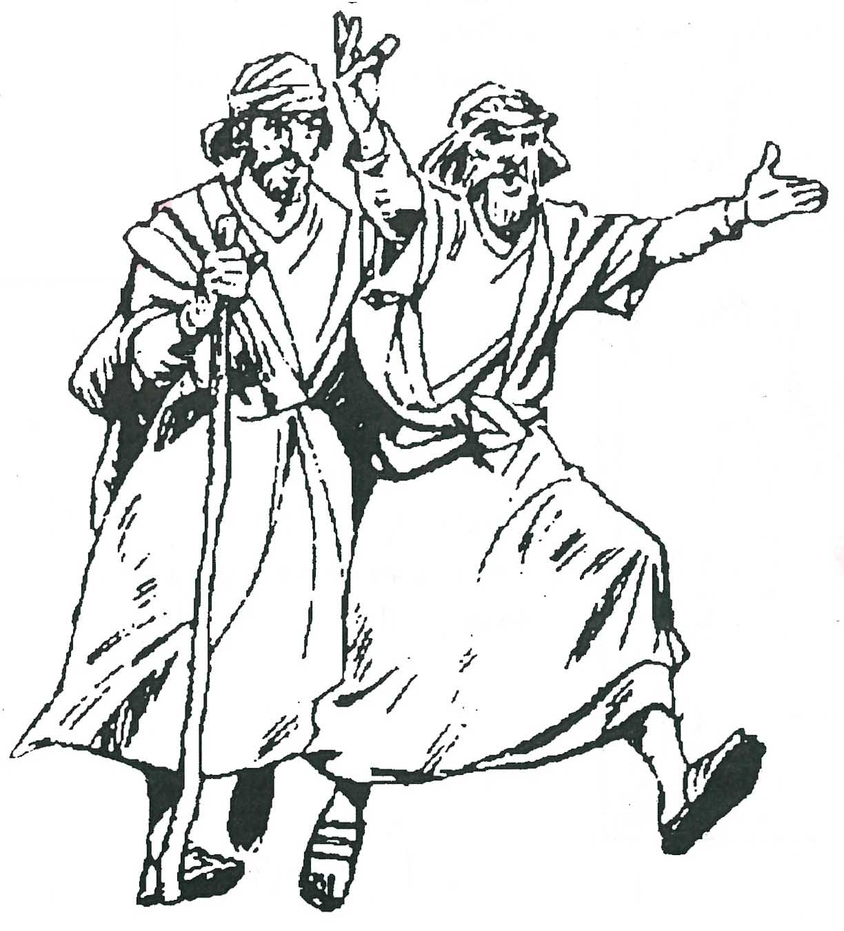

1. The Angel brought __ __ __ __ news!

2. At last the S ___ ___ ___ ___ ___ R was born.

3. The Angels sang G ___ ___ ___ ___ to G ___ ___ .

4. Who are these men? What are they doing?

________________________________________

________________________________________

________________________________________

**Level 2 lesson 42**

**Extra:** What message of “good news” did   
the angels bring to the shepherds?

**Read Matthew 2:1-12**In a land far away from Bethlehem lived some very wise men called “Magi.” They liked to study the stars. One night they saw a beautiful, new star in the sky. They knew it meant that God had sent a new baby into the world to be King.

The Wise Men wanted to worship Him, even though they knew He was far away. Quickly they packed food, water, and clothes for the long trip. They also packed some very special gifts to give to the new-born King. They mustn’t forget them!

When everything was ready, they climbed onto their camels and rode away. The bright star led them firstly to the city of Jerusalem. They went to King Herod’s palace and asked him, “Where is the new King?” King Herod knew nothing about it. In his heart, he was angry that another King was born.

So Herod asked the chief priests where this ‘new King’ should be born. “In Bethlehem,” they replied. “Alright,” Herod said to the Magi, “Go to Bethlehem and make a careful search for the child.

**The Wise Men visit Jesus**

Key Verse:  
**“They opened their treasures and presented him (Jesus) with gifts of gold, incense, and myrrh.”**Matthew 2:11b

When you find Him, let me know, so that I can go and worship Him too.” But really, Herod was lying. He wanted to kill the baby, not worship Him!

The Wise Men left the palace and followed the star until it stopped right over the place where the new baby King was. Who do you think the baby was? Yes, of course, it was the Lord Jesus! They knew He was to be a great King and save people from their sin. How happy they were to worship Him and give Him their special gifts.

We can also give Jesus gifts. Not toys, money or games, although they are all nice gifts. No, what He really wants is US – yes, YOU and ME! When we ask Jesus to be our Saviour and take away the sin from our lives, it is like giving Him the gift of our lives. Then we can love, obey, and serve Him with our whole heart and all our effort.

Later, an angel warned the Wise Men not to go back to King Herod’s palace. God knew that the wicked King Herod only wanted to kill baby Jesus, but God would not let him do that!

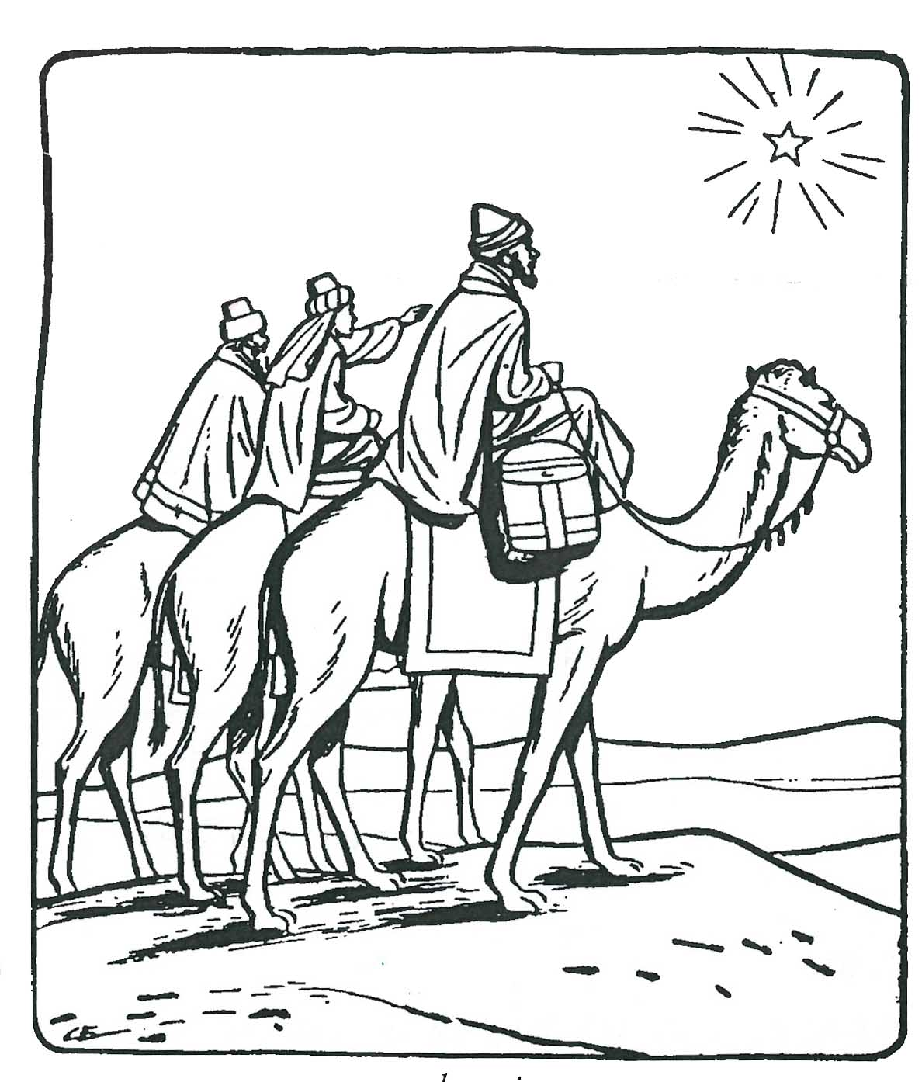

1. What did the wise men bring to Jesus?

G__ __ __ S

2. What is the best gift _______________________  
 (write your name)

can give to the Lord Jesus?

Some money Some food

My life My toys

A game A book

(Circle your answer)

**Level 2 lesson 43**

**Extra:** How did the wise men know where to find the new King Jesus?

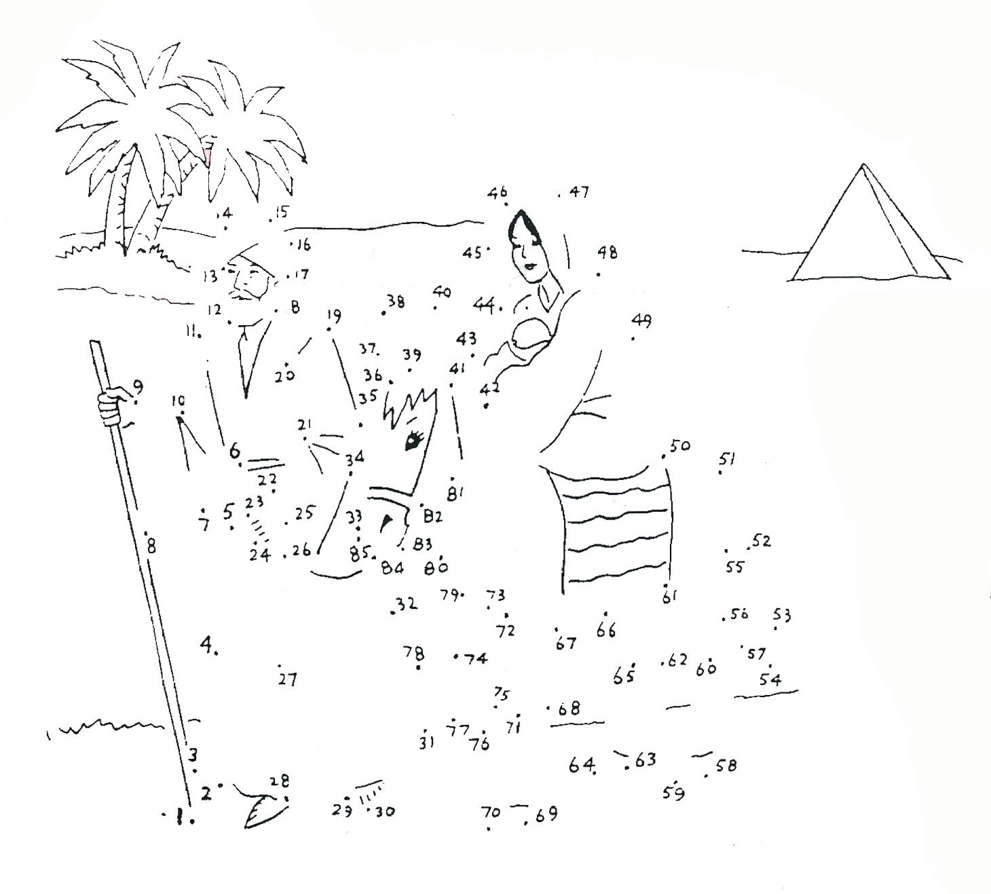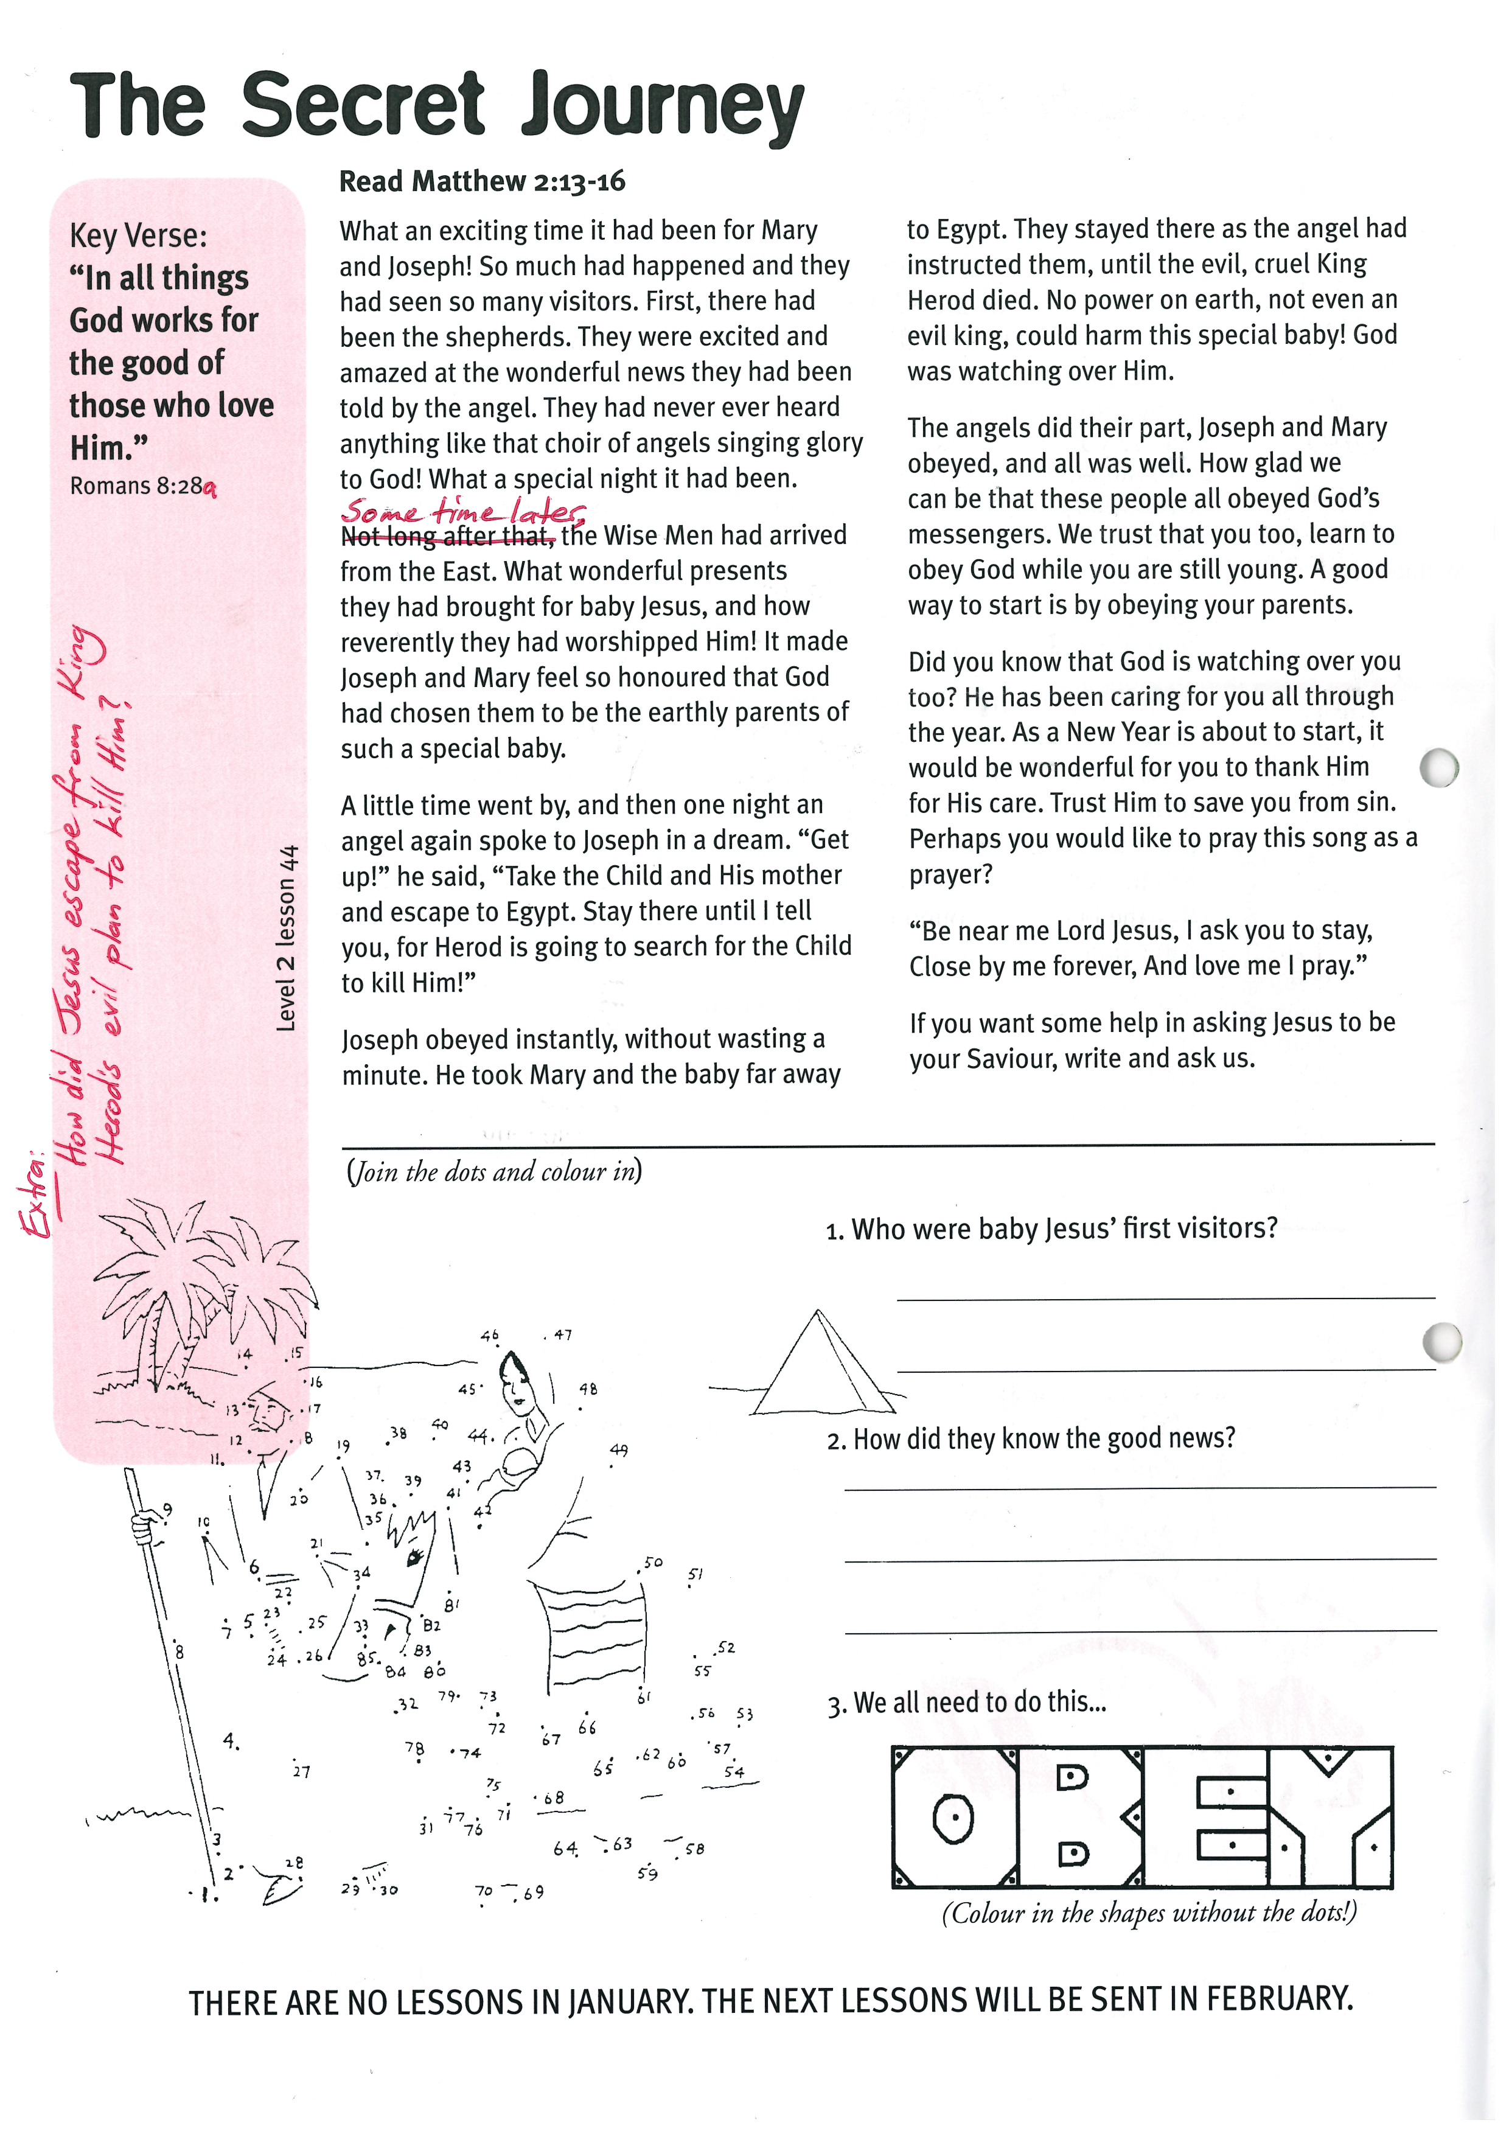

**Level 2 lesson 44**

**THERE ARE NO LESSONS IN JANUARY. THE NEXT LESSONS WILL BE SENT IN FEBRUARY**

*Colour in the shapes without the dots!*

1. Who were baby Jesus’ first visitors?

______________________________________

______________________________________

2. How did they know the good news?

_________________________________

______________________________________

3. We all need to do this…

**Extra:** How did Jesus escape from King   
Herod’s evil plan to kill Him?

Joseph obeyed instantly, without wasting a minute. He took Mary and the baby far away to Egypt. They stayed there as the angel had instructed them, until the evil, cruel King Herod died. No power on earth, not even an evil king, could harm this special baby! God was watching over Him.

The angels did their part, Joseph and Mary obeyed, and all was well. How glad we can be that these people all obeyed God’s messengers. We trust that you too, learn to obey God while you are still young. A good way to start is by obeying your parents.

Did you know that God is watching over you too? He has been caring for you all through the year. As a New Year is about to start, it would be wonderful for you to thank Him for His care. Trust Him to save you from sin. Perhaps you would like to pray this song as a prayer?

“Be near me Lord Jesus, I ask you to stay,  
Close by me forever, And love me I pray.”

If you want some help in asking Jesus to be your Saviour, write and ask us.

**Read Matthew 2:13-16**

What an exciting time it had been for Mary and Joseph! So much had happened and they had seen so many visitors. First, there had been the shepherds. They were excited and amazed at the wonderful news they had been told by the angel. They had never ever heard anything like that choir of angels singing glory to God! What a special night it had been.

Some time later, the Wise Men had arrived from the East. What wonderful presents they had brought for baby Jesus, and how reverently they had worshipped Him! It made Joseph and Mary feel so honoured that God had chosen them to be the earthly parents of such a special baby.

A little time went by, and then one night an angel again spoke to Joseph in a dream. “Get up!” he said, “Take the Child and His mother and escape to Egypt. Stay there until I tell you, for Herod is going to search for the Child to kill Him!”

Key Verse: **“In all things God works for the good of those who love Him.”**Romans 8:28a

**The Secret Journey**