**Read Genesis 44:1-45:8**

Joseph’s brothers returned to Egypt with Benjamin, their younger brother. Jacob had not wanted to let him go, but he finally agreed. When they arrived in Egypt, Joseph the Governor seemed pleased to see them all again, especially Benjamin!

After a while, he loaded up their donkeys with sacks of food and they set off back home. They were really happy. Simeon was free and the Governor had not kept Benjamin either. But they had not gone very far when some of Joseph’s servants came chasing after them. “Why have you repaid evil for good?” they asked. Our master helped you a lot and now one of you has robbed him of his silver cup. You come back with us; our master wants to speak to you!”

The brothers were very upset. What did these men mean? They hadn’t stolen the Governor’s cup! When they stood before Joseph, he acted as though he was very angry. He said all of them could go back home, except the one who had the cup in his sack. Joseph’s men searched all their sacks and finally found it in Benjamin’s!

The brothers didn’t know Joseph had secretly put it there. They begged Joseph to let Benjamin go home with them. They said they could never face their father without him. He would be sad and die if Benjamin was not with them.

Joseph could see that his brothers had changed. They were no longer cruel as they had been, when they had sold him. They truly loved their father and didn’t want to make him sad. They loved Benjamin too, and didn’t want to leave him behind. Joseph was really happy. He couldn’t hide his secret anymore. He sent everyone out of the room, except for his brothers. Then he told them who he was. They could hardly believe their ears!

At first they were scared. They thought Joseph would be angry and punish them for the way they had treated him. Instead, he forgave them! He told them he was still their brother and he loved them. He cried because he was so happy to see that they had changed. “Don’t be sad or angry with yourselves,” he said. “You meant to hurt me, but God meant it for good, to save lives.” Joseph forgave his brothers. He repaid good for evil. If you have asked God to forgive your sin, then you should forgive those who do wrong to you too!

**Joseph Forgives his Brothers**

Key Verse:  
**“God sent me ahead of you… to save your lives”**Genesis 45:7

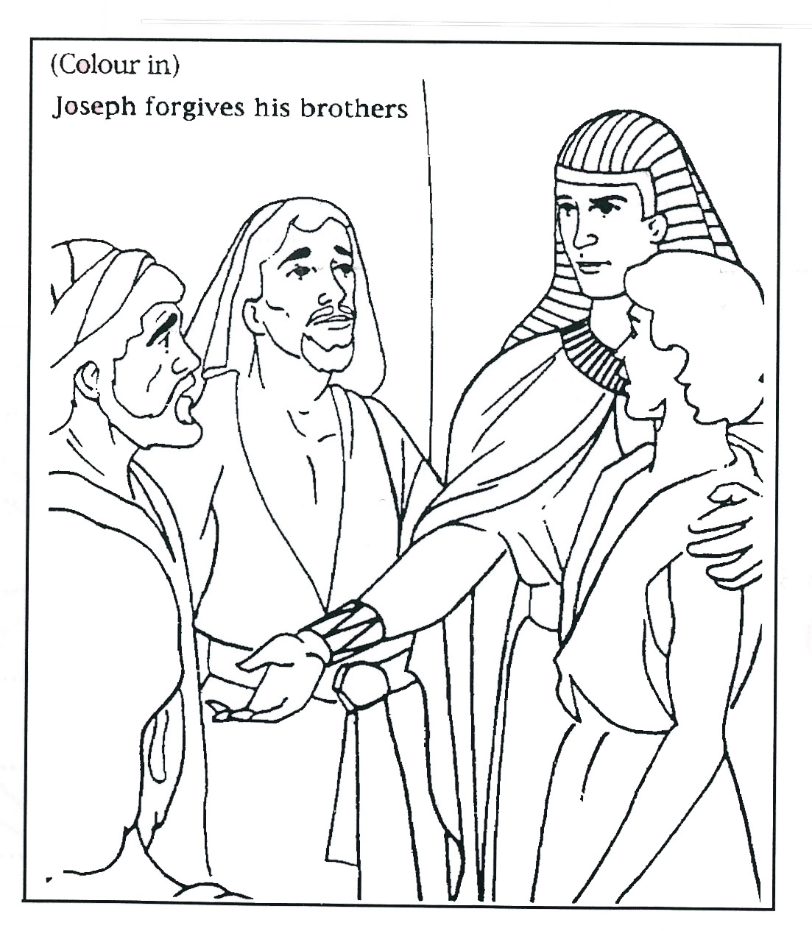

1. Why were Joseph’s brothers scared?

_______________________________________

_______________________________________2. What did Joseph do instead?

_______________________________________

_______________________________________3. Who do we ask to forgive our sin?

_______________________________________

_______________________________________

**Extra:** How can you show forgiveness   
to others as Joseph did?

FORGIVE ONE ANOTHER

**Level 2 lesson 37**

My Name is________________________________________ Age ______________

**Read Genesis 45:9-46:7**

Joseph wanted to show his brothers how much he still loved them, even though they had treated him badly. He was in charge of all Egypt and was very rich now, so was able to give them lots of gifts. Then he said, “Hurry home, tell my father about me and then bring him down here.” He sent lots of presents to his father Jacob too.

So his brothers went home, with their wagons full of food and gifts. They could hardly wait to see their father’s face when he saw it all. What a story they had to tell. Most of all, they wanted to tell Jacob the wonderful news about Joseph!

As they got near they called out, “Joseph is alive!” But Jacob couldn’t believe it. Again and again they told him it was true. “Joseph is alive! He is a ruler in Egypt now. He lives in a huge palace and is very rich.” They showed him the wagons and all the gifts Joseph had sent.

At last Jacob said, “I believe you. My son Joseph is alive! I will go and see him before I die.” So they packed up all their things and set off for Egypt.

Before they had gone very far, Jacob stopped to say ‘thank you’ to God for all His goodness to them.

God showed how much He loves us by sending His own Son, the Lord Jesus Christ, to die for our sin on a cruel cross. Let’s not forget to say ‘thank you’ to God for all His love and kindness.

After thanking God, Jacob and the whole family continued on down to Egypt. They took their flocks of sheep and herds of cattle with them. Jacob was so excited to meet Joseph, his long-lost son again. What a wonderful family reunion they were going to have!

**Joseph Sends for Jacob**

**Key Verse:  
“Thanks be to God! He gives us the victory through our Lord Jesus Christ.”**1 Corinthians 15:57

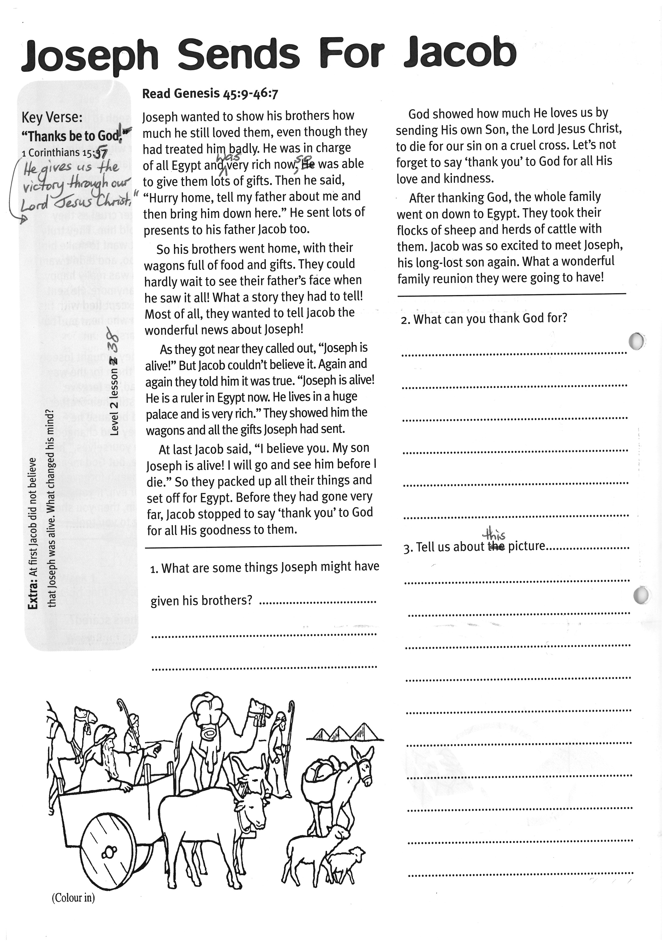

**Level 2 lesson 38**

**Extra:** At first Jacob did not believe that Joseph was alive. What changed his mind?

2. What can you thank God for?

____________________________

____________________________

____________________________

____________________________

____________________________

3. Tell us about this picture:

____________________________

____________________________

____________________________

____________________________

____________________________

____________________________

____________________________

____________________________

1. What are some things Joseph might have given his brothers?

__________________________________________

__________________________________________

3. Tell us about this picture:

Pharaoh kindly gave them some land in a place called Goshen, which was the best farm land in Egypt. So Jacob’s family settled there very happily, and Pharaoh put them in charge of all his cattle too.

Jacob was 130 years old when he went to Egypt. He lived to be 147. But before he died, he called his twelve sons together to talk to them. He spoke to Joseph and said that one day God would lead his people back to the ‘Promised Land’ of Canaan.

Then Jacob asked Joseph to bring his two sons to him. He wanted to bless them before he died. So Joseph brought his sons Manasseh and Ephraim to their grandfather and Jacob blessed them. When Jacob died, Joseph did as his father had asked. He travelled with his brothers back to their first home and buried Jacob in a cave in the land of Canaan. Then they all went back to live in Egypt.

How perfect God’s plans are. For all those years, God was looking after Jacob, Joseph, and all their families. We can trust God to look after us too, even when things get tough!

**Key Verse:**

**“Be kind and compassionate to one another, forgiving each other.”**

Ephesians 4:32

**Read Genesis 46:29-34, 47:27-30 and Genesis 49:29-33**

For many years Jacob had thought that his son Joseph was dead. He had always been so sad about that. Now that he had learnt Joseph was alive, a new joy filled his old heart. As the family rode along towards Egypt, he probably wondered what Joseph looked like and what he would say to him when they met.

Joseph also had longed to see his father Jacob. He would have been really excited about meeting his dad again and probably kept a look out for them to arrive! At last the day came and Joseph rushed down from his palace to meet his dear father. They laughed and cried together, and hugged each other. There was so much to talk about!

Joseph welcomed them all into his palace and Jacob was amazed to see how much God had blessed Joseph. Then Joseph introduced his family to Pharaoh, the King of Egypt. He told him that his brothers were good farmers, and shepherds, but that there was no grass in Canaan because of the famine.

Key Verse:  
**“Be kind and compassionate to one another, forgiving each other.”**

Ephesians 4:32

**Joseph and Jacob Meet Again**

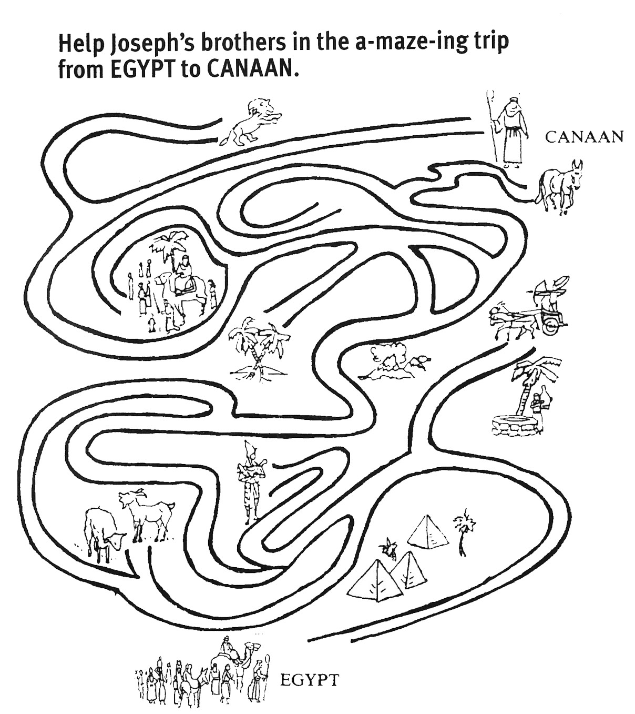

1. What had Joseph longed for?

____________________________

____________________________  
2. Why was Jacob amazed?

____________________________

____________________________  
3. What did Joseph do for his family?

____________________________

____________________________

____________________________  
4. God’s plans are __ E __ __ __ __ __

We can __ R __ __ __ God to L __ __ __ after us too

**Level 2 lesson 39**

**Extra:** Find out all you can about   
the job that Joseph’s brothers did.

**Level 2 lesson 39**

**Extra:** Find out all you can about the job that Joseph’s brothers did.

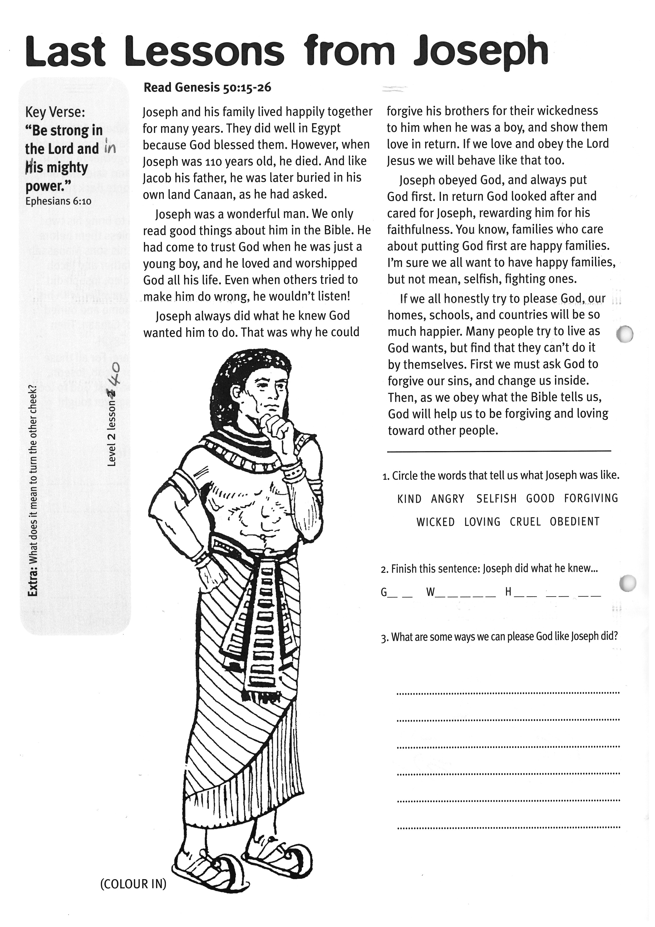

1. Circle the words that tell us what Joseph was like: KIND ANGRY SELFISH GOOD FORGIVING WICKED LOVING CRUEL OBEDIENT

2. Finish this sentence: Joseph did what he knew…

G__ __ W__ __ __ __ __   
H __ __ __ __ __ __

3. What are some ways we can please God like Joseph did?

­­­­­­­­­­__________________________________________

__________________________________________

__________________________________________

__________________________________________

__________________________________________

**Level 2 lesson 40**

**Extra:** What does it mean to turn the other cheek?

**Key Verse:**

**“Be strong in the Lord and in His mighty power.”**

Ephesians 6:10

**Read Genesis 50:15-26**Joseph and his family lived happily together for many years. They did well in Egypt because God blessed them. However, when Joseph was 110 years old, he died. And like Jacob his father, he was later buried in his own land Canaan, as he had asked.

Joseph was a wonderful man. We only read good things about him in the Bible. He had come to trust God when he was just a young boy, and he loved and worshipped God all his life. Even when others tried to make him do wrong, he wouldn’t listen!

Joseph always did what he knew God wanted him to do. That was why he could forgive his brothers for their wickedness to him when he was a boy, and show them love in return. If we love and obey the Lord Jesus we will behave like that too.

Joseph obeyed God, and always put God first. In return God looked after and cared for Joseph, rewarding him for his faithfulness. You know, families who care about putting God first are happy families. I’m sure we all want to have happy families, but not mean, selfish, fighting ones.

If we all honestly try to please God; our homes, schools, and countries will be so much happier. Many people try to live as God wants, but find that they can’t do it by themselves. First we must ask God to forgive our sins, and change us inside. Then, as we obey what the Bible tells us, God will help us to be forgiving and loving toward other people.

Please complete and return by post to   
**PSSM, 1-2A (G2) 93 Dominion Rd, Mt Eden, Auckland 1024** or scan & email to **info@biblediscovery.org.nz**

**Last Lessons from Joseph**