Key Verse:
“But you Bethlehem Ephrathah… out of you will come for Me one who will be ruler over Israel, whose origins are from… ancient times.”
Micah 5:2
Read Luke 1:26-56
and 2 Peter 3:8-13
Christmas is a time when children often hope to receive that special present they’ve been promised; a new bike, watch, clothes, or whatever it may be. Sometimes, for various reasons, parents fail to keep their promises. At Christmas though, we especially remember how God kept His promise by sending a wonderful gift to the world - His Son, the Lord Jesus Christ!
At the beginning of the New Testament, the Romans ruled over Israel and the Jews weren’t happy about it! Many waited hopefully for that great day when God’s promised ‘Messiah’ (the Christ) would be their new King, and set them free from the Romans. They longed for this day, just as we often long for Christmas Day to come. “I can’t wait for tomorrow to come!” we say. Have you ever felt like that?
The people of Israel knew quite a lot about God’s promise to send The Messiah, as they had read the prophecies God had given them in the Old Testament. For example, they knew He would be born in Bethlehem, and that He would be a prophet, a priest, and a King. They knew that He would do wonderful miracles. Unfortunately, they seemed to ignore the fact that God’s Word also told them that this One must give His life to save His people from their sins (see Isaiah 53)!
Every Jewish mother in Israel hoped that she might be the mother of this wonderful child. Yet when the time came for God to fulfil His promise, it was a humble, young girl that He chose

He sent Gabriel the angel to her, and Mary was at first frightened when he suddenly appeared. But her fear changed to wonder when she heard Gabriel’s message. She was to have a baby! Yet how could she have a baby when she was not yet married to Joseph?
The angel explained that Joseph would not be the father of this baby. God the Holy Spirit would cause this baby to be born, so that He would be the HOLY SON OF GOD! This was ‘the Messiah’ God had promised, whom all God’s people had been waiting so long for!
What a tremendous honour for Mary to be chosen to be the mother of the promised Saviour. She was so happy! As she thought about it, she sang a beautiful song of praise to God. You can read what she sang (often called ‘Mary’s Magnificat’) in Luke 1:46-56. Yet even Mary, who was so honoured by God, realised her sin and her own need of a Saviour (v47).
The Lord Jesus Christ came to save us from our sins, just as God had promised. Let’s praise God this Christmas for the gift of His Son the Lord Jesus Christ, the Saviour of the World!
Promises
1. What promise had God made many times in the Old Testament? | __O __E__ __ __ __E M E__ __I__ __
2. What four things did the Jews know about the promised Messiah?

3. Who did Gabriel say that Mary’s baby would be?
4. What did Mary realise about herself, and her own need?
5. What was the purpose of Christ’s coming?
My Name is _____________________________________________ Age ___________
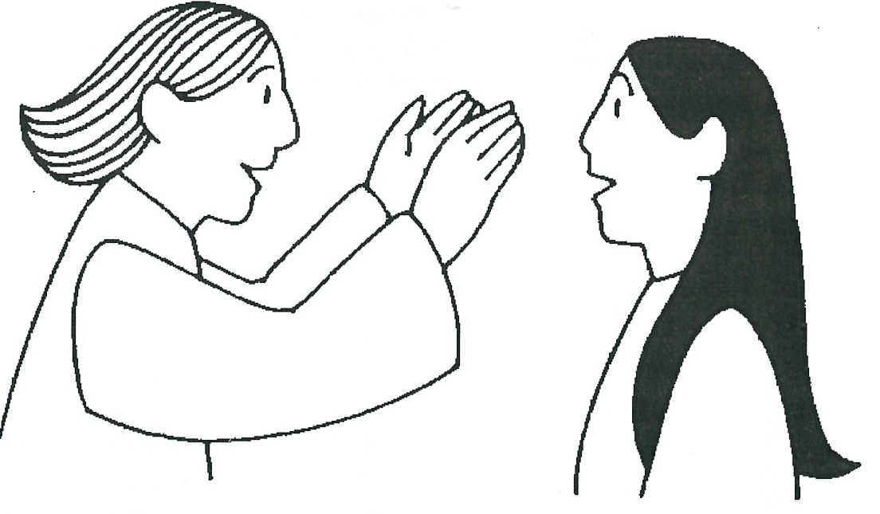
Level 3 lesson 1
Extra: Find some promises in the Bible that God made about the coming Saviour.

Level 4 lesson 41
QUESTIONS & ANSWERS
Key Verse:
“Jesus said, ‘I tell you the truth, unless a man is born again, he cannot see the kingdom of God.’”
John 3:3

1. What brought Mary and Joseph to Bethlehem?
2. What happened when they could find no place to stay? | Mary and Joseph were offered __ __ __ __ __ __ __ in a __ __ __ __ __ __
3. Describe who the child Jesus really was!
4. What was happening in the fields outside Bethlehem?
5. Why did the Lord Jesus come to this world?
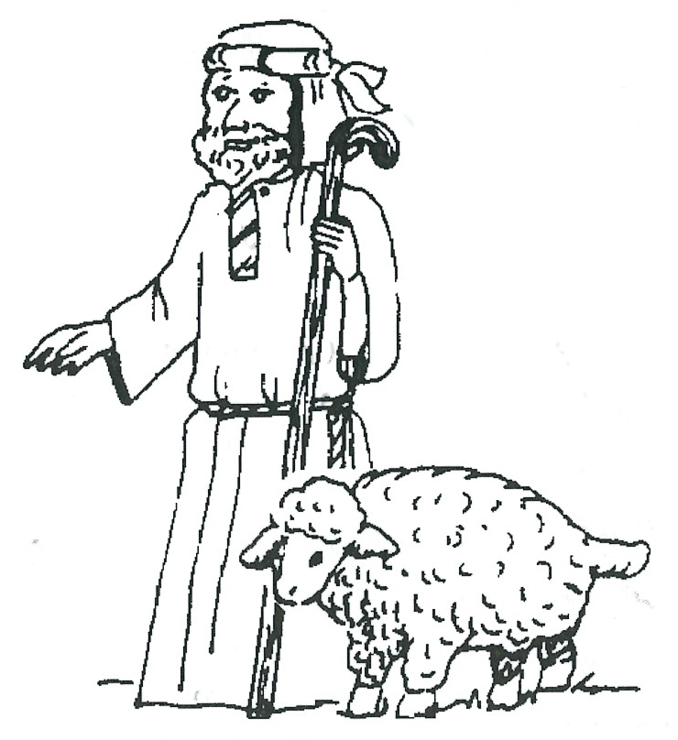
___
Extra: Explain in your own words the meaning of the Key Verse.
Level 4 lesson 42
QUESTIONS & ANSWERS
Problems
Key Verse:
“For you know the grace of our Lord Jesus Christ, that though He was rich, yet for your sakes He became poor, so that you through His poverty might become rich.”
2 Corinthians 8:9
Read Luke 2:1-20
and Matthew 1:18-25
Around the time Jesus was to be born, Caesar Augustus, the Roman Emperor, sent word to King Herod that he was to take a Census of the Jews. In a Census, everyone’s name, age, address, and family details are recorded. Mary and Joseph lived in Nazareth where Joseph was a carpenter. However, Roman law for the Census required every man to return to the town where their grandfather was born, and have their details recorded there.
Joseph was descended from the family of the great King David, who was born in Bethlehem. This meant that just when Jesus was about to be born, Joseph and Mary had to travel there. Although this was inconvenient for them, God was in control. He was simply working things out to fulfil Bible prophecies, which clearly said that Jesus would be born in Bethlehem (Micah 5:2).
When Joseph and Mary arrived they found the town packed with people. Every lodging-house seemed full. If they had been wealthy they may have found somewhere to stay, but as it was, no-one seemed to want them. Mary’s first baby was about to be born, and even the cheapest inn in town had no room for them.
Finally, one innkeeper took pity on Mary, and offered them shelter in a stable. This would have been dark, cold, damp, and probably dirty. No pretty cot in which to lay her precious, first-born baby; just an animal’s manger (feed-bin) lined with hay! God’s Son, the Creator of the Universe, was born into this world to absolute poverty. What incredible humility!
At that moment outside Bethlehem, some shepherds were watching over their flocks of sheep during the night, just as King David had done centuries before.

Suddenly, they were terrified by a glorious light, as a shining angel appeared before their eyes! “Don’t be afraid!” he told them. “For unto you is born this day in the city of David, a Saviour, who is Christ the Lord.” Then a whole choir of angels appeared, filling the sky with their singing, “Glory to God in the highest, and on earth peace and goodwill to men.”
What an amazing sight! The shepherds could hardly believe their eyes. Then as quickly as they had appeared, the angels were gone. Still almost breathless in awe and astonishment, the shepherds set out at once to find the child. We read that they hurried off and found Mary, and Joseph, with the baby, who was lying in a manger. Then they immediately praised Him - the long awaited Messiah!
How wonderful to think that this babe lying there in the hay was the holy, SON of GOD, our Saviour! He left the glory and splendour of His heavenly home to come to this sin-sick world where there was “no room for Him.”
Our memory verse reminds us though, that He was willing to become poor, so that we might become rich. He came in order to share the riches of His love and salvation with poor sinful people like us. What great love and sacrifice! There was no room for Him in the inn, but is there room for Him in your heart this Christmas? Can you say the simple words of this little chorus and really mean it? “Come into my heart Lord Jesus, There is room in my heart for you!”

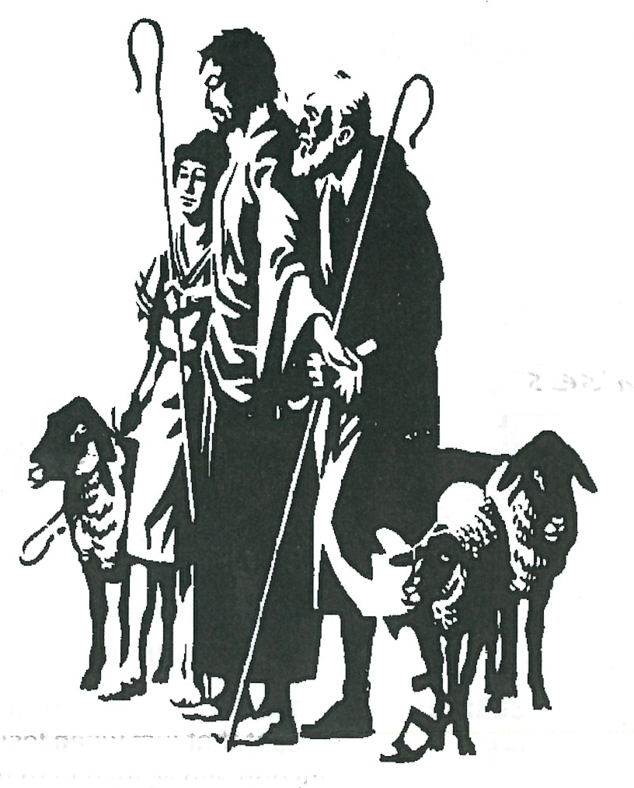
Level 4 lesson 43
Key Verse:
“On coming to the house, they saw the child with His mother Mary, and they bowed down and worshipped Him.”
Matthew 2:11a

much. It was just like that incense going up to God. Sinful men hated the Lord Jesus because He was so good and perfect, and showed up their sinful lives; but God loved Him and was well pleased with Him.
Myrrh was something bitter and yet it was sweet-smelling. This pictured the Lord’s life in a special way, for as He grew up He knew what it was to suffer. He was “despised and rejected by men.” His life was perfect and beautiful, yet He knew the bitterness of sorrow and suffering, even dying for you and I on Calvary’s cruel cross!
I wonder if the Wise men realised as they laid their gifts at Jesus’ feet, that they were looking at God’s greatest gift to men? John 3:16 tells us, “For God so loved the world that He gave His one and only Son, that whosoever believes in Him should not perish, but have everlasting life.” What gift on earth could ever truly compare to that?!
They were ready to give to Him, but God had already given to them (and us) the greatest gift! Of all the presents we will ever receive at Christmas-time, there is none as wonderful as this. Have you received Him yourself? Have you thanked God for His grace and kindness in sending Jesus to save you from your sins? This is the true meaning of Christmas. We remember God’s perfect gift. We cannot give costly gifts like the Wise men, but we can give our hearts and lives to Jesus!
Read Matthew 2:1-15
and John 3:16-21
Christmas morning is a happy time! All the presents are opened and there are many surprises. Of course, sometimes we know all along what is coming, but it’s still great to finally get it, isn’t it!
Receiving presents is fun that’s for sure; however, we can easily become selfish and forget about others if we only think about what we are getting. Jesus said it was better for us to give than to receive! That seems strange doesn’t it? But it’s true - you try it!
Presents also can show how generous or mean the giver is too! When God gave the Lord Jesus as the gift of His love, He gave us the most generous gift of all! The story we read in Matthew 2 is one that speaks of ‘two-way’ giving.
The Wise Men in the story had been alerted by the appearance of a bright star that a great King had been born. They left their home in the East to follow the star, seeking the King of the Jews. They took with them some very precious gifts to give in worship to this great King.
Finally, they came to the place where Jesus was. There, they bowed in worship and offered their gifts to Him. First, we read, they gave gold. We all know how valuable gold is! Gold was a gift for a King. This showed that they realised that even though Jesus was only a little baby, He was truly “the King of Kings and Lord of Lords.” How suitable this gift was!
Then we read they offered Him frankincense. This was precious, sweet-smelling incense, offered by priests in their sacrifices. As the Lord Jesus grew up, some men hated Him, despised Him, and saw no beauty in Him at all.
We think of the lovely life of the Lord Jesus though, and remember that it pleased God very
Presents
1. What did the star tell the wise men about the child they were seeking?
2. Why did sinful men hate the Lord Jesus so much?

3. What does the gift of myrrh, that the men brought, remind us about the Lord Jesus? | His l_ _ _ was p_ _ _ _ _ _ and b_ _ _ _ _ _ _ _, yet He knew the b_ _ _ _ _ _ _ _ _ of s_ _ _ _ _ and s_ _ _ _ _ _ _ g.
4. What verse from this study tells us about God’s great gift to us?

5. What is the best gift that we can give to the Lord Jesus? (If you don’t understand, please ask us.)
Extra: Why do you think people give gifts at Christmas?

QUESTIONS & ANSWERS

Praise
Key Verse:
“And Mary said ‘My soul praises the Lord and my spirit rejoices in God my Saviour’.”
Luke 1:46-47
Read Luke 1:46-56
and Luke 2:8-14; 25-32
The message of Christmas is a message of JOY! We always associate singing and rejoicing with it. It is wonderful at this time of year to hear the bells ringing, to listen to carol singing, and to feel the atmosphere of joy all around. Sadly, some Christmas celebrations are not the right kind, and they certainly do not bring lasting satisfaction. So many people use this time of the year as merely an excuse for excess and foolishness. They eat and drink too much, which often robs Christmas of its true joy.
The joy of the coming of Christ into the world was very real. Indeed, Heaven and earth joined together to announce the Good News of His birth, with a heavenly choir of angels singing His praises. What an amazing experience for the shepherds, to hear that great chorus of the angels!
Imagine as they watched their sheep, the silence of the night broken by an angelic choir singing, “Glory to God in the highest and on earth peace, good will toward men!” Look too, at the message of joy the angels gave to the world when Christ was born. “Today in the town of David, a Saviour has been born to you; He is Christ the Lord!”
Here are three great reasons for praising God:
1. CHRIST was born: God was showing His love for people. Christ was sent into the world to bring God’s love and mercy to us.
2. The SAVIOUR was given: The Lord Jesus came to save us from God’s righteous punishment of our sin. Bethlehem began the pathway that led to Calvary’s Cross, where Jesus died in our place!
3. This was GOOD NEWS: It has been spreading ever since. People everywhere can now experience God’s forgiveness for their sin! Praise
Peace

on Earth
1. What message of joy did the angels sing?
2. Name two people who rejoiced at the birth of Jesus.
3. What did Simeon say as he held the Lord Jesus in his arms?

4. Complete this sentence: | Christmas without C_ _ _ _ _ would be very e_ _ _ _ indeed.
5. Do you know Jesus as your own personal Saviour? Tell us how.
Extra: Try writing a song or poem of praise to God.

Level 4 lesson 44
QUESTIONS & ANSWERS
God that in a world of gloom and misery, the Christmas message still brings joy and gladness!
All the praise for the joyous coming of Christ went to God Himself. Just a small, helpless baby lying in a manger in a stable, yet the highest praise of Heaven was given to God because of Him. It’s true that if you experience in your life how wonderful the Lord Jesus is, you too will always be able to find cause for thanksgiving and praise to God.
Others too, praised God for the fact that Jesus was born. Zacharias (the father of John the Baptist who was the forerunner of Jesus) broke out in praise when he realised that a much greater person than his son John was coming. Mary sang that wonderful song we call ‘the Magnificat’ even before her Son was born. She was so full of praise to God she sang, “My soul praises the Lord!”
Then, later on, when Simeon held baby Jesus in his arms, he too sang a song of praise to God because, as he said, “My eyes have seen Your salvation!” All these different people sang their songs of praise to God. I wonder… this Christmas, will YOU find time to think about the arrival of Jesus Christ into the world, and will YOU praise God for Him?
To know the ‘Christ’ of Christmas as YOUR Saviour is true joy! How sad if among all the ‘joys’ we have, we know nothing of this joy. Christmas without Christ is very empty indeed. Above all this Christmas, make sure you find time to thank and praise God for the Lord Jesus Christ, the greatest gift of all!
THERE ARE NO LESSONS IN JANUARY. THE NEXT LESSONS WILL BE SENT IN FEBRUARY

