**Read John 1:29-42**Happy New Year! We hope you all had a nice Christmas holiday and are keen to get on with your Bible lessons for another year. At Christmas we celebrated the time when Jesus was born as a baby. In our next lessons we are going to find out some of the wonderful things that happened when Jesus grew up and began His work on earth.

John the Baptist was a prophet. He gave God’s messages to the people. One day he was talking to some people beside the Jordan River when he looked up and saw the Lord Jesus coming. Pointing to Jesus he said, “Look; the Lamb of God who takes away the sin of the world!” He knew that Jesus had come to save people from their sin. He knew that to do this, Jesus had to die and take the punishment for everyone’s sin. Then everyone who trusts Him as Saviour no longer has to be punished for their sin, but can be forgiven!

Key Verse:  
**“Look, the Lamb of God, who takes away the sin of the world!”**

John 1:29

**Followers of the Lord Jesus**

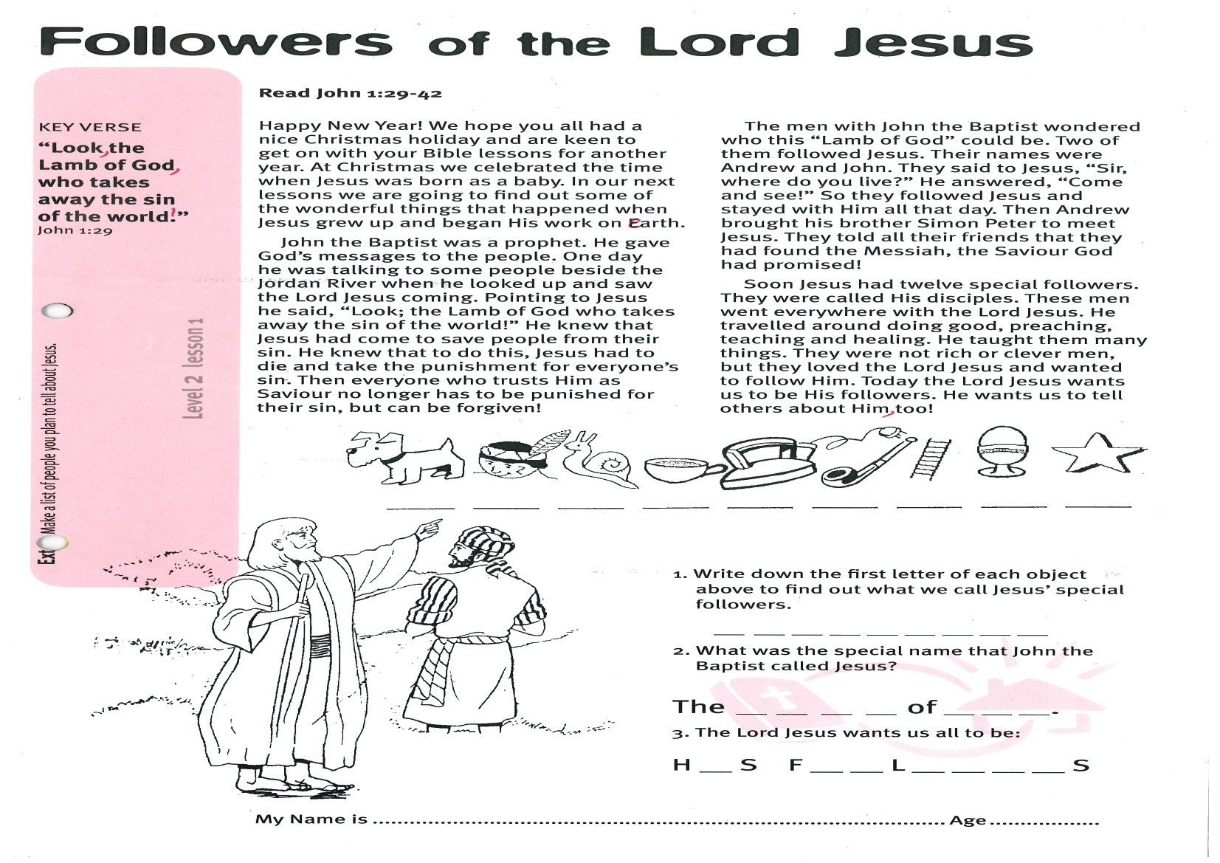

1. Write down the first letter of each object above to find out what we call Jesus’ special followers.

2. What was the special name that John the Baptist called Jesus?

The __ __ __ __ of __ __ __.

3. The Lord Jesus wants us all to be:

H __ S F __ __ L __ __ __ __ S

**Extra:** Make a list of people you   
plan to tell about Jesus.

**Level 2 lesson 1**

The men with John the Baptist wondered who this “Lamb of God” could be. Two of them followed Jesus. Their names were Andrew and John. They said to Jesus, “Sir, where do you live?” He answered, “Come and see!” So they followed Jesus and stayed with Him all that day. Then Andrew brought his brother Simon Peter to meet Jesus. They told all their friends that they had found the Messiah, the Saviour God had promised!

Soon Jesus had twelve special followers. They were called His disciples. These men went everywhere with the Lord Jesus. He travelled around doing good, preaching, teaching and healing. He taught them many things. They were not rich or clever men, but they loved the Lord Jesus and wanted to follow Him. Today the Lord Jesus wants us to be His followers. He wants us to tell others about Him, too!

My Name is________________________________________ Age ______________

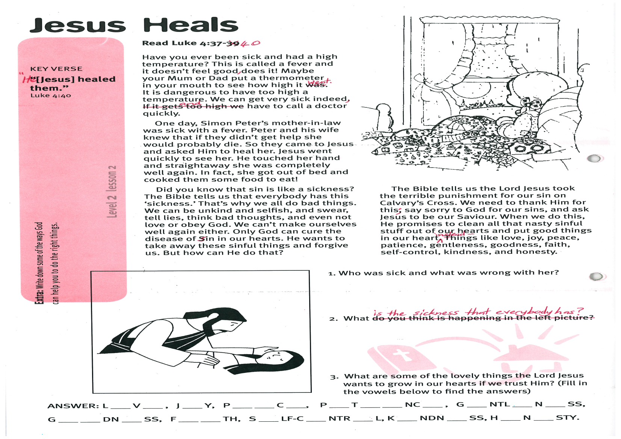

**Read Luke 4:37-40**

Have you ever been sick and had a high temperature? This is called a fever and it doesn’t feel good, does it! Maybe your Mum or Dad put a thermometer in your mouth to see how high it went. It is dangerous to have too high a temperature. We can get very sick indeed, and have to call a doctor quickly!

One day, Simon Peter’s mother-in-law was sick with a fever. Peter and his wife knew that if they didn’t get help she would probably die. So they came to Jesus and asked Him to heal her. Jesus went quickly to see her. He touched her hand and straightaway she was completely well again. In fact, she got out of bed and cooked them some food to eat!

Did you know that sin is like a sickness? The Bible tells us that everybody has this ‘sickness.’ That’s why we all do bad things. We can be unkind and selfish, and swear, tell lies, think bad thoughts, and even not love or obey God. We can’t make ourselves well again either. Only God can cure the disease of sin in our hearts. He wants to take away these sinful things and forgive us. But how can He do that?

**Jesus Heals**

Key Verse:  
**“He [Jesus] healed them.”**  
Luke 4:40



3. What are some of the lovely things the Lord Jesus wants to grow in our hearts if we trust Him? (Fill in the vowels below to find the answers)

ANSWER: L ___ V ___ , J ___ Y, P ___ ___ C ___, P ___ T ___ ___ NC ___ , G ___ NTL ___ N ___ SS, G ___ ___ DN ___ SS, F ___ ___ TH, S ___ LF-C ___ NTR ___ L, K ___ NDN ___ SS, H ___ N ___ STY.

1. Who was sick and what was wrong with her?

___________________________________________________

___________________________________________________

2. What is the sickness that everybody has?

___________________________________________________

___________________________________________________

**Extra:** Write down some of the ways   
God can help you to do the right things.

**Level 2 lesson 2**

The Bible tells us that the Lord Jesus took the terrible punishment for our sin on Calvary’s Cross. We need to thank Him for this; say sorry to God for our sins, and ask Jesus to be our Saviour. When we do this, He promises to clean all that nasty sinful stuff out of our hearts and put good things in our heart instead - things like love, joy, peace, patience, gentleness, goodness, faith, self-control, kindness, and honesty.

**Read Luke 5:1-3**One day the Lord Jesus was down by the Lake of Galilee where the fishermen kept their boats. The fishermen had been out fishing all night. But this time they had not caught any fish. Now they were cleaning all the weed and rubbish out of their nets. They knew it was good to have them clean and ready for next time. It is good to be careful, to look after our things, and do our jobs well, too.

On this day, there were crowds of people there also. They had come to hear Jesus speak. As the crowds pushed nearer to the Lord Jesus, He climbed into one of the boats. It was Simon Peter’s. He asked Peter to push the boat out a little bit from the shore. As the people stood on the shore, Jesus sat down in the boat and taught

**Jesus Borrows a Boat**

Key Verse:  
**“My son [child], give Me your heart and let your eyes keep to My ways.**Proverbs 23:26

them. Peter must have been glad to have Jesus use his boat that day.

Imagine if Jesus wanted to use something of yours! Wouldn’t that be just wonderful? What do you think He would like to have most of all? Firstly, He wants your HEART to love and obey Him. Then, your HANDS to do kind things for others, your FEET to walk in His ways, and your LIPS to tell others about Him.

A little poem says: “He has no HANDS but our hands, to do His work today. He has no FEET but our feet, to lead others in His way. He has no LIPS but our lips, to tell others how He died. He has no HELP but our help, to bring others to His side.”

What is Jesus using of yours today?

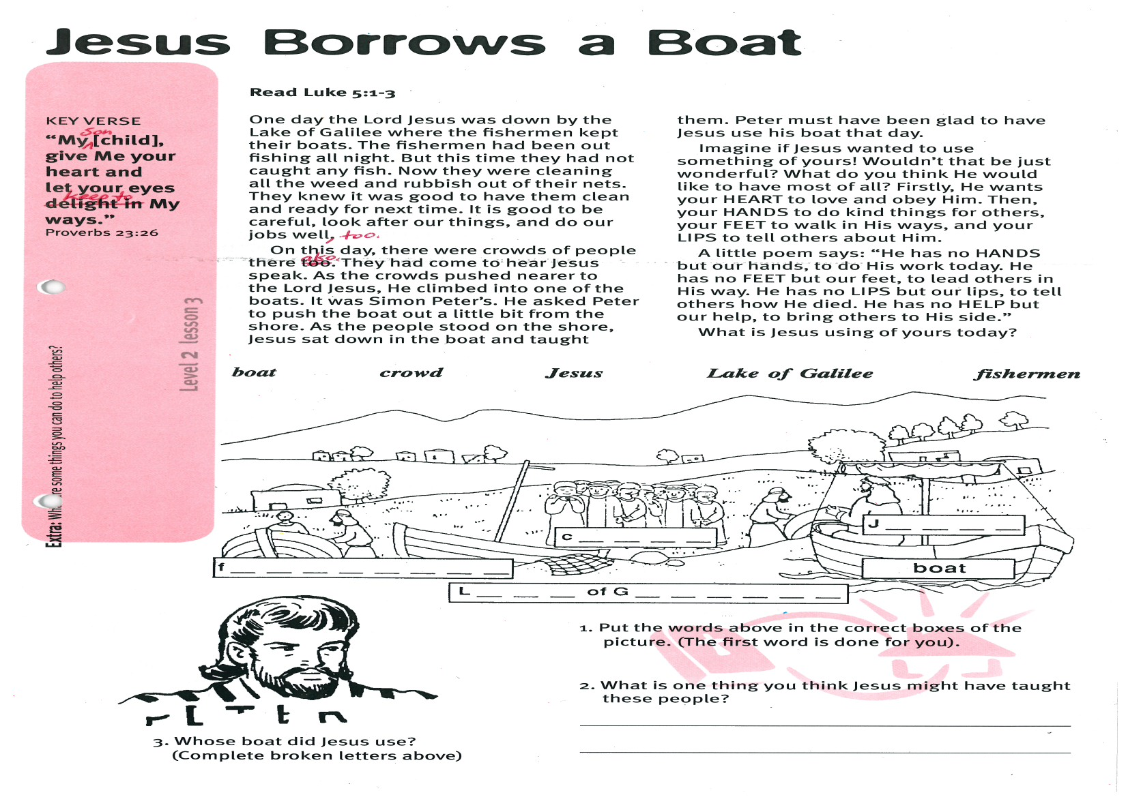

1. Put the words above in the correct boxes of the picture. (The first word is done for you).

2. What is one thing you think Jesus might have taught these people?

_________________________________________________

_________________________________________________

3. Whose boat did Jesus use? (Complete broken letters to the left)

**Extra:** What are some things YOU can do to help others?

**Level 2 lesson 3**

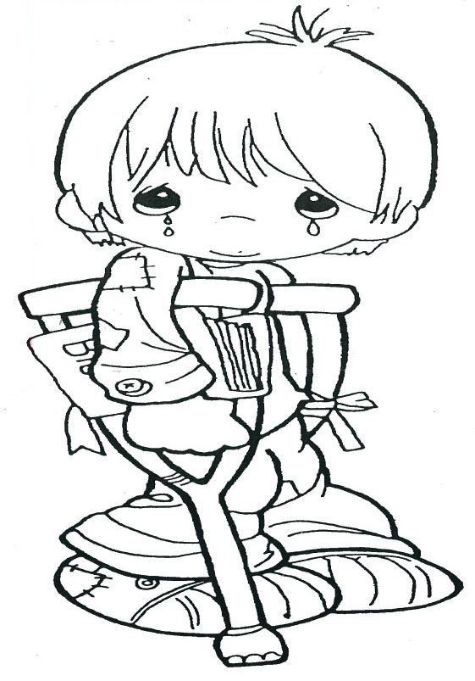

Anybody who caught leprosy had to go away and live **by themselves**, so that **others** wouldn’t catch it. Not just for a while, but for the rest of their life! No one would touch them, or even go near them. They were often very sad and lonely.

One day a poor leper came to the Lord Jesus. He bowed down on the ground in front of Him and said, “Lord, if you will, you can make me **clean**.” He had faith: he really believed Jesus could do that. Do you know what the Lord Jesus did? He put out His hand and touched the leper! Yes - He touched him, and said, “I will, be clean!” Instantly the **leprosy** left the man and he was completely healed!

When Jesus was on earth, He healed many people of this disease. He always healed those who came to Him really believing. Jesus could cure the disease of leprosy. He can cure sin too, which is like a terrible disease. He died on Calvary’s Cross so that our sins could be cleansed away and forgiven. If you ask Him, He will take away your sins. The Lord **Jesus** is a wonderful **Saviour**!

From the text above, find and fill in the missing words. (They are in bold)

1. The people with leprosy had to live __ __

__ __ __ __ __ __ __ __ __ __ , so that

__ __ __ __ __ __ wouldn’t catch it.

2. Lord if you will, you can make me __ __ __ __ __ .

3. Instantly the __ __ __ __ __ __ __ left the man.

4. The Lord __ __ __ __ __ is our wonderful __ __ __ __ __ __ __ !

**Extra:** How can we help the sick, sad, and lonely people?

**Read Luke 5:12-15**

I wonder; how many of you have ever had measles or chickenpox? They are horrible diseases aren’t they? When you are sick with those things, you have to stay away from school, so you do not pass it on to others.

Well, in the Bible we read a lot about people with a terrible sickness called leprosy. It was far worse than measles or chickenpox. In fact, there was no cure for this disease!

**Level 2 lesson 4**

Key Verse: **“Lord, if You are willing, You can make me clean.”**

Luke 5:12

**Jesus Heals a Leper**

Please complete and return by post to   
**PSSM, 1-2A (G2) 93 Dominion Rd, Mt Eden, Auckland 1024** or scan & email to **info@biblediscovery.org.nz**