○

**Read: Exodus 25:10-22**When God called Moses up Mount Sinai to give him the Ten Commandments, He also gave him plans to build some other things. One of those things was called the ‘ARK of the Covenant.’ No, it was not to be a big ship like Noah built! It was to be a very special storage box made out of wood.

It was to be covered with pure gold and have long poles on each side to carry it. Also, the lid covering the chest was to have two gold-shaped angels (called cherubim) built on top at each end. They were to face each other with their wings pointing forward and over the box.

This Ark was for keeping safe the Ten Commandments and other holy things, too. Once the Ark had been built, no-one was allowed to touch it. It was very holy and special to God. It was to stay in the tabernacle (a big special tent) where the people worshipped Him.

Now remember that after the Israelites (God’s special people) left Egypt, God led them and showed them when and where to go.

Key Verse:  
**“Your Word is a lamp to my feet and a light for my path.”**

Psalm 119:105

**The Ark of the Covenant**

He did this by making a PILLAR OF CLOUD in the sky for the daytime and a PILLAR OF FIRE in the sky at night. These pillars hovered above the tabernacle where the Ark was kept. When God moved the pillar of cloud or fire, the Israelites followed. When God stopped the cloud or fire, the Israelites stopped too. The people always carried the ARK with them when they moved camp. When they stopped, the ARK was put back in the TABERNACLE and kept safely there until they moved again.

Today God uses a different way to guide us. It is through His Word the BIBLE. Our Key Verse from the Bible today tells us this. In the Bible, God tells us the right way to live and behave. Sadly, lots of people take no notice. But if you read, listen to, and obey God’s Word, He will guide you and help you to follow Him. God’s way is always best!

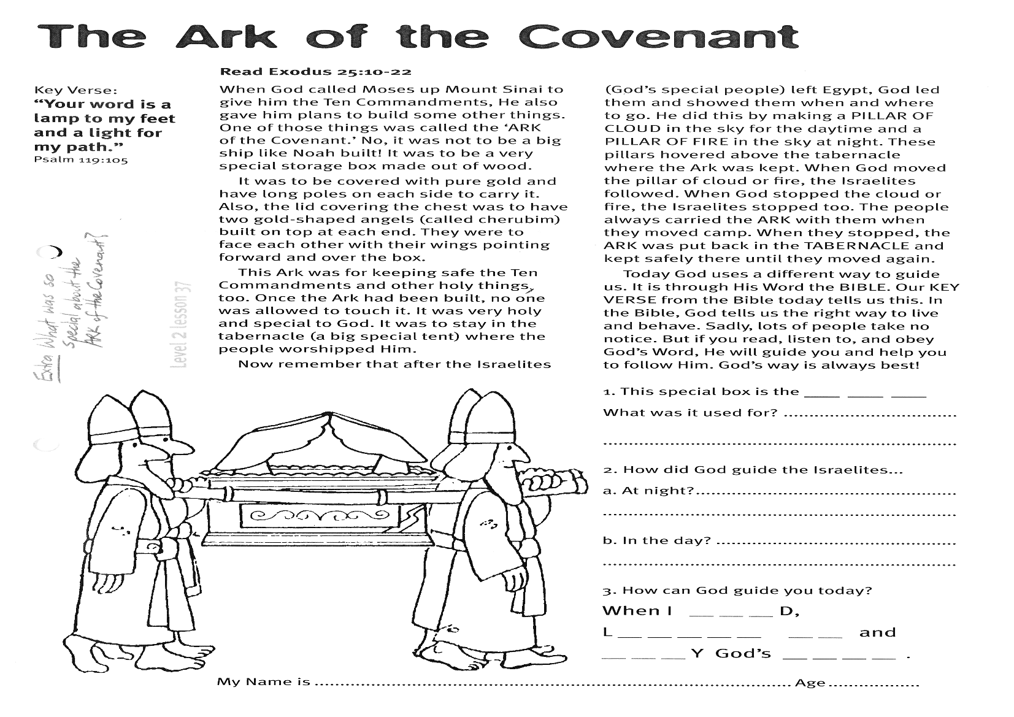

My Name is________________________________________ Age ______

1. This special box is the **__ __ __**  
What was it used for?  
…………………………………………………………………………………………………………………………

2. How did God guide the Israelites?

(a) at night……………………………………………  
(b) in the day………………………………………..

3. How can God guide you today?

**When I r __ __ d,  
l __ __ __ __ n to and  
__ __ __ y God’s W __ __ d.**

**Level 2 lesson 37**

**Extra:** What was so special about the Ark of the Covenant?

Joshua believed God and trusted God to help him. Today, God wants you to be strong and courageous too. If you love and trust the Lord Jesus Christ then you don’t need to be worried or afraid about anything. God will be your helper!

Now the Israelites were at the Jordan River and Joshua had a problem. How was he to get all the people across the river? There was no bridge and the river was flooded. Once again, God spoke to Joshua and told him what to do. The priests were to carry the Ark of the Covenant down to the river. When their feet touched the water’s edge, the river would stop flowing and go dry.

God kept His promise and stopped the water flowing. Then all the people of Israel crossed the river on dry ground. It was a great miracle! They then set up a pile of 12 big rocks to remember this miracle and to show everyone that God is all-powerful!

There was still a lot to do before they could take over the land of Canaan, but Joshua knew that if the people would obey God, all would be well.

**Read Joshua 3:14-17;   
and Joshua 4:1-7; 21-24**

The Israelites were marching through the desert toward Canaan, the land God had promised them. MOSES was their leader and his brother AARON helped. Moses was a patient leader but the people often grumbled at him and disobeyed God.

When they first arrived at the border of Canaan, the Israelites were too scared to enter. They didn’t believe God would help them conquer Canaan. So as punishment, God made them live in the desert for forty years. If only they had trusted God!

Later on, when the Israelites came to Canaan the second time, Moses died. He had been training a fine young man named JOSHUA to be the next leader. God was with Joshua and then made a lovely promise to him. “Be strong, and courageous,” He said, “Don’t be afraid ... for I am with you wherever you go.”

**Crossing the Jordan River**

Key Verse:

**“Be strong and courageous…”**Joshua 1:6a

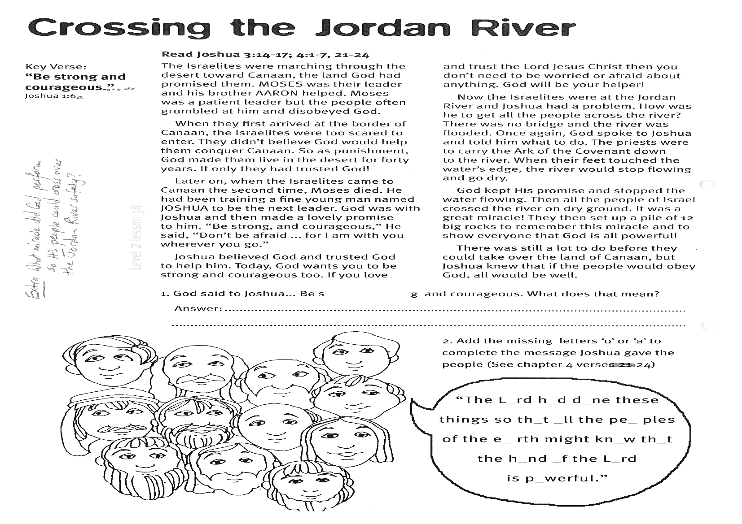

**Extra:** What miracle did God perform so His people could cross over the Jordan River safely?

2. Add the missing letters ‘o’ or ‘a’ to complete the message Joshua gave the people (see Joshua 4:24)

**“The L__RD h__d d__ne these things so tha__t all the pe__ples of the e__rth might kn__w th__t the h__nd __f the L__RD is p__werful.”**

**Level 2 lesson 38**

1. God said to Joshua “Be s __ __ __ __ g and courageous”  
What does that mean?

…………………………………………………………………………………………………………………………………………………………………………………………………………………………

**Read Joshua 6:1-21**  
On the other side of the Jordan River, the people in the city of Jericho were scared. They watched as the Israelites crossed the river. They were very wicked people and were scared of God and Israel’s army. They had shut the big city gates and would not let anyone in or out of the city. Then they kept guards on their city walls and got ready for a big battle.

Soon they saw the Israelites marching toward the city. First there were rows and rows of armed men. Then came seven men carrying trumpets made out of ram’s horns. Next the Ark of the Covenant was carried on the shoulders of four priests. Lastly, all the people came in a great procession. They walked very slowly around the city in complete silence. No-one spoke at all. Just the priests blew their trumpets. They did this once every day for six days.

Key Verse:  
**“The Lord your God will be with you wherever you go.”**

Joshua 1:9

**Victory at Jericho**

What a strange thing! Can you imagine seeing that? But God had told Joshua what they were to do, and they were obeying God. It was really a test of their faith in Him. The people of Jericho were puzzled—they had never seen anything like it!

Then on the seventh day, the Israelites had to get up early in the morning and march around Jericho seven times. As they finished marching, the priests blew loudly with their trumpets. Joshua called out, “Shout, for the Lord has given us the city!”

The Bible says, “When the people shouted, the walls of Jericho fell down flat!” God gave His people a wonderful victory because they trusted and obeyed Him. Also, God can give you victory over sin, when you trust Jesus as your Saviour and obey Him.

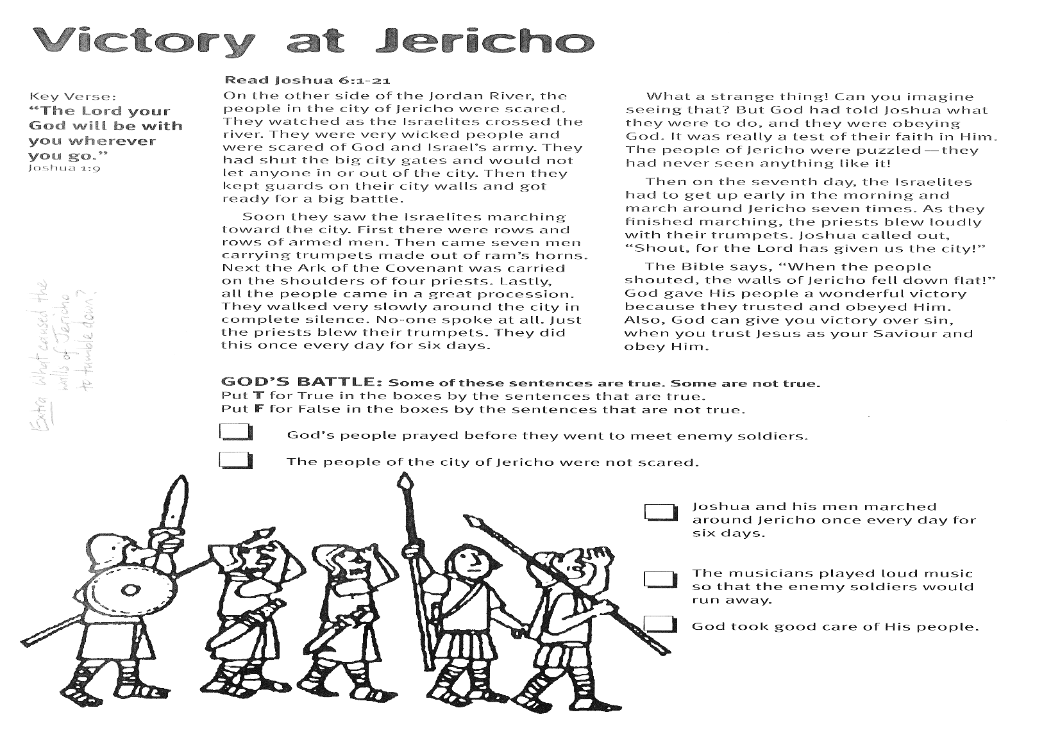

□ Joshua and his men marched around Jericho once every day for six days.

□ The musicians played loud music so that the enemy soldiers would run away.  
  
□ God took good care of His people.

**GOD’S BATTLE: Some of these sentences are true, and some are not true.**  
Put **T** for True in the boxes by the sentences that are true.  
Put **F** for False in the boxes by the sentences that are not true.  
**□** God’s people prayed before they went to meet enemy soldiers.  
□ The people of the city of Jericho were not scared.

**Level 2 lesson 39**

**Extra:** What really caused the walls of Jericho to tumble down?

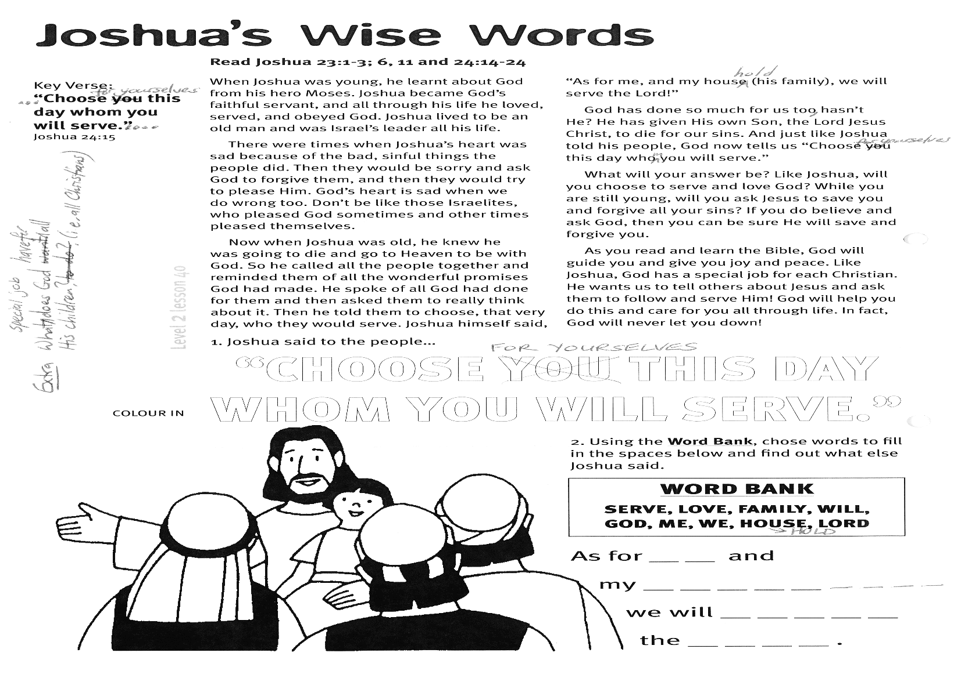

**Using the words below, choose words to fill in the spaces, and find out what else Joshua said.**

**SERVE LOVE FAMILY WILL GOD ME WE HOUSEHOLD LORD**

**“As for __ __ and my  
 __ __ __ __ __ __ __ __ __  
we will __ __ __ __ __  
the __ __ __ __ .”**

**“CHOOSE FOR YOURSELVES  
THIS DAY WHOM YOU WILL SERVE.”**

**COLOUR IN VERSE:**

**Read Joshua 23:1-3, 6, 11 and  
Joshua 24:14-24**

When Joshua was young, he learnt about God from his hero Moses. Joshua became God’s faithful servant, and all through his life he loved, served, and obeyed God. Joshua lived to be an old man and was Israel’s leader all his life.

There were times when Joshua’s heart was sad because of the bad, sinful things the people did. Then they would be sorry and ask God to forgive them, and then they would try to please Him. God’s heart is sad when we do wrong too. Don’t be like those Israelites, who pleased God sometimes and other times pleased themselves.

Now when Joshua was old, he knew he was going to die and go to Heaven to be with God. So he called all the people together and reminded them of all the wonderful promises God had made. He spoke of all God had done for them and then asked them to really think about it.

Then he told them to choose, that very day, who they would serve. Joshua himself said, “As for me, and my household (his family), we will serve the Lord!”

God has done so much for us too, hasn’t He? He has given His own Son, the Lord Jesus Christ, to die for our sins. And just like Joshua told his people, God now tells us “Choose for yourselves this day whom you will serve.”

What will your answer be? Like Joshua, will you choose to serve and love God? While you are still young, will you ask Jesus to save you and forgive all your sins? If you do believe and ask God, then you can be sure He will save and forgive you.

As you read and learn the Bible, God will guide you and give you joy and peace. Like Joshua, God has a special job for each Christian. He wants us to tell others about Jesus and ask them to follow and serve Him! God will help you do this and care for you all through life. In fact, God will never let you down!

**Level 2 lesson 40**

**Extra:** What special job does God have for all His children? (i.e. All Christians)

Key Verse: **“…Choose for yourselves this day whom you will serve…”**Joshua 24:15

Please complete and return by post to   
**PSSM, 1-2A (G2) 93 Dominion Rd, Mt Eden, Auckland 1024** or scan & email to **info@biblediscovery.org.nz**

**Joshua’s Wise Words**