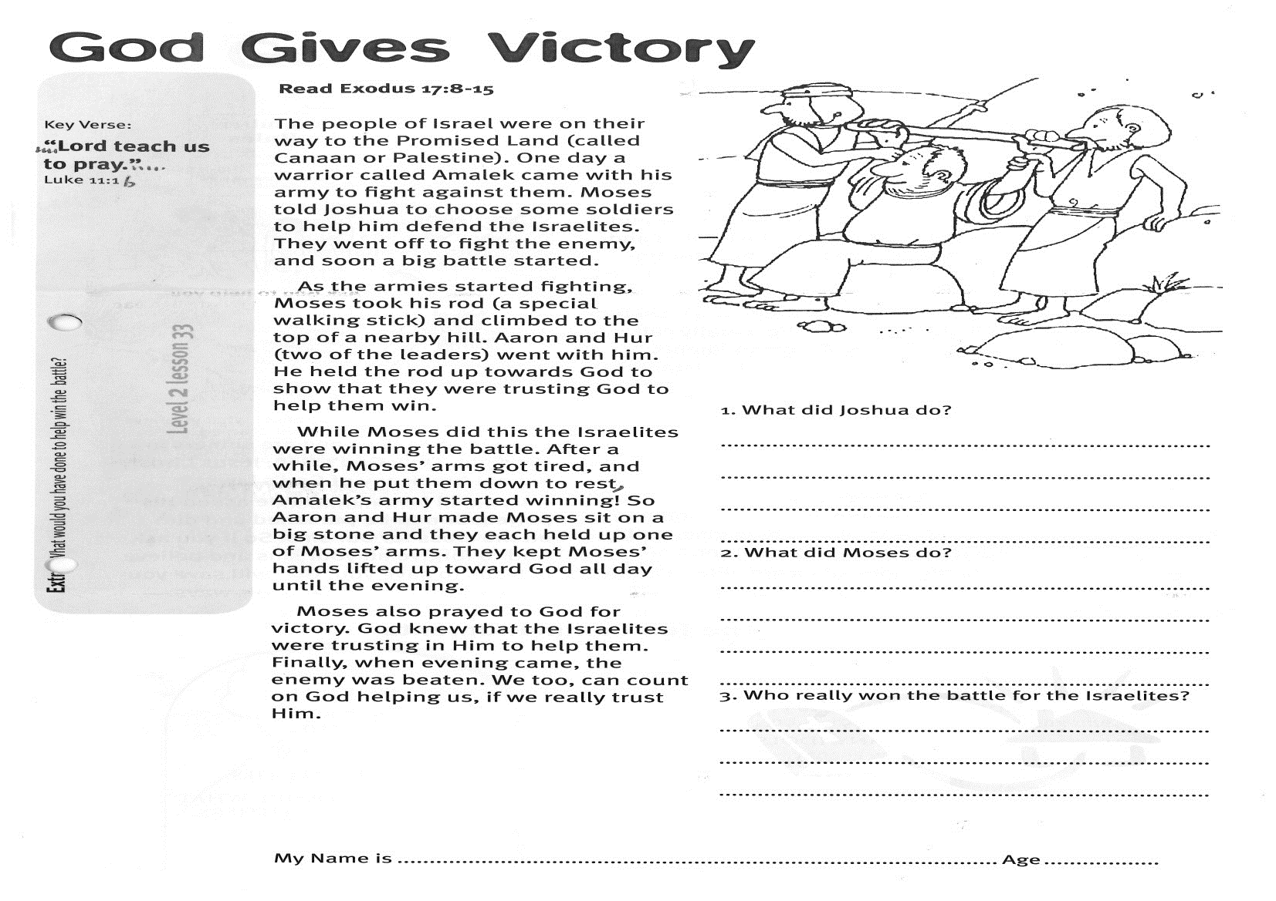○

**Read: Exodus 17:8-15**The people of Israel were on their way to the Promised Land (called Canaan or Palestine). One day a warrior called Amalek came with his army to fight against them. Moses told Joshua to choose some soldiers to help him defend the Israelites. They went off to fight the enemy, and soon a big battle started.

As the armies started fighting, Moses took his rod (a special walking stick) and climbed to the top of a nearby hill. Aaron and Hur (two of the leaders) went with him. He held the rod up towards God to show that they were trusting God to help them win.

While Moses did this the Israelites were winning the battle. After a while, Moses’ arms got tired, and when he put them down to rest, Amalek’s army started winning! So Aaron and Hur made Moses sit on a big stone and they each held up one of Moses’ arms. They kept Moses’ hands lifted up toward God all day until the evening.

Moses also prayed to God for victory. God knew that the Israelites were trusting in Him to help them. Finally, when evening came, the enemy was beaten. We too, can count on God helping us, if we really trust Him.

Key Verse:  
**“…Lord teach us to pray…”**

Luke 11:1b

**God Gives Victory**

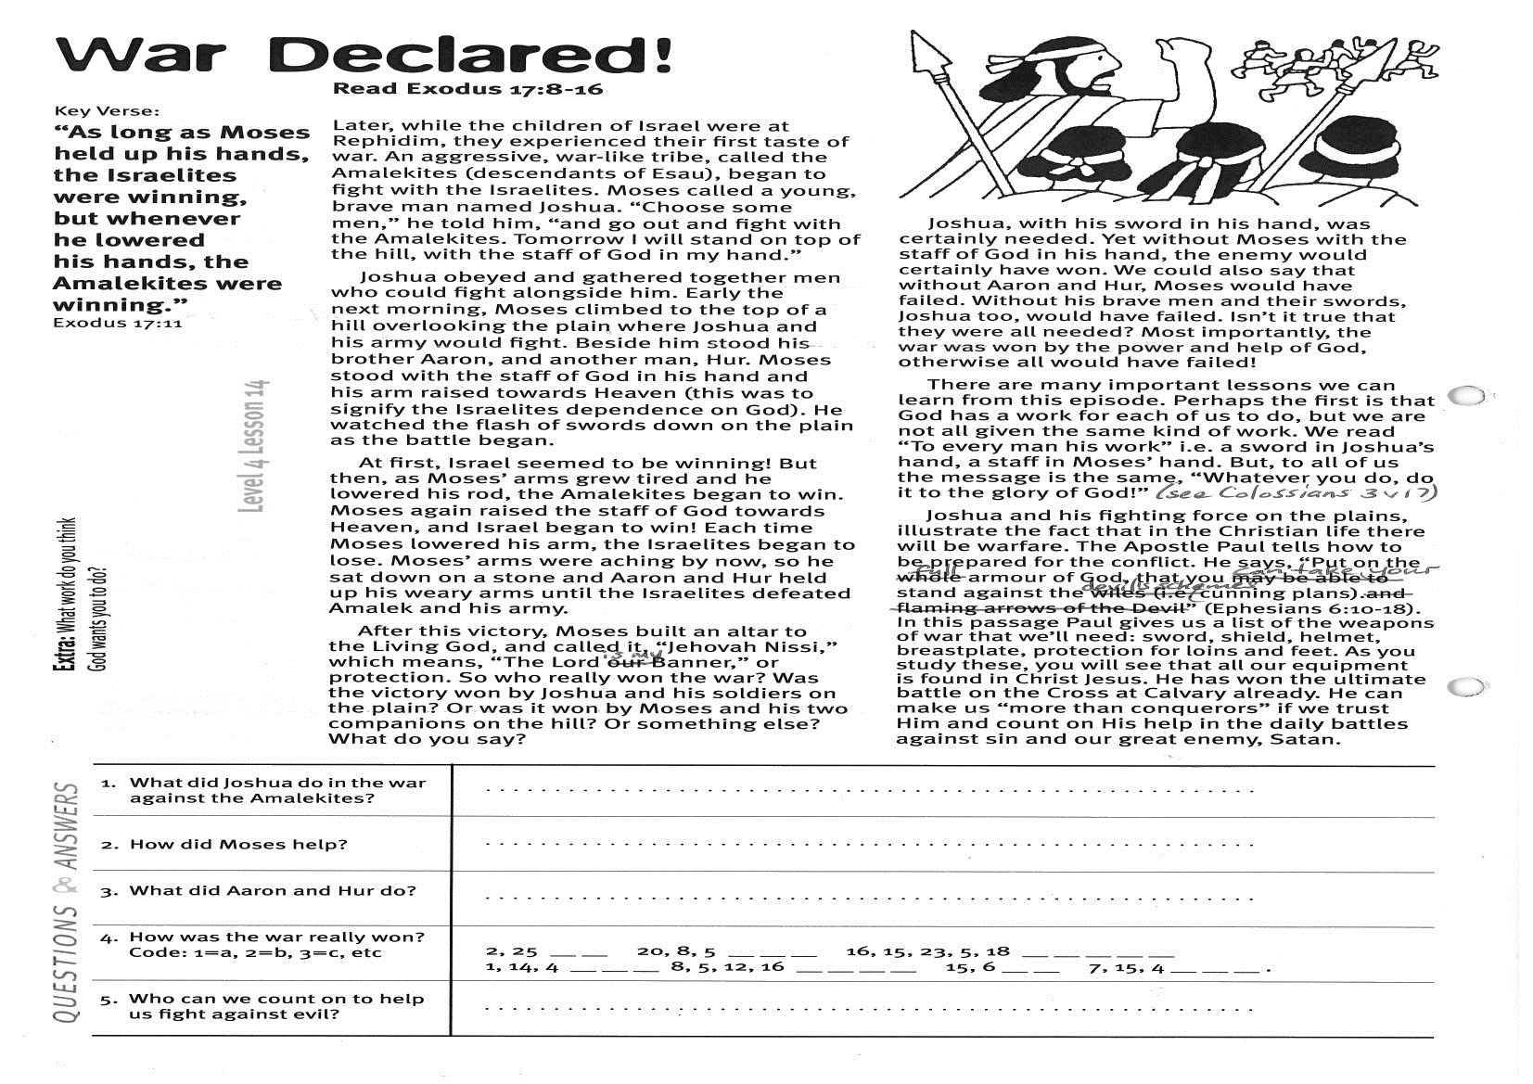

!. What did Joshua do?

……………………………………………………………………………………………………………………………………………………………………………………………………………………

2. What did Moses do?

……………………………………………………………………………………………………………………………………………………………………………………………………………………

3. Who really won the battle for the Israelites?

**____ ____ ____**

**Level 2 lesson 33**

**Extra:** What would you have done to help win the battle?

My Name is________________________________________ Age ______________

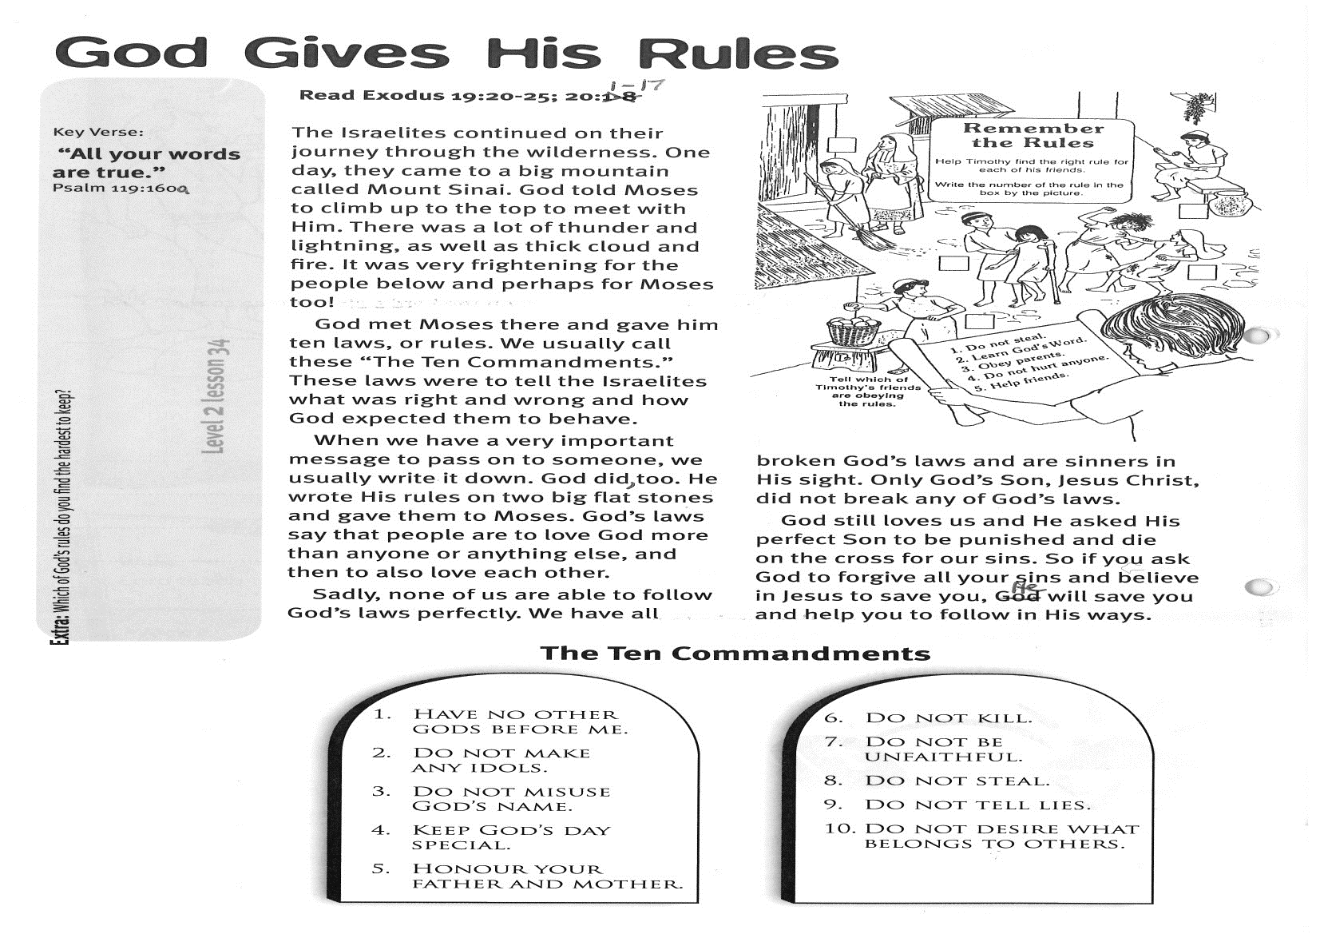

Key Verse:

**“All your words are true…”**

Psalm 119:160a

**God Gives His Rules**

**Read Exodus 19:20-25; 20:1-17**

The Israelites continued on their journey through the wilderness. One day, they came to a big mountain called Mount Sinai. God told Moses to climb up to the top to meet with Him. There was a lot of thunder and lightning, as well as thick cloud and fire. It was very frightening for the people below and perhaps for Moses too!

God met Moses there and gave him ten laws, or rules. We usually call these “The Ten Commandments.” These laws were to tell the Israelites what was right and wrong and how God expected them to behave.

When we have a very important message to pass on to someone, we usually write it down. God did, too. He wrote His rules on two big flat stones and gave them to Moses. God’s laws say that people are to love God more than anyone or anything else, and then to also love each other.

Sadly, none of us are able to follow God’s laws perfectly. We have all broken God’s laws and are sinners in His sight. Only God’s Son, Jesus Christ, did not break any of God’s laws.



God still loves us and He asked His perfect Son to be punished and die on the cross for our sins. So if you ask God to forgive all your sins and believe in Jesus to save you, He will save you and help you to follow in His ways.

**Extra:** Which of God’s rules do you find the hardest to keep?

**Level 2 lesson 34**

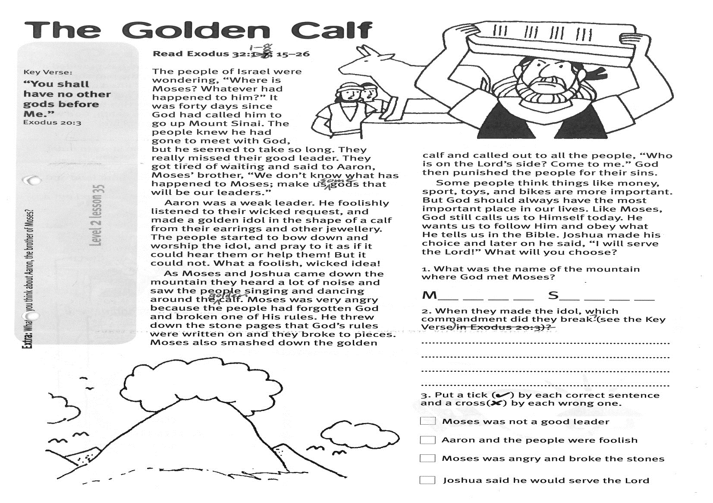

**Read Exodus 32:1-8; 15-26**  
The people of Israel were wondering, “Where is Moses? Whatever had happened to him?” It was forty days since God had called him to go up Mount Sinai. The people knew he had gone to meet with God, but he seemed to take so long. They really missed their good leader. They got tired of waiting and said to Aaron, Moses’ brother, “We don’t know what has happened to Moses; make us some gods that will be our leaders.”

Aaron was a weak leader. He foolishly listened to their wicked request, and made a golden idol in the shape of a calf from their earrings and other jewellery. The people started to bow down and worship the idol, and pray to it as if it could hear them or help them! But it could not. What a foolish, wicked idea!

As Moses and Joshua came down the mountain they heard a lot of noise and saw the people singing and dancing around the golden calf. Moses was very angry because the people had forgotten God and broken one of His rules. He threw down the stone pages that God’s rules were written on and they broke to pieces. Moses also smashed down the golden calf and called out to all the people, “Who is on the Lord’s side? Come to me.” God then punished the people for their sins.

Key Verse:  
**“You shall have no other gods before Me.”**

Exodus 20:3

**The Golden Calf**

Some people think things like money, sport, toys, and bikes are more important. But God should always have the most important place in our lives. Like Moses, God still calls us to Himself today. He wants us to follow Him and obey what He tells us in the Bible. Joshua made his choice and later on he said, “I will serve the Lord!” What will you choose?

True or False?

Moses was not a good leader T/F

Aaron and the people were   
foolish T/F

Moses was angry and broke the stones T/F

Joshua said he would serve the Lord T/F

**Extra:** What do you think about Aaron, the brother of Moses?

**Level 2 lesson 35**

1. What was the name of the mountain where God met Moses?

**M ___ ___ ___ ___ S ___ ___ ___ ___**

2. When they made the idol, which commandment did they break? (see Key Verse)

………………………………………………………………………………………………………………………………………………………………………………………………………………………………………………………………………………………………………………………………………………………………………………………………………………………………………………………

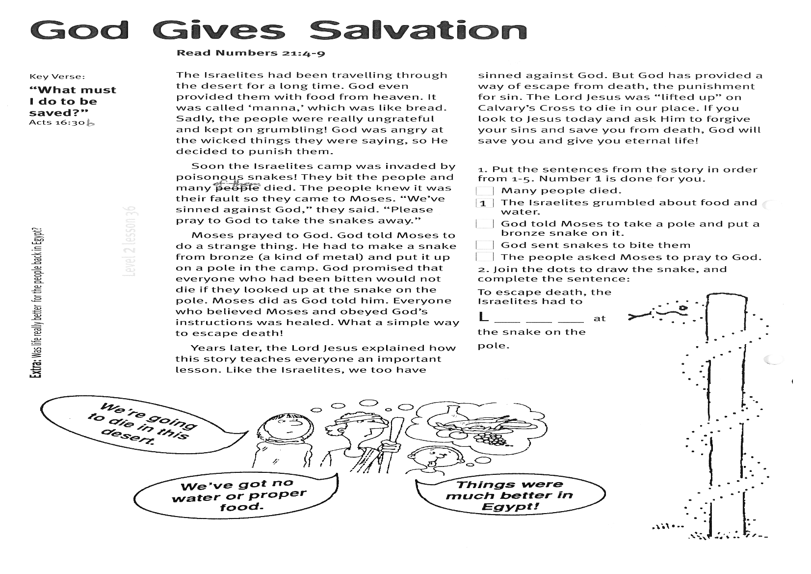

Please complete and return by post to   
**PSSM, 1-2A (G2) 93 Dominion Rd, Mt Eden, Auckland 1024** or scan & email to **info@biblediscovery.org.nz**

1. Put the sentences from the story in order from 1-5.  
○ Many people died.  
○ The Israelites grumbled about food and water  
**○** God told Moses to take a pole andput a bronze snake on it  
○ God sent snakes to bite them  
○ The people asked Moses to pray to God

Years later, the Lord Jesus explained how this story teaches everyone an important lesson. Like the Israelites, we too have sinned against God. But God has provided a way of escape from death, the punishment for sin. The Lord Jesus was “lifted up” on Calvary’s Cross to die in our place. If you look to Jesus today and ask Him to forgive your sins and save you from death, God will save you and give you eternal life!

2. Join the dots to draw the snake, then complete the sentence:

**‘To escape death, the Israelites had to**   
**L** **__ __ __ at  
the snake on the pole’**

**Read Numbers 21:4-9**

The Israelites had been travelling through the desert for a long time. God even provided them with food from heaven. It was called ‘manna,’ which was like bread. Sadly, the people were really ungrateful and kept on grumbling! God was angry at the wicked things they were saying, so He decided to punish them.

Soon the Israelites’ camp was invaded by poisonous snakes! They bit the people and many of them died. The people knew it was their fault so they came to Moses. “We’ve sinned against God,” they said. “Please pray to God to take the snakes away.”

Moses prayed to God. God told Moses to do a strange thing. He had to make a snake from bronze (a kind of metal) and put it up on a pole in the camp. God promised that everyone who had been bitten would not die if they looked up at the snake on the pole. Moses did as God told him. Everyone who believed Moses and obeyed God’s instructions was healed. What a simple way to escape death!

**Level 2 lesson 36**

**Extra:** Was life really better for the people back in Egypt?

Key Verse: **“What must I do to be saved?”**

Acts 16:30b

**God Gives Salvation**