

**A Story of a Shepherd**

Key Verse:  
**“Jesus said, ‘I am the Good Shepherd. The Good Shepherd lays down His life for the sheep.’ “**

John 10:11

**Read John 10:1-29   
and Psalm 23**

**Follow the Leader!** Have you ever seen how silly sheep are? They will follow whichever sheep is at the front—even if it doesn’t know where it’s going! The Bible says we are like sheep, and if we just follow each other, we’re going to keep getting lost. Like sheep, we were made to need a shepherd, but not just any shepherd!

Jesus talked about Himself in many different ways: He said He was “the Way, the Truth, and the Life,” “the Light of the World,” and many others. One of the most well-known ways Jesus described Himself was as the “GOOD SHEPHERD”. That’s great news, because the Bible tells us we are like sheep that have gone astray (read Isaiah 53:6), and we really need a Shepherd to rescue us from sin!

Jesus often taught others by using PARABLES. Parables are little stories that use well-known objects to explain or illustrate different truths. Jesus lived in farming country, so He used a lot of objects like plants and animals (things the people saw every day) to help teach them what He wanted them to understand. The people knew about shepherds and how they cared for the sheep by leading, feeding, and protecting each one. So when Jesus said, “I am the Good Shepherd!” all His listeners understood what He was saying.

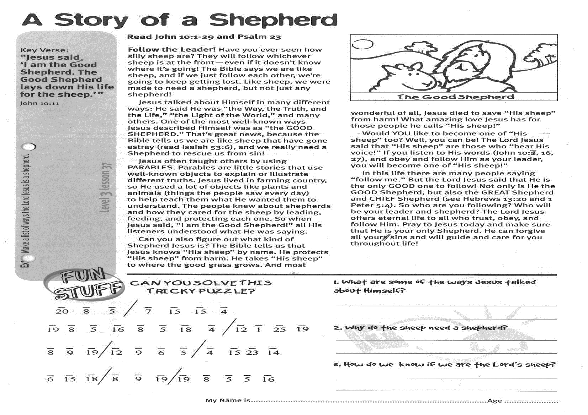

**CAN YOU SOLVE THIS TRICKY PUZZLE ?**

**Level 3 lesson 37**

**Extra:** Make a list of ways the Lord Jesus is a shepherd.

**1. What are some of the ways Jesus talked about Himself ?**

…………………………………………………………………………………………………………………………………………………………

**2. Why do the sheep need a shepherd ?**

…………………………………………………………………………………………………………………………………………………………

**3. How do we know if we are the Lord’s sheep ?**

…………………………………………………………………………………………………………………………………………………………

Can you also figure out what kind of Shepherd Jesus is? The Bible tells us that Jesus knows “His sheep” by name. He protects “His sheep” from harm. He takes “His sheep” to where the good grass grows. And most wonderful of all, Jesus died to save “His sheep” from harm! What amazing love Jesus has for those people he calls “His sheep!”

Would YOU like to become one of “His sheep” too? Well, you can be! The Lord Jesus said that “His sheep” are those who “hear His voice!” If you listen to His words (John 10:3, 16, 27), and obey and follow Him as your leader, you will become one of “His sheep!”

In this life there are many people saying “follow me.” But the Lord Jesus said that He is the only GOOD one to follow! Not only is He the GOOD Shepherd, but also the GREAT Shepherd and CHIEF Shepherd (see Hebrews 13:20 and 1 Peter 5:4). So who are you following? Who will be your leader and shepherd? The Lord Jesus offers eternal life to all who trust, obey, and follow Him. Pray to Jesus today and make sure that He is your only Shepherd. He can forgive all your sins and will guide and care for you throughout life!

My Name is ……………………………………………………… Age…………………

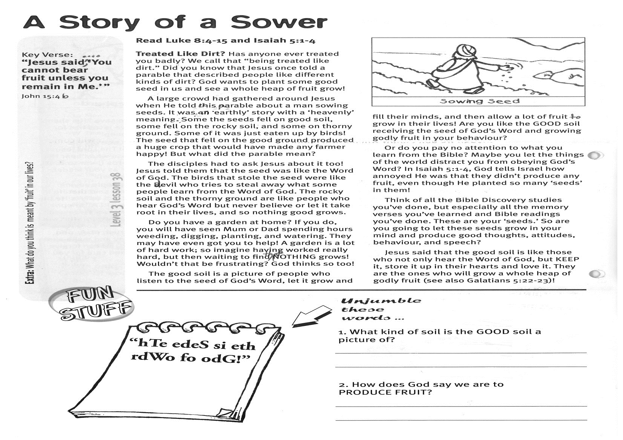

**Read Luke 8:4-15   
and Isaiah 5:1-4**

**Treated Like Dirt!** Has anyone ever treated you badly? We call that “being treated like dirt.” Did you know that Jesus once told a parable that described people like different kinds of dirt? God wants to plant some good seed in us and see a whole heap of fruit grow!

A large crowd had gathered around Jesus when He told this parable about a man sowing seeds. It was an ‘earthly’ story with a ‘Heavenly’ meaning. Some of the seeds fell on good soil, some fell on the rocky soil, and some on thorny ground. Some of it was just eaten up by birds! The seed that fell on the good ground produced a huge crop that would have made any farmer happy! But what did the parable mean?

The disciples had to ask Jesus about it too! Jesus told them that the seed was like the Word of God. The birds that stole the seed were like the devil who tries to steal away what some people learn from the Word of God. The rocky soil and the thorny ground are like people who hear God’s Word but never believe or let it take root in their lives, and so nothing good grows.

Do you have a garden at home? If you do, you will have seen Mum or Dad spending hours weeding, digging, planting, and watering. They may have even got you to help! A garden is a lot of hard work; so imagine having worked really hard, but then waiting to find that NOTHING grows! Wouldn’t that be frustrating? God thinks so, too!

Key Verse:  
**“Jesus said, ‘…you cannot bear fruit unless you remain in Me.’ “**

John 15:4b

**A Story of a Sower**



**Unjumble these words:**

The good soil is a picture of people who listen to the seed of God’s Word, let it grow and fill their minds, and then allow a lot of fruit to grow in their lives! Are you like the GOOD soil receiving the seed of God’s Word and growing Godly fruit in your behaviour?

Or do you pay no attention to what you learn from the Bible? Maybe you let the things of the world distract you from obeying God’s Word? In Isaiah 5:1-4, God tells Israel how annoyed He was that they didn’t produce any fruit, even though He planted so many ‘seeds’ in them!

Think of all the Bible Discovery studies you’ve done, but especially all the memory verses you’ve learned and Bible readings you’ve done. These are your ‘seeds.’ So are you going to let these seeds grow in your mind and produce good thoughts, attitudes, behaviour, and speech?

Jesus said that the good soil is like those who not only hear the Word of God, but KEEP it, store it up in their hearts and love it. They are the ones who will grow a whole heap of Godly fruit (see also Galatians 5:22-23)!

**Level 3 lesson 38**

**Extra:** What do you think is meant by ‘fruit’ in our lives?

**1. What kind of soil is the GOOD soil a picture of ?**

……………………………………………………………………………………………………………………………………………………………………

**2. How does God say we are to produce FRUIT ?**

………………………………………………………………………………………………………………………………………………………………………………………………………………………………………………………



**Read Matthew 24:42-44; 25:1-13**  
 **“Coming, ready or not**!” That’s what we call out when we’re playing hide-and-seek, isn’t it? Everyone is given a short time to hide and then whoever is ‘it’ comes looking—even if you haven’t had time to hide!

Of course, some things are easier to get ready for - like school in the morning, football practise, or birthday parties. We know when these things are going to happen, so we make sure we are ready. But in this story Jesus teaches about something that we need to be always ready for, even though we don’t know when it will happen.

To show what He meant, the Lord Jesus told a story about a thief. He said if a house owner knew that a burglar was prowling about, he would be ready and not let him break in! Now, burglars don’t usually tell us when they’re going to be coming, do they? Can you imagine finding a notice in the letterbox saying, “Dear Householder: I plan to be stealing in your area next Tuesday. Please be kind enough to leave your doors unlocked and your guard dog firmly tied up?” Not likely is it!

The Lord Jesus is coming back to earth again, this time to take Christians to Heaven! Isn’t that great? But we don’t know when that will be! Just as a burglar doesn’t announce when he’s in town, so the Lord Jesus warns that He will come back unexpectedly!

Key Verse:  
**“You also must be ready, because the Son of Man will come at an hour when you do not expect Him.”**

Matthew 24:44

**A Story of a Thief**

|  |  |  |
| --- | --- | --- |
|  |  |  |
|  |  |  |
|  |  |  |

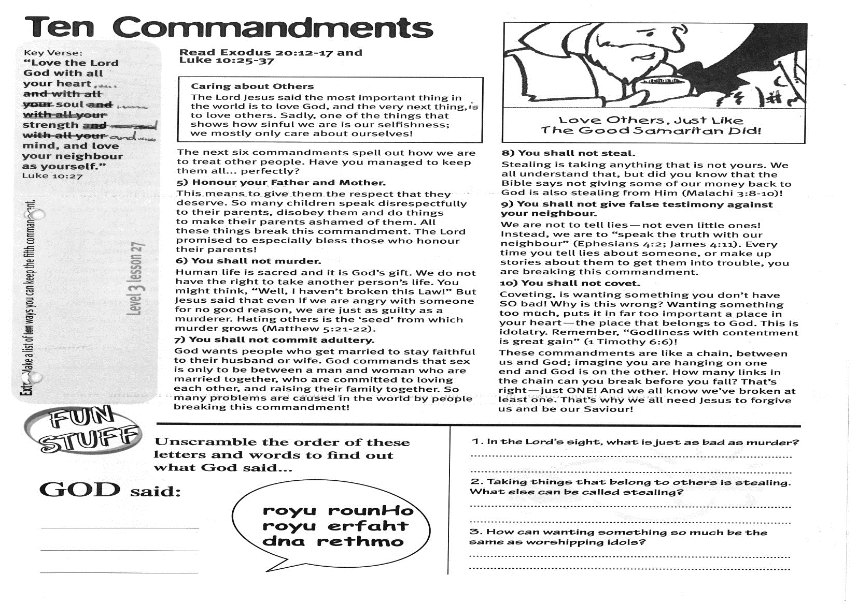

**Shade in the letters and words to reveal the secret sentence:**

**Level 3 lesson 39**

**Extra:** How can we keep ourselves ready for Jesus’ return?

That’s why Jesus told this story. He wants everyone to get ready and wait for Him, so that no- one misses out on Heaven! We may not know exactly when the Lord will come again, but we do know that He will keep His promise to return! But once He comes, it will be too late to get ready. So are you ready yet?

To get ready you need to become a Christian. To do this, you must believe that when Jesus first came to earth He died to pay the penalty for your sins, and that three days later He came back to life! So be sure that you ask Him to cleanse your heart from sin and ask Him to save you from hell! Then you need to stay ready - by always doing and saying the things that Jesus would be pleased with.

Remember, this could be the very day that the Lord Jesus comes back. So do not delay or avoid making a decision. Make sure you are ready and looking forward to seeing Him!

**1. Why did the Lord choose to tell a story about a BURGLAR ?**

…………………………………………………………………………………………………………………………………………………………………………

**2. Why do you think the Lord wants to come when everyone least expects it ?**

………………………………………………………………………………………………………………………………………………………………………………………………………………………………………………………………



Key Verse:  
**“For no-one can lay any foundation other than the one already laid, which is Jesus Christ.”**

1 Corinthians 3:11

**Read: Matthew 7:24-27   
and 1 Corinthians 3:10-15**

**“Solid as a Rock!”** Have you ever heard that saying? What’s the biggest tower you’ve ever made with building blocks? Have you ever made one that’s taller than you are? But no matter how big a tower of blocks is, if we take out blocks from the bottom, it will start to shake, wobble, and eventually fall down!

This is because a tower needs a good strong foundation. And just like blocks, we must build our lives on the right foundation—one that can’t be moved. One that will keep us safe and secure! Where can we find a strong foundation before trouble comes?

Jesus once told a story about two men. A wise man built his house on solid rock, while a foolish man built his house on sand. Soon a storm arrived and the wind blew, the rain came down, and the streams flooded. One house stayed standing and the other collapsed with a huge crash! Can you guess which one? That’s right, the wise man’s house on the rock survived, but the fool’s house on the sand just fell to pieces!

So why did Jesus tell this story? Was it simply to help you know the safest foundation for building houses? No—the Lord Jesus wants you to understand how important it is to build your life on the strong foundation of His words! Jesus Christ wants you to read and listen to His words in the Bible, and then to practice all the things He asks you to do!

**A Story of a Builder**

Please complete and return by post to   
**PSSM, 1-2A (G2) 93 Dominion Rd, Mt Eden, Auckland 1024** or scan & email to **info@biblediscovery.org.nz**

**Answer:**

There are many “foundations” that aren’t safe to build on, for example, listening to sinful advice of others in the world. The ways of the world only offer foundations like sand, and we all know that sand is real soft—just walking on it leaves a trail of footprints! Following the moral advice of the world will only end in disaster!

The Bible calls Jesus ‘the Rock’. He is the ONLY perfect foundation for building your life on! So how do you build your life on the Rock? Jesus said, “Everyone who hears My words and puts them into practice is like a wise man who built his house upon the rock.”

For the Lord Jesus to be the foundation of your life, you must start by asking Him to forgive your sins and save you from the disaster of eternal death! Then Jesus will be the strong rock in your life and He will also help build you into a strong person as you practice obeying the Bible. Who will save you when the storms of life come? Why not choose the right foundation now—before it’s too late!

**Level 3 lesson 40**

**Extra:** Why is the foundation of our life so important?

**1. Why do we need a strong foundation when building a house ?**

………………………………………………………………………………  
……………………………………………………………………………..

**2. How can YOU make the Lord Jesus the foundation of YOUR life ?**

………………………………………………………………………………………………………………………………………………………………

……………………………………………………………………………………………………………………………………………………………..

**Tick the correct box to show which statements are true and which are false:**



