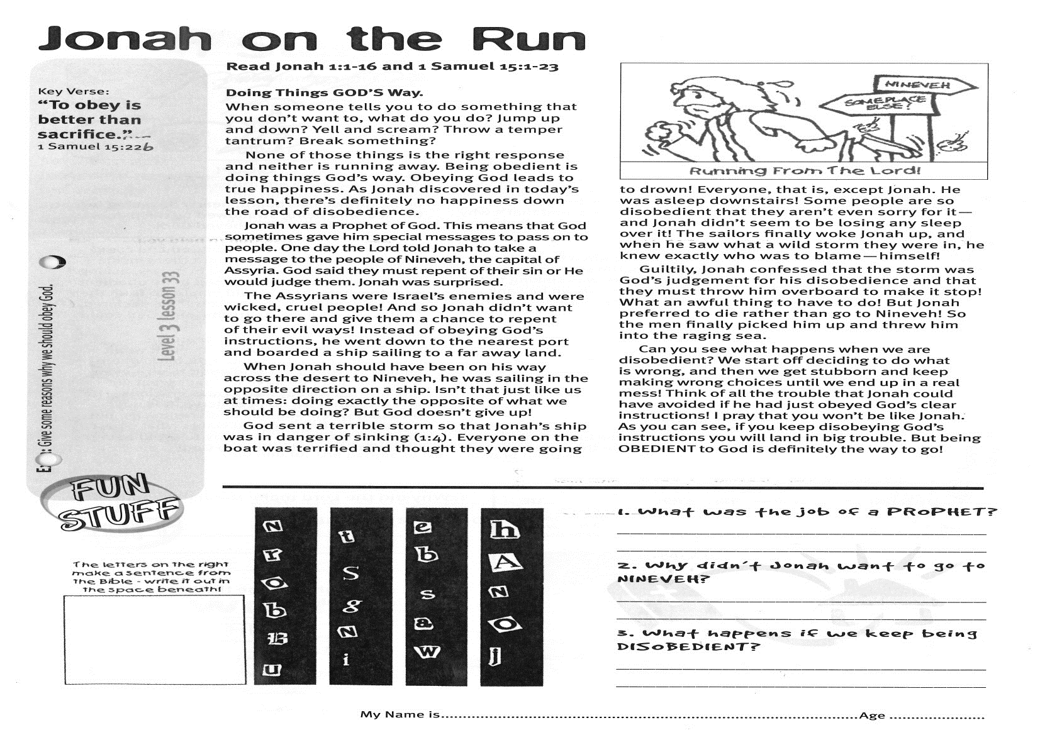

**Read Jonah 1:1-16;   
and 1 Samuel 15:1-23**

**Doing Things GOD’S Way!**

When someone tells you to do something that you don’t want to, what do you do? Jump up and down? Yell and scream? Throw a temper tantrum? Break something?

None of those things is the right response and neither is running away. Being obedient is doing things God’s way. Obeying God leads to true happiness. As Jonah discovered in today’s lesson, there’s definitely no happiness down the road of disobedience.

Jonah was a Prophet of God. This means that God sometimes gave him special messages to pass on to people. One day the Lord told Jonah to take a message to the people of Nineveh, the capital of Assyria. God said they must repent of their sin or He would judge them. Jonah was surprised.

The Assyrians were Israel’s enemies and were wicked, cruel people! And so Jonah didn’t want to go there and give them a chance to repent of their evil ways! Instead of obeying God’s instructions, he went down to the nearest port and boarded a ship sailing to a faraway land.

When Jonah should have been on his way across the desert to Nineveh, he was sailing in the opposite direction on a ship. Isn’t that just like us at times: doing exactly the opposite of what we should be doing? But God doesn’t give up!

**Jonah on the Run**

Key Verse:  
**“To obey is better than sacrifice…”**

1 Samuel 15:22b

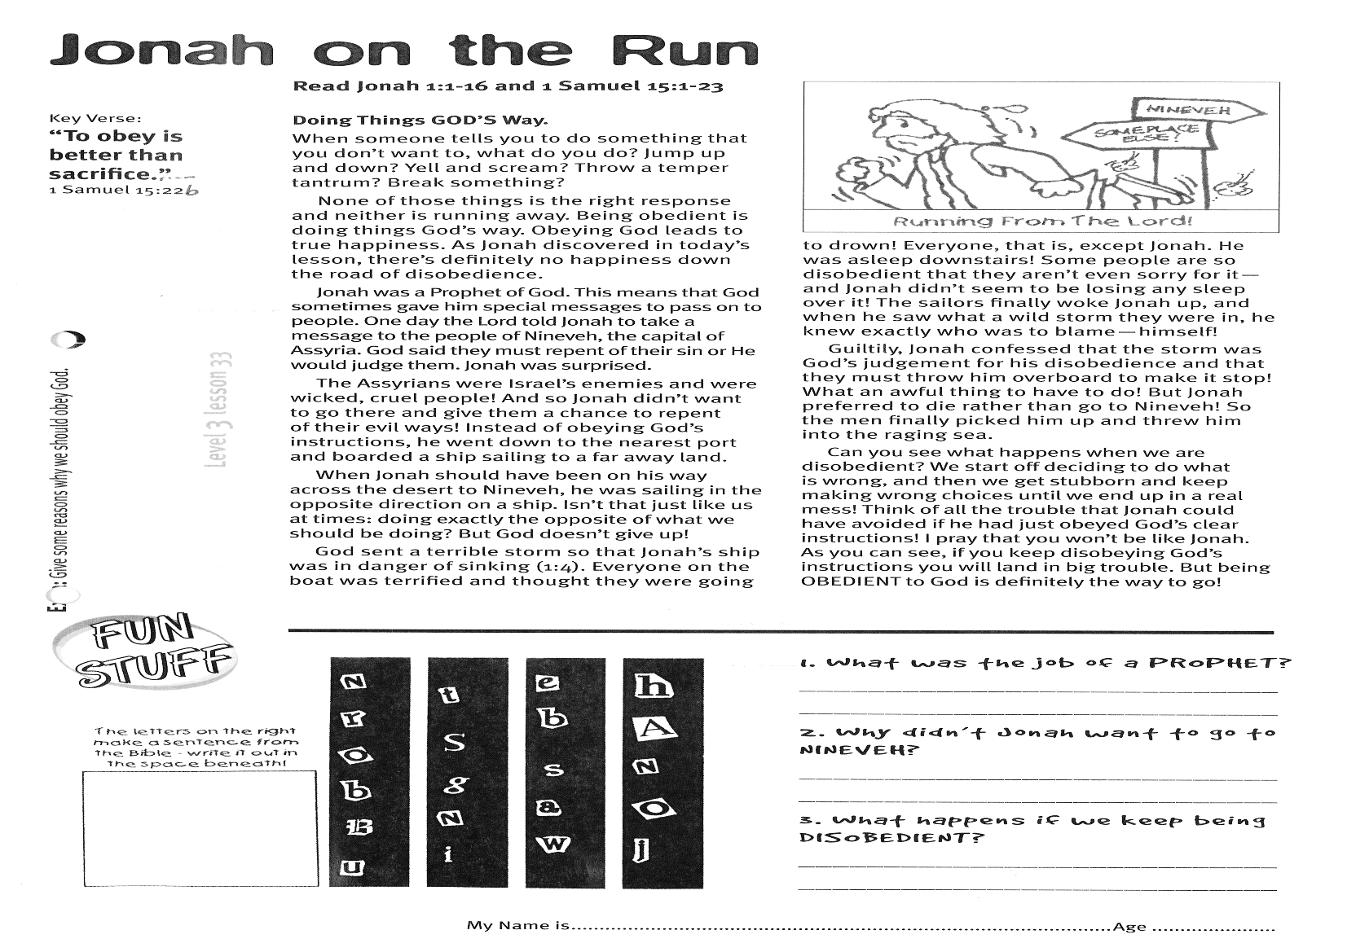

God sent a terrible storm so that Jonah’s ship was in danger of sinking (1:4). Everyone on the boat was terrified and thought they were going to drown! Everyone, that is, except Jonah. He was asleep downstairs! Some people are so disobedient that they aren’t even sorry for it; and Jonah didn’t seem to be losing any sleep over it! The sailors finally woke Jonah up, and when he saw what a wild storm they were in, he knew exactly who was to blame - himself!

Guiltily, Jonah confessed that the storm was God’s judgement for his disobedience and that they must throw him overboard to make it stop! What an awful thing to have to do! But Jonah preferred to die rather than go to Nineveh! So the men finally picked him up and threw him into the raging sea.

Can you see what happens when we are disobedient? We start off deciding to do what is wrong, and then we get stubborn and keep making wrong choices until we end up in a real mess! Think of all the trouble that Jonah could have avoided if he had just obeyed God’s clear instructions! I pray that you won’t be like Jonah. As you can see, if you keep disobeying God’s instructions you will land in big trouble. But being OBEDIENT to God is definitely the way to go!

**1. What was the job of a prophet?**

…………………………………………………………………………………………………………………………………………………………

**2. Why didn’t Jonah want to go to Nineveh?**

…………………………………………………………………………………………………………………………………………………………

**3. What happens if we keep being disobedient?**

…………………………………………………………………………………………………………………………………………………………

**The letters on the right make a sentence from the Bible. Write it out in the space below:**

__ __ __ __ __

__ __ __

__ __ __ __ __

__ __ __ __ __ __ __ __

**Extra:** Give some reasons why we should obey God.

**Level 3 lesson 33**

My Name is ……………………………………………………… Age…………………

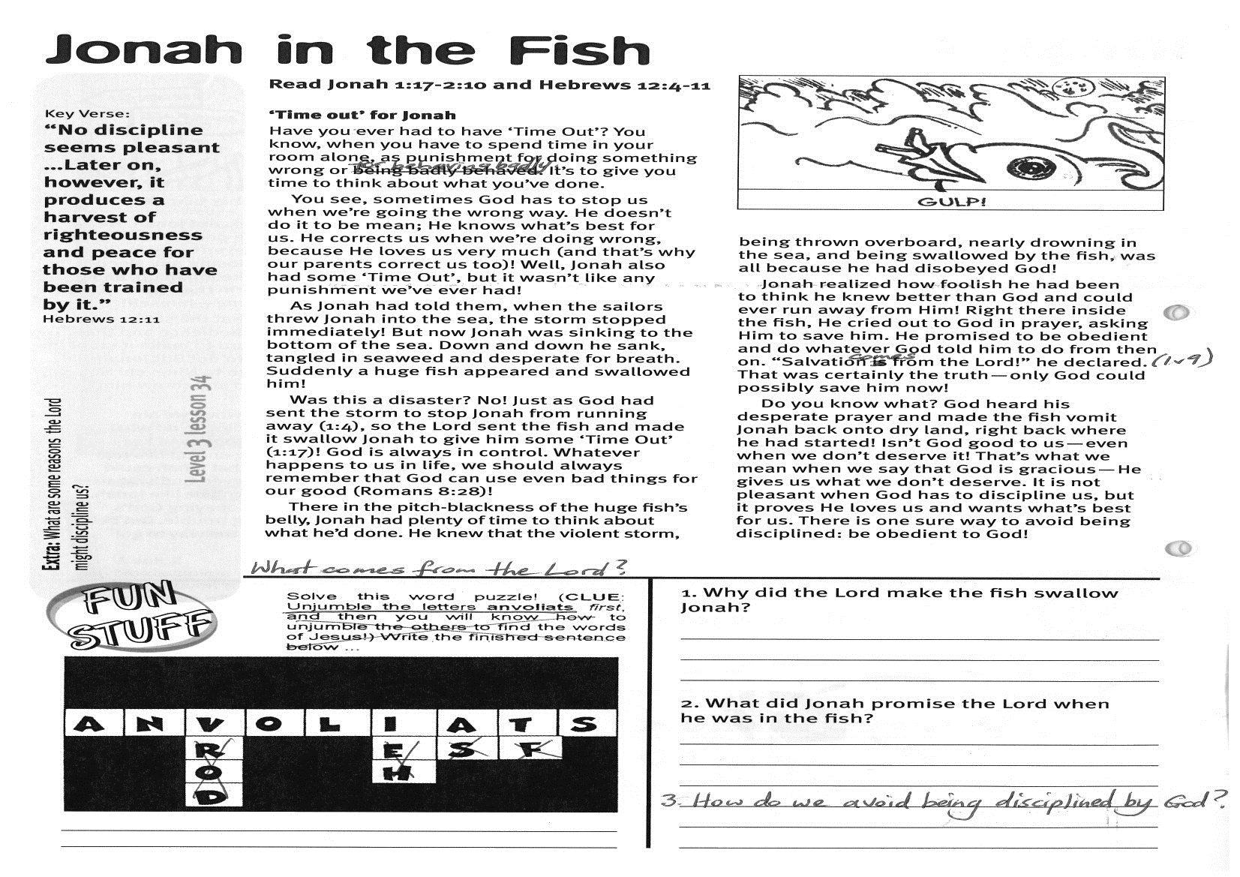

**Read Jonah 1:17-2:10;   
and Hebrews 12:4-11**

**‘Time Out’ for Jonah**Have you ever had to have ‘Time Out’? You know, when you have to spend time in your room alone, as punishment for doing something wrong or for behaving badly. It’s to give you time to think about what you’ve done.  
  
You see, sometimes God has to stop us when we’re going the wrong way. He doesn’t do it to be mean; He knows what’s best for us. He corrects us when we’re doing wrong, because He loves us very much (and that’s why our parents correct us, too)! Well, Jonah also had some ‘Time Out’, but it wasn’t like any punishment we’ve ever had!

As Jonah had told them, when the sailors threw Jonah into the sea, the storm stopped immediately! But now Jonah was sinking to the bottom of the sea. Down and down he sank, tangled in seaweed and desperate for breath. Suddenly a huge fish appeared and swallowed him!

Was this a disaster? No! Just as God had sent the storm to stop Jonah from running away (1:4), so the Lord sent the fish and made it swallow Jonah to give him some ‘Time Out’ (1:17)! God is always in control. Whatever happens to us in life, we should always remember that God can use even bad things for our good! (Romans 8:28)

There in the pitch-blackness of the huge fish’s belly, Jonah had plenty of time to think about what he’d done.

Key Verse:  
**“No discipline seems pleasant…Later on, however, it produces a harvest of righteousness and peace for those who have been trained by it.”**

Hebrews 12:11

**Jonah in the Fish**

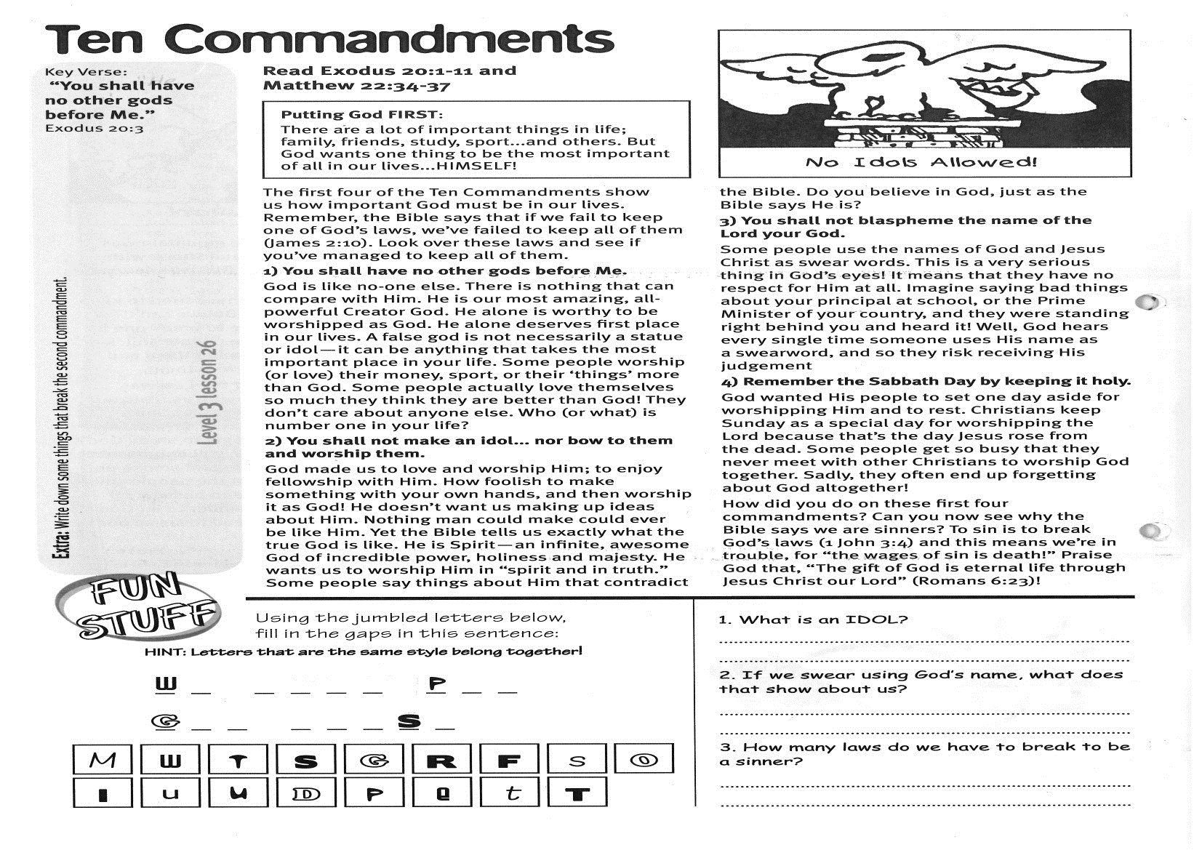

What comes from the Lord?  
(Unjumble the letters below)

He knew that the violent storm, being thrown overboard, nearly drowning in the sea, and being swallowed by the fish, was all because he had disobeyed God!

Jonah realized how foolish he had been to think he knew better than God and could ever run away from Him! Right there inside the fish, He cried out to God in prayer, asking Him to save him. He promised to be obedient and do whatever God told him to do from then on. “Salvation comes from the Lord!” he declared. (1:9) That was certainly the truth: only God could possibly save him now!

Do you know what? God heard his desperate prayer and made the fish vomit Jonah back onto dry land, right back where he had started! Isn’t God good to us - even when we don’t deserve it! That’s what we mean when we say that God is gracious - He gives us what we don’t deserve. It is not pleasant when God has to discipline us, but it proves He loves us and wants what’s best for us. There is one sure way to avoid being disciplined: be obedient to God!

**1. Why did the Lord make the fish swallow Jonah?**

…………………………………………………………………………………………………………………………………………………………

**2. What did Jonah promise the Lord when he was in the fish?**

…………………………………………………………………………………………………………………………………………………………

**3. How do we avoid being disciplined by the Lord?**

…………………………………………………………………………………………………………………………………………………………………………

__ __ __ __ __ __ __ __ __

|  |  |  |  |  |  |  |  |  |
| --- | --- | --- | --- | --- | --- | --- | --- | --- |
| A | N | V | O | L | I | A | T | S |

**Extra:** What are some reasons the Lord might discipline us?

**Level 3 lesson 34**

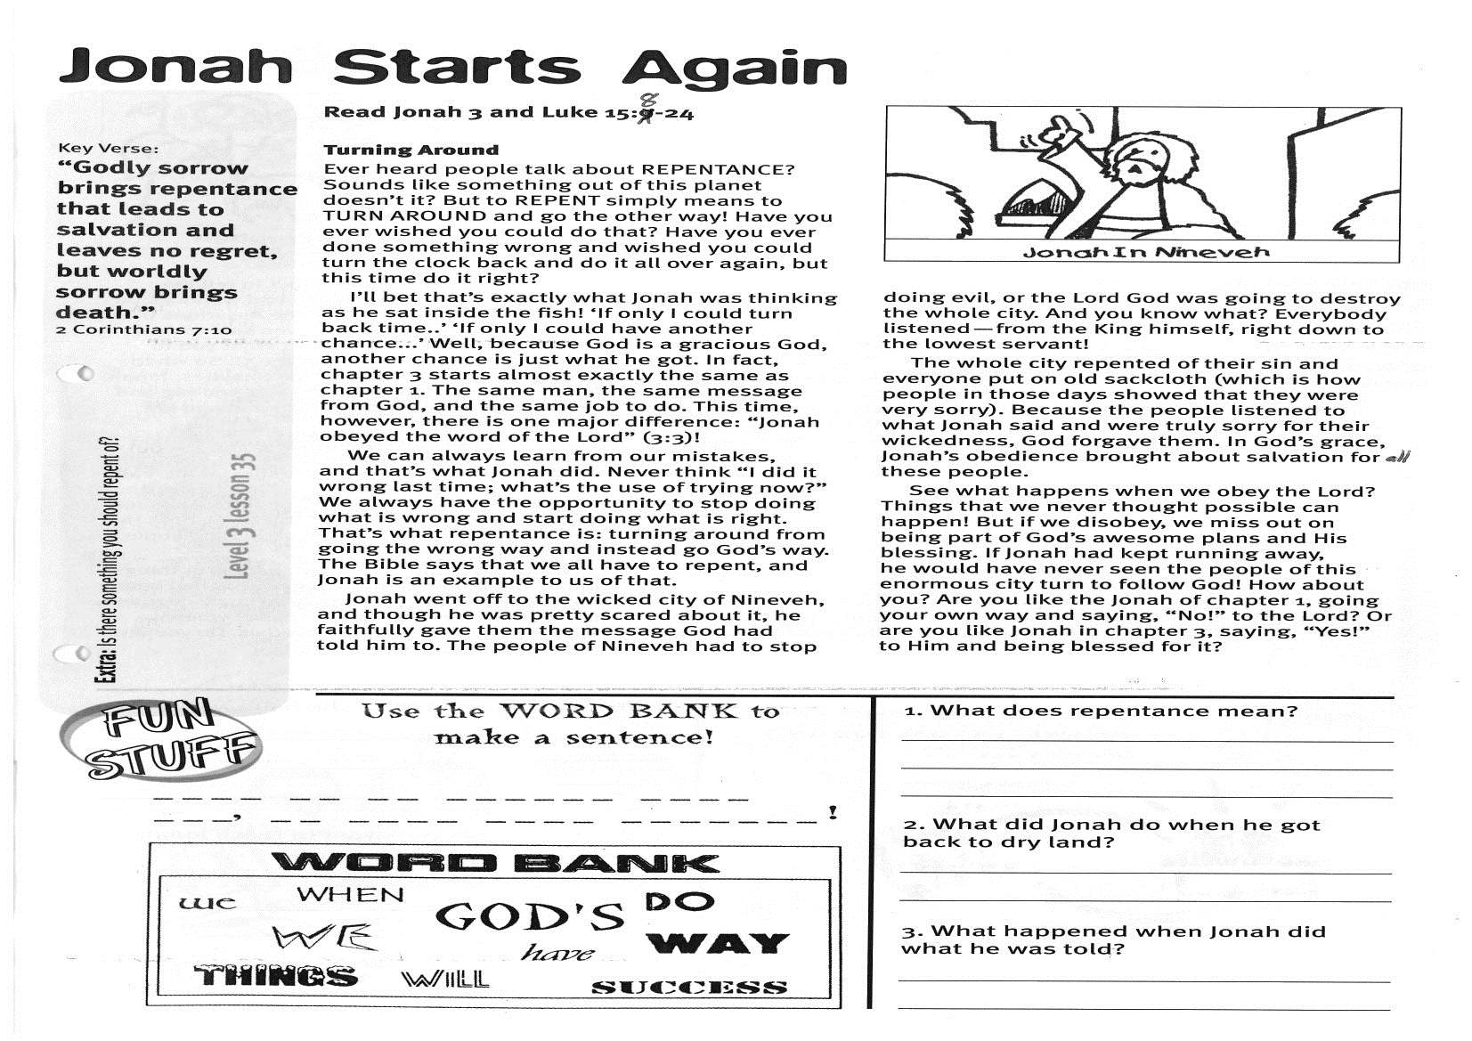

**Read Jonah 3 and Luke 15:8-24**  
 **Turning Around!**  
Ever heard people talk about REPENTANCE? Sounds like something out of this planet doesn’t it? But to REPENT simply means to TURN AROUND and go the other way! Have you ever wished you could do that? Have you ever done something wrong and wished you could turn the clock back and do it all over again, but this time do it right?

I’ll bet that’s exactly what Jonah was thinking as he sat inside the fish! ‘If only I could turn back time..’ ‘If only I could have another chance...’ Well, because God is a gracious God, another chance is just what he got! In fact, chapter 3 starts almost exactly the same as chapter 1. The same man, the same message from God, and the same job to do! This time, however, there is one major difference: “Jonah **obeyed** the word of the Lord” (3:3)

We can always learn from our mistakes, and that’s what Jonah did. Never think “I did it wrong last time; what’s the use of trying now?” We always have the opportunity to stop doing what is wrong and start doing what is right. That’s what repentance is: turning around from going the wrong way and instead go God’s way. The Bible says that we all have to repent, and Jonah is an example to us of that.

Jonah went off to the wicked city of Nineveh, and though he was pretty scared about it, he faithfully gave them the message God had told him to.

Key Verse:  
**“Godly sorrow brings repentance that leads to salvation and leaves no regret, but worldly sorrow brings death.”**

2 Corinthians 7:10

**Jonah Starts Again**

|  |  |  |
| --- | --- | --- |
|  | Use the WORD BANK to make a sentence: |  |
|  |  |  |
|  |  |  |

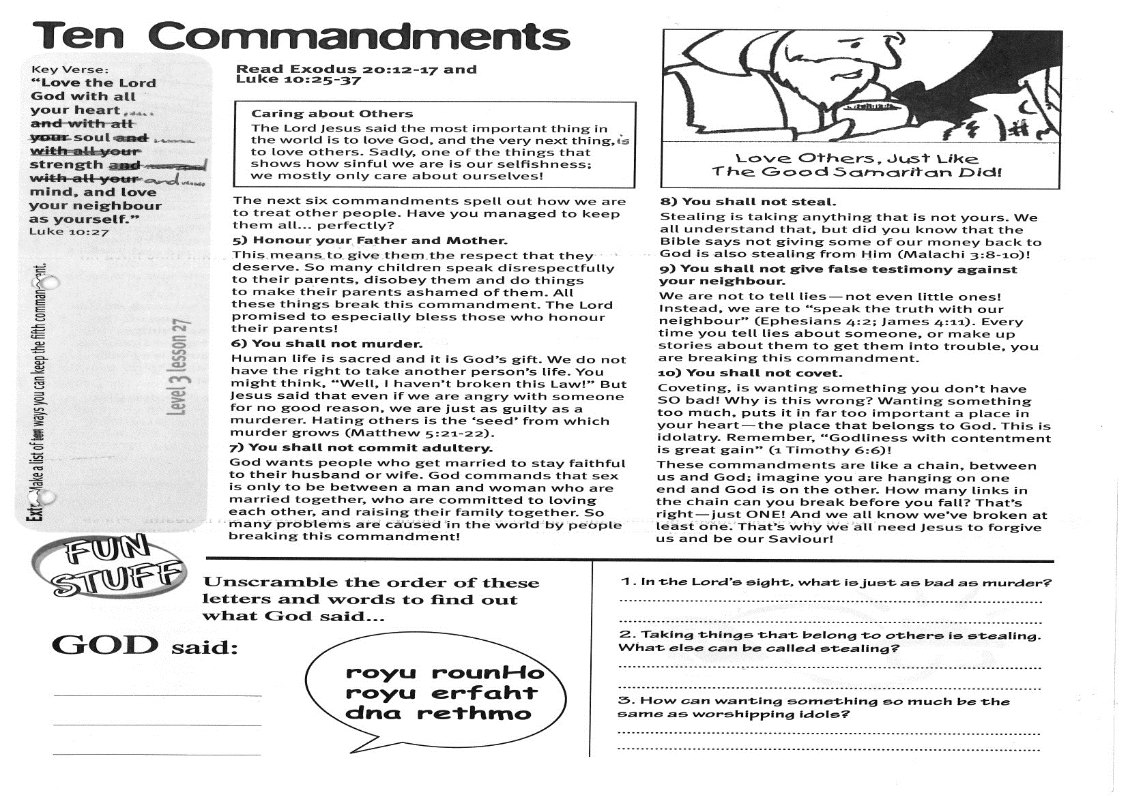

**1. What does repentance mean?**

…………………………………………………………………………………………………………………………………………………………………………

**2. What did Jonah do when he got back to dry land?**

………………………………………………………………………………………………………………………………………………………………………..

**3. What happened when Jonah did what he was told?**

…………………………………………………………………………………………………………………………………………………………………………

……………………………………………………………………………………

The people of Nineveh had to stop doing evil, or the Lord God was going to destroy the whole city. And you know what? Everybody listened - from the King himself, right down to the lowest servant!

The whole city repented of their sin and everyone put on old sackcloth (which is how people in those days showed that they were very sorry). Because the people listened to what Jonah said and were truly sorry for their wickedness, God forgave them. In God’s grace, Jonah’s obedience brought about salvation for all these people.

See what happens when we obey the Lord? Things that we never thought possible can happen! But if we disobey, we miss out on being part of God’s awesome plans and His blessing. If Jonah had kept running away, he would have never seen the people of this enormous city turn to follow God! How about you? Are you like the Jonah of chapter 1, going your own way and saying, “No!” to the Lord? Or are you like Jonah in chapter 3, saying, “Yes!” to Him and being blessed for it?

**Extra:** Is there something that you should repent of? If so, pray about it now.

**Level 3 lesson 35**

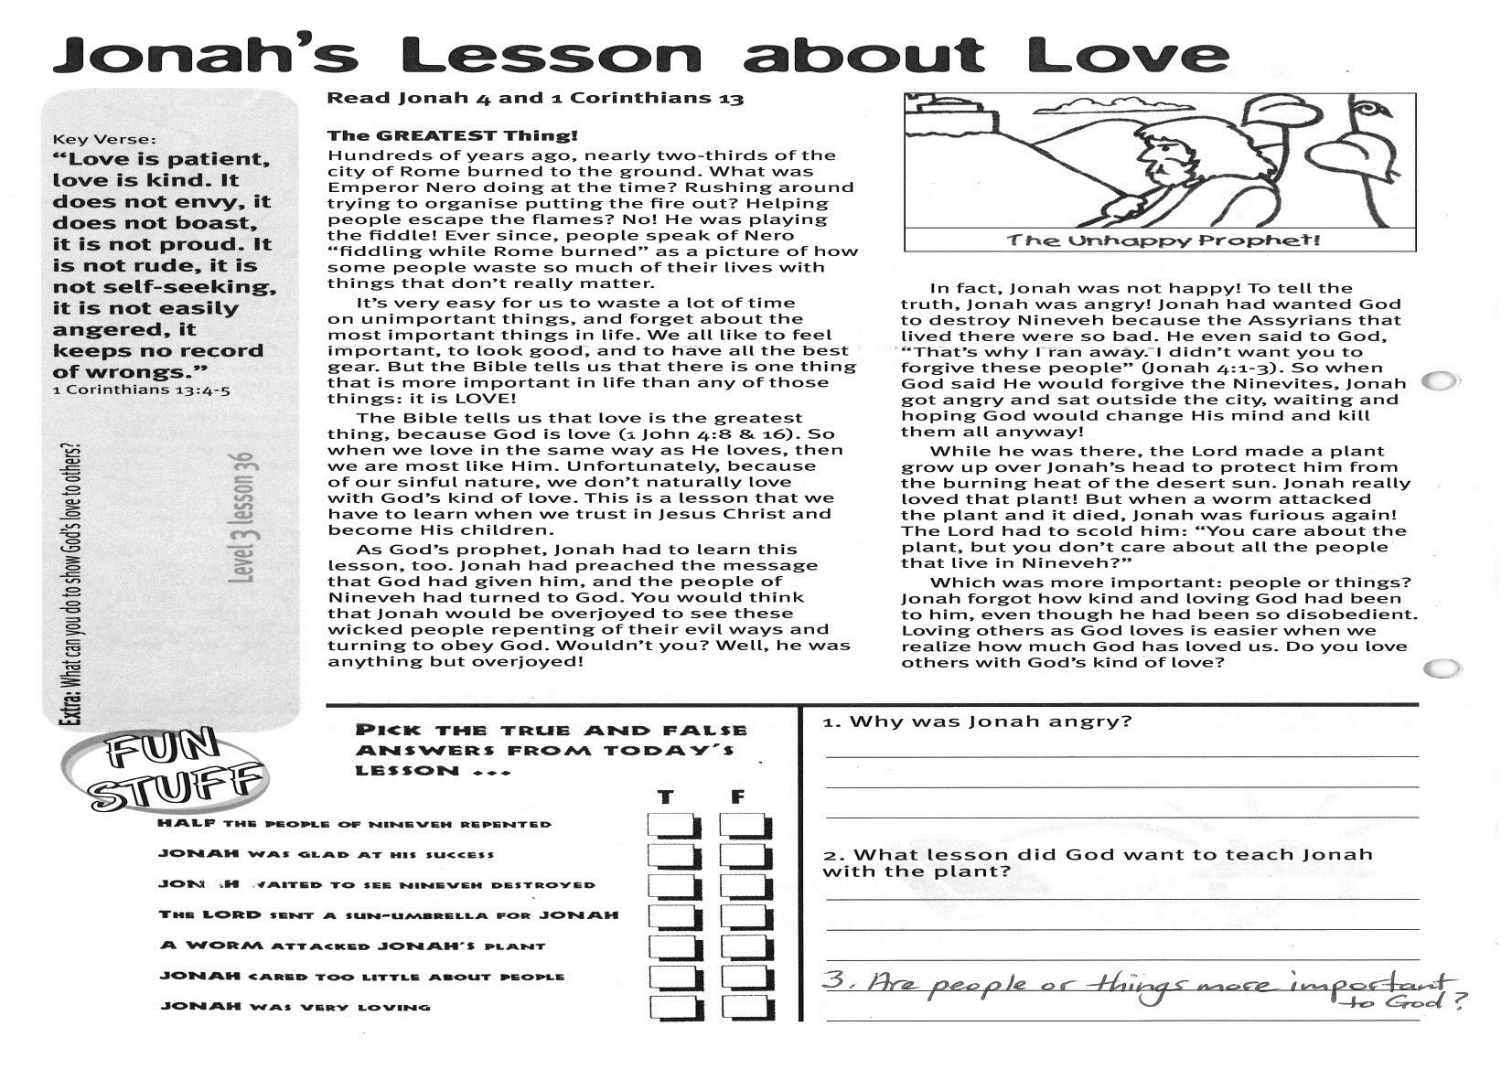

Key Verse:  
**“Love is patient, love is kind. It does not envy, it does not boast, it is not proud. It is not rude, it is not self-seeking, it is not easily angered, it keeps no record of wrongs.”**

1 Corinthians 13:4-5

**Read: Jonah 4;   
and 1 Corinthians 13**

**The GREATEST Thing!**  
Hundreds of years ago, nearly two-thirds of the city of Rome burned to the ground. What was Emperor Nero doing at the time? Rushing around trying to organise putting the fire out? Helping people escape the flames? No! He was playing the fiddle! Ever since, people speak of Nero “fiddling while Rome burned” as a picture of how some people waste so much of their lives with things that don’t really matter.

It’s very easy for us to waste a lot of time on unimportant things, and forget about the most important things in life. We all like to feel important, to look good, and to have all the best gear. But the Bible tells us that there is one thing that is more important in life than any of those things: it is LOVE!

The Bible tells us that love is the greatest thing, because God is love (1 John 4:8,16). So when we love in the same way as He loves, then we are most like Him. Unfortunately, because of our sinful nature, we don’t naturally love with God’s kind of love. This is a lesson that we have to learn when we trust in Jesus Christ and become His children.

As God’s prophet, Jonah had to learn this lesson, too. Jonah had preached the message that God had given him, and the people of Nineveh had turned to God. You would think that Jonah would be overjoyed to see these wicked people repenting of their evil ways and turning to obey God.

**Jonah’s Lesson about Love**

Please complete and return by post to   
**PSSM, 1-2A (G2) 93 Dominion Rd, Mt Eden, Auckland 1024** or scan & email to **info@biblediscovery.org.nz**

**Answer:**

Wouldn’t you? Well, he was anything but overjoyed! In fact, Jonah was not happy! To tell the truth, Jonah was angry!

Jonah had wanted God to destroy Nineveh because the Assyrians that lived there were so bad. He even said to God, “That’s why I ran away. I didn’t want you to forgive these people” (Jonah 4:1-3). So when God said He would forgive the Ninevites, Jonah got angry and sat outside the city, waiting and hoping God would change His mind and kill them all anyway!

While he was there, the Lord made a plant grow up over Jonah’s head to protect him from the burning heat of the desert sun. Jonah really loved that plant! But when a worm attacked the plant and it died, Jonah was furious again! The Lord had to scold him: “You care about the plant, but you don’t care about all the people that live in Nineveh?”

Which was more important: people or things? Jonah forgot how kind and loving God had been to him, even though he had been so disobedient. Loving others as God loves is easier when we realize how much God has loved us. Do you love others with God’s kind of love?

**Level 3 lesson 36**

**Extra:** What can you do to show God’s love to others?

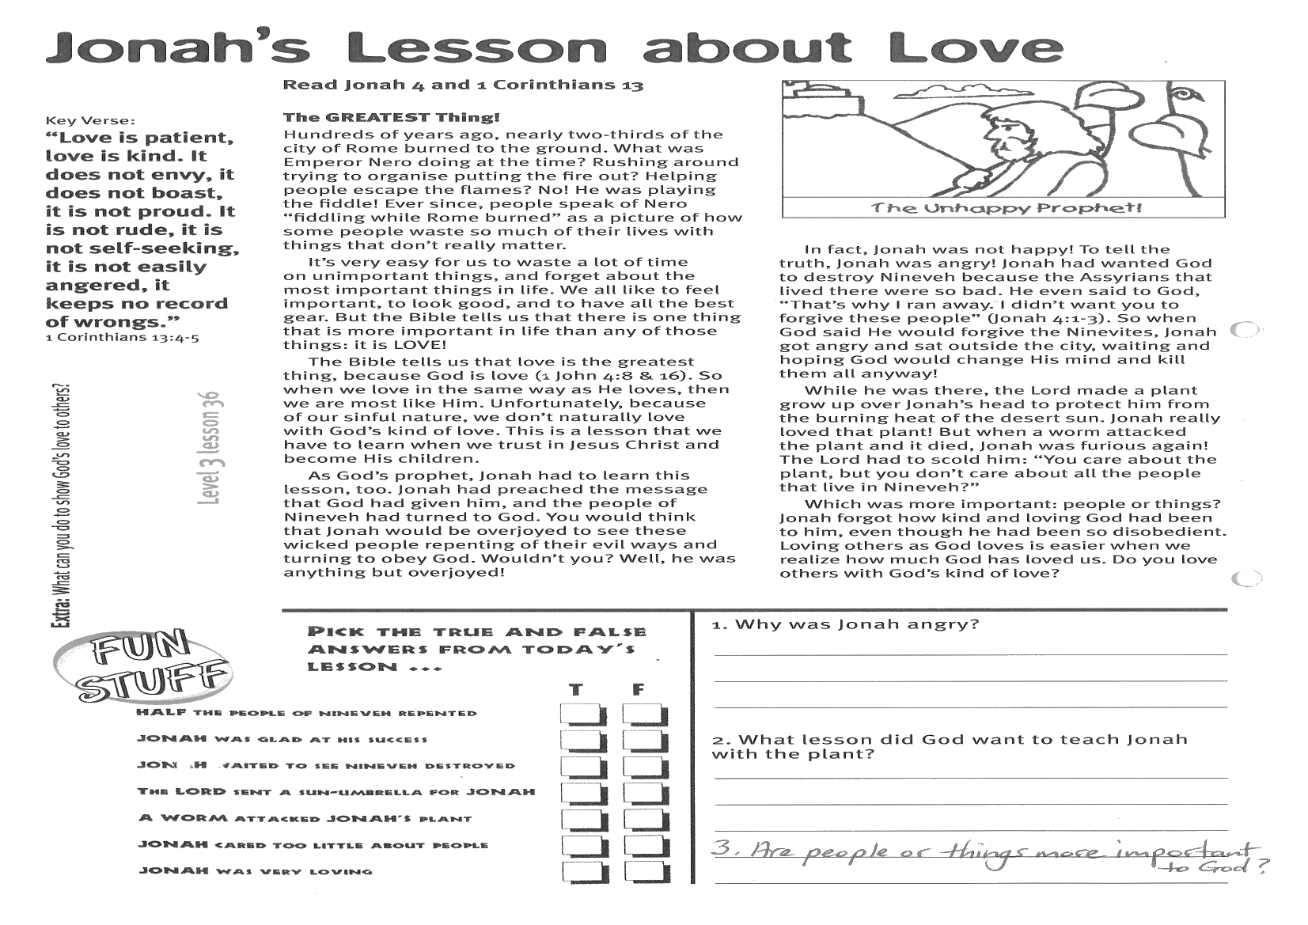

**1. Why was Jonah angry?**

……………………………………………………………………………………………………………………………………………………………..

**2. What lesson did God want to teach Jonah with  
the plant?**

………………………………………………………………………………………………………………………………………………………………

……………………………………………………………………………..

**3. Are people or things more important to God?**

………………………………………………………………………………

CIRCE THE TRUE OR FALSE ANSWER FROM TODAY’S LESSON…

Half the people of Nineveh repented T/F

Jonah was glad at his success T/F

Jonah wanted to see Nineveh destroyed T/F

The Lord sent a sun-umbrella for Jonah T/F

A worm attacked Jonah’s plant T/F

Jonah cared too little about people T/F

Jonah was very loving T/F

□