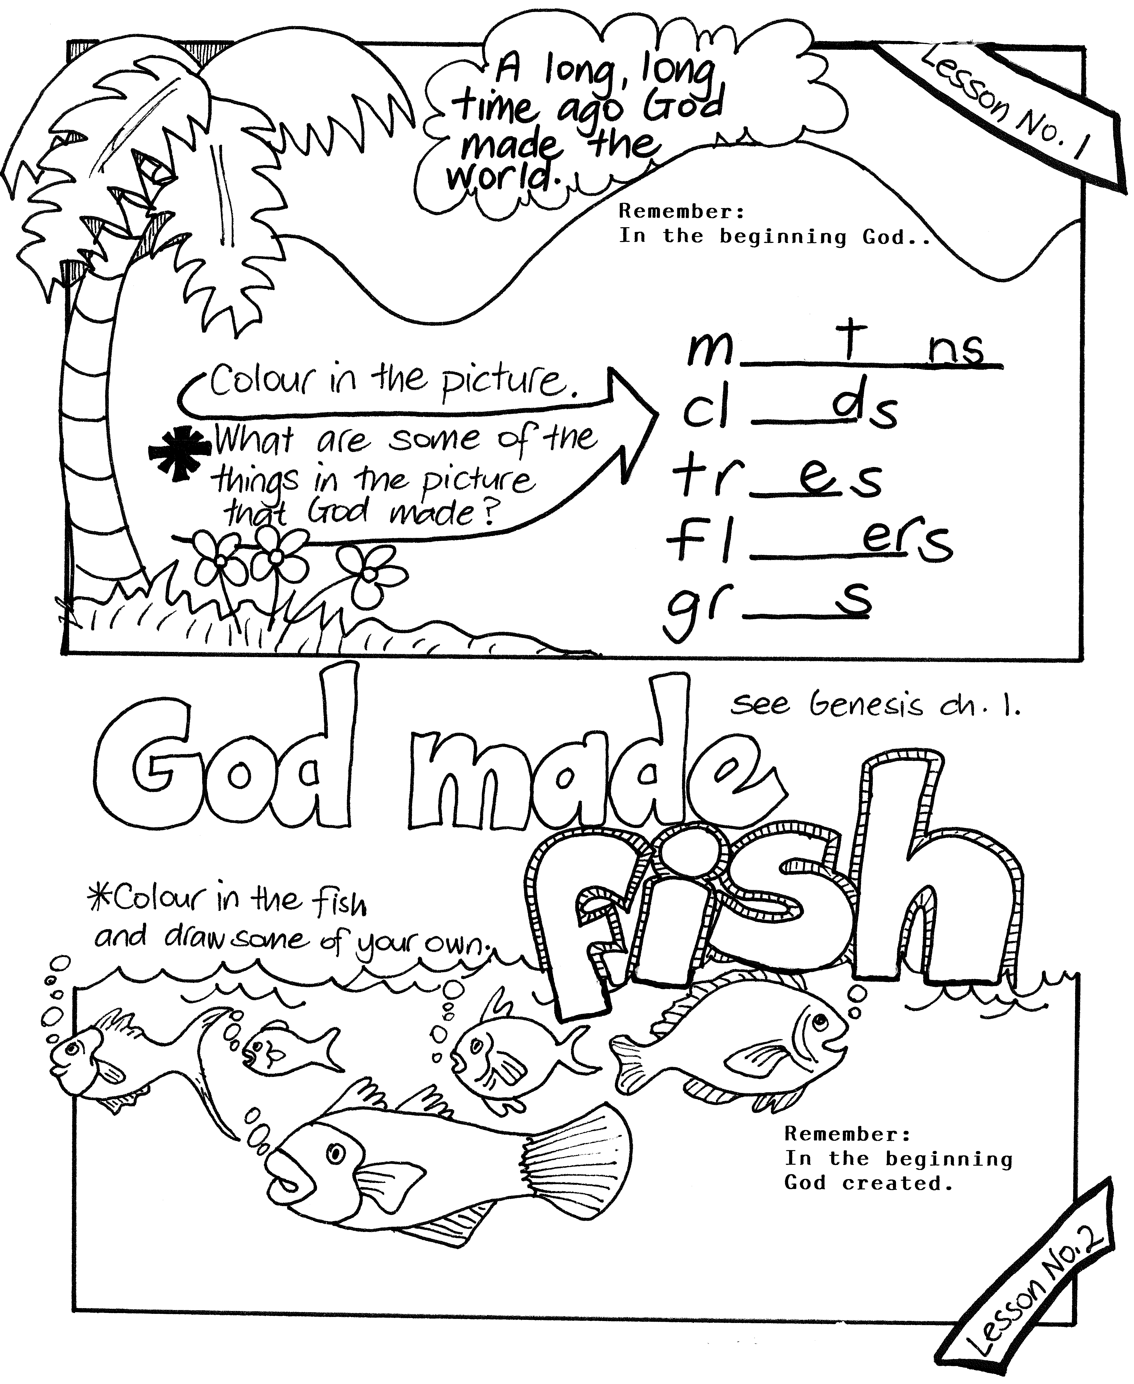

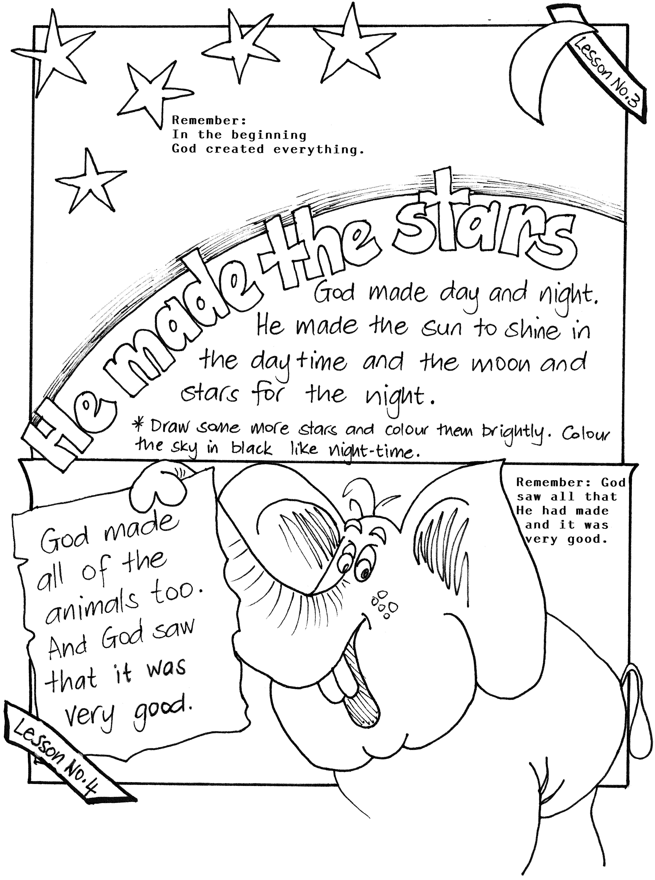1-2a (G2) 93 Dominion Road, Mt Eden, AUCKLAND 1024, New Zealand. PH: 064-09-846 1776
info@biblediscovery.org.nz www.biblediscovery.org.nz

