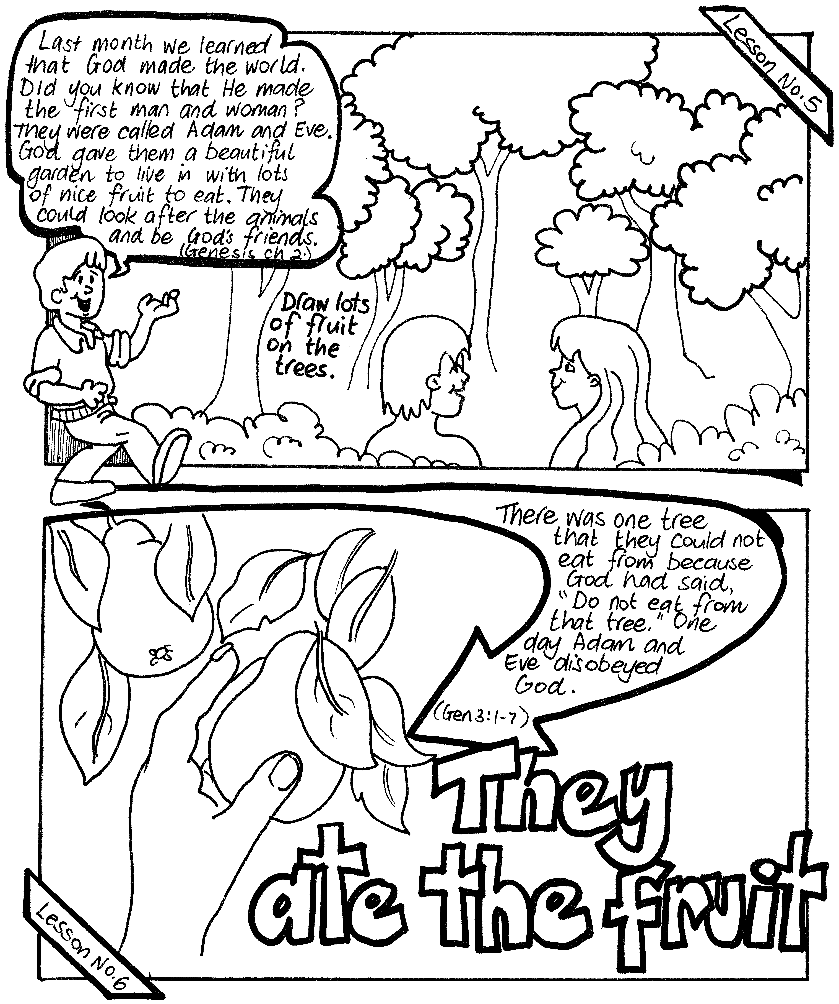

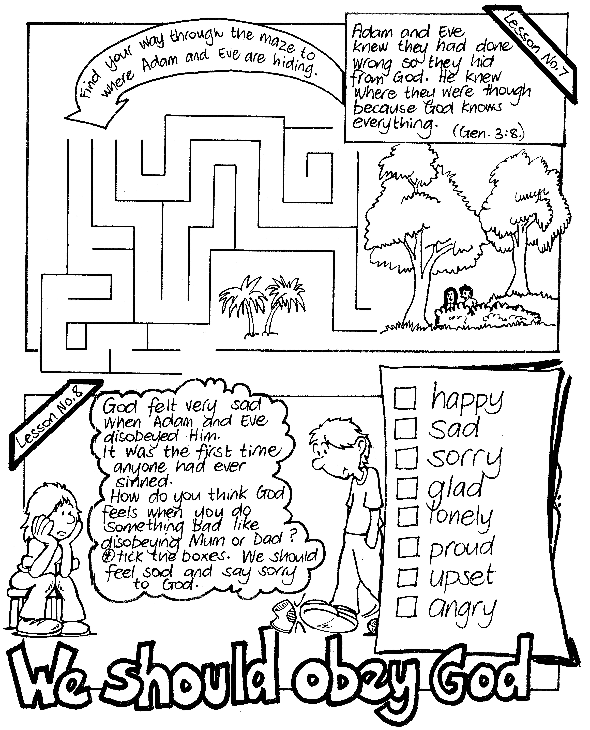
Please complete and return to: PSSM Bible Discovery, 5/399 New North Road, Kingsland, AUCKLAND 1021, New Zealand. PH: 064-09-846 1776
info@biblediscovery.org.nz www.biblediscovery.org.nz

