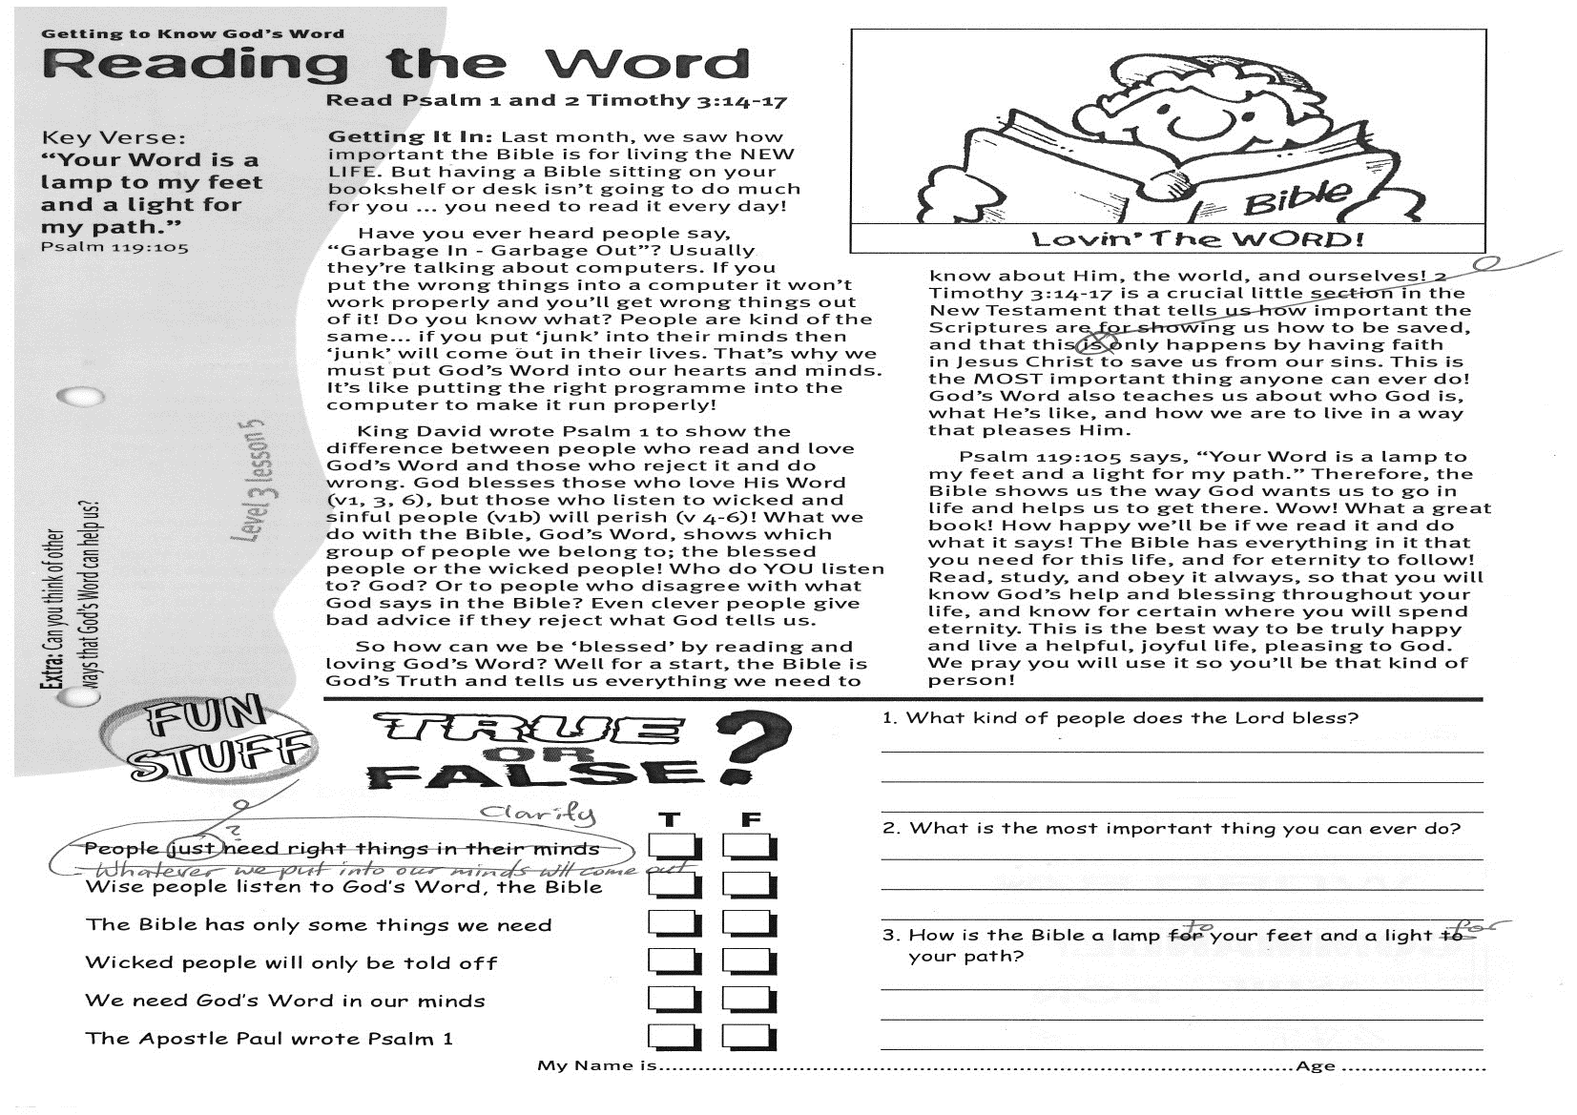

Key Verse:  
**“Your Word is a lamp to my feet and a light for my path.”**

Psalm 119:105

**Read Psalm 1   
and 2 Timothy 3:14-17**

**Getting It In:** Last month, we saw how important the Bible is for living the NEW LIFE. But having a Bible sitting on your bookshelf or desk isn’t going to do much for you ... you need to read it every day!

Have you ever heard people say, “Garbage In - Garbage Out”? Usually they’re talking about computers. If you put the wrong things into a computer it won’t work properly and you’ll get wrong things out of it! Do you know what? People are kind of the same... if you put ‘junk’ into their minds then ‘junk’ will come out in their lives. That’s why we must put God’s Word into our hearts and minds. It’s like putting the right programme into the computer to make it run properly!

King David wrote Psalm 1 to show the difference between people who read and love God’s Word and those who reject it and do wrong. God blesses those who love His Word (v1, 3, 6), but those who listen to wicked and sinful people (v1b) will perish (v 4-6)! What we do with the Bible, God’s Word, shows which group of people we belong to; the blessed people or the wicked people! Who do YOU listen to? God? Or to people who disagree with what God says in the Bible? Even clever people give bad advice if they reject what God tells us.

**Getting to know God’s Word**

**Reading the Word**

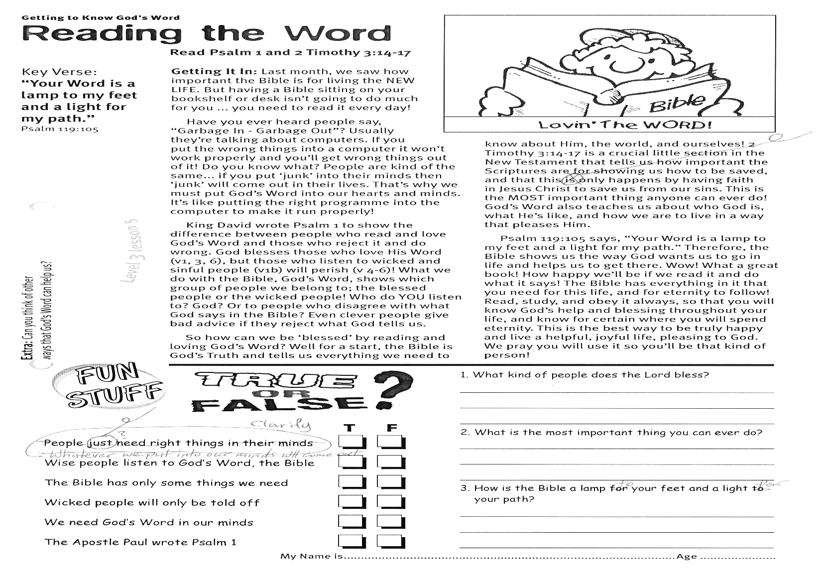

1. What kind of people does the Lord bless?

…………………………………………………………………………

2. What is the most important thing you can ever do?

…………………………………………………………………………

3. How is the Bible a lamp to your feet and a light for your path?

……………………………………………………………………………………………………………………………………………………………………………………………………………………………

My Name is …………………………………………………… Age……………

Whatever we put into our minds will come out **T/F**

Wise people listen to God’s Word, the Bible **T/F**

The Bible has only some things we need **T/F**

Wicked people will only be told off **T/F**

We need God’s Word in our minds **T/F**

The Apostle Paul wrote Psalm 1 **T/F**

So how can we be ‘blessed’ by reading and loving God’s Word? Well for a start, the Bible is God’s Truth and tells us everything we need to know about Him, the world, and ourselves!  
2 Timothy 3:14-17 is a crucial little section in the New Testament that tells us how important the Scriptures are for showing us how to be saved, and that this only happens by having faith in Jesus Christ to save us from our sins. This is the MOST important thing anyone can ever do! God’s Word also teaches us about who God is, what He’s like, and how we are to live in a way that pleases Him.

Psalm 119:105 says, “Your Word is a lamp to my feet and a light for my path.” Therefore, the Bible shows us the way God wants us to go in life and helps us to get there. Wow! What a great book! How happy we’ll be if we read it and do what it says! The Bible has everything in it that you need for this life, and for eternity to follow! Read, study, and obey it always, so that you will know God’s help and blessing throughout your life, and know for certain where you will spend eternity. This is the best way to be truly happy and live a helpful, joyful life, pleasing to God. We pray you will use it so you’ll be that kind of person!

**Extra:** Can you think of other ways that God’s Word can help us?

**Level 3 lesson 5**

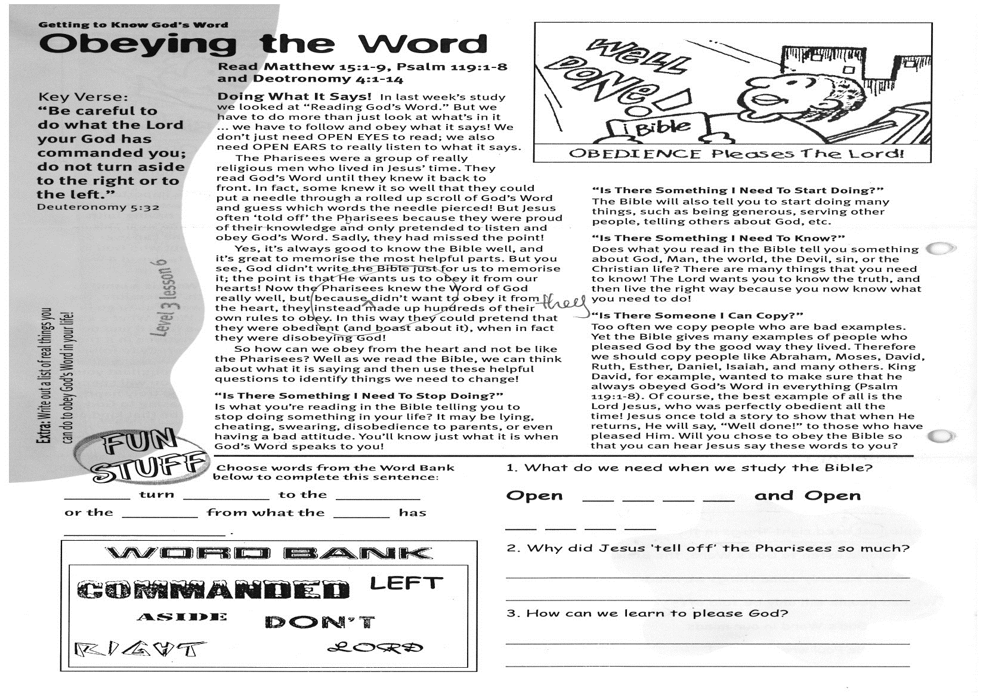

**Read Matthew 15:1-9; Psalm 119:1-8 and Deuteronomy 4:1-14**

**Doing What It Says!** In last week’s study we looked at “Reading God’s Word.” But we have to do more than just look at what’s in it ... we have to follow and obey what it says! We don’t just need OPEN EYES to read; we also need OPEN EARS to really listen to what it says.

The Pharisees were a group of really religious men who lived in Jesus’ time. They read God’s Word until they knew it back to front. In fact, some knew it so well that they could put a needle through a rolled up scroll of God’s Word and guess which words the needle pierced! But Jesus often ‘told off’ the Pharisees because they were proud of their knowledge and only pretended to listen and obey God’s Word. Sadly, they had missed the point!

Yes, it’s always good to know the Bible well, and it’s great to memorise the most helpful parts. But you see, God didn’t write the Bible just for us to memorise it; the point is that He wants us to obey it from our hearts! Now the Pharisees knew the Word of God really well, but because they didn’t want to obey it from the heart, they instead made up hundreds of their own rules to obey. In this way they could pretend that they were obedient (and boast about it), when in fact they were disobeying God!  
So how can we obey from the heart and not be like the Pharisees? Well, as we read the Bible, we can think about what it is saying and then use these helpful questions to identify things we need to change!

**“Is There Something I Need To Stop Doing?”**

Is what you’re reading in the Bible telling you to stop doing something in your life? It may be

**Getting to know God’s Word**

**Obeying The Word**

Key Verse:  
**“Be careful to do what the Lord your God has commanded you: do not turn aside to the right or to the left.”**

Deuteronomy 5:32

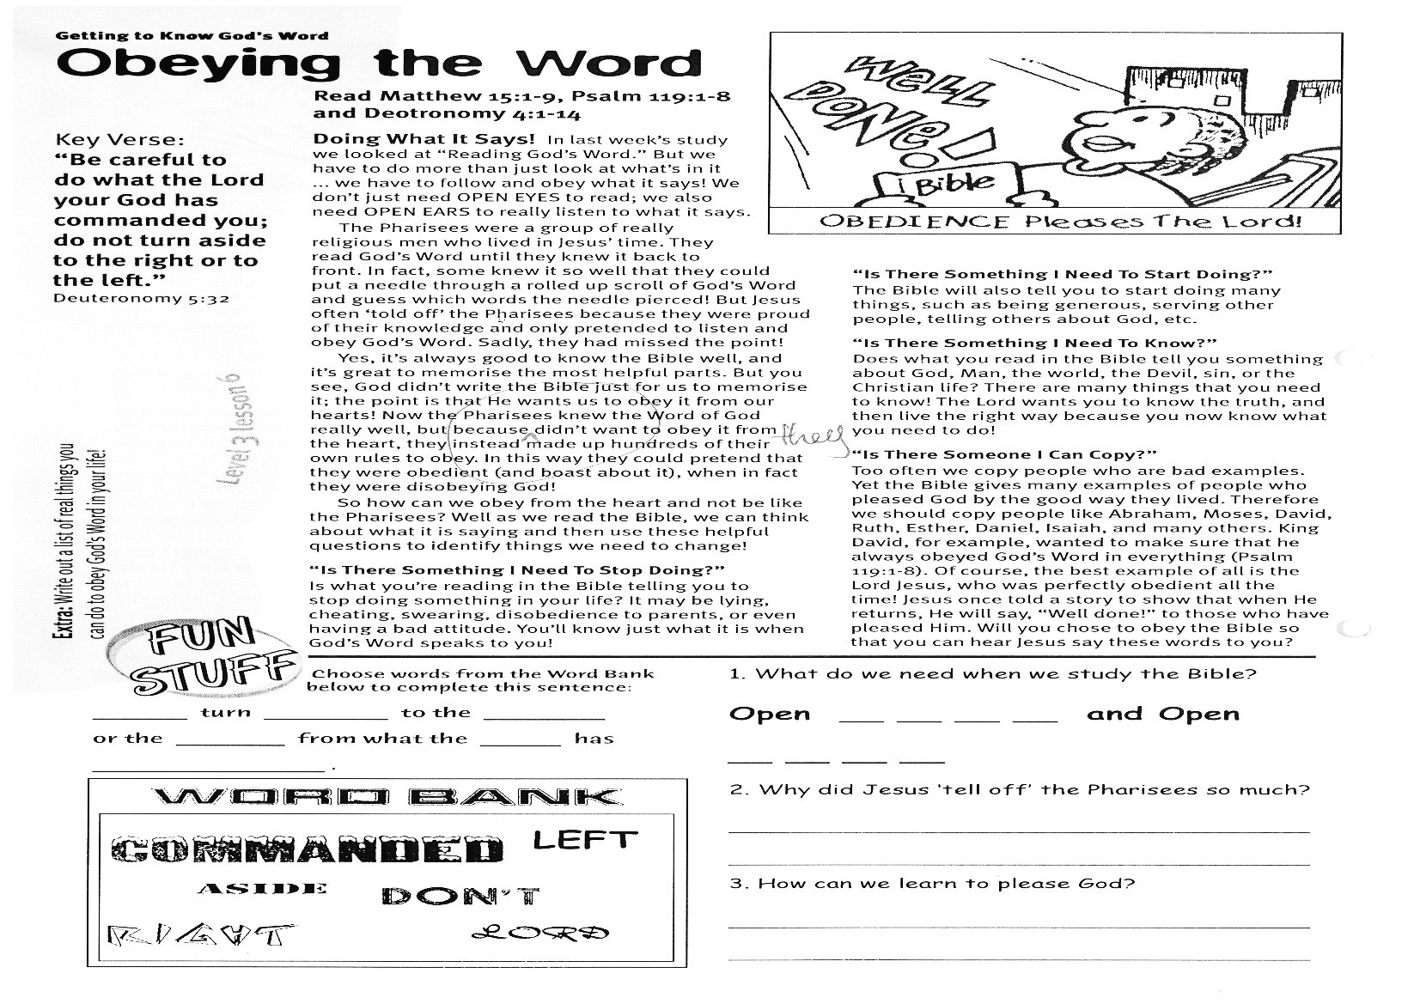

Choose words from the Word Bank below to complete this sentence:

**__ __ __ __ turn __ __ __ __ __ to the  
__ __ __ __ __ or the __ __ __ __ from what the  
__ __ __ __ has __ __ __ __ __ __ __ __ __**

lying, cheating, swearing, disobedience to parents, or even having a bad attitude. You’ll know just what it is when God’s Word speaks to you!

**“Is There Something I Need To Start Doing?”**

The Bible will also tell you to start doing many things, such as being generous, serving other people, telling others about God, etc.

**“Is There Something I Need To Know?”**

Does what you read in the Bible tell you something about God, man, the world, the devil, sin, or the Christian life? There are many things that you need to know! The Lord wants you to know the truth, and then live the right way because you now know what you need to do!

**“Is There Someone I Can Copy?”**

Too often we copy people who are bad examples. Yet the Bible gives many examples of people who pleased God by the good way they lived. Therefore we should copy people like Abraham, Moses, David, Ruth, Esther, Daniel, Isaiah, and many others. King David, for example, wanted to make sure that he always obeyed God’s Word in everything - (see Psalm  
119:1-8). Of course, the best example of all is the Lord Jesus, who was perfectly obedient all the time! Jesus once told a story to show that when He returns, He will say, “Well done!” to those who have pleased Him. Will you choose to obey the Bible so that you can hear Jesus say these words to you?

**Extra:** Write out a list of things you can do to obey God’s Word in your life.

**Level 3 lesson 6**

1. What do we need when we study the Bible?

**Open __ __ __ __ and open __ __ __ __ __**

2. Why did Jesus ‘tell off’ the Pharisees so much?

…………………………………………………………………………………

…………………………………………………………………………………

3. How can we learn to please God?

......................................................................................  
  
.....................................................................................

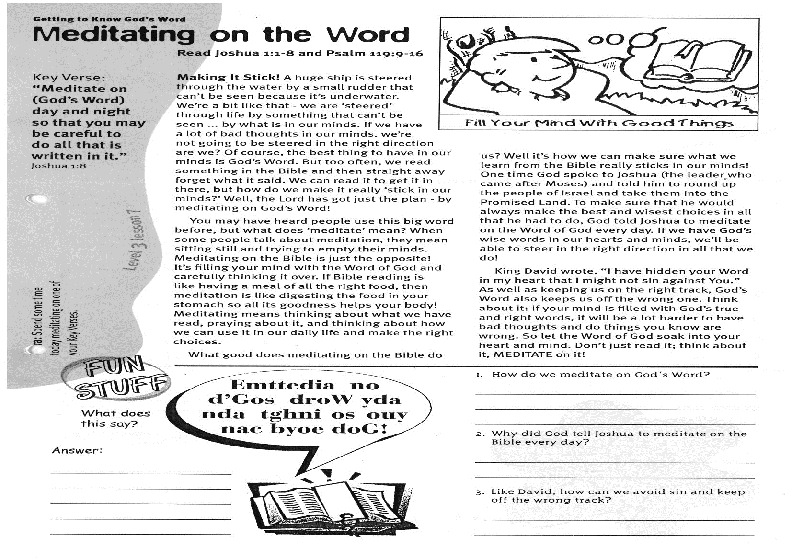

**Read Joshua 1:1-8   
and Psalm 119:9-16**

**Making It Stick!** A huge ship is steered through the water by a small rudder that can’t be seen because it’s underwater. We’re a bit like that - we are ‘steered’ through life by something that can’t be seen ... by what is in our minds. If we have a lot of bad thoughts in our minds, we’re not going to be steered in the right direction are we? Of course, the best thing to have in our minds is God’s Word. But too often, we read something in the Bible and then straight away forget what it said. We can read it to get it in there, but how do we make it really ‘stick in our minds?’ Well, the Lord has got just the plan - by meditating on God’s Word!

You may have heard people use this big word before, but what does ‘meditate’ mean? When some people talk about meditation, they mean sitting still and trying to empty their minds. Meditating on the Bible is just the opposite! It’s filling your mind with the Word of God and carefully thinking it over. If Bible reading is like having a meal of all the right food, then meditation is like digesting the food in your stomach so all its goodness helps your body! Meditating means thinking about what we have read, praying about it, and thinking about how we can use it in our daily life and make the right choices.

**Getting to know God’s Word**

Key Verse:  
**“Meditate on (God’s Word) day and night so that you may be careful to do all that is written in it.”**

Joshua 1:8

**Meditating on the Word**

**FUN**

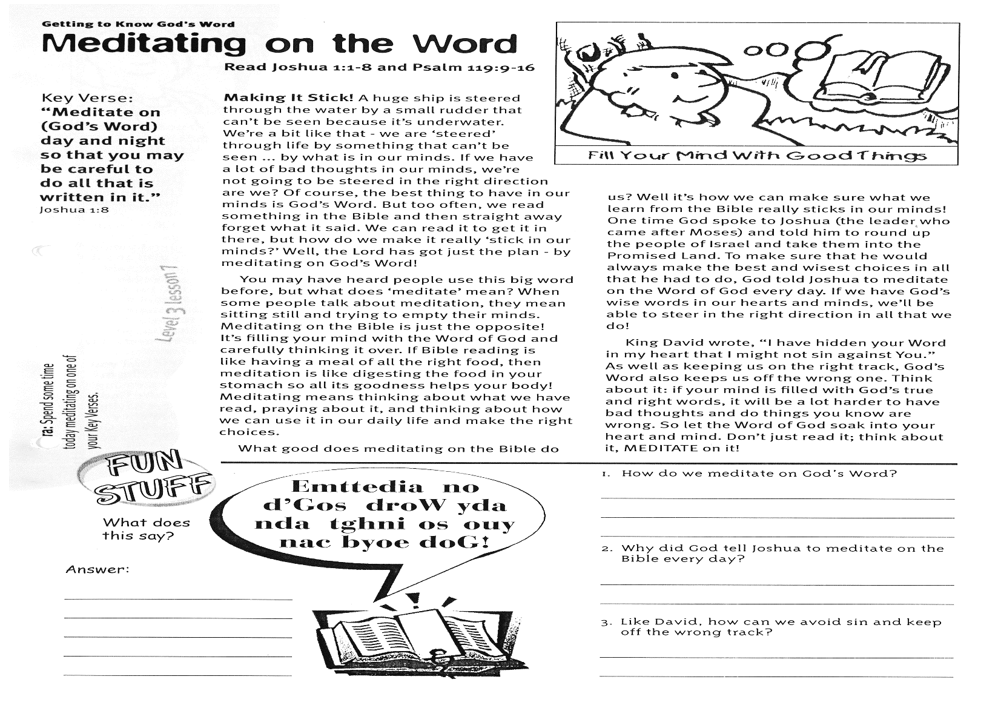

………………………………………………………………………………………………………………………………………………………………………………………………………………………………………………………………………………………………………………..

**What does this say?  
Answer:**

1. How do we meditate on God’s Word?  
_______________________________________  
_______________________________________

2. Why did God tell Joshua to meditate on the Bible every day?  
______________________________________________________________________________  
_______________________________________

3. Like David, how can we avoid sin and keep off the wrong track?  
______________________________________________________________________________  
_______________________________________

**Level 3 lesson 7**

**Extra:** Spend some time today meditating on one of your Key Verses.

What good does meditating on the Bible do us? Well it’s how we can make sure what we learn from the Bible really sticks in our minds! One time God spoke to Joshua (the leader who came after Moses) and told him to round up the people of Israel and take them into the Promised Land. To make sure that he would always make the best and wisest choices in all that he had to do, God told Joshua to meditate on the Word of God every day. If we have God’s wise words in our hearts and minds, we’ll be able to steer in the right direction in all that we do!

King David wrote, “I have hidden your Word in my heart that I might not sin against You.” As well as keeping us on the right track, God’s Word also keeps us off the wrong one. Think about it: if your mind is filled with God’s true and right words, it will be a lot harder to have bad thoughts and do things you know are wrong. So let the Word of God soak into your heart and mind. Don’t just read it; think about it, MEDITATE on it!

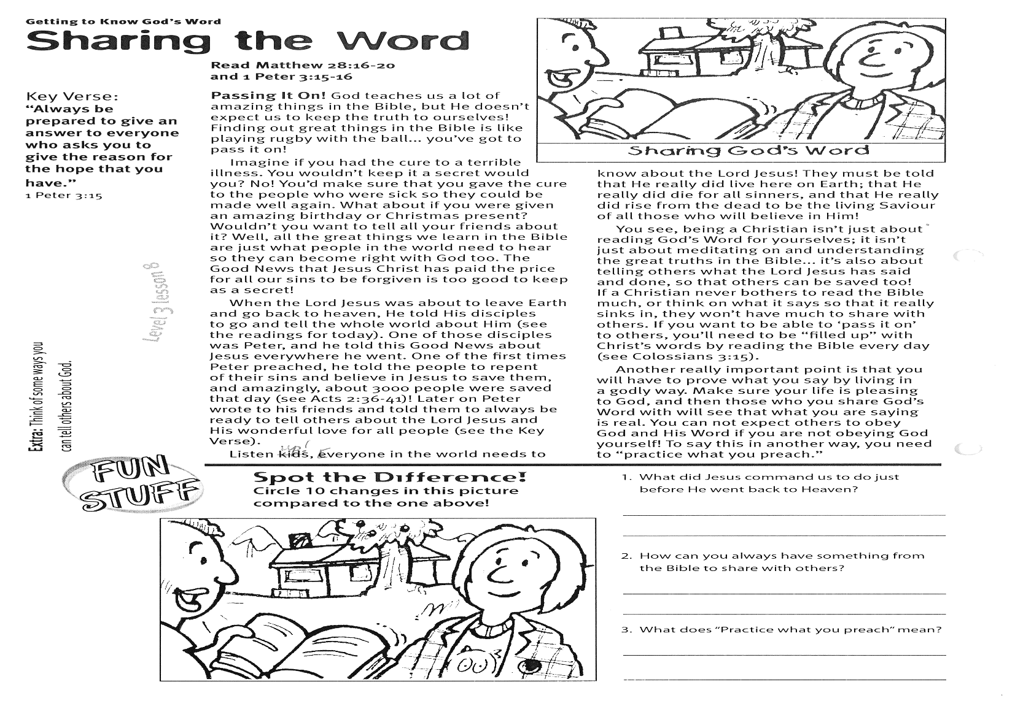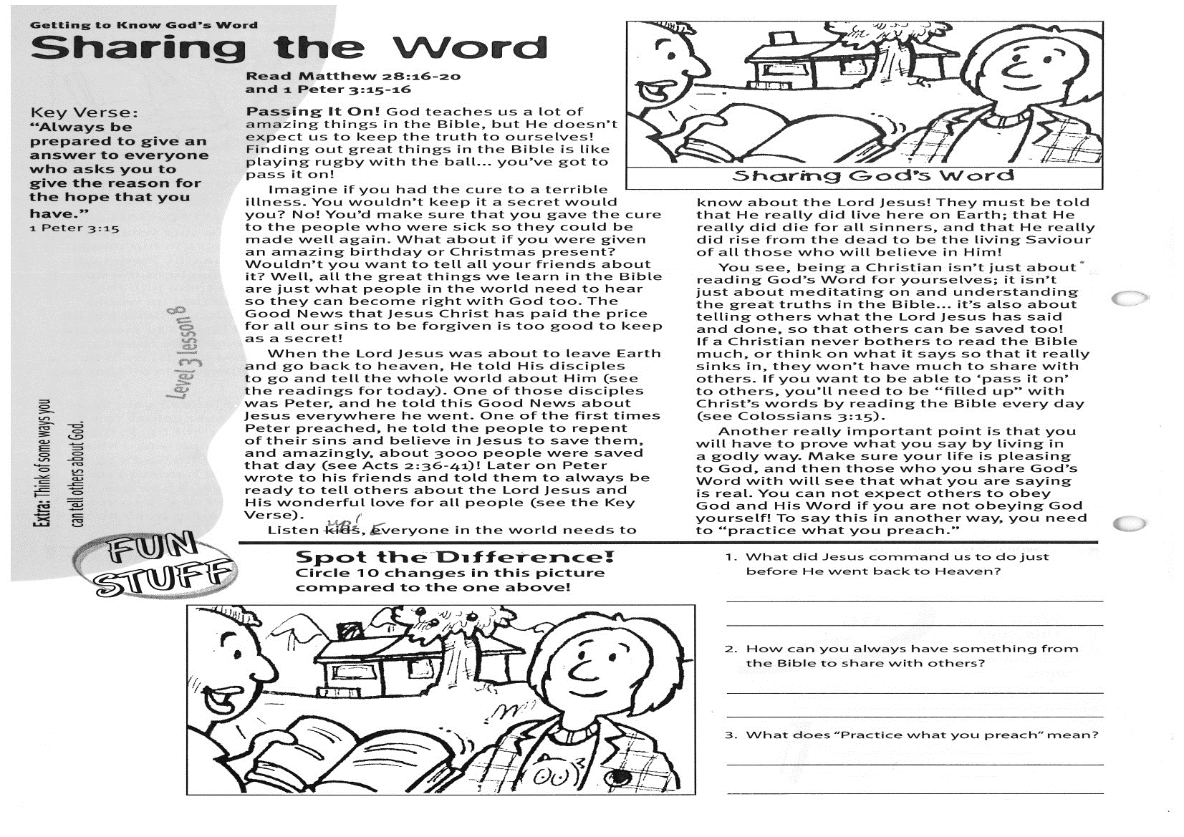

**Extra:** Think of some ways you can tell others about God.

**Spot the difference:**

**Circle 10 changes in the picture compared to the one above!**

Please complete and return by post to   
**PSSM, 5/399 New North Road, Kingsland, Auckland 1021**or scan & email to **info@biblediscovery.org.nz**

1. What did Jesus command us to do just before He went back to Heaven?

________________________________________________________________________________________

2. How can you always have something from the Bible to share with others?  
____________________________________________________________________________________

3. What does “Practise what you preach” mean?  
______________________________________________________________________________________________________________________________

**Listen up!** Everyone in the world needs to know about the Lord Jesus! They must be told that He really did live here on earth; that He really did die for all sinners, and that He really did rise from the dead to be the living Saviour of all those who will believe in Him!

You see, being a Christian isn’t just about reading God’s Word for yourselves; it isn’t just about meditating on and understanding the great truths in the Bible... it’s also about telling others what the Lord Jesus has said and done, so that others can be saved too! If a Christian never bothers to read the Bible much, or think on what it says so that it really sinks in, they won’t have much to share with others. If you want to be able to ‘pass it on’ to others, you’ll need to be ‘filled up’ with Christ’s words by reading the Bible every day. (see Colossians 3:15)

Another really important point is that you will have to prove what you say by living in a godly way. Make sure your life is pleasing to God, and then those who you share God’s Word with will see that what you are saying is real. You cannot expect others to obey God and His Word if you are not obeying God yourself! To say this in another way, you need to “practice what you preach.”

**Read Matthew 28:16-20   
and 1 Peter 3:15-16**

**Passing It On!** God teaches us a lot of amazing things in the Bible, but He doesn’t expect us to keep the truth to ourselves! Finding out great things in the Bible is like playing rugby with the ball... you’ve got to pass it on!

Imagine if you had the cure to a terrible illness. You wouldn’t keep it a secret, would you? No! You’d make sure that you gave the cure to the people who were sick so they could be made well again. What about if you were given an amazing birthday or Christmas present? Wouldn’t you want to tell all your friends about it? Well, all the great things we learn in the Bible are just what people in the world need to hear so they can become right with God too. The Good News that Jesus Christ has paid the price for all our sins to be forgiven is too good to keep as a secret!

When the Lord Jesus was about to leave earth and go back to heaven, He told His disciples to go and tell the whole world about Him (see the readings for today). One of those disciples was Peter, and he told this Good News about Jesus everywhere he went. One of the first times Peter preached, he told the people to repent of their sins and believe in Jesus to save them, and amazingly, about 3000 people were saved that day! (see Acts 2:36-41) Later on Peter wrote to his friends and told them to always be ready to tell others about the Lord Jesus and His wonderful love for all people. (see the Key Verse)

Key Verse:  
**“Always be prepared to give an answer to everyone who asks you to give the reason for the hope that you have.”**

1 Peter 3:15

**Getting to know God’s Word**

**Level 3 lesson 8**

**Sharing the Word**