Fire from the Sky
Key Verse:
“The Lord accepts my prayer.”
Psalm 6:9
Read Genesis 18:16-33; 19:15-26
One day, three strangers came to visit Abraham, so he went out to meet them and talk to them. They looked just like normal men, but they were really angels sent from Heaven! When they left, they told Abraham they were on their way to the city of Sodom where Lot was living. The people who lived in Sodom were very bad, and they would not stop doing bad things.
The Bible tells us that God loves everyone, but that He is also Holy. This means that God is perfectly right and good. God is the opposite of evil and so He must punish sin and disobedient people. So although it made God sad, He decided to punish the people in Sodom for their sins.
Abraham was worried about his nephew Lot, who lived in Sodom. He prayed to God to save the city if there were ten good people there. God said yes, but Sodom was so bad that not even ten good people could be found there! Lot was the only good one.

The wicked people of Sodom had to be destroyed. So Abraham asked God to save Lot and his family.
The angels told Lot and his wife and two of his children to hurry away as fast as they could and not look back. The angels even helped them escape quickly. When they were far enough away, God sent terrible fire from Heaven. This totally burned the whole city and destroyed all the people of Sodom.
Another sad thing happened as God was destroying the city. Lot’s wife disobeyed His command to not look back. When she turned and looked back at Sodom, she turned into a pillar of salt! And so after God had finished, only Lot and his two daughters were left alive.
It is always very bad to disobey God and do wrong things. He wants you also to be saved and change for good. Jesus loves you so much that He died and rose again to save you. So ask God to forgive you, and ask Jesus to be your Saviour. Then He can help you to please God and do what is right.

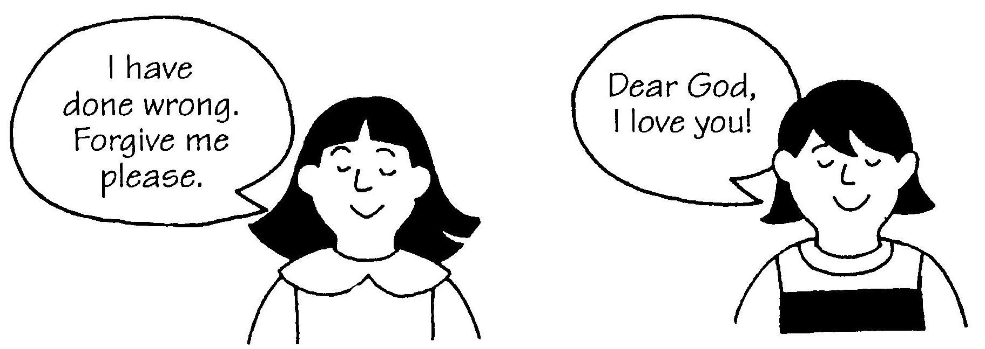
My Name is ……………………………………………………………………… Age……………
Abraham prayed to God so Lot would be __________________________________
How many people were saved from Sodom? _______________________________
Who can forgive you for all the bad things you have done? ___________________
J _______________ died to save ________________________________________
(your name)
Level 2 Lesson 13
Extra: Why did God have to punish the people of Sodom?

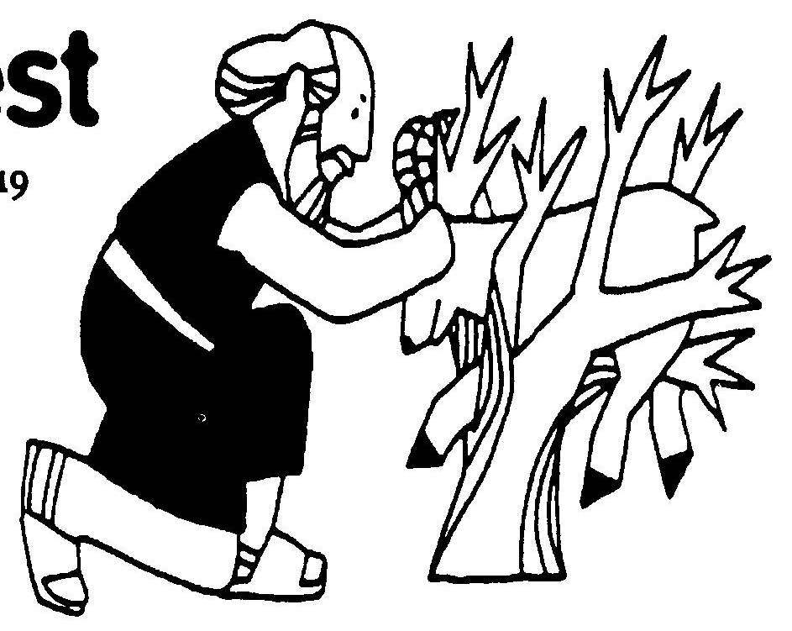
Key Verse:
“God Himself will provide the lamb.”
Genesis 22:8
Read Genesis 22:1-18 and Hebrews 11:11-12, 17-19
God gave Abraham and Sarah a very special son named Isaac. They loved him very much. However, one day when Isaac had grown into a teenager, Abraham got a big surprise. God told him to take his son Isaac into the mountains for an offering to God. God asked him to give up his son’s life, instead of the lamb he usually killed! Did God really mean it? Yes, God was testing Abraham to see if he really loved God most. What a very hard test!
Early the next morning, Abraham and Isaac set off for the mountains with two servants to help them. After travelling for three days, Abraham said to the servants, “You stay here. My son Isaac and I will go on alone. We will worship God and then come back to you.” Abraham didn’t know what would happen but he trusted God. He believed that somehow, God would let Isaac come back with him.
Isaac carried the firewood, and Abraham carried a knife and the fire in an iron pot, because there were no matches back then. As they walked on together, Isaac was puzzled. “Father,” he asked after a while, “here is the fire and the wood - but where is the lamb for the offering?” Abraham simply told Isaac that God would provide the lamb for the offering. He was really trusting God, wasn’t he?
Abraham’s Hardest Test

Extra: Has God ever helped you in some way? How did He help you?
Level 2 lesson 14
When they came to the right place, Abraham built an altar out of stones. Then he tied Isaac up with rope and laid him on the altar. Isaac thought he would have to die as the offering. But just when Abraham picked up the knife, God called out “Abraham, Abraham.” God didn’t really want Abraham to kill Isaac, so He told him to stop!
God’s test had worked and He knew that obedience was more important to Abraham than anything else in the world. Abraham had proved that he loved God even more than his promised son. He had passed his hardest test!
Suddenly, as Abraham looked up he saw a ram caught by its horns in the bushes nearby. God had provided this sheep as an offering instead of Isaac! So after offering the ram, they returned to the servants and they all went home rejoicing. Abraham was so happy because he had obeyed God. And God was very pleased with Abraham’s faith and obedience. You see, obeying God always brings joy!

1. Isaac was God’s special gift to Abraham and Sarah. Now write your own list of special people and things below.
Things that are special to you:
People who are special to you:
2. Who should you love and obey more than those on your list?______________________________________

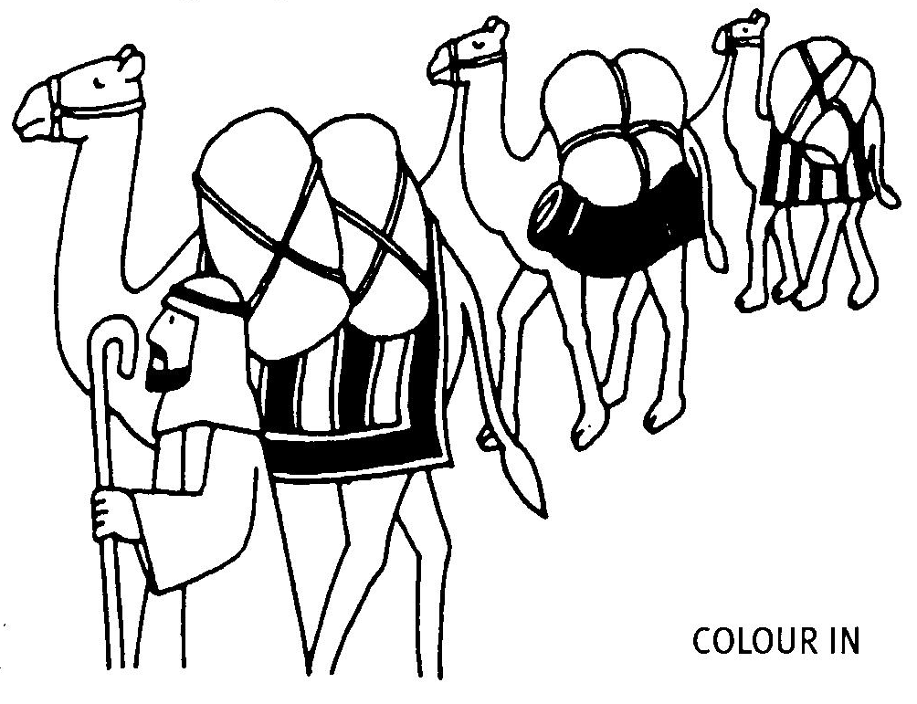
Read Genesis 24:1-27; 50-67
Abraham knew God didn’t want his growing son Isaac to marry any of the girls who lived near them, as the young women of Canaan did not know or love God. The Canaanites did not believe in God and they worshipped idols instead. Abraham wanted Isaac to have a good wife who would help him love and serve the One true God. So he asked his trusted servant Eliezer, to find a wife for Isaac. Abraham told him to travel back to Haran, where he used to live, and look there, amongst his relatives.
So Eliezer set off on the journey, taking ten camels and many presents. After travelling for many days, he came to Haran. He stopped at the well outside the city, and prayed that God would help him find the right wife. He asked that God would answer him by sending the right one to the well, to give him and his camels a drink.
After a while, a lovely young lady came to the well with her water jar. Eliezer asked her for a drink and guess what? She gave him water and then offered some for the camels too! What an answer to Eliezer’s prayer: she was the one! He prayed again, and thanked the Lord, saying “The Lord has led me.”

Key Verse:
“The Lord has led me.”
Genesis 24:27
Here Comes the Bride

Level 2 lesson 15
Extra: Write down some ways that you can help serve others!
The young woman told him her name was Rebekah and she was the daughter of one of Abraham’s relatives. Eliezer gave her presents and went with her to her parent’s house. There he told them all about his prayer at the well. He told them that Rebekah was the young woman God had chosen. He asked if she would return with him and marry Isaac. She said “Yes” and her father gave his permission too.
So Rebekah went with Eliezer to meet Isaac. Isaac had been sad and lonely since his mother, Sarah, had died. But as he saw the camels coming, he ran excitedly to meet his beautiful bride. When he saw her, he loved her straight away. Soon they were married and Rebekah brought love and happiness to his heart and home.

1. For each sentence, draw a circle around the correct answer:
What did Isaac need? camel servants wife house
Where did the servant go? Canaan Egypt Israel Haran
What was the servant’s name? Joshua Eliezer Esau Abraham
What was the bride’s name? Mary Rebekah Catherine Sarah
Who did the bride marry? Abraham Eliezer Jacob Isaac

2. Find the words in the story to complete these sentences:
The servant prayed and asked God to help him find __ __ __ __ __ for Isaac.
The servant prayed again and __ __ __ __ __ __ __ the Lord, saying “The L __ __ __
has __ __ __ me.”

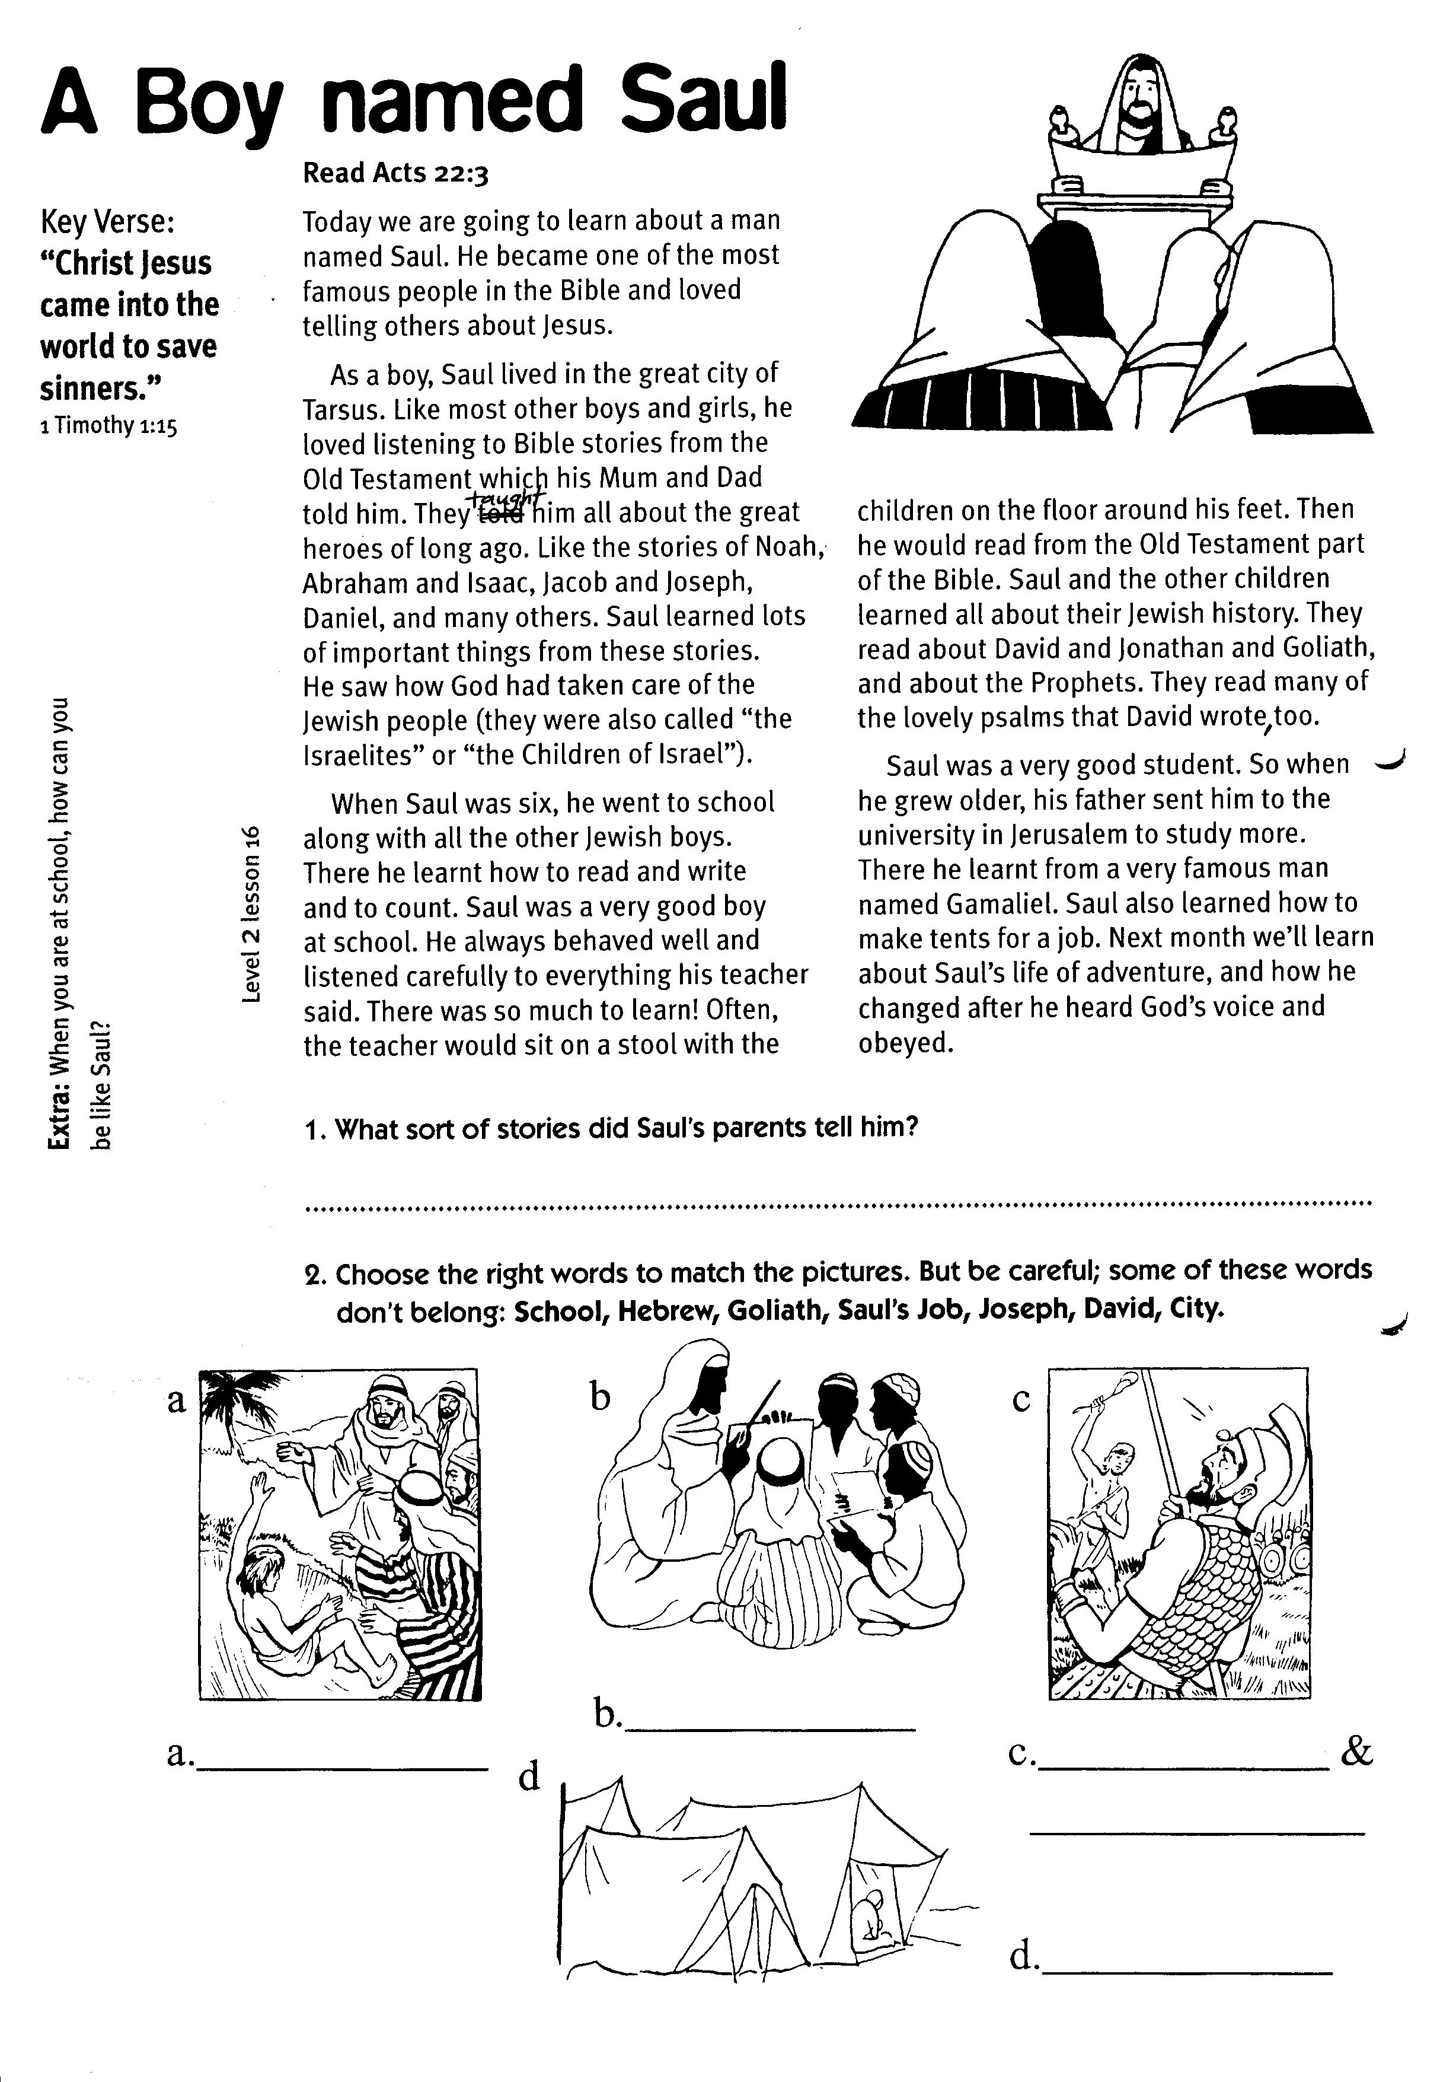
A Boy named Saul
Key Verse:
“Christ Jesus came into the world to save sinners.”
1 Timothy 1:15
Read Acts 22:3
Today we are going to learn about a man named Saul. He became one of the most famous people in the Bible and loved telling others about Jesus.
As a boy, Saul lived in the great city of Tarsus. Like most other boys and girls, he loved listening to Bible stories from the Old Testament which his Mum and Dad told him. They taught him all about the great heroes of long ago; like the stories of Noah, Abraham and Isaac, Jacob and Joseph, Daniel, and many others. Saul learned lots of important things from these stories. He saw how God had taken care of the Jewish people (they were also called “the Israelites” or “the Children of Israel”).
When Saul was six, he went to school along with all the other Jewish boys. There he learnt how to read and write and to count. Saul was a very good boy at school. He always behaved well and listened carefully to everything his teacher said. There was so much to learn!

1003
Level 2 lesson 16
Extra: When you are at school, how can you be like Saul?
Often, the teacher would sit on a stool with the children on the floor around his feet. Then he would read from the Old Testament part of the Bible. Saul and the other children learned all about their Jewish history. They read about David and Jonathan and Goliath, and about the Prophets. They read many of the lovely Psalms that David wrote, too.
Saul was a very good student. So when he grew older, his father sent him to the university in Jerusalem to study more. There he learnt from a very famous man named Gamaliel. Saul also learned how to make tents for a job. Next month we’ll learn about Saul’s life of adventure, and how he changed after he heard God’s voice and obeyed.

1. What sort of stories did Saul’s parents tell him?
__________________________________________________________

2. Choose the right words to match the pictures. But be careful; some of these words don’t belong: school, Hebrew, Goliath, Saul’s Job, Joseph, David, city.

a. _____________ b. ______________ c. ________&__________ d. ______________

Please complete and return by post to
PSSM, 5/399 New North Road, Kingsland, Auckland 1021 or scan & email to info@biblediscovery.org.nz

