Lot’s Choice

Key Verse:
“But seek first His [God’s] kingdom and His righteousness, and all these things will be given to you as well.”
Matthew 6:33
Read Genesis 13 and Acts 7:1-5
Abraham loved his young nephew Lot; they had travelled from their own country to the land of Canaan and they lived happily together with their families, moving from place to place with their cattle and sheep. But as their flocks and herds grew larger, it became harder to find enough grass and water for them all. Soon their shepherds, who looked after the flocks, began arguing and fighting amongst themselves.
Abraham was not happy to hear about this. He realized that the only way to avoid more trouble between their shepherds was for Lot and himself to split up. So one day, he walked with Lot up to a hilltop where they could see over the land for miles around. There, Abraham generously asked Lot to choose which part he wanted for his flocks, even though he was older than Lot and had the right of first choice.
It looked an easy decision for Lot. On one side were the hill pastures of Canaan. On the other side, was the fertile Jordan River valley with the flourishing cities of Sodom and Gomorrah. Clearly, the best “business decision” was to take the Jordan valley and the plains of Sodom. Selfishly, Lot chose the valley and left Abraham only the hills of Canaan.
Lot’s selfish choice may have made good “business sense,” but it was not wise. He forgot there is more to life than just ‘business’. By splitting from Abraham he was leaving his best and truest friend, the very man who had taught him about believing in God. We are told that “Lot lived in the cities of the plain, and set up his tents near Sodom.” He chose to take his family and live right next to the most depraved and evil living people in the world at that time! It appears Lot didn’t think about what effect this might have on him, or his family!
Seemingly, he had set his heart on becoming rich and saw only the fertile, well-watered land, and the business opportunities in the city.
How careful (and prayerful) we too need to be with the big decisions we make in life! A right decision can lead to blessing, but a wrong one can lead to our ruin. As we look at Lot’s life, we will find that he made a bad choice. It was a tragic day for him and his family, when he went down to live by the wicked people of Sodom. Finally, in the last verse of our reading in Genesis, we read that Abraham built another altar to the Lord. However, we never read that Lot did such a thing down in Sodom. It seems as though Lot did not consider this very important, or perhaps was ashamed of his faith in God. His main concern, it would appear, was to “get ahead in life.” Abraham, on the other hand, was always concerned to see that God had first place in his life.
Many young people face similar choices today. Often the attractions of the world appear to offer much more, just like Sodom offered Lot. Yes, Lot did become rich and influential - a real ‘somebody’ in Sodom, but eventually he paid a huge price for it. His personal life, his family life, and his business life all ended in ruin!
If you are facing a similar choice, remember this disastrous story of Lot. Remember the consequences of turning away from God to follow the ways of the world. When you are tempted to go along with bad friends or to do wrong things, you need to be able to say “NO!” Why don’t you try to be someone like Abraham? Will you stand up for what is good, right, and true? Will you seek to please God in your life and desire His blessing on all you do? Will you avoid evil and do good? What a huge amount of heartache and trouble poor Lot would have saved himself, if only he had made the right choices!
1. What caused Lot and Abraham to separate?
2. What was good about Abraham’s action?
3. What had Lot set his heart on?
4. What were the consequences of Lot’s choice?
5. What have you learnt from this study?
Level 3 lesson 1
Extra: What might be a modern-day equivalent of Lot’s choice?
Level 4 lesson 13
QUESTIONS & ANSWERS
The Right Start
Key Verse:
“Jesus said, ‘I tell you the truth, unless a man is born again, he cannot see the kingdom of God.’”
John 3:3
My Name is ……………………………………………………………………… Age ………………….
God’s Judgement on Sodom
Key Verse:
“The Lord is compassionate and gracious; slow to anger and abounding in love.”
Psalm 103:8
Read Genesis 18:16-33; 19:1-26
and Jude 7
After Abraham and Lot moved away from each other, they slowly lost contact with one another. One day, while Abraham sat in the shade of the door of his tent, he saw three men approaching. He rose and welcomed them warmly, inviting them to sit and enjoy a meal with him. After they had eaten and rested a while, they rose to go on with their journey. Abraham went part of the way with them. It was then he found that these men were actually angels with a message from God! They told Abraham they were going toward the cities of Sodom and that God was going to send terrible judgement on them. God could no longer put up with the sinful behaviour of these people; in fact, the cities and all their inhabitants were going to be totally destroyed!
Abraham didn’t doubt this for a moment; the disgraceful and depraved behaviour in Sodom and Gomorrah was known everywhere. Then suddenly, he remembered Lot and his family! What would happen to them? Earnestly he prayed to God, pleading with Him to spare Sodom if there were just 50 good people found in it. God mercifully agreed to this. But not even 10 righteous men could be found in that wicked city!
However, for Abraham’s sake, God did not forget Lot. He sent two angels to save him and his family. They arrived at Lot’s house late one afternoon, and Lot invited them in to stay and have a meal. Then they told Lot, “The Lord is going to destroy this town because of the people’s sin; gather your family, and escape with them early in the morning.” Lot immediately sent this message to the two local men who were engaged to be married to his daughters. They just laughed and thought it was a joke.

Even Lot’s wife and daughters seemed reluctant to leave. Their hearts were really set on the city now, despite its wickedness. “Hurry,” said the messenger, “escape for your lives. Do not even look back or you will die too!” Finally, as Lot and his wife still hesitated, the angels took them and their daughters by the hand and hurried them out of the city forcibly. Once outside they repeated their message, “run for your lives to the mountains. Do not look back or you will die too!”
Lot was old though, and could not travel quickly or very far. He asked if the nearby little town of Zoar could be spared so that he could take shelter there. Again, God was merciful and agreed to his request. As they ran toward Zoar the dreadful rain of fire began falling from Heaven, and quickly started destroying the cities of Sodom. Sadly at that moment, Lot’s wife disobeyed the angel’s command and looked back towards Sodom. Immediately she was turned into a pillar of salt! But Lot and his two daughters obeyed, escaped, and entered Zoar safely.
What a sad story this is! It clearly highlights how the selfish, foolish choice Lot made so many years earlier, had terrible consequences for him and his family. Preferring to pursue earthly riches, instead of seeking God’s direction and blessing on his life, he was brought to complete ruin.
There are other lessons that we can learn too. First, God hears and answers prayer. Abraham prayed - and God heard and answered.
Second, God is Holy - He cannot allow sin to go unpunished.
Third, God is merciful and kind and will not punish anyone who will turn away from sin and toward Him. Because God is merciful and kind, He sent His Son Jesus to be punished for our sins. Jesus once said, “Remember Lot’s wife.” Turn away from your sin today and be saved! Believe in Jesus Christ the Saviour and follow Him as your Lord, and never look back longingly to your old way of life like she did!
1. How did Abraham receive the messengers of God?
2. What did Abraham do when he heard of God’s plan to punish Sodom?
3. Before God punished Sodom, what did He do for Lot and his family?
4. How do the cities of Sodom compare to our modern world?

5. Write out one of the lessons you have learnt from this story.
Extra: Do you think Sodom’s punishment was right? Why or why not?
Level 4 lesson 14
QUESTIONS & ANSWERS

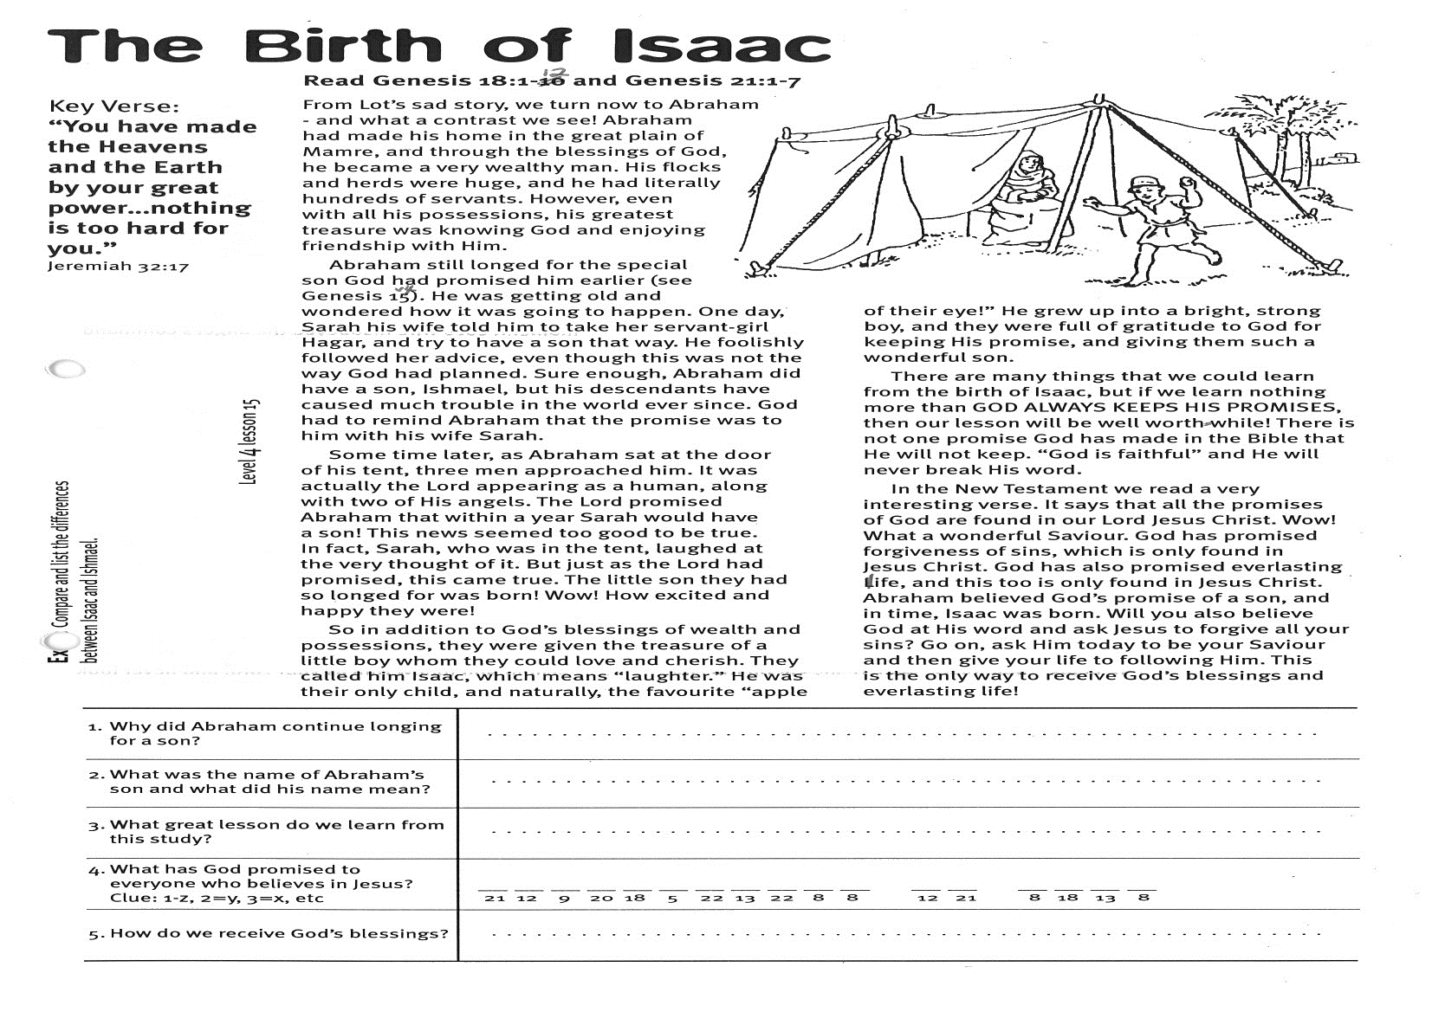
The Birth of Isaac

Key Verse:
“You have made the Heavens and the earth by Your great power… nothing is too hard for You.”
Jeremiah 32:17
Read Genesis 18:1-12
and Genesis 21:1-7
From Lot’s sad story, we turn now to Abraham - and what a contrast we see! Abraham had made his home in the great plain of Mamre, and through the blessings of God, he became a very wealthy man. His flocks and herds were huge, and he had literally hundreds of servants. However, even with all his possessions, his greatest treasure was knowing God and enjoying friendship with Him.
Abraham still longed for the special son God had promised him earlier (see Genesis 15:4). He was getting old and wondered how it was going to happen. One day, Sarah his wife told him to take her servant-girl Hagar, and try to have a son that way. He foolishly followed her advice, even though this was not the way God had planned. Sure enough, Abraham did have a son, Ishmael, but his descendants have caused much trouble in the world ever since. God had to remind Abraham that the promise was to him with his wife Sarah.
Some time later, as Abraham sat at the door of his tent, three men approached him. It was actually the Lord appearing as a human, along with two of His angels. The Lord promised Abraham that within a year Sarah would have a son! This news seemed too good to be true. In fact, Sarah, who was in the tent, laughed at the very thought of it. But just as the Lord had promised, this came true. The little son they had so longed for was born! Wow! How excited and happy they were!
So in addition to God’s blessings of wealth and possessions, they were given the treasure of a little boy whom they could love and cherish. They called him Isaac, which means “laughter.” He was their only child, and naturally, the favourite “apple of their eye!”

1. Why did Abraham continue longing for a son?
2. What was the name of Abraham’s son and what did his name mean?
3. What great lesson do we learn from this study?
4. What has God promised to everyone who believes in Jesus? Clue: 1=z, 2=y, 3=x, etc | __ __ __ __ __ __ __ __ __ __ __ __ __ __ __ __ __  21 12 9 20 18 5 22 13 22 8 8 12 21 8 18 13 8
5. How do we receive God’s blessings?
Extra: Compare and list the differences between Isaac and Ishmael.
Level 4 lesson 15
QUESTIONS & ANSWERS
He grew up into a bright, strong boy, and they were full of gratitude to God for keeping His promise, and giving them such a wonderful son.
There are many things that we could learn from the birth of Isaac, but if we learn nothing more than GOD ALWAYS KEEPS HIS PROMISES, then our lesson will be well worthwhile! There is not one promise God has made in the Bible that He will not keep. “God is faithful” and He will never break His word.
In the New Testament we read a very interesting verse. It says that all the promises of God are found in our Lord Jesus Christ. Wow! What a wonderful Saviour! God has promised forgiveness of sins, which is only found in Jesus Christ. God has also promised everlasting life, and this too is only found in Jesus Christ. Abraham believed God’s promise of a son, and in time, Isaac was born. Will you also believe God at His word and ask Jesus to forgive all your sins? Go on, ask Him today to be your Saviour and then give your life to following Him. This is the only way to receive God’s blessings and everlasting life!
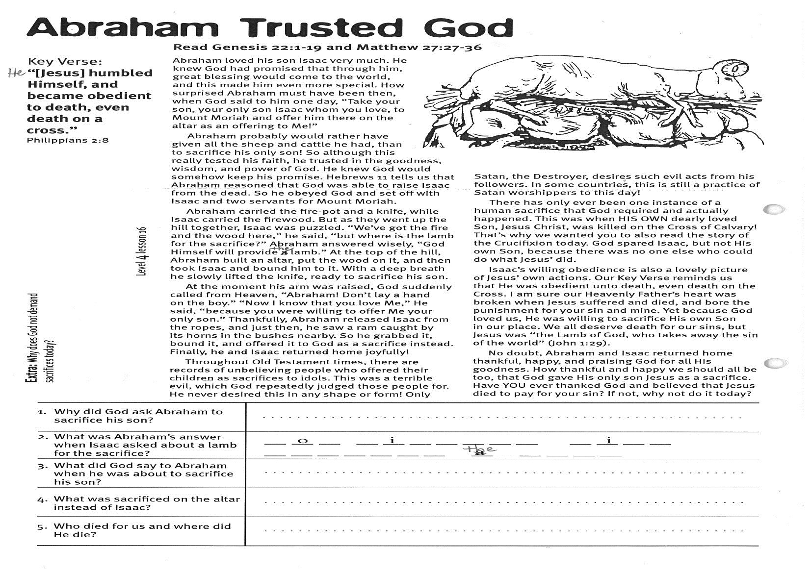
Abraham Trusted God
Key Verse:
“He [Jesus] humbled Himself, and became obedient to death, even death on a cross.”
Philippians 2:8
Read Genesis 22:1-19
and Matthew 27:27-36
Abraham loved his son Isaac very much. He knew God had promised that through him, great blessing would come to the world, and this made him even more special. How surprised Abraham must have been then, when God said to him one day, “Take your son, your only son Isaac whom you love, to Mount Moriah and offer him there on the altar as an offering to Me!”
Abraham probably would rather have given all the sheep and cattle he had, than to sacrifice his only son! So although this really tested his faith, he trusted in the goodness, wisdom, and power of God. He knew God would somehow keep his promise. Hebrews 11 tells us that Abraham reasoned that God was able to raise Isaac from the dead. So he obeyed God and set off with Isaac and two servants for Mount Moriah.
Abraham carried the fire-pot and a knife, while Isaac carried the firewood. But as they went up the hill together, Isaac was puzzled. “We’ve got the fire and the wood here,” he said, “but where is the lamb for the sacrifice?” Abraham answered wisely, “God Himself will provide the lamb.” At the top of the hill, Abraham built an altar, put the wood on it, and then took Isaac and bound him to it. With a deep breath he slowly lifted the knife, ready to sacrifice his son.
At the moment his arm was raised, God suddenly called from Heaven, “Abraham! Don’t lay a hand on the boy.” “Now I know that you love Me,” He said, “because you were willing to offer Me your only son.” Thankfully, Abraham released Isaac from the ropes, and just then, he saw a ram caught by its horns in the bushes nearby. So he grabbed it, bound it, and offered it to God as a sacrifice instead. Finally, he and Isaac returned home joyfully!
1. Why did God ask Abraham to sacrifice his son?
2. What was Abraham’s answer when Isaac asked about a lamb for the sacrifice? | __ o __ __ i __ __ e __ __ __ I __ __ __ __ o __ i __ e  __ __ e __ a __ __
3. What did God say to Abraham when he was about to sacrifice his son?
4. What was sacrificed on the altar instead of Isaac?
5. Who died for us and where did He die?
Extra: Why does God not demand sacrifices today?
Level 4 lesson 16
QUESTIONS & ANSWERS
Throughout Old Testament times, there are records of unbelieving people who offered their children as sacrifices to idols. This was a terrible evil, which God repeatedly judged those people for. He never desired this in any shape or form! Only Satan, the Destroyer, desires such evil acts from his followers. In some countries, this is still a practice of Satan worshippers to this day!
There has only ever been one instance of a human sacrifice that God required and actually happened. This was when HIS OWN dearly loved Son, Jesus Christ, was killed on the Cross of Calvary! That’s why we wanted you to also read the story of the Crucifixion today. God spared Isaac, but not His own Son, because there was no-one else who could do what Jesus did.
Isaac’s willing obedience is also a lovely picture of Jesus’ own actions. Our Key Verse reminds us that He was obedient unto death, even death on the cross. I am sure our Heavenly Father’s heart was broken when Jesus suffered and died, and bore the punishment for your sin and mine. Yet because God loved us, He was willing to sacrifice His own Son in our place. We all deserve death for our sins, but Jesus was “the Lamb of God, who takes away the sin of the world” (John 1:29).
No doubt, Abraham and Isaac returned home thankful, happy, and praising God for all His goodness. How thankful and happy we should all be too, that God gave His only son Jesus as a sacrifice. Have YOU ever thanked God and believed that Jesus died to pay for your sin? If not, why not do it today?

Please complete and return by post to
PSSM, 5/399 New North Road, Kingsland, Auckland 1021 or scan & email to info@biblediscovery.org.nz

