

**Saul: New Heart, New Name**

Key Verse:  
**“What shall I do Lord?”**  
Acts 22:10

**Extra:** Think about how you are going to tell your friends about Jesus.

**Level 2 lesson 17**

**Read Acts 9:1-10, 17-19**

Saul was a very clever man. From the time he was young, he had been taught from the Old Testament Scriptures. He became a Pharisee, a leader in the Jewish religion. Saul did not believe that Jesus was God’s Son. He thought God was pleased with him for trying to stop people from following Jesus and becoming Christians. He treated the Christians very badly and even had some killed!

When Saul heard there were some new Christians in the city of Damascus, he wanted to go there straight away and put them into prison! He got permission from the other Jewish leaders and set off for Damascus. But God had other plans!

As Saul walked along the road to Damascus, suddenly a bright light - even brighter than the sun - shone down from heaven all around him! Blinded, he fell to the ground. Then a voice said, “Saul, Saul, why do you persecute Me?” “Who are you Lord?” Saul asked terrified. Then came these amazing words in reply. “I am JESUS - who you are persecuting!” Saul realised he had been wrong about Jesus - He really WAS God! Humbly he cried out, “Lord, what do you want me to do?”

He now believed the truth and God saved this once proud man! Saul’s hard heart was changed and instead of being an enemy of God he was now a friend, who loved Jesus with all his heart. Saul had been blinded by the light, but God told him what to do and he happily obeyed. The men who were with him led him into Damascus. God sent a Christian man, Ananias, to meet with Saul and touch his eyes. God gave Saul his sight back. Later on, God gave him a new name - Paul - to show how different he was.

Wow! A new heart and a new name! If you ask the Lord Jesus to be your Saviour, and to forgive your sin, He will save and forgive you, and give you a new clean heart. We don’t get a new name, but the Bible says that our name is written in God’s Book of Life in Heaven!

**PRAYER TIME**

Thank you, Lord, that you can change our hearts from being unkind and cruel,   
into being kind   
and caring....

1. Whose voice called out to Saul? _____________________________________________________

2. What did the voice say? _______________________________

_____________________________________________________

3. Underline the words which describe how Paul might have felt.  
 angry frightened ashamed happy  
 upset confused sorry excited

4. The Lord Jesus Christ changed his enemy Saul into his friend. He is still able to change enemies into friends today. Write down the name of someone you can tell about today’s lesson:

_____________________________________________________

My Name is ……………………………………………………………………… Age……………

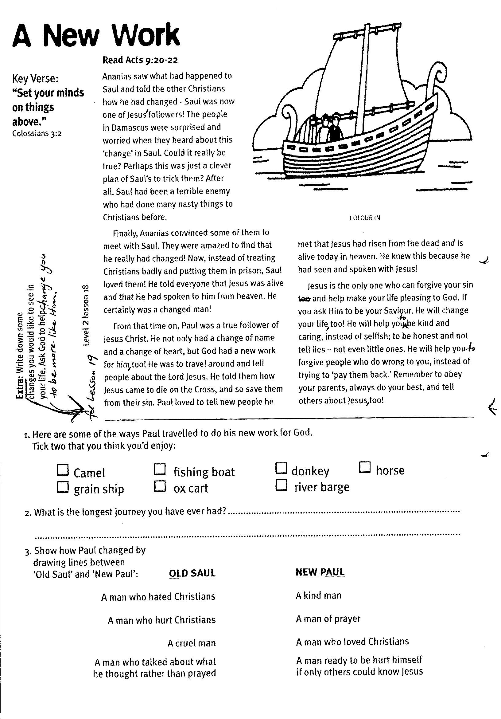

Key Verse:  
**“Set your minds on things above.”**  
Colossians 3:2

**Level 2 lesson 18**

**A New Work**

**Read Acts 9:20-22**

Ananias saw what had happened to Saul and told the other Christians how he had changed - Saul was now one of Jesus’ followers! The people in Damascus were surprised and worried when they heard about this ‘change’ in Saul. Could it really be true? Perhaps this was just a clever plan of Saul’s to trick them? After all, Saul had been a terrible enemy who had done many nasty things to Christians before.

Finally, Ananias convinced some of them to meet with Saul. They were amazed to find that he really had changed! Now, instead of treating Christians badly and putting them in prison, Saul loved them! He told everyone that Jesus was alive and that He had spoken to him from Heaven. He certainly was a changed man!

From that time on, Paul was a true follower of Jesus Christ. He not only had a change of name and a change of heart, but God had a new work for him, too! He was to travel around and tell people about the Lord Jesus.

He told them how Jesus came to die on the cross, and so save them from their sin. Paul loved to tell new people he met that Jesus had risen from the dead and is alive today in Heaven. He knew this because he had seen and spoken with Jesus!

Jesus is the only one who can forgive your sin and help make your life pleasing to God. If you ask Him to be your Saviour, He will change your life, too!  
He will help you to be kind and caring, instead of selfish; to be honest and not tell lies – not even little ones. He will help you to forgive people who do wrong to you, instead of trying to ‘pay them back.’ Remember to obey your parents, always do your best, and tell others about Jesus, too!

NEW PAUL

A kind man

A man of prayer

A man who loved Christians

A man ready to be hurt himself   
if only others could know Jesus

OLD SAUL

A man who hated Christians

A man who hurt Christians

A cruel man

A man who talked about what he thought rather than prayed

3. Show how Paul changed by drawing lines between ‘Old Saul’ and ‘New Paul’:

2. What is the longest journey you have ever had? ___________________________________

____________________________________________________________________________

1. Here are some of the ways Paul travelled to do his new work for God.  
Tick two that you think you’d enjoy:

⃝ camel ⃝ fishing boat ⃝ donkey ⃝ horse

⃝ grain ship ⃝ ox cart ⃝ river barge

**Extra:** Why do you think people were surprised at the change in Paul?

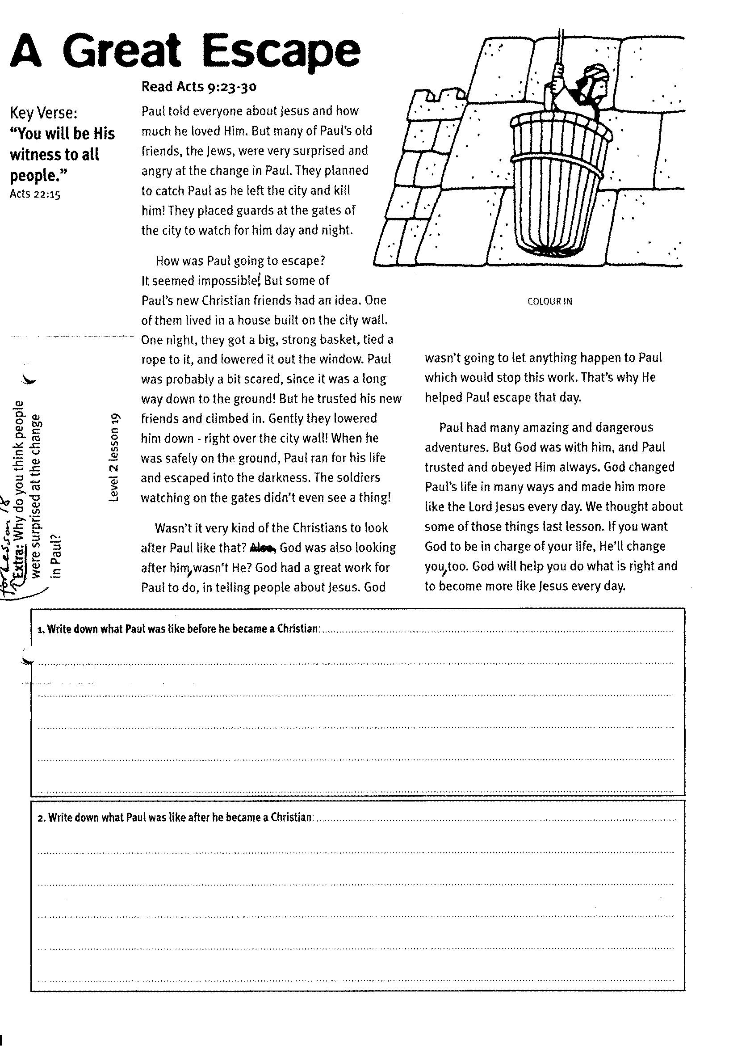

**Read Acts 9:23-30**

Paul told everyone about Jesus and how much he loved Him. But many of Paul’s old friends, the Jews, were very surprised and angry at the change in Paul. They planned to catch Paul as he left the city and kill him! They placed guards at the gates of the city to watch for him day and night.

How was Paul going to escape? It seemed impossible! But some of Paul’s new Christian friends had an idea. One of them lived in a house built on the city wall. One night, they got a big, strong basket, tied a rope to it, and lowered it out the window. Paul was probably a bit scared, since it was a long way down to the ground! But he trusted his new friends and climbed in. Gently they lowered him down - right over the city wall! When he was safely on the ground, Paul ran for his life and escaped into the darkness. The soldiers watching on the gates didn’t even see a thing!

Wasn’t it very kind of the Christians to look after Paul like that? God was also looking after him, wasn’t He?

Key Verse:  
**“You will be His witness to all people.”**  
Acts 22:15

**A Great Escape**

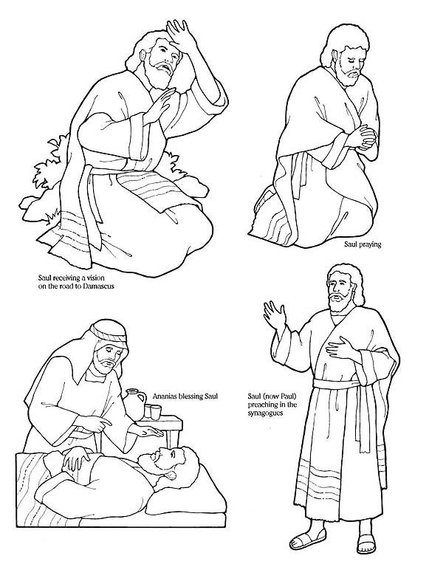

God had a great work for Paul to do, in telling people about Jesus. God wasn’t going to let anything happen to Paul which would stop this work. That’s why He helped Paul escape that day.

Paul had many amazing and dangerous adventures. But God was with him, and Paul trusted and obeyed Him always. God changed Paul’s life in many ways and made him more like the Lord Jesus every day. We thought about some of those things last lesson. If you want God to be in charge of your life, He’ll change you too. God will help you do what is right and to become more like Jesus every day.

1. Write down what Paul was like before he became a Christian:

_____________________________________________________________________

_____________________________________________________________________

_____________________________________________________________________

_____________________________________________________________________

**Extra:** Write down some changes you would like to see in your life. Ask God to help change you to be more like Him.

2. Write down what Paul was like after he became a Christian:

_________________________________________________________________

______________________________________________________________

________________________________________________________________

________________________________________________________________________

______________________________________________________________________________

**Level 2 lesson 19**

COLOUR IN

So Paul and Barnabas went by boat to an island called Cyprus. When they got there, they obeyed God and told all the people about Jesus.

One of the people they met was a magician (or sorcerer) who worked for the Roman governor. His name was Elymas. The governor was very keen to meet Paul and Barnabas and to hear what he had to say about Jesus. But Elymas tried to stop him from believing in the Lord Jesus. Paul told the magician that he was doing wrong and that God would make him blind for a while. At once Elymas became blind and had to ask someone to lead him around by the hand!

The governor was amazed when he saw what happened. He made the right choice and believed in Jesus straight away! The Lord Jesus wants people everywhere to know about Him and believe in Him. Paul is a good example for us of what makes a great missionary. He gave his life to praying, obeying God, and telling others about Jesus and the salvation He offers. Who could YOU tell about Jesus and their need to be saved?

**Read Acts 13: 1-12**

After Paul had escaped from Damascus in the basket, he hurried to Jerusalem. But at first, the Christians there were still scared of him. Like the Christians in Damascus, they weren’t sure that God had really changed him.

However, one Christian man, named Barnabas, was caring and helpful. He became Paul’s special friend. He told the others, “Paul has seen the Lord on the road to Damascus. The Lord has spoken to him and really changed him. He has preached boldly in the name of the Lord Jesus.”

If we trust in the Lord Jesus, like Paul did, Jesus will help us to be forgiving and kind, instead of being angry and full of hatred. As we read God’s Word, the Bible, and pray to God each day; He will fill our lives with His joy and peace, and a love for others.

God wanted Paul and Barnabas to travel around telling other people about the Good News that Jesus died to save them. This is what it means to be a missionary. Therefore, you too can be a missionary by telling your friends about Jesus (and even the kids you don’t know so well)!

Key Verse:  
**“I will be with you always.”**  
Matthew 28:20

**Givers of the Good News**

1003

Please complete and return by post to   
**PSSM Bible Discovery, 5/399 New North Road, Kingsland, Auckland 1021**   
or scan & email to **info@biblediscovery.org.nz**

**Extra:** How can you be a missionary right where you are today?

⃝ A missionary is someone who travels to other countries to enjoy the scenery

⃝ Saul travelled with Barnabas to tell people about Jesus

⃝ Paul was a great missionary

1. Tick the correct answers:

⃝ The Christians in Jerusalem were pleased to see Paul

⃝ Barnabas was caring and helpful

2. When we trust the Lord Jesus we should become:

____________________________________

____________________________________

____________________________________

**Level 2 lesson 20**