Key Verse:
“In all your ways acknowledge Him and He will make your paths straight.”
Proverbs 3:6
A Bride for Isaac

Read Genesis 24:1-4; 10-51
and Matthew 19:4-6
Abraham was a very rich and great man, but after his wife Sarah died, he realised that his son Isaac was very lonely. Isaac had no brothers or sisters - and now his mother was gone, too. In those days it was usually the parents who chose the marriage partners for their children. Abraham wanted his son to marry a young woman who worshipped the true God, not one who worshipped idols of wood and stone. This would be a big help for Isaac as he would one day live in the Promised Land and be surrounded by pagan, idol worshippers.
So one day, Abraham called his most trusted servant, Eliezer, and told him what he wanted him to do. He was to find a wife for Isaac from Abraham’s own relatives in the land of Mesopotamia (an area known today as Iraq). This was no small task! It would mean a 700 kilometre trip through the desert, and lots of preparation. Finally, all was ready and Eliezer set off, taking 10 camels, servants, treasures of silver and gold, and enough food and provisions for the long trip. How exciting it must have been!
Some weeks later, the long journey was over when the travellers arrived at the town of Nahor and stopped at the well to drink and rest. The first part of Eliezer’s job was over; but how was he to find the right girl for Isaac? Being brought up in Abraham’s home, Eliezer had come to trust in God, as his master Abraham did. He knew that towards evening, the young women usually came to draw water for their households. So he prayed. He asked God that the young woman who gave him a drink of water and then offered to give water to the camels also, would be the one that God had chosen as a bride for Isaac.
Key Verse:
“In all your ways acknowledge Him and He will make your paths straight.”
Proverbs 3:6

1. Why did Abraham’s servant go to Haran?
2. What did the servant do when he came to the well?
3. What did Eliezer ask of God?
4. Why were Rebekah’s parents willing for her to go?
5. What took place in Laban’s house before everyone began to eat?
Level 4 lesson 17
Level 3 lesson 1
Extra: Look in the Bible and find some evidence of God answering prayer.
QUESTIONS & ANSWERS
(Read this prayer in verses 12 to 14 of our reading).
So does God answer prayer? Yes, He most definitely does! Before Eliezer had finished praying, a beautiful girl came down carrying her jar to fill it with water at the well. He ran to meet her and asked her for a drink. What would she say? Was this Isaac’s future bride? Eliezer didn’t have to wait long to find out; she immediately offered him (a complete stranger) a drink, and then offered to draw water for his thirsty camels as well!
Eliezer knew straightaway that God had answered his prayer! This beautiful, kind girl was to be Isaac’s wife! Her name was Rebekah. Eliezer gave her some lovely presents of gold and asked her if it was possible for the group to stay with her family. She assured him this was fine, and hurried home to tell and ask her family. Before long, Rebekah returned to the well with her brother Laban. He welcomed Eliezer to their home and prepared him a wonderful meal.
However, Eliezer wouldn’t eat until he’d told them all why he had come, and how God had led him to their home. As they listened, they saw that God had truly led him and brought about the meeting. So the family agreed for Rebekah to become Isaac’s wife and to go with Eliezer. How glad he was that God had guided and directed him to Rebekah’s home. Once again, he worshipped and gave thanks to God. How true it is that “the steps of a good man are ordered by the Lord!”
The Right Start
My Name is ……………………………………………………………………… Age ………………….
Key Verse:
“Jesus said, ‘I tell you the truth, unless a man is born again, he cannot see the kingdom of God.’”
John 3:3
Level 4 Lesson 17
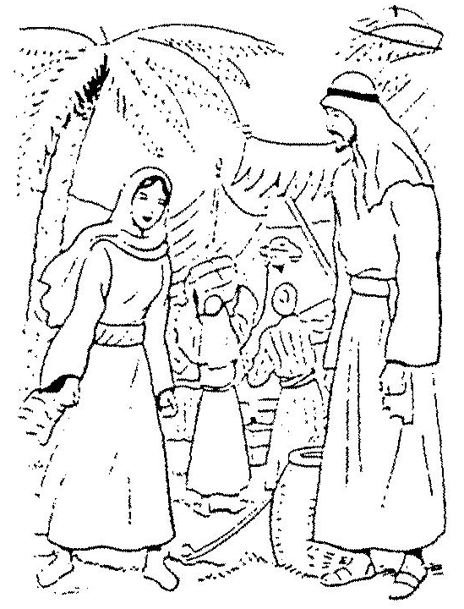
A Great Decision
Key Verse:
“If anyone would come after Me, he must deny himself, and take up his cross and follow Me.”
Mark 8:34
Read Genesis 24:52-67
and Proverbs 31:10-31
When Eliezer had finished giving thanks to God, he opened his bags and brought out the beautiful gifts that Isaac had sent with him. There were jewels of silver and gold, and beautiful clothes. How Rebekah’s eyes must have sparkled as the servant handed her these beautiful things! Then there were presents for her mother and father and also for her brother Laban. At last all the presents had been given out and they all sat down to eat. It was probably quite late when they all went to bed that night; I wonder what Rebekah was thinking as she went off to sleep.
The next morning, Eliezer was up early and told Laban that he wanted to leave straight away. “But,” said Laban, “this is a bit sudden, isn’t it? Can’t you stay for ten days and then take our sister away?” “No,” said Eliezer. “Don’t stop me now. The Lord has prospered my way and I must return at once!” Things were no doubt a bit tense for a few moments, but after the family had talked the matter over, it was decided to call Rebekah and leave the decision with her. So Rebekah was called and in front of everyone was asked, “Will you go with this man?”
Everyone was silent. What would the answer be? Was it going to be too much for Rebekah? Or was she so thrilled with all she’d heard about Isaac that she would decide to go and be his bride? God’s involvement in all of this was clearly evident in Rebekah’s answer. “I will go!” she said firmly. So gathering all her belongings and taking her servant with her, Rebekah went with Eliezer to meet Isaac, her future husband.
When the time comes, make sure God is involved in your marriage too. Pray even now, that God would prepare you for each other and guide you together. Believe me, He does!
1. Eliezer said the Lord prospered his way. What did he mean?
2. What great question did Rebekah have to answer? Find the vowels and write this sentence correctly. | W__ ll y __ __ g __ w __th th __ s m__n?
3. Once Isaac had married Rebekah, how did this help him?
4. What has the Lord Jesus done for us?

5. What is the greatest and best decision anyone can make?
Level 4 lesson 18
Extra: What guided Rebekah in making her choice?
QUESTIONS & ANSWERS
After a long journey they arrived at Isaac’s home. What joy must have filled Rebekah’s heart when she met Isaac, the man she had heard so much about! They were married and we read that “Isaac loved her and was comforted after his mother’s death.” I’m sure Rebekah never regretted her decision – “I will go!”
In a similar way, God wants us to love His only Son Jesus Christ. He has given us His Word the Bible, and sent His Holy Spirit into the world so that we might know how wonderful He is. Although we cannot see Jesus, we can read of how He loved us by dying and suffering on the cross for our sins. Have you ever felt you wanted to know Him as your own loving Saviour? Have you ever felt a desire to turn from sin and live for Him?
Perhaps you have been tempted by thoughts like, “Just wait a while” or “Leave it till tomorrow - or perhaps next week.” But NOW is the time to choose! God blessed Rebekah for her wise decision to go to Isaac. You too, can know God’s blessings of sin forgiven and eternal life received. Respond to the love of God by saying, “Yes, Lord Jesus, I will trust you and follow you.” To repent of your sin and believe in Jesus Christ to save you is the greatest and best decision you will ever make!

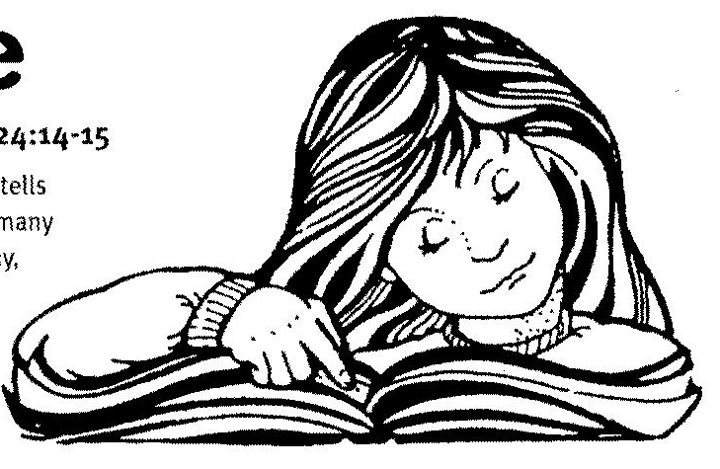
Making a Choice
Key Verse:
“But seek first His (God’s) kingdom and His righteousness: and all these things will be given to you as well.”
Matthew 6:33
Read Genesis 25:27-34
and Joshua 24:14-15

As we mentioned earlier, the Book of Genesis tells us about the beginning of things and we find many things mentioned for the first time there. Today, as we continue studying the life of Isaac and Rebekah, we come to a wonderful story. Like his mother Sarah, Isaac’s wife Rebekah was barren and couldn’t have children. Isaac “prayed to God on her behalf” and the Lord graciously answered his prayer. Before long she was pregnant, and not only that, it was twins!
When they were born it was soon obvious they were not ‘identical twins.’ In fact, they were like ‘chalk and cheese!’ The first born was reddish coloured and hairy; he was named Esau. The second was pale and smooth-skinned and was named Jacob. As they grew up, they proved different in nature, too. Esau was an ‘outdoors man’ who loved hunting with his bow and arrow. Jacob, on the other hand, was quiet and liked to be at home. Isaac loved Esau the best, while Jacob became his mother’s favourite. By the way, it is not wise for parents to have ‘favourites’ in this way, because each child needs the love of both parents equally. This story certainly shows the trouble and strife that favouritism can cause within a family.
In those days the oldest son in the family had a special right that none of the other children had. It was called ‘the birthright.’ This meant he became the head of the family when the father died and would receive most of the father’s property also. In this case, the birthright meant even more than normal. Now the blessing of God, given originally to Abraham, would belong to Isaac, and he would in turn pass it on to his son Esau.
1. What sort of man did Esau grow up to be?
2. How was Jacob different to Esau?
3. Name one of the blessings of “the birthright.”
4. What do you think of Esau’s choice?
5. What great blessings does Jesus offer to us?
Extra: List some of the blessings of God available to us today.
Level 4 lesson 19
QUESTIONS & ANSWERS
Not only would this son receive most of Isaac’s property, but he would be the father of a great nation. And from this nation would come the Saviour who would bring God’s blessing to all nations! Strangely, Esau, was not really interested the birthright. He didn’t seem to value God’s blessing at all. But Jacob did!
One day Esau came in from hunting and he was hungry; so hungry, that as the saying goes, he could have ‘eaten a horse and chased the rider!’ When he smelt what Jacob was cooking, he just HAD to have some! Jacob immediately saw an opportunity and cunningly suggested Esau exchange his birthright for some of the stew. Foolishly, Esau agreed. He didn’t care too much about God’s promises at the time, and the bargain was made. He ate all he wanted and was satisfied. It was only afterwards, that he realised he’d done a really stupid thing - but then it was all too late!
Don’t ever refuse, or lose your appreciation for the great blessings that God has for you, and which are written about in the Bible. It is a wonderful thing just to be able to read the Bible in a language you understand. Men of God have died to give you that privilege! READ IT! KNOW IT! OBEY IT! You have been privileged to hear the story of the Saviour’s love. He offers you ETERNAL LIFE, FORGIVENESS OF SIN, AND A HOME IN HEAVEN. Don’t despise these things! Accept Jesus Christ as Saviour today. I have met many, many people who have done that - but I have never met anyone who was sorry about it!
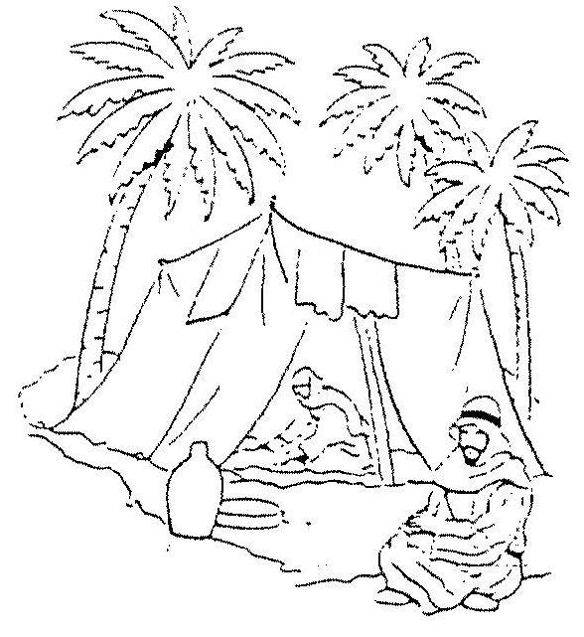
Read Genesis 27
and Hebrews 12:14-17
Have you ever made a bad decision, or done something you really regretted later? Esau foolishly traded his ‘birthright’ for some of Jacob’s soup and boy, did he regret it! Today, we’re going to see how that decision affected Jacob, Esau, and the whole family. [Make sure you read the story in Genesis 27]. Isaac, by this time, was old and blind. He knew his life was almost over and so it was time to pass on his blessings to Esau. Isaac asked him to go and catch a wild animal and prepare his favourite meal for him. He wanted to enjoy it once more before passing on his blessing.
Rebekah overheard the conversation and decided she must act quickly to prevent Esau receiving the birthright. So she devised a plan to deceive Isaac. Calling Jacob, she told him he must pretend to be Esau and take his father a meal of his favourite wild meat. Jacob knew his father would recognise him, and was scared Isaac would curse him for his deceitfulness, rather than bless him. However, Rebekah had thought of a way around that! She disguised Jacob in Esau’s clothes, put goatskins on his arms and sent him into Isaac with the meal. Isaac was not sure it was Esau initially. However, finally convinced by the earthy smell of Esau’s clothing, he gave his blessing to Jacob.
Jacob was barely outside when Esau returned! When Esau heard that his brother had received the blessing he was terribly upset. In tears, he pleaded with his father to bless him in some way - but it was too late! Esau remembered clearly the day he had thought so little of God’s blessing and given it away for a plate or two of soup - and all the tears in the world would not help now! Later, when Esau’s disappointment subsided, fierce anger filled his heart. He threatened to kill Jacob for what he’d done! Jacob heard of his plans and knew he must run for his life, so sadly, he packed a few belongings and left home – never to see his mother again.

Deceit Ruins a Happy Home
Key Verse:
“Jesus said, ‘I am the gate; whoever enters through Me will be saved. He will come in and go out, and find pasture’.”
John 10:9
1. What did Esau really regret?
2. In what ways did Rebekah act like Sarah, her mother-in-law?
3. Why did Jacob leave home?
4. What is the most important thing you have learnt from this story?
5. What are some things can you ask God to help you with?
Extra: What was the real cause of this family trouble?
Level 4 lesson 20
QUESTIONS & ANSWERS
Key Verse:
“Jesus said, ‘I am the gate; whoever enters through Me will be saved. He will come in and go out, and find pasture.”
John 10:9
What a sad story! It is always sad to read of anything that breaks up a family and causes such disharmony. But there are some important lessons we can learn from it. Firstly, sin ALWAYS has consequences! Remember the Lord’s promise to Rebekah in Genesis 25:23? It was God’s will that Jacob receive the blessing all along; how sad then, that like her mother-in-law Sarah, Rebekah tried to ‘make it happen,’ instead of waiting in faith for God to act in His own time and way. And how sad that Jacob, should stoop to such deceit – even lying directly to his own father! Later, we read of the consequences Jacob had to deal with as a result. He learnt a very harsh lesson himself of what it meant to be deceived!
Friend, have you ever deceived anyone? Have you told lies to family and friends? Stop now! There is an old saying that goes like this, “Oh what a tangled web we weave, when we first start to deceive!” It’s true! Like Jacob, our lies and deceit will catch up with us and there will be a price to pay. Confess your sins and ask God to cleanse your heart and help you OVERCOME every temptation. Pray that you will become a person of integrity, honesty, and truth in all you do and say.
Please complete and return by post to
PSSM Bible Discovery, 5/399 New North Road, Kingsland, Auckland 1021 or scan & email to info@biblediscovery.org.nz

Level 4 Lesson 20
Extra: What was the real cause of this family trouble?

