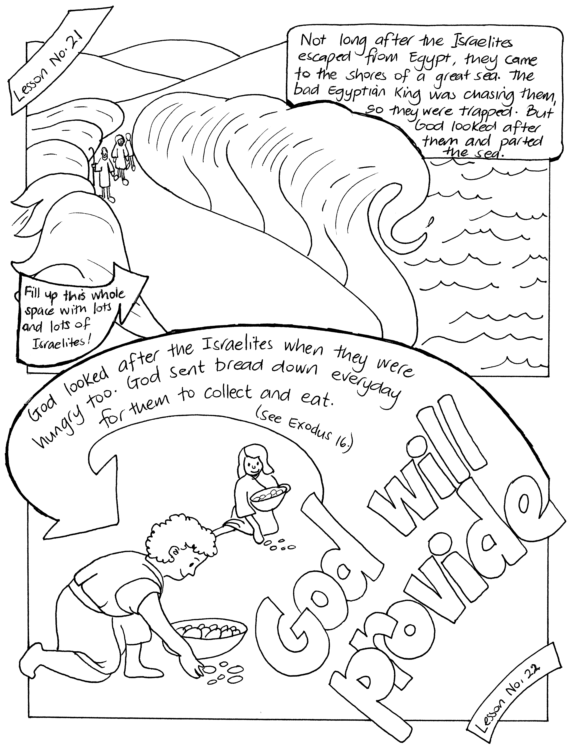
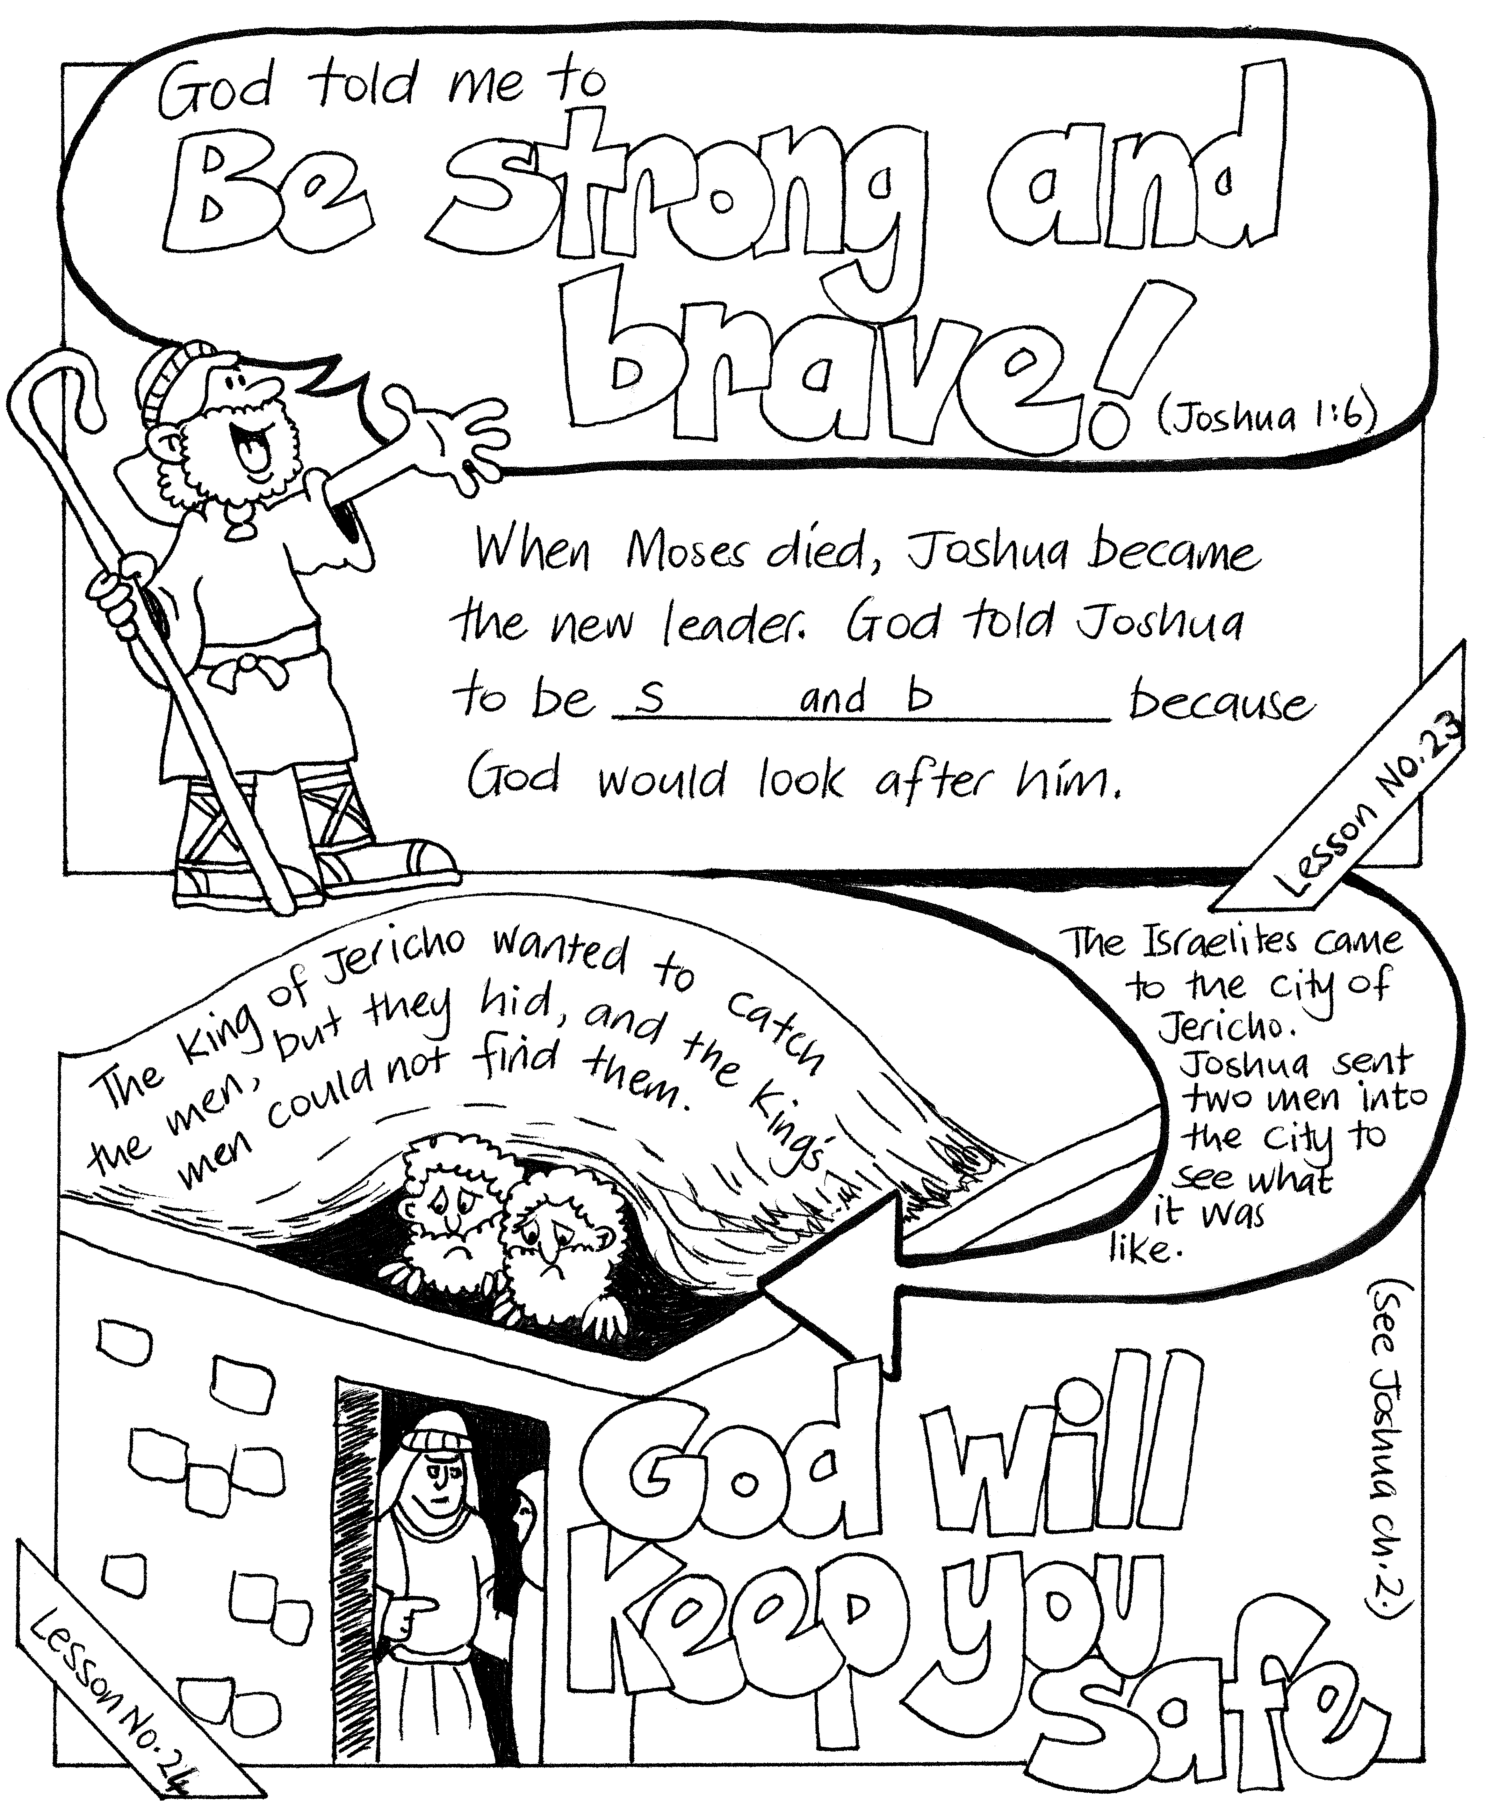

Please complete and return by post to
PSSM Bible Discovery, 5/399 New North Road, Kingsland, Auckland 1021
or scan & email to info@biblediscovery.org.nz

