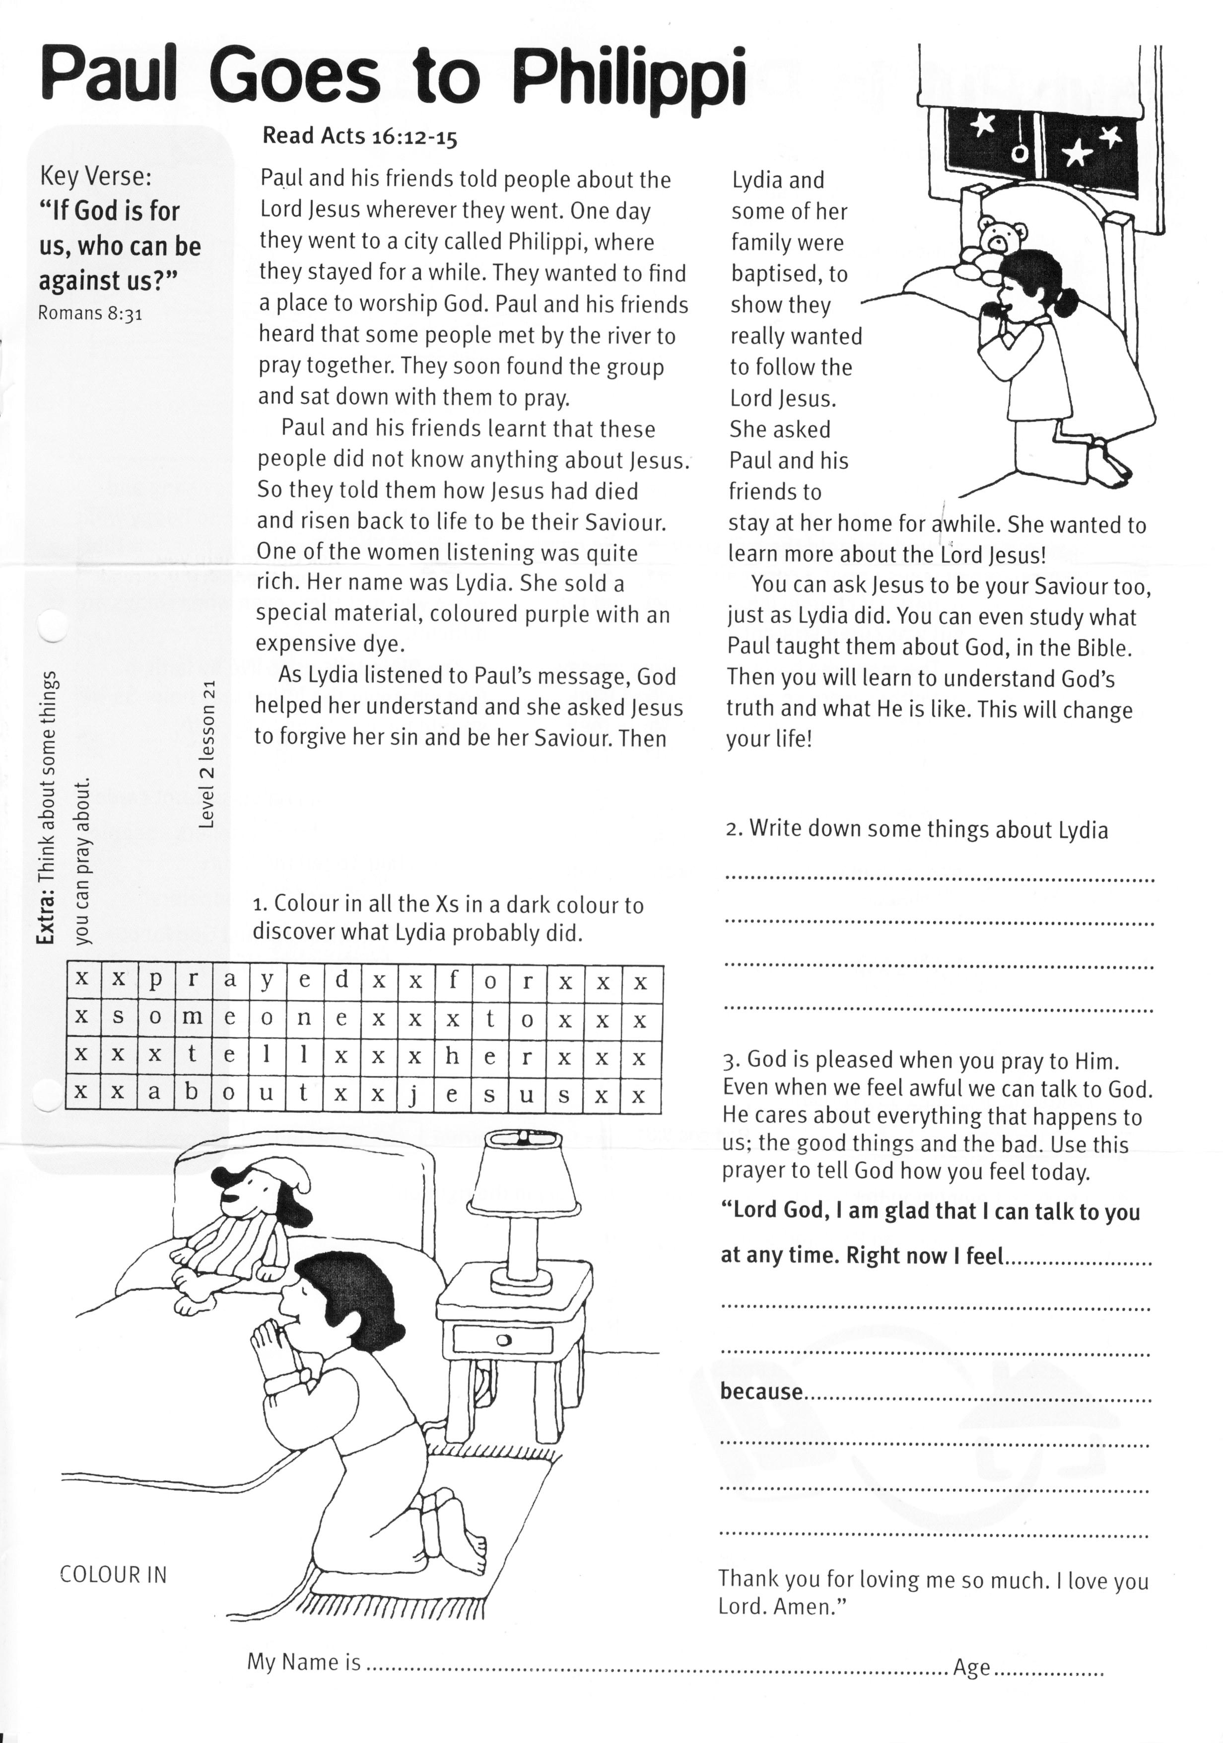

**Paul Goes to Philippi**

Key Verse:  
**“If God is for us, who can be against us?”**Romans 8:31b

**Extra:** What are some things you can pray about?

**Level 2 lesson 21**

**Read Acts 16:12-15**

Paul and his friends told people about the Lord Jesus wherever they went. One day they went to a city called Philippi, where they stayed for a while. They wanted to find a place to worship God. Paul and his friends heard that some people met by the river to pray together. They soon found the group and sat down with them to pray.

Paul and his friends learnt that these people did not know anything about Jesus. So they told them how Jesus had died and risen back to life to be their Saviour. One of the women listening was quite rich. Her name was Lydia. She sold a special material, coloured purple with an expensive dye.

As Lydia listened to Paul’s message, God helped her understand and she asked Jesus to forgive her sin and be her Saviour.

Then Lydia and some of her family were baptised, to show they really wanted to follow the Lord Jesus. She asked Paul and his friends to stay at her home for a while. She wanted to learn more about the Lord Jesus!

You can ask Jesus to be your Saviour too, just as Lydia did. You can even study what Paul taught them about God, in the Bible. Then you will learn to understand God’s truth and what He is like. This will change your life!

|  |  |  |  |  |  |  |  |  |  |  |  |  |  |  |  |
| --- | --- | --- | --- | --- | --- | --- | --- | --- | --- | --- | --- | --- | --- | --- | --- |
| X | X | P | R | A | Y | E | D | X | X | F | O | R | X | X | X |
| X | S | O | M | E | O | N | E | X | X | X | T | O | X | X | X |
| X | X | X | T | E | L | L | X | X | X | H | E | R | X | X | X |
| X | X | A | B | O | U | T | X | X | J | E | S | U | S | X | X |



**“Lord God, I am glad that I can talk to you at any time. Right**

**now I feel** __________________________________________

___________________________________________________

___________________________________________________

**Because** ____________________________________________

___________________________________________________

___________________________________________________**Thank you for loving me so much. I love you Lord. Amen.”**

**2. Write down some things about Lydia:**___________________________________________________________________

___________________________________________________________________

**3. God is pleased when you pray to Him.** Even when we feel awful, we can talk to God. He cares about everything that happens to us; the good things and the bad. Use this prayer to tell God how you feel today:

**“Lord God, I**

**1. Colour in all the Xs in a dark colour to discover what Lydia probably did.**

My Name is ……………………………………………………………………… Age……………

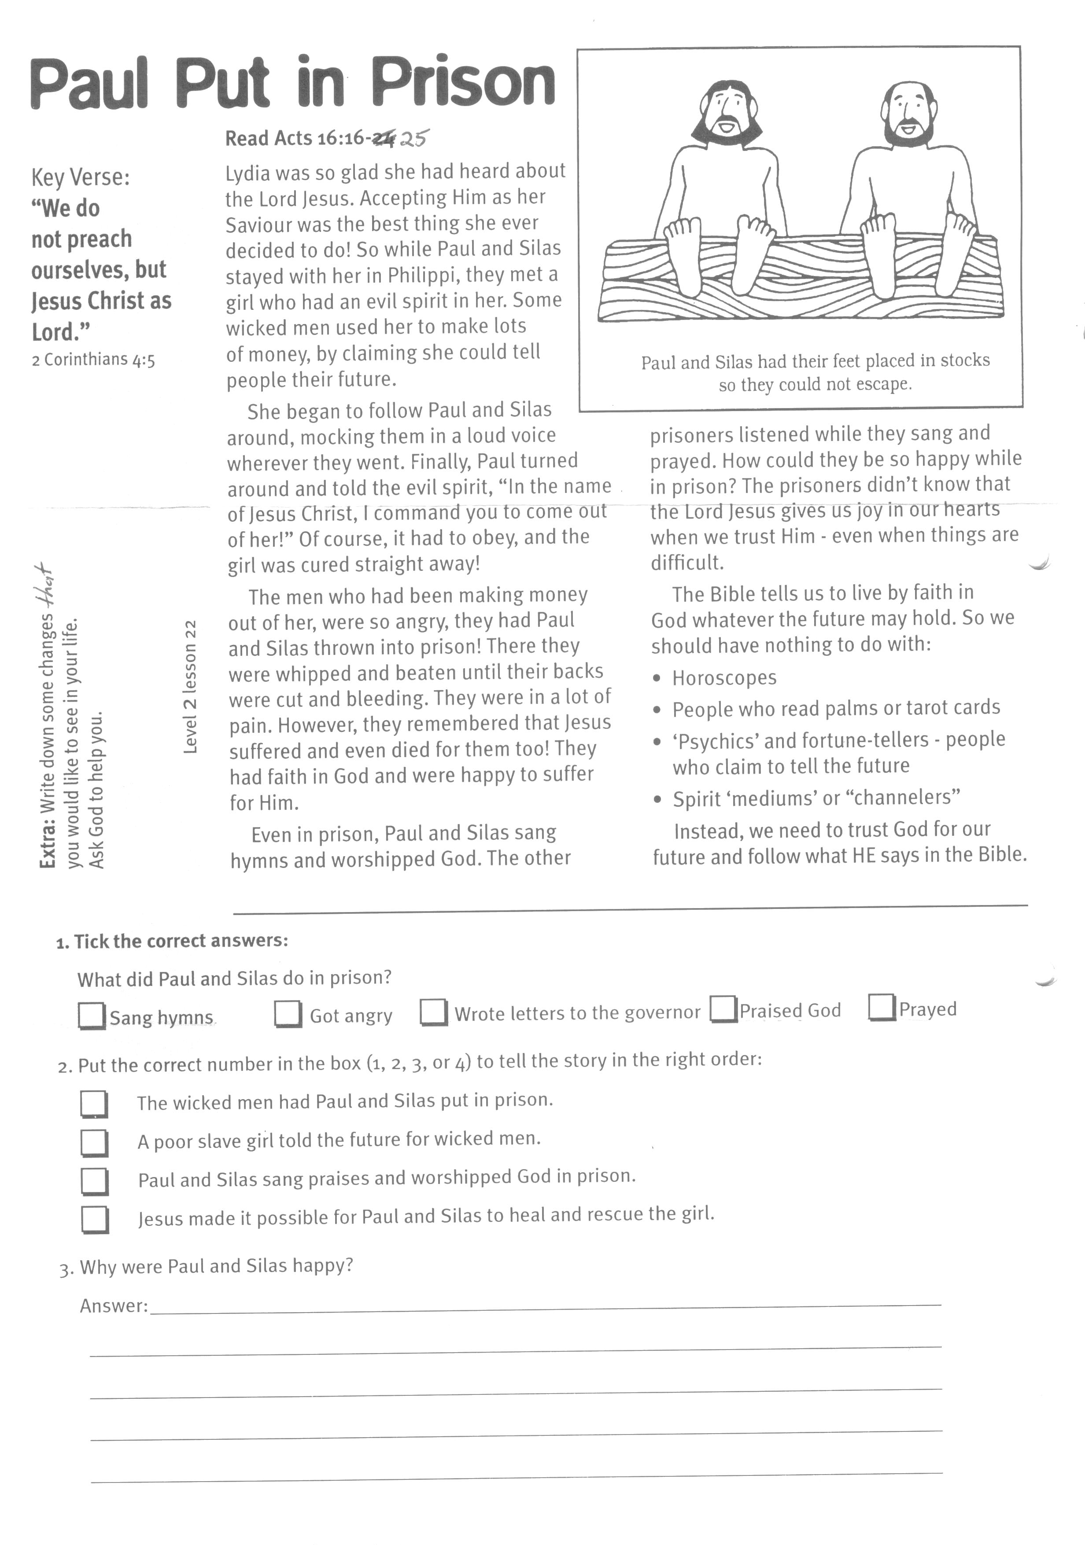

Key Verse:  
**“We do not preach ourselves, but Jesus Christ as Lord.”**  
2 Corinthians 4:5

**Read Acts 16:16-25**

Lydia was so glad she had heard about the Lord Jesus. Accepting Him as her Saviour was the best thing she ever decided to do! So while Paul and Silas stayed with her in Philippi, they met a girl who had an evil spirit in her. Some wicked men used her to make lots of money, by claiming she could tell people their future.

She began to follow Paul and Silas around, mocking them in a loud voice wherever they went. Finally, Paul turned around and told the evil spirit, “In the name of Jesus Christ, I command you to come out of her!” Of course, it had to obey, and the girl was cured straight away!

The men who had been making money out of her, were so angry, they had Paul and Silas thrown into prison! There they were whipped and beaten until their backs were cut and bleeding. They were in a lot of pain. However, they remembered that Jesus suffered and even died for them too! They had faith in God and were happy to suffer for Him.

**Level 2 lesson 22**

**Paul Put in Prison**

**Extra:** Write down some changes that you would like to see in your life. Ask God to help you.

**2. Put the correct number in the space** (1, 2, 3, or 4) **to tell the story in the right order:**

__ The wicked men had Paul and Silas put in prison.  
__ A poor slave girl told the future for wicked men.  
__ Paul and Silas sang praises and worshipped God in prison.  
__ Jesus made it possible for Paul and Silas to heal and rescue the girl.

**3. Why were Paul and Silas happy?**

Answer: ________________________________________________________________________________

_______________________________________________________________________________________

_______________________________________________________________________________________

**1. What did Paul and Silas do in prison?** (tick the correct answers)

⃝ Sang hymns ⃝ Got angry ⃝ Wrote letters to the governor

⃝ Praised God ⃝ Prayed

Even in prison, Paul and Silas sang hymns and worshipped God. The other prisoners listened while they sang and prayed. How could they be so happy while in prison? The prisoners didn’t know that the Lord Jesus gives us joy in our hearts when we trust Him - even when things are difficult.

The Bible tells us to live by faith in God whatever the future may hold. So we should have nothing to do with:

* Horoscopes
* People who read palms or tarot cards
* ‘Psychics’ and fortune-tellers - people who claim to tell the future
* Spirit ‘mediums’ or “channellers”

Instead, we need to trust God for our future and follow what HE says in the Bible.

He knew this was no ordinary earthquake! He came and fell down in front of Paul. Trembling in fear, he asked, “Men, what must I do to be saved?” Paul answered in a loud voice, “Believe in the Lord Jesus and you will be saved.”

Paul and Silas then taught the jailer and his family about Jesus. They all believed and became Christians and were baptised. The jailer was sorry for treating Paul and Silas so badly. He washed their backs, gave them food and took good care of them. That night turned out to be a special night, full of joy and happiness for them all.

If you want to be saved and have your sins forgiven, you need to believe in the Lord Jesus, too! Just like the jailer and his family did.

**Read Acts 16:25-34**

Paul and Silas kept singing and praying to God all through the night. Suddenly, about midnight, a huge earthquake shook the walls of the prison. The heavy doors were torn from their hinges and fell open. God even broke the chains that bound the prisoners. They were all free!

When the jailer woke up and saw all the doors open, he was very frightened. He knew his job was to guard those prisoners carefully. Now he thought they had all escaped! He took his sword and was going to kill himself, but Paul called out, “Don’t hurt yourself, we are all here!”

I’m sure the jailer had heard Paul and Silas preaching about the Lord Jesus, and singing praises to God.

**God Saves in a Prison!**

Key Verse:  
**“Believe in the Lord Jesus and you will be saved.”**  
Acts 16:31

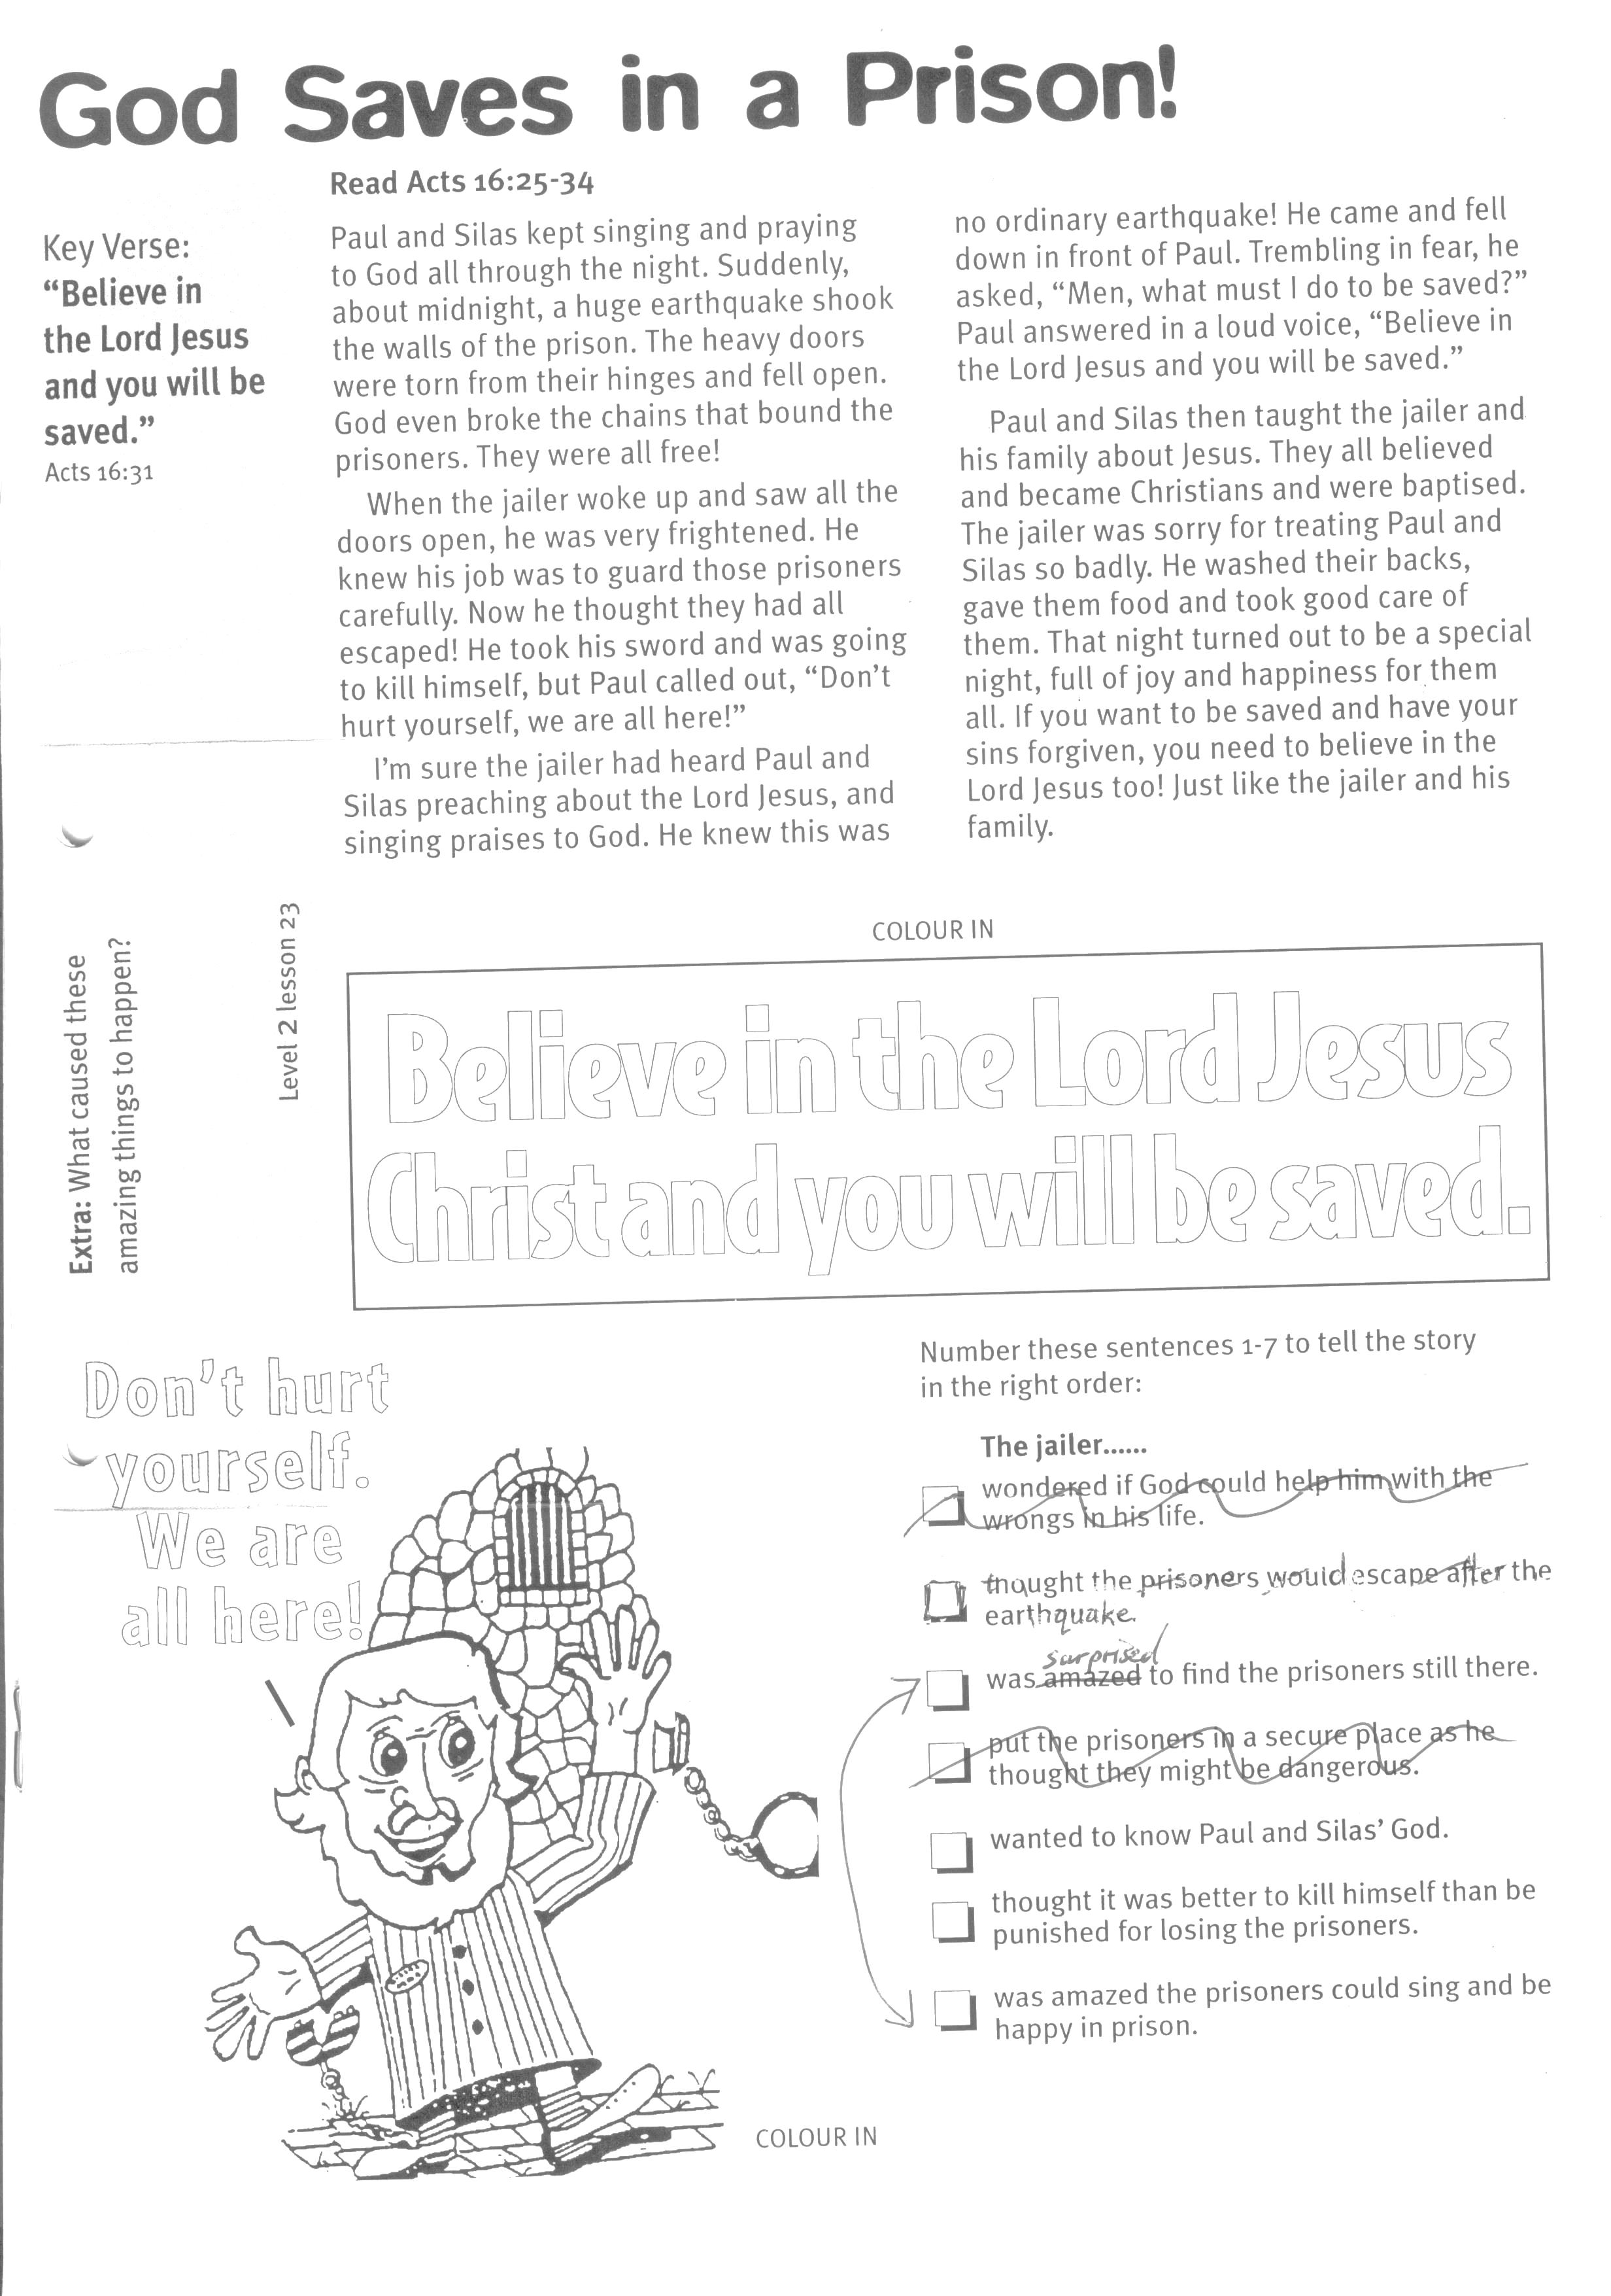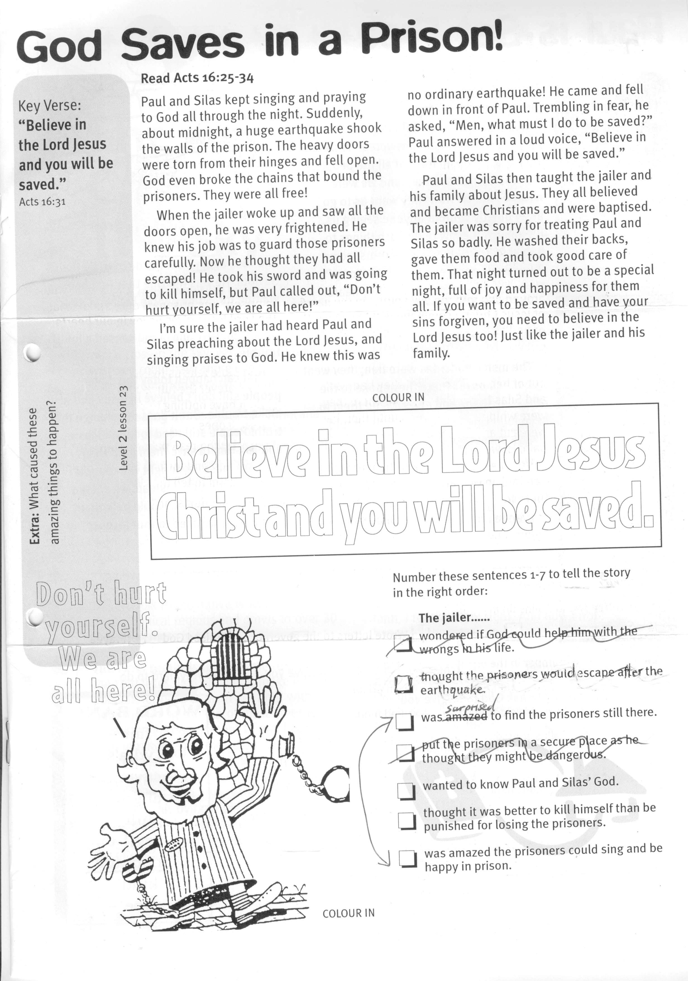

**Extra:** What caused these amazing things to happen?

**Don’t hurt yourself we are all here!**

COLOUR IN

Number these sentences 1-5 to tell the story in the right order:

**The jailer......**

….. thought the prisoners would escape after the earthquake.

….. was amazed the prisoners could sing and be happy in prison.

….. wanted to know Paul and Silas’ God.

….. thought it was better to kill himself than be punished for losing the prisoners.

….. was surprised to find the prisoners still there.

**Level 2 lesson 23**

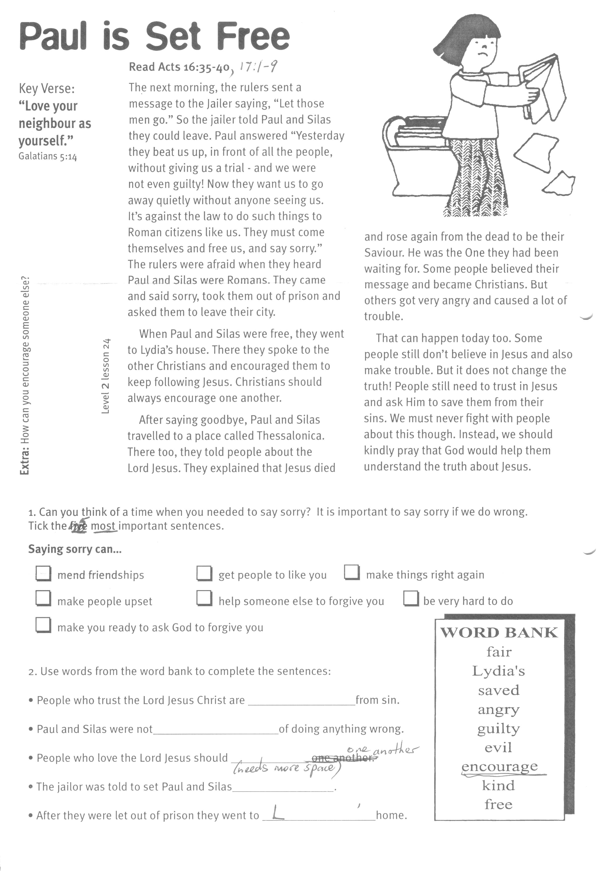

**.Read Acts 16:35-40, 17:1-9**

The next morning, the rulers sent a message to the jailer saying, “Let those men go.” So the jailer told Paul and Silas they could leave. Paul answered “Yesterday they beat us up, in front of all the people, without giving us a trial - and we were not even guilty! Now they want us to go away quietly without anyone seeing us. It’s against the law to do such things to Roman citizens like us. They must come themselves and free us, and say sorry.” The rulers were afraid when they heard Paul and Silas were Romans. They came and said sorry, took them out of prison and asked them to leave their city.

When Paul and Silas were free, they went to Lydia’s house. There they spoke to the other Christians and encouraged them to keep following Jesus. Christians should always encourage one another.

After saying goodbye, Paul and Silas travelled to a place called Thessalonica. There too, they told people about the Lord Jesus.

Key Verse:  
**“Love your neighbour as yourself.”**  
Galatians 5:14

**Paul is Set Free**

1003

**WORD BANK**  
fair free saved angry

guilty evil encourage kind Lydia’s

Please complete and return by post to   
**PSSM, 5/399 New North Road, Kingsland, Auckland, 1021**   
or scan & email to **info@biblediscovery.org.nz**

2. Use words from the word bank to complete the sentences:

* People who trust the Lord Jesus Christ are __ __ __ __ __ from sin.
* Paul and Silas were not __ __ __ __ __ __ of doing anything wrong.
* People who love the Lord Jesus should __ __ __ __ __ __ __ __ __ one another.
* The jailor was told to set Paul and Silas __ __ __ __
* After they were let out of prison they went to L __ __ __ __ ‘__ home.

1. Can you think of a time when you needed to say sorry? It is important to say sorry if we do wrong. Tick the 5 most important sentences.

**Saying sorry can......**

⃝ mend friendships ⃝ get people to like you ⃝ make things right again

⃝ make people upset ⃝ help someone else to forgive you

⃝ be very hard to do ⃝ make you ready to ask God to forgive you

They explained that Jesus died and rose again from the dead to be their Saviour. He was the One they had been waiting for. Some people believed their message and became Christians. But others got very angry and caused a lot of trouble.

That can happen today, too. Some people still don’t believe in Jesus and also make trouble. But it does not change the truth! People still need to trust in Jesus and ask Him to save them from their sins. We must never fight with people about this though. Instead, we should kindly pray that God would help them understand the truth about Jesus.

**Extra:** How can you encourage someone else?

**Level 2 lesson 24**