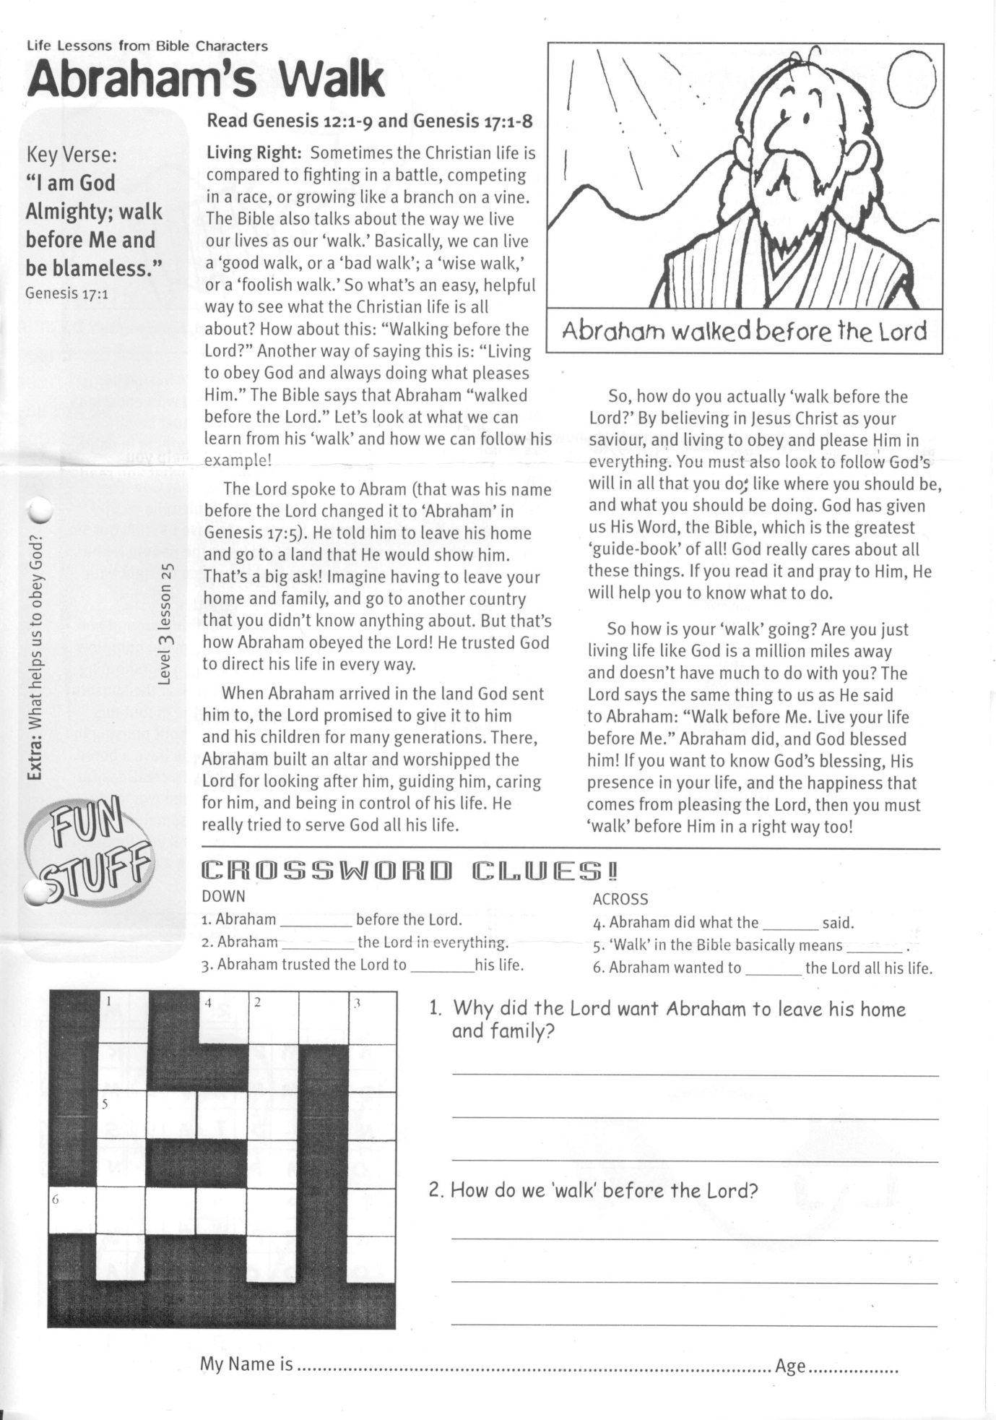

**Read Genesis 12:1-9  
and Genesis 17:1-8**

**Living Right**: Sometimes the Christian life is compared to fighting in a battle, competing in a race, or growing like a branch on a vine. The Bible also talks about the way we live our lives as our ‘walk.’ Basically, we can live a ‘good walk’, or a ‘bad walk’; a ‘wise walk,’ or a ‘foolish walk.’ So what’s an easy, helpful way to see what the Christian life is all about? How about this: “Walking before the Lord?” Another way of saying this is: “Living to obey God and always doing what pleases Him.” The Bible says that Abraham “walked before the Lord.” Let’s look at what we can learn from his ‘walk’ and how we can follow his example!

The Lord spoke to Abram (that was his name before the Lord changed it to ‘Abraham’ in Genesis 17:5). He told him to leave his home and go to a land that He would show him. That’s a big ask! Imagine having to leave your home and family, and go to another country that you didn’t know anything about. But that’s how Abraham obeyed the Lord! He trusted God to direct his life in every way.

When Abraham arrived in the land God sent him to, the Lord promised to give it to him and his children for many generations. There, Abraham built an altar and worshipped the Lord for looking after him, guiding him, caring

Key Verse:  
**“I am God Almighty; walk before Me and be blameless.”**  
Genesis 17:1

**Level 3 lesson 25**

**Abraham’s Walk**

LIFE LESSONS FROM BIBLE CHARACTERS

|  |  |  |  |  |  |  |
| --- | --- | --- | --- | --- | --- | --- |
|  | 1 |  | 4 | 2 |  | 3 |
|  |  |  |  |  |  |  |
|  | 5 |  |  |  |  |  |
|  |  |  |  |  |  |  |
| 6 |  |  |  |  |  |  |
|  |  |  |  |  |  |  |

for him, and being in control of his life. He really tried to serve God all his life.

So, how do you actually ‘walk before the Lord?’ By believing in Jesus Christ as your Saviour, and living to obey and please Him in everything. You must also look to follow God’s will in all that you do, like where you should be, and what you should be doing. God has given us His Word, the Bible, which is the greatest ‘guide-book’ of all! God really cares about all these things. If you read it and pray to Him, He will help you to know what to do.

So how is your ‘walk’ going? Are you just living life like God is a million miles away and doesn’t have much to do with you? The Lord says the same thing to us as He said to Abraham: “Walk before Me. Live your life before Me.” Abraham did, and God blessed him! If you want to know God’s blessing, His presence in your life, and the happiness that comes from pleasing the Lord, then you must ‘walk’ before Him in a right way too!

**Extra:** What helps us to obey God?

1. Why did the Lord want Abraham to leave his home and family?  
________________________________________________  
________________________________________________  
________________________________________________  
2. How do we ‘walk’ before the Lord?  
________________________________________________  
________________________________________________  
 _____________________________________

**ACROSS**

4. Abraham did what the ______ said.

5. ‘Walk’ in the Bible basically means ______ .

6. Abraham wanted to ______ the Lord all his life.

**CROSSWORD CLUES**

**DOWN**

1. Abraham ______ before the Lord.

2. Abraham ______ the Lord in everything.

3. Abraham trusted the Lord to ______ his life.

My Name is ……………………………………………………………… Age ………………….

My Name is ……………………………………………………… Age…………………



Key Verse:  
**“The heavens declare the glory of God; the skies proclaim the work of His hands.”**Psalm 19:1

**Read Psalm 8; John 4:23, 24;   
and Romans 1:18-20**

**A Worshipping Heart:** A painting in an art gallery shows the artist’s talent; a piece of music reveals the composer’s gift and shows the musician’s skill; and medals and trophies show an athlete’s strength and speed! In the same way, the universe and everything in it shows the power and greatness of God who made it all! When we look at everything around us, we should be saying, “Wow! What an awesome God we have! Look at all the incredible things He made!” This is worship. Worship is not just about going to church on Sundays ­ although that is an important part! Worship is an attitude that shows up in all that a Christian does with their life. David shows us how to always have a worshipping heart!

David was a shepherd boy before he became King over God’s people. He spent many days and nights wandering through the countryside with his sheep, looking for the best places for the flock to find grass and water. Being outside so much, David got to see the sun rise and set; he got to spend many hours gazing off to the hills and down into the valleys; and it all made him worship the Lord. In fact, David used to make up songs to praise the Lord on his harp (You can see many of those songs in the Bible by checking out the book of Psalms).

You see, for David worship wasn’t just going to the Tabernacle (a big tent that the Israelites worshipped God in) once a week.

LIFE LESSONS FROM BIBLE CHARACTERS

**David’s Worship**

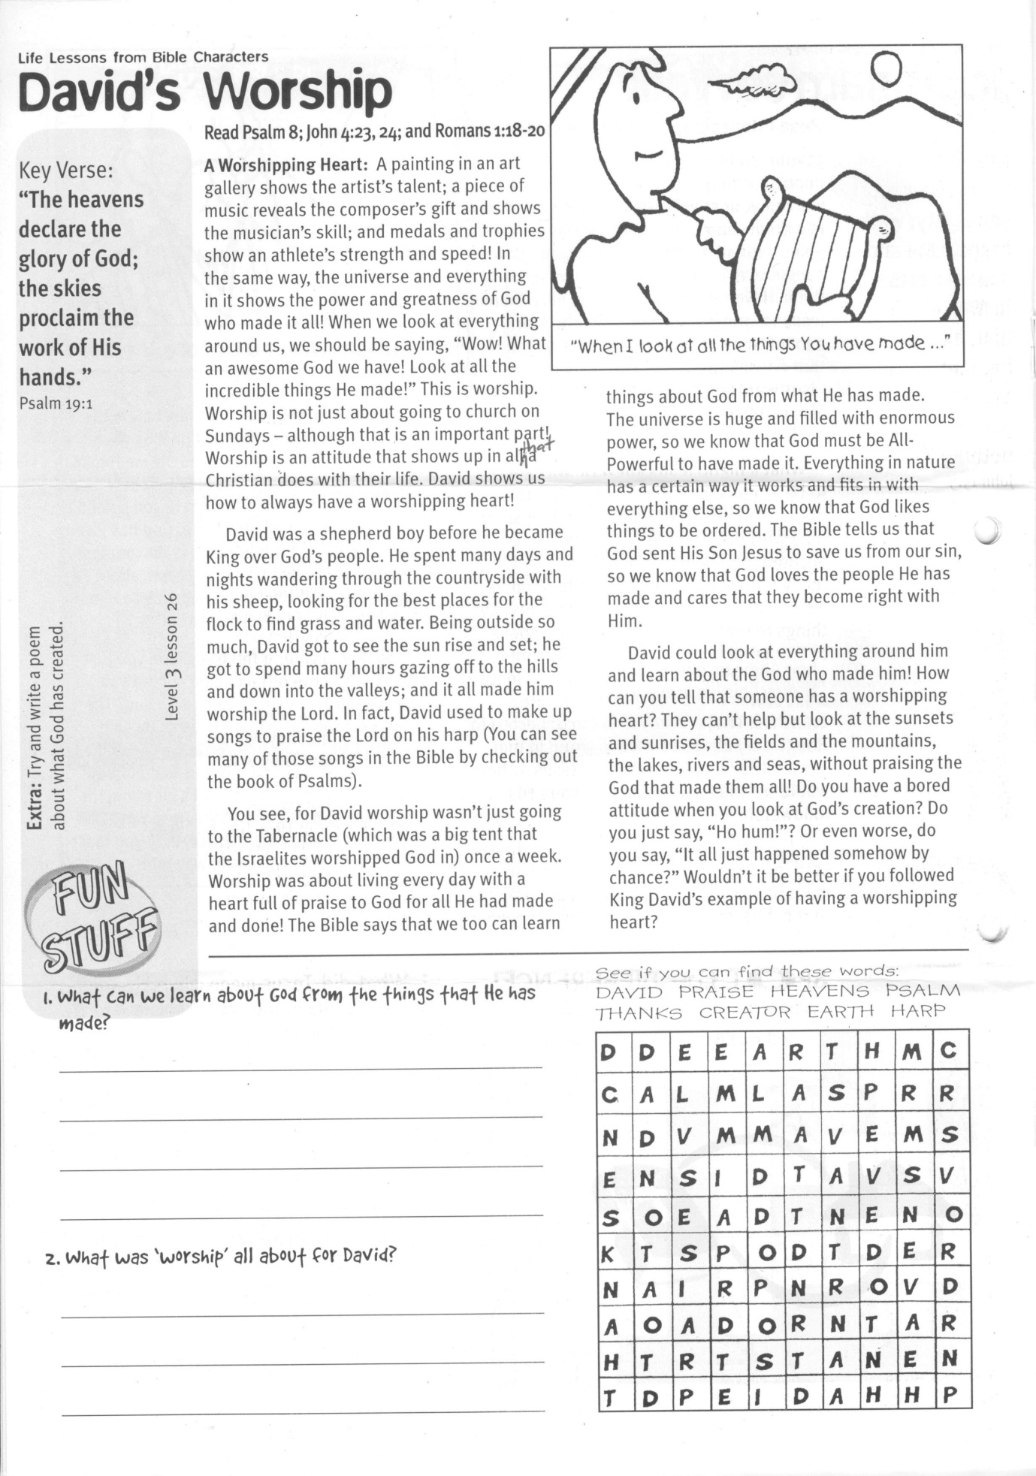

Worship was about living every day with a heart full of praise to God for all He had made and done! The Bible says that we too can learn things about God from what He has made.

The universe is huge and filled with enormous power, so we know that God must be All-Powerful to have made it. Everything in nature has a certain way it works and fits in with everything else, so we know that God likes things to be ordered. The Bible tells us that God sent His Son Jesus to save us from our sin, so we know that God loves the people He has made and cares that they become right with Him.

David could look at everything around him and learn about the God who made him! How can you tell that someone has a worshipping heart? They can’t help but look at the sunsets and sunrises, the fields and the mountains, the lakes, rivers and seas, without praising the God that made them all! Do you have a bored attitude when you look at God’s creation? Do you just say, “Ho hum!”? Or even worse, do you say, “It all just happened somehow by chance?” Wouldn’t it be better if you followed King David’s example of having a worshipping heart?

**Extra:** Try and write a poem about what God has created.

1. What can we learn about God from the   
things that He has made?  
__________________________________________________

__________________________________________________

__________________________________________________  
2. What was ‘worship’ all about for David?

_____________________________________________

_____________________________________________

_________________________________________________

**See if you can find these words:**DAVID PRAISE HEAVENS PSALM THANKS CREATOR EARTH HARP

**Level 3 lesson 26**

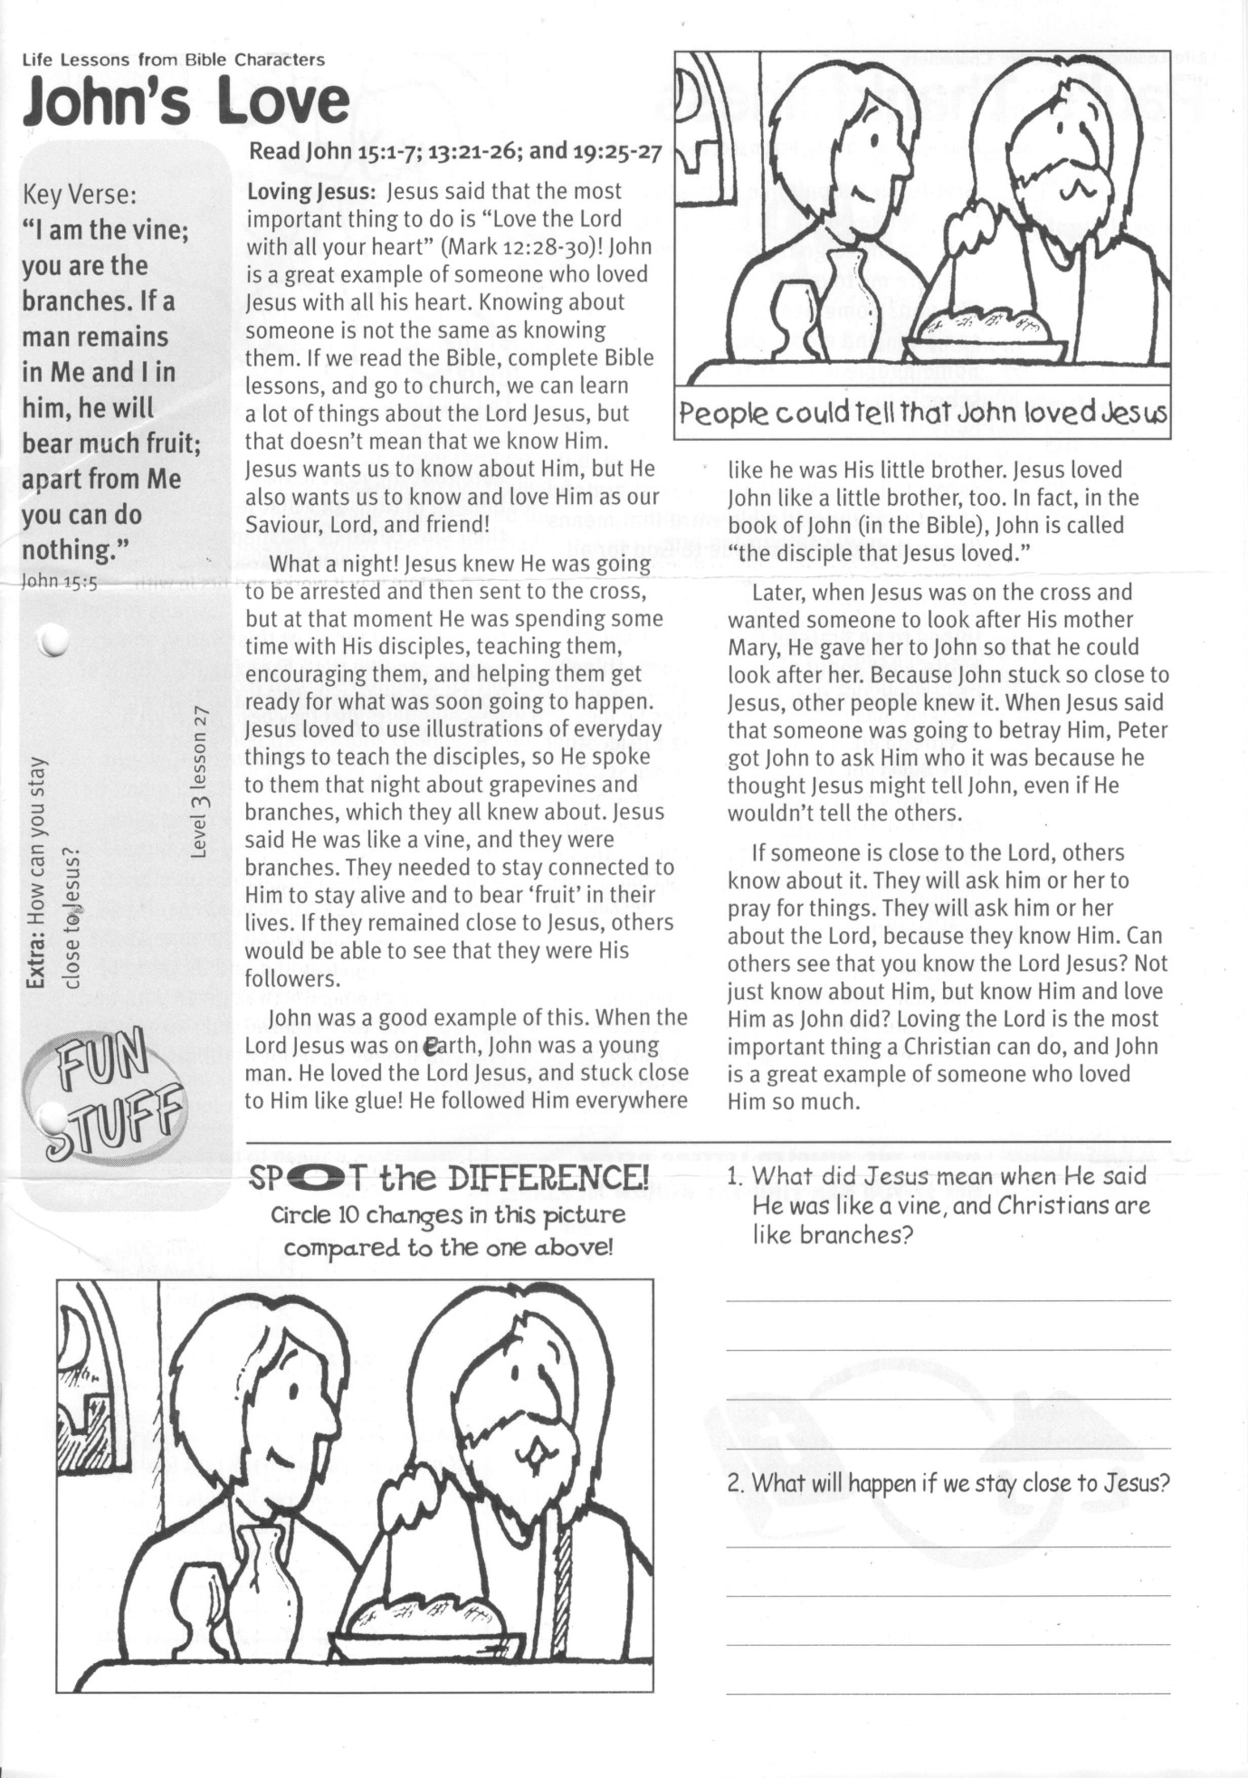

Key Verse:  
**“I am the vine; you are the branches. If a man remains in Me and I in him, he will bear much fruit; apart from Me you can do nothing.”**John 15:5

**Read John 15:1-7; 13:21-26;   
and 19:25-27**

**Loving Jesus:** Jesus said that the most important thing to do is “Love the Lord with all your heart” (Mark 12:28-30)! John is a great example of someone who loved Jesus with all his heart. Knowing about someone is not the same as knowing them. If we read the Bible, complete Bible lessons, and go to church, we can learn a lot of things about the Lord Jesus, but that doesn’t mean that we know Him. Jesus wants us to know about Him, but He also wants us to know and love Him as our Saviour, Lord, and friend!

What a night! Jesus knew He was going to be arrested and then sent to the cross, but at that moment He was spending some time with His disciples, teaching them, encouraging them, and helping them get ready for what was soon going to happen. Jesus loved to use illustrations of everyday things to teach the disciples, so He spoke to them that night about grapevines and branches, which they all knew about. Jesus said He was like a vine, and they were branches. They needed to stay connected to Him to stay alive and to bear ‘fruit’ in their lives. If they remained close to Jesus, others would be able to see that they were His followers.

John was a good example of this. When the Lord Jesus was on earth, John was a young man. He loved the Lord Jesus, and stuck close to Him like glue!

**John’s Love**

LIFE LESSONS FROM BIBLE CHARACTERS



**Level 3 lesson 27**

**Extra:** How can you stay close to Jesus?

1. What did Jesus mean when He said He was like a vine, and Christians are like branches?  
____________________________________  
____________________________________  
________________________________________________________________________

2. What will happen if we stay close to Jesus?  
________________________________________________________________________  
____________________________________  
____________________________________

**SPOT the DIFFERENCE!**Circle 10 changes in this picturecompared to the one above!   
to the one above!

He followed Him everywhere like he was His little brother. Jesus loved John like a little brother, too. In fact, in the book of John (in the Bible), John is called “the disciple that Jesus loved.”

Later, when Jesus was on the cross and wanted someone to look after His mother Mary, He gave her to John so that he could look after her. Because John stuck so close to Jesus, other people knew it. When Jesus said that someone was going to betray Him, Peter got John to ask Him who it was because he thought Jesus might tell John, even if He wouldn’t tell the others.

If someone is close to the Lord, others know about it. They will ask him or her to pray for things. They will ask him or her about the Lord, because they know Him. Can others see that you know the Lord Jesus? Not just know about Him, but know Him and love Him as John did? Loving the Lord is the most important thing a Christian can do, and John is a great example of someone who loved Him so much.

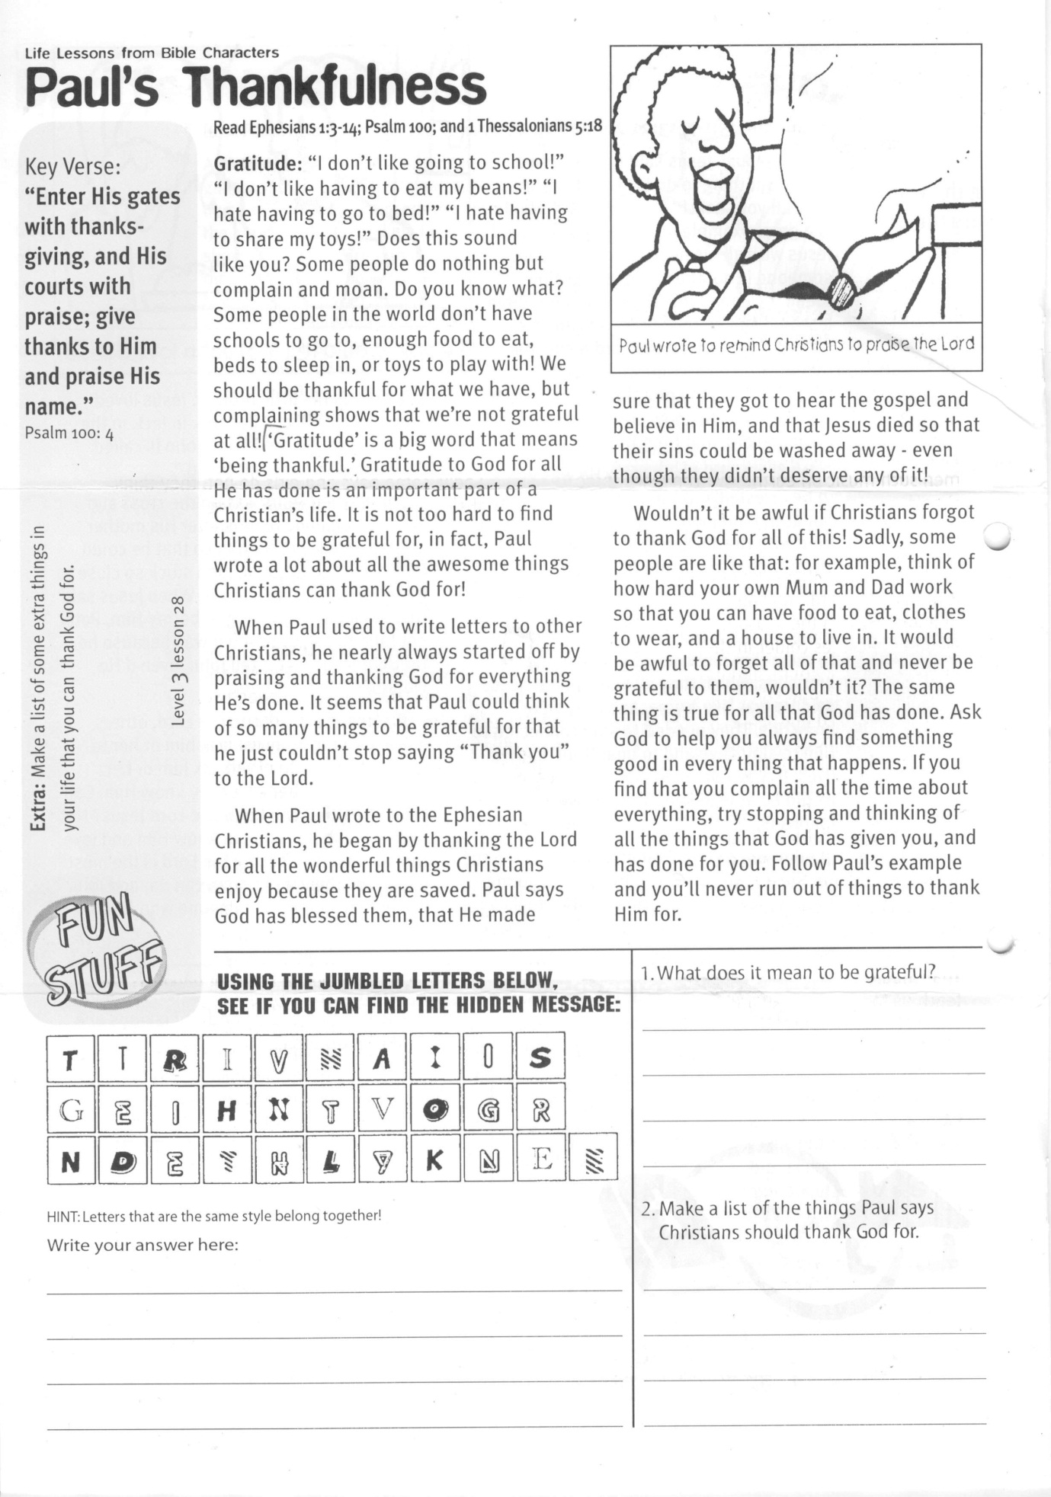

**Read Ephesians 1:3-14; Psalm 100 and 1 Thessalonians 5:18**

**Gratitude**: “I don’t like going to school!” “I don’t like having to eat my beans!” “I hate having to go to bed!” “I hate having to share my toys!” Does this sound like you? Some people do nothing but complain and moan. Do you know what? Some people in the world don’t have schools to go to, enough food to eat, beds to sleep in, or toys to play with! We should be thankful for what we have, but complaining shows that we’re not grateful at all! ‘Gratitude’ is a big word that means ‘being thankful.’

Gratitude to God for all He has done is an important part of a Christian’s life. It is not too hard to find things to be grateful for, in fact, Paul wrote a lot about all the awesome things Christians can thank God for!

When Paul used to write letters to other Christians, he nearly always started off by praising and thanking God for everything He’s done. It seems that Paul could think of so many things to be grateful for that he just couldn’t stop saying “Thank you” to the Lord.

When Paul wrote to the Ephesian Christians, he began by thanking the Lord for all the wonderful things Christians enjoy because they are saved.

**Paul’s Thankfulness**

LIFE LESSONS FROM BIBLE CHARACTERS

Key Verse:  
**“Enter His gates with thanksgiving, and His courts with praise; give thanks to Him and praise His name.”**Psalm 100:4



Please complete and return by post to   
**PSSM, 5/399 New North Road, Kingsland, Auckland 1021**   
or scan & email to **info@biblediscovery.org.nz**

**Level 3 lesson 28**

**Extra:** Make a list of some extra things in your life that you can thank God for.

Paul says God has blessed them, that He made sure that they got to hear the gospel and believe in Him, and that Jesus died so that their sins could be washed away even though they didn’t deserve any of it!

Wouldn’t it be awful if Christians forgot to thank God for all of this! Sadly, some people are like that: for example, think of how hard your own Mum and Dad work so that you can have food to eat, clothes to wear, and a house to live in. It would be awful to forget all of that and never be grateful to them, wouldn’t it?

The same thing is true for all that God has done. Ask God to help you always find something good in everything that happens. If you find that you complain all the time about everything, try stopping and thinking of all the things that God has given you, and has done for you. Follow Paul’s example and you’ll never run out of things to thank Him for.

**USING THE JUMBLED LETTERS BELOW, SEE IF YOU CAN FIND THE HIDDEN MESSAGE:**

**HINT: Letters that are the same style belong together!**

Write your answer here:

_____________________________________________________

_____________________________________________________

_____________________________________________________

_____________________________________________________

1. What does it mean to be grateful?  
________________________________________________

________________________________________________

________________________________________________

________________________________________________  
2. Make a list of the things Paul says Christians should thank God for.

________________________________________________

________________________________________________

________________________________________________

finish