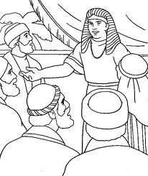
Joseph and His Brothers
Key Verse:
“We know that in all things God works for the good of those who love Him, who have been called according to His purpose.”
Romans 8:28
Read Genesis 44 and Acts 7:9-15
After visiting Egypt, Joseph’s brothers began the long journey home again. However, besides telling the steward to return their money in their sacks, Joseph had told him to “Put my silver cup in the youngest one’s sack.” Then, before they had gone far, Joseph’s steward came hurrying after them. “Why have you done evil for good?” he demanded, “Why have you stolen my lord’s silver cup?” “We would never do such a thing,” the brothers protested, “search our sacks, and if you find the silver cup in anyone’s sack you may kill him, and all the rest of us will become slaves to your master.” Imagine their horror and surprise when the silver cup was found in Benjamin’s sack!
Frightened and puzzled, they turned around and accompanied the steward back to Joseph’s house. “What is this you have done?” demanded Joseph as they fell down before him. “The man in whose hand my cup is found shall be my servant; the rest of you can go in peace.” Anxiously, Judah the eldest brother stepped forward and begged to be allowed to speak. “Oh, my Lord,” he pleaded, “we cannot go home without our youngest brother. Our father loves him greatly! We had another brother, but he is dead, and if we lose Benjamin, my father will die of sorrow. When our father told us to return here to Egypt to buy corn, we said, ‘we cannot go unless Benjamin goes with us!’ I also promised our father to take care of Benjamin, therefore, let me be your slave and let him go home to his father.” What a noble thing for Judah to do!
At this, Joseph could contain himself no longer. “Get everybody except these men out of the room!” he ordered. Then, alone with his brothers, he burst into tears. “I am Joseph!” he cried. “Is my father still alive?” The brothers were completely shocked. This great man was Joseph, their own brother; who they had ill-treated, and sold as a slave for 20 pieces of silver!! Suddenly, real fear filled their hearts.
1. What was found in Benjamin’s sack?
2. What noble thing did Judah try to do?
3. What were Joseph’s brothers completely shocked to discover?
   |  | I |  |  |  |  | E | A |  |  |  | A |  |  |  | A
   | O |  | E |  |  |  |  |  | E | I |  |  |  |  | O |  |  | E
4. What did Joseph do for his brothers in spite of all that they had done to him?
5. How can you be forgiven for your sins and be saved?
Level 3 lesson 1
Extra: Compare the brothers’ actions of selling Joseph to their defence of Benjamin.
Level 4 lesson 29
QUESTIONS & ANSWERS
Key Verse:
“Jesus said, ‘I tell you the truth, unless a man is born again, he cannot see the kingdom of God.’”
John 3:3
My Name is ……………………………………………………………………… Age ………………….
What would he do to them? How would he punish them? Oh, how wicked and evil they had been! They couldn’t even bring themselves to speak. As they stood speechless, overwhelmed by guilt, Joseph said kindly and lovingly, “Come near to me.” Shuffling closer, they heard him say, “Yes! I am Joseph your brother, whom you sold, but don’t be distressed or angry with yourselves. It was to save lives that God sent me here. It was not you who sent me here, but God!”
Many people today think that they are innocent and will be able to argue their case before God in the future. In fact, on the day they finally stand before God in all His holiness, their personal guilt will silence them. How kind and gracious Joseph was to forgive his brothers so freely! This too is a wonderful picture of God, who is far more loving and gracious than even Joseph! You see, every human is guilty before God for their sin, but God will forgive every sinner who confesses (1 John 1:8-9). God can do this because His Son Jesus was crucified in our place, taking the punishment of death that we deserved!
If you believe in Jesus Christ, confess your sins, and ask Him to save you from the penalty of death, He will indeed save you and give you eternal life (John 3:16-18)! How foolish it would have been if Joseph’s brothers had rejected his kindness. Yet some people do that to God! So don’t be foolish - accept the offer of forgiveness and salvation which He offers freely today!

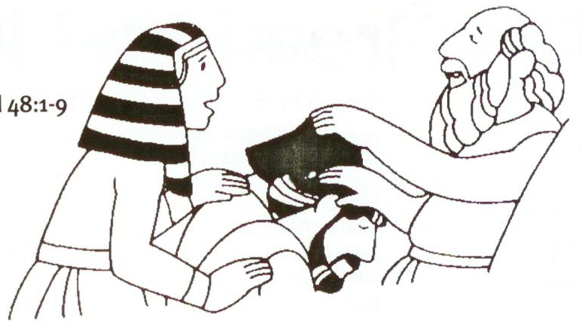
Great Rejoicing
Key Verse:
“God sent me ahead of you..... to save your lives by a great deliverance.”
Genesis 45:7
Read Genesis 45; 46:1-7 & 26-30;
and 48:1-9
Pharaoh was pleased when he heard that Joseph had been reunited with his brothers. He told Joseph, “Tell your brothers to go back to Canaan. Gather up your father and your families, your flocks and herds, and bring them down here to Egypt. I will give you the best of the land for them to live in.” So Joseph gratefully passed this message on to his brothers.
Joseph then gave them all new clothes and food for the journey, but to Benjamin (his closest brother) he gave three hundred pieces of silver and five sets of new clothes. He then organised wagons for their families so that they could ride back in comfort. Joseph also sent ten donkeys loaded up with the good things of Egypt, and ten donkeys loaded with food for his father.
Joyfully the brothers returned to their father with the wonderful news. Jacob could hardly believe it - until he saw the wagons Joseph had sent, the donkeys laden with food and fine clothes, and Benjamin’s Egyptian coins. That night, God spoke to the old man in a dream “I am the God of your fathers,” God said, “don’t be afraid to go down to Egypt, for I will make you into a great nation there.” “I’m convinced!” replied Jacob, “My son Joseph is still alive. I will go and see him before I die!” So the huge procession of people and animals travelled slowly from Canaan, all the way down to Egypt.
When they finally approached the city, Joseph rode out in his chariot to meet them, and greeted his father. Together they wept for joy! Then Jacob said, “Now I am ready to die, since I have seen for myself!” So Joseph led his family into Goshen (a very fertile part of Egypt on the east side of the River Nile) where they lived
happily for seventeen years until just before his father died.

1. What did Pharaoh say he would give to Joseph’s family?  (Write in the consonants) | “ __ __ e __ e __ __ o __ __ __ e __ a __ __  __ o __ __ __ e __ __ o __ i __ e i __ .”
2. What made Jacob believe that Joseph was still alive?
3. What did God say to Jacob in a dream?
4. Name some ways in which Joseph is like the Lord Jesus.

5. What has the Lord Jesus prepared for those who trust in Him?
Extra: What do you think of Joseph’s statement in Genesis 45:7?
Level 4 lesson 30
QUESTIONS & ANSWERS
Jacob then individually blessed Joseph and his two sons, and all Joseph’s brothers, for the future years. Peacefully, Jacob then curled up in bed and passed away into God’s presence.
As we have enjoyed studying the interesting life of Joseph, let’s remember these things:
• He was especially loved by his father.
• He was misunderstood by his own people.
• He was sold for 20 pieces of silver.
• He suffered even though he was righteous.
• He was raised up to save all who needed help.
All these things have been written about the Lord Jesus, too. That’s why Joseph is sometimes seen as a “type” (or “picture”) of Jesus. What Joseph did for his brothers and all the people was wonderful; but what the Lord Jesus does for all who come to Him for salvation is far more wonderful.
Joseph forgave his brothers of one sin - a great one yes, but only one; but the Lord Jesus can forgive ALL the sins of anyone who comes to Him. Joseph saved many people from famine and physical death; but the Lord Jesus can save anyone from eternal death in Hell. Jesus also gives spiritual blessings and has prepared a home in Heaven for all who will come and trust Him to save them from sin and death.
Have you done this? We hope you have!

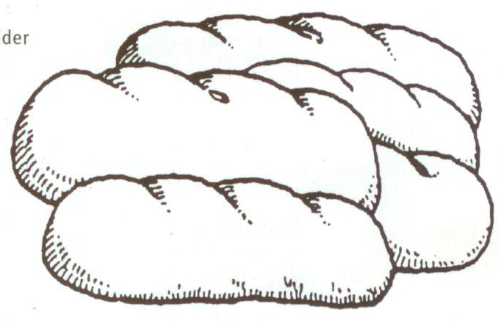
The Bread of Life
Key Verse:
“Jesus declared, ‘I am the Bread of Life. He who comes to Me will never go hungry, and he who believes in Me will never be thirsty.’”
John 6:35
Read John 6:29-51 and Luke 22:14-23
Over the next few lessons, we are going to consider the “I AM” sayings of the Lord Jesus.
We will see the Lord presenting Himself as the ONLY ONE able to fully meet the real needs in
our lives. In the first lesson we are going to think about food.
It is a sad fact that in our world today there are millions of hungry people, and yet many others have food to spare! Pictures of children whose health and growth have been ruined by malnutrition are so very sad to see. Many starve to death, while the world rushes on, too busy to care or share. When we eat our food each day we should be thankful to God for His kindness to us and remember those who live with constant hunger.
You will notice in John 6:35 that Jesus says, “I am the Bread of Life.” What do you think He meant when He said that? At the beginning of the chapter, He had fed more than five thousand people with just five loaves and two fish. The people were hungry at the end of a long day, and Jesus would not let them go home without food. How kind and thoughtful He was! Yet Jesus knew that some people wanted to use Him just to get food for their bodies, so He began to talk about a different kind of food altogether.
You see, hunger for food is not the only hunger; there are people who are hungry for other things as well. Some people are hungry for real, genuine love; others for pleasure, money, comfort, or peace. These are all things people desire in life. If you come home from school or college feeling hungry, there is usually something in the kitchen to satisfy your need; but this is often not the case with those other kinds of hunger.

1. How does Jesus present Himself through these ‘I am’ sayings?
2. Name the different kinds of hunger mentioned in this lesson.
3. Sin leaves our lives empty because… (complete this sentence) | _ _ _ _ _ _ _ _ _ _ _ _ _ .
4. What do you think Jesus meant by saying, “I am the Bread of Life”?
5. How can we find lasting satisfaction?
Extra: Do some research about bread – different kinds, different uses, etc.
Level 4 lesson 31
QUESTIONS & ANSWERS
The greatest hunger and deepest need in our lives is for God. This is a spiritual need, far greater than mere physical hunger. This was the need that Jesus came to meet. He said that He was the “Bread of God” sent from Heaven (v33).
Let’s look at this in three ways:
1. We can FIND satisfaction in the Lord Jesus. Sin leaves our lives empty because it robs us of God. Just as when we are hungry we look for food, so we can seek Jesus and find Him to satisfy our greatest spiritual need. He is the ONLY One who can truly satisfy!
2. We can FEED upon the Lord. Notice v51, “I am the living bread that came down from Heaven. If any man eats of this bread he will live forever.” You know, when we read the Bible and learn about Jesus, we are ‘feeding’ on Him and His words, and our lives become strong as we are satisfied by God.
3. We can be FILLED (or satisfied) with the good things the Lord Jesus Christ gives. The worldly pleasures we have in our lives, can never really satisfy. All of them, as good as they may seem, last for only a short time. Jesus says that those who come to Him will never hunger; in other words, they will be really satisfied forever. I hope you have found this satisfaction!


The Light of the World
Key Verse:
“[Jesus] said, ‘I am the Light of the world. Whoever follows Me will never walk in darkness, but will have the light of life.’”
John 8:12
Read John 1:1-9; 3:18-21;
and Matthew 5:14-16
Can you remember being scared of the dark? Have you ever been in a dark cave, or mine-shaft, where there is absolutely no light? I have known some adults who were terrified of this! Darkness can appear cheerless and cruel. The world that Jesus came into was a dark world, not because there was no sun, but because of the great darkness of sin in everyone’s life. Just as the hunger we thought about in our last lesson was spiritual, so the darkness we are talking about is spiritual.
Can you think what sorts of things lights are used for? Round the coast of New Zealand there are many lighthouses. These usually stand near dangerous unseen rocks, which are a terrible danger to passing ships. The lighthouse stands as a WARNING to ships that could be wrecked on these rocks. Jesus said, “I am the light of the world,” and just as the lighthouse is a warning light to prevent ships being wrecked, so Jesus stands as a warning to help us avoid those things that would wreck our lives. You know, there are many evils, which endanger your life. Satan makes sin look attractive, but the dangers of immorality, drugs, gambling, violence, selfishness, etc. are real, just like unseen rocks. The Lord warns us of these things in His Word the Bible.
What about another kind of light - a light to GUIDE? Have you ever tried to find your way along a dark track without a light? It can take you a long time, groping in the dark trying not to trip over things and find your way. How much easier it is when you have a powerful torch or lamp! The Lord is a light to guide us through the uncertain ways of life. Notice He said, “Whoever follows Me will never walk in darkness.” There are so many wrong paths, so many temptations in life; we need the Lord to guide us safely.
1. How is Jesus like a lighthouse?
2. Why do we need the Lord Jesus to be a light to guide us?
3. Why do those who do evil hate the light?
4. What did King David say was a lamp and a light?
5. In what three ways will the Lord Jesus be our light?  (Code: 1=Z, 2=Y, 3=X, etc) | _ _ _ _ _ _ _ _ _ _ _ _ _ _ _ _  4 26 9 13 20 6 18 23 22 22 3 26 14 18 13 22
Extra: In Matthew 5:14, who do you think Jesus is talking to and why?
Level 4 lesson 32
QUESTIONS & ANSWERS
King David said, “Your Word is a lamp to my feet and a light for my path” (Psalm 119:105).
Of course, there are other uses for light - have you ever been to the dentist? He usually has an x-ray light which he uses to find where there is decay hidden within your teeth. This is a light to EXAMINE. Jesus is like this too, because He shows up the sin in people’s hearts. He said in John 3:20 that those who do evil hate the light and will not come to it because they are afraid it will expose them. However, if we are willing to accept what He shows us in the Bible, He is ready to forgive our sin and lead us in ways of truth and righteousness.
Lights to WARN, to GUIDE, and to EXAMINE: How wonderful that Jesus is the Light of the World in all these ways! He wants us to follow Him and it’s why He made this great claim. The amazing thing about this is that if we follow Him, we’ll not only walk in the Light, but we’ll be lights which reflect His light to others, too!
Please complete and return by post to
PSSM Bible Discovery, 5/399 New North Rd, Kingsland, Auckland 1021 or scan & email to info@biblediscovery.org.nz

