Paul in Rome
Key Verse:
“Boldly... [Paul] preached the kingdom of God and taught about the Lord Jesus Christ.”
Acts 28:31
Read Acts 28:16-31
After many adventures, Paul’s ship sailed into the lovely Bay of Naples, in Italy. There, he and the other prisoners went ashore and began the long march to Rome. Paul had wanted to visit Rome for a long time. He wanted to meet the Christians there (Christians are those who love and trust the Lord Jesus as their Saviour).
Paul had not planned on visiting Rome as a prisoner, but that’s the way God planned it. On and on they marched – “left, right, left, right” - right along the road (called the Appian Way) to Rome. Many Christians had heard Paul was coming, so they travelled down to greet him. They then walked with him back toward the big city of Rome.
The centurion and soldiers had looked after the prisoners all the way from Caesarea - shipwreck and all! Now they handed them over to the Captain of the prison.
The centurion probably told him that Paul was not a criminal: that he loved God, was always honest and true, and could be trusted. So Paul was not put in jail like the others.
For two years, Paul was allowed to live in a house, but he always had a soldier guarding him. This didn’t concern Paul too much. He just put up with it cheerfully, being grateful not to be in a terrible dungeon in the castle. Paul was also allowed to have visitors and even speak outside his house to big crowds. Paul loved the Lord Jesus, and he told many people about Jesus’ love and how He died for all of us.
During those two years, Paul also wrote letters to churches and friends. Some of his letters are still in the Bible today! Paul was a faithful, true disciple of Jesus until he died. God wants you to follow and obey Him, too. It is important to do what God says so that we can say as Paul did, “I have finished all the work God gave me to do.”

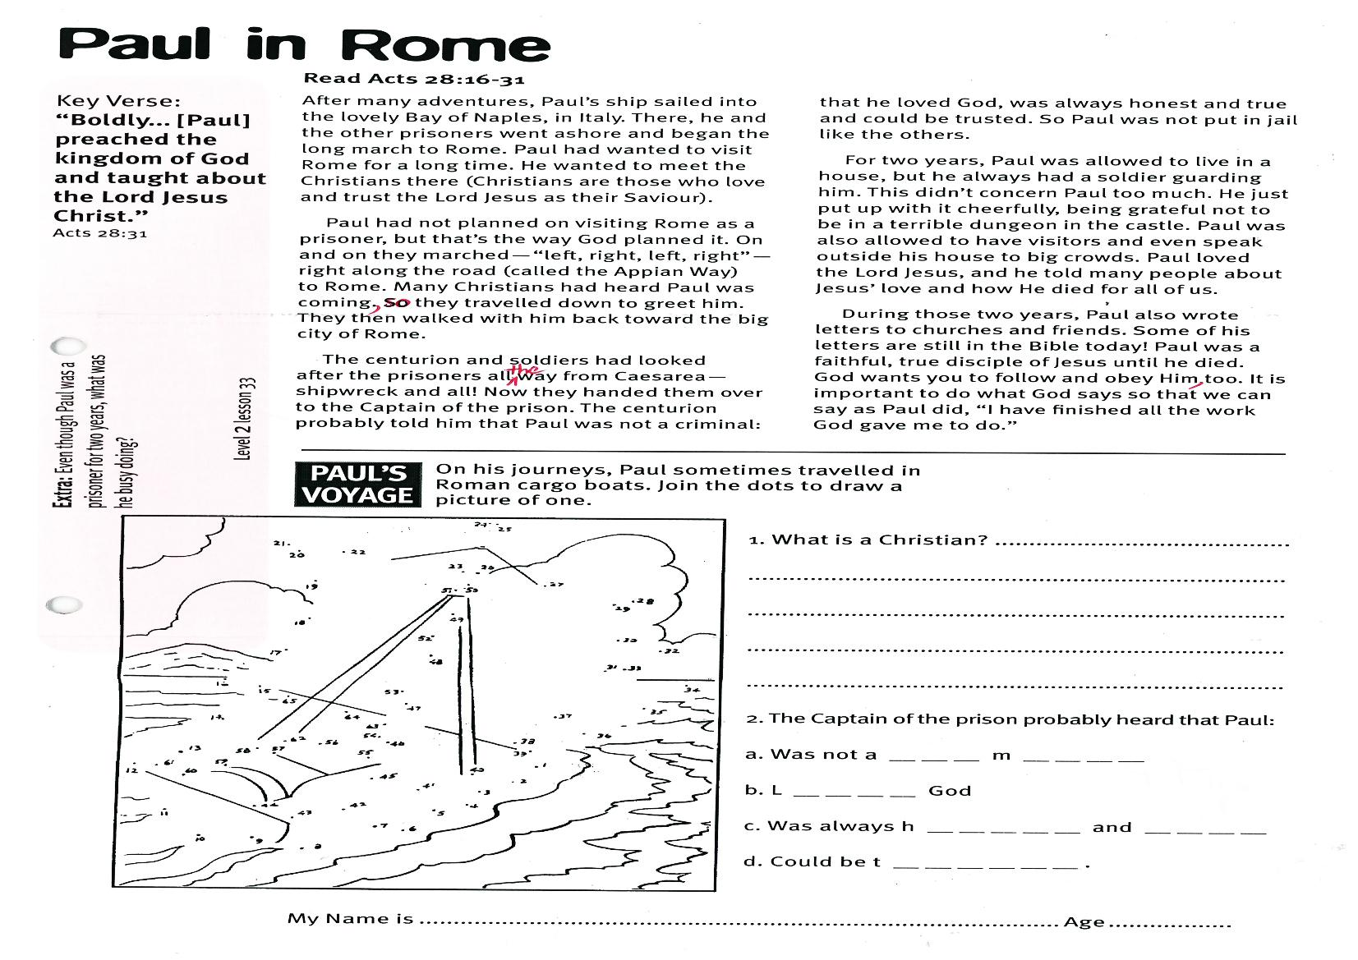
Extra: Even though Paul was a prisoner for two years, what was he busy doing?
Level 2 lesson 33
1. What is a Christian?
________________________________
________________________________
________________________________
________________________________
2. The Captain of the prison probably heard that Paul:
a. Was not a __ __ __m__ __ __ __
b. L__ __ __ __ God
c. Was always h__ __ __ __ __ and
__ __ __ __
d. Could be t__ __ __ __ __ __ .

My Name is ……………………………………………………………………… Age……………
On his journeys, Paul sometimes travelled in Roman cargo boats.
Join the dots to draw a picture of one:
PAUL’S
VOYAGE

Key Verse:
“Everyone who calls on the name of the Lord will be saved.”
Romans 10:13
Read Matthew 28:16-20
and Acts 1:6-8
Paul worked hard, telling people everywhere about Jesus. The people who followed Jesus were called ‘Christians.’ They are part of God’s family, called ‘the Church.’ In the early days of the church, many people were killed for loving Jesus and obeying God. These people were called ‘martyrs.’
Stephen was the first Christian martyr. You can read about it in Acts 7:51-60. Wicked men threw big stones at Stephen and killed him. When someone is dying, or leaving us, their last words are very important. Before Stephen died, he asked the Lord Jesus to forgive the wicked men who stoned him. Remember when Jesus died on the Cross? He also asked God, His Father, to forgive those who had crucified Him.
Although many people have come to know, love, and trust the Lord Jesus, there are still many who have not. Others have never heard about the Lord Jesus at all. They don’t know that Jesus loves them and died to save them.
They still worship gods they have made with their hands out of wood and stone. Some worship spirits, or their ancestors. They do not know that the Lord Jesus Christ is the only way to God.
These people have no way of hearing this good news unless someone tells them. That’s why, just before Jesus left His disciples to return to Heaven, He had one last special message: Jesus told them to tell everyone about God’s love and how to be saved from sin. His work for all Christians was to tell the good news to the whole world about how to become part of His family.
If you want to be saved into God’s family, then tell Him you are sorry for your sins and ask Jesus to be your Saviour. When you do this, God makes you part of His family. Then one day you will go to Heaven to live with Him forever. Of course, if we love and trust the Lord Jesus, it is important to do what He tells us in the Bible. Jesus said we are to teach others to obey Him, and that He would always be with us!
The Early Church

Level 2 lesson 34
Extra: What work does God want all Christians to do?

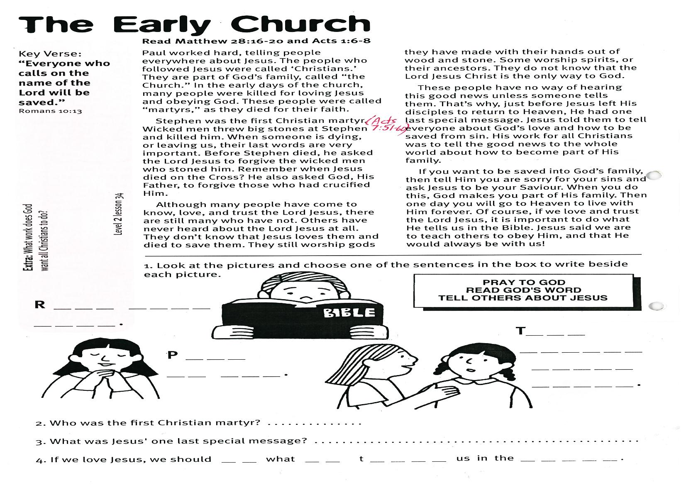
gf
2. Who was the first Christian martyr? _____________________________________________
3. What was Jesus’ one last special message? ________________________________________
4. If we love Jesus, we should __ __ what __ __ t__ __ __ __ us in the __ __ __ __ __ .
1. Look at the pictures and choose one of the sentences in the box to write beside each picture.

What would Jesus say? What do you think?
This important man got a big surprise; Jesus simply said, “Go back home; your son is better!” Something wonderful happened in that man’s heart and he simply trusted Jesus’ words. On the way home the rich man’s servants met him and said his son was all better. This happened at exactly the time Jesus said it would.

Arriving home, he found his little boy was completely better! So the boy, his father and mother, and even the whole family, believed in Jesus and were saved! He really was God’s Son! You can trust Jesus too and believe what He tells us in the Bible.
Key Verse:
“The man took Jesus at his word and departed.”
John 4:50
Jesus Can be Trusted
Read John 4:46-53
Once, while Jesus lived here on earth, a little boy became very sick. His head and body were so hot and his mouth was very dry. His mother put cool cloths on his head and tried to get him to eat or drink - but nothing seemed to help. His father was a nobleman and very rich, but even the best and most expensive doctors could not make him well.
Every day he got worse, and his parents became even more worried and sad. They did not like to see their little boy so sick. They were afraid that he would die! They had heard about Jesus and some of the wonderful things He had done. When the boy’s father heard Jesus was in a little town about 30 kilometres away, he hurried there to meet Him. Perhaps Jesus could help their sick boy!
When the rich man arrived at the town, he found Jesus talking to a big crowd of people. He knelt humbly in front of Him and said, “Please come to my home and heal my son. He is so sick, I am afraid he is going to die!”

Level 2 lesson 35

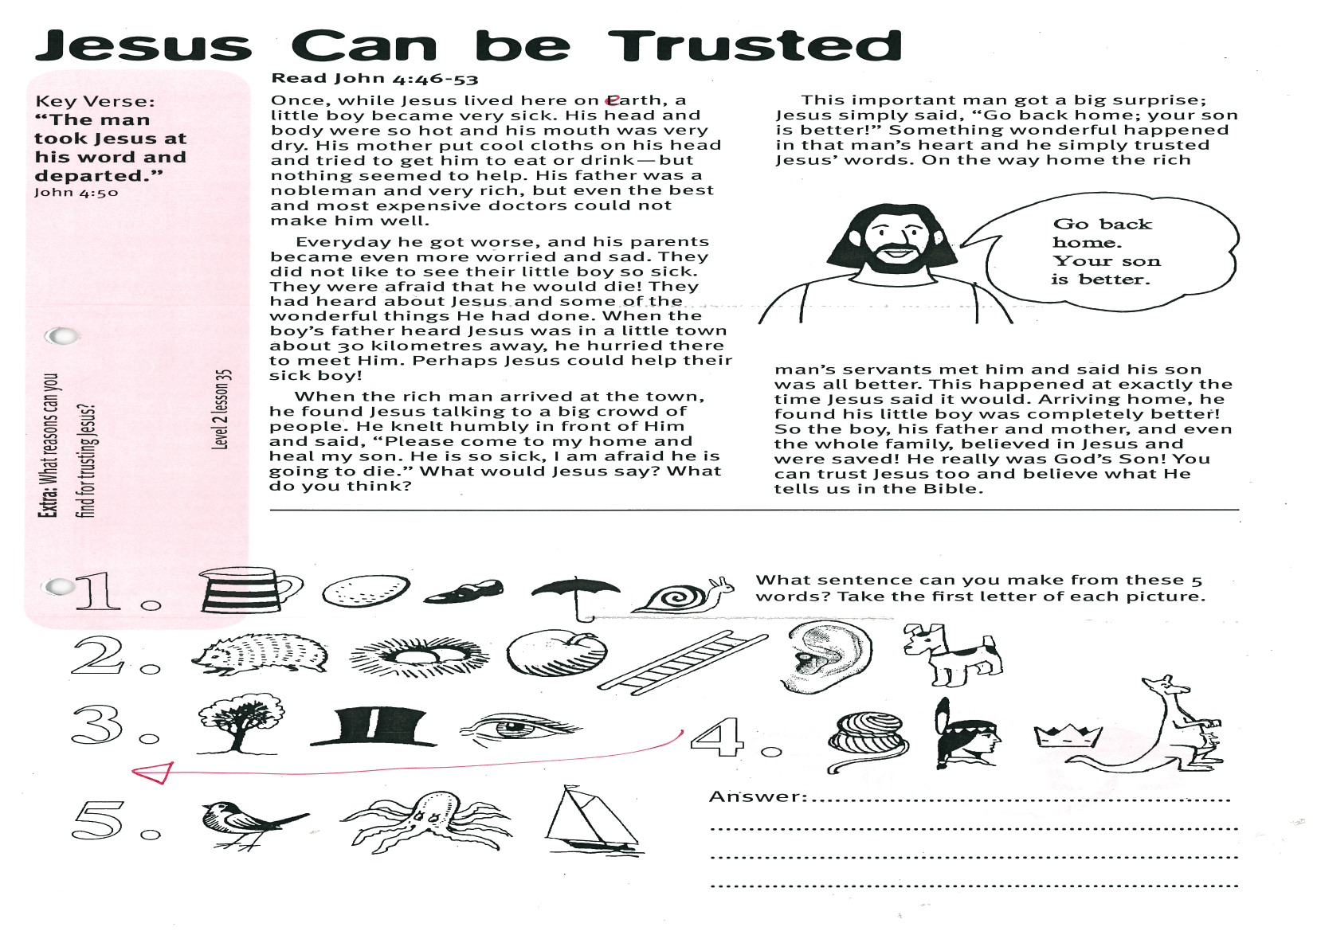
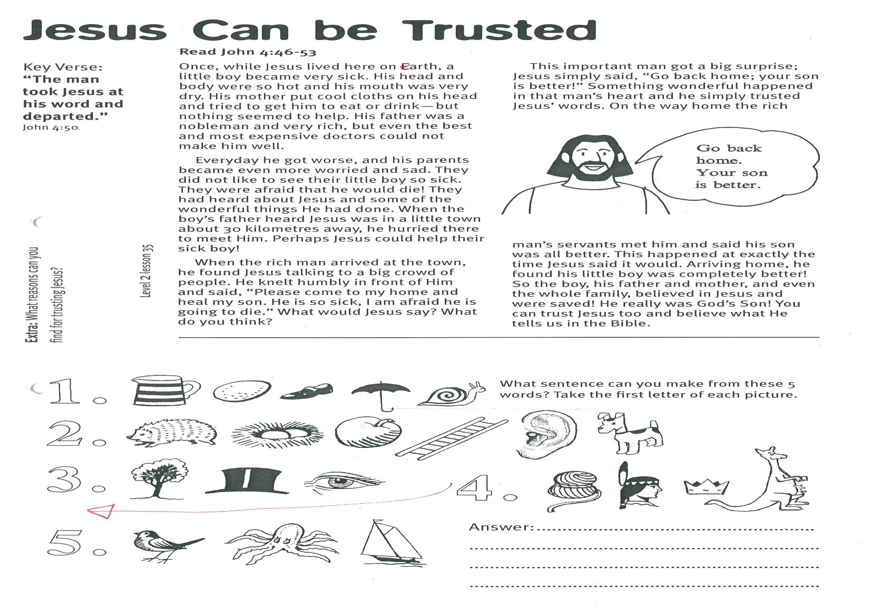
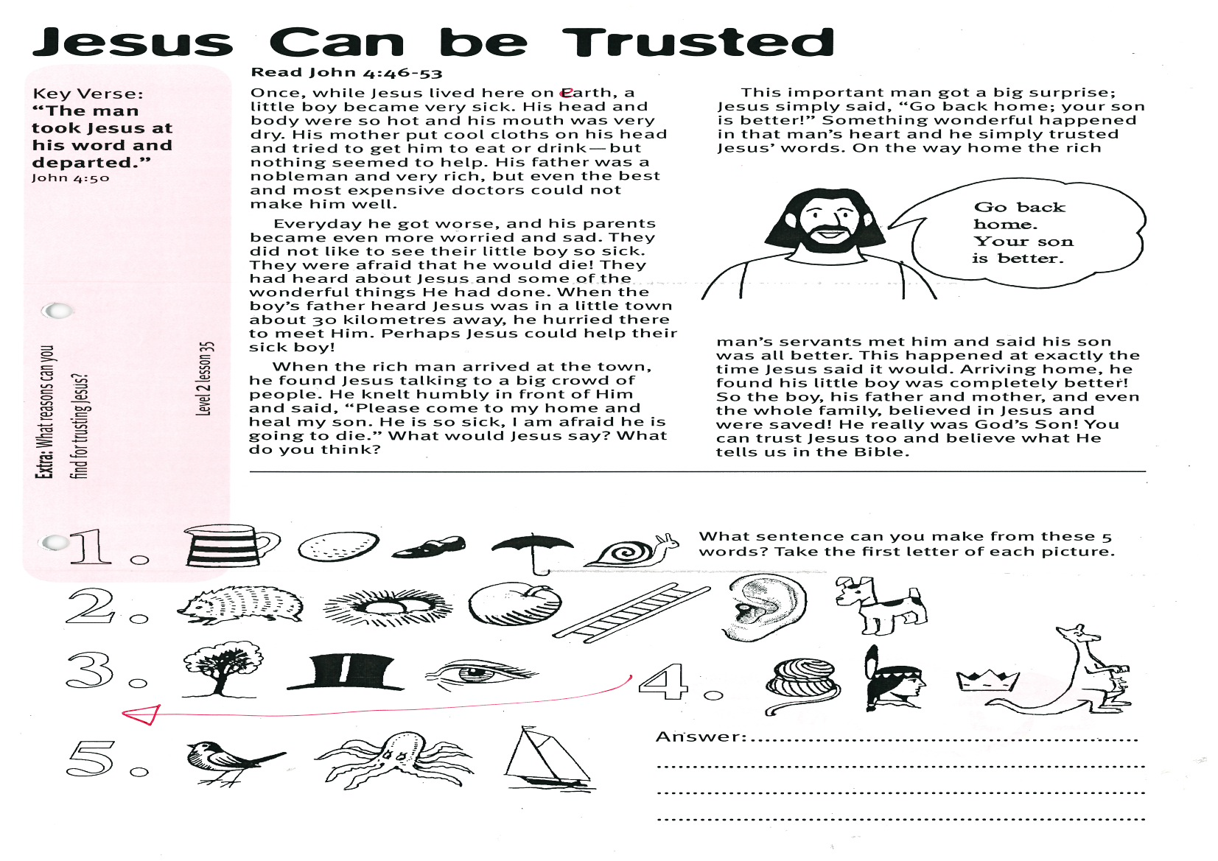
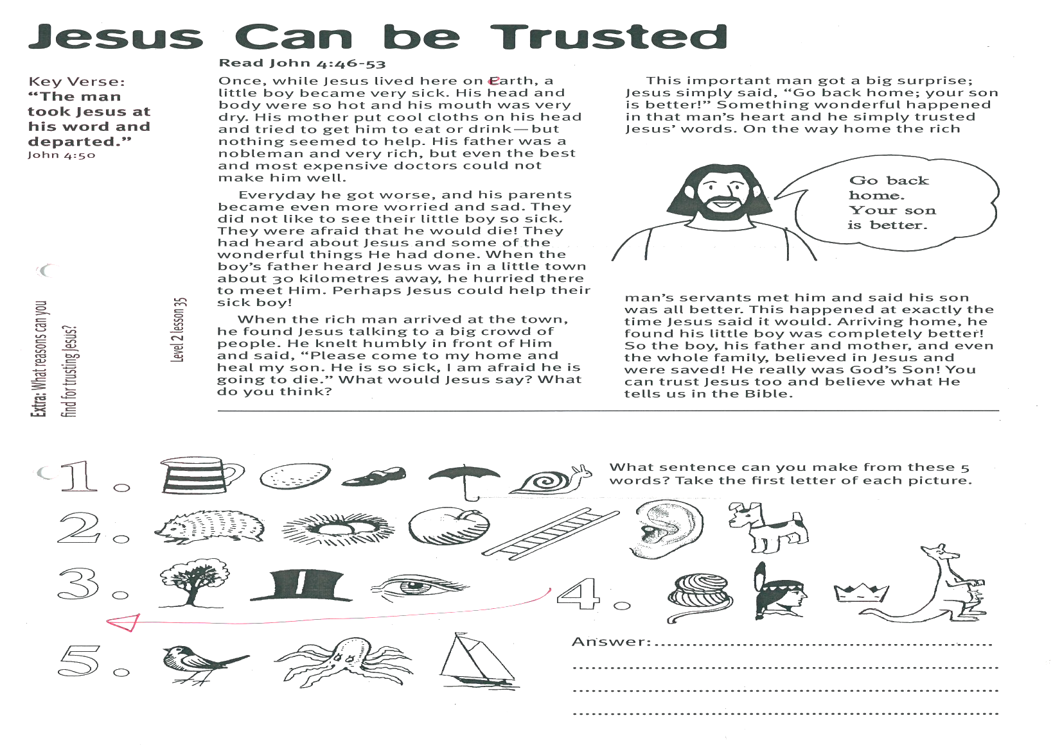
Extra: What reasons can you find for trusting Jesus?
What sentence can you make from these 5 words?
(Take the first letter of each picture)
Answer: _______________________________________________
_______________________________________________
_______________________________________________

Jesus and the Crippled Man
Key Verse:
“...believe that Jesus is the Christ, the Son of God….”
John 20:31
Read John 5:1-15
How wonderful it is to be strong and healthy! God gave us legs and feet so we can move about easily and walk, run or jump. One day Jesus met a man who had been a cripple for 38 years. There was something wrong with his legs and he could not walk at all! There were no kind and clever doctors to care for him and he just had to beg people for help.

This man was lying near the pool of Bethesda. Sometimes this pool would bubble up and move as though it was being stirred. Many sick people believed that if they could be first into the pool after this happened, they would be made well. Lots of sick people were waiting at this pool, but of course this poor man had no chance to be first anyway - he couldn’t walk and had no-one to help him.
Jesus visited the pool one Sabbath day (a day of rest, when no one worked).
He saw all the sick people there and went over to the crippled man. He asked him, “Do you want to be made better?” The man didn’t know who Jesus was. He told Jesus that no-one ever helped him into the pool. But Jesus is the Son of God. He could do something much more wonderful than just help the man into the pool!
Jesus said to him, “Stand up, pick up your bed and walk.” Straight away the man was healed! So he stood up, rolled up his bed, (a mat for sleeping on) and walked away. We can imagine how happy he was as he walked along the road carrying his mat. This was the first time in 38 years that he had walked!
The Jewish leaders were not happy though. They said the man was breaking their rules by carrying his bed on God’s day of rest. They thought it was more important for the poor lame man to obey their rules, than for Jesus to heal him!
Did you know that sin is like a bad sickness? Many of us don’t even know that we are sick with sin! We are like that crippled man and need someone to heal our sinful hearts. Jesus is the only one who can save us. If we ask Him, Jesus will forgive all our sins and help us to live a godly life!


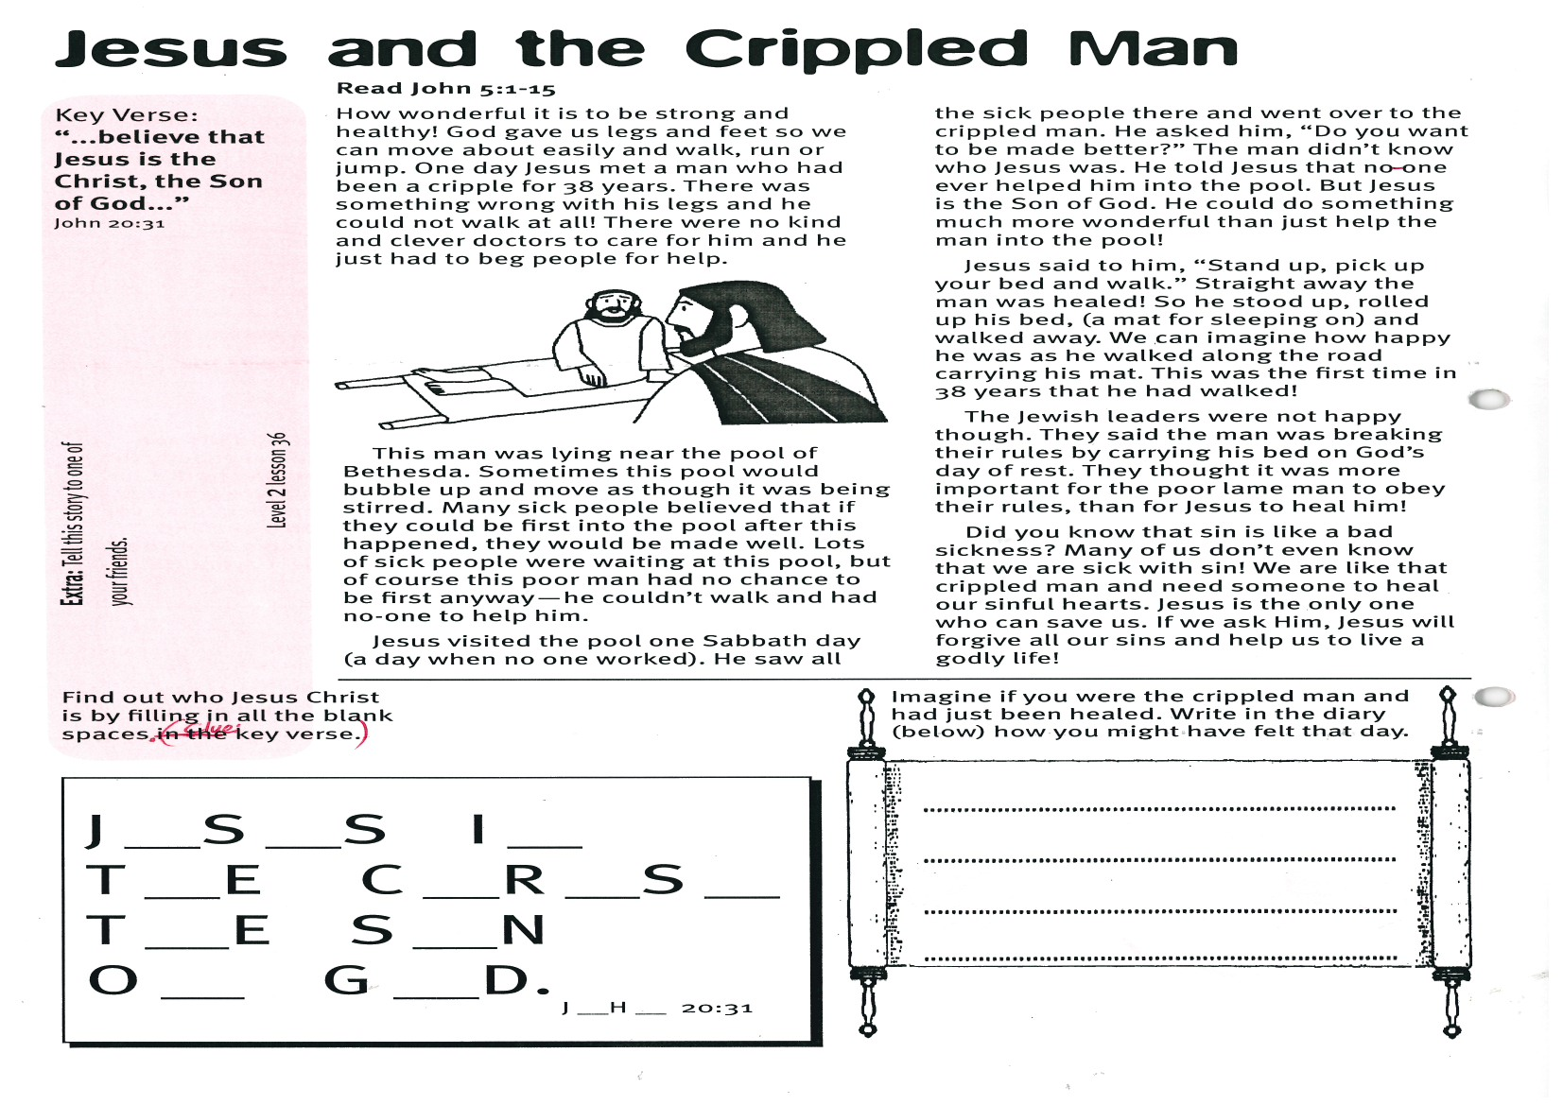
1003
Level 2 lesson 36
Extra: Tell this story to one of your friends.
Please complete and return by post to PSSM Bible Discovery, 5/399 New North Rd, Kingsland, Auckland, 1021
or scan & email to info@biblediscovery.org.nz

2. Imagine if you were the crippled man and had just been healed. Write in the diary (below) how you might have felt that day.
1. Find out who Jesus Christ is by filling in all the blank spaces. (Clue: Key Verse)

J__
J__S__S I__ T__E C__R__S__, T__E S__N O__ G__D.
J_H_ 20:31

