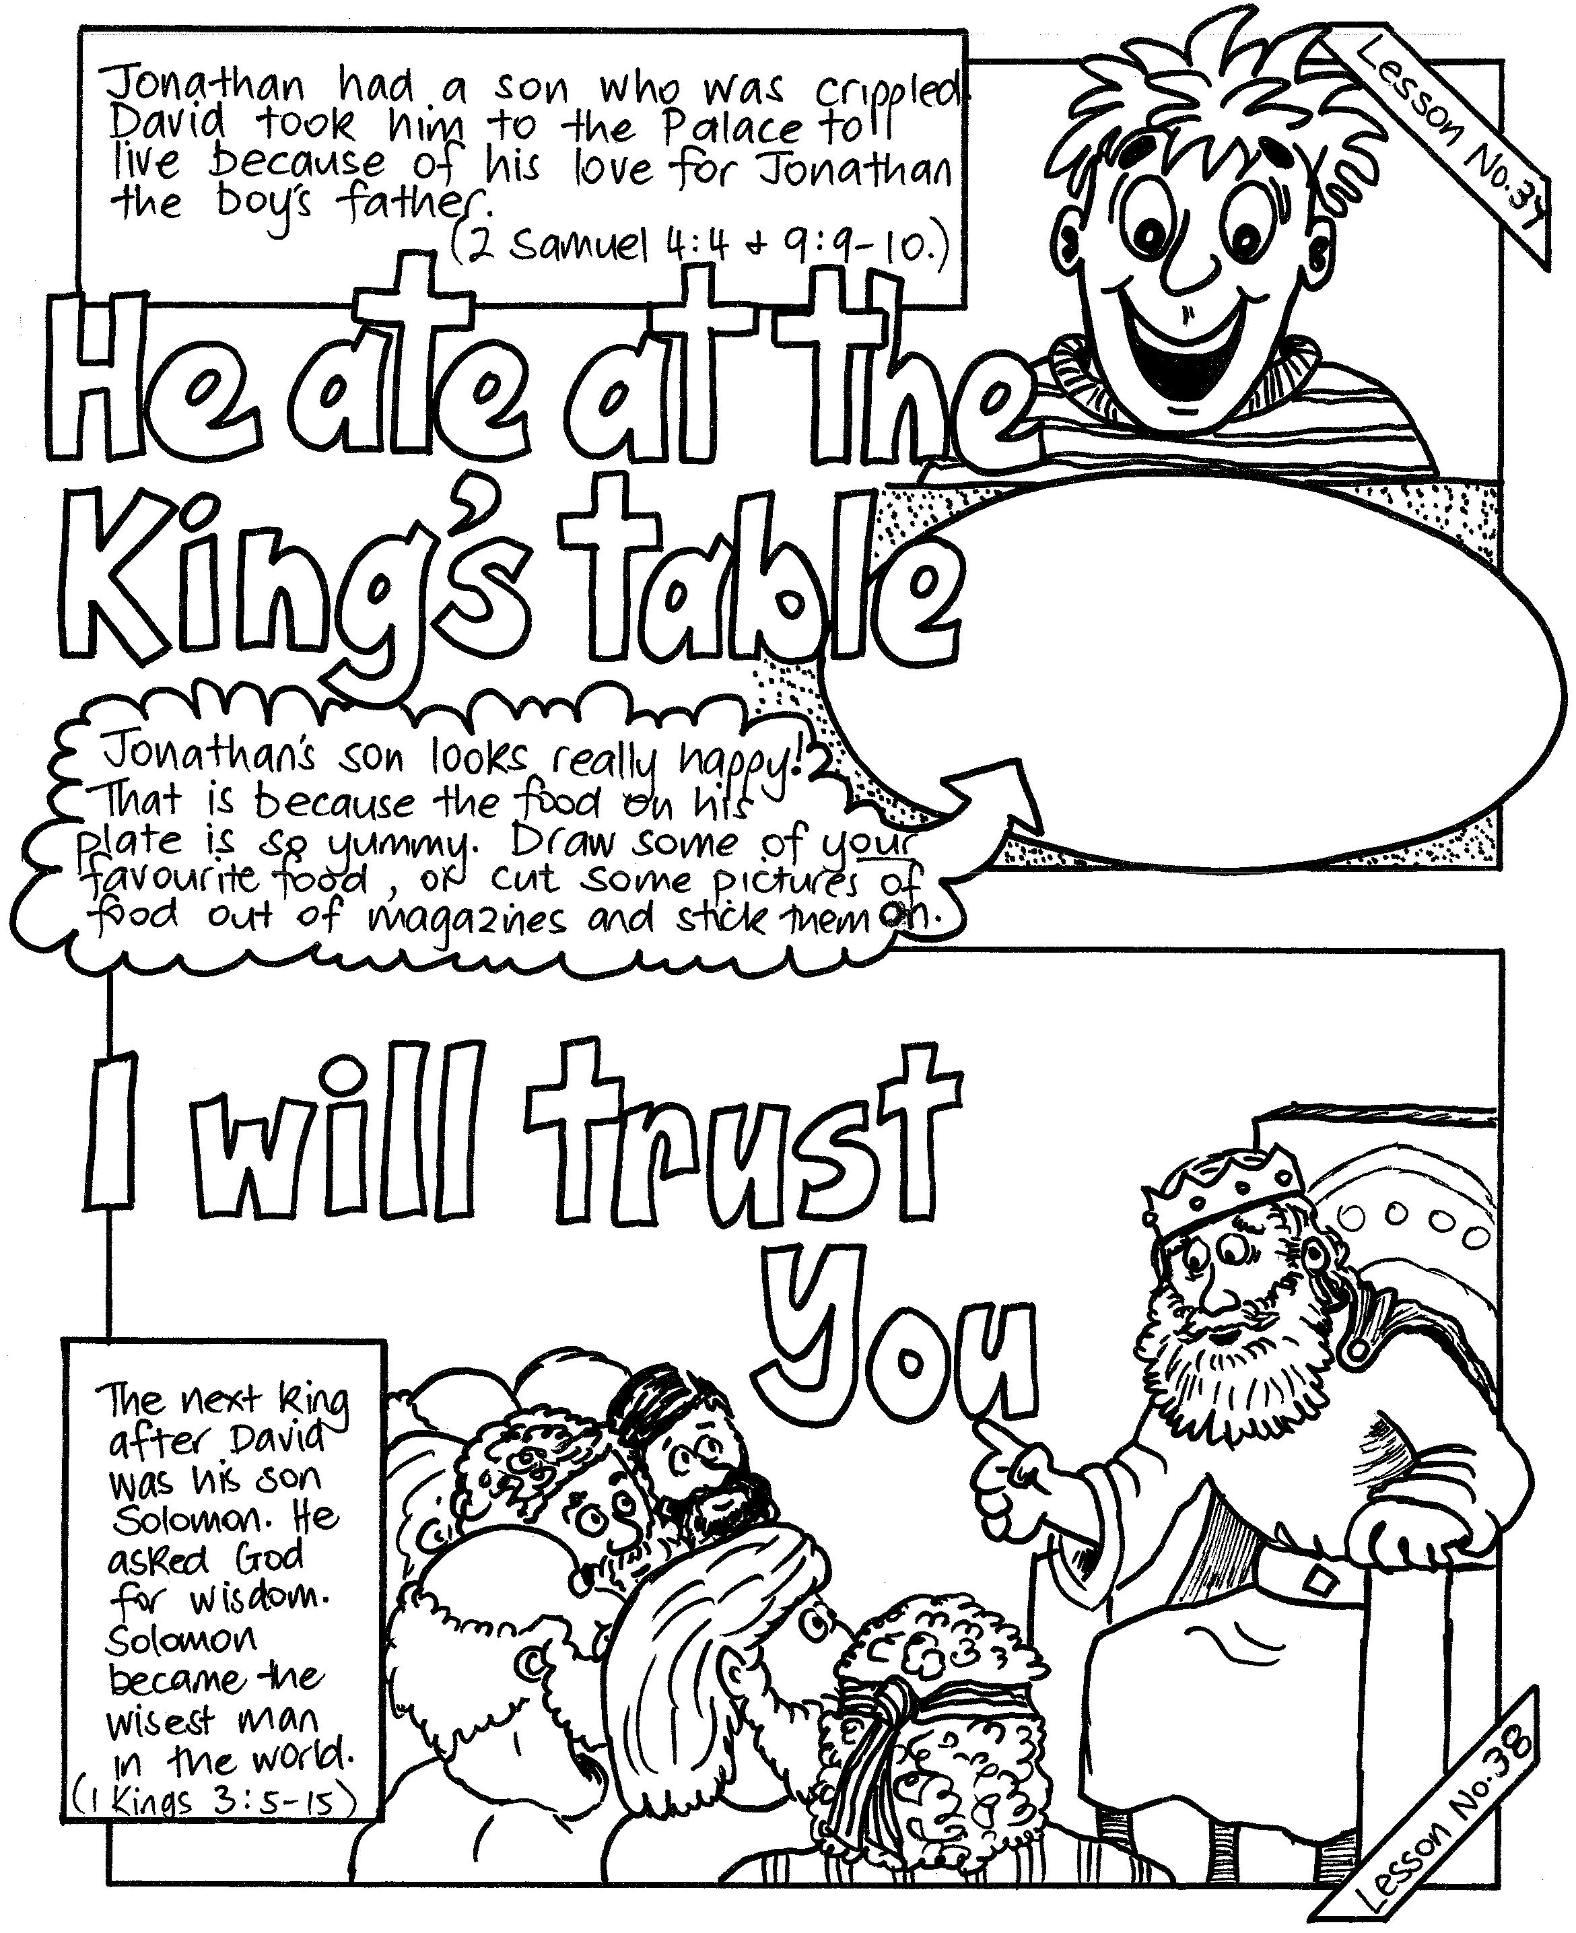


PSSM BIBLE DISCOVERY
5/399 New North Rd, Kingsland, AUCKLAND 1021, New Zealand. PH: 064-09-846 1776
info@biblediscovery.org.nz www.biblediscovery.org.nz

