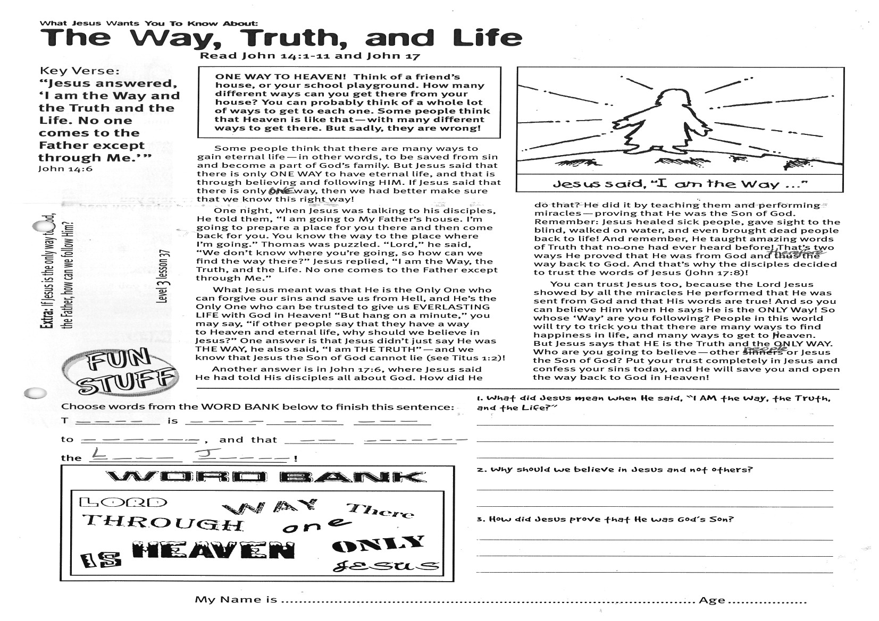

Key Verse:  
**“Jesus answered, ‘I am the Way and the Truth and the Life. No-one comes to the Father except through Me.’”**  
John 14:6

**Read John 14:1-11 and John 17**

**ONE WAY TO HEAVEN! Think of a friend’s house, or your school playground. How many different ways can you get there from your house? You can probably think of a whole lot of ways to get to each one. Some people think that Heaven is like that— with many different ways to get there. But sadly, they are wrong!**

Some people think that there are many ways to gain eternal life— in other words, to be saved from sin and become a part of God’s family. But Jesus said that there is only ONE WAY to have eternal life, and that is through believing and following HIM. If Jesus said that there is only one way, then we had better make sure that we know this right way!

One night, when Jesus was talking to his disciples, He told them, “I am going to My Father’s house. I’m going to prepare a place for you there and then come back for you. You know the way to the place where I’m going.” Thomas was puzzled. “Lord,” he said, “We don’t know where you’re going, so how can we find the way there?” Jesus replied, “I am the Way, the Truth, and the Life. No-one comes to the Father except through Me.”

What Jesus meant was that He is the Only One who can forgive our sins and save us from Hell, and He’s the Only One who can be trusted to give us EVERLASTING LIFE with God in Heaven! “But hang on a minute,” you may say, “if other people say that they have a way to Heaven and eternal life, why should we believe in Jesus?” One answer is that Jesus didn’t just say He was THE WAY, he also said, “I am THE TRUTH”— and we know that Jesus the Son of God cannot lie (see Titus 1:2)!

**The Way, Truth, and Life**

What Jesus Wants You to Know About:

1. What did Jesus mean when He said, “I AM the Way, the Truth, and the Life?”  
________________________________________________  
________________________________________________  
________________________________________________  
2. Why should we believe in Jesus and not others?  
________________________________________________  
________________________________________________  
3. How did Jesus prove that He was God’s Son?___________________________________________  
   
________________________________________________

**Extra:** If Jesus is the only way to God, the Father, how can we follow Him?

Another answer is in John 17:6, where Jesus said He had told His disciples all about God. How did He do that? He did it by teaching them and performing miracles — proving that He was the Son of God. Remember: Jesus healed sick people, gave sight to the blind, walked on water, and even brought dead people back to life! And remember, He taught amazing words of Truth that no one had ever heard before! That’s two ways He proved that He was from God and therefore the way back to God. And that’s why the disciples decided to trust the words of Jesus (John 17:8)!

You can trust Jesus too, because the Lord Jesus showed by all the miracles He performed that He was sent from God and that His words are true! And so you can believe Him when He says He is the ONLY Way! So whose ‘Way’ are you following? People in this world will try to trick you that there are many ways to find happiness in life, and many ways to get to Heaven. But Jesus says that HE is the Truth and the ONLY WAY. Who are you going to believe— other people or Jesus the Son of God? Put your trust completely in Jesus and confess your sins today. He **will** save you and open the way back to God in Heaven!

**Choose words from the WORD BANK below to finish this sentence:**T__ __ __ __ is __ __ __ __ __ __ __ __ __ __ to H__ __ __ __ __ and   
that __ __ __ __ __ __ __ __ __ the   
L__ __ __ J__ __ __ __

**Level 3 lesson 37**

**Lord** Way There Through one only

Heaven is Jesus

My Name is ………………………………………………… Age ………………….

My Name is ……………………………………………………… Age…………………

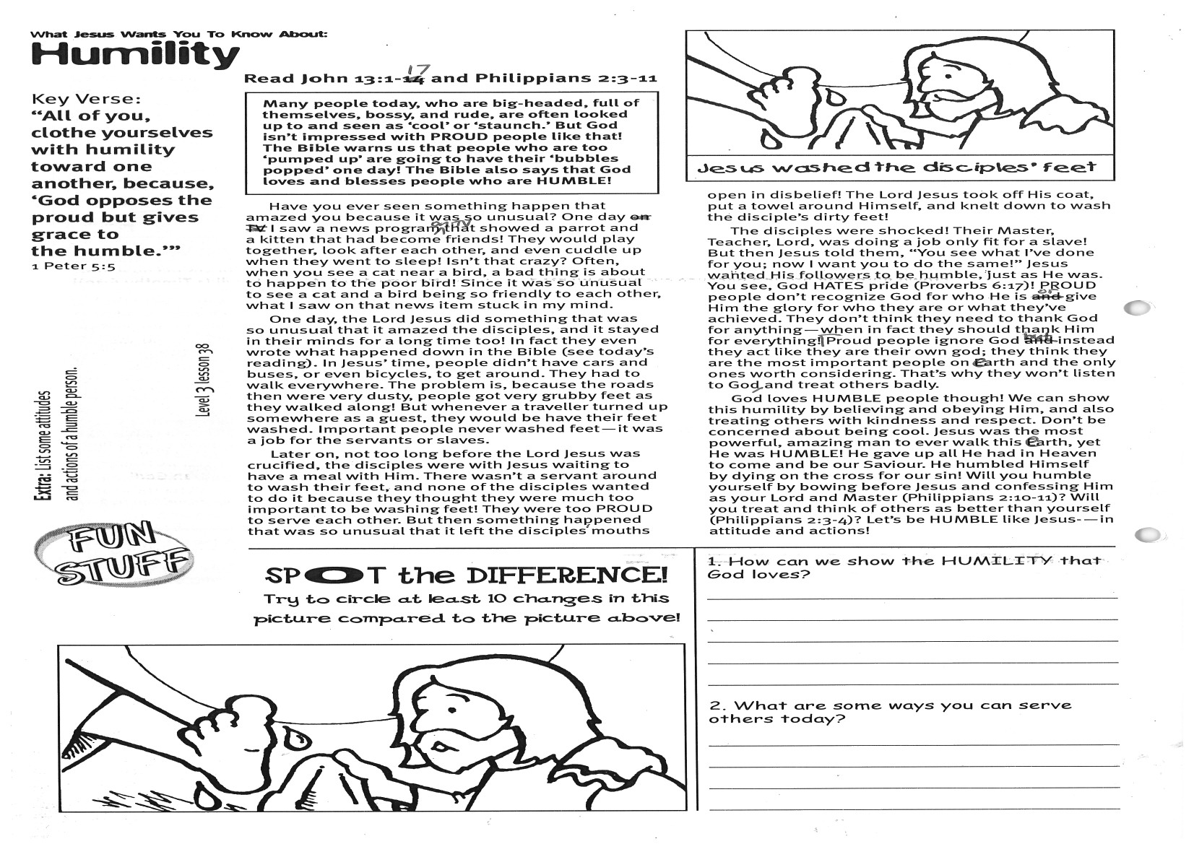

Key Verse:  
**“Clothe yourselves with humility toward one another, because, ‘God opposes the proud but gives grace to the humble.’”**  
1 Peter 5:5

**Read John 13:1-17  
and Philippians 2:3-11**

**Many people today, who are big-headed, full of themselves, bossy, and rude, are often looked up to and seen as ‘cool’ or ‘staunch.’ But God isn’t impressed with PROUD people like that! The Bible warns us that people who are too ‘pumped up’ are going to have their ‘bubbles popped’ one day! The Bible also says that God loves and blesses people who are HUMBLE!**

Have you ever seen something happen that amazed you because it was so unusual? One day I saw a news programme on TV that showed a parrot and a kitten that had become friends! They would play together, look after each other, and even cuddle up when they went to sleep! Isn’t that crazy? Often, when you see a cat near a bird, a bad thing is about to happen to the poor bird! Since it was so unusual to see a cat and a bird being so friendly to each other, what I saw on that news item stuck in my mind.

One day, the Lord Jesus did something that was so unusual that it amazed the disciples, and it stayed in their minds for a long time too! In fact they even wrote what happened down in the Bible (see today’s reading). In Jesus’ time, people didn’t have cars and buses, or even bicycles, to get around. They had to walk everywhere. The problem is, because the roads then were very dusty, people got very grubby feet as they walked along! But whenever a traveller turned up somewhere as a guest, they would be have their feet washed. Important people never washed feet— it was a job for the servants or slaves.

Later on, not too long before the Lord Jesus was crucified, the disciples were with Jesus waiting to have a meal with Him. There wasn’t a servant around to wash their feet, and none of the disciples wanted to do it because they thought

**Humility**

What Jesus Wants You to Know About:

they were much too important to be washing feet! They were too PROUD to serve each other.   
But then something happened that was so unusual that it left the disciples’ mouths open in disbelief! The Lord Jesus took off His coat, put a towel around Himself, and knelt down to wash the disciple’s dirty feet!

The disciples were shocked! Their Master, Teacher, Lord, was doing a job only fit for a slave! But then Jesus told them, “You see what I’ve done for you; now I want you to do the same!” Jesus wanted His followers to be humble, just as He was. You see, God HATES pride (Proverbs 6:17)! PROUD people don’t recognize God for who He is or give Him the glory for who they are or what they’ve achieved. They don’t think they need to thank God for anything— when in fact they should thank Him for everything!   
Proud people ignore God but instead they act like they are their own god; they think they are the most important people on earth and the only ones worth considering. That’s why they won’t listen to God and treat others badly.

God loves HUMBLE people though! We can show this humility by believing and obeying Him, and also treating others with kindness and respect. Don’t be concerned about being cool. Jesus was the most powerful, amazing man to ever walk this earth, yet He was HUMBLE! He gave up all He had in Heaven to come and be our Saviour. He humbled Himself by dying on the cross for our sin! Will you humble yourself by bowing before Jesus and confessing Him as your Lord and Master? (Philippians 2:10-11) Will you treat and think of others as better than yourself? (Philippians 2:3-4) Let’s be HUMBLE like Jesus— in attitude and actions!



1. How can we show the HUMILITY that God loves? __________________________________________________

__________________________________________________

__________________________________________________

__________________________________________________  
2. What are some ways you can serve others today?  
_____________________________________________

_____________________________________________

_________________________________________________

**Level 3 lesson 38**

**Extra:** List some attitudes and actions of a humble person.

**Spot   
the Difference!**  
Check the picture above and then   
circle 10 changes in this picture!

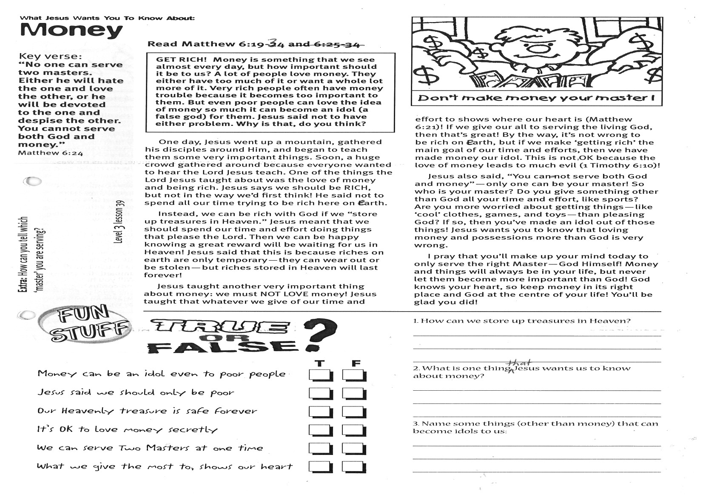

**Read Matthew 6:19-34**

**GET RICH! Money is something that we see almost every day, but how important should it be to us? A lot of people love money. They either have too much of it or want a whole lot more of it. Very rich people often have money trouble because it becomes too important to them. But even poor people can love the idea of money so much it can become an idol (a false god) for them. Jesus said not to have either problem. Why is that, do you think?**

One day, Jesus went up a mountain, gathered his disciples around Him, and began to teach them some very important things. Soon, a huge crowd gathered around because everyone wanted to hear the Lord Jesus teach. One of the things the Lord Jesus taught about was the love of money and being rich. Jesus says we should be RICH, but not in the way we’d first think! He said not to spend all our time trying to be rich here on earth.

Instead, we can be rich with God if we “store up treasures in Heaven.” Jesus meant that we should spend our time and effort doing things that please the Lord. Then we can be happy knowing a great reward will be waiting for us in Heaven! Jesus said that this is because riches on earth are only temporary — they can wear out or be stolen — but riches stored in Heaven will last forever!

Key Verse:  
**“No one can serve two he will hate the one and love the other, or he will be devoted to the one and despise the other. You cannot serve both God and money.”**Matthew 6:24

What Jesus Wants You to Know About:

**Money**

Jesus taught another very important thing about money: we must NOT LOVE money! Jesus taught that whatever we give of our time and effort to shows where our heart is! (Matthew 6:21) If we give our all to serving the living God, then that’s great! By the way, it’s not wrong to be rich on earth, but if we make ‘getting rich’ the main goal of our time and efforts, then we have made money our idol. This is not OK because the love of money leads to much evil! (1 Timothy 6:10)

Jesus also said, “You cannot serve both God and money”— only one can be your master! So who is your master? Do you give something other than God all your time and effort, like sports? Are you more worried about getting things— like ‘cool’ clothes, games, and toys— than pleasing God? If so, then you’ve made an idol out of those things! Jesus wants you to know that loving money and possessions more than God is very wrong.

I pray that you’ll make up your mind today to only serve the right Master— God Himself! Money and things will always be in your life, but never let them become more important than God! God knows your heart, so keep money in its right place and God at the centre of your life! You’ll be glad you did!

**Extra:** How can you tell which ‘master’ you are serving?

**T F**

Money can be an idol even to poor people ⃝ ⃝

Jesus said we should only be poor ⃝ ⃝

Our Heavenly treasure is safe forever ⃝ ⃝

It’s OK to love money secretly ⃝ ⃝

We can serve two Masters at one time ⃝ ⃝

What we give the most to, shows our heart ⃝ ⃝

These lessons help us to know Jesus better ⃝ ⃝

**?**

TRUE OR FALSE

1. How can we store up treasures in Heaven?  
________________________________________  
________________________________________  
________________________________________

2. What is one thing that Jesus wants us to know about money?  
________________________________________  
________________________________________  
________________________________________  
3. Name some things (other than money) that can become idols to us:  
________________________________________  
________________________________________  
________________________________________

**Level 3 lesson 39**

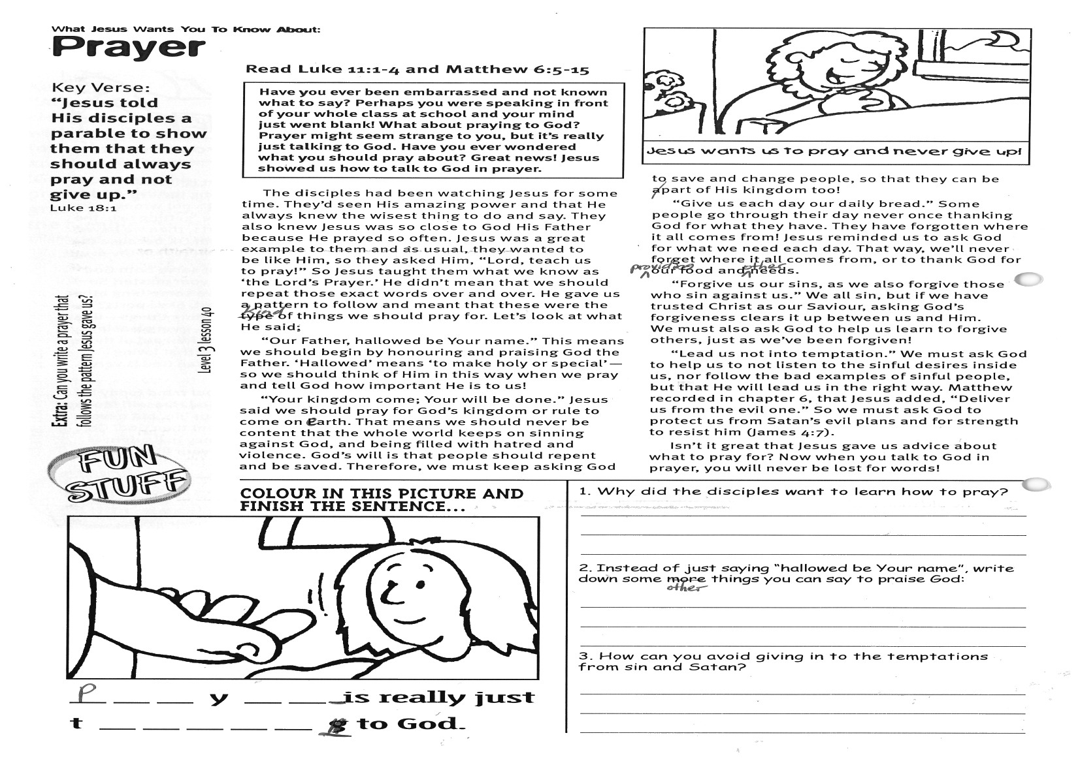

**Read Luke 11:1-4  
and Matthew 6:5-15**

**Have you ever been embarrassed and not known what to say? Perhaps you were speaking in front of your whole class at school and your mind just went blank! What about praying to God? Prayer might seem strange to you, but it’s really just talking to God. Have you ever wondered what you should pray about? Great news! Jesus showed us how to talk to God in prayer.**

The disciples had been watching Jesus for some time. They’d seen His amazing power and that He always knew the wisest thing to do and say. They also knew Jesus was so close to God His Father because He prayed so often. Jesus was a great example to them and as usual, they wanted to be like Him, so they asked Him, “Lord, teach us to pray!” So Jesus taught them what we know as ‘the Lord’s Prayer.’ He didn’t mean that we should repeat those exact words over and over. He gave us a pattern to follow and meant that these were the kind of things we should pray for. Let’s look at what He said.  
**“Our Father, hallowed be Your name.”** This means we should begin by honouring and praising God the Father. ‘Hallowed’ means ‘to make holy or special’— so we should think of Him in this way when we pray and tell God how important He is to us!  
**“Your kingdom come; Your will be done.”** Jesus said we should pray for God’s kingdom or rule to come on earth. That means we should never be content that the whole world keeps on sinning against God, and being filled with hatred and violence.

What Jesus Wants You to Know About:

**Prayer**

Key Verse:  
**“Jesus told his disciples a parable to show them that they should always pray and not give up.”**  
Luke 18:1

**Level 3 lesson 40**



*Please complete and return by post to* **PSSM Bible Discovery,   
5/399 New North** **Rd, Kingsland, Auckland, 1021**or scan & email to **info@biblediscovery.org.nz**

**Extra:** Can you write a prayer that follows the pattern Jesus gave us?

1. Why did the disciples want to learn how to pray?  
______________________________________________________________________________________________________

2. Instead of ‘hallowed be Your name’ (or, ‘holy is Your name’), write down something else you can say to praise God:  
______________________________________________________________________________________________________  
3. How can you avoid giving in to the temptations from sin and Satan?  
______________________________________________  
______________________________________________

**Colour in this picture and finish the sentence below:**

P__ __ y __ __ __ is really just   
t __ __ __ __ __ __ to God.

God’s will is that people should repent and be saved. Therefore, we must keep asking God to save and change people, so that they can be a part of His kingdom too!   
**“Give us each day our daily bread.”** Some people go through their day never once thanking God for what they have. They have forgotten where it all comes from! Jesus reminded us to ask God for what we need each day. That way, we’ll never forget where it all comes from, or to thank God for providing our food and other needs.  
**“Forgive us our sins, as we also forgive those who sin against us.”** We all sin, but if we have trusted Christ as our Saviour, asking God’s forgiveness clears it up between us and Him. We must also ask God to help us learn to forgive others, just as we’ve been forgiven!  
**“Lead us not into temptation.”** We must ask God to help us to not listen to the sinful desires inside us, nor follow the bad examples of sinful people, but that He will lead us in the right way. Matthew recorded in chapter 6, that Jesus added, **“Deliver us from the evil one.”** So we must ask God to protect us from Satan’s evil plans and for strength to resist him (James 4:7).  
Isn’t it great that Jesus gave us advice about what to pray for? Now when you talk to God in prayer, you will never be lost for words!

finish