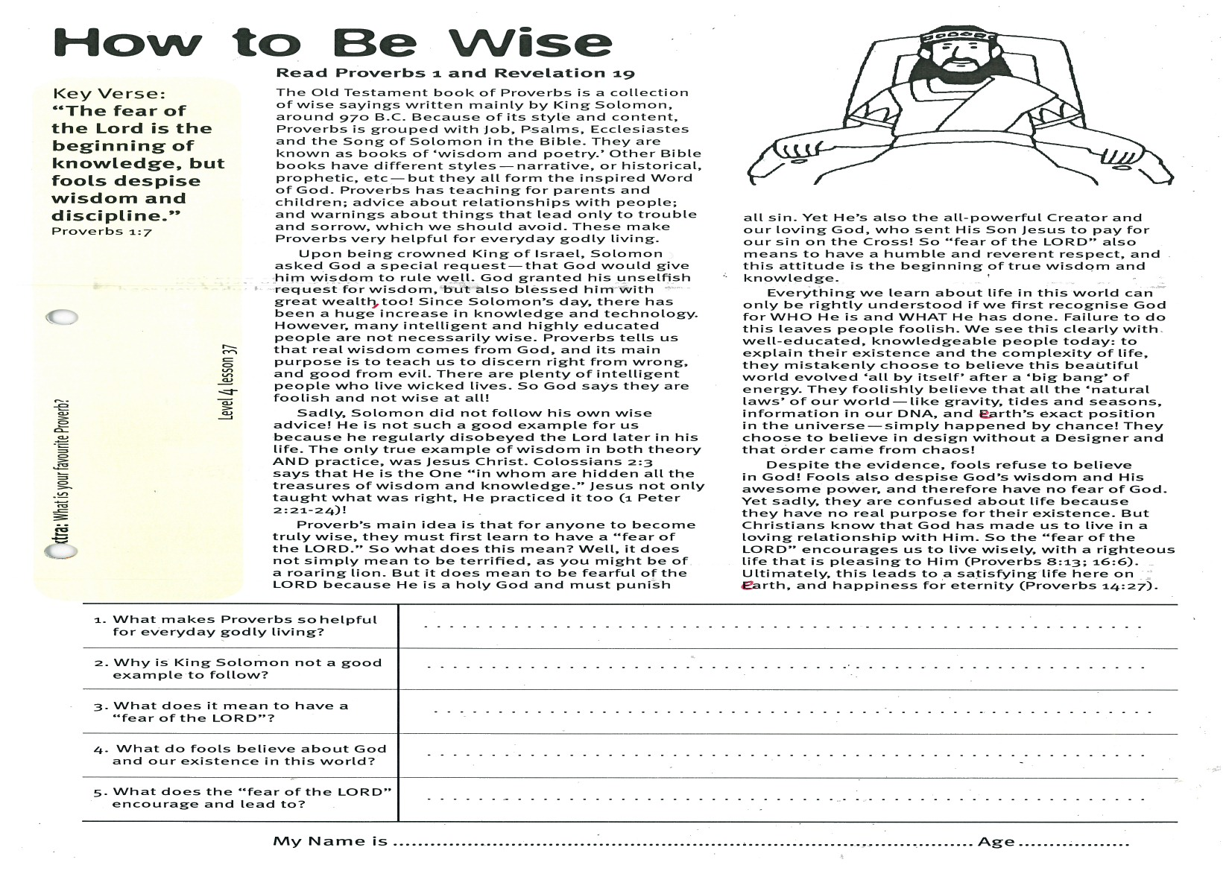
How to Be Wise
Key Verse:
“The fear of the Lord is the beginning of knowledge, but fools despise wisdom and discipline.”
Proverbs 1:7
Read Proverbs 1 and Revelation 19
The Old Testament book of Proverbs is a collection of wise sayings written mainly by King Solomon, around 970 B.C. Because of its style and content, Proverbs is grouped with Job, Psalms, Ecclesiastes and the Song of Solomon in the Bible. They are known as books of ‘wisdom and poetry.’ Other Bible books have different styles - narrative, or historical, prophetic, etc, but they all form the inspired Word of God. Proverbs has teaching for parents and children; advice about relationships with people; and warnings about things that lead only to trouble and sorrow, which we should avoid. These make Proverbs very helpful for everyday godly living.
Upon being crowned King of Israel, Solomon asked God a special request - that God would give him wisdom to rule well. God granted his unselfish request for wisdom, but also blessed him with great wealth, too! Since Solomon’s day, there has been a huge increase in knowledge and technology. However, many intelligent and highly educated people are not necessarily wise. Proverbs tells us that real wisdom comes from God, and its main purpose is to teach us to discern right from wrong, and good from evil. There are plenty of intelligent people who live wicked lives. So God says they are foolish and not wise at all!
Sadly, Solomon did not follow his own wise advice! He is not such a good example for us because he regularly disobeyed the Lord later in his life. The only true example of wisdom in both theory AND practice, was Jesus Christ. Colossians 2:3 says that He is the One “in whom are hidden all the treasures of wisdom and knowledge.” Jesus not only taught what was right, He practiced it too! (1 Peter 2:21-24)
Proverb’s main idea is that for anyone to become truly wise, they must first learn to have a “fear of the LORD”.
1. What makes Proverbs so helpful for everyday godly living?
2. Why is King Solomon not a good example to follow?
3. What does it mean to have a “fear of the LORD”?
4. What do fools believe about God and our existence in this world?
5. What does the “fear of the LORD” encourage and lead to?
Level 3 lesson 1
Extra: What is your favourite Proverb?
Level 4 lesson 37
QUESTIONS & ANSWERS
Key Verse:
“Jesus said, ‘I tell you the truth, unless a man is born again, he cannot see the kingdom of God.’”
John 3:3
My Name is ……………………………………………………………………… Age ………………….
So what does this mean? Well, it does not simply mean to be terrified, as you might be of a roaring lion. But it does mean to be fearful of the LORD because He is a holy God and must punish all sin. Yet He’s also the all-powerful Creator and our loving God, who sent His Son Jesus to pay for our sin on the Cross! So “fear of the LORD” also means to have a humble and reverent respect, and this attitude is the beginning of true wisdom and knowledge.
Everything we learn about life in this world can only be rightly understood if we first recognise God for WHO He is and WHAT He has done. Failure to do this leaves people foolish. We see this clearly with well-educated, knowledgeable people today: to explain their existence and the complexity of life, they mistakenly choose to believe this beautiful world evolved ‘all by itself’ after a ‘big bang’ of energy. They foolishly believe that all the ‘natural laws’ of our world - like gravity, tides and seasons, information in our DNA, and earth’s exact position in the universe - simply happened by chance! They choose to believe in design without a Designer and that order came from chaos!
Despite the evidence, fools refuse to believe in God! Fools also despise God’s wisdom and His awesome power, and therefore have no fear of God. Yet sadly, they are confused about life because they have no real purpose for their existence. But Christians know that God has made us to live in a loving relationship with Him. So the “fear of the LORD” encourages us to live wisely, with a righteous life that is pleasing to Him (Proverbs 8:13; 16:6). Ultimately, this leads to a satisfying life here on earth, and happiness for eternity (Proverbs 14:27).

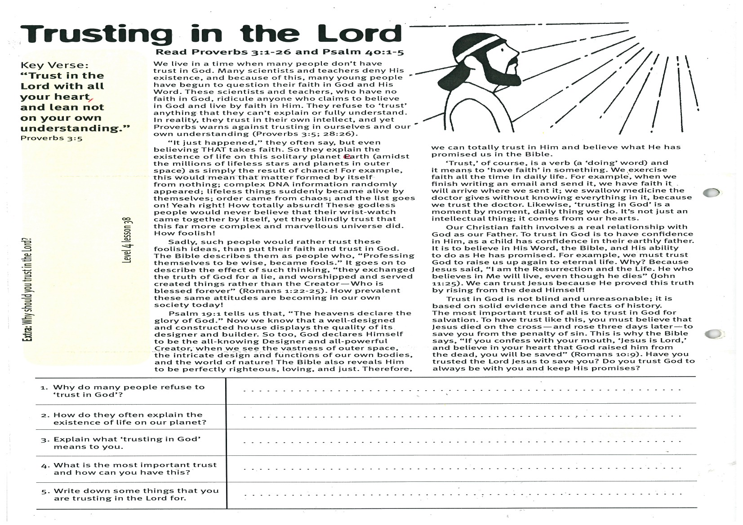
Trusting in the Lord
Key Verse:
“Trust in the Lord with all your heart, and lean not on your own understanding.”
Proverbs 3:5
Read Proverbs 3:1-26
and Psalm 40:1-5
We live in a time when many people don’t have trust in God. Many scientists and teachers deny His existence, and because of this, many young people have begun to question their faith in God and His Word. These scientists and teachers, who have no faith in God, ridicule anyone who claims to believe in God and live by faith in Him. They refuse to ‘trust’ anything that they can’t explain or fully understand.
In reality, they trust in their own intellect, and yet Proverbs warns against trusting in ourselves and our own understanding (Proverbs 3:5 and 28:26).
“It just happened,” they often say, but even believing THAT takes faith. So they explain the existence of life on this solitary planet earth (amidst the millions of lifeless stars and planets in outer space) as simply the result of chance! For example, this would mean that matter formed by itself from nothing; complex DNA information randomly appeared; lifeless things suddenly became alive by themselves; order came from chaos; and the list goes on! Yeah right! How totally absurd! These godless people would never believe that their wrist-watch came together by itself, yet they blindly trust that this far more complex and marvellous universe did. How foolish!
Sadly, such people would rather trust these foolish ideas, than put their faith and trust in God. The Bible describes them as people who, “Professing themselves to be wise, became fools.” It goes on to describe the effect of such thinking, “they exchanged the truth of God for a lie, and worshipped and served created things rather than the Creator - Who is blessed forever” (Romans 1:22-25). How prevalent these same attitudes are becoming in our own society today!
Psalm 19:1 tells us that, “The Heavens declare the glory of God.” Now we know that a well-designed and constructed house displays the quality of its designer and builder. So too, God declares Himself to be the all-knowing Designer and all-powerful Creator, when we see the vastness of outer space, the intricate design and function of our own bodies, and the world of nature!
1. Why do many people refuse to ‘trust in God’?
2. How do they often explain the existence of life on our planet?
3. Explain what ‘trusting in God’ means to you.
4. What is the most important trust and how can you have this?

5. Write down some things that you are trusting in the Lord for.
Extra: Why should you trust in the Lord?
Level 4 lesson 38
QUESTIONS & ANSWERS
The Bible also reveals Him to be perfectly righteous, loving, and just. Therefore, we can totally trust in Him and believe what He has promised us in the Bible.
‘Trust,’ of course, is a verb (a ‘doing’ word) and it means to ‘have faith’ in something. We exercise faith all the time in daily life. For example, when we finish writing an email and send it, we have faith it will arrive where we sent it; we swallow medicine the doctor gives without knowing everything in it, because we trust the doctor. Likewise, ‘trusting in God’ is a moment by moment, daily thing we do. It’s not just an intellectual thing; it comes from our hearts.
Our Christian faith involves a real relationship with God as our Father. To trust in God is to have confidence in Him, as a child has confidence in their earthly father. It is to believe in His Word, the Bible, and His ability to do as He has promised. For example, we must trust God to raise us up again to eternal life. Why? Because Jesus said, “I am the Resurrection and the Life. He who believes in Me will live, even though he dies” (John 11:25). We can trust Jesus because He proved this truth by rising from the dead Himself!
Trust in God is not blind and unreasonable; it is based on solid evidence and the facts of history. The most important trust of all is to trust in God for salvation. To have trust like this, you must believe that Jesus died on the cross - and rose three days later - to save you from the penalty of sin. This is why the Bible says, “If you confess with your mouth, ‘Jesus is Lord,’ and believe in your heart that God raised him from the dead, you will be saved” (Romans 10:9). Have you trusted the Lord Jesus to save you? Do you trust God to always be with you and keep His promises?

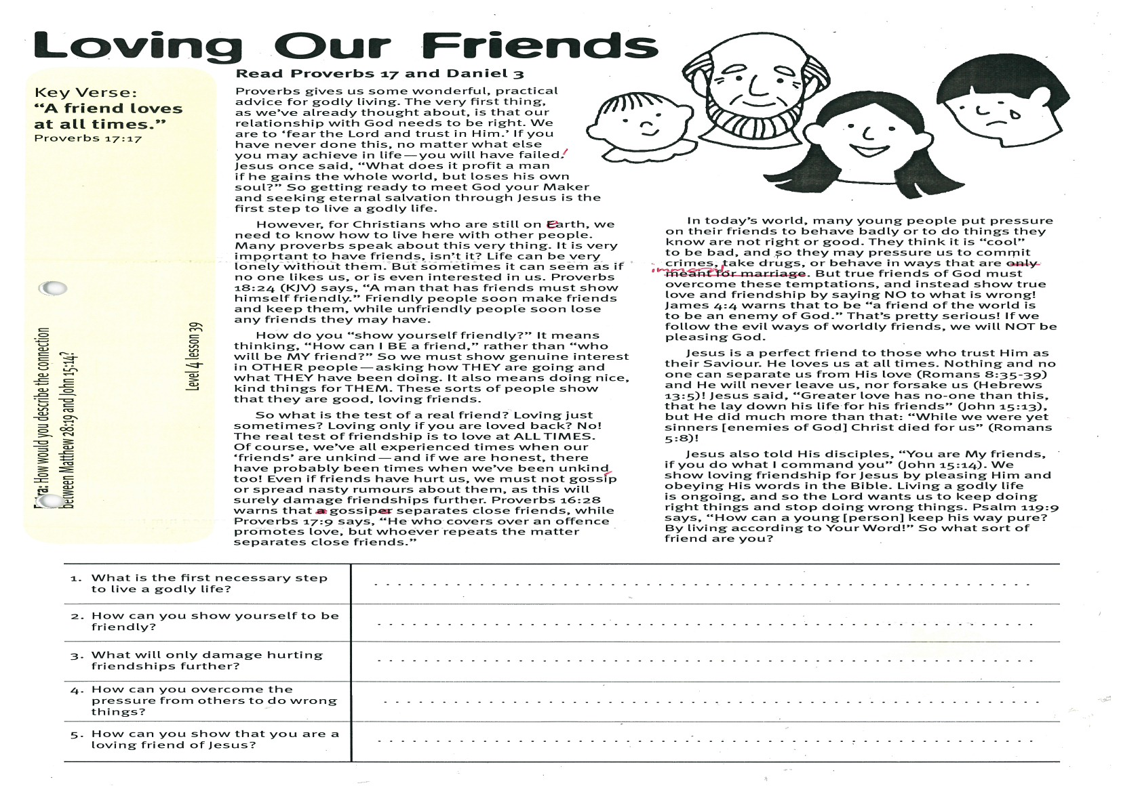
Loving Our Friends
Key Verse:
“A friend loves at all times.”
Proverbs 17:17
Read Proverbs 17 and Daniel 3
Proverbs gives us some wonderful, practical advice for godly living. The very first thing, as we’ve already thought about, is that our relationship with God needs to be right. We are to ‘fear the Lord and trust in Him.’ If you have never done this, no matter what else you may achieve in life - you will have failed! Jesus once said, “What does it profit a man if he gains the whole world, but loses his own soul?” So getting ready to meet God your Maker and seeking eternal salvation through Jesus is the first step to live a godly life.
However, for Christians who are still on earth, we need to know how to live here with other people. Many proverbs speak about this very thing. It is very important to have friends, isn’t it? Life can be very lonely without them. But sometimes it can seem as if no one likes us, or is even interested in us. Proverbs 18:24 (KJV) says, “A man that has friends must show himself friendly.” Friendly people soon make friends and keep them, while unfriendly people soon lose any friends they may have.
How do you “show yourself friendly?” It means thinking, “How can I BE a friend,” rather than “who will be MY friend?” So we must show genuine interest in OTHER people - asking how THEY are going and what THEY have been doing. It also means doing nice, kind things for THEM. These sorts of people show that they are good, loving friends.
So what is the test of a real friend? Loving just sometimes? Loving only if you are loved back? No! The real test of friendship is to love at ALL TIMES. Of course, we’ve all experienced times when our ‘friends’ are unkind - and if we are honest, there have probably been times when we’ve been unkind, too! Even if friends have hurt us, we must not gossip or spread nasty rumours about them, as this will surely damage friendships further.
1. What is the first necessary step to live a godly life?
2. How can you show yourself to be friendly?
3. What will only damage hurting friendships further?
4. How can you overcome the pressure from others to do wrong things?
5. How can you show that you are a loving friend of Jesus?
Extra: How would you describe the connection between Matthew 28:19 and John 15:14?
Level 4 lesson 39
QUESTIONS & ANSWERS
Proverbs 16:28 warns that gossip separates close friends, while Proverbs 17:9 says, “He who covers over an offence promotes love, but whoever repeats the matter separates close friends.”
In today’s world, many young people put pressure on their friends to behave badly or to do things they know are not right or good. They think it is “cool” to be bad, and so they may pressure us to commit crimes, take drugs, or behave in ways that are immoral. But true friends of God must overcome these temptations, and instead show true love and friendship by saying NO to what is wrong! James 4:4 warns that to be “a friend of the world is to be an enemy of God.” That’s pretty serious! If we follow the evil ways of worldly friends, we will NOT be pleasing God.
Jesus is a perfect friend to those who trust Him as their Saviour. He loves us at all times. Nothing and no one can separate us from His love (Romans 8:35-39) and He will never leave us, nor forsake us! (Hebrews 13:5)
Jesus said, “Greater love has no-one than this, that he lay down his life for his friends” (John 15:13), but He did much more than that: “While we were yet sinners (enemies of God) Christ died for us!” (Romans 5:8!
Jesus also told His disciples, “You are My friends, if you do what I command you” (John 15:14). We show loving friendship for Jesus by pleasing Him and obeying His words in the Bible. Living a godly life is ongoing, and so the Lord wants us to keep doing right things and stop doing wrong things. Psalm 119:9 says, “How can a young man (person) keep his way pure? By living according to Your Word!” So what sort of friend are you?

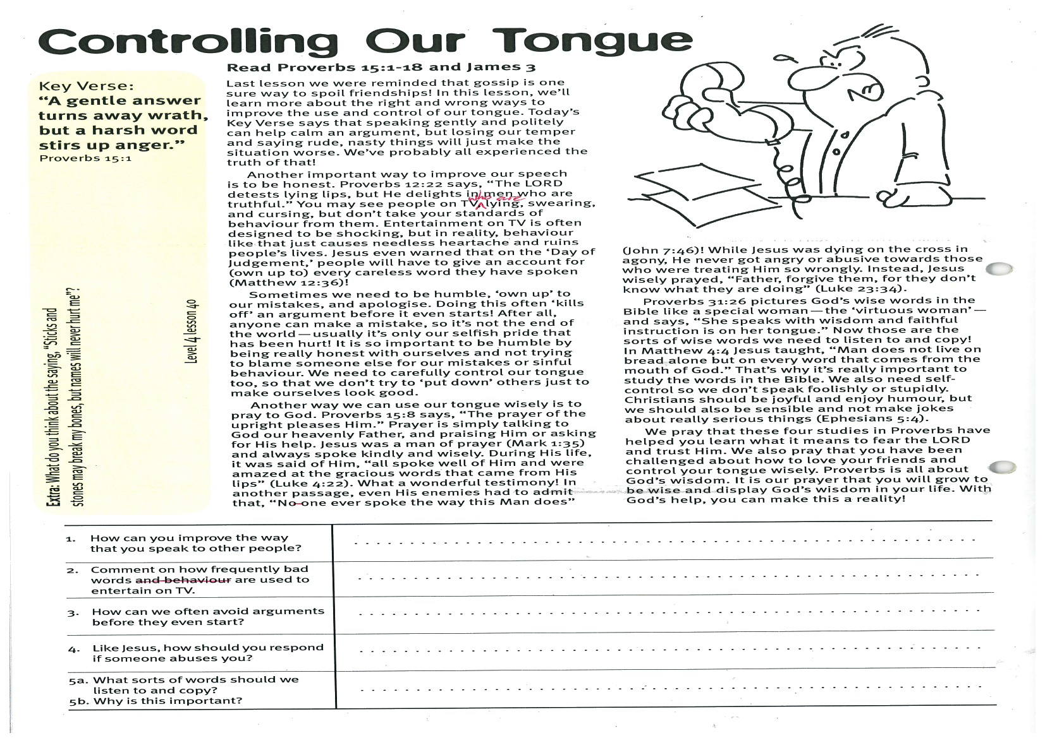
Controlling Our Tongue
Key Verse:
“A gentle answer turns away wrath, but a harsh word stirs up anger.”
Proverbs 15:1
Read Proverbs 15:1-18
and James 3
Last lesson we were reminded that gossip is one sure way to spoil friendships! In this lesson, we’ll learn more about the right and wrong ways to improve the use and control of our tongue. Today’s Key Verse says that speaking gently and politely can help calm an argument, but losing our temper and saying rude, nasty things will just make the situation worse. We’ve probably all experienced the truth of that!
Another important way to improve our speech is to be honest. Proverbs 12:22 says, “The LORD detests lying lips, but He delights in men who are truthful.” You may see people on TV who are lying, swearing, and cursing, but don’t take your standards of behaviour from them. Entertainment on TV is often designed to be shocking, but in reality, behaviour like that just causes needless heartache and ruins people’s lives. Jesus even warned that on the ‘Day of Judgement,’ people will have to give account for every careless word they have spoken! (Matthew 12:36)
Sometimes we need to be humble, ‘own up’ to our mistakes, and apologise. Doing this often ‘kills off’ an argument before it even starts! After all, anyone can make a mistake, so it’s not the end of the world - usually it’s only our selfish pride that has been hurt! It is so important to be humble by being really honest with ourselves and not trying to blame someone else for our mistakes or sinful behaviour. We need to carefully control our tongue too, so that we don’t try to ‘put down’ others just to make ourselves look good.
Another way we can use our tongue wisely is to pray to God. Proverbs 15:8 says, “The prayer of the upright pleases Him.” Prayer is simply talking to God as our Heavenly Father and praising Him or asking for His help. Jesus was a man of prayer (Mark 1:35) and always spoke kindly and wisely.
1. How can you improve the way that you speak to other people?
2. Comment on how frequently bad words are used to entertain on TV.
3. How can we often avoid arguments before they even start?
4. Like Jesus, how should you respond if someone abuses you?
5. (a) What sort of words should we listen to and copy? (b) Why is this important?
5
Extra: What do you think about the saying, “Sticks and stones may break my bones, but names will never hurt me”?
Level 4 lesson 40
QUESTIONS & ANSWERS
Please complete and return by post to
PSSM Bible Discovery, 5/399 New North Rd, Kingsland, Auckland 1021 or scan & email to info@biblediscovery.org.nz

During His life, it was said of Him, “all spoke well of Him and were amazed at the gracious words that came from His lips” (Luke 4:22). What a wonderful testimony! In another passage, even His enemies had to admit that, “No-one ever spoke the way this Man does” (John 7:46)! While Jesus was dying on the cross in agony, He never got angry or abusive towards those who were treating Him so wrongly. Instead, Jesus wisely prayed, “Father, forgive them, for they don’t know what they are doing” (Luke 23:34).
Proverbs 31:26 pictures God’s wise words in the Bible like a special woman - the ‘virtuous woman’ and says, “She speaks with wisdom and faithful instruction is on her tongue.” Now those are the sort of wise words we need to listen to and copy! In Matthew 4:4 Jesus taught, “Man does not live on bread alone but on every word that comes from the mouth of God.” That’s why it’s really important to study the words in the Bible. We also need self-control so we don’t speak foolishly or stupidly. Christians should be joyful and enjoy humour, but we should also be sensible and not make jokes about really serious things (Ephesians 5:4).
We pray that these four studies in Proverbs have helped you learn what it means to fear the LORD and trust Him. We also pray that you have been challenged about how to love your friends and control your tongue wisely. Proverbs is all about God’s wisdom. It is our prayer that you will grow to be wise and display God’s wisdom in your life. With God’s help, you can make this a reality!

