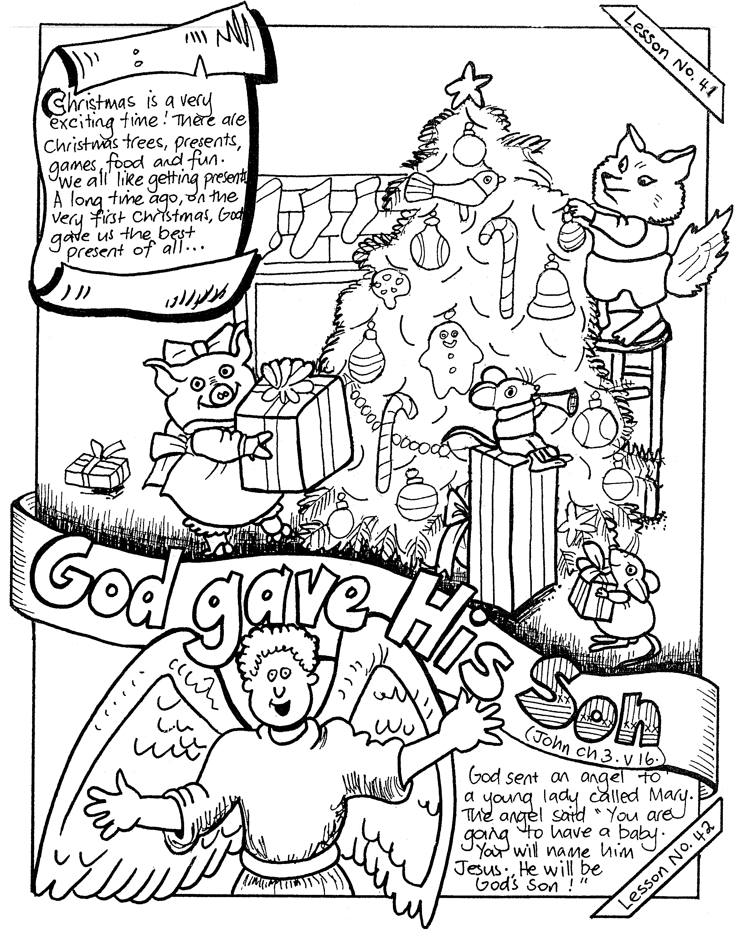

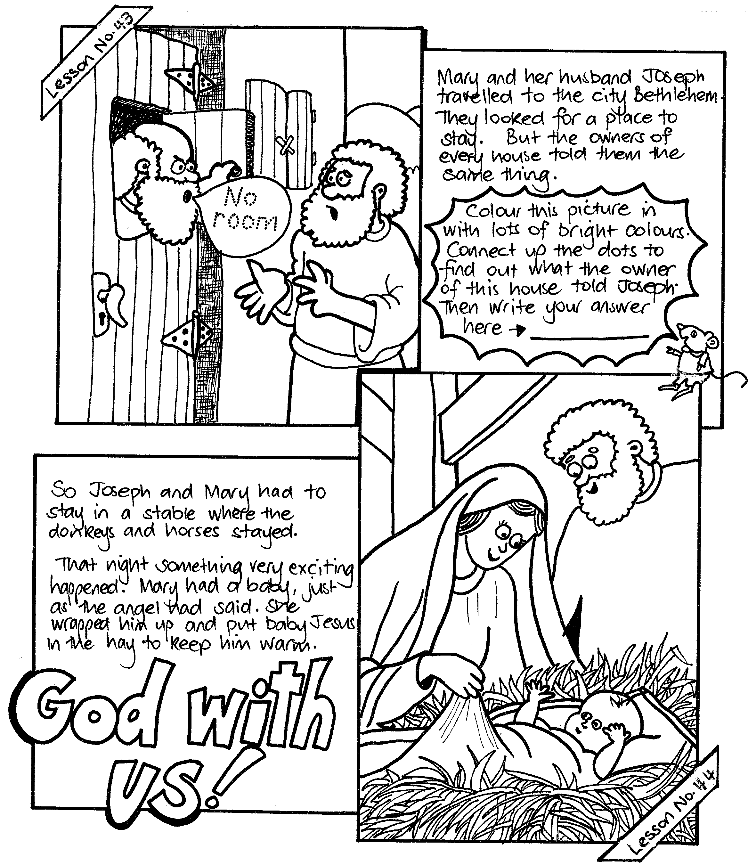
NOTE: THERE ARE NO LESSONS IN JANUARY. THE NEXT ONES WILL BE FOR FEBRUARY 2016.

