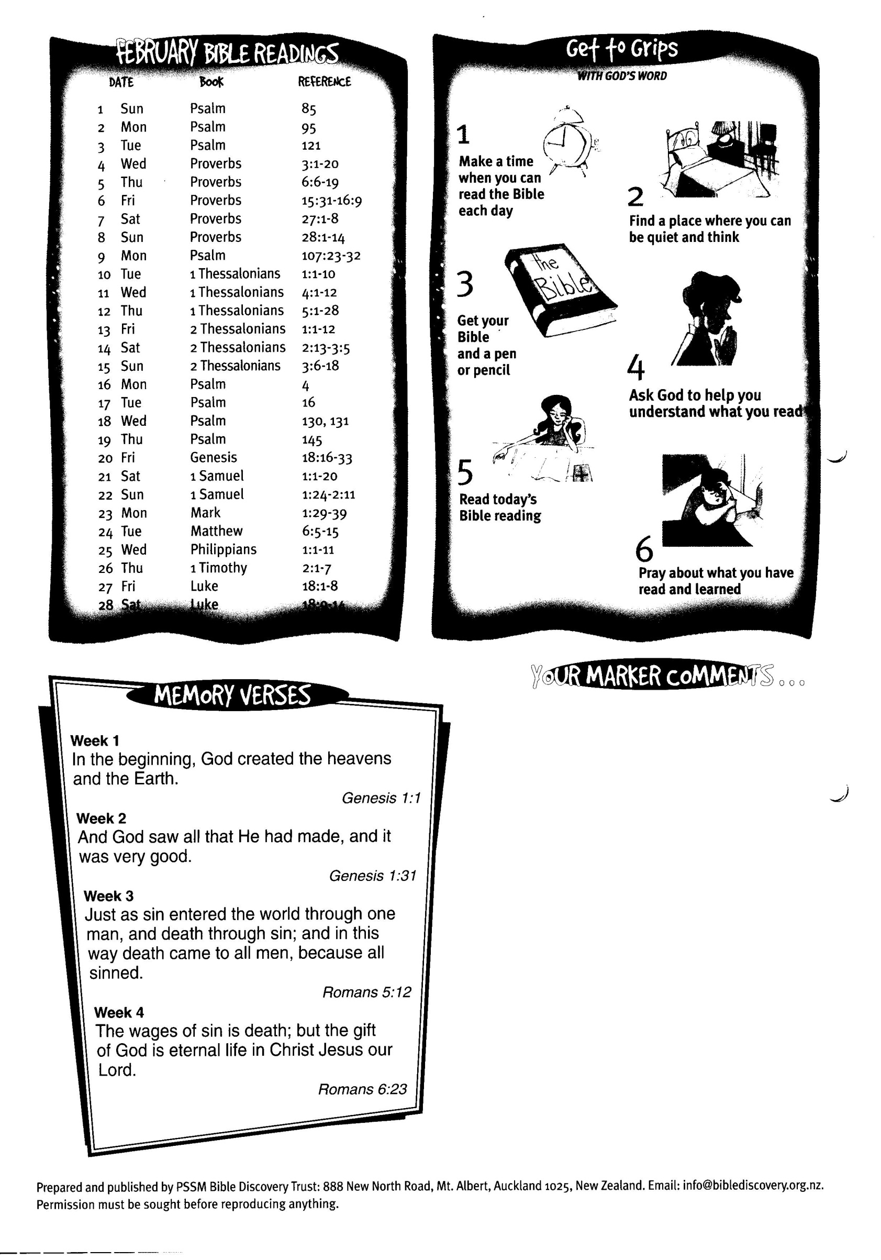

**28 Luke 18:9-14  
29 Psalm 23:1-6**

**February’16 Bible Readings**

DATE BOOK REFERENCE