**Read Proverbs 3:1-12**

*Welcome to another year of lessons! We hope you had a lovely, happy holiday. It would be nice to hear about what you did. With the holidays over, you’ll be back at school and we hope you make a good start for the term - and in your Bible lessons, too! We pray you will want to “Hide God’s Word in your heart, so you will not sin against Him.” That means to read the Bible, learn it, and obey it!*

Do you know what a motto is? It’s a helpful little saying with a lot of meaning. The Bible has some excellent mottos that can help and encourage you. Here are some good ones:

“Trust in the Lord with all your heart and never rely on what you think you know.” “Always tell the truth.” “Love one another.” “Be forgiving.” Can you think of a good one for yourself?

Maybe you could write it on a card and decorate it to make it look special.

Then you could put it up in your room so you can see it every day. That will help you to remember to do what it says!

The Bible is our guide-book. It tells us what God is like and how we can live to please Him. God wants to help us do what is right and good. So keep learning and obeying what He tells us in the Bible. Start now and make this your best year yet!

Key Verse:  
**“Teach me Your way, O Lord, and I will walk in Your truth.”**

Psalm 86:11

**The New Year**

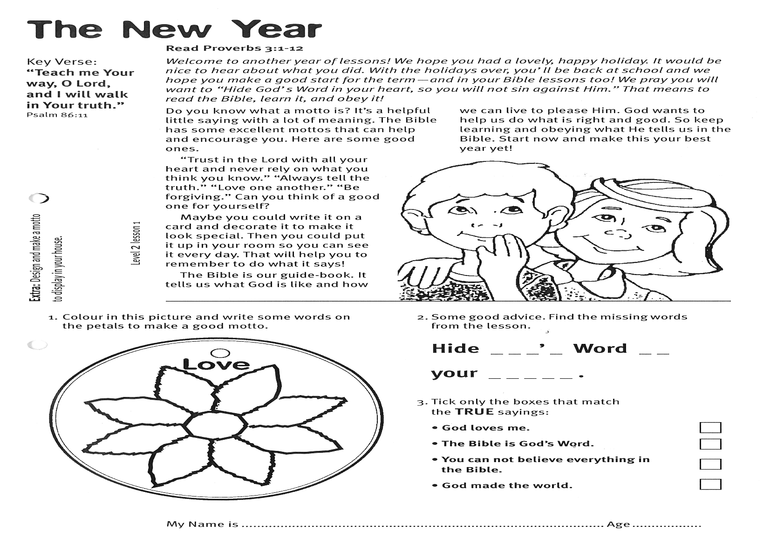

**Extra:** Design and make a motto to display in your house.

**3. Tick only the boxes that match the TRUE sayings:**

God loves me □

The Bible is God’s Word □

You cannot believe everything in the Bible □

God made the world □

**2. Find the missing words from the lesson, to complete this good advice:**

Hide __ __ __ ‘ __  
Word __ __ your  
__ __ __ __ __.

**1. Colour in this picture and write some words on the petals to make a good motto.**

My Name is________________________________________ Age ______________

**Level 2 lesson 1**

Samuel then lived at the temple and helped Eli the priest to serve God. Each year Hannah went to see Samuel and took him some new clothes. Samuel did his work well.

One night, when Samuel was about twelve, he heard a voice calling him. He thought it was Eli and ran in to see what he wanted. But it wasn’t Eli. Eli told him to go back to bed. Then the voice called again, “SAMUEL!” Again he ran in to Eli. After this happened three times, Eli realised it must be God calling Samuel. He told Samuel to be ready to answer the next time God called.

Sure enough, God called again! Samuel answered, “Speak, for your servant is listening.” God calls to us too, boys and girls. He asks us to listen to His teaching in the Bible. He wants us to love Him and do what He says. Let’s be like Samuel, quick to obey God and our parents.

**Read 1 Samuel 1:20-28   
and 1 Samuel 3:1-10**

The Bible has two main parts: The Old Testament was written before Jesus came; and the New Testament was written after Jesus was here on earth. There are 39 different books in the Old Testament.  
Let’s look at one named after a man called Samuel. In 1 Samuel we read about a lady, called Hannah. She was very sad because she didn’t have any children. So she prayed to God and asked Him for a little boy. She promised God that if He gave her a little son she would give the boy back to serve Him.

So God gave Hannah and her husband Elkanah a lovely baby boy. They called him SAMUEL which means, “asked of God.” Hannah kept her promise, too. When Samuel was about five, she took him to the temple.

**Samuel**

Key Verse:  
**“Speak, Lord, for Your servant is listening.”**

1 Samuel 3:9

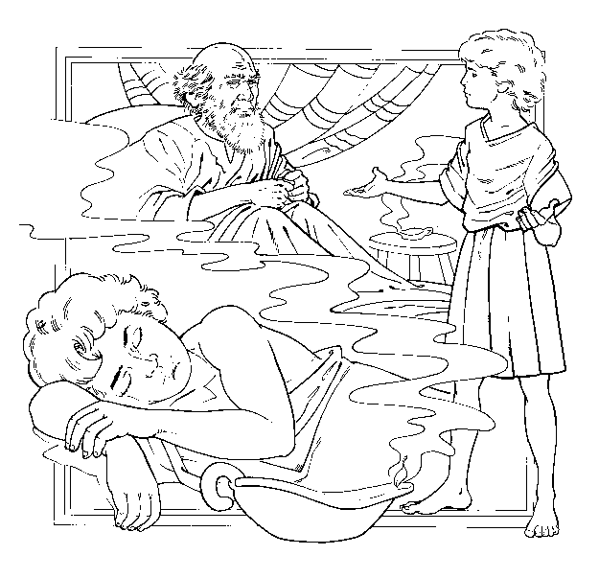

**Extra:** Find out what it means for someone to serve God.

**1. Tick true or false to answer:**  **TRUE FALSE**

a. Hannah asked God for a baby boy   
 b. God gave her a baby.   
 c. Samuel means “asked of God.”   
 d. One night Eli called Samuel.   
 e. Hannah broke her promise.   
 f. God wants us to obey Him.

**2. The Bible has two main parts. What are they?**

__ __ __ Testament

__ __ __ Testament

**3. Finish these sentences:**

a. The __ __ __ Testament was written before Jesus came

b. Samuel did his work __ __ __ __

c. __ __ __ calls to us too.

d. The New Testament was written __ __ __ __ __ Jesus came.

**Level 2 lesson 2**

**Colour in the picture of Samuel & Eli below**

So God told Samuel to give the people a king. Then He told Samuel where to find the right young man. His name was Saul.

When Samuel found him, Saul was looking for some of his father’s donkeys, which were lost. He was very tall and good-looking and a good worker. When Samuel saw him, God told him this was the one chosen to be king. Saul was made king of Israel and all the people said, “God save the King!”

Saul started off well as king. But sadly, when he grew older, he became proud, bad tempered, and disobedient. He forgot that God was in charge of his life and tried to do things his own way. When people think they know better than God, things always go wrong. Always let Jesus be in charge of your life. Remember our first lesson told us to “Trust in the Lord and never rely on what you think you know!”

**Read 1 Samuel 8:4-9, 22  
and 1 Samuel 9:1-17**

Samuel grew to be a good man, who loved and obeyed God. The people of Israel had no King and Queen. Instead, God gave them Judges to lead them. One was a strong man called Samson. He once killed a lion with his own hands!

Israel had lots of Judges and God made Samuel one, too. He was a good, righteous leader of His people. All the people loved him. Sadly, his sons were not good like he had been. They loved money more than they loved God. The people didn’t want them to be their leaders, so they asked Samuel to give them a man to be their King.

Samuel was very sad about this. He prayed to God about it. God was sad, too. He knew the people really didn’t want Him as their ruler.

Key Verse:  
**“The Lord is the great God, the great King above all gods.”**  
Psalm 95:3

**The First King**

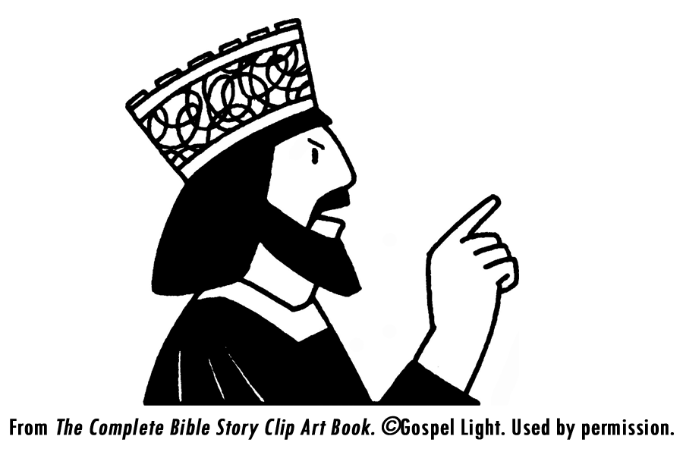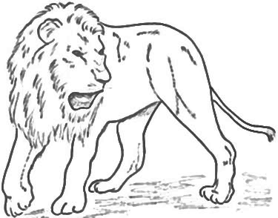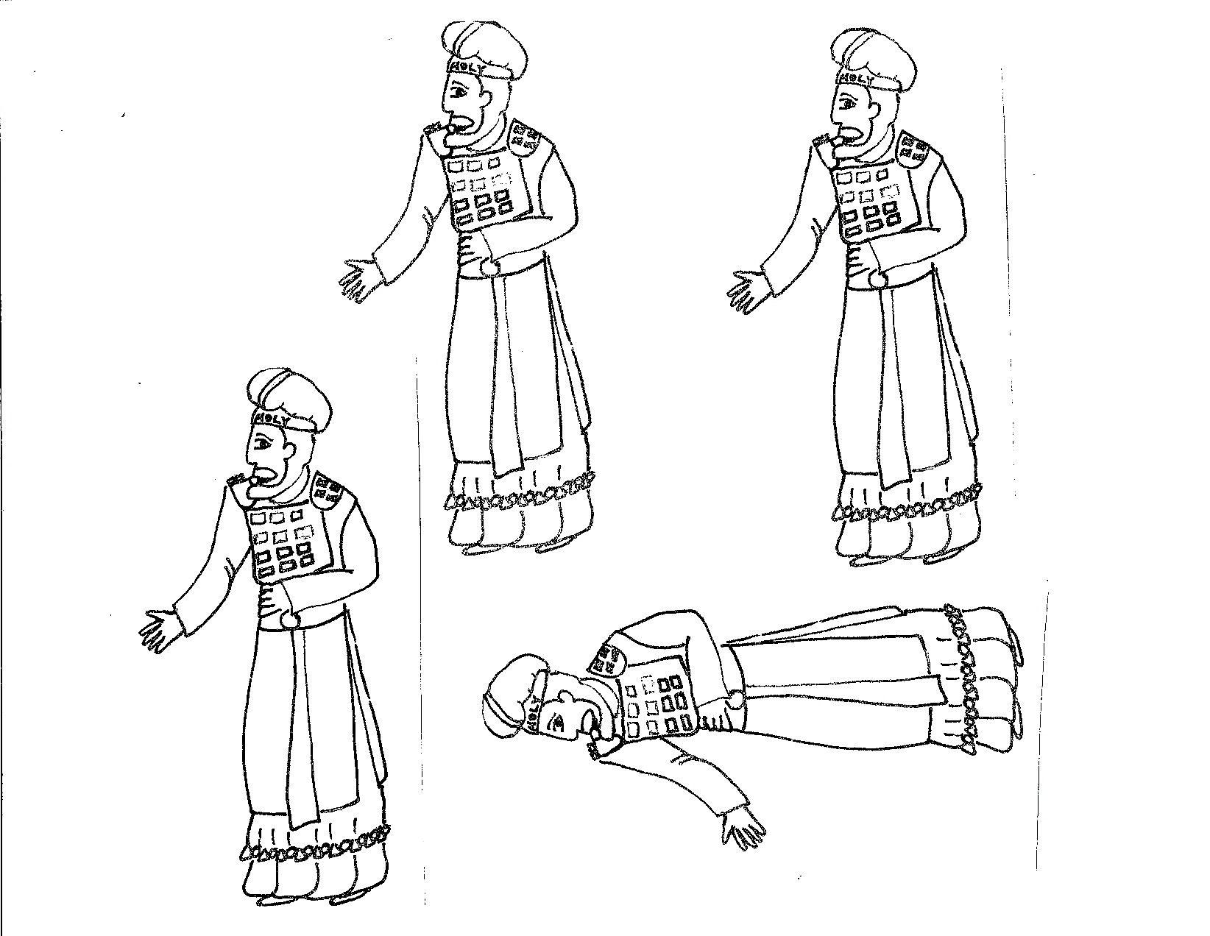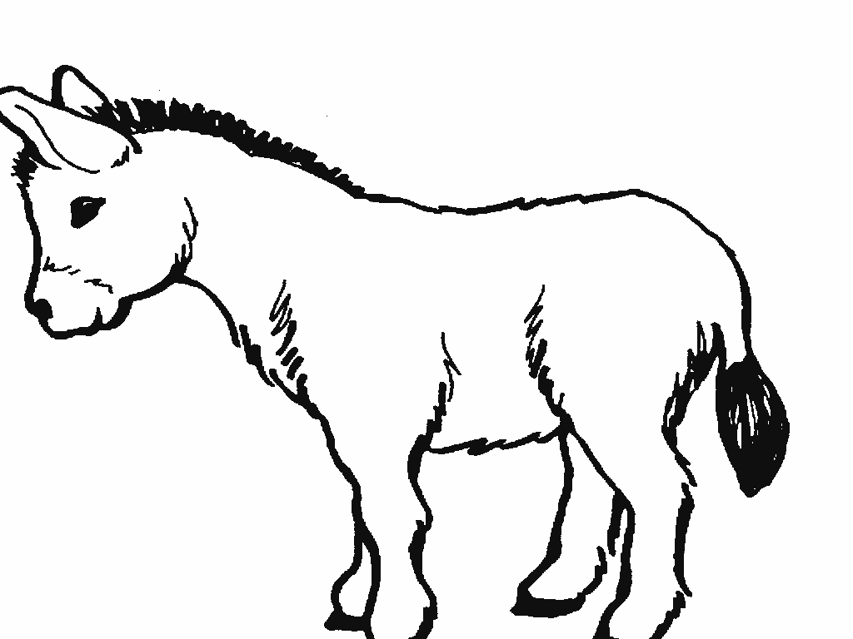

**Extra:** What happens when people think they know better than God?

**2. What did King Saul do when he got older?**__________________________________

__________________________________

__________________________________

**3. Fill in the missing letters:**

Saul tr__ __d

t__ d__

th__ __gs

h__s __wn

w__y.

**1. Match the names from this story with these pictures (one is used twice):**

**Samuel Saul Samson**

**Level 2 lesson 3**

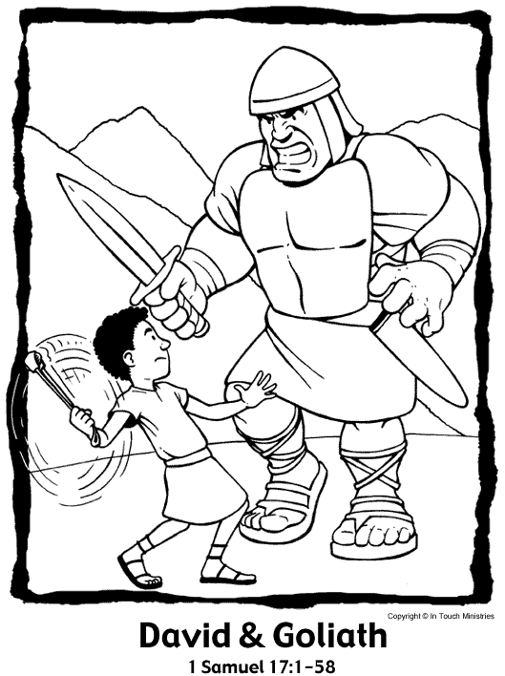

**Extra:** Tell us about a time when God has helped you a lot.

Key Verse:  
**“The Lord saves, for the battle is the Lord’s.”**

1 Samuel 17:47

**1. Black out the X’s to find the secret message in the box below:**

**Read 1 Samuel 17:32-51**

During the time Saul was king, the country of Israel had many enemies. Saul’s army often had to fight to protect the land. One of their enemies had a giant, a champion soldier named Goliath. He was over nine feet tall! Ask Mum or Dad to show you how tall that is. Goliath called out to Saul’s army to send someone out to fight him. But nobody was brave enough because he was so big and strong.

One day, a shepherd boy named David arrived to see his brothers who were in Saul’s army. He had been sent by his father to find out how they were getting on. While David was talking to them, Goliath again called out from the other side of the valley for someone to come and fight him.

David heard Goliath and saw that the soldiers in Saul’s army were all frightened. David told King Saul he would go and fight this giant! Everyone thought he was being silly, but David was serious. He was also very brave and not afraid. He told them how God had helped him kill a lion and a bear to protect his sheep. He knew God would help him kill this wicked giant who was saying bad things about God.

Saul said, “Go and the Lord be with you.” Saul gave David some armour to wear. But it was so heavy David couldn’t walk properly, so he took it off. He just took his sling and put five stones in his bag. Then he went to fight Goliath with God’s help. Goliath laughed at the shepherd boy. David said, “You come with a shield and a spear, but I come to you with God’s help!”

Then David put a stone in his sling, whirled it around and let the stone fly toward Goliath. It hit him hard on the forehead and Goliath crashed to the ground dead. David then took the giant’s own sword and cut off his head. God helped David win that great battle against those wicked people. God still helps us to do what is right too, if we trust Him like David did.

**XXGOXX**

**XXANDXXTHEXX**

**XXLORDXX**

**XXBEXXWITHXX**

**XXYOUXX**

Please complete and return by post to   
**PSSM Bible Discovery, 5/399 New North Rd, Kingsland, Auckland 1021** or scan & email to **info@biblediscovery.org.nz**

**2. Describe Goliath!**

________________________________

________________________________

________________________________

**3. Why do you think David was not afraid?**

________________________________

________________________________

________________________________

__ __ __ __ __

**David and Goliath**

**Level 2 lesson 4**