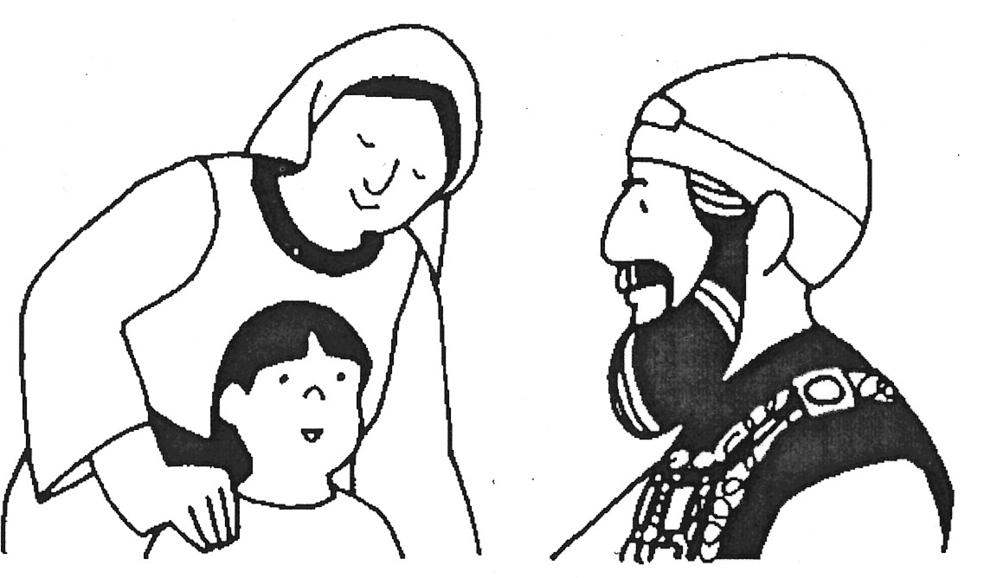
 |  | 1 |  |  | H
2
A
 | 3 |  |  |  | N
 |  |  | 4 |  | N
 |  |  |  | 5 | A
6 |  |  |  |  | H
Praying to God
Key Verse:
“Ask and it will be given to you; seek and you will find; knock and the door will be opened to you.”
Matthew 7:7
Read 1 Samuel 1
and Luke 18:1-8
HAPPY NEW YEAR! Let’s start the year by looking at the life of a man named Samuel. His story is found in the Bible’s Old Testament book of 1 Samuel. But first, think about this: Does prayer ever seem weird to you? Talking to your friends who you can see and touch is one thing, but talking to God (who is invisible) is another thing!
For some people, prayer seems strange - like talking into the air or speaking to an imaginary friend. Yet for people who already know God, it’s not weird but very real! For these people it’s perfectly normal to pray to the God of the Universe, because even though He is so great, He cares about them and listens to what they have to say! And so prayer is all about talking to God, thanking and praising Him, and asking Him for things.
In today’s reading we discover a married couple, Hannah and Elkanah, who loved God and prayed to Him often. Every year, they went to a place called Shiloh to worship God and offer special sacrifices in the temple, just as God had commanded. Hannah and Elkanah really wanted children of their own, but Hannah couldn’t get pregnant. She would often pray about this to God. She knew that only He could help her. In fact, James 1:17 says, “Every good and perfect gift is from above, coming down from the Father of the Heavenly lights.”

Extra: People who know and love God like to pray often. How often do YOU pray?
Level 3 lesson 1
One year, Eli the Priest saw Hannah praying in the temple and wondered what she was doing. Her lips were moving but he couldn’t hear her voice because she was praying silently. Eli spoke to Hannah and found out that she was very sad, and that she had been asking God for a son. She promised that if God gave her a son, she would give him back to God to serve Him in the temple. Hannah knew that everything she had then, and in her future, belonged to God. We need to remember this too, as it helps us to not be selfish about things.
Eli blessed Hannah for her faithful trust in the Lord, and God answered her prayer! Soon after this, she discovered she was pregnant and finally she gave birth to a little boy. They called him Samuel, which means “asked of God.” Hannah was so happy! She prayed and thanked the Lord for caring and answering her prayers. Thankful people can always find reasons to be joyful! Ungrateful people though, end up very miserable; always grumbling and complaining.
When Samuel was still a young boy, Hannah took him to the temple. She left Samuel there with Eli as she had promised, so that he could learn about the Lord and serve Him. She never forgot that God had answered her prayer in a wonderful way!
1. Fill in the missing letters
to complete this crossword:
1. Hannah was the _ _ _ _ _ _ of Samuel
2. Samuel means _ _ _ _ _ of God.

3. Hannah’s husband’s name E _ _ _ _ _ _
4. Hannah wanted a _ _ _
5. Hannah’s son’s name. _ _ _ _ _ _
6. The temple was in _ _ _ _ _ _
2. Unscramble this sentence:
NAHNAH ERUSTTD NI ETH DLOR
Answer: __________________________________
__________________________________________
3. Can you fill in the vowels?
S__ M __ __ L L __ __ R N __ D
__ B __ __ T T H __ L __ R D.
My Name is ……………………………………………………… Age…………………

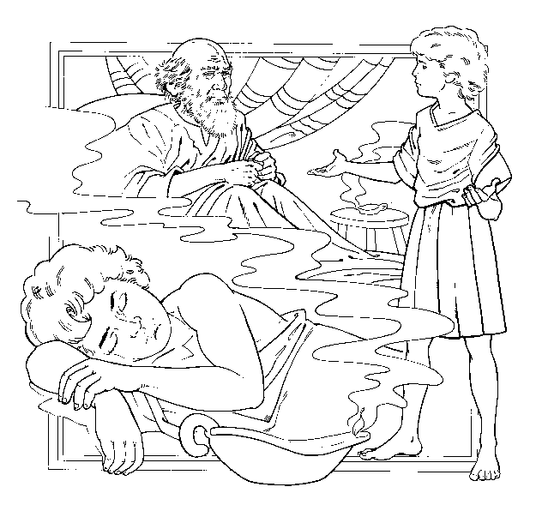
Never Too Young...
Key Verse:
“Speak, Lord, for Your servant is listening.”
1 Samuel 3:9
Read 1 Samuel 3:1-14
and Matthew 19:13-15
Don’t you hate it when people tell you that you’re too young to do something!?? But there is something that you can do, no matter how young you are! Not only can you do it by yourself, but nobody else can do it for you. When it comes to knowing and trusting God, it’s something that each person has to understand and believe for themselves! This is important, good news, because there is no age limit for becoming a friend of God!
Samuel was still a young boy when this story took place. He had been living at the temple with Eli the Priest, learning all about the Lord God. However, Samuel didn’t really know the Lord yet (1 Samuel 3:7). He knew about God, but didn’t really know Him. It’s like when we see someone famous on TV, or in a magazine; we might recognise those people and know all about them, but we don’t know them personally. And we certainly wouldn’t be called their friend! In the same way, it’s good to learn about the Lord from our parents, Bible teachers, or Christian friends, but we need to do more than that. We need to know God personally.
Samuel’s relationship with God began late one night in the Temple. After finishing all his daily duties, Samuel went to bed. Suddenly, in the still of night, he heard a voice, “Samuel!” He sat bolt upright in bed, straining his ears to hear anything. “It must be Eli!” he thought, and ran into the old priest’s room. “Here I am,” he said. “What’s the matter?” “I didn’t call you,” said Eli, “Go back to bed!” They were probably both a bit confused now! They were the only two people there at the time, so who had called out the boy’s name if it wasn’t Eli?

S | O | U | I | S | G
P | Y | R | T | L | N
E | R | S | N | I | I
A | O | E | A | S | N
K | F | R | V | T | E
Extra: Why is it so important to know and trust God?
Level 3 lesson 2
Twice more this happened, until finally Eli realised that Samuel was hearing God calling him! The old Priest said to the boy, “Go back to bed. If you hear someone call you again, answer, ‘Speak, Lord, for your servant is listening.’” Samuel went back to bed and waited. Again he heard his name called: “Samuel! Samuel!” No doubt a bit nervous, Samuel obeyed Eli’s instructions and said, “Speak, for your servant is listening.”
So the Lord God spoke to him that night. He told Samuel that He was very angry with Eli’s own two sons. They were not obedient like Samuel, but were rebellious and evil. In fact, He was going to terribly punish Israel because of their sinful behaviour.
We all have a similar opportunity to Samuel. We have the Bible - God’s special message for us - written down so that we can know who He is and what He expects of us. We can be rebellious and wicked like Eli’s sons and refuse to listen to God, or we can follow Samuel’s obedient and faithful example. Will you listen to and trust what God has to say? Will you believe that Jesus died to save you? Will you obey Him as Lord? The reward is to become a friend of God. You are never too young… but are you willing to listen and obey?
1. Can you figure out what this says? Hint: ↓↑↓↑
Answer: ______________________________________________
_______________________________________________________
2. Find the names of these people in this story:
S __ __ __ __ __ E __ __
L __ __ __ G __ __
3a. Another name for God’s Word:
The __ __ __ __ __
b. The opposite of obey: __ __ __ __ __ __ __
c. We must learn to __ __ __ __ __ __ and
__ __ __ __ while we are still y__ __ __ __
d. The Bible is God’s special m__ __ __ __ __ __ to us.

Start here ↓

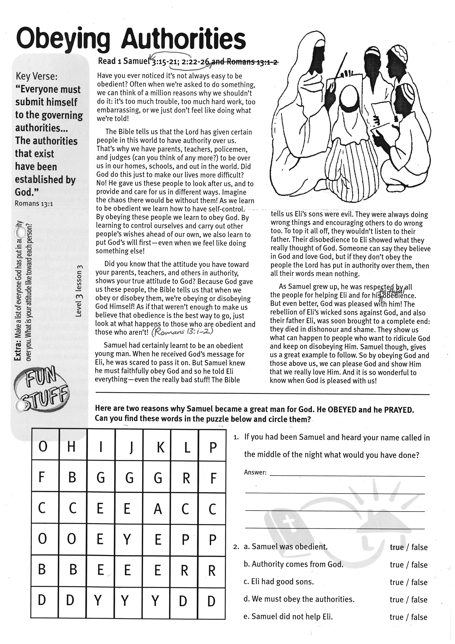
Obeying Authorities
Key Verse:
“Everyone must submit himself to the governing authorities... The authorities that exist have been established by God.”
Romans 13:1
Read 1 Samuel 2:22-26; 3:15-21
Have you ever noticed it’s not always easy to be obedient? Often when we’re asked to do something, we can think of a million reasons why we shouldn’t do it: it’s too much trouble, too much hard work, too embarrassing, or we just don’t feel like doing what we’re told!
The Bible tells us that the Lord has given certain people in this world to have authority over us. That’s why we have parents, teachers, policemen, and judges (can you think of any more?) to be over us in our homes, schools, and out in the world. Did God do this just to make our lives more difficult? No! He gave us these people to look after us, and to provide and care for us in different ways. Imagine the chaos there would be without them! As we learn to be obedient we learn how to have self-control. By obeying these people we learn to obey God. By learning to control ourselves and carry out other people’s wishes ahead of our own, we also learn to put God’s will first - even when we feel like doing something else!
Did you know that the attitude you have toward your parents, teachers, and others in authority, shows your true attitude to God? Because God gave us these people, the Bible tells us that when we obey or disobey them, we’re obeying or disobeying God Himself! As if that weren’t enough to make us believe that obedience is the best way to go, just look at what happens to those who are obedient and those who aren’t! (Romans 13:1-2).
Samuel had certainly learnt to be an obedient young man. When he received God’s message for Eli, he was scared to pass it on.

Level 3 lesson 3
Extra: Make a list of everyone God has put in authority over you. What is your attitude like toward each person?
 | H | I | J | K | L | P
F | B | G | G | G | R | F
C | C | E | E | A | C | C
O | O | E | Y | E | P | P
B | B | E | E | E | R | R
D | D | Y | Y | Y | D | D
But Samuel knew he must faithfully obey God and so he told Eli everything; even the really bad stuff! The Bible tells us Eli’s sons were evil. They were always doing wrong things and encouraging others to do wrong, too. To top it all off, they wouldn’t listen to their father. Their disobedience to Eli showed what they really thought of God. Someone can say they believe in God and love God, but if they don’t obey the people the Lord has put in authority over them, then all their words mean nothing.
As Samuel grew up, he was respected by all the people for helping Eli and for his faithful obedience. Much more than that, God was pleased with him, too! The rebellion of Eli’s wicked sons against God, and also their father Eli, was soon brought to a complete end: they died in dishonour and shame. They show us what can happen to people who want to ridicule God and keep on disobeying Him. Samuel though, gives us a great example to follow. So by obeying God and those above us, we can please God and show Him that we really love Him. And nothing is better than knowing that God is pleased with us!
1. If you had been Samuel and heard your name called in the middle of the night, what would you have done?
Answer: ____________________________________
_____________________________________________
_____________________________________________
2. True or False?
a. Samuel was obedient. true / false
b. Authority comes from God. true / false
c. Eli had good sons. true / false
d. We must obey the authorities. true / false
e. Samuel did not help Eli. true / false
Here are two reasons why Samuel became a great man for God: He OBEYED and he PRAYED. Can you find these words in the puzzle above and circle them?

O H I J K L P
F B G G G R F
C C E E A C C
O O E Y E P P
B B E E E R R
D D Y Y Y D D
Extra: Make a list of everyone God has put in authority over you. What is your attitude toward each person?
Level 3 Lesson 3
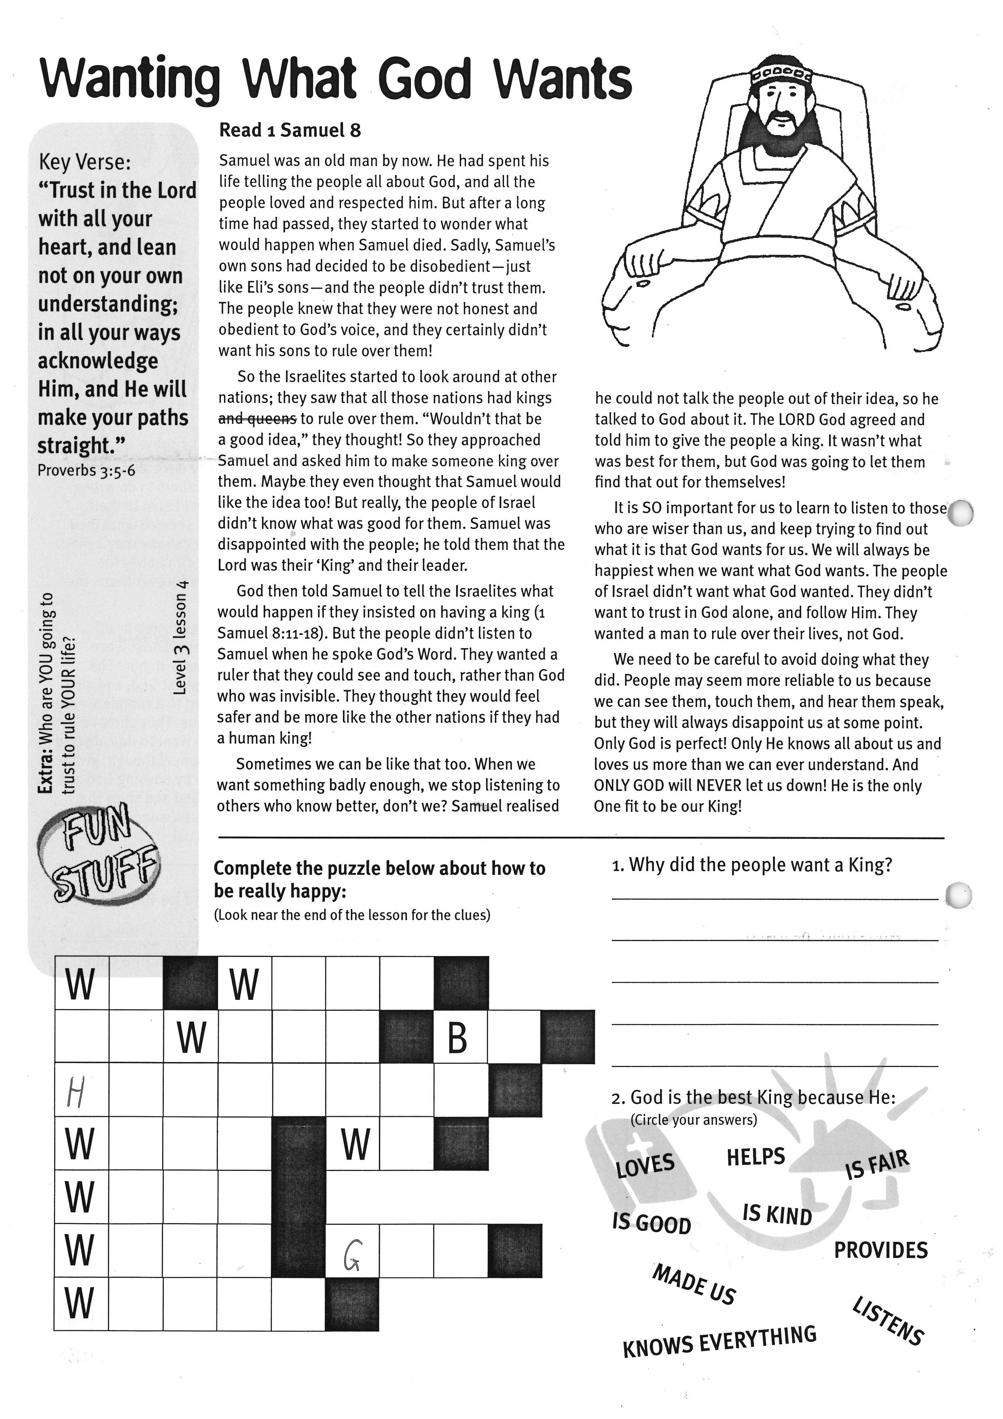
W |  |  | W
 |  | W |  |  |  |  | B
H
W |  |  |  |  | W
W
W |  |  |  |  | G
W
Key Verse:
“Trust in the Lord with all your heart, and lean not on your own understanding; in all your ways acknowledge Him, and He will make your paths straight.”
Proverbs 3:5-6
Read 1 Samuel 8
Samuel was an old man by now. He had spent his life telling the people all about God, and all the people loved and respected him. But after a long time had passed, they started to wonder what would happen when Samuel died. Sadly, Samuel’s own sons had decided to be disobedient (just like Eli’s sons) and the people didn’t trust them. The people knew that they were not honest and obedient to God’s voice, and they certainly didn’t want his sons to rule over them!
So the Israelites started to look around at other nations; they saw that all those nations had kings to rule over them. “Wouldn’t that be a good idea,” they thought! So they approached Samuel and asked him to make someone king over them. Maybe they even thought that Samuel would like the idea, too! But really, the people of Israel didn’t know what was good for them. Samuel was disappointed with the people; he told them that the Lord was their ‘King’ and their leader.
God then told Samuel to tell the Israelites what would happen if they insisted on having a king
(1 Samuel 8:11-18). But the people didn’t listen to Samuel when he spoke God’s Word. They wanted a ruler that they could see and touch, rather than God who was invisible. They thought they would feel safer and be more like the other nations if they had a human king!

Sometimes we can be like that, too. When we want something badly enough, we stop listening to others who know better, don’t we?
Wanting What God Wants
Level 3 lesson 4
Extra: Who are you going to trust to rule YOUR life?

1. Why did the people want a King?
___________________________________
___________________________________
___________________________________
2. God is the best King because He:
(Highlight your answers)
LOVES IS KIND
HELPS PROVIDES
IS FAIR MADE US
IS GOOD LISTENS
KNOWS EVERYTHING
Answer:
Complete the puzzle above about how to be really happy:
(Look near the end of the lesson for the sentence)

Sometimes we can be like that, too. When we want something badly enough, we stop listening to others who know better, don’t we? Samuel realised he could not talk the people out of their idea, so he talked to God about it. The Lord God agreed and told him to give the people a king. It wasn’t what was best for them, but God was going to let them find that out for themselves!
It is SO important for us to learn to listen to those who are wiser than us, and keep trying to find out what it is that God wants for us. We will always be happiest when we want what God wants. The people of Israel didn’t want what God wanted. They didn’t want to trust in God alone, and follow Him. They wanted a man to rule over their lives, not God.
We need to be careful to avoid doing what they did. People may seem more reliable to us because we can see them, touch them, and hear them speak, but they will always disappoint us at some point. Only God is perfect! Only He knows all about us and loves us more than we can ever understand. And ONLY GOD will NEVER let us down! He is the only One fit to be our King!
Please complete and return by post to
PSSM Bible Discovery, 5/399 New North Rd, Auckland 1021 or scan & email to info@biblediscovery.org.nz

Please complete and return by post to
PSSM Bible Discovery, 5/399 New North Rd, Auckland 1021 or scan & email to info@biblediscovery.org.nz

