The Saviour’s Home at Nazareth
Key Verse:
“For He will command His angels concerning you, to guard you in all your ways.”
Psalm 91:11
Read Matthew 2:13-23
and Luke 2:39-40
Welcome to the start of a New Year of Bible Discovery lessons & we trust you had wonderful Christmas holiday break!
Last year we learnt a lot of interesting lessons from the lives of Jacob, Joseph, and others in the Old Testament. These men were great and important men of Bible history. This year we’re going to begin by looking at the life, teachings, and works of the man who is without doubt or question, the greatest and most important figure in all of history: Jesus Christ!
In fact, history and our calendar dates are divided into ‘before Christ was born’ (B.C.) and ‘after Jesus was born’ (A.D.) Now THAT’S important!! Sadly, some people know nothing of this wonderful One, the Son of God. There is so much we can learn from Him through what has been recorded for us in the New Testament. He came to reveal what God our creator is like and His will and purpose for us as people.
Of course, much of the world has recently celebrated Jesus’ birth, at Christmas time. In our last lesson, we talked about His special birth and how the Wise Men visited Him in Bethlehem. If you want to refresh your memory, check it out in Luke chapter 2 of your Bible.
After the wise men had been warned by God in a dream to leave Bethlehem, Joseph, the husband of Mary (Jesus’ mother) was also warned by God in a dream, “Arise and take the young child and His mother, and hurry into Egypt,” He said. “Stay there until I tell you to leave, for Herod will try to kill the child.” Joseph obeyed by immediately packing up their belongings and leaving while it was still dark.

1. What message did Joseph receive from the angel after the Wise Men left Bethlehem? | T |  |  |  |  | T |  |  |  | Y |  |  |  |  |  | C |  |  |  |  |  | A |  |  |  | H
 | M |  |  |  |  |  |  | A |  |  |  | H |  |  |  |  |  | I |  |  |  |  | E
2. How would you describe King Herod?
3. What did Herod hope to do by killing all the boys under 2 years of age?
4. How did God protect Jesus and His family?
5. Where did Jesus live as a boy?
Level 3 lesson 1
Extra: Compare the childhood of Moses and Jesus.
Level 4 lesson 1
QUESTIONS & ANSWERS
The Right Start
Key Verse:
“Jesus said, ‘I tell you the truth, unless a man is born again, he cannot see the kingdom of God.’”
John 3:3
For days and weeks they travelled, until they found a safe place to stay near the Nile River, in Egypt. Back in Jerusalem, ‘Herod the Great’ was waiting for the wise men to return with details of where this “new King” was. Herod was a wicked, evil man, intent only on keeping power and riches for himself. He had no intention of worshipping this new ‘King’ as had been claimed! Instead, as we’ll see, he planned to murder the child and so prevent any future threat to his reign.
So as Herod waited, and waited, he got madder and madder! Finally, realising that he’d been outsmarted, he flew into a rage and sent for his soldiers. “Go to Bethlehem and kill all the boys who are under two years old!” he bellowed. “In that way,” he thought, “I will surely destroy the child, for from what the Wise Men said, this king is still only a baby.” What an evil, murderous man!
We can hardly imagine the grief his order caused to so many families! But Jesus was safe and for two years the little family lived peacefully in Egypt. Then Herod died, and once more Joseph had a dream. The angel of the Lord said, “Get up, take the child and His mother, and go back to the land of Israel, for those who were trying to take the child’s life are dead.”
As they were returning to Israel, God warned Joseph not to return to Bethlehem, but to settle in Nazareth, a village in the district of Galilee. So Jesus grew up there in that humble village. The people in the village, who saw the happy child coming and going with His mother along the street, or helping Joseph with the carpentry, did not realise that Jesus was the Christ (Israel’s Messiah and deliverer) and was living among them! So Jesus grew into a strong, lovely boy, pure in heart and loved by all who knew Him.
My Name is _____________________________________________ Age ___________
Jesus Visits the Temple
Key Verse:
“And Jesus grew in wisdom and stature and in favour with God and men.”
Luke 2:52
Read Luke 2:41-52
As soon as Jesus was old enough He went to the village school. This was held in the synagogue, which was where Jewish people met to read and learn from God’s Word. None of the children had text-books as we do today; instead their only lessons were from the “books” of the Old Testament part of the Bible. They were actually large scrolls rather than books, and were read from by the teacher.
As they grew older, every Jewish boy was expected to have some useful occupation, or trade. Joseph was the village carpenter, and so Jesus learnt this trade, too. A carpenter in those days not only built houses; he made carts, and ploughs, and yokes for the necks of the oxen, who drew the ploughs and wagons. He made tables and chairs, and all the furniture for the village homes.
The Bible tells us very little about the years Jesus spent in Nazareth, but there is one story which gives us an insight into His real identity. When Jesus was twelve years old, Joseph and Mary took Him to the great Jewish feast of the Passover. This was held in the temple at Jerusalem every year. This Passover Feast recalled the night long ago when the Israelites were gathered together to leave Egypt and go out into the wilderness. You can read about this story in Exodus 11-12.
In Egypt, they were told that God’s Angel of Death would be visiting that night and would kill the first-born of every family in Egypt, except for houses where the door-posts were sprinkled with the blood of a lamb.
So in obedience to God’s command, each Israelite family killed a lamb, sprinkled the blood on the sides and top of the doorway, and stood waiting for the judgement of God to fall on the oppressive Egyptians. Just as God promised, His judgement fell on the Egyptians, but the Angel of Death passed over the Jews and they then quickly escaped from slavery in Egypt!
Jesus must have been excited as He entered Jerusalem, to see the temple and take part in the Passover Feast. In fact, Jesus was so delighted and interested that when Joseph and Mary and their friends set out to return to Nazareth, He stayed behind! At first He wasn’t missed. Joseph and Mary were thinking that He was with some of their friends. But when they couldn’t find him, they anxiously returned to Jerusalem to look for Him.
After three days they found Him sitting in the temple with the teachers and educated men, listening to them and questioning them. They were amazed at His knowledge and understanding. His mother said to Him, “Son, why have you done this to us? We’ve been anxiously looking for You.” Jesus replied, “Didn’t you know I had to be in My Father’s house?” Basically, He was telling them that He was sent from God and that His actual Father was God!
So He left with his parents, and for years He continued to live in humble obedience at home in Nazareth. Yes, the Lord Jesus was obedient to His mother and Joseph all the years that He was with them in their home. In this way Jesus was a great example to all the boys and girls that He grew up with. What an example that is for us, too! Jesus did all these things to please and honour God, so let us live to please and honour God also!
1. What work did Jesus learn to do as a young man?
2. Why did the Jews keep the Passover feast?
3. What was Jesus doing in the Temple when Mary and Joseph found Him? (Clue: Take the next alphabetical letter and write it below)
  K | H | R | S | D | M | H | M | F | & | P | T | D | R | S | H | N | M | H | M | F
  L |  |  |  |  |  |  |  |  | & | Q
4. What did Jesus mean when He answered His mother at the temple?
5. What great example did Jesus show when He returned home?
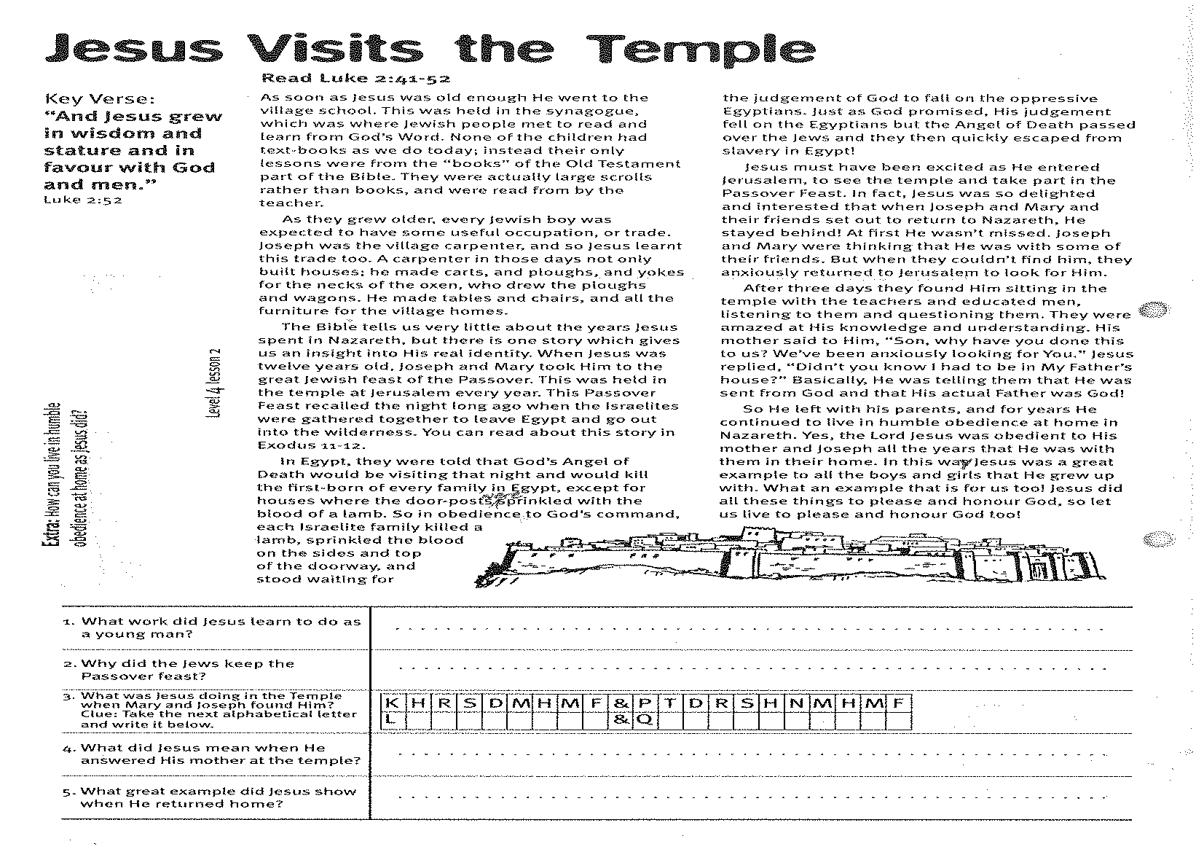
Extra: How can you live in humble obedience at home as Jesus did?
Level 4 lesson 2
QUESTIONS & ANSWERS

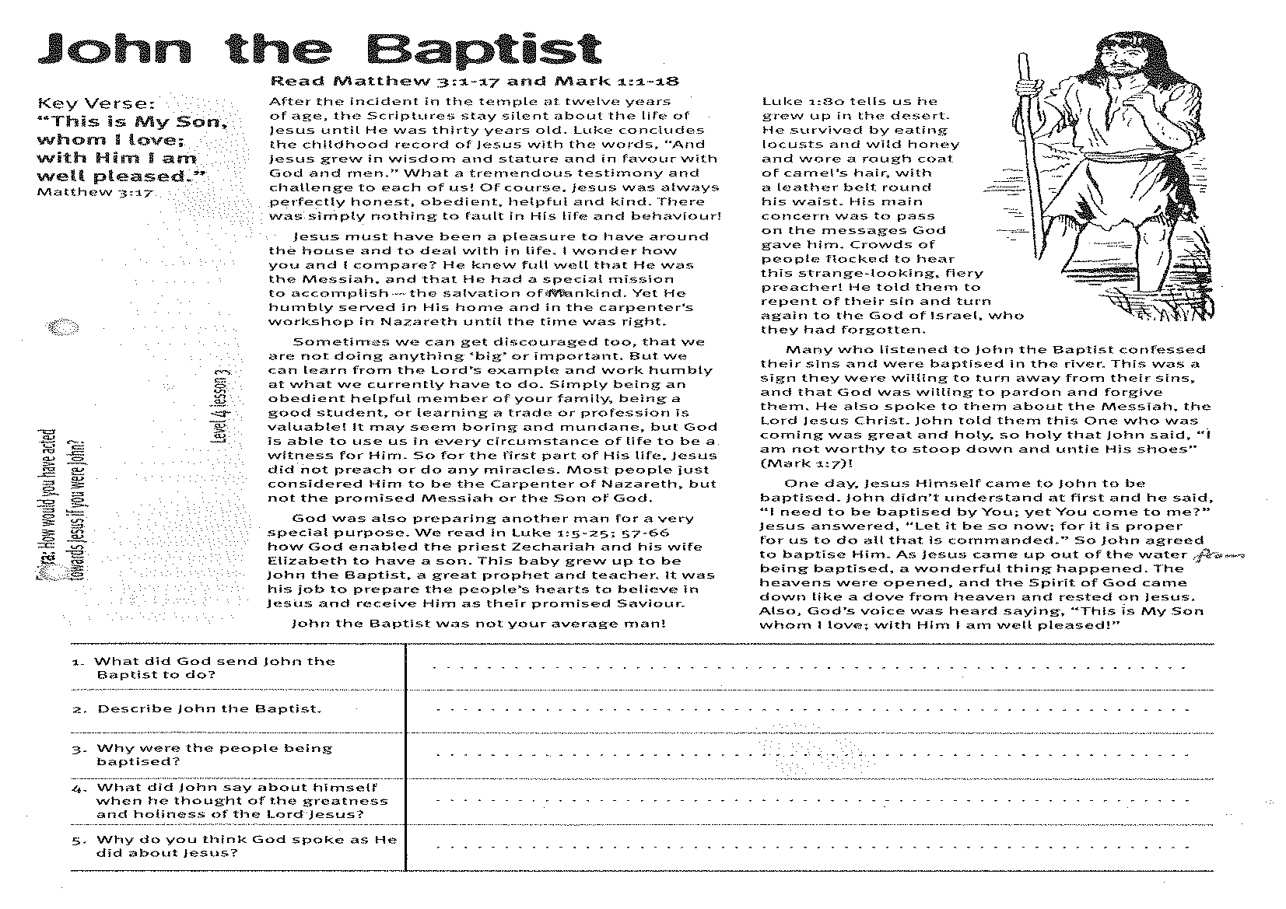
John the Baptist
Key Verse:
“This is My Son, whom I love; with Him I am well pleased.”
Matthew 3:17
Read Matthew 3:1-17
and Mark 1:1-18
After the incident in the temple at twelve years of age, the Scriptures stay silent about the life of Jesus until He was thirty years old. Luke concludes the childhood record of Jesus with the words, “And Jesus grew in wisdom and stature and in favour with God and men.” What a tremendous testimony and challenge to each of us! Of course, Jesus was always perfectly honest, obedient, helpful and kind. There was simply nothing to fault in His life and behaviour!
Jesus must have been a pleasure to have around the house and to deal with in life. I wonder how you and I compare? He knew full well that He was the Messiah, and that He had a special mission to accomplish - the salvation of mankind. Yet He humbly served in His home and in the carpenter’s workshop in Nazareth until the time was right.
Sometimes we can get discouraged, feeling that we are not doing anything ‘big’ or important. But we can learn from the Lord’s example and work humbly at what we currently have to do. Simply being an obedient helpful member of your family, being a good student, or learning a trade or profession is valuable! It may seem boring and mundane, but God is able to use us, in every circumstance of life, to be a witness for Him. So for the first part of His life, Jesus did not preach or do any miracles. Most people just considered Him to be the carpenter of Nazareth, but not the promised Messiah or the Son of God.
God was also preparing another man for a very special purpose. We read in Luke 1:5-25; 57-66 how God enabled the priest Zechariah and his wife Elizabeth to have a son. This baby grew up to be John the Baptist, a great prophet and teacher. It was his job to prepare the people’s hearts to believe in Jesus and receive Him as their promised Saviour.
John the Baptist was
not your average man!
Luke 1:80 tells us he
grew up in the desert.
He survived by eating
locusts and wild honey
and wore a rough coat
of camel’s hair, with a
leather belt round his
waist. His main concern
was to pass on the messages
God gave him. Crowds of people
flocked to hear this strange-looking,
fiery preacher! He told them to repent of their sin and turn again to the God of Israel, who they had forgotten.
Many who listened to John the Baptist confessed their sins and were baptised in the river. This was a sign they were willing to turn away from their sins, and that God was willing to pardon and forgive them. He also spoke to them about the Messiah, the Lord Jesus Christ. John told them this One who was coming was great and holy, so holy that John said, “I am not worthy to stoop down and untie His shoes”! (Mark 1:7)
One day, Jesus Himself came to John to be baptised. John didn’t understand at first and he said, “I need to be baptised by You; yet You come to me?” Jesus answered, “Let it be so now; for it is proper for us to do all that is commanded.” So John agreed to baptise Him. As Jesus came up out of the water from being baptised, a wonderful thing happened. The heavens were opened, and the Spirit of God came down like a dove from heaven and rested on Jesus. Also, God’s voice was heard saying, “This is My Son whom I love; with Him I am well pleased!”
We trust that God is well-pleased with your obedience to Him, also!
1. What did God send John the Baptist to do?
2. Describe John the Baptist.

3. Why were the people being baptised?
4. What did John say about himself when he thought of the greatness and holiness of the Lord Jesus?

5. Why do you think God spoke as He did about Jesus?
Extra: How would you have acted towards Jesus if you were John?
Level 4 lesson 3
QUESTIONS & ANSWERS
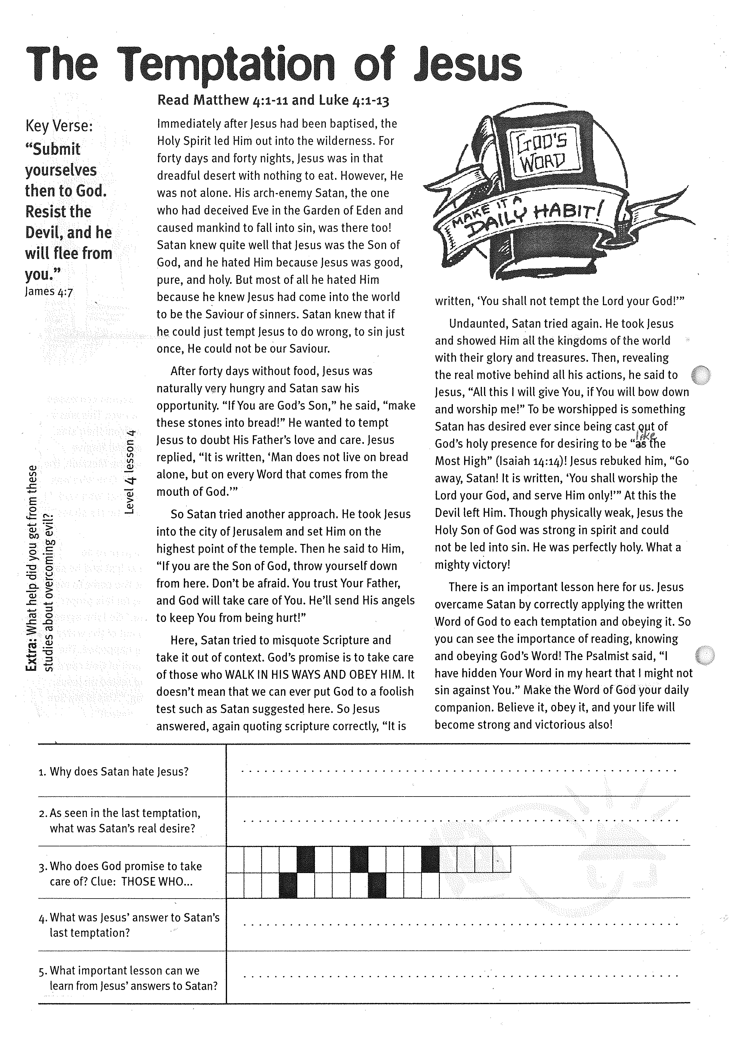
The Temptation of Jesus
Key Verse:
“Submit yourselves then to God. Resist the Devil, and he will flee from you.”
James 4:7
Read Matthew 4:1-11
and Luke 4:1-13
Immediately after Jesus had been baptised, the Holy Spirit led Him out into the wilderness. For forty days and forty nights, Jesus was in that dreadful desert with nothing to eat. However, He was not alone. His arch-enemy Satan, the one who had deceived Eve in the Garden of Eden and caused mankind to fall into sin, was there too! Satan knew quite well that Jesus was the Son of God, and he hated Him because Jesus was good, pure, and holy. But most of all he hated Him because he knew Jesus had come into the world to be the Saviour of sinners. Satan knew that if he could just tempt Jesus to do wrong, to sin just once, He could not be our Saviour.
After forty days without food, Jesus was naturally very hungry and Satan saw his opportunity. “If You are God’s Son,” he said, “make these stones into bread!” He wanted to tempt Jesus to doubt His Father’s love and care. Jesus replied, “It is written, ‘Man does not live on bread alone, but on every Word that comes from the mouth of God.’”
So Satan tried another approach. He took Jesus into the city of Jerusalem and set Him on the highest point of the temple. Then he said to Him, “If you are the Son of God, throw yourself down from here. Don’t be afraid. You trust Your Father, and God will take care of You. He’ll send His angels to keep You from being hurt!”
Here, Satan tried to misquote Scripture and take it out of context. God’s promise is to take care of those who WALK IN HIS WAYS AND OBEY HIM. It doesn’t mean that we can ever put God to a foolish test such as Satan suggested here.

1. Why does Satan hate Jesus?
2. As seen in the last temptation, what was Satan’s real desire?
.
3. Who does God promise to take care of?
Clue: THOSE WHO…

4. What was Jesus’ answer to Satan’s last temptation?
5. What important lesson can we learn from Jesus’ answers to Satan?
Please complete and return by post to
PSSM Bible Discovery, 5/399 New North Rd, Auckland, 1021 or scan & email to info@biblediscovery.org.nz

Extra: What help did you get from these studies about overcoming evil?
Level 4 lesson 4
QUESTIONS & ANSWERS
So Jesus answered again, quoting Scripture correctly, “It is written, ‘You shall not tempt the Lord your God!’”
Undaunted, Satan tried again. He took Jesus and showed Him all the kingdoms of the world with their glory and treasures. Then, revealing the real motive behind all his actions, he said to Jesus, “All this I will give You, if You will bow down and worship me!” To be worshipped is something Satan has desired ever since being cast out of God’s holy presence for desiring to be “like the Most High”! (Isaiah 14:14) Jesus rebuked him, “Go away, Satan! It is written, ‘You shall worship the Lord your God, and serve Him only!’” At this the devil left Him. Though physically weak, Jesus the Holy Son of God, was strong in spirit and could not be led into sin. He was perfectly holy. What a mighty victory!
There is an important lesson here for us. Jesus overcame Satan by correctly applying the written Word of God to each temptation and obeying it. So you can see the importance of reading, knowing and obeying God’s Word!
The Psalmist said, “I have hidden Your Word in my heart that I might not sin against You.” Make the Word of God your daily companion. Believe it, obey it, and your life will become strong and victorious also!

