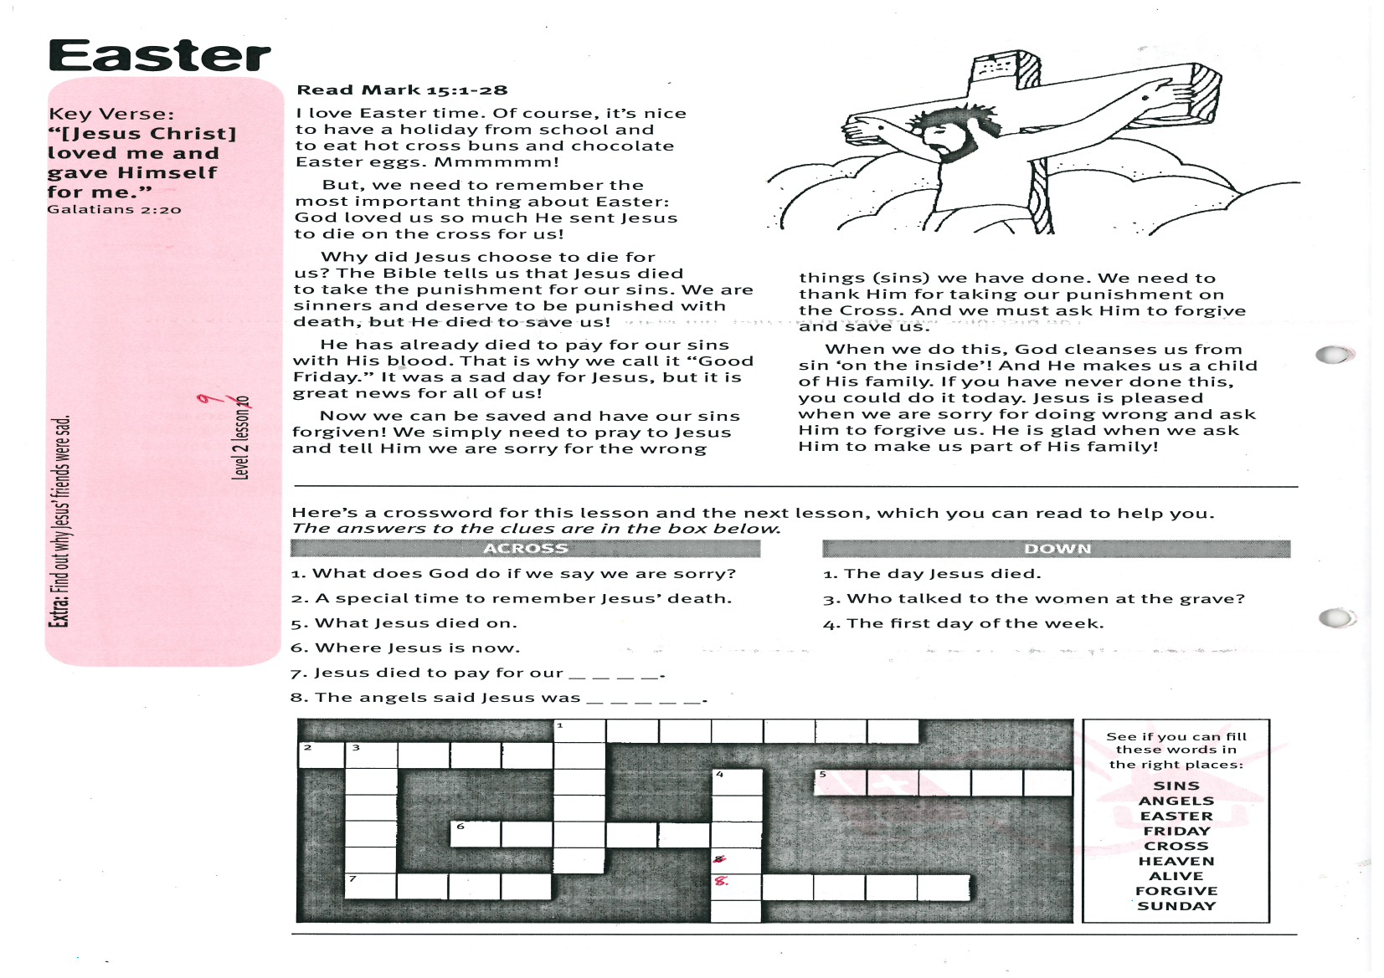
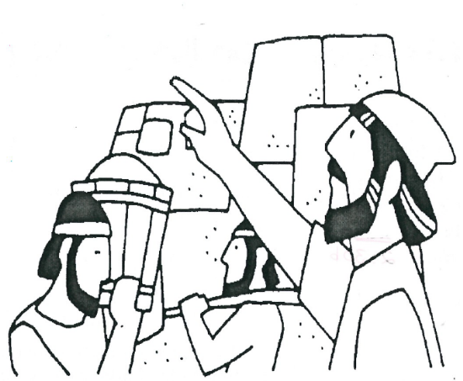
Nehemiah

Key Verse:
“The Lord will hear when I call to Him.”
Psalm 4:3b

Read Nehemiah 1:1-6; 2:2-8
In Bible times the people who lived in different cities were not always friendly to each other. Each city had a high wall around it with big, heavy gates. One day, some enemies attacked Jerusalem. They destroyed the beautiful temple Solomon had built. They also took many people away as prisoners. This happened because after Solomon died many of the Israelites turned away from God. They started worshipping idols instead.
One of the prisoners became a servant in the king’s palace. His name was Nehemiah. He was very sad that the walls of Jerusalem had been broken down. Later, Nehemiah heard that the people left in Jerusalem were being badly treated and the gates of the city had been burnt with fire. All this made Nehemiah very sad.
He wanted to do something to help. He prayed to God about what to say to the king.

Extra: Find out why cities used to have gates and walls.
Level 2 lesson 9
Then he asked the king if he could go home for a while to fix the wall. God answered Nehemiah’s prayer. The king agreed and helped him go.
It took many days for Nehemiah to reach Jerusalem. When he saw the walls all broken down, he knew God wanted him to fix them. He said to the people, “Let’s get the walls fixed up! That will make God happy!” All the people worked hard and they worked well together.
God helped them to do their very best. It didn’t take long until the wall was built up again. Nehemiah and his friends were glad to work together. It’s easier to get jobs done when we work well together. You can be a helper, too!

When you are needed to help at home, will you work with
A smile (put a tick beside one)
or a frown
?

My Name is________________________________________ Age ______________


Tick the box with the right answer:
1. Where did Nehemiah live?
In his own home
In the King’s palace
On the farm
2. Who did Nehemiah pray to?
To the King
To a golden image
To God
3. Why did Nehemiah want to go to Jerusalem?
To see his father
To repair the city & the walls
To enjoy travelling
When can ………………………………………….. (your name)
pray to God?
ANSWER: …………………………………………………………….

Daniel and his Friends
Key Verse:
“Those who honour me, I will honour.”
1 Samuel 2:30b

Read Daniel 1:3-20
Six hundred years before Jesus was born, there was a great King named Nebuchadnezzar. That’s an unusual name isn’t it? Nebuchadnezzar was at war with the Jewish people. His soldiers went to Jerusalem and attacked the city. They won the battle and took many prisoners back to their own country.
The soldiers took the prisoners to King Nebuchadnezzar. He said to his servants: “Choose some of the best of the young men and send them to my school. I want them to learn to be my helpers. I will look after them well.”
Daniel was one of the young men chosen. He and his three friends, Shadrach, Meshach and Abednego were taken to live in the king’s palace. They went to the king’s school. He gave them nice clothes and sent them food. But Daniel knew the food and drink had been offered to idols. He remembered that God had told His people not to eat or drink such food.
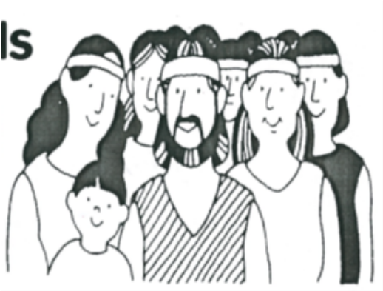

Extra: Tell us something you like about Daniel.
Level 2 lesson 10
So Daniel refused to eat it. He asked the King’s servant to give them water to drink and plain food. Later, the servant could check if this had been better for them. The servant agreed. After some time, he found that Daniel and his friends were fitter than the others who had eaten the king’s food.
They all learned to read and speak the same language as the king and also did very well in their school-work. After three years the king called the men to him and asked them lots of hard questions. Daniel and his friends topped the class! They obeyed God and God helped them. When you obey God and do what God wants you to do, He will help you, too!

1. When should we obey God? (tick one)
a. When everyone else does
b. Always
c. Sometimes
2. Match these sentences (using a ruler and pen)
The soldiers God
Daniel had don’t eat food offered to idols
Daniel obeyed some helpers
The king wanted what God had told His people
Daniel remembered attacked Jerusalem
God said three friends

Here’s a song for you to learn about Daniel:
(same tune as “Mary had a little lamb”)
Who prayed three times every day?
Every day?
Every day?
Who prayed three times every day?
Daniel, brave and true.
God wants me to trust Him, too.
Trust Him, too.
Trust Him, too.
God wants me to trust Him, too.
Like Daniel, brave and true.



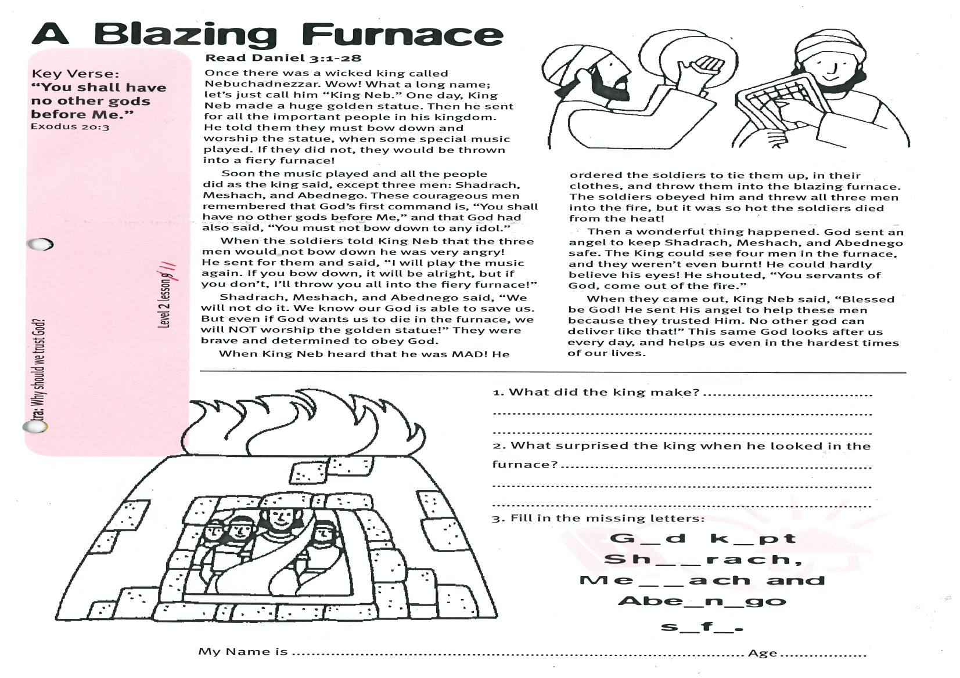
A Blazing Furnace
Read Daniel 3:1-28
King Nebuchadnezzar (“King Neb” for short) was a very wicked king. One day, he made a huge golden statue. Then he sent for all the important people in his kingdom. King Neb told them they must bow down and worship the statue, when some special music played. If they did not, they would be thrown into a fiery furnace!
Soon the music played and all the people did as the king said, except three men: Shadrach, Meshach, and Abednego. These courageous men remembered that God’s first command is, “You shall have no other gods before Me,” and that God had also said, “You must not bow down to any idol.”
When the soldiers told King Neb that the three men would not bow down he was very angry! He sent for them and said, “I will play the music again. If you bow down, it will be alright, but if you don’t, I’ll throw you all into the fiery furnace!”
Shadrach, Meshach, and Abednego said, “We will not do it. We know our God is able to save us. But even if God wants us to die in the furnace, we will NOT worship the golden statue!” They were brave and determined to obey God.
Key Verse:
“You shall have no other gods before Me.”
Exodus 20:3
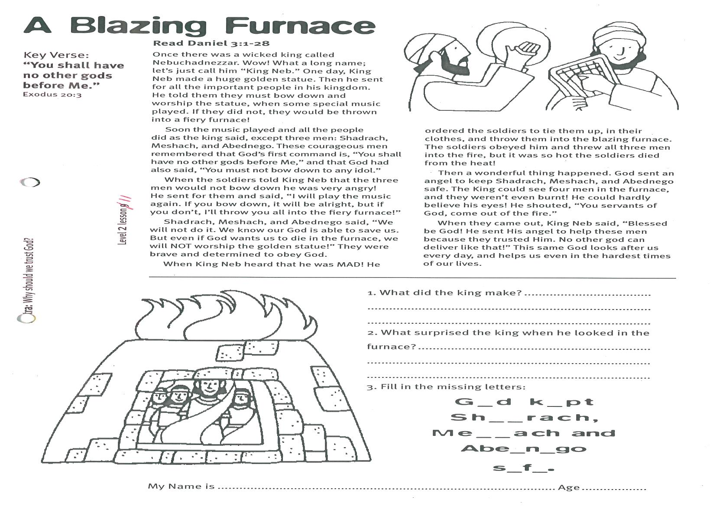
Level 2 lesson 11
Extra: Why should we trust God?
When King Neb heard that he was MAD! He ordered the soldiers to tie them up, in their clothes, and throw them into the blazing furnace. The soldiers obeyed him and threw all three men into the fire, but it was so hot the soldiers died from the heat!
Then a wonderful thing happened. God sent an angel to keep Shadrach, Meshach, and Abednego safe. The King could see four men in the furnace, and they weren’t even burnt! He could hardly believe his eyes! He shouted, “You servants of God, come out of the fire.”
When they came out, King Neb said, “Blessed be God! He sent His angel to help these men because they trusted Him. No other god can deliver like that!” This same God looks after us every day, and helps us even in the hardest times of our lives.
1. What did the king make?
___________________________________
___________________________________
2. What surprised the king when he looked in the furnace?
___________________________________
__________________________________
__________________________________
3. Fill in the missing letters:
G_d k_pt Sh_ _rach,
Me_ _ach and
Abe_n_go s_f_

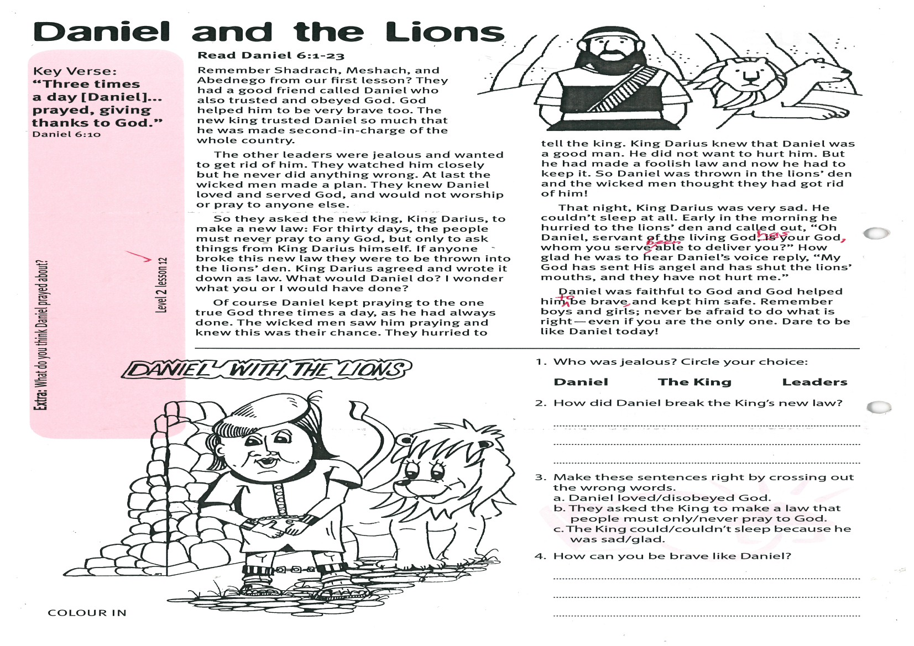
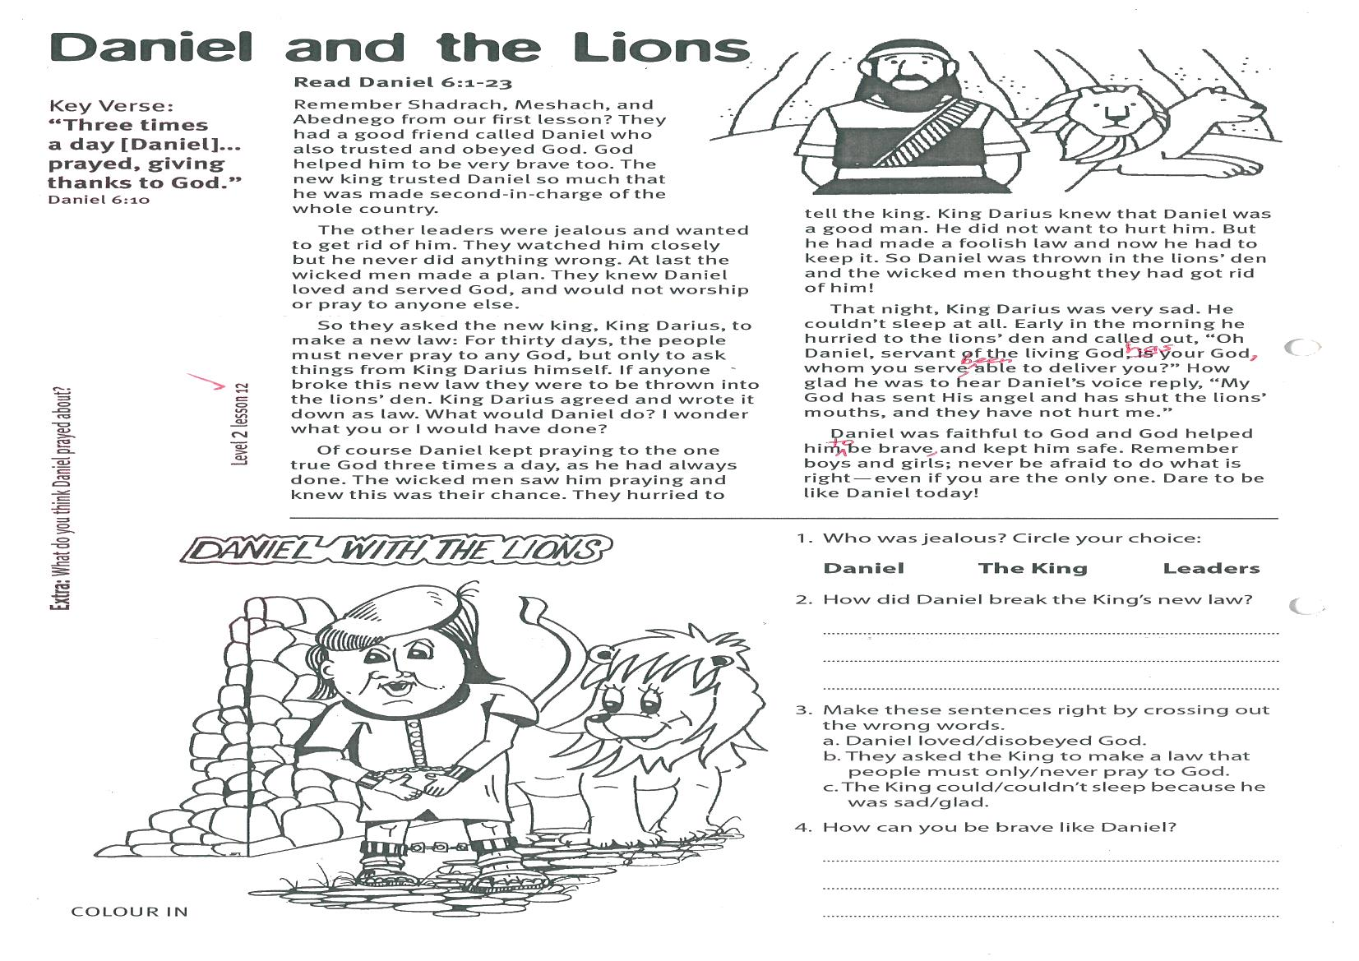
Level 2 lesson 12
Extra: What do you think Daniel prayed about?
Daniel and the Lions
Key Verse:
“Three times a day [Daniel]... prayed, giving thanks to God.”
Daniel 6:10
Read Daniel 6:1-23
Remember Shadrach, Meshach, and Abednego from our second lesson? They were good friends of Daniel, who also trusted and obeyed God. God helped him to be very brave, too. The new king trusted Daniel so much that he was made second-in-charge of the whole country.
The other leaders were jealous and wanted to get rid of him. They watched him closely but he never did anything wrong. At last the wicked men made a plan. They knew Daniel loved and served God, and would not worship or pray to anyone else.
So they asked the new king, King Darius, to make a new law: For thirty days, the people must never pray to any God, but only to ask things from King Darius himself. If anyone broke this new law they were to be thrown into the lions’ den. King Darius agreed and wrote it down as law. What would Daniel do? I wonder what you or I would have done!
Of course Daniel kept praying to the one true God three times a day, as he had always done. The wicked men saw him praying and knew this was their chance. They hurried to tell the king.
King Darius knew that Daniel was a good man. He did not want to hurt him. But he had made a foolish law and now he had to keep it. So Daniel was thrown in the lions’ den and the wicked men thought they had got rid of him!
That night, King Darius was very sad. He couldn’t sleep at all. Early in the morning he hurried to the lions’ den and called out, “Oh Daniel, servant of the living God, has your God, whom you serve, been able to deliver you?” How glad he was to hear Daniel’s voice reply, “My God has sent His angel and has shut the lions’ mouths, and they have not hurt me.”
Daniel was faithful to God and God helped him to be brave and kept him safe. Remember boys and girls; never be afraid to do what is right - even if you are the only one. Dare to be like Daniel today!
1. Who was jealous? Circle your choice:
Daniel The King Leaders
2. How did Daniel break the King’s new law?
_________________________________________
3. Make these sentences right by crossing out the wrong words.
a. Daniel loved/disobeyed God.
b. They asked the King to make a law that people must only/never pray to God.
c. The King could/couldn’t sleep because he was sad/glad.
4. How can you be brave like Daniel?
________________________________________
________________________________________

Please complete and return by post to
PSSM, 5/399 New North Rd, Kingsland, Auckland 1021 or scan & email to info@biblediscovery.org.nz

Daniel with the Lions
(colour in)

