Friends
Key Verse:
“Let the little children come to Me, and do not hinder them.”
Matthew 19:14
Read 1 Samuel 18:1-5
David was one of the bravest boys around. Remember last month, we learnt how with God’s help, he fought and killed the enemy giant, Goliath? When King Saul saw how brave David was, he wanted him to be a soldier in his army. He took David to live in his palace. There, David met Jonathan, the King’s son. The two young men became best friends.
We all like to have fun together with friends, don’t we? These two boys did everything together! They went for walks, ate meals and played games together. They shared everything. David was happy to have such a good friend.
Jonathan wanted to show David how much he loved him, so one day he gave him his coat, his sword, his belt and his bow and arrows as a present! How kind! David was poor, and didn’t have anything special to give Jonathan. But he was thankful for the gifts and Jonathan’s promise to always be his best friend.


Extra: What are some things I can do for my friends?
Level 2 lesson 5
Have you got a good friend like this? It’s good to give thanks to God for our friends. They are very special. Did you know that the Lord Jesus is the very best friend we can have? If you love and trust Jesus, He will help you to be a good, kind and generous friend to other people too!
Who is the very best friend
…………………………………………
can have?
J

Colour in this picture
My Name is________________________________________ Age ______________
PRAYER TIME
Dear God,
Thank you for my friend
________________________
Help me to be a good friend at home, at school, and everywhere I go.
(write your name)

Friends are a gift from God

Wise Solomon
Key Verse:
“The Lord is my helper; I will not be afraid.”
Hebrews 13:6
Read 1 Kings 10:1-9
David became king when Saul died, and when David died, his son Solomon became king. One night God spoke to Solomon in a dream. He asked him what gift he would most like to have. Solomon asked for wisdom to be a good king. God was pleased with his unselfish request. As well as making him very wise, God made Solomon famous and very rich too!
People came from all over the world to see him. The Queen of Sheba did not believe all she heard about Solomon. So she travelled a long way to see for herself. After she met Solomon and talked to him, she said he was twice as great as she had heard!
Solomon built a beautiful temple for God in Jerusalem. It took seven years to build! Finally, it was finished and King Solomon called all the people together.
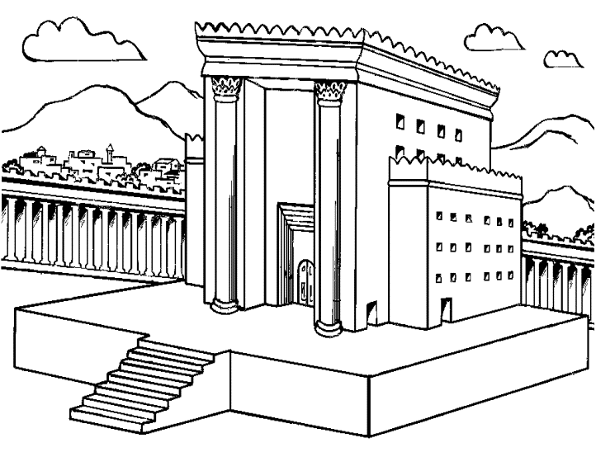
Extra: Why do you think Solomon built this big temple building?
Level 2 lesson 6
He thanked God, and prayed that the people would love and serve God all their lives.
Solomon was very wise, but that didn’t mean he couldn’t make mistakes! Although he knew what was right he didn’t always do it. He made some very bad mistakes when he got older. Sometimes we can be like this too. We need to ask God to help us do the right things always.

1. This wise king was called
__ __ __ __ __ __ __
2. He was __ __ __ __ __ ‘__ son.
3. People came from all over the
__ __ __ __ __ to see him.
4. __ __ __ made him famous and rich.
5. Who built the temple for God?
___ ___ ___ ___ ___ ___ ___
6. How many years did the temple take to build?
Circle the correct answer:
1 year 3 years
5 years 7 years
9 years 11 years
Colour in the picture

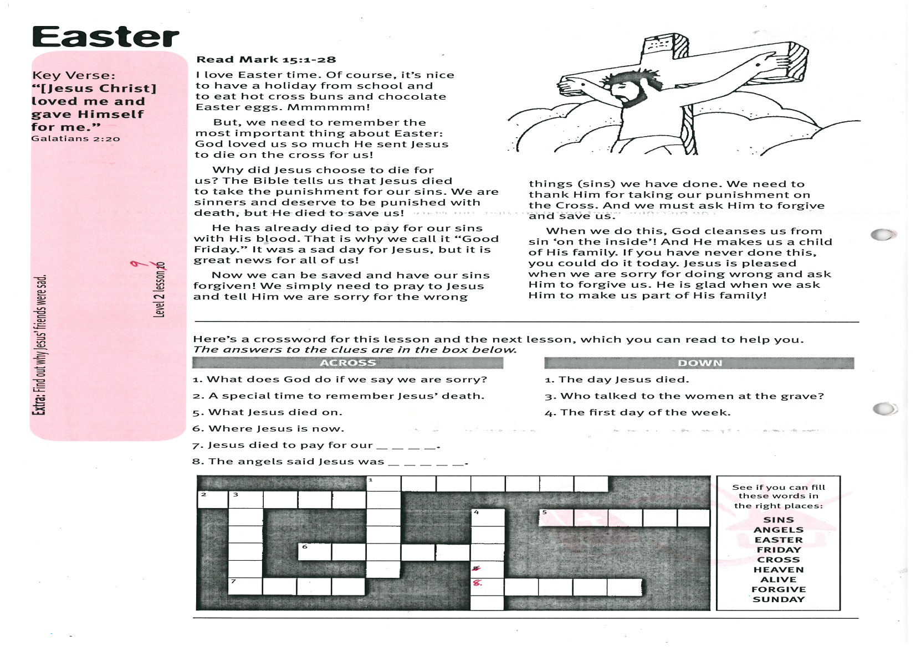
Easter
Read Mark 15:1-28
I love Easter time. Of course, it’s nice to have a holiday from school and to eat hot cross buns and chocolate Easter eggs. Mmmmmm!
But, we need to remember the most important thing about Easter: God loved us so much He sent Jesus to die on the cross for us!
Why did Jesus choose to die for us? The Bible tells us that Jesus died to take the punishment for our sins. We are sinners and deserve to be punished with death, but He died to save us!
He has already died to pay for our sins with His blood. That is why we call it “Good Friday.” It was a sad day for Jesus, but it is great news for all of us!
Now we can be saved and have our sins forgiven! We simply need to pray to Jesus and tell Him we are sorry for the wrong things (sins) we have done.
Key Verse:
“[Jesus Christ] loved me and gave Himself for me.”
Galatians 2:20
Level 2 lesson 7
Extra: Find out why Jesus’ friends were sad.
We also need to thank Him for taking our punishment on the Cross, and we must ask Him to forgive and save us.
When we do this, God cleanses us from sin ‘on the inside’! And He makes us a child of His family.
If you have never done this, you could do it today. Jesus is pleased when we are sorry for doing wrong and ask Him to forgive us. He is glad when we ask Him to make us part of His family!!
Here’s a crossword for this lesson and the next lesson, which you can read to help you.
ACROSS
1. What does God do if we say we are sorry?
2. A special time to remember Jesus’ death.
5. What Jesus died on.
6. Where Jesus is now.
7. Jesus died to pay for our _ _ _ _.
8. The angels said Jesus was _ _ _ _ _.

DOWN
1. The day Jesus died.
3. Who talked to the women at the grave?
4. The first day of the week.

 |  |  |  |  | 1
2 | 3
 |  |  |  |  |  |  |  | 4 |  | 5
 |  |  | 6
 | 7 |  |  |  |  |  |  | 8

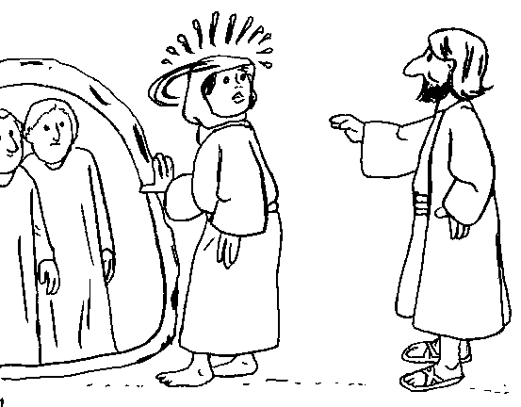
Level 2 lesson 8
Extra: What is your favourite part of the Easter story?
Jesus is Alive!

Key Verse:
“Stop doubting and believe’”
John 20:27

Read John 20 and Acts 1:9-11
Last lesson we saw that Jesus died on the Cross for our sins. We call that day ‘Good Friday.’ Very early the following Sunday morning, Mary Magdalene and a few other women, who loved Jesus, went to his grave.
Right away they knew something had happened. The huge stone that had been placed over the door to Jesus’ tomb had been rolled away! Mary ran to tell the other disciples. Peter and John ran back to the tomb and looked inside. They could see the burial clothes still lying there, but Jesus’ body had gone!
The disciples went home puzzled, but Mary was too upset. She stayed there, just crying. Finally, she looked inside the empty tomb for herself. To her surprise she saw two angels in there. They told her that Jesus was ALIVE again. What great news!
Mary could hardly believe it. As she left the tomb, she saw a man standing nearby. She thought it was a gardener at first, but then she heard her name called, “Mary!” It was actually Jesus. He really WAS alive!

Jesus told her to go and tell the other disciples. Mary was so excited! She ran and told them the news that she had seen Jesus! But the disciples didn’t really believe that Jesus had risen from the dead.
Later that day, most of the disciples were hiding together in a locked room. Suddenly, Jesus Himself appeared right in the room! The disciples were amazed. Jesus showed them the marks where the nails had been in His hands and feet. Yes, it really was Him! Jesus was alive again! Later, Jesus showed Himself to lots of other people too. Then He went back to HEAVEN, where He still is now.
Jesus has promised that He will come back again one day, to take everyone who loves Him back to Heaven with Him. WOW! That will be wonderful! Jesus is alive forever, so we can talk to Him and He always hears us. He also helps us and teaches us the right way through His Word, the Bible. Have you asked Him save you and change your heart?
1. What do you think this picture is about?
_______________________________________
_______________________________________
_______________________________________
2. This is written back to front. Please write it out correctly: evila si suseJ
_________________________________
_________________________________
3. Name something wonderful that Jesus can do for us because He is alive.
_______________________________________
_______________________________________
_______________________________________
Please complete and return by post to
PSSM, 5/399 New North Rd, Kingsland, Auckland 1021 or scan & email to info@biblediscovery.org.nz

Colour in this picture:

