Key Verse:
“I am grieved that I made Saul king, because he has turned away from Me and not carried out My instructions.”
1 Samuel 15:11

Read 1 Samuel 15:1-26 and Deuteronomy 5:32- 6:3

What’s the first thing we’re tempted to do when someone points out something wrong we’ve done? Cover it up, right? And the way we often do that, is by making out that what we’ve done isn’t as bad as it looks. We try and ‘dress it up’ a little: “I didn’t push my sister over; I was just ‘helping her along!” “I wasn’t hitting my brother; he was coughing and I was just patting him on the back!” You know what I’m talking about! Saul was just the same in our passage. This is the way it all began:

Samuel passed on a message from the Lord to Saul, telling him to go and fight against the Amalekites, who were enemies of the true God. Samuel was clear about one thing: Saul and his army were not to keep anything that had belonged to the Amalekites. They were to burn and destroy everything that their enemies owned. Clear, simple instructions don’t you think? So what went wrong?

Saul obeyed God, got his army together, and set off to fight the Amalekites. The Israelites fought well and God gave them a wonderful victory! But then we read that Saul and his men kept some of the things that had belonged to the Amalekites. He only obeyed part of what the Lord wanted him to do, and so failed to do it all. Perhaps Saul thought that being a little bit obedient would be good enough.

Part time Obedience!

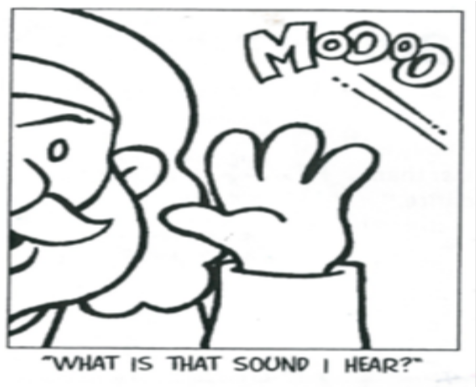

Extra: Try to think of some excuses you have made to cover up for not doing the right thing. How can you stop doing this in future?
Level 3 lesson 9
I hope you aren’t like that - thinking that if God wants you to do something, only doing part
of it will be OK! Instead of being OK, what Saul did greatly displeased the Lord. He said to Samuel, “I am sorry that I have made Saul king, because he has not carried out all my instructions.” No - part-time obedience is NOT OK in God’s eyes!

Soon Samuel arrived and asked Saul, “What have you done? I can hear the sheep and the cattle that you took from the Amalekites. You were told to destroy everything!” Saul tried to ‘dress up’ what he’d done by saying, “But I saved these animals to make a sacrifice to the Lord!” So Samuel told Saul that obedience is more important than offering God sacrifices.

Too often we try and pretend that what we’ve done is for the benefit of someone else - even the Lord! But really, we’ve selfishly done something just because we wanted to. What a sad end to it all. Saul had stopped obeying the Lord, and so he was no longer going to be king. God would choose someone else to serve Him as king instead.

1. Unscramble these words from the story:
a. MULEAS . . . . . . . . . . . . . . . . .
b. LASU . . . . . . . . . . . . . . . . .
c. LEKATAMEIS . . . . . . . . . . . . . . . . .

2. Choose TRUE or FALSE. Circle your choice:
a. Samuel told Saul to go and fight T / F
b. Saul obeyed God completely T / F
c. Part-time obedience is OK T / F
d. Saul was told to destroy everything T / F
e. Saul was a good king T / F

My Name is ……………………………………………………… Age…………………

What is the only way to be happy in Jesus? (Cross out letters that occur three or more times)

T | H | R | C | U | G | S | H | T
G | I | A | I | N | P | D | G | H
C | O | P | B | C | E | P | Y | I

ANSWER: ________________________________________________
_________________________________________________
_________________________________________________

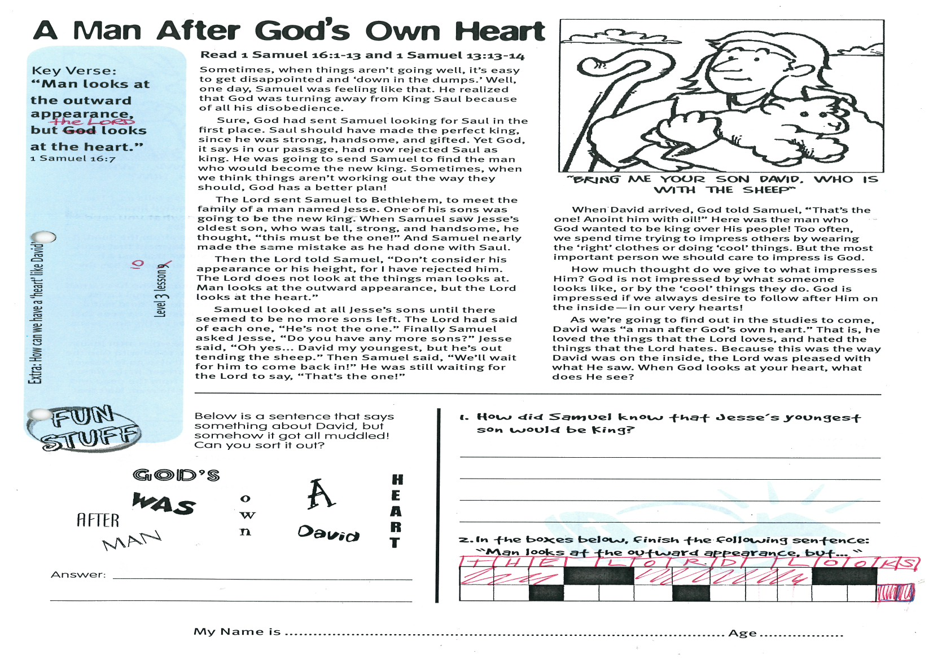
A Man After God’s Own Heart
Key Verse:
“Man looks at the outward appearance, but the Lord looks at the heart.”
1 Samuel 16:7
Read 1 Samuel 16:1-13
and 1 Samuel 13:13-14
Sometimes, when things aren’t going well, it’s easy to get disappointed and ‘down in the dumps.’ Well, one day, Samuel was feeling like that. He realized that God was turning away from King Saul because of all his disobedience.

Sure, God had sent Samuel looking for Saul in the first place. Saul should have made the perfect king, since he was strong, handsome, and gifted. Yet God, it says in our passage, had now rejected Saul as King. He was going to send Samuel to find the man who would become the new king. Sometimes, when we think things aren’t working out the way they should, God has a better plan!

The Lord sent Samuel to Bethlehem, to meet the family of a man named Jesse. One of his sons was going to be the new king. When Samuel saw Jesse’s oldest son, who was tall, strong, and handsome, he thought, “This must be the one!” And Samuel nearly made the same mistake as he had done with Saul.

Then the Lord told Samuel, “Don’t consider his appearance or his height, for I have rejected him. The LORD does not look at the things man looks at. Man looks at the outward appearance, but the LORD looks at the heart.”

Samuel looked at all Jesse’s sons until there seemed to be no more sons left. The Lord had said of each one, “He’s not the one.” Finally Samuel asked Jesse, “Do you have any more sons?” Jesse said, “Oh yes… David, my youngest, but he’s out tending the sheep.”

Extra: How can we have a ‘heart’ like David?
Level 3 lesson 10
Then Samuel said, “We’ll wait for him to come back in!” He was still waiting for the Lord to say, “That’s the one!”

When David arrived, God told Samuel, “That’s the one! Anoint him with oil!” Here was the man who God wanted to be king over His people! Too often, we spend time trying to impress others by wearing the ‘right’ clothes or doing ‘cool’ things. But the most important person we should care to impress is God.

How much thought do we give to what impresses Him? God is not impressed by what someone looks like, or by the ‘cool’ things they do. God is impressed if we always desire to follow after Him on the inside—in our very hearts!

As we’re going to find out in the studies to come, David was “a man after God’s own heart.” That is, he loved the things that the Lord loves, and hated the things that the Lord hates. Because this was the way David was on the inside, the Lord was pleased with what He saw. When God looks at your heart, what does He see?

1. How did Samuel know that Jesse’s youngest son would be King?
______________________________________
______________________________________

2. In the boxes below, finish the following sentence: “Man looks at the outward appearance, but... ”
 |  |  |  | L |  |  |  |  |  | O | O
 |  |  |  |  |  |  | H
(Clue: Key Verse)

Below is a sentence that says something about David, but somehow it got all muddled! Can you sort it out?
GOD’S AFTER
WAS A
DAVID HEART

MAN OWN

Answer:______________________________________________________________________________________________________________________________________________________

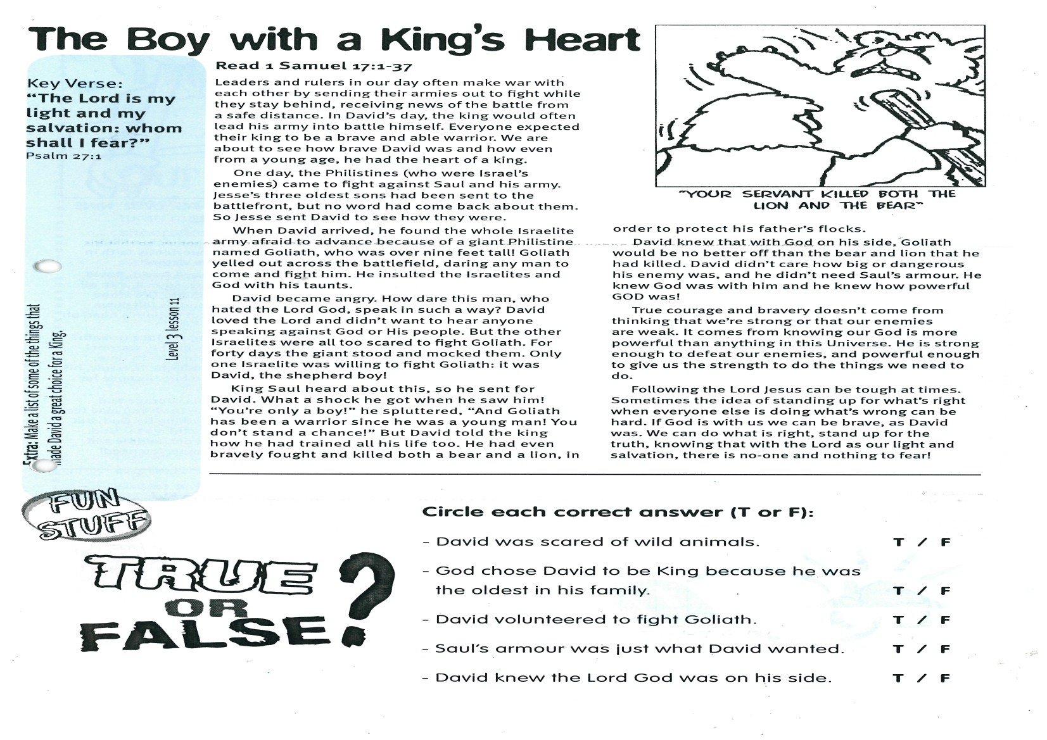
The Boy with a King’s Heart
Key Verse:
“The Lord is my light and my salvation: whom shall I fear?”
Psalm 27:1
Read 1 Samuel 17:1-37
Leaders and rulers in our day often make war with each other by sending their armies out to fight while they stay behind, receiving news of the battle from a safe distance. In David’s day, the king would often lead his army into battle himself. Everyone expected their king to be a brave and able warrior. We are about to see how brave David was and how even from a young age, he had the heart of a king.

One day, the Philistines (who were Israel’s enemies) came to fight against Saul and his army. Jesse’s three oldest sons had been sent to the battlefront, but no word had come back about them. So Jesse sent David to see how they were.

When David arrived, he found the whole Israelite army afraid to advance because of a giant Philistine named Goliath, who was over nine feet tall! Goliath yelled out across the battlefield, daring any man to come and fight him. He insulted the Israelites and God with his taunts.

David became angry. How dare this man, who hated the Lord God, speak in such a way? David loved the Lord and didn’t want to hear anyone speaking against God or His people. But the other Israelites were all too scared to fight Goliath. For forty days the giant stood and mocked them. Only one Israelite was willing to fight Goliath: it was David, the shepherd boy!

King Saul heard about this, so he sent for David. What a shock he got when he saw him! “You’re only a boy!” he spluttered, “And Goliath has been a warrior since he was a young man! You don‘t stand a chance!” But David told the king how he had trained all his life too. He had even bravely fought and killed both a bear and a lion, in order to protect his father’s flocks.

Level 3 lesson 11
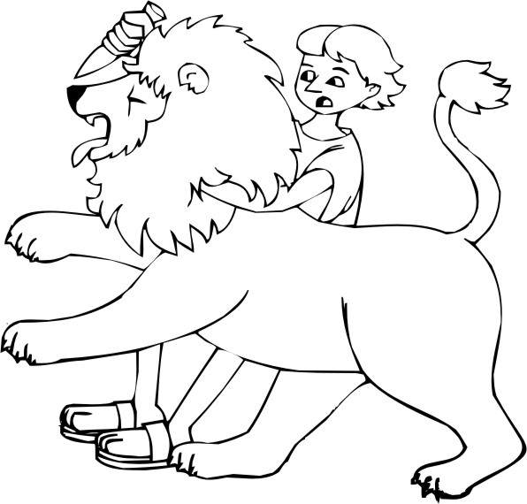
Extra: Make a list of some of the things that made David a great choice for a King.

David knew that with God on his side, Goliath would be no better off than the bear and lion that he had killed. David didn’t care how big or dangerous his enemy was, and he didn’t need Saul’s armour. He knew God was with him and he knew how powerful GOD was!

True courage and bravery doesn’t come from thinking that we’re strong or that our enemies are weak. It comes from knowing our God is more powerful than anything in this Universe. He is strong enough to defeat our enemies, and powerful enough to give us the strength to do the things we need to do.

Following the Lord Jesus can be tough at times. Sometimes the idea of standing up for what’s right when everyone else is doing what’s wrong can be hard. If God is with us we can be brave, as David was. We can do what is right, stand up for the truth, knowing that with the Lord as our light and salvation, there is no-one and nothing to fear!

Circle each correct answer (True or False)

David was scared of wild animals. T / F

God chose David to be King because
he was the oldest in his family. T / F

David volunteered to fight Goliath. T / F

Saul’s armour was just what David wanted. T / F

David knew the Lord God was on his side. T / F

True
or
False?

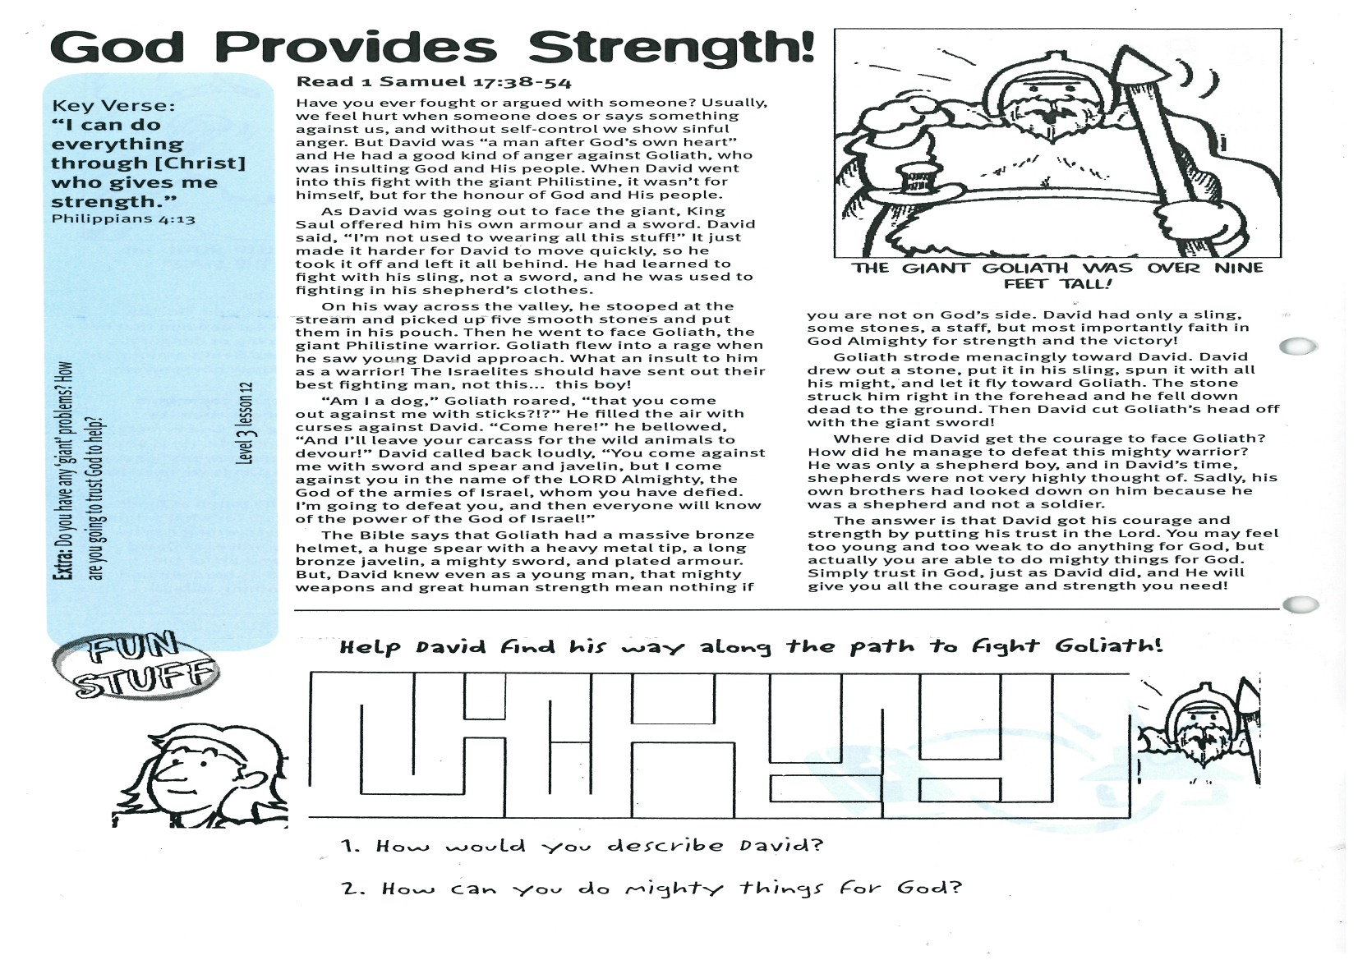
Key Verse:
“I can do everything through Him [Christ] who gives me strength.”
Philippians 4:13
Read 1 Samuel 17: 38-54
Have you ever fought or argued with someone? Usually, we feel hurt when someone does or says something against us, and without self-control we show sinful anger. But David was “a man after God’s own heart” and He had a good kind of anger against Goliath, who was insulting God and His people. When David went into this fight with the giant Philistine, it wasn’t for himself, but for the honour of God and His people.
As David was going out to face the giant, King Saul offered him his own armour and a sword. David said, “I’m not used to wearing all this stuff!” It just made it harder for David to move quickly, so he took it off and left it all behind. He had learned to fight with his sling, not a sword, and he was used to fighting in his shepherd’s clothes.

On his way across the valley, he stooped at the stream and picked up five smooth stones and put them in his pouch. Then he went to face Goliath, the giant Philistine warrior. Goliath flew into a rage when he saw young David approach. What an insult to him as a warrior! The Israelites should have sent out their best fighting man, not this… this boy!

“Am I a dog,” Goliath roared, “that you come out against me with sticks?!?” He filled the air with curses against David. “Come here!” he bellowed, “And I’ll leave your carcass for the wild animals to devour!” David called back loudly, “You come against me with sword and spear and javelin, but I come against you in the name of the LORD Almighty, the God of the armies of Israel, whom you have defied. I’m going to defeat you, and then everyone will know of the power of the God of Israel!”

God Provides Strength!
Answer:
The Bible says that Goliath had a massive bronze helmet, a huge spear with a heavy metal tip, a long bronze javelin, a mighty sword, and plated armour. But, David knew even as a young man, that mighty weapons and great human strength mean nothing if you are not on God’s side. David had only a sling, some stones, a staff, but most importantly faith in God Almighty for strength and the victory!

Goliath strode menacingly toward David. David drew out a stone, put it in his sling, spun it with all his might, and let it fly toward Goliath. The stone struck him right in the forehead and he fell down dead to the ground. Then David cut Goliath’s head off with the giant sword!

Where did David get the courage to face Goliath? How did he manage to defeat this mighty warrior? He was only a shepherd boy, and in David’s time, shepherds were not very highly thought of. Sadly, his own brothers had looked down on him because he was a shepherd and not a soldier.

The answer is that David got his courage and strength by putting his trust in the Lord. You may feel too young and too weak to do anything for God, but actually you are able to do mighty things for God. Simply trust in God, just as David did, and He will give you all the courage and strength you need!

Level 3 lesson 12
Extra: Do you have any ‘giant’ problems? How are you going to trust God to help?

Help David find his way along the path to fight Goliath!

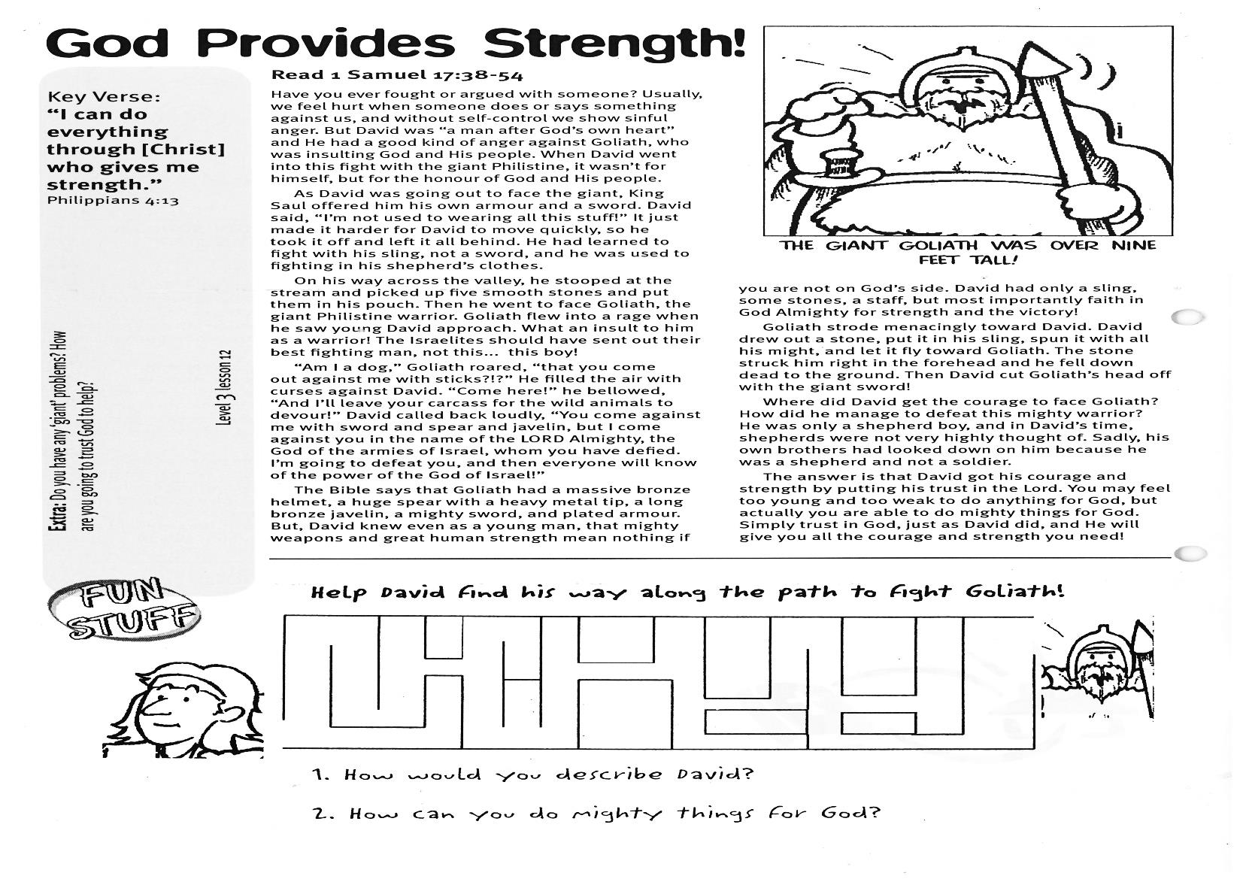

Please complete and return by post to
PSSM, 5/399 New North Rd, Kingsland, Auckland 1021 or scan & email to info@biblediscovery.org.nz

1. How would you describe David? __________________________________________________________________
_________________________________________________________________________________________________
2. How can you do mighty things for God? ___________________________________________________________
_________________________________________________________________________________________________

