

**Read John 4:1-42 and   
1 John 4:7-12**

On one occasion, Jesus decided to return to Galilee through Samaria. Most Jews avoided Samaria because of a long-running feud between them and the Samaritans. Around midday on the second day’s walk, Jesus neared the village of Sychar. He and the disciples were tired and hungry. Jesus sat down to rest at the famous ‘Jacob’s Well,’ about a mile from the village, while the disciples went on into the village to buy bread.

As he waited, a woman came to draw water from the well. He stood up and asked her for a drink. Surprised, she looked at Him and said, “How can you (a Jew) ask me (a Samaritan) for a drink?” Jesus felt sorry for her. Not only did this woman need water from Jacob’s well, she needed spiritual water that only God could supply to cleanse and refresh her heart and soul.

He said, “If you knew the gift of God, and who it is that asks you for a drink, you would have asked Him, and He would have given you living water.” The woman said to Him, “Sir, you have nothing to draw with, and the well is deep; where can you get this ‘living water’? Jesus gently replied, “Whoever drinks the water I give him will never thirst.”

Now this woman of Samaria was a social outcast; the other women would not have anything to do with her because of her immoral lifestyle. That was probably why she’d come to the well at midday alone. She probably felt trapped by her sinful life and bad reputation, but the Lord Jesus looked at her with great pity in his heart. He knew her immoral ways had not brought her satisfaction or real happiness. Oh how she needed His spiritual ‘water’ to be forgiven and cleansed inside and made right with God!

**A Samaritan Woman**

Key Verse:  
**“Now… we know that this man really is the Saviour of the world.”**  
John 4:42

|  |
| --- |
| 1. Why do you think Jesus chose to go through Samaria? |
|
| 2. Why was Jesus sorry for the woman who came to draw water? |  |
| 3. Why did the lady not want anything more said about her life? |  |
| 4. What did she do when she discovered who Jesus really was? |  |
| 5. What was the people’s reaction to all this? |  |

My Name is _____________________________________________ Age ___________

Quietly, Jesus said to her, “Go, call your husband, and come back here.” Embarrassed, the woman replied, “I have no husband.” Jesus told her He knew all about the ‘husbands’ she’d had, and that she was currently just living with another man! Sensing that this stranger, with the piercing gaze who seemed to know all about her, must be some sort of prophet, the woman guiltily changed the subject to the religious feud between the Jews and Samaritans. She probably hoped to avoid any further discussion of her sinful life, too. Finally, after some discussion, she said, “When Christ comes, He will explain everything.” Then Jesus made this wonderful statement, “I who speak to you, am He!”

At this point, the disciples arrived from the village with the bread they had bought. They were amazed to see Jesus speaking with this Samaritan woman. Jesus’ words had penetrated this poor woman’s guilty heart though. She saw how impure her life was and how far she was from God.   
No-one had ever spoken to her the way Jesus did. Leaving her pot by the well, she hurried into the city to tell everyone about her wonderful talk with Jesus.

“Come see a man who told me everything I ever did!” she said. “Surely this must be the Christ (Saviour)!” So the people came to see and hear for themselves. Many believed in Jesus when they heard His teaching and saw the change in this woman. They said, “This man really is the Saviour of the world.” What a wonderful discovery! Have YOU realised that the Lord Jesus is the Saviour? Have you believed in Him and asked Him to be YOUR Saviour and make you clean from sin?

**Extra:** What can you find out about the Jews and the Samaritans?

**QUESTIONS & ANSWERS**

**Level 4 lesson 9**

**The Right Start**

Key Verse:  
**“Jesus said, ‘I tell you the truth, unless a man is born again, he cannot see the kingdom of God.’”**  
John 3:3

**Level 3 lesson 1**

|  |  |
| --- | --- |
| 1. What did this man know about himself? |  |
| 2. What did the Lord ask the crippled man? |  |
| 3. What did the Lord say that made the man well again?  **(Fill in the vowels)** | **S T __ N D __ P T __ K __ __ P Y __ __ R  M __ T __ N D W __ L K** |
| 4. Why were the religious leaders furious? |  |
| 5. In what ways are we like the crippled man? |  |

**Level 4 lesson 10**

**Extra:**  What does this study teach you about Jesus?



The Jewish religious leaders saw this man carrying his mat and questioned him about it. They were angry because they had made a rule that people should not carry mats on the Sabbath day. At first, the man could not answer their questions as he didn’t know who had healed him, because after healing him, Jesus had simply disappeared into the crowd. But later, Jesus met him in the Temple and encouraged him. He reminded him that now he had been made well he must stop sinning and live for God!

When the religious leaders questioned him again later on, he told them it was Jesus who had healed him, and they were furious! These men did not really love and obey God from their hearts. They certainly did not believe Jesus’ claim to have come from God and to be equal with Him. But God is able to protect all who trust Him and he gave this man strength to stand up to the pressure from these leaders and to clearly testify the truth of the miracle.

In some ways we are like this crippled man. The Lord Jesus knows all about us, too. He knows all our sins and sorrows. There is nothing hidden from His eyes. He knows that we are totally helpless to save ourselves from our sin. Only “He is able to save,” but we must first be willing for Him to save us. Unless we admit our need to be healed from sin, He will do nothing.   
If you have been saved, you now belong to the Lord Jesus. Live for Him and be a witness to others by stopping your sinful ways and bad habits. Start showing that God is now in control of your life!

**Read John 5:1-15  
and Acts 5:12-16**

Our studies in the life of Jesus continue with His visit in Jerusalem to the ‘Pool of Bethesda,’ which means “House of Mercy.” The Bible reading today indicates that people living in Jesus’ time believed that when the water in the pool was stirred up, then the first person to enter the pool would be healed. Therefore it was common for a great number of sick and crippled people to be waiting around the pool!

While Jesus was there, He noticed a man who had been a cripple for 38 years. Poor man! Every day, he just lay helplessly beside the pool, no doubt begging for money and food, too. He had been paralysed almost all his life and had just about given up hope. This man knew he was helpless to get in the pool first, because he had no friends to carry him. He knew that others were able to move faster and so he would miss out.

Jesus, of course knew all about this poor man’s condition and hopeless situation. He felt so sorry for this lame man and so He approached him and asked, “Do you want to get well?” The crippled man looked up and saw Jesus standing by him. We can imagine that perhaps he wondered if this questioner was a helper or someone mocking him. “Sir, I have no-one to help me into the pool when the water is stirred,” he answered, “while I am trying to get in someone else goes down ahead of me.”

Imagine his surprise at Jesus’ next words, “Stand up! Take up your mat and walk!” Imagine how much more shocked he must have been to feel a strange, new strength running through his legs! Obediently and joyfully, he picked up his mat and walked away, no doubt rejoicing with profuse thanks to this kind stranger. However, he soon found himself in unexpected trouble.

Key Verse:  
**“Jesus asked him, ‘Do you want to get well?’”**John 5:6

**Sadness to Gladness**

**QUESTIONS & ANSWERS**

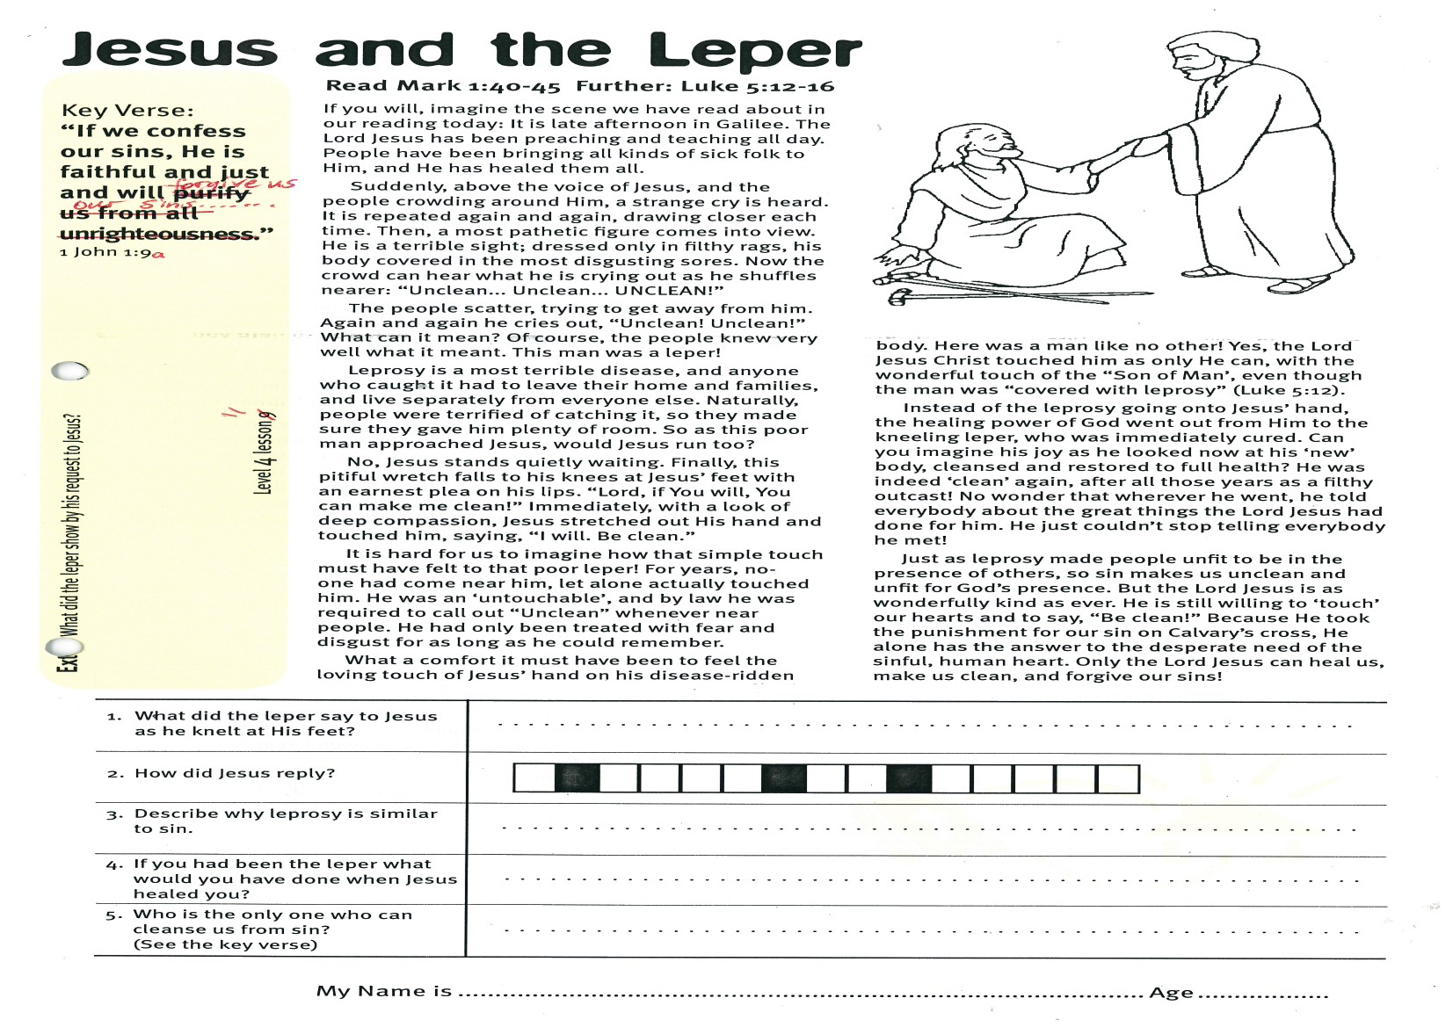

**Read Mark 1:40-45  
and Luke 5:12-16**

If you will, imagine the scene we have read about in our reading today: It is late afternoon in Galilee. The Lord Jesus has been preaching and teaching all day. People have been bringing all kinds of sick people to Him, and He has healed them all.

Suddenly, above the voice of Jesus, and the people crowding around Him, a strange cry is heard. It is repeated again and again, drawing closer each time. Then, a most pathetic figure comes into view. He is a terrible sight; dressed only in filthy rags, his body covered in the most disgusting sores. Now the crowd can hear what he is crying out as he shuffles nearer: “Unclean... Unclean... UNCLEAN!”

The people scatter, trying to get away from him. Again and again he cries out, “Unclean! Unclean!” What can it mean? Of course, the people knew very well what it meant. This man was a leper!

Leprosy is a most terrible disease, and anyone who caught it had to leave their home and families, and live separately from everyone else. Naturally, people were terrified of catching it, so they made sure they gave him plenty of room. So as this poor man approached Jesus, would Jesus run, too?

No! Jesus stands quietly waiting. Finally, this pitiful wretch falls to his knees at Jesus’ feet with an earnest plea on his lips. “Lord, if You will, You can make me clean!” Immediately, with a look of deep compassion, Jesus stretched out His hand and touched him, saying, “I will. Be clean.”

It is hard for us to imagine how that simple touch must have felt to that poor leper! For years,  
no-one had come near him, let alone actually touched him! He was an ‘untouchable’, and by law he was required to call out “Unclean” whenever he was near people. He had only been treated with fear and disgust for as long as he could remember.

Key Verse:  
**“If we confess our sins, He is faithful and just and will forgive us our sins, and cleanse us from all unrighteousness.”**  
1 John 1:9

**Jesus and the Leper**

|  |  |
| --- | --- |
| 1. What did the leper say to Jesus as he knelt at His feet? |  |
| 2. What was Jesus’ reply? | |  |  |  |  |  |  |  |  |  |  |  |  |  |  |  | | --- | --- | --- | --- | --- | --- | --- | --- | --- | --- | --- | --- | --- | --- | --- | |  |  |  |  |  |  |  |  |  |  |  |  |  |  |  | |
| 3. Describe how leprosy is similar to sin. |  |
| 4. If you had been the leper, what would you have done when Jesus healed you? |  |
| 5. Who is the only one who can cleanse us from sin? **(See Key Verse)** |  |

What a comfort it must have been to feel the loving touch of Jesus’ hand on his disease-ridden body. Here was a man like no other! Yes, the Lord Jesus Christ touched him as only He can, with the wonderful touch of the “Son of Man’, even though the man was “covered with leprosy” (Luke 5:12).

Instead of the leprosy going onto Jesus’ hand, the healing power of God went out from Him to the kneeling leper, who was immediately cured. Can you imagine his joy as he looked now at his ‘new’ body, cleansed and restored to full health? He was indeed ‘clean’ again, after all those years as a filthy outcast! No wonder that wherever he went, he told everybody about the great things the Lord Jesus had done for him. He just couldn’t stop telling everybody he met!

Just as leprosy made people unfit to be in the presence of others, so sin makes us unclean and unfit for God’s presence. But the Lord Jesus is as wonderfully kind as ever. He is still willing to ‘touch’ our hearts and to say, “Be clean!” Because He took the punishment for our sin on Calvary’s cross, He alone has the answer to the desperate need of the sinful, human heart. Only the Lord Jesus can heal us, make us clean, and forgive our sins!

**Extra:** What did the leper show by his request to Jesus?

**Level 4 Lesson 11**

**QUESTIONS & ANSWERS**

|  |  |
| --- | --- |
| 1. How is Jesus different than normal doctors? |  |
| 2. What was different about the way the soldier treated his servant?  . |  |
| 3. Why did the Centurion seek Jesus for help? |  |
| 4. What did the messenger find when he returned to the Centurion’s house? | |  |  |  |  |  |  |  |  |  |  |  |  |  |  |  |  | | --- | --- | --- | --- | --- | --- | --- | --- | --- | --- | --- | --- | --- | --- | --- | --- | |  |  |  |  |  |  |  |  |  |  |  |  |  |  |  |  | |  |  |  |  |  |  |  |  |  |  |  |  |  |  |  |  | |
| 5. What lesson of belief and faith is there in this story for us today? |  |

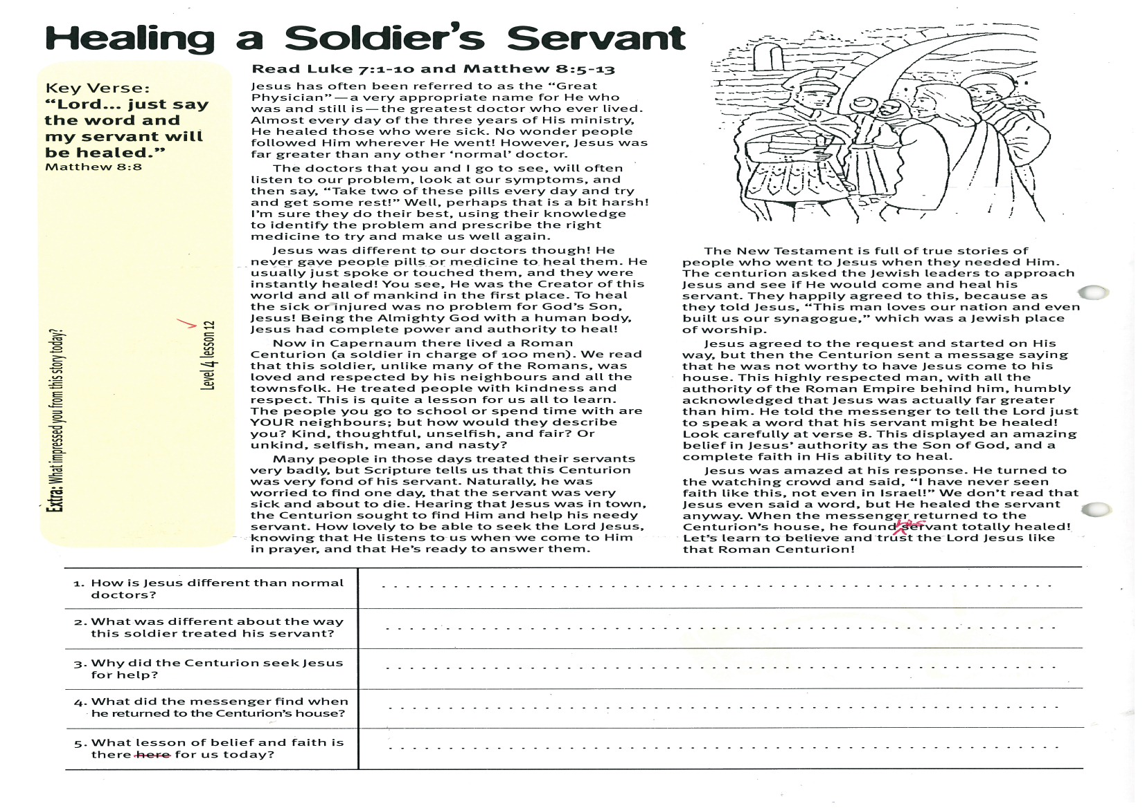

**Read Luke 7:1-10   
and Matthew 8:5-13**

Jesus has often been referred to as the “Great Physician” - a very appropriate name for the One who was and still is, the greatest doctor who ever lived. Almost every day of the three years of His ministry, He healed those who were sick. No wonder people followed Him wherever He went! However, Jesus was far greater than any other ‘normal’ doctor.

The doctors that you and I go to see, will often listen to our problem, look at our symptoms, and then say, “Take two of these pills every day and try and get some rest!” Well, perhaps that is a bit harsh! I’m sure they do their best, using their knowledge to identify the problem and prescribe the right medicine to try and make us well again.

Jesus was different to our doctors though! He never gave people pills or medicine to heal them. He usually just spoke or touched them, and they were instantly healed! You see, He was the Creator of this world and all of mankind in the first place. To heal the sick or injured was no problem for God’s Son, Jesus! Being the Almighty God with a human body, Jesus has complete power and authority to heal!

Now in Capernaum there lived a Roman Centurion (a soldier in charge of 100 men). We read that this soldier, unlike many of the Romans, was loved and respected by his neighbours and all the people in his town. He treated people with kindness and respect. This is quite a lesson for us all to learn. The people you go to school or spend time with are YOUR neighbours; but how would they describe you? - kind, thoughtful, unselfish, and fair; or unkind, selfish, mean, and nasty?

Many people in those days treated their servants very badly, but Scripture tells us that this Centurion was very fond of his servant and really cared.

**Level 4 Lesson 12**

Please complete and return by post to   
**PSSM Bible Discovery, 5/399 New North Rd, Auckland, 1021** or scan & email to **info@biblediscovery.org.nz**

Naturally he was worried to find one day, that the servant was very sick and about to die. Hearing that Jesus was in town, the Centurion sought to find Him to help his needy servant. How lovely to be able to seek the Lord Jesus, knowing that He listens to us when we come to Him in prayer, and that He’s ready to answer us at all times.

The New Testament is full of true stories of people who went to Jesus when they needed Him. The centurion asked the Jewish leaders to approach Jesus and see if He would come and heal his servant. They happily agreed to this, because as they told Jesus, “This man loves our nation and even built us our synagogue,” which was a Jewish place of worship.

Jesus agreed to the request and started on His way, but then the Centurion sent a message saying that he was not worthy to have Jesus come to his house. This highly respected man, with all the authority of the Roman Empire behind him, humbly acknowledged that Jesus was actually far greater than him. He told the messenger to tell the Lord just to ‘speak a word’ that his servant might be healed! Look carefully at verse 8. This displayed an amazing belief in Jesus’ authority as the Son of God, and a complete faith in His ability to heal.

Jesus was amazed at his response. He turned to the watching crowd and said, “I have never seen faith like this, not even in Israel!” We don’t read that Jesus even said a word, but He healed the servant anyway. When the messenger returned to the Centurion’s house, he found the servant was totally healed! Let’s learn to believe and trust the Lord Jesus like that Roman Centurion!

**Extra:** What impressed you from this story today?

Key Verse:  
**“Lord… just say the word and my servant will be healed.”**Matthew 8:8

**Healing a Soldier’s Servant**

**QUESTIONS & ANSWERS**