**March Bible Readings**

DATE BOOK REFERENCE

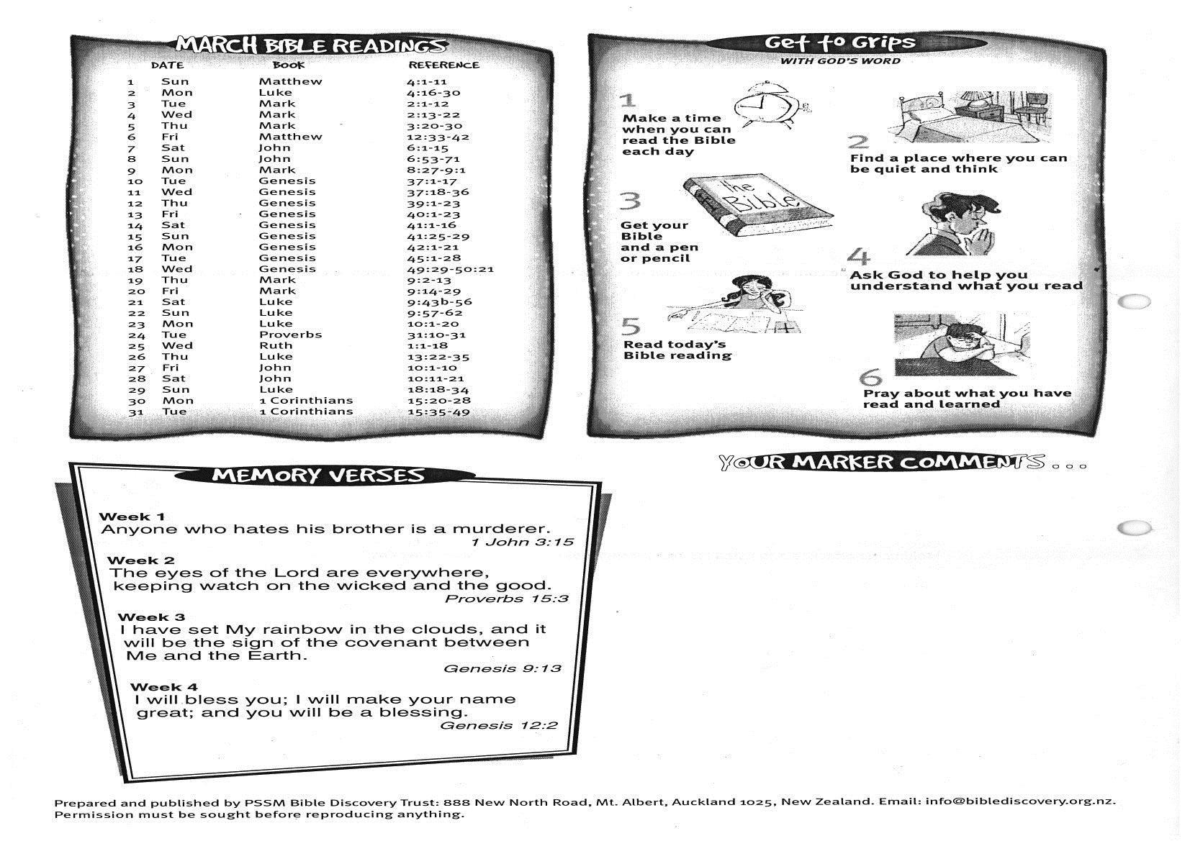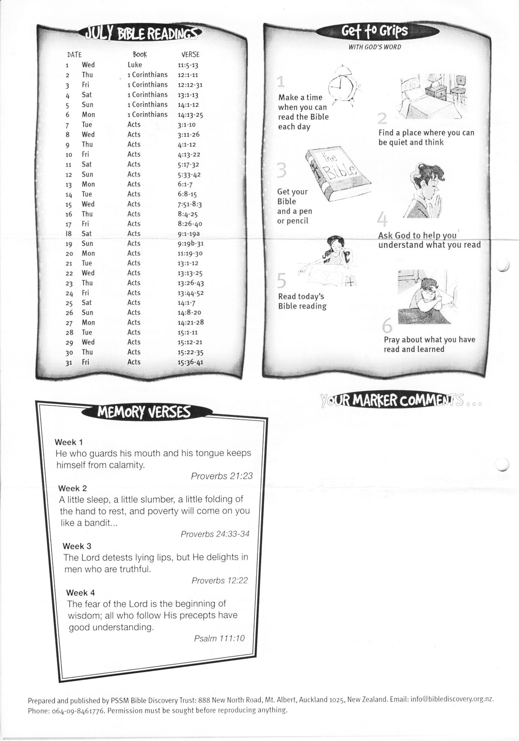

**31 Acts 15:36-41**