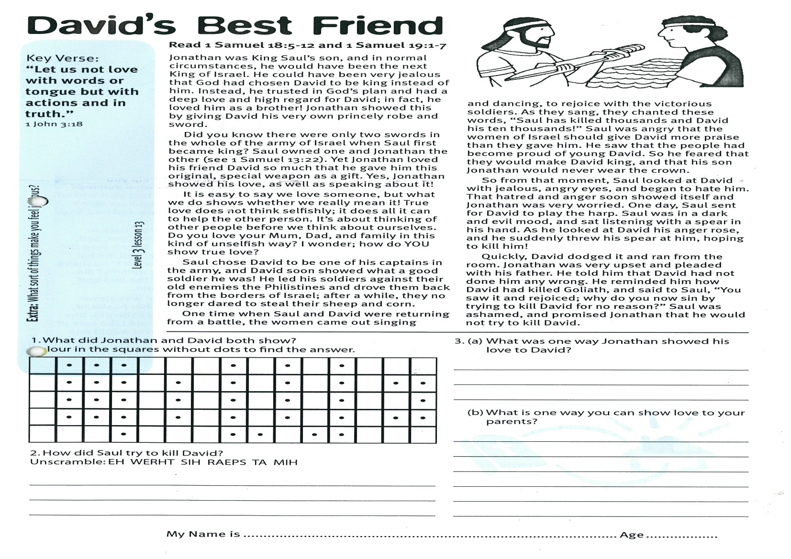

**Read 1 Samuel 18:5-12   
and 1 Samuel 19:1-7**

Jonathan was King Saul’s son, and in normal circumstances, he would have been the next King of Israel. He could have been very jealous that God had chosen David to be king instead of him. Instead, he trusted in God’s plan and had a deep love and high regard for David; in fact, he loved him as a brother! Jonathan showed this by giving David his very own princely robe and sword.

Did you know there were only two swords in the whole of the army of Israel when Saul first became king? Saul owned one and Jonathan the other (see 1 Samuel 13:22). Yet Jonathan loved his friend David so much that he gave him this original, special weapon as a gift. Yes, Jonathan showed his love, as well as speaking about it!

It is easy to say we love someone, but what we do shows whether we really mean it! True love does not think selfishly; it does all it can to help the other person. It’s about thinking of other people before we think about ourselves. Do you love your Mum, Dad, and family in this kind of unselfish way? I wonder; how do YOU show true love?

Saul chose David to be one of his captains in the army, and David soon showed what a good soldier he was! He led his soldiers against their old enemies, the Philistines and drove them back from the borders of Israel. After a while, they no longer dared to steal their sheep and corn.

Key Verse:  
**“Let us not love with words or tongue but with actions and in truth.”**  
1 John 3:18

**David’s Best Friend**

|  |  |  |  |  |  |  |  |  |  |  |  |  |  |  |
| --- | --- | --- | --- | --- | --- | --- | --- | --- | --- | --- | --- | --- | --- | --- |
|  | **⋅** | **⋅** | **⋅** |  |  |  | **⋅** |  | **⋅** |  | **⋅** |  |  |  |
|  | **⋅** | **⋅** | **⋅** |  | **⋅** |  | **⋅** |  | **⋅** |  | **⋅** |  | **⋅** | **⋅** |
|  | **⋅** | **⋅** | **⋅** |  | **⋅** |  | **⋅** |  | **⋅** |  | **⋅** |  |  | **⋅** |
|  | **⋅** | **⋅** | **⋅** |  | **⋅** |  | **⋅** |  | **⋅** |  | **⋅** |  | **⋅** | **⋅** |
|  |  |  | **⋅** |  |  |  | **⋅** | **⋅** |  | **⋅** | **⋅** |  |  |  |

One time when Saul and David were returning from a battle, the women came out singing and dancing, to rejoice with the victorious soldiers. As they sang, they chanted these words, “Saul has killed thousands and David his ten thousands!” Saul was angry that the women of Israel should give David more praise than they gave him. He saw that the people had become proud of young David. So he feared that they would make David king, and that his son Jonathan would never wear the crown.

So from that moment, Saul looked at David with jealous, angry eyes, and began to hate him. That hatred and anger soon showed itself and Jonathan was very worried. One day, Saul sent for David to play the harp. Saul was in a dark and evil mood, and sat listening with a spear in his hand. As he looked at David his anger rose, and he suddenly threw his spear at him, hoping to kill him!

Quickly, David dodged it and ran from the room. Jonathan was very upset and pleaded with his father. He told him that David had not done him any wrong. He reminded him how David had killed Goliath, and said to Saul, “You saw it and rejoiced; why do you now sin by trying to kill David for no reason?” Saul was ashamed, and promised Jonathan that he would not try to kill David.

2. How did Saul try to kill David?  
Unscramble: **EH WERHT SIH RAEPS TA MIH**

____________________________________________

1. What did Jonathan and David both show?

(Colour in the squares without dots to find the answer)

**Level 3 lesson 13**

**Extra:** What sort of things make you feel jealous?

3(a) What was one way Jonathan showed his love to David?

_________________________________

_________________________________

___________________  
3(b) What is one way you can show love to your parents?

_________________________________

_________________________________

_________________________________

_________________________________

_________________________________

_________________________________(

My Name is ……………………………………………………… Age…………………

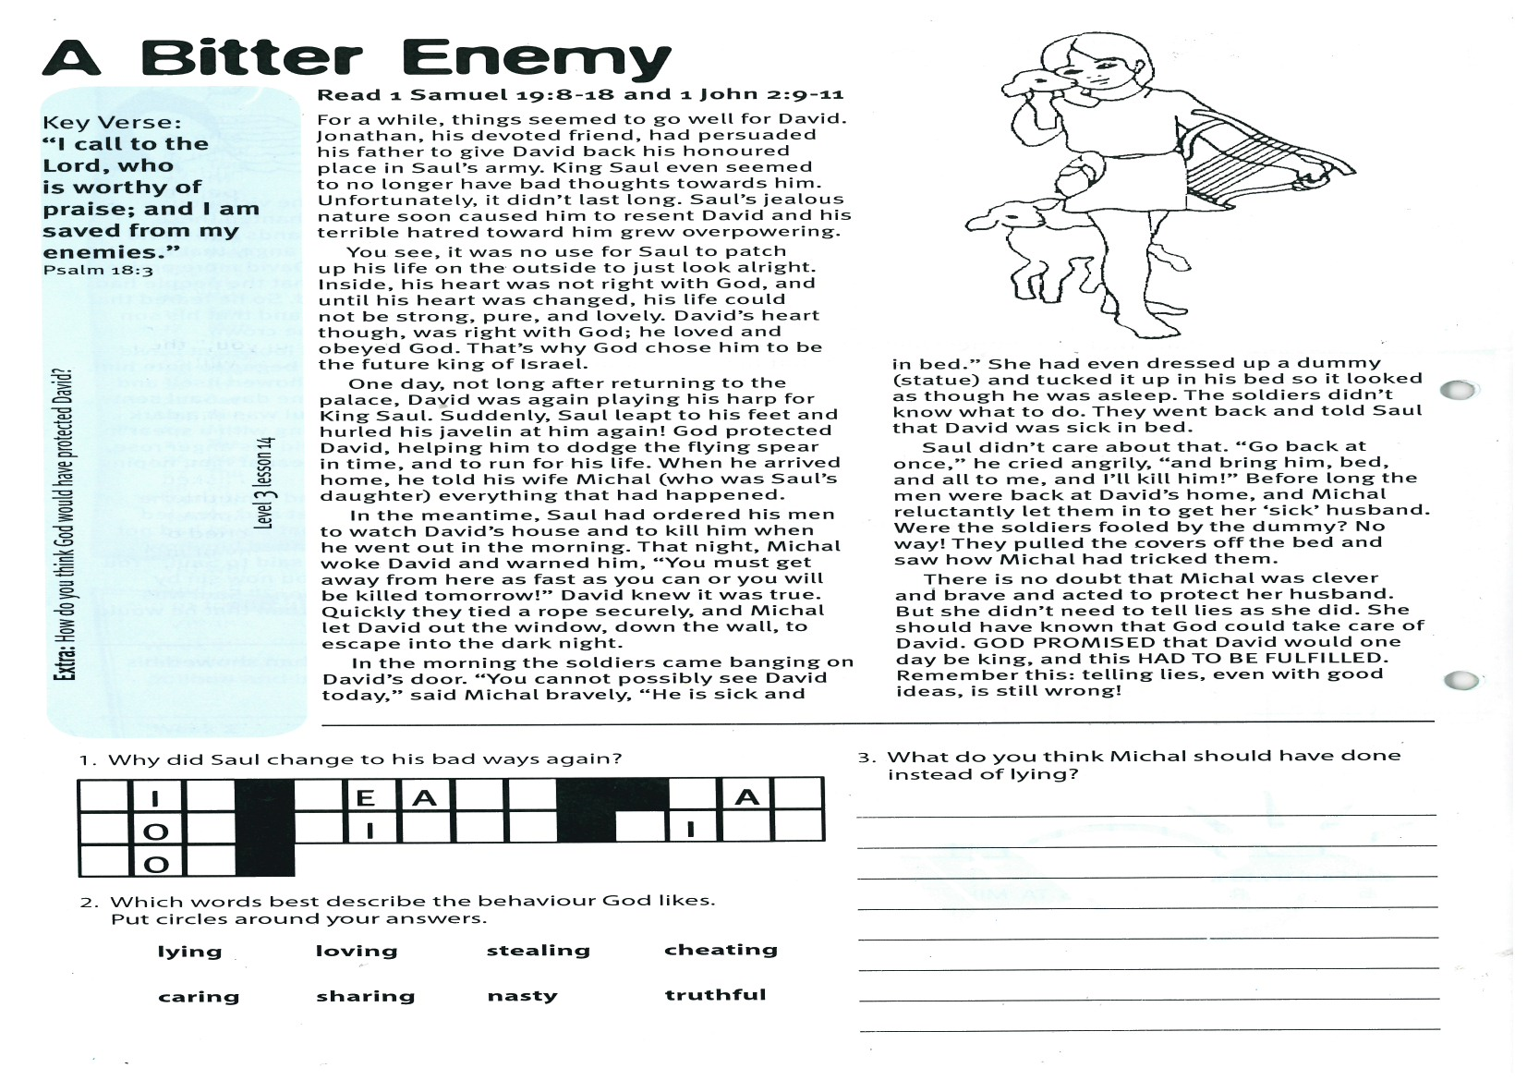

**Read 1 Samuel 19:8-18   
and 1 John 2:9-11**

For a while, things seemed to go well for David. Jonathan, his devoted friend, had persuaded his father to give David back his honoured place in Saul’s army. King Saul even seemed to no longer have bad thoughts towards him. Unfortunately, it didn’t last long. Saul’s jealous nature soon caused him to resent David and his terrible hatred toward him grew overpowering.

You see, it was no use for Saul to patch up his life on the outside to just look alright. Inside, his heart was not right with God, and until his heart was changed, his life could not be strong, pure, and lovely. David’s heart though, was right with God; he loved and obeyed God. That’s why God chose him to be the future king of Israel.

One day, not long after returning to the palace, David was again playing his harp for King Saul. Suddenly, Saul leapt to his feet and hurled his javelin at him again! God protected David, helping him to dodge the flying spear in time, and to run for his life. When he arrived home, he told his wife Michal (who was Saul’s daughter) everything that had happened.

In the meantime, Saul had ordered his men to watch David’s house and to kill him when he went out in the morning. That night, Michal woke David and warned him, “You must get away from here as fast as you can or you will be killed tomorrow!” David knew it was true. Quickly they tied a rope securely, and Michal let David out the window, down the wall, to escape into the dark night.

Key Verse:  
**“I call to the Lord, who is worthy of praise; and I am saved from my enemies.”**Psalm 18:3

**A Bitter Enemy**

|  |  |  |  |  |  |  |  |  |  |  |  |  |  |
| --- | --- | --- | --- | --- | --- | --- | --- | --- | --- | --- | --- | --- | --- |
|  | **I** |  |  |  | **E** | **A** |  |  |  |  |  | **A** |  |
|  | **O** |  |  |  | **I** |  |  |  |  |  | **I** |  |  |
|  | **O** |  |  |  |  |  |  |  |  |  |  |  |  |

In the morning the soldiers came banging on David’s door. “You cannot possibly see David today,” said Michal bravely, “He is sick and in bed.” She had even dressed up a dummy (statue) and tucked it up in his bed so it looked as though he was asleep. The soldiers didn’t know what to do. They went back and told Saul that David was sick in bed.

Saul didn’t care about that. “Go back at once,” he cried angrily, “and bring him, bed, and all to me, and I’ll kill him!” Before long the men were back at David’s home, and Michal reluctantly let them in to get her ‘sick’ husband. Were the soldiers fooled by the dummy? No way! They pulled the covers off the bed and saw how Michal had tricked them.

There is no doubt that Michal was clever and brave and acted to protect her husband. But she didn’t need to tell lies as she did. She should have known that God could take care of David. GOD PROMISED that David would one day be king, and this HAD TO BE FULFILLED. Remember this: telling lies, even with good intentions, is still wrong!

2. Which words best describe the behaviour God likes *(Circle your answers*)

lying loving stealing cheating

caring sharing nasty truthful

1. Why did Saul change to his bad ways again?

**Level 3 lesson 14**

**Extra:** How do you think God would have protected David?

3. What do you think Michal should have done instead of lying?

_______________________________________

_______________________________________

_______________________________________

_______________________________________

_______________________________________

_______________________________________

**Read 1 Samuel 20:1-34**

David escaped, but Saul’s anger and jealousy toward David grew worse every day. He was still determined to capture him, so whenever someone told him where David had gone, he took off in hot pursuit! Poor David was in real trouble, but God was still caring for him. Jonathan was always ready to help his friend through these difficult days. Somehow, he managed to keep in touch with David, although sometimes it was quite dangerous for him to do so.

Once, David asked Jonathan, “What have I done that your father wants to kill me?” Jonathan found it hard to believe that his father still meant to harm David. “But,” David said, “I am sure he still wants to kill me!” So David suggested a plan to find out Saul’s real feelings. The next time Jonathan met with King Saul at the meal table, he must watch Saul’s reaction when he saw that the place reserved for David was empty. If he was mad about it, Jonathan would know that he really did want to harm David.

Jonathan was still hopeful though. “Perhaps, even now, my father may become your friend,” he told David. “His feelings toward you may have changed. But if he is your enemy, I know that the Lord is with you, and that Saul will not succeed against you. Promise me that as long as you live you will be kind to me and to my children after me.”

Key Verse:  
**“The Lord confides in those who fear Him.”**Psalm 25:14

**A True Friend**

Jonathan believed, like many others, that David would one day be King of Israel. He was happy about that because he loved David so much. So that day, Jonathan and David promised that they, their children, and all those who came after them, would be friends forever.

Jonathan told David, “I will find out how my father feels towards you, and let you know. After three days I will be here with my bow and arrows and I will send a boy out near where you are hiding and I will shoot three arrows. If I say to the boy, “Run find the arrows, they are on this side of you,” then you can come safely, for the king will not harm you. But if I call out to the boy, “The arrows are way beyond you,” that will mean that there is danger and you must hide from the king.” This they both agreed to.

Later, at the meal table, Saul asked where David was. Jonathan said, “David asked permission to go to his home at Bethlehem and visit his oldest brother.” Saul was mad! “You are a disobedient son!” he cried out, “Why have you chosen this enemy of mine as your best friend? Don’t you know that as long as he is alive you can never be king? Send for him and let him be brought to me. He shall surely die!”  
  
Saul was so angry he threw his spear at his own son Jonathan! As Jonathan ran from the room, he knew now that David was definitely on his father’s ‘hit list.’ He must warn him!

|  |  |  |  |  |  |  |  |
| --- | --- | --- | --- | --- | --- | --- | --- |
| **K** | **P** | **O** | **B** | **U** | **I** | **B** | **O** |
|  |  |  |  |  |  |  |  |

|  |  |  |  |  |  |  |  |  |  |  |
| --- | --- | --- | --- | --- | --- | --- | --- | --- | --- | --- |
|  |  |  | ● |  |  |  | ● |  |  | ● |
|  | ● | ● | ● |  | ● |  | ● |  | ● |  |
|  | ● |  | ● |  | ● |  | ● |  | ● |  |
|  |  |  | ● |  |  |  | ● |  |  | ● |

**(Colour in the squares without dots to see the answer!)**

4. What are some ways you can show that you love God?

_______________________________________

________________________________________

_______________________________________

3. Who took care of David and also cares for us?

**Level 3 lesson 15**

**Extra:** Why do you think Saul was so mad at David and Jonathan?

2. Write down one thing that shows Jonathan loved David.

__________________________________________________

__________________________________________________

__________________________________________________

1. Can you work out the name in the box below?  
**(Clue: use the alphabet letters that come before each of the letters below)**

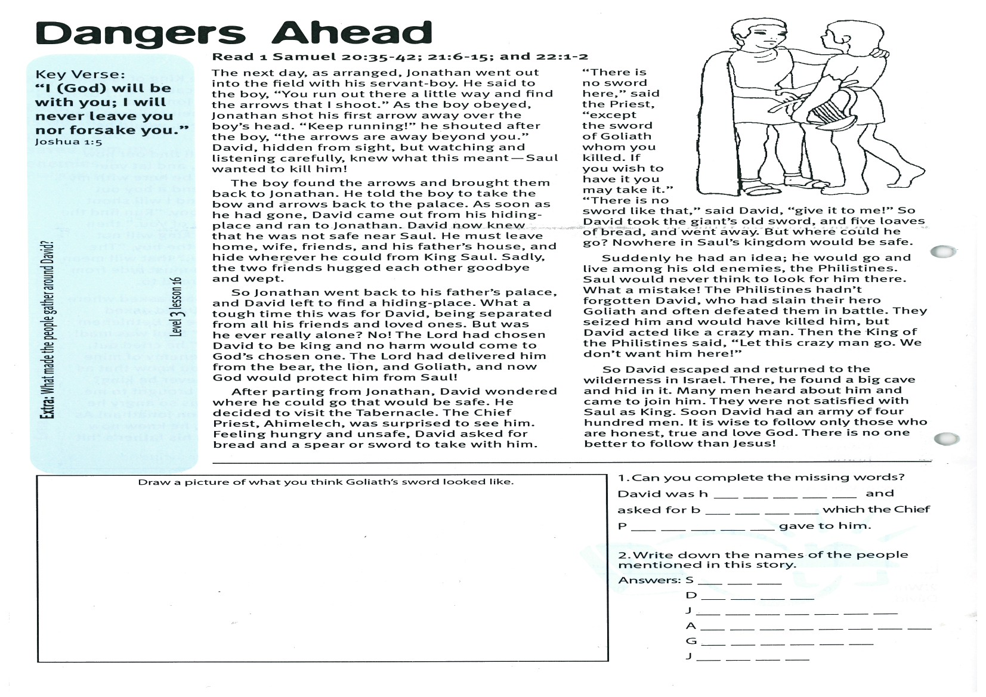

**Read 1 Samuel 20:35-42; 21:6-15; and 22:1-2**

The next day, as arranged, Jonathan went out into the field with his servant-boy. He said to the boy, “You run out there a little way and find the arrows that I shoot.” As the boy obeyed, Jonathan shot his first arrow away over the boy’s head. “Keep running!” he shouted after the boy, “the arrows are way beyond you.” David, hidden from sight, but watching and listening carefully, knew what this meant - Saul wanted to kill him!

The boy found the arrows and brought them back to Jonathan. He told the boy to take the bow and arrows back to the palace. As soon as he had gone, David came out from his hiding-place and ran to Jonathan. David now knew that he was not safe near Saul. He must leave home, wife, friends, and his father’s house, and hide wherever he could from King Saul. Sadly, the two friends hugged each other goodbye and wept.

So Jonathan went back to his father’s palace, and David left to find a hiding-place. What a tough time this was for David, being separated from all his friends and loved ones. But was he ever really alone? No! The Lord had chosen David to be king and no harm would come to God’s chosen one. The Lord had delivered him from the bear, the lion, and Goliath, and now God would protect him from Saul!

After parting from Jonathan, David wondered where he could go that would be safe. He decided to visit the Tabernacle. The Chief Priest, Ahimelech, was surprised to see him.

Key Verse:  
**“I (God) will be with you; I will never leave you nor forsake you.”**Joshua 1:5

**Dangers Ahead**

Feeling hungry and unsafe, David asked for bread and a spear or sword to take with him. “There is no sword here,” said the Priest, “except the sword of Goliath whom you killed. If you wish to have it you may take it.” “There is no sword like that,” said David, “give it to me!” So David took the giant’s old sword, and five loaves of bread, and went away. But where could he go? Nowhere in Saul’s kingdom would be safe.

Suddenly he had an idea; he would go and live among his old enemies, the Philistines. Saul would never think to look for him there. What a mistake! The Philistines hadn’t forgotten David, who had slain their hero Goliath and often defeated them in battle. They seized him and would have killed him, but David acted like a crazy man. Then the King of the Philistines said, “Let this crazy man go. We don’t want him here!”

So David escaped and returned to the wilderness in Israel. There, he found a big cave and hid in it. Many men heard about him and came to join him. They were not satisfied with Saul as King. Soon David had an army of four hundred men. It is wise to follow only those who are honest, true and love God. There is no-one better to follow than Jesus!

Please complete and return by post to   
**PSSM, 1-2A (G2) 93 Dominion Rd, Mt Eden, Auckland 1024** or scan & email to **info@biblediscovery.org.nz**

**Answer:**

**Level 3 lesson 16**

**Extra:** What made the people gather around David?

Draw a picture of what you think Goliath’s sword looked like:

1. Can you complete the missing words:  
David was h __ __ __ __ __ and asked for   
 b __ __ __ __ which the Chief   
 P __ __ __ __ __ gave to him.

2. Write down the names of the people mentioned in this story:   
Answers: S __ __ __ D __ __ __ __

J __ __ __ __ __ __ __

A __ __ __ __ __ __ __ __

G __ __ __ __ __ __

J __ __ __ __

Please complete and return by post to   
**PSSM Bible Discovery, 5/399 New North Rd, Kingsland, Auckland, 1021**or scan & email to **info@biblediscovery.org.nz**