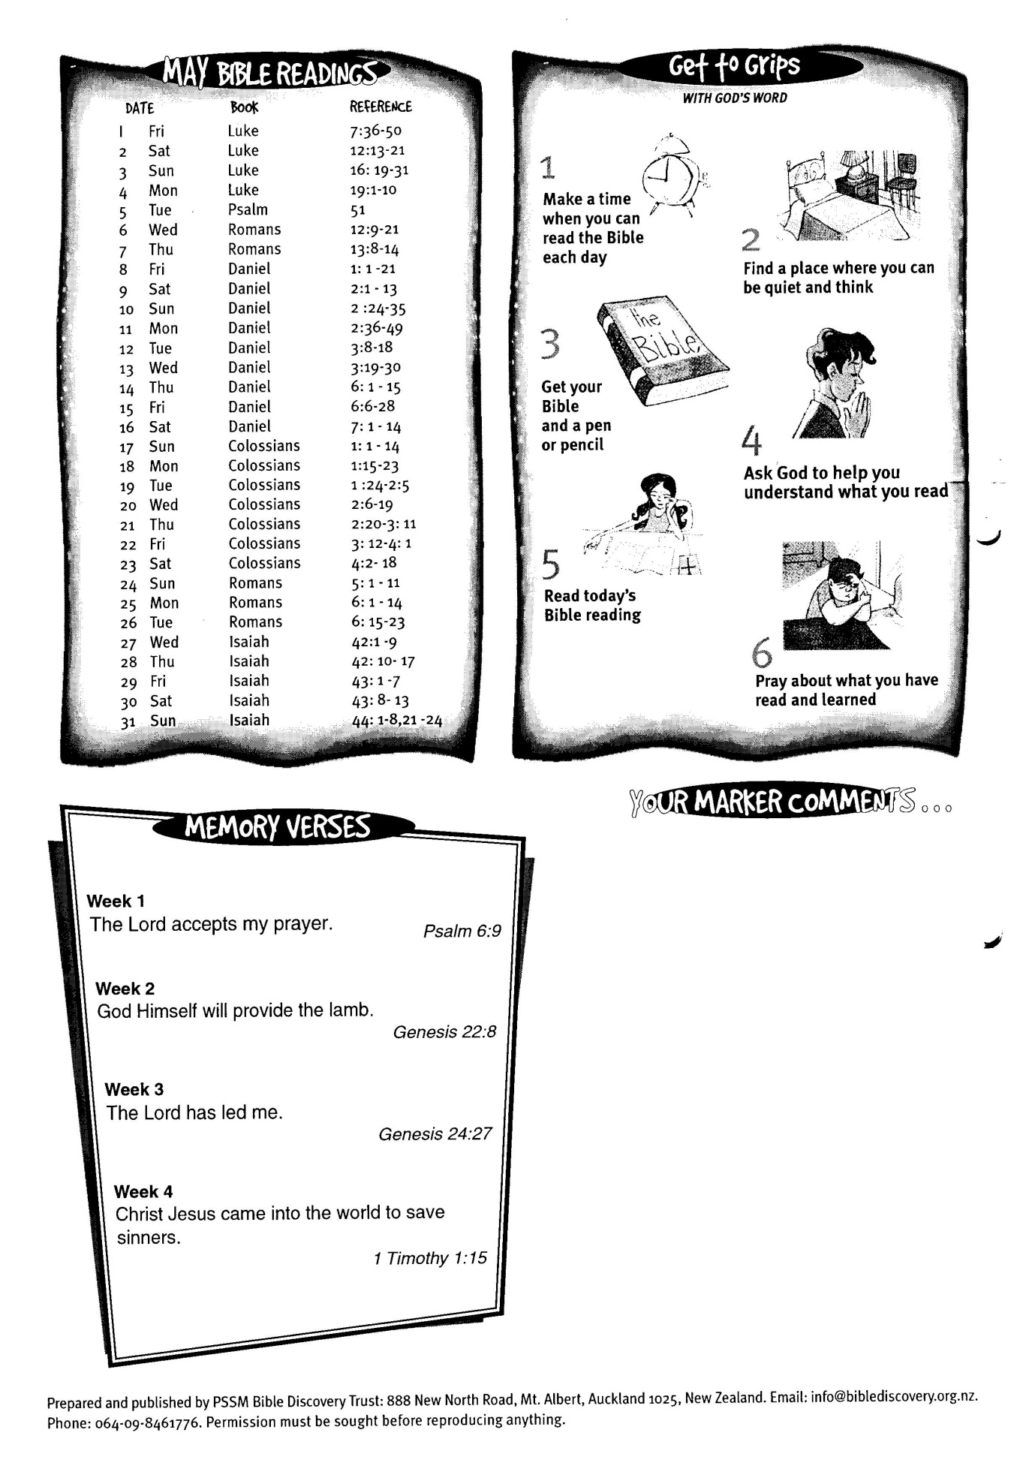

**May Bible Readings**

DATE BOOK REFERENCE

**31 Isaiah 44: 1-8; 21-24**

6:16 - 28