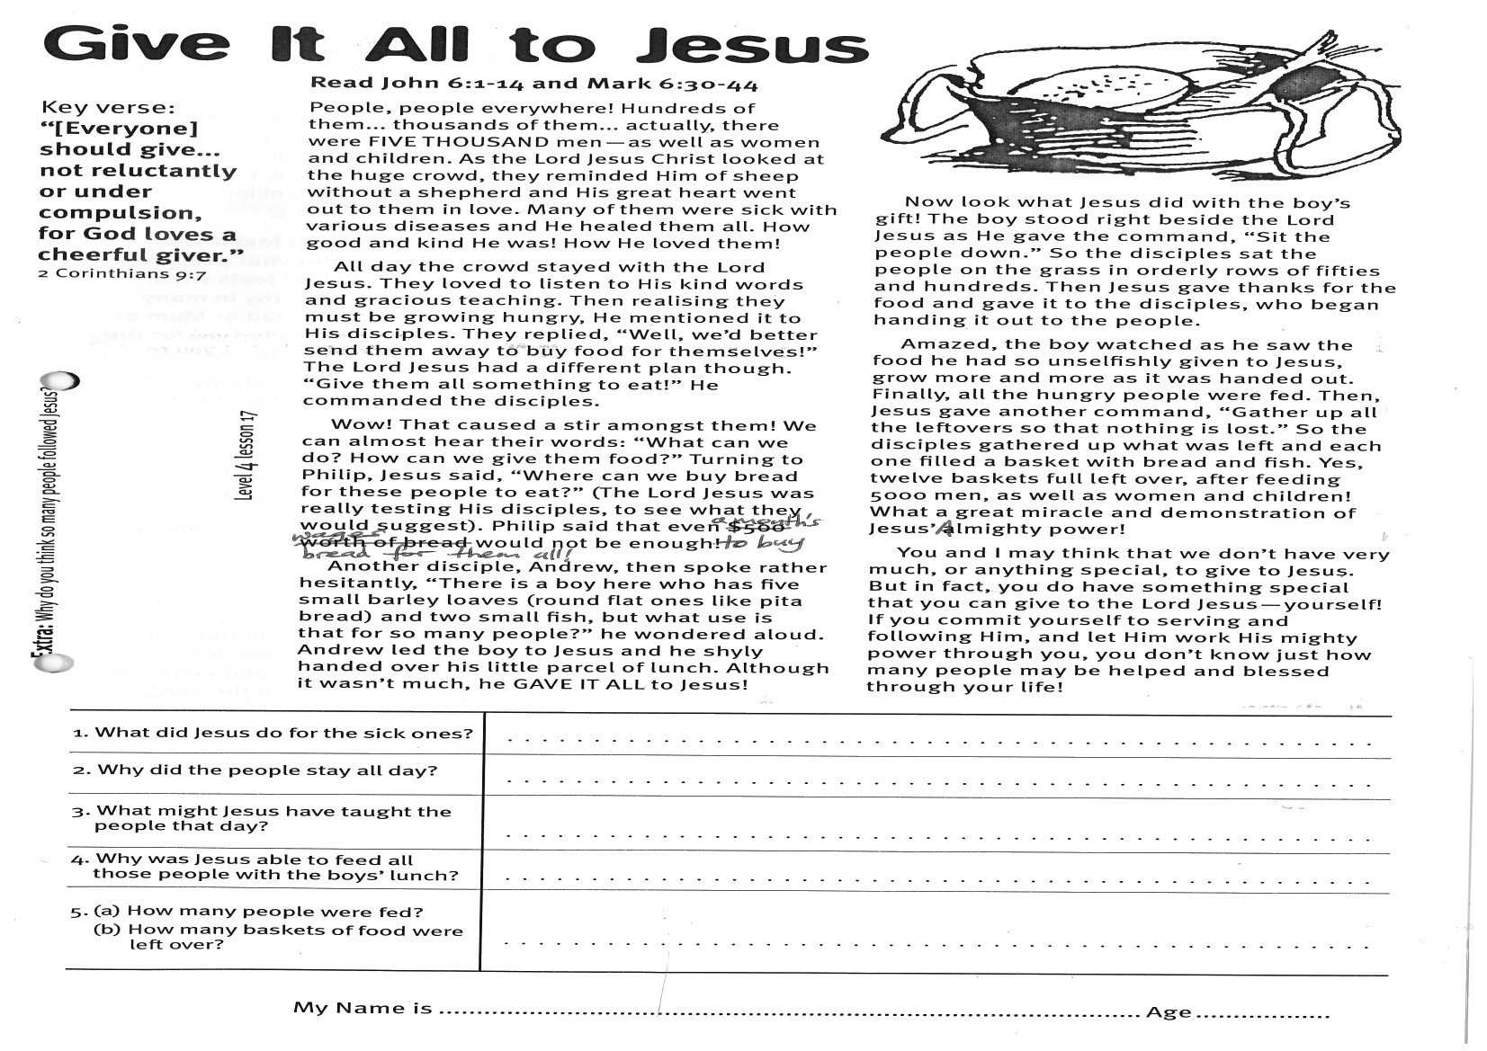
Give it All to Jesus
Key Verse:
“[Everyone] should give… not reluctantly or under compulsion, for God loves a cheerful giver.”
2 Corinthians 9:7
Read John 6:1-14
and Mark 6:30-44
People, people everywhere! Hundreds of them… thousands of them… actually, there were FIVE THOUSAND men - as well as women and children. As the Lord Jesus Christ looked at the huge crowd, they reminded Him of sheep without a shepherd and His great heart went out to them in love. Many of them were sick with various diseases and He healed them all. How good and kind He was! How He loved them!
All day the crowd stayed with the Lord Jesus. They loved to listen to His kind words and gracious teaching. Then realising they must be growing hungry, He mentioned it to His disciples. They replied, “Well, we’d better send them away to buy food for themselves!” The Lord Jesus had a different plan though. “Give them all something to eat!” He commanded the disciples.
Wow! That caused a stir amongst them! We can almost hear their words: “What can we do? How can we give them food?” Turning to Philip, Jesus said, “Where can we buy bread for these people to eat?” (The Lord Jesus was really testing His disciples, to see what they would suggest). Philip said that even a month’s wages would not be enough to buy bread for them all!
Another disciple, Andrew, then spoke rather hesitantly, “There is a boy here who has five small barley loaves (round flat ones like pita bread) and two small fish, but what use is that for so many people?” he wondered aloud.
1. What did Jesus do for the sick ones?
2. Why did the people stay all day?
3. What might Jesus have taught the people that day?
4. Why was Jesus able to feed all those people with the boy’s lunch?
5. (a) How many people were fed? (b) How many baskets of food were left over?
My Name is _____________________________________________ Age ___________
Extra: Why do you think so many people followed Jesus?

Level 4 lesson 17
QUESTIONS & ANSWERS
Level 3 lesson 1
Andrew led the boy to Jesus and he shyly handed over his little parcel of lunch. Although it wasn’t much, he GAVE IT ALL to Jesus!
Now look what Jesus did with the boy’s gift! The boy stood right beside the Lord Jesus as He gave the command, “Sit the people down.” So the disciples sat the people on the grass in orderly rows of fifties and hundreds. Then Jesus gave thanks for the food and gave it to the disciples, who began handing it out to the people.
Amazed, the boy watched as he saw the food he had so unselfishly given to Jesus, grow more and more as it was handed out. Finally, all the hungry people were fed. Then, Jesus gave another command, “Gather up all the leftovers so that nothing is lost.” So the disciples gathered up what was left and each one filled a basket with bread and fish. Yes, twelve baskets full left over, after feeding 5000 men, as well as women and children! What a great miracle and demonstration of Jesus’ Almighty power!
You and I may think that we don’t have very much, or anything special, to give to Jesus. But in fact, you do have something special that you can give to the Lord Jesus - yourself! If you commit yourself to serving and following Him, and let Him work His mighty power through you, you don’t know just how many people may be helped and blessed through your life!
Key Verse:
“Jesus said, ‘I tell you the truth, unless a man is born again, he cannot see the kingdom of God.’”
John 3:3
Keep Giving Thanks
Key Verse:
“Give thanks to the Lord, for He is good. His love endures forever.”
Psalm 136:1
Read Psalm 118
and Colossians 3:15-17
What would you think if you gave a friend a present and they just took it without even saying “thank you”? I know I’d be hurt and disappointed and think that my friend didn’t really care about me at all. I don’t think I’d feel like giving them anything else until they learned to say “thank you!” Would you? Of course, everyone should be taught to say “thank you” when receiving a gift. It’s not only polite, but it shows we appreciate the person who has given us the gift, and their kindness and thoughtfulness too.
Today we want to think about saying ‘thank you’ to God for the things He provides for us day by day. Can you think of some of them? We read in James 1:17 that “Every good gift and every perfect gift is from above, and comes down from the Father of Lights” (which is another name for God). He provides the sunshine, and sends the rain. He makes the seeds to grow and the trees to bear fruit. Without these very important things, we would have no food and clothing. So you see, we really do depend on God to provide a lot for us, don’t we? Let’s not forget to give thanks to Him!
In our last lesson we saw the Lord Jesus feed more than 5000 people with five loaves and two small fish. Did you notice what He did before He broke the loaves and fish to give to the people? He “gave thanks.” That simply means He said “thank you” to His Father, God, for the food.

Some people call it ‘saying grace’ before a meal. Do you say grace before your meals, thanking God for the food you are about to eat?
Remember, how would it feel if your friend didn’t thank you for your present? Now, how do you think God feels when people ignore Him? That’s why in many homes before every meal, Dad or Mum or someone else, gives thanks to God for the food. Why not do it in your home too?
Here are a few suggestions to help you to start giving thanks to God before meals:
One is:
“Lord, bless this food, which now we take;
help us do good, for Jesus’ sake.”
Another is:
“Thank you for the world so sweet;
Thank you for the food we eat;
Thank you for the birds that sing;
Thank you God, for everything!”
Another one:
“Thank you Lord for this good food. Amen.”
You don’t even need a rhyme or verse at all; just thank God for your food in a simple prayer. There are probably many more things that you can think of to thank Him for, like His goodness and love. Remember, the reading for today starts and ends with these words, “Give thanks to the Lord, for He is good. His love endures forever!”
1. Why should we say “thank you” when someone gives us something?
2. What did Jesus do before He fed the five thousand plus? Why?
3. What does ‘saying Grace’ mean?
4. What are some of the things that God provides for us every day?
5. Write a prayer of thanks you can use.
Extra: Make it a habit before every meal to say thanks to God. So, other than food, what can you thank Him for?
Level 4 lesson 18
QUESTIONS & ANSWERS

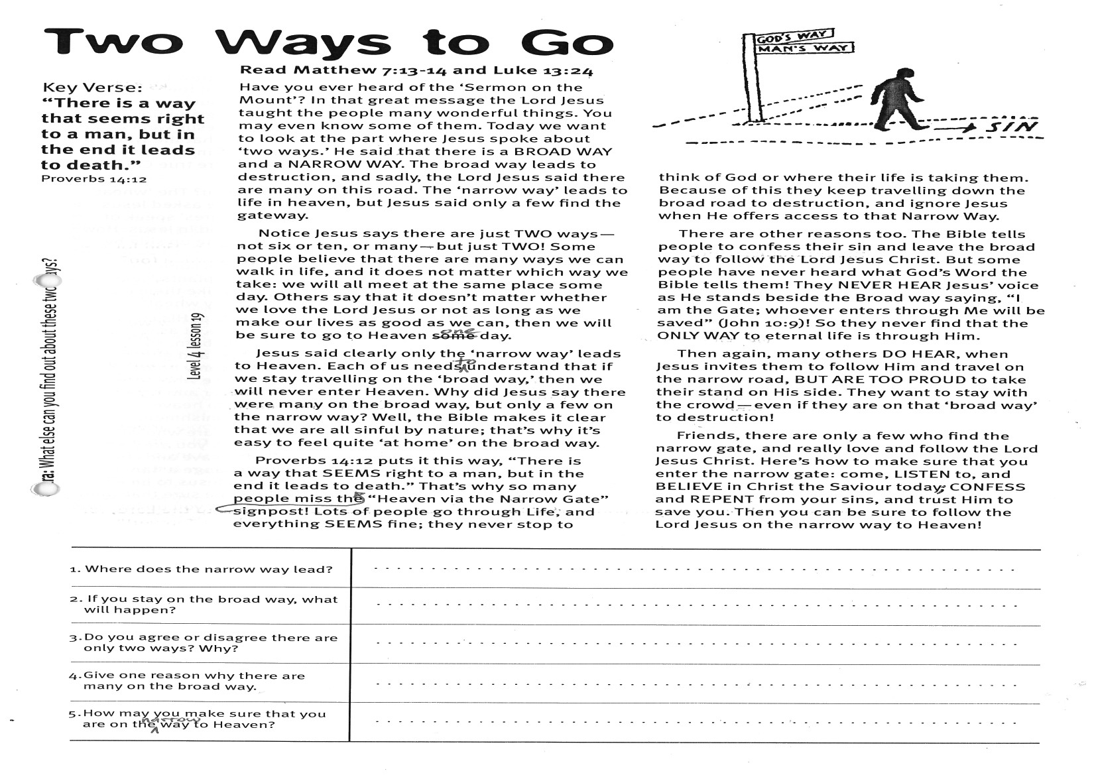
Key Verse:
“There is a way that seems right to a man, but in the end it leads to death.”
Proverbs 14:12
Read Matthew 7:13-14
and Luke 13:24
Have you ever heard of the ‘Sermon on the Mount’? In that great message the Lord Jesus taught the people many wonderful things. You may even know some of them. Today we want to look at the part where Jesus spoke about ‘two ways.’ He said that there is a BROAD WAY and a NARROW WAY. The broad way leads to destruction, and sadly, the Lord Jesus said there are many on this road. The ‘narrow way’ leads to life in heaven, but Jesus said only a few find the gateway.
Notice Jesus says there are just TWO ways - not six or ten, or many - but just TWO! Some people believe that there are many ways we can walk in life, and it does not matter which way we take: we will all meet at the same place one day. Others say that it doesn’t matter whether we love the Lord Jesus or not as long as we make our lives as good as we can, then we will be sure to go to Heaven one day.
Jesus said clearly only the ‘narrow way’ leads to Heaven. Each of us needs to understand that if we stay travelling on the ‘broad way,’ then we will never enter Heaven. Why did Jesus say there were many on the broad way, but only a few on the narrow way? Well, the Bible makes it clear that we are all sinful by nature; that’s why it’s easy to feel quite ‘at home’ on the broad way.
Proverbs 14:12 puts it this way, “There is a way that SEEMS right to a man, but in the end it leads to death.” That’s why so many people miss the signpost - “Heaven via the Narrow Gate”!

Two Ways to Go
1. Where does the narrow way lead?
2. If you stay on the broad way, what will happen?

3. Do you agree or disagree there are only two ways? Why?
4. Give one reason why there are many on the broad way.

5. How may you make sure that you are on the narrow way to Heaven?
Extra: What else can you find out about these two ways?

Level 4 lesson 19
QUESTIONS & ANSWERS
Lots of people go through life, and everything SEEMS fine; they never stop to think of God or where their life is taking them. Because of this they keep travelling down the broad road to destruction, and ignore Jesus when He offers access to that Narrow Way.
There are other reasons too. The Bible tells people to confess their sin and leave the broad way to follow the Lord Jesus Christ. But some people have never heard what God’s Word the Bible tells them! They NEVER HEAR Jesus’ voice as He stands beside the broad way saying, “I am the Gate; whoever enters through Me will be saved” (John 10:9)! So they never find that the ONLY WAY to eternal life is through Him.
Then again, many others DO HEAR, when Jesus invites them to follow Him and travel on the narrow road, BUT ARE TOO PROUD to take their stand on His side. They want to stay with the crowd - even if they are on that ‘broad way’ to destruction!
Friends, there are only a few who find the narrow gate, and really love and follow the Lord Jesus Christ. Here’s how to make sure that you enter the narrow gate: come, LISTEN to, and BELIEVE in Christ the Saviour today; CONFESS and REPENT from your sins, and trust Him to save you. Then you can be sure to follow the Lord Jesus on the narrow way to Heaven!

Two Kinds of People
Key Verse:
“So you also must be ready: because the Son of Man will come at an hour when you do not expect Him.”
Matthew 24:44
Read Matthew 13:24-30, 36-42 and Revelation 20:11-15
In past lessons we have sometimes mentioned that before the Lord Jesus went back to Heaven, He promised to one day return and take all those who love Him to be with Himself forever (John 14:1-3). What an awesome, joyful moment THAT will be for those who have received Him as Saviour! Wow, I can hardly wait! But oh, what a sad, terrible day, for those who have ignored or refused His invitation to receive pardon for their sin!
The Lord Jesus Christ told today’s story or parable, to teach us about His second coming. A parable is a story about something that happens in everyday life, explaining some truth or lesson which is good for us to learn. Someone once described a parable as “an earthly story with a heavenly meaning!”
In this parable, Jesus spoke of a farmer who sowed his fields with good wheat seed. But at night-time, one of his enemies came and sowed tares (or weeds) in his field. Tares were very bad weeds that were useless for both people and animals. As the seeds sprouted and grew, the farmer’s servants could see what had happened and asked, “Shall we go and pull the useless tares out and throw them away?”
The farmer said, “No. While they are growing, the tares and the wheat look so much alike that if you start pulling them out you might pull the wheat out too. Leave them until harvest time, and then it will be clearly seen which is which. When my reapers go out to harvest, they will be able to separate the wheat and tares. They will burn the tares and gather the wheat into my barn.”
1. How would you describe what a parable is?
2. What 2 things were sown in the field, and by whom?
3. Why did the farmer tell the servants to leave the tares until harvest?

4. What kind of people are like: (a) the wheat? and (b) the tares?
5. How can your life be made like the good wheat?
Extra: Is there any test to know if you are truly a Christian?
Level 4 lesson 20
QUESTIONS & ANSWERS
Meanwhile, the two crops grew up side by side and it almost seemed as if the tares were pretending to be wheat. Of course, it was impossible to pretend for long and harvest time soon showed them up! Jesus went on to explain the parable. He said that the wheat and tares represent the two kinds of people in the world today: those who are true Christians and those who are not.
I wonder, which type are you? The ‘wheat’ represents all those who have asked Jesus to save them from sin. The ‘tares’ speak of those who have never believed in Jesus. How sad to be like a ‘tare’ - growing up side by side with the wheat, trying to look like wheat, but always knowing there was something different about those ‘wheat plants,’ and knowing you were not really like them on the inside and will never grow any wheat!
The Lord Jesus then said that His coming will be like the harvest time: just as the good wheat was gathered into the barn, so all true Christian men, women, boys, and girls, will be gathered into Jesus’ heavenly home. Those who are not Christians (those who have never trusted Jesus as Saviour and repented from sin) will not be taken to Heaven. Instead, they face eternal punishment in hell.
NOW is the time to make sure who you really are: ‘tare’ or ‘wheat’? If you are just pretending but want God to save and change you, then He can. He can change a ‘tare plant’ into a ‘wheat plant’! So ask Jesus to be your Saviour today, and you can be sure that when He comes back He will gather you up into ‘His barn’, i.e. Heaven!
Please complete and return by post to
PSSM Bible Discovery, 5/399 New North Rd, Kingsland, Auckland 1021 or scan & email to info@biblediscovery.org.nz

