Key Verse:  
**“Jesus said, Let the little children come to Me.”**

Matthew 19:14

**Read Matthew 19:13-15**  
Jesus loves little children like you! While He was here on earth, He was never too busy to help and talk to children. One day, He had been teaching crowds of people and He was really tired. Just then some mothers came up to Him with their little children. They wanted their children to meet Jesus so that He could speak with them and pray for them.

Jesus’ disciples thought He would be too tired to be bothered by more people. And they thought He would certainly not be interested in little children! So they tried to stop the mothers bringing their children to Jesus, and told them to go away.

Jesus heard them arguing and told the disciples to let the little children come, and not to stop them. Heaven belongs to them as well, He said. Then He took the children in His arms and prayed for them.

**Jesus Loves Children!**

Jesus is now living in Heaven, but we can still talk to Him in prayer and He will help us. He wants us to love each other just as He loves us.

**Can you think of two ways you can show love to others as Jesus wants you to?** Write them on the lines below:

**1**._______________________________

_________________________________

_________________________________

_________________________________

**2.** _______________________________

_________________________________

_________________________________

_________________________________

**Level 2 lesson 21**

**Read each paragraph. If it talks about loving, colour the hearts red. If it doesn’t, draw an X through the hearts.**

2. Maryanne wanted to be top of the class. She asked her father who owned a local McDonalds restaurant to give free vouchers to her class. Her father agreed because the parents would come with the children and he would make lots of money out of them all.

3. Luke’s mother works long hours to support her family and she comes home very tired from her job. Luke often helps to get tea ready. His mother and his two younger sisters especially like the hamburgers he makes.

1. Jonathan knew that his old friend, Mrs Reid, had fallen and broken her hip. She was home from hospital but found walking difficult. Each morning Jonathan took in Mrs Reid’s newspaper. After school he took in her mail from her letterbox.

**Extra:** How do we know God loves us?

My Name is________________________________________ Age ______________

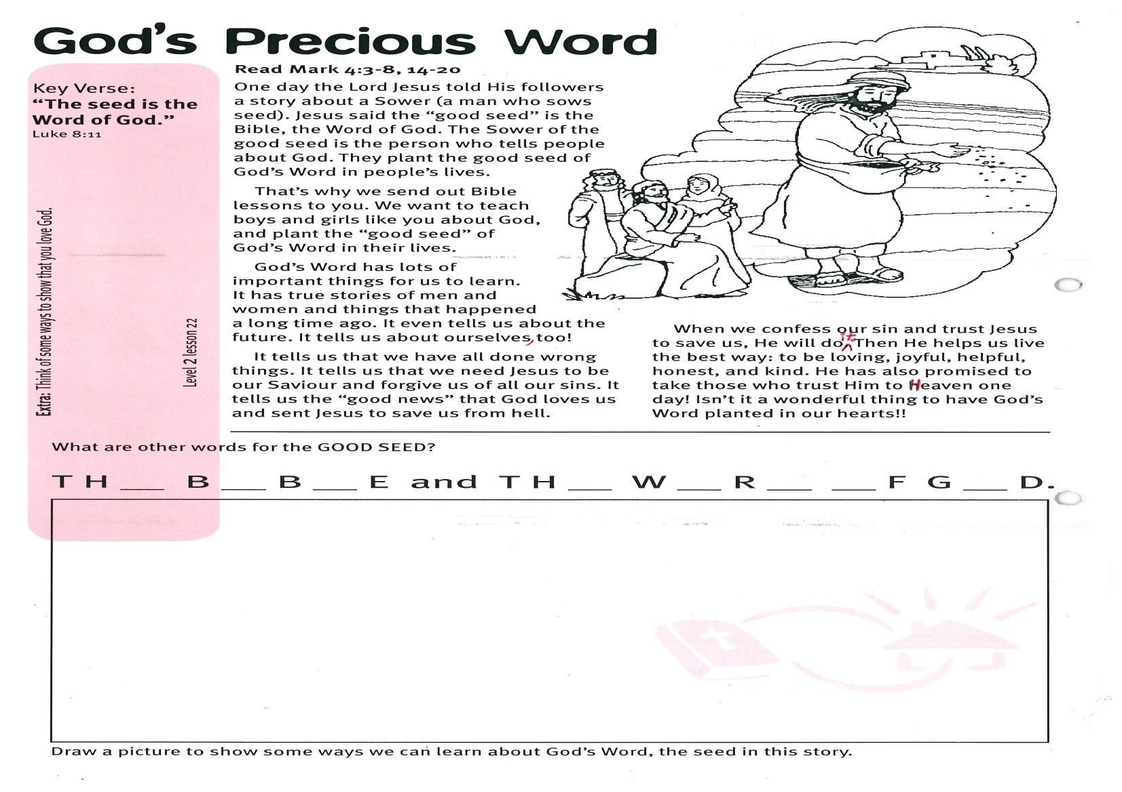

Key Verse:  
**“The seed is the Word of God.”**

Luke 8:11

**Read Mark 4:3-8, 14-20**

One day the Lord Jesus told His followers a story about a Sower (a man who sows seed). Jesus said the “good seed” is the Bible, the Word of God. The Sower of the good seed is the person who tells people about God. They plant the good seed of God’s Word in people’s lives.

That’s why we send out Bible lessons to you. We want to teach boys and girls like you about God, and plant the “good seed” of God’s Word in their lives.

God’s Word has lots of important things for us to learn. It has true stories of men and women and things that happened a long time ago. It even tells us about the future. It tells us about ourselves, too!

It tells us that we have all done wrong things. It tells us that we need Jesus to be our Saviour and forgive us of all our sins.

**God’s Precious Word**

It tells us the “good news” that God loves us and sent Jesus to save us from hell.

When we confess our sin and trust Jesus to save us, He will do it. Then He helps us live the best way: to be loving, joyful, helpful, honest, and kind. He has also promised to take those who trust Him to Heaven one day! Isn’t it a wonderful thing to have God’s Word planted in our hearts!!

**Level 2 lesson 22**

**Draw a picture to show some ways we can learn about God’s Word, the seed in this story.**

**What are other words for the GOOD SEED?**

**T H __ B __ B __ E AND T H __ W __ R __ __ F G __ D.**

**Extra:** Think of some ways to show that you love God.

**Read Luke 2:41-52**

Jesus grew up to be wise when He was here on earth, by listening to the Jewish leaders and asking them questions. He also knows all about our problems and questions. He gave lots of instructions to help us know what to do. They are recorded in the New Testament part of your Bible.

Read each Bible verse below. Then write in the empty balloon what Jesus might say to help each person with their problem.

Key Verse:  
**“Let the Word of Christ dwell in you richly.”**

Colossians 3:16

**Jesus: A Child’s Best Friend**

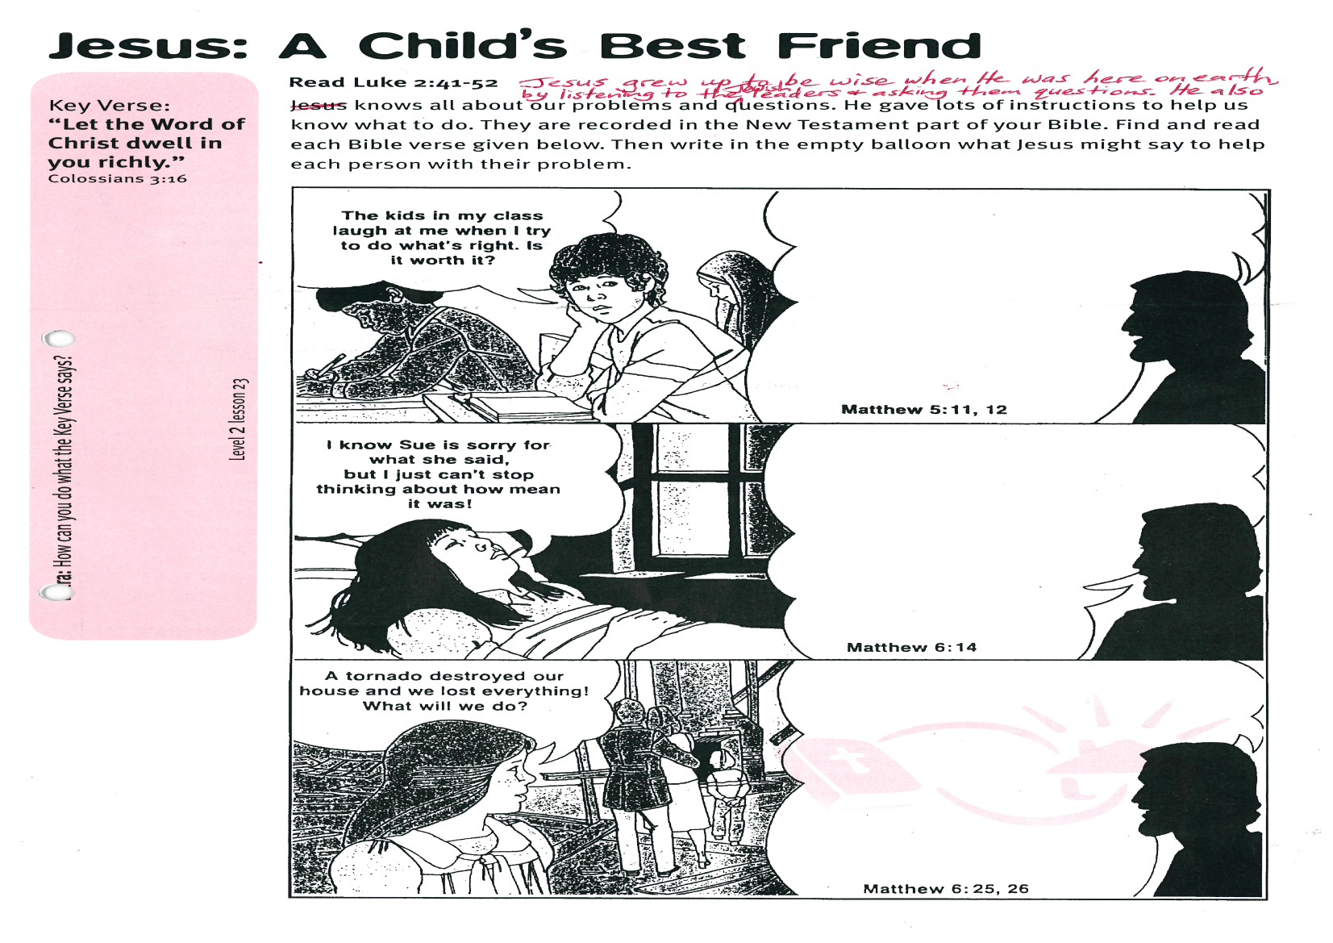

**Extra:** How can you do what the Key Verse says?

**Level 2 lesson 23**

C:\Users\Accounts\AppData\Local\Microsoft\Windows\Temporary Internet Files\Content.IE5\B5701BJ2\MC900292594[1].wmf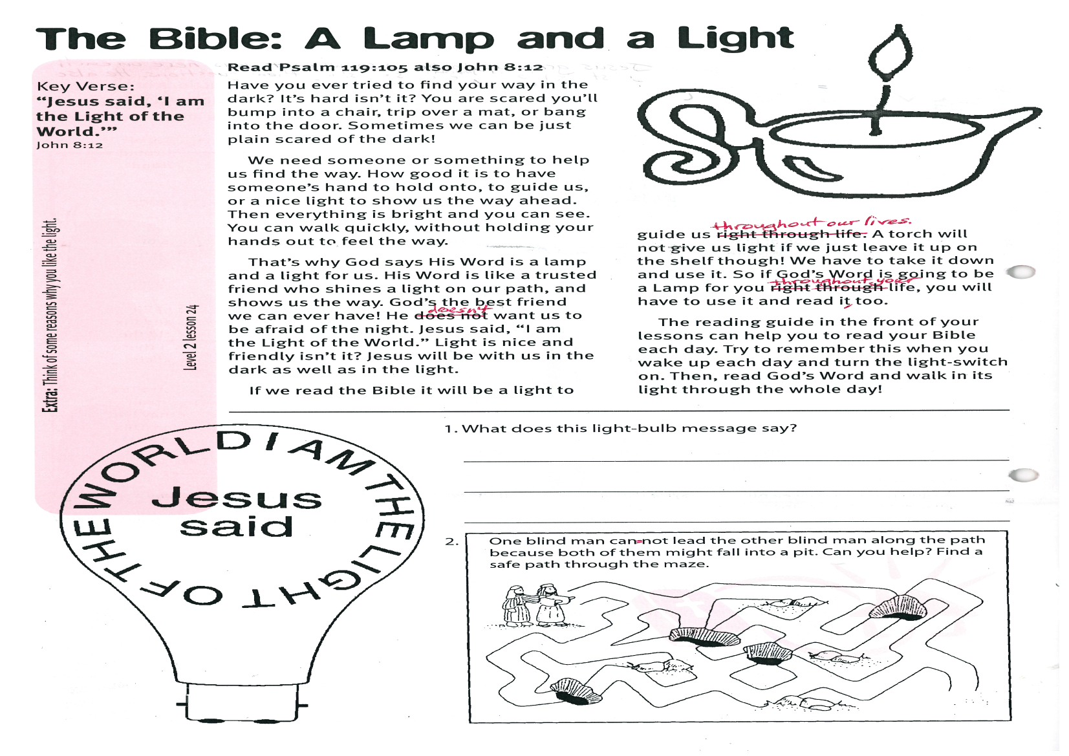

**Extra:** Think of some reasons why you like the light.

Key Verse:  
**“Jesus said, I am the Light of the world.”**

John 8:12

**Level 2 lesson 24**

Please complete and return by post to   
**PSSM Bible Discovery, 5/399 New North Rd, Kingsland, Auckland 1021** or scan & email to **info@biblediscovery.org.nz**

**What does the light bulb message say?**

_________________________________________

_________________________________________

_________________________________________

**Jesus said**

**I AM THE LIGHT   
OF THE WORLD**

If we read the Bible it will be a light to guide us throughout our lives. A torch will not give us light if we just leave it up on the shelf though! We have to take it down and use it. So if God’s Word is going to be a Lamp for you throughout your life, you will have to use it and read it, too.

The reading guide in the front of your lessons can help you to read your Bible each day. Try to remember this when you wake up each day and turn the light-switch on. Then, read God’s Word and walk in its light through the whole day!

**Read Psalm 119:105   
also John 8:12**

Have you ever tried to find your way in the dark? It’s hard isn’t it? You are scared you’ll bump into a chair, trip over a mat, or bang into the door. Sometimes we can be just plain scared of the dark!

We need someone or something to help us find the way. How good it is to have someone’s hand to hold onto, to guide us, or a nice light to show us the way ahead. Then everything is bright and you can see. You can walk quickly, without holding your hands out to feel the way.

That’s why God says His Word is a lamp and a light for us. His Word is like a trusted friend who shines a light on our path, and shows us the way. God’s the best friend we can ever have! He doesn’t want us to be afraid of the night. Jesus said, “I am the Light of the world.” Light is nice and friendly isn’t it? Jesus will be with us in the dark as well as in the light.

**The Bible: A Lamp and a Light**