**August Bible Readings**

DATE BOOK REFERENCE

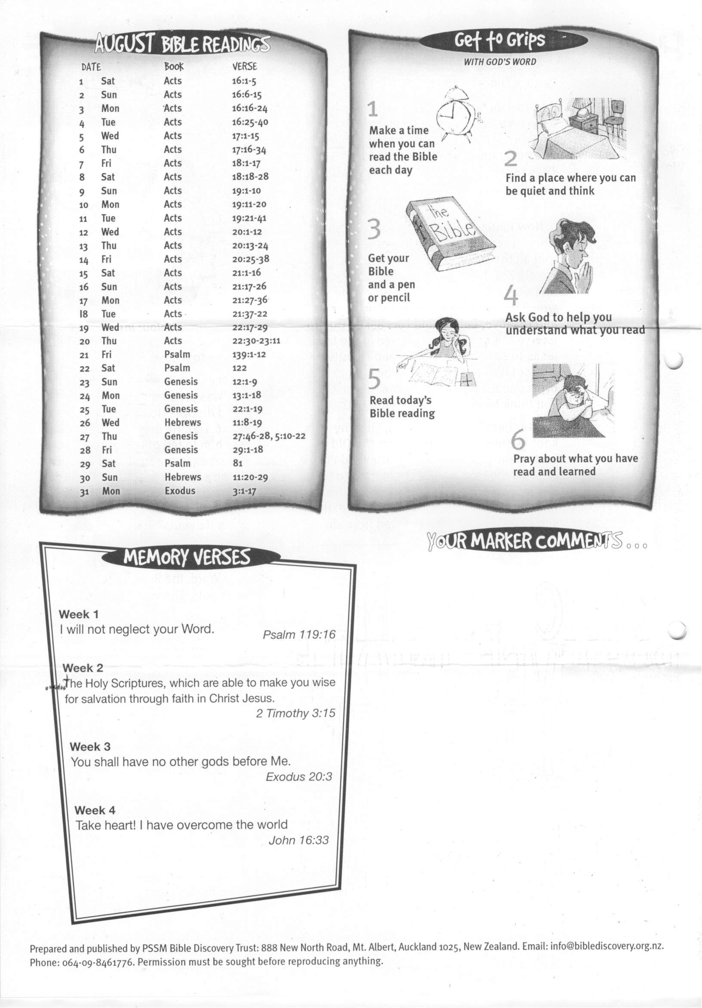

**30 Hebrews 11:20-29  
 31 Exodus 3:1-17**