**September Bible Readings**

DATE BOOK REFERENCE

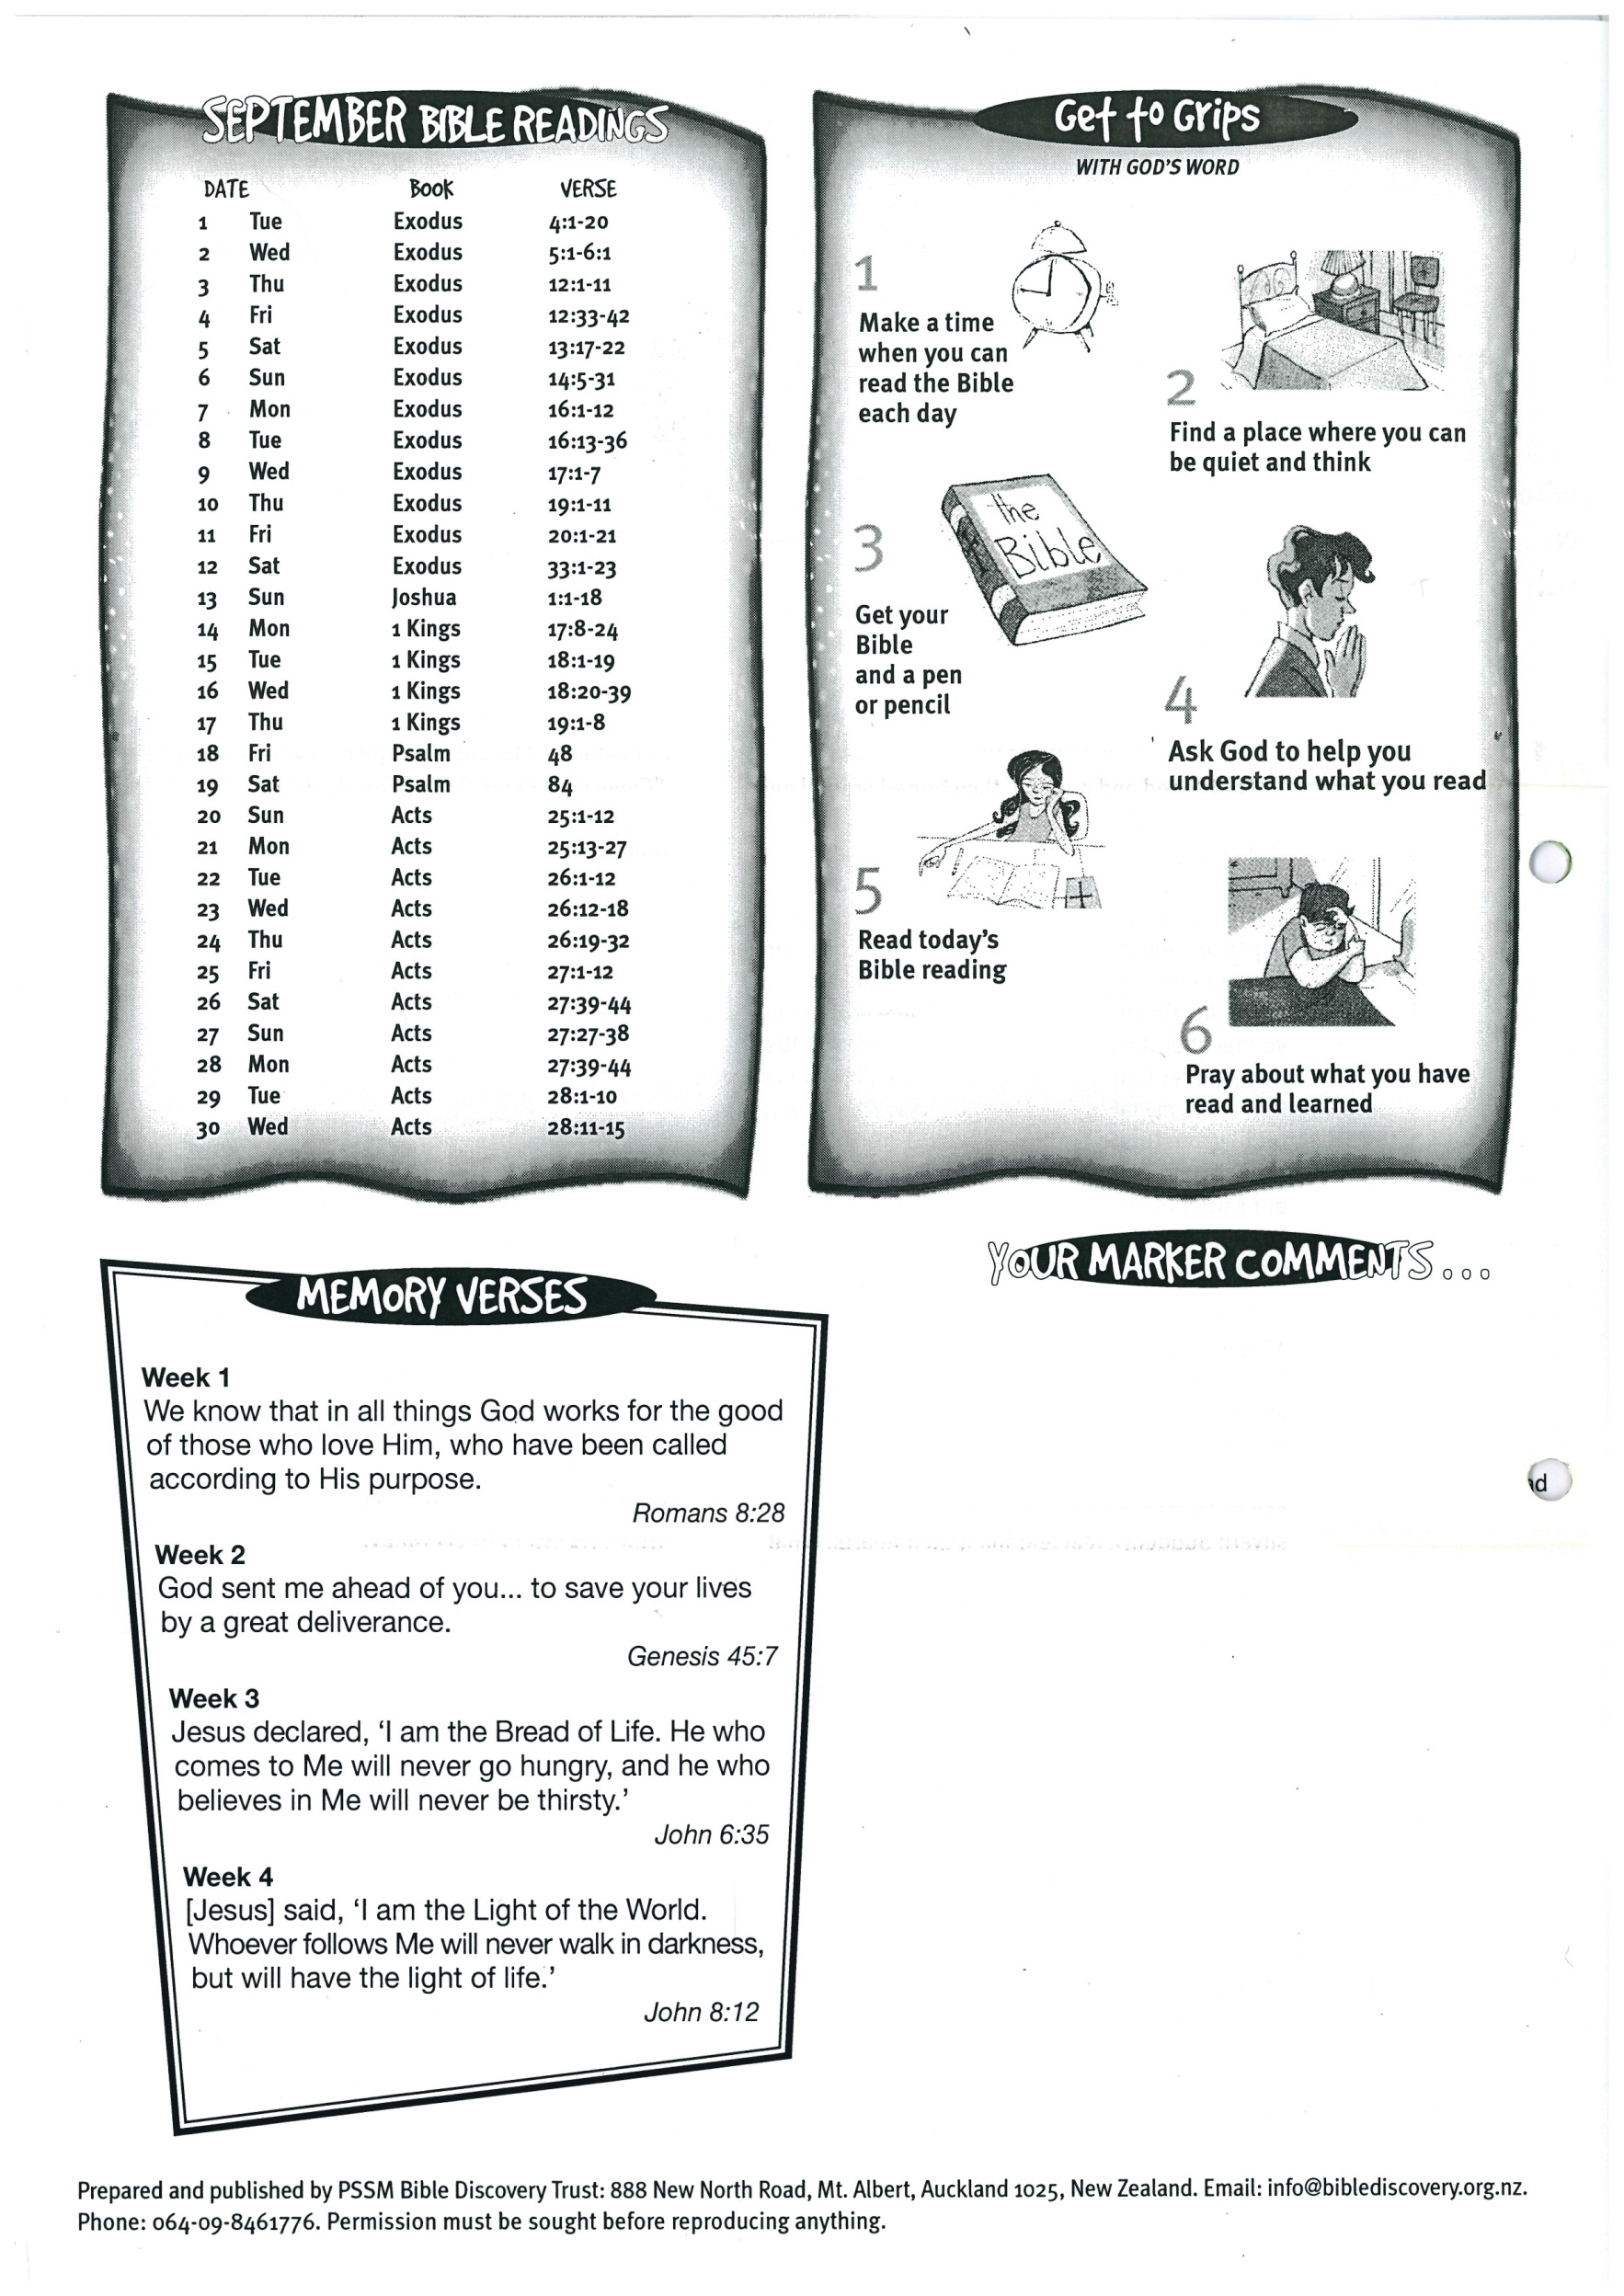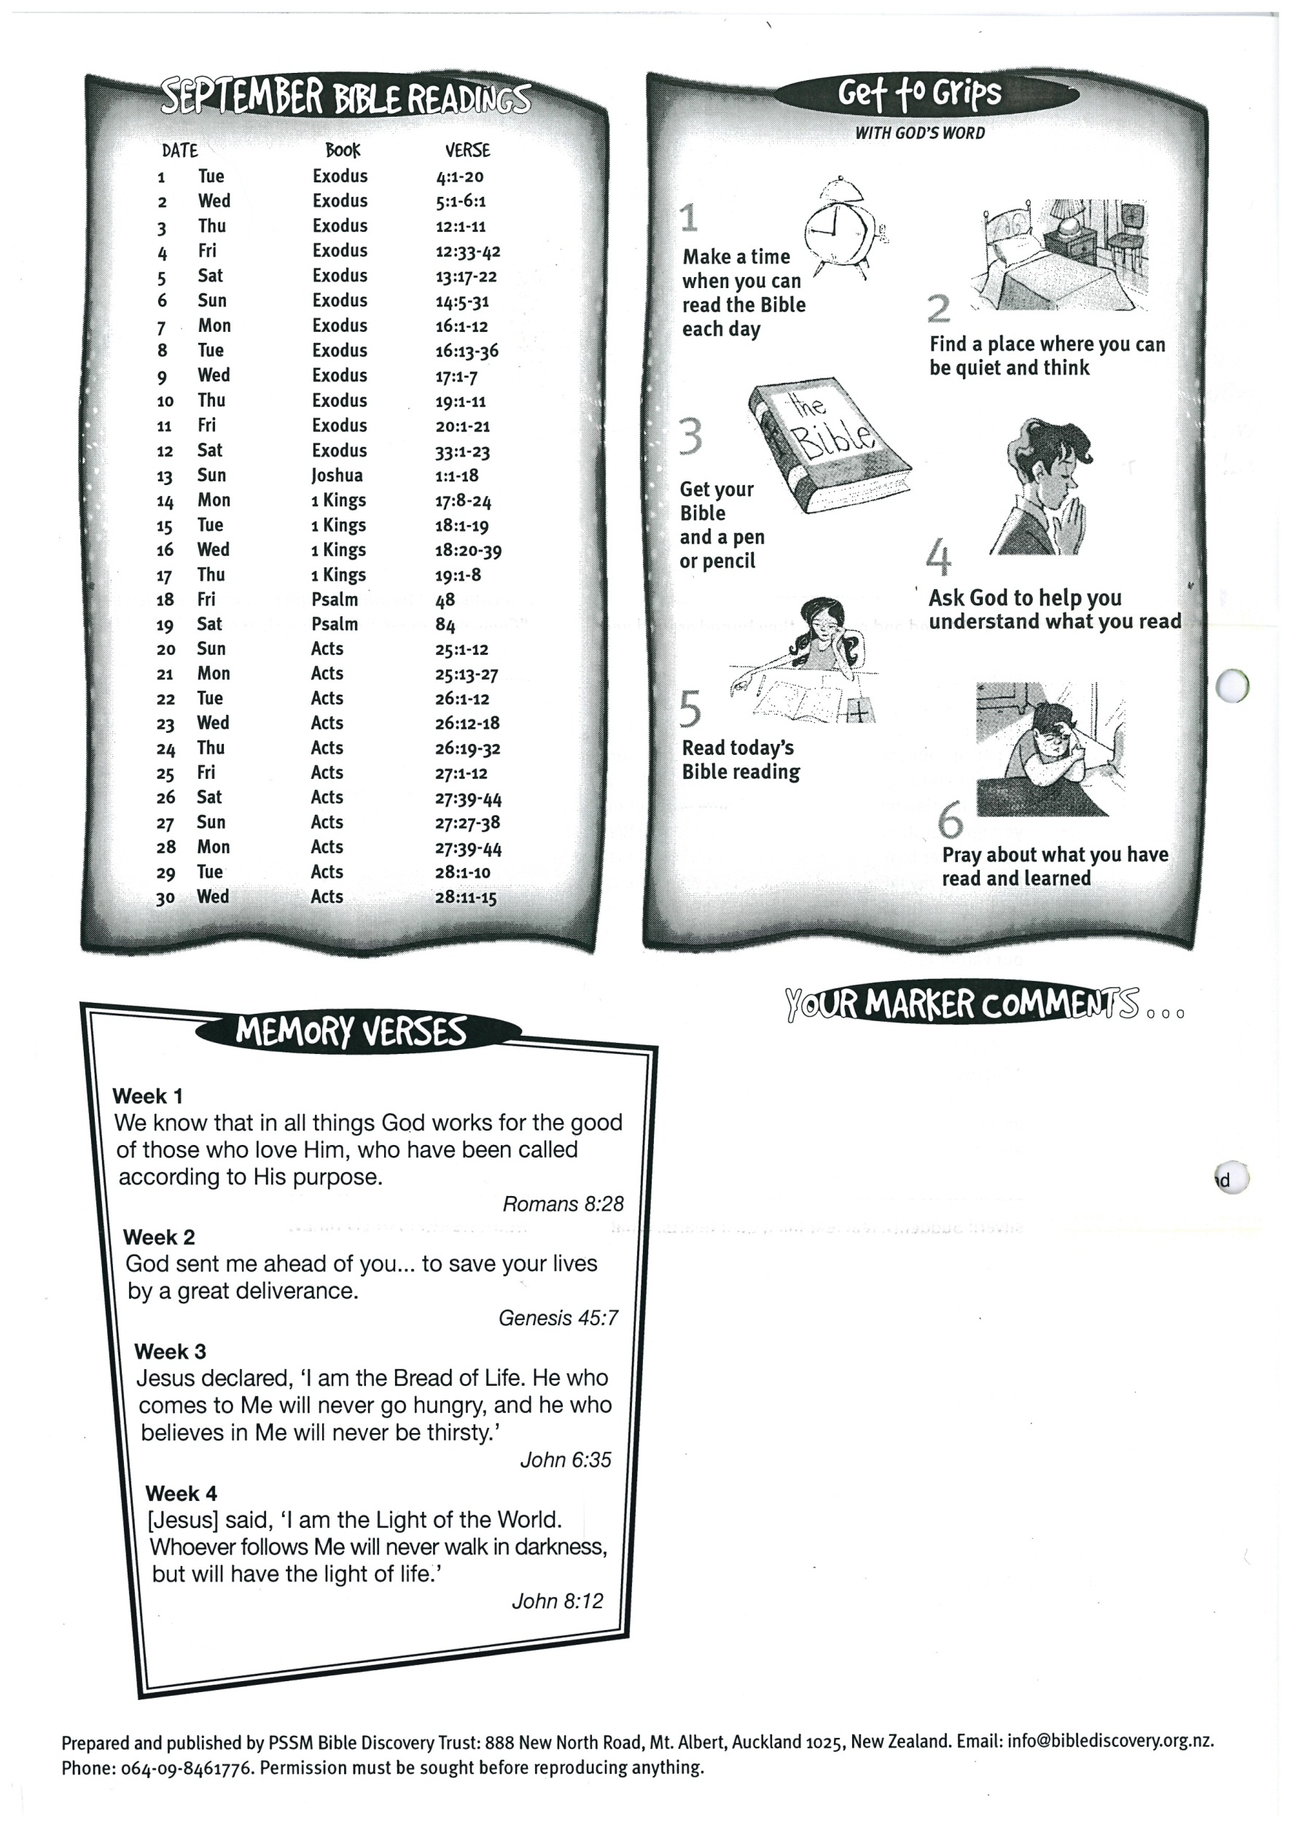

**30 Hebrews 11:20-29**