**October Bible Readings**

DATE BOOK REFERENCE

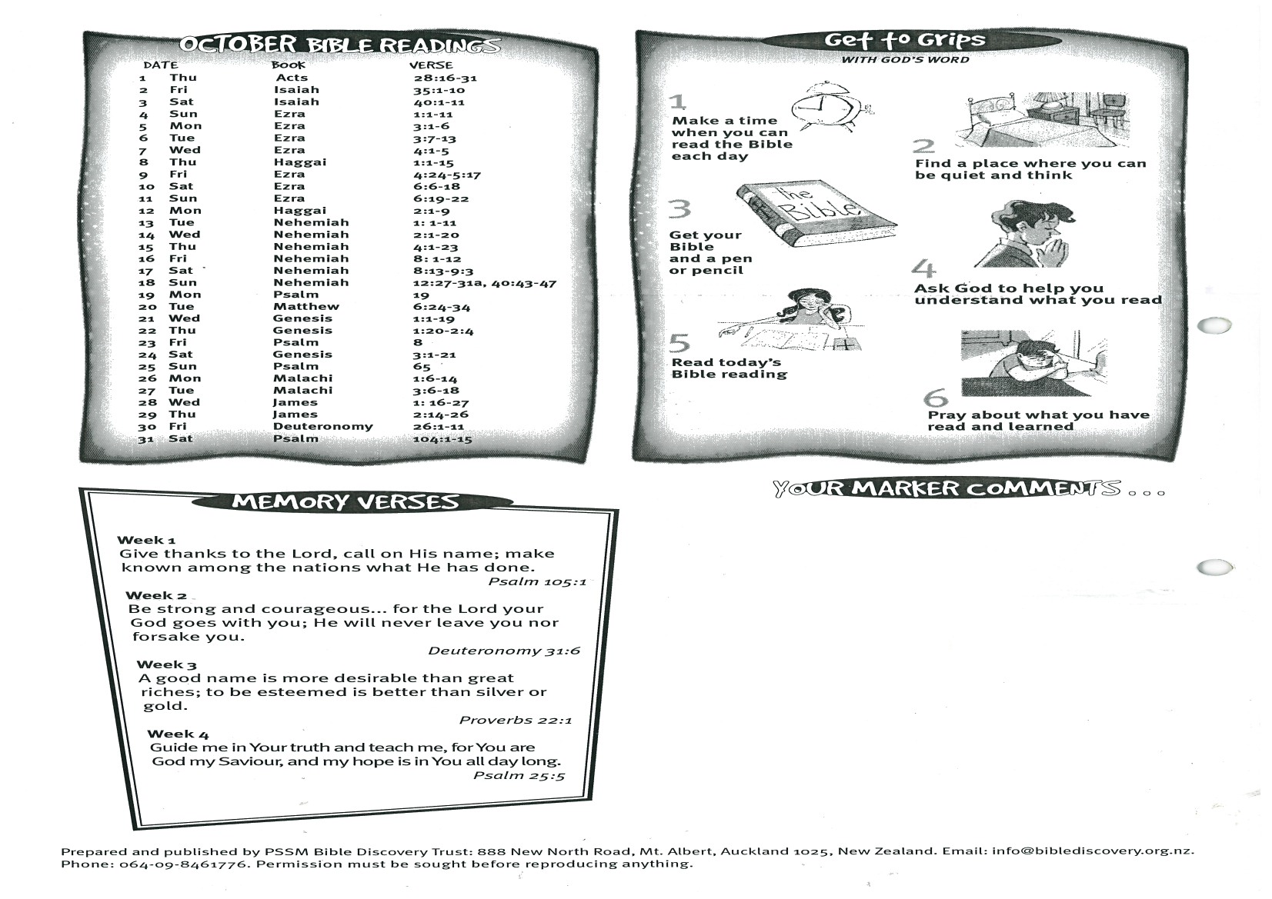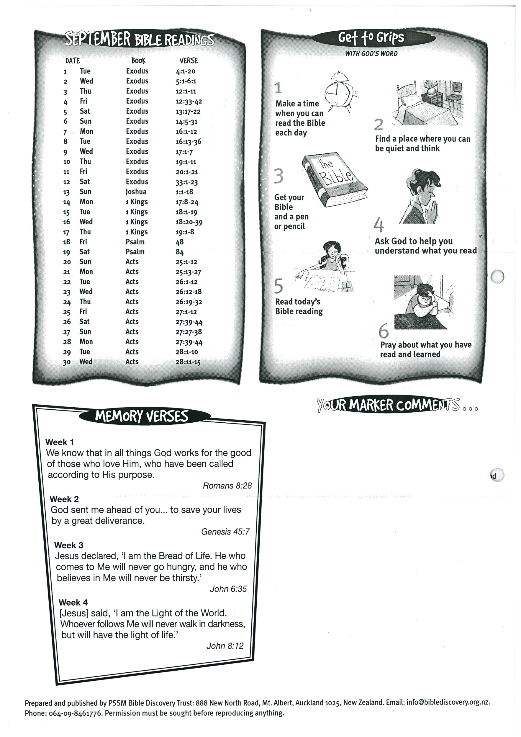

**30   
31 Psalm 104:1-15**