**November Bible Readings**

DATE BOOK REFERENCE

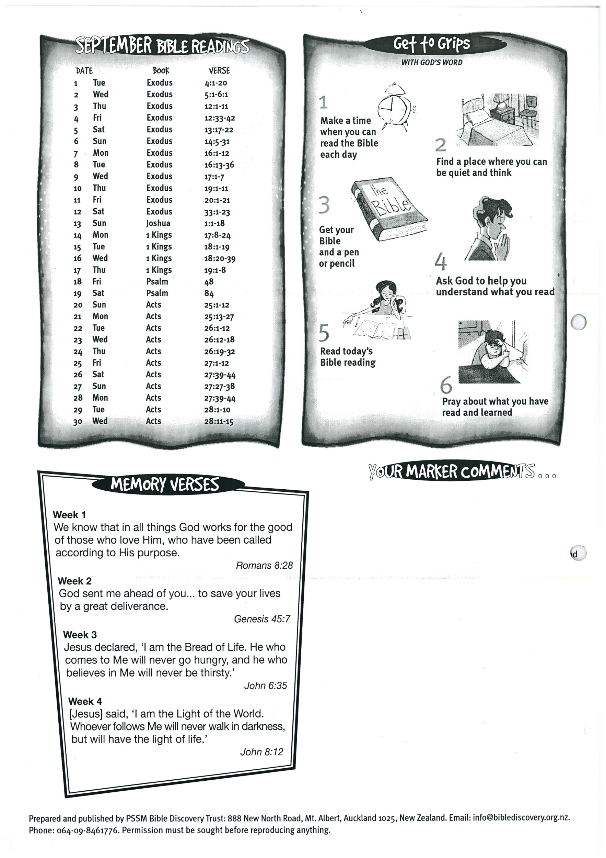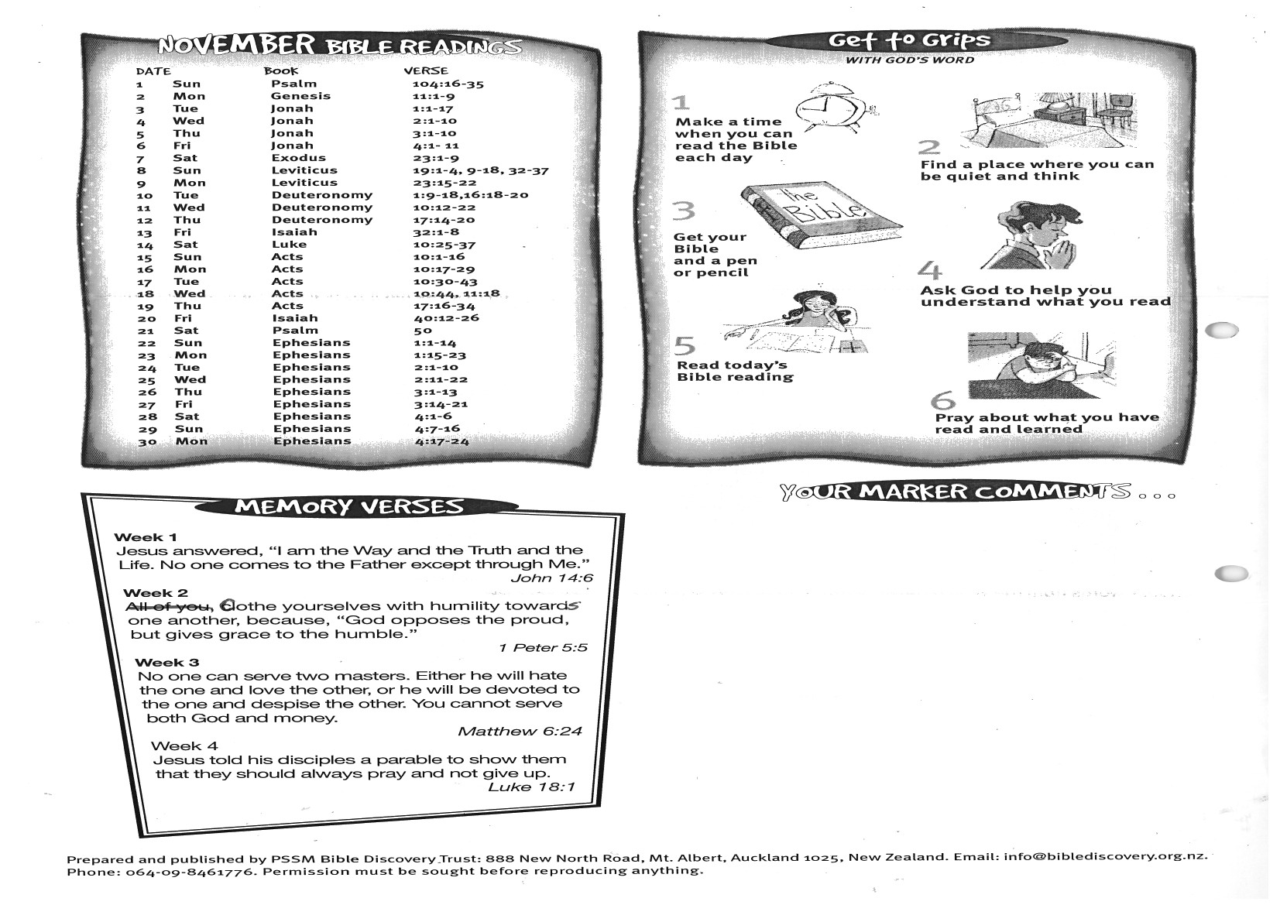

**30 Ephesians 4:17-24**