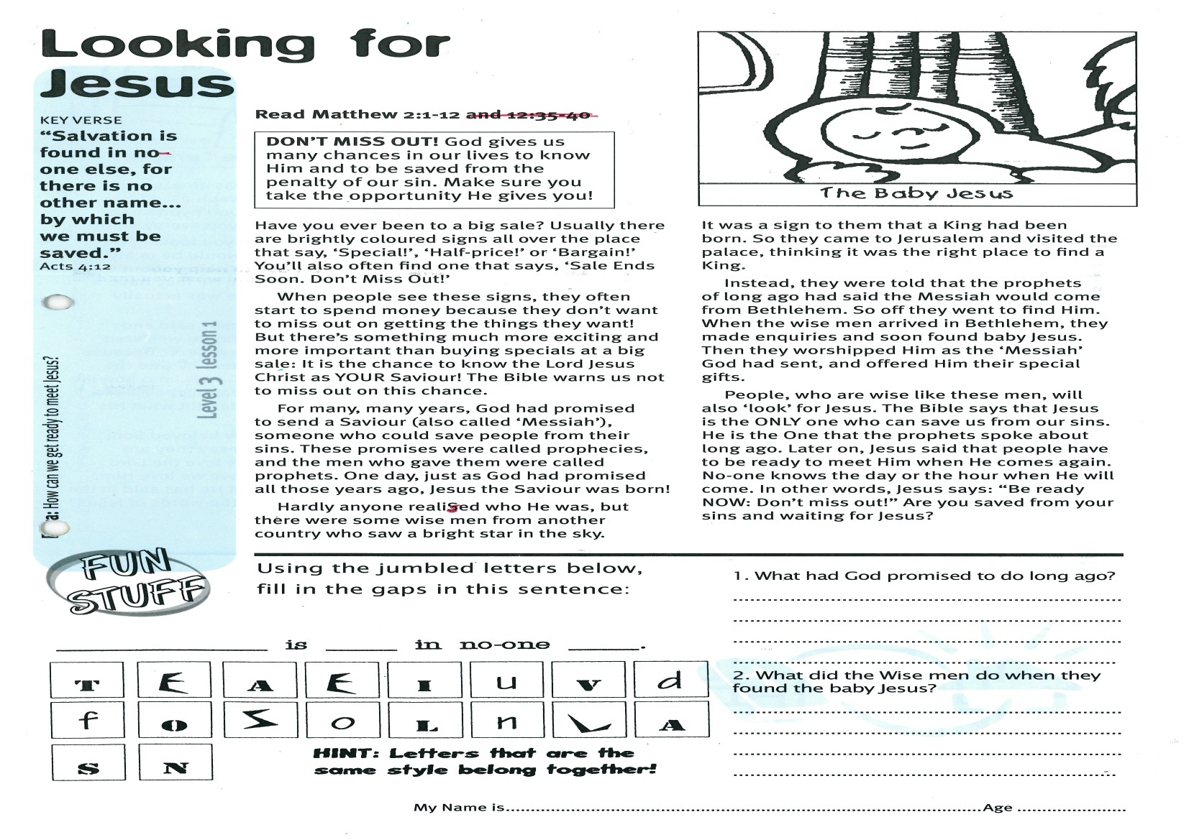

**Read Matthew 2:1-12**

**DON’T MISS OUT! God gives us many chances in our lives to know Him and to be saved from the penalty of our sin. Make sure you take the opportunity He gives you!**

Have you ever been to a big sale? Usually there are brightly coloured signs all over the place that say, ‘Special!’, ‘Half-price!’ or ‘Bargain!’ You’ll also often find one that says, ‘Sale Ends Soon. Don’t Miss Out!’

When people see these signs, they often start to spend money because they don’t want to miss out on getting the things they want! But there’s something much more exciting and more important than buying specials at a big sale: It is the chance to know the Lord Jesus Christ as YOUR Saviour! The Bible warns us not to miss out on this chance.

For many, many years, God had promised to send a Saviour (also called ‘Messiah’), someone who could save people from their sins. These promises were called prophecies, and the men who gave them were called prophets. One day, just as God had promised all those years ago, Jesus the Saviour was born!

Hardly anyone realised who He was, but there were some wise men from another country who saw a bright star in the sky.

**Looking for Jesus**

Key Verse:  
**“Salvation is found in no-one else, for there is no other name… by which we must be saved.”**

Acts 4:12



It was a sign to them that a King had been born. So they came to Jerusalem and visited the palace, thinking it was the right place to find a King.

Instead, they were told that the prophets of long ago had said the Messiah would come from Bethlehem. So off they went to find Him. When the wise men arrived in Bethlehem, they made enquiries and soon found baby Jesus. Then they worshipped Him as the ‘Messiah’ God had sent, and offered Him their special gifts.

People, who are wise like these men, will also ‘look’ for Jesus. The Bible says that Jesus is the ONLY one who can save us from our sins. He is the One that the prophets spoke about long ago. Later on, Jesus said that people have to be ready to meet Him when He comes again. No-one knows the day or the hour when He will come. In other words, Jesus says: “Be ready NOW: Don’t miss out!”  
Are you saved from your sins and waiting for Jesus?

Using the jumbled letters below, fill in the gaps in this sentence:

**__ __ __ __ __ __ __ __ __ is __ __ __ __ __   
  
in no-one __ __ __ __.**

1. What had God promised to do long ago?   
_______________________________

_______________________________

2. What did the Wise men do when they found the baby Jesus?

_____________________________________________________________________________________________

**Level 3 lesson 1**

**Extra:** How can we get ready to meet Jesus?

My Name is ……………………………………………………… Age…………………

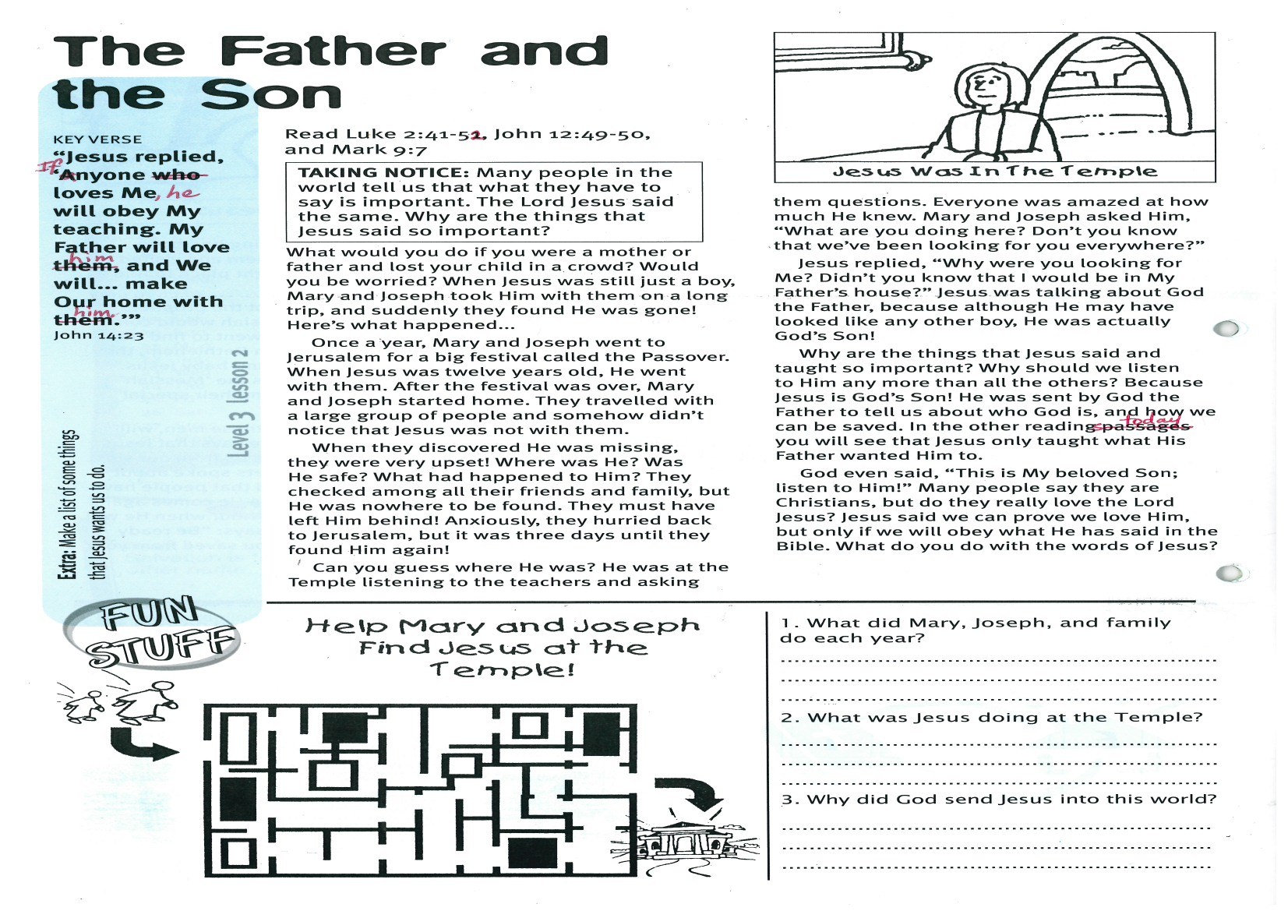

**Read Luke 2:41-52, John 12:49-50,  
and Mark 9:7**

**TAKING NOTICE: Many people in the world tell us that what they have to say is important. The Lord Jesus said the same. Why are the things that Jesus said so important?**

What would you do if you were a mother or father and lost your child in a crowd? Would you be worried? When Jesus was still just a boy, Mary and Joseph took Him with them on a long trip, and suddenly they found He was gone! Here’s what happened...

Once a year, Mary and Joseph went to Jerusalem for a big festival called the Passover. When Jesus was twelve years old, He went with them. After the festival was over, Mary and Joseph started home. They travelled with a large group of people and somehow didn’t notice that Jesus was not with them.

When they discovered He was missing, they were very upset! Where was He? Was He safe? What had happened to Him? They checked among all their friends and family, but He was nowhere to be found. They must have left Him behind! Anxiously, they hurried back to Jerusalem, but it was three days until they found Him again!

Can you guess where He was?

**The Father and the Son**

Key Verse:  
**“Jesus replied, ‘If anyone loves Me, he will obey My teaching. My Father will love him, and we will… make our home with him.’”**

John 14:23



1. What did Mary, Joseph, and family do each year?

____________________________________________

____________________________________________

2. What was Jesus doing at the Temple?

____________________________________________

____________________________________________

3. Why did God send Jesus into this world?

____________________________________________________________________________________________________________________________________

He was at the Temple listening to the teachers and asking them questions. Everyone was amazed at how much He knew. Mary and Joseph asked Him, “What are you doing here? Don’t you know that we’ve been looking for you everywhere?”

Jesus replied, “Why were you looking for Me? Didn’t you know that I would be in My Father’s house?” Jesus was talking about God the Father, because although He may have looked like any other boy, He was actually God’s Son!

Why are the things that Jesus said and taught so important? Why should we listen to Him any more than all the others? Because Jesus is God’s Son! He was sent by God the Father to tell us about who God is, and how we can be saved. In the other readings today you will see that Jesus only taught what His Father wanted Him to.

God even said, “This is My beloved Son; listen to Him!” Many people say they are Christians, but do they really love the Lord Jesus? Jesus said we can prove we love Him, but only if we will obey what He has said in the Bible. What do **you** do with the words of Jesus?

**Extra:** Make a list of some things that Jesus wants us to do.

Help Mary and Joseph find Jesus at the Temple!

**Level 3 lesson 2**

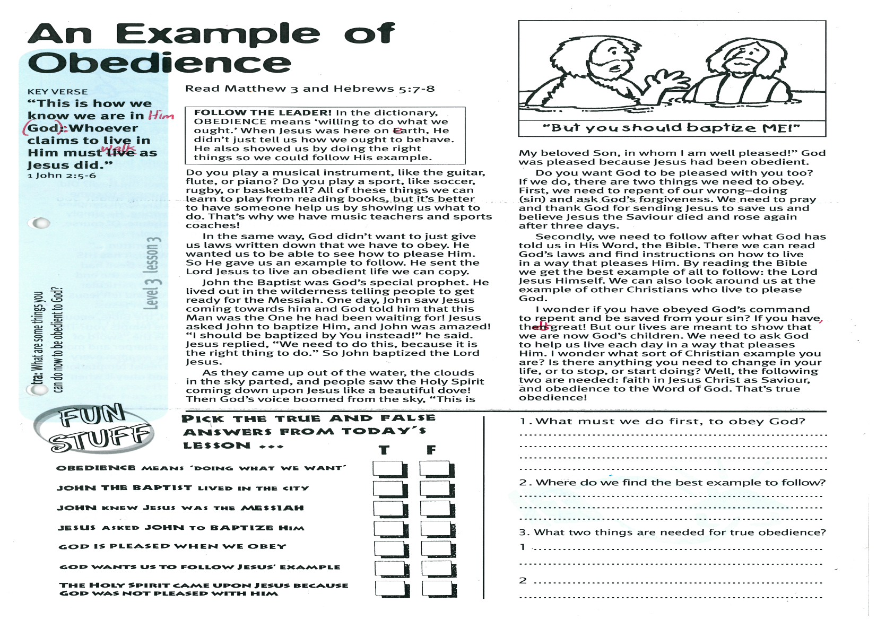

**An Example of Obedience**

**Read Matthew 3  
and Hebrews 5:7-8**

**FOLLOW THE LEADER! In the dictionary, OBEDIENCE means ‘willing to do what we ought.’ When Jesus was here on earth, He didn’t just tell us how we ought to behave. He also showed us by doing the right things so we could follow His example.**

Do you play a musical instrument, like the guitar, flute, or piano? Do you play a sport, like soccer, rugby, or basketball? All of these things we can learn to play from reading books, but it’s better to have someone help us by showing us what to do. That’s why we have music teachers and sports coaches!

In the same way, God didn’t want to just give us laws written down that we have to obey. He wanted us to be able to see how to please Him. So He gave us an example to follow. He sent the Lord Jesus to live an obedient life we can copy.

John the Baptist was God’s special prophet. He lived out in the wilderness telling people to get ready for the Messiah. One day, John saw Jesus coming towards him and God told him that this Man was the One he had been waiting for! Jesus asked John to baptize Him, and John was amazed! “I should be baptized by You instead!” he said. Jesus replied, “We need to do this, because it is the right thing to do.” So John baptized the Lord Jesus.

As they came up out of the water, the clouds in the sky parted, and people saw the Holy Spirit coming down upon Jesus like a beautiful dove!

Key Verse:  
**“This is how we know we are in Him [God]: whoever claims to live in Him must walk as Jesus did.”**

1 John 2:5-6

Then God’s voice boomed from the sky, “This is My beloved Son, in whom I am well pleased!” God was pleased because Jesus had been obedient.

Do you want God to be pleased with you, too? If we do, there are two things we need to obey. First, we need to repent of our wrong–doing (sin) and ask God’s forgiveness. We need to pray and thank God for sending Jesus to save us and believe Jesus the Saviour died and rose again after three days.

Secondly, we need to follow after what God has told us in His Word, the Bible. There we can read God’s laws and find instructions on how to live in a way that pleases Him. By reading the Bible we get the best example of all to follow: the Lord Jesus Himself. We can also look around us at the example of other Christians who live to please God.

I wonder if you have obeyed God’s command to repent and be saved from your sin? If you have, that’s great! But our lives are meant to show that we are now God’s children. We need to ask God to help us live each day in a way that pleases Him. I wonder what sort of Christian example you are? Is there anything you need to change in your life, or to stop, or start doing? Well, the following two are needed: faith in Jesus Christ as Saviour, and obedience to the Word of God. That’s true obedience!



1. What must we do first, to obey God?

____________________________________________

2. Where do we find the best example to follow?

____________________________________________

3. What two things are needed for true obedience?

1. _________________________________________

2. _________________________________________

__________________________________________

**Level 3 lesson 3**

**Extra:** What are some things you can do now to be obedient to God?

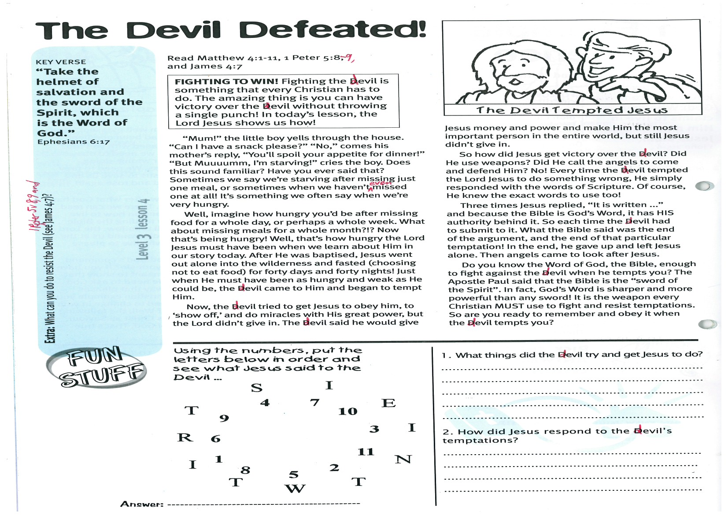

**Read Matthew 4:1-11,  
1 Peter 5:8-9 and James 4:7  
  
  
FIGHTING TO WIN! Fighting the devil is something that every Christian has to do. The amazing thing is you can have victory over the devil without throwing a single punch! In today’s lesson, the Lord Jesus shows us how!**

“Mum!” the little boy yells through the house. “Can I have a snack please?” “No,” comes his mother’s reply, “You’ll spoil your appetite for dinner!” “But Muuuumm, I’m starving!” cries the boy. Does this sound familiar? Have you ever said that? Sometimes we say we’re starving after missing just one meal, or sometimes when we haven’t even missed one at all! It’s something we often say when we’re very hungry.

Well, imagine how hungry you’d be after missing food for a whole day, or perhaps a whole week. What about missing meals for a whole month?!? Now that’s being hungry! Well, that’s how hungry the Lord Jesus must have been when we learn about Him in our story today.   
After He was baptised, Jesus went out alone into the wilderness and fasted (choosing not to eat food) for forty days and forty nights! Just when He must have been as hungry and weak as He could be, the devil came to Him and began to tempt Him.

Key Verse:  
**“Take the helmet of salvation and the sword of the Spirit, which is the Word of God.”**

Ephesians 6:17

**The Devil Defeated!**

Now, the devil tried to get Jesus to obey him, to ‘show off,’ and do miracles with His great power, but the Lord didn’t give in. The devil said he would give Jesus money and power and make Him the most important person in the entire world, but still Jesus didn’t give in.  
So how did Jesus get victory over the devil? Did He use weapons? Did He call the angels to come and defend Him? No! Every time the devil tempted the Lord Jesus to do something wrong, He simply responded with the words of Scripture. Of course, He knew the exact words to use, too!  
Three times Jesus replied, “It is written ...” and because the Bible is God’s Word, it has HIS authority behind it. So each time the devil had to submit to it. What the Bible said was the end of the argument, and the end of that particular temptation! In the end, he gave up and left Jesus alone. Then angels came to look after Jesus.

Do you know the Word of God, the Bible, enough to fight against the devil when he tempts you? The Apostle Paul said that the Bible is the “sword of the Spirit”. In fact, God’s Word is sharper and more powerful than any sword! It is the weapon every Christian MUST use to fight and resist temptations. So are you ready to remember and obey it when the devil tempts you?

**Answer:**

**Level 3 lesson 4**

**Extra:** What can you do to resist the devil?

(See 1 Peter 5:8-9 and James 4:7)



1. What things did the devil try and get Jesus to do?

__________________________________________

__________________________________________

__________________________________________

2. How did Jesus respond to the devil’s temptations?

____________________________________________________________________________________

__________________________________________

Please complete and return by post to   
**PSSM Bible Discovery, 5/399 New North Rd, Kingsland, Auckland 1021** or scan & email to **info@biblediscovery.org.nz**

Answer:_________________________________