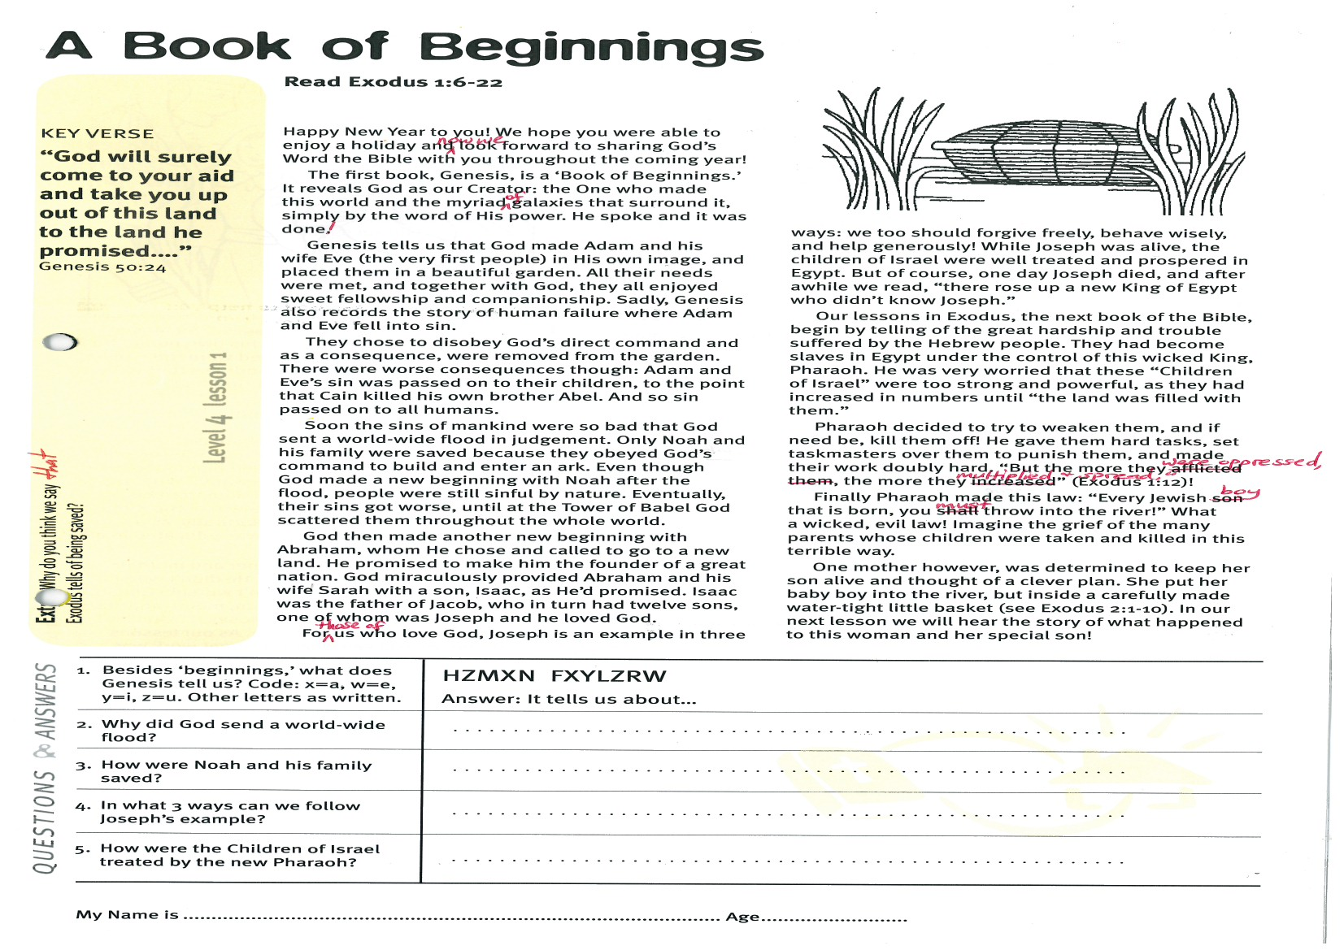
Key Verse:
“…God will surely come to your aid and take you up out of this land to the land He promised…”
Genesis 50:24
Read Exodus 1:6-22
Happy New Year to you! We hope you were able to enjoy a holiday and now we look forward to sharing God’s Word the Bible with you throughout the coming year!
The first book, Genesis, is a ‘Book of Beginnings.’ It reveals God as our Creator: the One who made this world and the myriad of galaxies that surround it, simply by the word of His power. He spoke and it was done!
Genesis tells us that God made Adam and his wife Eve (the very first people) in His own image, and placed them in a beautiful garden. All their needs were met, and together with God, they all enjoyed sweet fellowship and companionship. Sadly, Genesis also records the story of human failure where Adam and Eve fell into sin.
They chose to disobey God’s direct command and as a consequence, were removed from the garden. There were worse consequences though: Adam and Eve’s sin was passed on to their children, to the point that Cain killed his own brother Abel. And so sin passed on to all humans.
Soon the sins of mankind were so bad that God sent a world-wide flood in judgement. Only Noah and his family were saved because they obeyed God’s command to build and enter an ark. Even though God made a new beginning with Noah after the flood, people were still sinful by nature. Eventually, their sins got worse, until at the Tower of Babel God scattered them throughout the whole world.
God then made another new beginning with Abraham, whom He chose and called to go to a new land. He promised to make him the founder of a great nation. God miraculously provided Abraham and his wife Sarah with a son, Isaac, as He’d promised. Isaac was the father of Jacob, who in turn had twelve sons, one of whom was Joseph and he loved God.
A Book of Beginnings
1. Besides ‘beginning’ what does Genesis also tell us?  Code: X = A, W = E, Y = I, Z = U | It tells us about: HZMXN FXYLZRW
2. Why did God send a world-wide flood?

3. How were Noah and his family saved?
4. In what 3 ways can we follow Joseph’s example?
5. How were the children of Israel treated by the new Pharoah?
My Name is _____________________________________________ Age ___________
Level 3 lesson 1
Extra: Why do you think we say that Exodus tells of being saved?

Level 4 lesson 1
QUESTIONS & ANSWERS
For those of us who love God, Joseph is an example in three ways: we too should forgive freely, behave wisely, and help generously! While Joseph was alive, the children of Israel were well treated and prospered in Egypt. But of course, one day Joseph died, and after a while we read, “there rose up a new King of Egypt who didn’t know Joseph.”
Our lessons in Exodus, the next book of the Bible, begin by telling of the great hardship and trouble suffered by the Hebrew people. They had become slaves in Egypt under the control of this wicked King, Pharaoh. He was very worried that these “Children of Israel” were too strong and powerful, as they had increased in numbers until “the land was filled with them.”
Pharaoh decided to try to weaken them, and if need be, kill them off! He gave them hard tasks, set taskmasters over them to punish them, and made their work doubly hard. “But the more they were oppressed, the more they multiplied and spread” (Exodus 1:12)!
Finally Pharaoh made this law: “Every Jewish boy that is born, you must throw into the river!” What a wicked, evil law! Imagine the grief of the many parents whose children were taken and killed in this terrible way.
One mother however, was determined to keep her son alive and thought of a clever plan. She put her baby boy into the river, but inside a carefully made water-tight little basket (see Exodus 2:1-10). In our next lesson we will hear the story of what happened to this woman and her special son!
Key Verse:
“Jesus said, ‘I tell you the truth, unless a man is born again, he cannot see the kingdom of God.’”
John 3:3
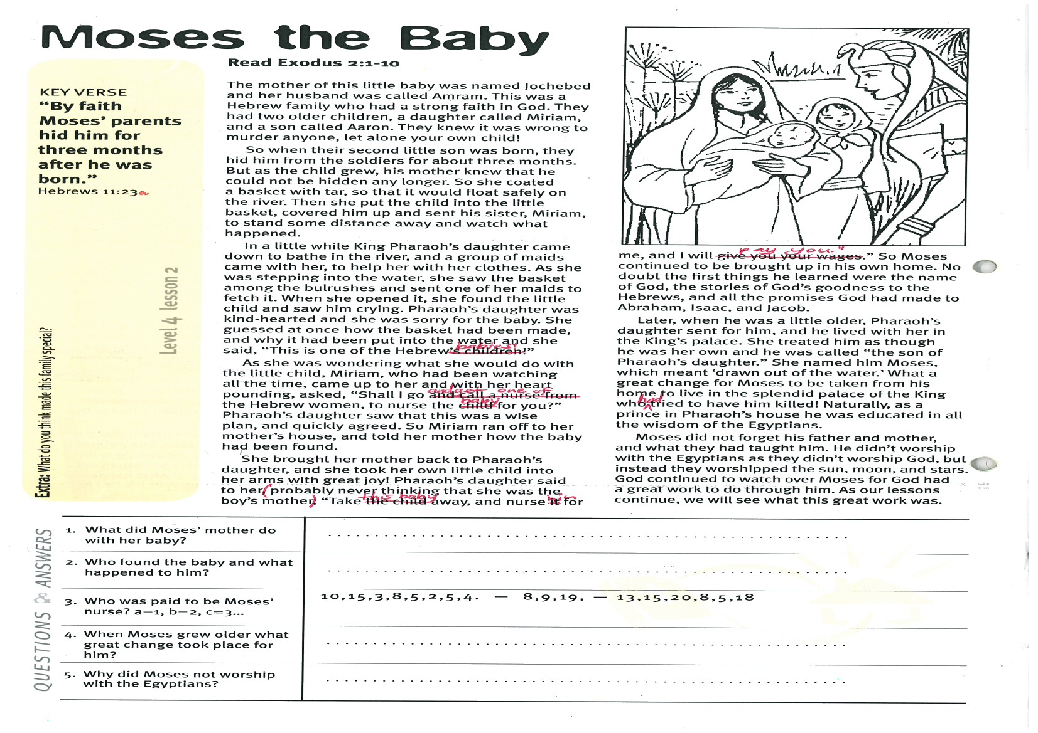
Moses the Baby
Key Verse:
“By faith Moses’ parents hid him for three months after he was born.”
Hebrews 11:23a
Read Exodus 2:1-10
The mother of this little baby was named Jochebed and her husband was called Amram. This was a Hebrew family who had a strong faith in God. They had two older children, a daughter called Miriam, and a son called Aaron. They knew it was wrong to murder anyone, let alone your own child!
So when their second little son was born, they hid him from the soldiers for about three months. But as the child grew, his mother knew that he could not be hidden any longer. So she coated a basket with tar, so that it would float safely on the river. Then she put the child into the little basket, covered him up and sent his sister, Miriam, to stand some distance away and watch what happened.
In a little while King Pharaoh’s daughter came down to bathe in the river, and a group of maids came with her, to help her with her clothes. As she was stepping into the water, she saw the basket among the bulrushes and sent one of her maids to fetch it. When she opened it, she found the little child and saw him crying. Pharaoh’s daughter was kind-hearted and she was sorry for the baby. She guessed at once how the basket had been made, and why it had been put into the water and she said, “This is one of the Hebrew babies!”
As she was wondering what she would do with the little child, Miriam, who had been watching all the time, came up to her and with her heart pounding, asked, “Shall I go and get one of the Hebrew women to nurse the baby for you?” Pharaoh’s daughter saw that this was a wise plan, and quickly agreed. So Miriam ran off to her mother’s house, and told her mother how the baby had been found.

1. What did Moses’ mother do with her baby?
2. Who found the baby and what happened to him?
3. Who was paid to be Moses’ nurse? (a = 1, b = 2, c = 3, etc) | __ __ __ __ __ __ __ __ __ __ __ __ __ __ __ __ __  10, 15, 3, 8, 5, 2, 5, 4 8, 9, 19 13, 15, 20, 8, 5, 18
4. When Moses grew older what great change took place for him?
5. Why did Moses not worship with the Egyptians?
___
Extra: What do you think made this family special?
Level 4 lesson 2
QUESTIONS & ANSWERS
She brought her mother back to Pharaoh’s daughter, and she took her own little child into her arms with great joy! Pharaoh’s daughter said to her, (probably never thinking that she was the boy’s own mother) “Take this baby away, and nurse him for me, and I will pay you.” So Moses continued to be brought up in his own home! No doubt the first things he learned were the name of God, the stories of God’s goodness to the Hebrews, and all the promises God had made to Abraham, Isaac, and Jacob.
Later, when he was a little older, Phaaraoh’s daughter sent for him, and he lived with her in the King’s palace. She treated him as though he was her own and he was called “the son of Pharaoh’s daughter.” She named him Moses, which meant ‘drawn out of the water.’ What a great change for Moses to be taken from his home to live in the splendid palace of the King who had tried to have him killed! Naturally, as a prince in Pharaoh’s house he was educated in all the wisdom of the Egyptians.
Moses did not forget his father and mother, and what they had taught him. He didn’t worship with the Egyptians as they didn’t worship God, but instead they worshipped the sun, moon, and stars. God continued to watch over Moses, for God had a great work to do through him. As our lessons continue, we will see what this great work was.

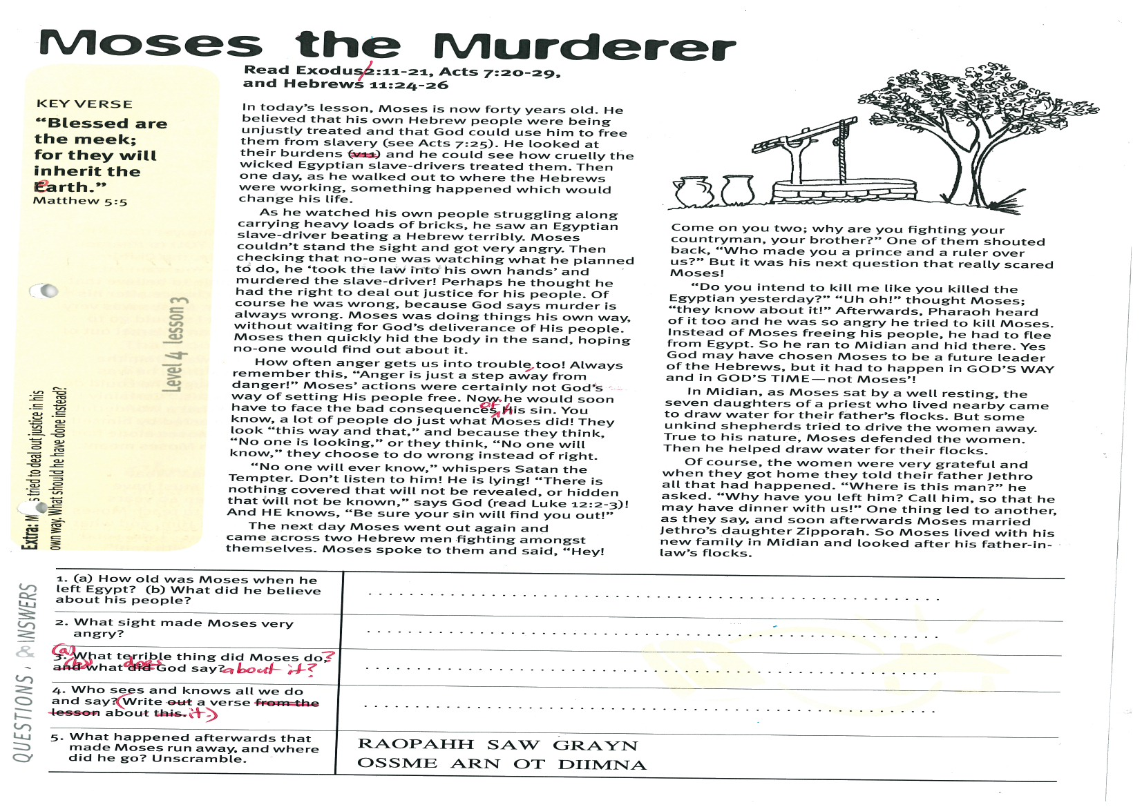
Key Verse:
“Blessed are the meek; for they will inherit the earth.”
Matthew 5:5
Read Exodus 2:11-21, Acts
7:20-29 and Hebrews 11:24-26
In today’s lesson, Moses is now forty years old. He believed that his own Hebrew people were being unjustly treated and that God could use him to free them from slavery (see Acts 7:25). He looked at their burdens and he could see how cruelly the wicked Egyptian slave-drivers treated them. Then one day, as he walked out to where the Hebrews were working, something happened which would change his life.
As he watched his own people struggling along carrying heavy loads of bricks, he saw an Egyptian slave-driver beating a Hebrew terribly. Moses couldn’t stand the sight and got very angry. Then checking that no-one was watching what he planned to do, he ‘took the law into his own hands’ and murdered the slave-driver! Perhaps he thought he had the right to deal out justice for his people. Of course he was wrong, because God says murder is always wrong. Moses was doing things his own way, without waiting for God’s deliverance of His people. Moses then quickly hid the body in the sand, hoping no-one would find out about it.
How often anger gets us into trouble, too! Always remember this, “Anger is just a step away from danger!” Moses’ actions were certainly not God’s way of setting His people free. Now he would soon have to face the bad consequences of his sin. You know, a lot of people do just what Moses did! They look “this way and that,” and because they think, “No-one is looking,” or they think, “No-one will know,” they choose to do wrong instead of right.
“No-one will ever know,” whispers Satan the Tempter. Don’t listen to him! He is lying! “There is nothing covered that will not be revealed, or hidden that will not be known,” says God (read Luke 12:2-3)! And HE knows, “Be sure your sin will find you out!”
Moses the Murderer
1. (a) How old was Moses when he left Egypt? (b) What did he believe about his people? | (a)  (b)
2. What sight made Moses very angry?

3. (a) What terrible thing did Moses do? (b) What does God say about it? | (a)  (b)
4. Who sees and knows all we do and say? (Write a verse about it)

5. What happened afterwards that made Moses run away, and where did he go? (Unscramble letters) | RAOPAHH SAW GRAYN  OSSME ARN OT DIIMNA
Extra: Moses tried to deal out justice in his own way. What should he have done instead?

Level 4 lesson 3
QUESTIONS & ANSWERS
The next day Moses went out again and came across two Hebrew men fighting amongst themselves. Moses spoke to them and said, “Hey! Come on you two; why are you fighting your countryman, your brother?” One of them shouted back, “Who made you a prince and a ruler over us?” But it was his next question that really scared Moses!
“Do you intend to kill me like you killed the Egyptian yesterday?” “Uh oh!” thought Moses; “they know about it!” Afterwards, Pharaoh heard of it too and he was so angry he tried to kill Moses. Instead of Moses freeing his people, he had to flee from Egypt. So he ran to Midian and hid there. Yes God may have chosen Moses to be a future leader of the Hebrews, but it had to happen in GOD’S WAY and in GOD’S TIME, not Moses’!
In Midian, as Moses sat by a well resting, the seven daughters of a priest who lived nearby came to draw water for their father’s flocks. But some unkind shepherds tried to drive the women away. True to his nature, Moses defended the women. Then he helped draw water for their flocks.
Of course, the women were very grateful and when they got home they told their father Jethro all that had happened. “Where is this man?” he asked. “Why have you left him? Call him, so that he may have dinner with us!” One thing led to another, as they say, and soon afterwards Moses married Jethro’s daughter Zipporah. So Moses lived with his new family in Midian and looked after his father-in-law’s flocks.

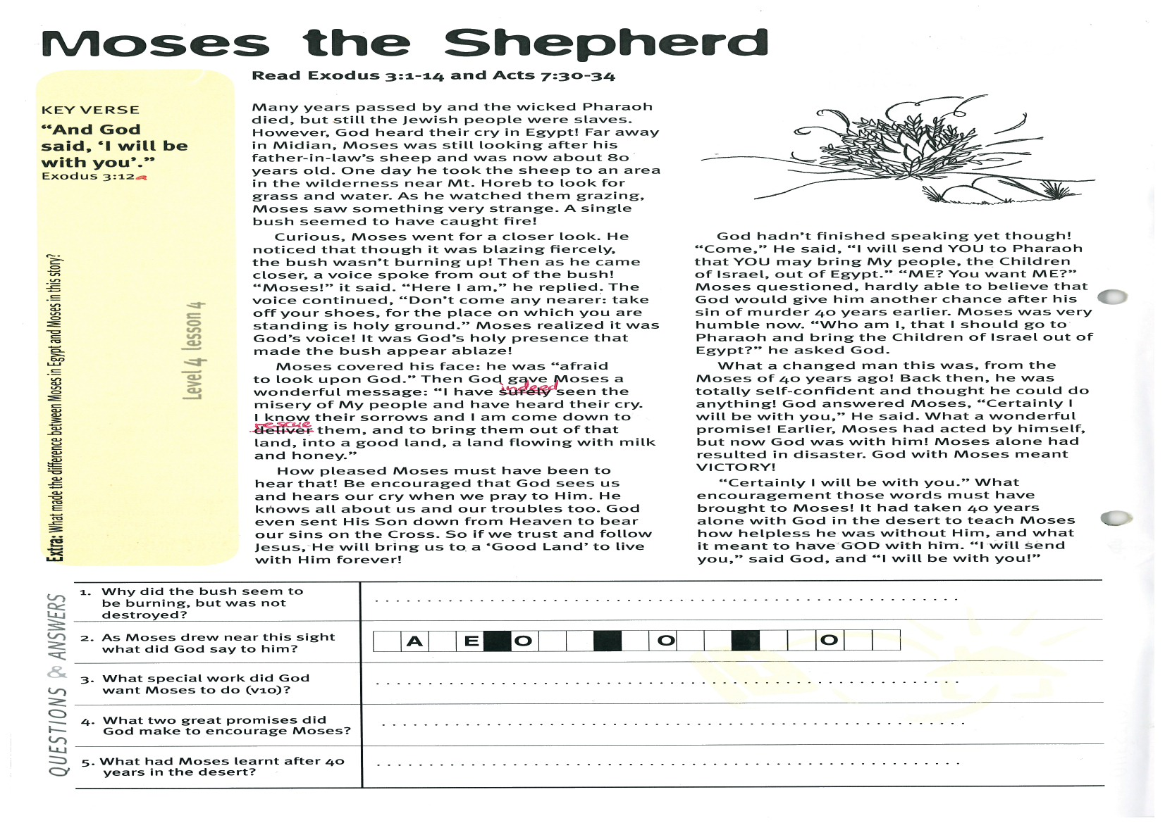
Moses the Shepherd
Key Verse:
“And God said, “I will be with you’.”
Exodus 3:12a
Read Exodus 3:1-14
and Acts 7:30-34
Many years passed by and the wicked Pharaoh died, but still the Jewish people were slaves. However, God heard their cry in Egypt! Far away in Midian, Moses was still looking after his father-in-law’s sheep and was now about 80 years old. One day he took the sheep to an area in the wilderness near Mt. Horeb to look for grass and water. As he watched them grazing, Moses saw something very strange. A single bush seemed to have caught fire!
Curious, Moses went for a closer look. He noticed that though it was blazing fiercely, the bush wasn’t burning up! Then as he came closer, a voice spoke from out of the bush! “Moses!” it said. “Here I am,” he replied. The voice continued, “Don’t come any nearer: take off your shoes, for the place on which you are standing is holy ground.” Moses realized it was God’s voice! It was God’s holy presence that made the bush appear ablaze!
Moses covered his face: he was “afraid to look upon God.” Then God gave Moses a wonderful message: “I have indeed seen the misery of My people and have heard their cry. I know their sorrows and I am come down to rescue them, and to bring them out of that land, into a good land, a land flowing with milk and honey.”
How pleased Moses must have been to hear that! Be encouraged that God sees us and hears our cry when we pray to Him. He knows all about us and our troubles, too. God even sent His Son down from Heaven to bear our sins on the cross. So if we trust and follow Jesus, He will bring us to a ‘Good Land’ to live with Him forever!

1. Why did the bush seem to be burning, but was not destroyed?
2. As Moses drew near this sight, what did God say to him? | __ A __ E O __ __ __ O __ __ __ __ O E __
3. What special work did God want Moses to do (v10)?

4. What two great promises did God make to encourage Moses?
5. What had Moses learnt after 40 years in the desert?
Extra: What made the difference between Moses in Egypt and Moses in this story?

Level 4 lesson 4
QUESTIONS & ANSWERS
God hadn’t finished speaking yet though! “Come,” He said, “I will send YOU to Pharaoh that YOU may bring My people, the Children of Israel, out of Egypt.” “ME? You want ME?” Moses questioned, hardly able to believe that God would give him another chance after his sin of murder 40 years earlier. Moses was very humble now. “Who am I, that I should go to Pharaoh and bring the Children of Israel out of Egypt?” he asked God.
What a changed man this was, from the Moses of 40 years ago! Back then, he was totally self-confident and thought he could do anything! God answered Moses, “Certainly I will be with you,” He said. What a wonderful promise! Earlier, Moses had acted by himself, but now God was with him! Moses alone had resulted in disaster. God with Moses meant VICTORY!
“Certainly I will be with you.” What encouragement those words must have brought to Moses! It had taken 40 years alone with God in the desert to teach Moses how helpless he was without Him, and what it meant to have GOD with him. “I will send you,” said God, and “I will be with you!”

Please complete and return by post to
PSSM Bible Discovery, 5/399 New North Rd, Kingsland, Auckland 1021 or scan & email to info@biblediscovery.org.nz

