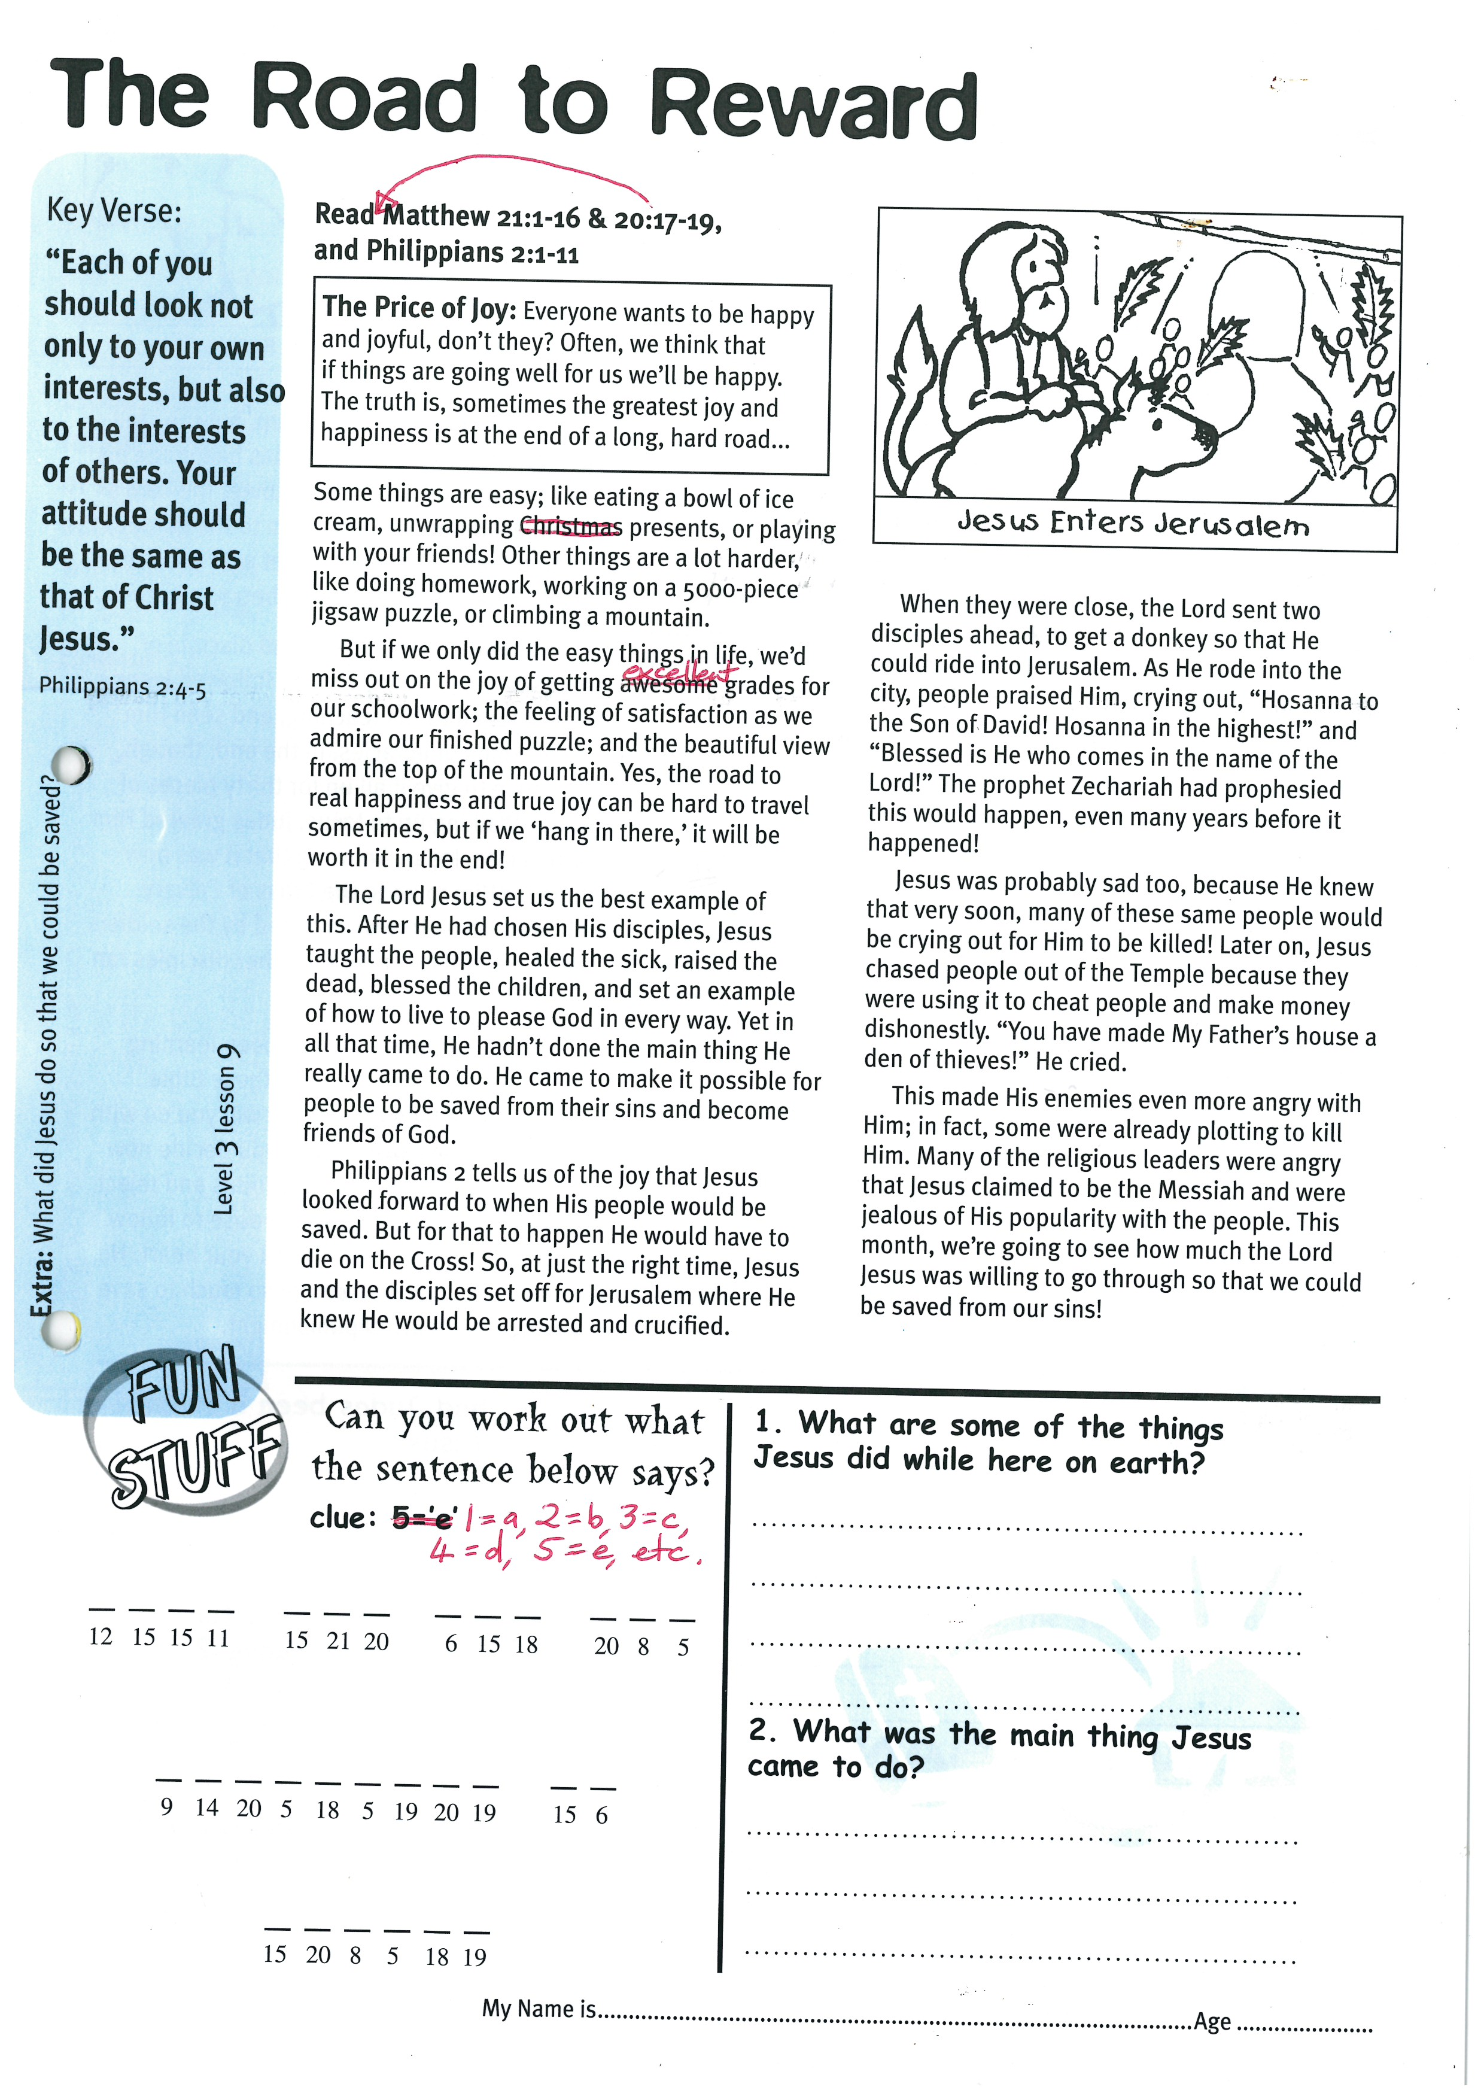

**Read Matthew 20:17-19 & 21:1-16  
and Philippians 2:1-11**

**THE PRICE OF JOY:  
Everyone wants to be happy and joyful, don’t they? Often, we think that if things are going well for us we’ll be happy. The truth is, sometimes the greatest joy and happiness is at the end of a long, hard road….**

Some things are easy; like eating a bowl of ice cream, unwrapping presents, or playing with your friends! Other things are a lot harder, like doing homework, working on a 5000-piece jigsaw puzzle, or climbing a mountain.   
But if we only did the easy things in life, we’d miss out on the joy of getting excellent grades for our schoolwork; the feeling of satisfaction as we admire our finished puzzle; and the beautiful view from the top of the mountain. Yes, the road to real happiness and true joy can be hard to travel sometimes, but if we ‘hang in there,’ it will be worth it in the end!  
The Lord Jesus set us the best example of this. After He had chosen His disciples, Jesus taught the people, healed the sick, raised the dead, blessed the children, and set an example of how to live to please God in every way. Yet in all that time, He hadn’t done the main thing He really came to do. He came to make it possible for people to be saved from their sins and become friends of God.   
Philippians 2 tells us of the joy that Jesus looked forward to when His people would be saved. But for that to happen He would have to die on the Cross! So, at just the right time, Jesus and the disciples set off for Jerusalem where He knew He would be arrested and crucified.

Key Verse:  
**“Each of you should look not only to your own interests, but also to the interests of others. Your attitude should be the same as that of Christ Jesus.**

Philippians 2:4-5

**The Road to Reward**

Can you work out what the sentence below says? Clue: 1=a, 2=b, 3=c, 4=d, 5-e, etc

__ __ __ __ __ __ __ __ __ __ __ __ __

12 15 15 11 15 21 20 6 15 18 20 8 5

__ __ __ __ __ __ __ __ __ __ __

9 14 20 5 18 5 19 20 19 15 6

__ __ __ __ __ __

15 20 8 5 18 19

My Name is ……………………………………………………… Age…………………

When they were close, the Lord sent two disciples ahead, to get a donkey so that He could ride into Jerusalem. As He rode into the city, people praised Him, crying out, “Hosanna to the Son of David! Hosanna in the highest!” and “Blessed is He who comes in the name of the Lord!” The prophet Zechariah had prophesied this would happen, even many years before it happened!  
  
Jesus was probably sad too, because He knew that very soon, many of these same people would be crying out for Him to be killed! Later on, Jesus chased people out of the Temple because they were using it to cheat people and make money dishonestly. “You have made My Father’s house a den of thieves!” He cried.  
  
This made His enemies even more angry with Him; in fact, some were already plotting to kill Him. Many of the religious leaders were angry that Jesus claimed to be the Messiah and were jealous of His popularity with the people.

This month, we’re going to see how much the Lord Jesus was willing to go through so that we could be saved from our sins!

1. What are some of the things Jesus did while here on earth?

_____________________________________

_____________________________________

_____________________________________

_____________________________________

_____________________________________

2. What was the main thing Jesus came to do?  
_____________________________________  
_____________________________________  
_____________________________________  
_____________________________________

**Level 3 lesson 9**

**Extra:** What did Jesus do so that we could be saved?

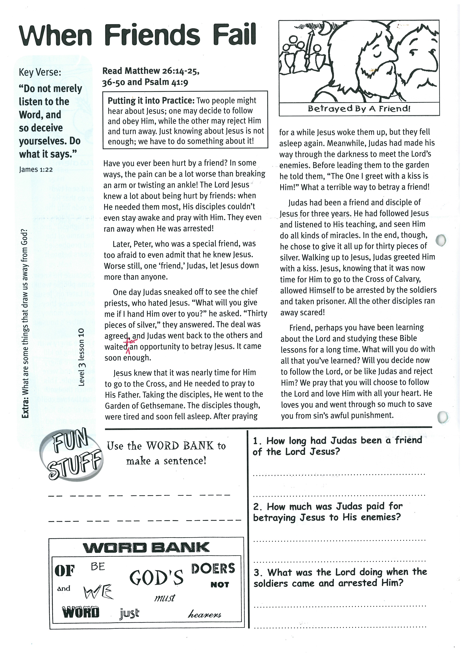

**Read Matthew 26:14-25 & 36-50   
and Psalm 41:9**

**PUTTING IT INTO PRACTICE:   
Two people might hear about Jesus; one may decide to follow and obey Him, while the other may reject Him and turn away. Just knowing about Jesus is not enough; we have to do something about it!**

Have you ever been hurt by a friend? In some ways, the pain can be a lot worse than breaking an arm or twisting an ankle! The Lord Jesus knew a lot about being hurt by friends: when He needed them most, His disciples couldn’t even stay awake and pray with Him. They even ran away when He was arrested!   
  
Later, Peter, who was a special friend, was too afraid to even admit that he knew Jesus. Worse still, one ‘friend,’ Judas, let Jesus down more than anyone.  
  
One day Judas sneaked off to see the chief priests, who hated Jesus. “What will you give me if I hand Him over to you?” he asked. “Thirty pieces of silver,” they answered. The deal was agreed, and Judas went back to the others and waited for an opportunity to betray Jesus. It came soon enough.  
  
Jesus knew that it was nearly time for Him to go to the Cross, and He needed to pray to His Father. Taking the disciples, He went to the Garden of Gethsemane. The disciples though, were tired and soon fell asleep.

**When Friends Fail**

Key Verse:  
**“Do not merely listen to the Word, and so deceive yourselves. Do what it says.”**

James 1:22

1. How long had Judas been a friend of the Lord Jesus?

________________________________________

________________________________________

2. How much was Judas paid for betraying Jesus to His enemies?

________________________________________

________________________________________

3. What was the Lord doing when the soldiers came and arrested Him?

________________________________________

________________________________________

________________________________________

Use the WORD BANK to make a sentence:  
   
__ __ __ __ __ __ __ __ __ __ __ __ __ __ __ __ __ __ __

__ __ __ __ __ __ __ __ __ __   
__ __ __ __ __ __ __ __ __ __ __

OF BE GOD’S DOERS NOT AND WE MUST WORD JUST HEARERS

**Extra:** What are some things that draw us away from God?

After praying for a while Jesus woke them up, but they fell asleep again. Meanwhile, Judas had made his way through the darkness to meet the Lord’s enemies. Before leading them to the garden he told them, “The One I greet with a kiss is Him!” What a terrible way to betray a friend!  
  
Judas had been a friend and disciple of Jesus for three years. He had followed Jesus and listened to His teaching, and seen Him do all kinds of miracles. In the end, though, he chose to give it all up for thirty pieces of silver. Walking up to Jesus, Judas greeted Him with a kiss. Jesus, knowing that it was now time for Him to go to the Cross of Calvary, allowed Himself to be arrested by the soldiers and taken prisoner. All the other disciples ran away scared!  
  
Friend, perhaps you have been learning about the Lord and studying these Bible lessons for a long time. What will you do with all that you’ve learned? Will you decide now to follow the Lord, or be like Judas and reject Him? We pray that you will choose to follow the Lord and love Him with all your heart. He loves you and went through so much to save you from sin’s awful punishment.

**Level 3 lesson 10**

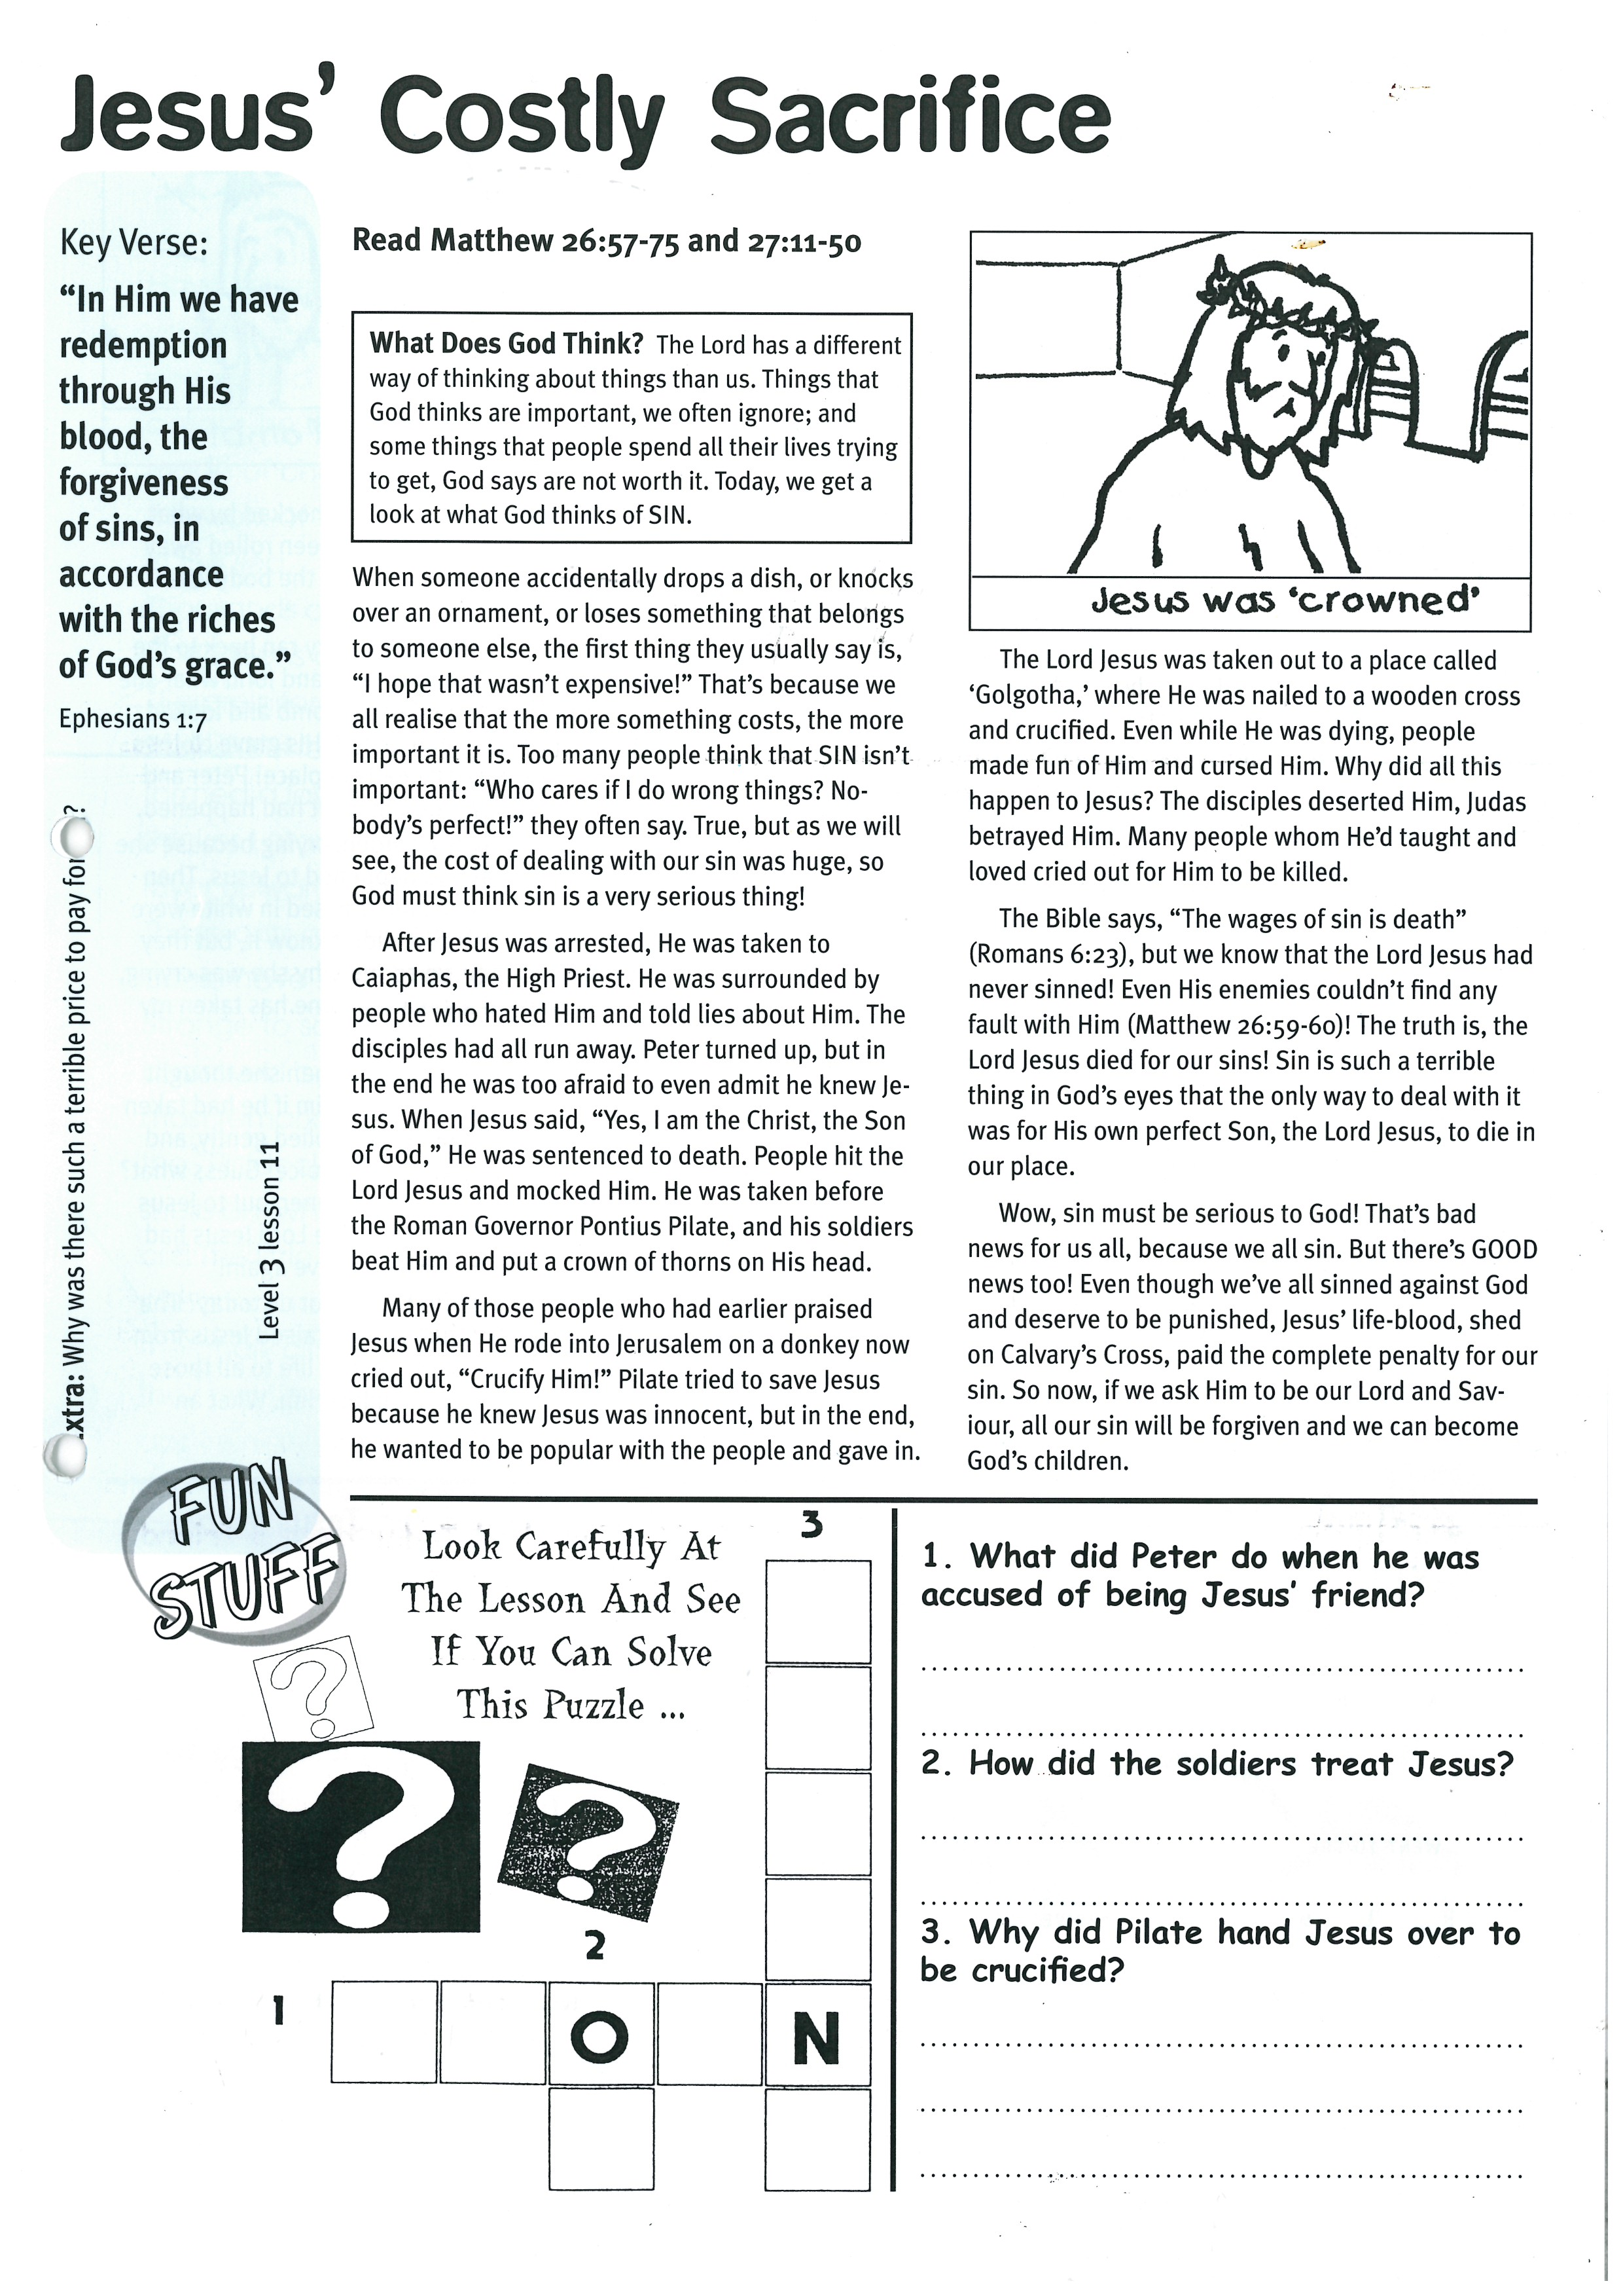

**Read Matthew 26:57-75   
and Matthew 27:11-50**

**WHAT DOES GOD THINK?**

**The Lord has a different way of thinking about things than us. Things that God thinks are important, we often ignore; and some things that people spend all their lives trying to get, God says are not worth it. Today, we get a look at what God thinks of SIN.**

When someone accidentally drops a dish, or knocks over an ornament, or loses something that belongs to someone else, the first thing they usually say is, “I hope that wasn’t expensive!” That’s because we all realise that the more something costs, the more important it is.   
Too many people think that SIN isn’t important: “Who cares if I do wrong things? Nobody’s perfect!” they often say. True; but as we will see, the cost of dealing with our sin was huge, so God must think sin is a very serious thing!  
  
After Jesus was arrested, He was taken to Caiaphas, the High Priest. He was surrounded by people who hated Him and told lies about Him. The disciples had all run away. Peter turned up, but in the end he was too afraid to even admit he knew Jesus. When Jesus said, “Yes, I am the Christ, the Son of God,” He was sentenced to death. People hit the Lord Jesus and mocked Him. He was taken before the Roman Governor Pontius Pilate, and his soldiers beat Him and put a crown of thorns on His head.

Key Verse:  
**“In Him we have redemption through His blood, the forgiveness of sins, in accordance with the riches of God’s grace.”**

Ephesians 1:7

**Jesus’ Costly Sacrifice**

|  |  |  |  |  |
| --- | --- | --- | --- | --- |
|  |  |  |  |  |
|  |  |  |  |  |
|  |  |  |  |  |
|  |  | **2** |  |  |
|  |  | **O** |  | **N** |
|  |  |  |  |  |

Many of those people who had earlier praised Jesus when He rode into Jerusalem on a donkey now cried out, “Crucify Him!” Pilate tried to save Jesus because he knew Jesus was innocent, but in the end, he wanted to be popular with the people and gave in.

The Lord Jesus was taken out to a place called ‘Golgotha,’ where He was nailed to a wooden cross and crucified. Even while He was dying, people made fun of Him and cursed Him. Why did all this happen to Jesus? The disciples deserted Him, Judas betrayed Him. Many people whom He’d taught and loved cried out for Him to be killed.

The Bible says, “The wages of sin is death” (Romans 6:23), but we know that the Lord Jesus had never sinned! Even His enemies couldn’t find any fault with Him! (Matthew 26:59-60). The truth is, the Lord Jesus died for our sins! Sin is such a terrible thing in God’s eyes that the only way to deal with it was for His own perfect Son, the Lord Jesus, to die in our place.

Wow, sin must be serious to God! That’s bad news for us all, because we all sin. But there’s GOOD news, too! Even though we’ve all sinned against God and deserve to be punished; Jesus’ life-blood, shed on Calvary’s Cross, paid the complete penalty for our sin. So now, if we ask Him to be our Lord and Saviour, all our sin will be forgiven and we can become God’s children.

1. What did Peter do when he was accused of being Jesus’ friend?

___________________________________________

___________________________________________

2. How did the soldiers treat Jesus?

___________________________________________

___________________________________________

3. Why did Pilate hand Jesus over to be crucified?

___________________________________________

___________________________________________

___________________________________________

**3**

**Extra:** Why was there such a terrible price to pay for sin?

**1**

Look carefully at the   
lesson, and see if you   
can solve this puzzle:

**Level 3 lesson 11**

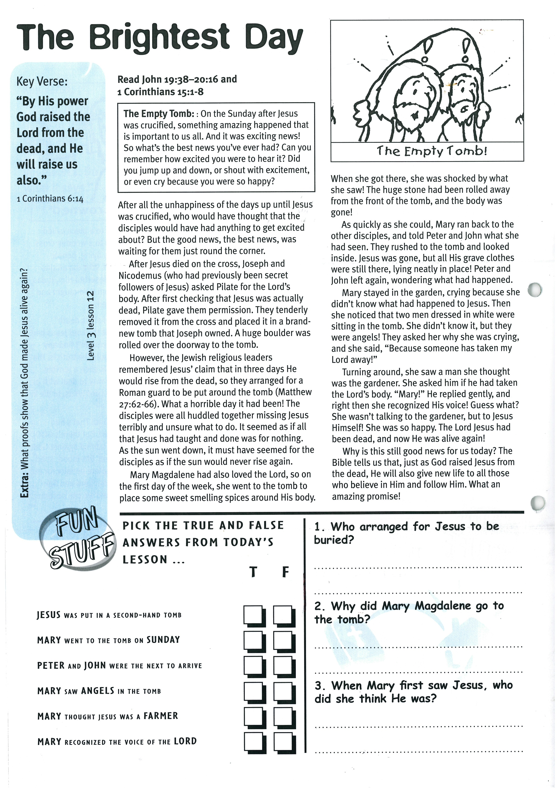

**Read John 19:38-20:16;   
and 1 Corinthians 15:1-8**

**THE EMPTY TOMB:   
On the Sunday after Jesus was crucified, something amazing happened that is important to us all. And it was exciting news! So what’s the best news you’ve ever had? Can you remember how excited you were to hear it? Did you jump up and down, or shout with excitement, or even cry because you were so happy?**

After all the unhappiness of the days up until Jesus was crucified, who would have thought that the disciples would have had anything to get excited about? But the good news, the best news, was waiting for them just round the corner.  
  
After Jesus died on the cross, Joseph and Nicodemus (who had previously been secret followers of Jesus) asked Pilate for the Lord’s body. After first checking that Jesus was actually dead, Pilate gave them permission. They tenderly removed it from the cross and placed it in a brand-new tomb that Joseph owned. A huge boulder was rolled over the doorway to the tomb.  
  
However, the Jewish religious leaders remembered Jesus’ claim that in three days He would rise from the dead, so they arranged for a Roman guard to be put around the tomb (Matthew 27:62-66). What a horrible day it had been! The disciples were all huddled together missing Jesus terribly and unsure what to do. It seemed as if all that Jesus had taught and done had been for nothing. As the sun went down, it must have seemed for the disciples as if the sun would never rise again.

**The Brightest Day**

Key Verse:  
**“By His power God raised the Lord from the dead, and He will raise us also.”**

1 Corinthians 6:14

**Answer:**

Mary Magdalene had also loved the Lord, so on the first day of the week, she went to the tomb to place some sweet smelling spices around His body. When she got there, she was shocked by what she saw! The huge stone had been rolled away from the front of the tomb, and the body was gone!  
As quickly as she could, Mary ran back to the other disciples, and told Peter and John what she had seen. They rushed to the tomb and looked inside. Jesus was gone, but all His grave clothes were still there, lying neatly in place! Peter and John left again, wondering what had happened.  
Mary stayed in the garden, crying because she didn’t know what had happened to Jesus. Then she noticed that two men dressed in white were sitting in the tomb. She didn’t know it, but they were angels! They asked her why she was crying, and she said, “Because someone has taken my Lord away!”  
  
Turning around, she saw a man she thought was the gardener. She asked him if he had taken the Lord’s body. “Mary!” He replied gently, and right then she recognized His voice! Guess what? She wasn’t talking to the gardener, but to Jesus Himself! She was so happy. The Lord Jesus had been dead, and now He was alive again.  
Why is this still good news for us today? The Bible tells us that, just as God raised Jesus from the dead, He will also give new life to all those who believe in Him and follow Him. What an amazing promise!

**Level 3 lesson 12**

**Extra:** What proofs show that God made Jesus alive again?

1. Who arranged for Jesus to be buried?

_______________________________________

_______________________________________

2. Why did Mary Magdalene go to the tomb?

_______________________________________

_______________________________________

_______________________________________

3. When Mary first saw Jesus, who did she think He was?

**Pick the True and False answers from today’s lesson:**

**True False**

JESUS was put in a second-hand tomb ⃝ ⃝

Mary went to the tomb on SUNDAY ⃝ ⃝

PETER and JOHN were the next to arrive ⃝ ⃝

MARY saw ANGELS in the tomb ⃝ ⃝

MARY thought Jesus was a FARMER ⃝ ⃝

MARY recognized the voice of the LORD ⃝ ⃝

Please complete and return by post to   
**PSSM Bible Discovery, 5/399 New North Rd, Kingsland, Auckland 1021** or scan & email to **info@biblediscovery.org.nz**