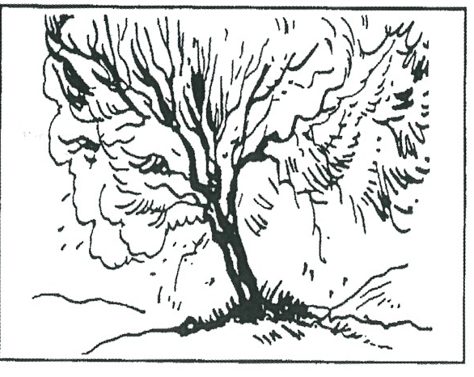
Key Verse:
“God said, ‘I will be with you.’”
Exodus 3:12a
Read Exodus 3:15-22; 4:1-9
and Acts 7:34
Moses now knew that God had made him leader of the people of Israel. This was something Moses had longed for earlier in his life, and now God was commissioning him to the task. Would it be easy? No way! Difficulties? Lots of them! But God would always be in control and now He told Moses to begin the work.
First God told Moses to gather the Elders of Israel together and tell them, “The Lord God of Abraham, Isaac and Jacob appeared to me saying, ‘I have watched over you... and I have promised to bring you out of your misery in Egypt... to a land flowing with milk and honey.’” (That means a land with a plentiful supply of all they needed).
Then God told Moses to tell Pharaoh, “The Lord God of the Hebrews has met with us; now let us go three day’s journey into the wilderness, to sacrifice to the Lord our God.” But God told Moses, “I know that the King of Egypt (Pharaoh) will NOT let you go, so I will strike Egypt and after that he WILL let you go!”
Strangely, Moses appeared to become nervous, and doubted the people would believe him. God answered by saying, “What is that in your hand?” “A rod,” answered Moses. “Throw it on the ground,” said God. Moses obeyed, and the rod became a live, wriggling serpent! Moses ran from it in fear. God said, “Put out your hand, and take it by the tail.” Moses did so, and the serpent again became a rod in his hand.

God Instructs Moses
1. What thing did God instruct Moses to do and say first?

2. What does ‘a land flowing with milk and honey’ mean?

3. Describe one of the three signs God gave Moses power to perform.
4. Why was Moses given this power?
5. What is the secret of victory?
My Name is _____________________________________________ Age ___________
Level 3 lesson 1
Extra: Why do you think Moses was chosen as a leader?

Level 4 lesson 5
QUESTIONS & ANSWERS
Again God instructed Moses, “Put your hand inside your cloak.” Moses did so. When he took it out, his hand was covered with leprosy - as white as snow! Once again, God spoke, “Put your hand in again.” Moses obeyed, and when he took it out the hand was normal again! “Now,” said God, “If they don’t believe the first sign, they may believe the second. If not, here is a third sign. Take some water from the river, pour it out on dry land, and it will become blood!”
How tenderly and graciously God dealt with Moses! He wanted Moses to really understand that He would enable him to do all He had in mind for him - all through His Almighty Power. He used ordinary, everyday things to show His glory: a bush, a shepherd’s rod, Moses’ own hand, and water. God doesn’t need anything fancy to show His Glory. So, though you may not be rich or great, God can use even you in your daily life to show His Glory!
God has made you just as He wants you. He wants to use you to do His work in this world. In the Bible we read just what He would have you and me to do, and how to do it for His glory. Be available to God, listen to His Word, and go forward, trusting Him for VICTORY!
Key Verse:
“Jesus said, ‘I tell you the truth, unless a man is born again, he cannot see the kingdom of God.’”
John 3:3
Moses Hesitates
Key Verse:
“I will help you speak and I will teach you what to say.”
Exodus 4:12
1. What were the 2 final excuses Moses made to God? (Cross out the extra letters) | AIBAMCNOTDELOQUENTE  FSENDGSOMEONEHELSE
2. What helpful promises did God give to Moses?
3. What does God want YOU to do?
4. Whom did God give to Moses as a helper, and why?
5. If you had been one of the people, how would you have reacted to Moses & Aaron?
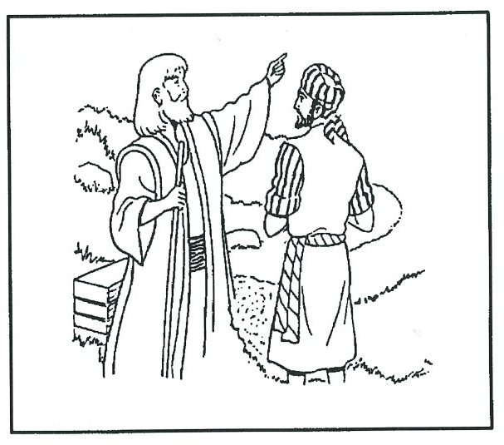
___
Extra: Make a list of people you need to tell the Good News to, then with God’s help, GO and do it!
Level 4 lesson 6
QUESTIONS & ANSWERS
Read Exodus 4:10-20 and 27-31
Even after God had given Moses all those instructions and promises, Moses was still doubtful. He hesitated to obey the Lord and began to make excuses! “O Lord,” he said, “I am not eloquent. I can’t make fine speeches like some people can.” It seems he ignored the fact that God had given him the very words he was to use!
Sometimes we as Christians can make the same weak excuse for not talking to our friends about Christ. Some Christians only talk about the weather, school, sport, or people - but they never have the courage to tell others about the Lord Jesus! Are you like that, too? God still asks the same question today, “Who made man’s mouth? ... Have not I the Lord? Now go; I will help you speak and teach you what to say!”
Moses was still reluctant. “Send someone else,” he said. Moses’ lack of faith disappointed and displeased God. After all the signs and promises God had graciously given him, Moses was still unwilling. UNWILLINGNESS to do God’s will is SIN (James 4:17)! If you are not yet a true Christian, God’s will for you is that you trust the Lord Jesus as your Saviour. His promise to you is, “Whoever comes to Me, I will never turn away.”
If you are already His, He wants you to tell others about Him. He says to you, “Go! I will help you speak, and teach you what to say.” Even in God’s displeasure with Moses, His great mercy and kindness are plain to see. He said to Moses, “Your brother Aaron can speak well. He is coming to meet you. He will be your spokesman.”

God promised again to be with both men. “I will be with your mouth, and with his mouth, and will teach you what you shall do. Take your rod, and GO!”
Moses was encouraged to have his brother with him, but though Aaron could speak well, he was a weak man. Later on, Moses realised it would have been better if he had gone alone as God’s chosen leader. Aaron caused him much heartache at times. How we too, need to obey the command of the Lord promptly, acting in faith. His way is always best!
Then the Lord told Moses, “Return to Egypt, for all the men who were trying to kill you are dead.” So Moses set off with his rod in his hand. As he went, he met Aaron at “the Mount of God.” Moses told Aaron everything God had told him and about the three signs God had given him.
So the brothers then gathered the elders of the people together as God had commanded. Aaron told them what God had spoken to Moses. Aaron did the signs before the people (which God had intended Moses to do) and the people believed, bowed down, and worshipped God.

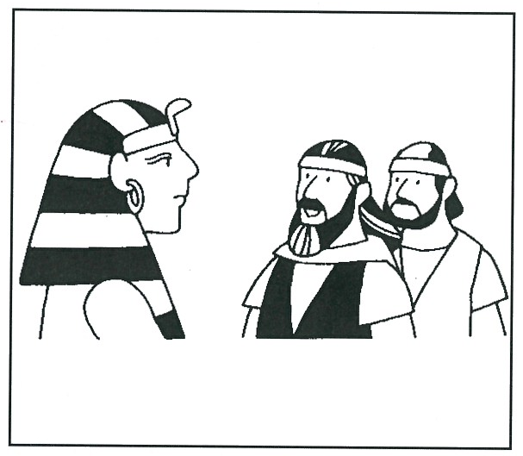
Key Verse:
“The Lord is my helper. I will not be afraid. What can man do to me?”
Hebrews 13:6
Read Exodus 5:1 to Exodus 6:8
and Isaiah 55:6-7
One day a messenger came to Pharaoh and told him, “Two Israelites are standing outside wishing to speak to you.” This was a new Pharaoh. The one who ruled when Moses was in Egypt had died. “Bring them in,” said the new Pharaoh.
Moses had not forgotten how to behave in a King’s palace, so he knew just what to do. Moses and Aaron gave him their message. “This is what the Lord God of Israel says: “Let My people go, that they may worship Me in the wilderness.”
Pharaoh sneered, “Who is the Lord, that I should obey His voice?” He was too proud to believe there could be anyone more powerful than him. “I don’t know the Lord, neither will I let Israel go!” he said defiantly, just as God had told Moses he would! Moses and Aaron repeated what God had said. Pharaoh got angry, and said, “Why are you trying to take the people from their work? They are lazy! Get back to your tasks, and let all of you carry your burdens!”
You may remember that at this time, the Israelites were slaves, making bricks and building houses for the Egyptian rulers. The bricks were made from clay with finely-chopped straw to hold them together. Every day the Egyptians supplied them with straw for this work. However, now Pharaoh called the task-masters together, and told them to make the Israelites work harder than they had ever worked before!
A Stubborn King
1. What message did Moses bring to Pharoah?
2. What answer did Pharoah give?

3. What made the people blame Moses and Aaron?
4. What did Moses do when the people blamed him?

5. How would you have reacted if you had been wrongly blamed as Moses was?
Extra: Find out more about what it was like to be a slave.

Level 4 lesson 7
QUESTIONS & ANSWERS
“Do not give the people straw to make bricks,” he commanded them. “Let them go out into the fields and gather it for themselves. But they must make just as many bricks as before, each day!” The Egyptian task-masters did as Pharaoh commanded. Of course, the people couldn’t make the same number of bricks each day though. The task-masters tried to hurry them, shouting at them, “Do your jobs just as before when there was straw!” and thrashed them with cruel whips and rods.
Some of the leading men complained to Pharaoh, but he only said, “You are just lazy! Get out and work harder!” Naturally, the people blamed Moses and Aaron for all their troubles. “You said you would bring us out of Egypt, but you have only brought more sorrow upon us,” they cried.
Moses loved his people and he felt sorry for them. What was God doing? Why were things going so badly when he had obeyed God? He cried in prayer to the Lord and said, “Why is it that You sent me to Pharaoh? He won’t let the people go, and is only making their lives harder!”
We can learn from this. Things don’t always go perfectly well for us, but we can always cry out to God for help. God comforted Moses (read Exodus 6:1-8), and Moses and Aaron comforted the people with these words, too. Then God told Moses that he and Aaron must go back to Pharaoh and show him the three signs God had given him!

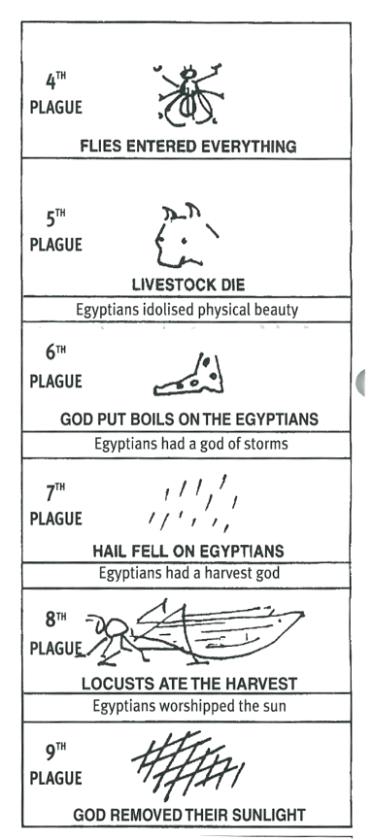
The Plagues of Egypt
Key Verse:
“You are the God who performs miracles; You display Your power among the peoples.”
Psalm 77:14
Read Exodus 7-10
and Hebrews 13:6
What great excitement there must have been at Pharaoh’s Palace, as Moses and Aaron demonstrated God’s miracles before the King! Aaron cast down his rod in the name of the Lord and it turned into a deadly snake!
The King’s magicians copied him and they threw down their rods, which also became serpents. Remember, Satan has limited evil power and can do counterfeit miracles! But God is infinite in power! We read that, “Aaron’s rod swallowed up their rods!”
This should have proved to Pharaoh that God was greater than the ‘gods’ of the Egyptians. But he resisted God and hardened his heart against God. He refused to let the Israelites go, just as God said he would.
So God sent plagues and troubles of different kinds, one after another, upon the Egyptians. Nine times God sent judgement on the Egyptians, and after each plague, God gave Pharaoh an opportunity to let the Israelites go. Still Pharaoh defied God and would not let the people go! Would anything change his mind? We’ll see next month!

1. How did Aaron show that his rod-miracle was greater than that of the magicians?
2. Why did God send these plagues?
3. If Pharoah and the Egyptians had obeyed God, what might have happened?

4. We can trust strange gods too, like money or fame. Who only should we trust?
5. Why do you think God brought judgement on Egypt’s gods?
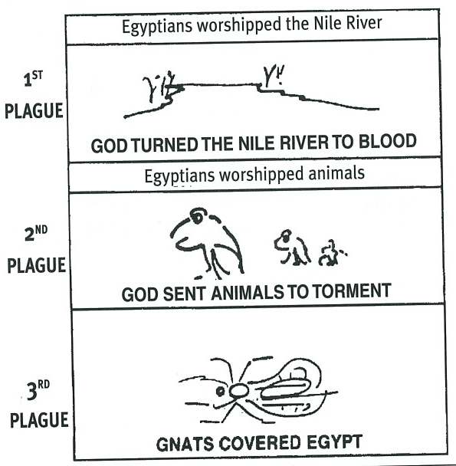
Extra: What do we learn from these plagues?

Level 4 lesson 8
QUESTIONS & ANSWERS
GOD SAID, “I WILL BRING JUDGEMENT ON ALL THE GODS OF EGYPT.” Exodus 12:12
After these nine plagues Pharaoh was furious and said to Moses, “Get out of my sight - make sure you do not appear before me again.” Moses said, “I will never appear before you again.”

Please complete and return by post to
PSSM Bible Discovery, 5/399 New North Rd, Kingsland, Auckland 1021 or scan & email to info@biblediscovery.org.nz

