**Read Luke 7:1-10**

The Lord Jesus once went to visit the town of Capernaum. A Roman Centurion (an important officer in the Roman Army in charge of 100 soldiers), lived there. His soldiers were very well trained and did whatever he told them to do.

The Centurion was very sad. One of his servants was sick and dying. Many Centurions were very hard and unkind, but this man loved his servant and always treated him kindly. He had heard about Jesus and His great power to heal people. He asked his friends to try and get Jesus to come and heal his servant.

The friends told Jesus that the Centurion was a good man and asked if He could please help him. Jesus agreed to go with the men. When they got near the Centurion’s house he sent a messenger out.

The messenger told them, “My master says he is not good enough for Jesus to come into his house. Please, just let Him speak and my servant will be healed.” The Centurion believed that Jesus didn’t even have to see his sick servant; He could make the sick man well wherever he was… just by speaking!

Jesus was really happy when He heard what the Centurion said. He told the people around Him, “I have never met anyone with faith like this man!” The messenger went back to the Centurion’s house. There he found that the sick servant was already better. Jesus had healed him!

Did you know that the Lord Jesus wants to be the Captain of your life? He is looking for boys and girls who will trust Him in the same way that Roman Centurion did. Learn to trust and obey Him while you are still young and He will take care of you and guide you all your life!

**A Roman Soldier’s Faith**

Key Verse:  
**“Trust in the Lord with all your heart.”**

Proverbs 3:5a



1. Whose servant was sick?

**Answer:** __________________________

2. Did Jesus go into the Centurion’s house?

**Answer:** _____________________

3. What happened to the sick man?

**Answer:** ___________________________

4. Who should we trust and obey?

**Answer:** _______________________

**Cross out one letter from each word below, to make the message correct.  
 strust hand lobey  
Answer: _________________________________**

My Name is________________________________________ Age ______________

**Level 2 lesson 13**

**Extra:** How could you show your faith in Jesus?

Peter, James, and John were amazed at what they saw and heard. Peter was really excited. “Lord,” he said. “Let’s always stay up here. Let’s make three shelters, one for you, one for Moses, and one for Elijah.” Peter didn’t really understand that Jesus knew He was soon going to die in Jerusalem. Jesus could not stay on the mountain top. At that moment God’s voice spoke out from the Heavens, **“This is** **my Son, listen to Him!”** This was no time for Peter to be speaking, because God’s own Son, the Lord Jesus, was there!

The disciples bowed low in worship before the Lord. Then they heard Jesus’ gentle voice saying, “Don’t be afraid. Don’t tell anyone what you have seen today. Wait until I have died and come back to life again. Then you may tell everyone.” (Matthew 17:9) The disciples obeyed.

*Today we can hear the Lord Jesus speak to us through our Bible. Do you listen to what He has to say to you? Do you obey Him, like the disciples did?*

**Read Luke 9:28-36**

One day, the Lord Jesus took three of His disciples, Peter, James and John up a mountain. He wanted to share something amazing with them. When they arrived at the top, Jesus began to pray. As He prayed, the disciples noticed His face and His clothes begin to shine with dazzling white light, even brighter than the sun! It was almost too bright to look at.

As the three disciples watched in amazement, Moses and Elijah appeared and talked with Jesus! They had lived a long time ago. When they lived on earth, they were true servants of God. Moses gave God’s Law to the people, while Elijah was one of God’s prophets or special messengers. When they were living in the world, they had both talked about the coming of the Lord Jesus. Now they had come back from Heaven to talk with Jesus about His death, which would soon happen at Jerusalem.

**On the Mountain Top**

Key Verse: **“(God said), ‘This is My Son, whom I have chosen; listen to Him.’ “**

Luke 9:35

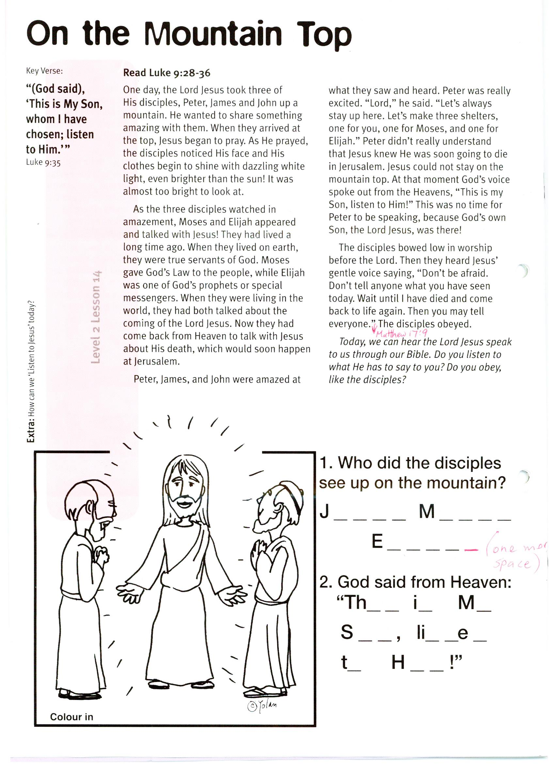

1. Who did the disciples see up on the mountain?

**J __ __ __ __**

**M __ __ __ __**

**E __ __ __ __ __**

2. God said from Heaven:

**“Th__ __ i __ M __**

**S __ __, L __ __ t __ __**

**t __ H __ __ !”**

**Level 2 lesson 14**

**Extra:** How can we “Listen to Jesus” today?

**Read Luke 11:1-4**In our Key Verse today, the Lord’s disciples asked Him to teach them to pray. Do you like praying to the Lord Jesus? Perhaps you have a special prayer you pray each night. One prayer that we have seen written in children’s books is: “Lead me, Lord Jesus, in my life each day. Help me to grow and to show your way, to all of my friends as we work and play.” While it is nice to learn a prayer like this, it’s even better to think up your very own words to say to Jesus. They don’t have to be the same every time.

You can thank Him for His loving care and all the good things He gives you every day. Things like: loving families, clothes to wear, a nice bed, good food, friends, and even pets.

You need to thank God for sending the Lord Jesus to be the Saviour of the world. Pray for sick people and children who can’t see or hear or run around. Don’t forget people who are sad, lonely, hungry, or live in countries where there is fighting.

There are some important things you need to pray for yourself, too. Ask God to help you to be good, kind, and loving, so that you please Him. Ask Him for strength to not say wrong things, or swear, tell lies, or be mean and selfish, steal or fight.

Maybe you have not prayed at all today. Why not decide to pray a little prayer to God each day? Remember: God loves to hear us and answer our prayers.   
We can pray to Him at **ANYTIME**, in **ANY PLACE**, and about **ANYTHING**, and He will hear us!

Key Verse: **“…Lord, teach us to pray…”**

Luke 11:1

Key Verse:  
**“Be kind and compassionate to one another, forgiving each other.”**

Ephesians 4:32

**Saying Our Prayers**

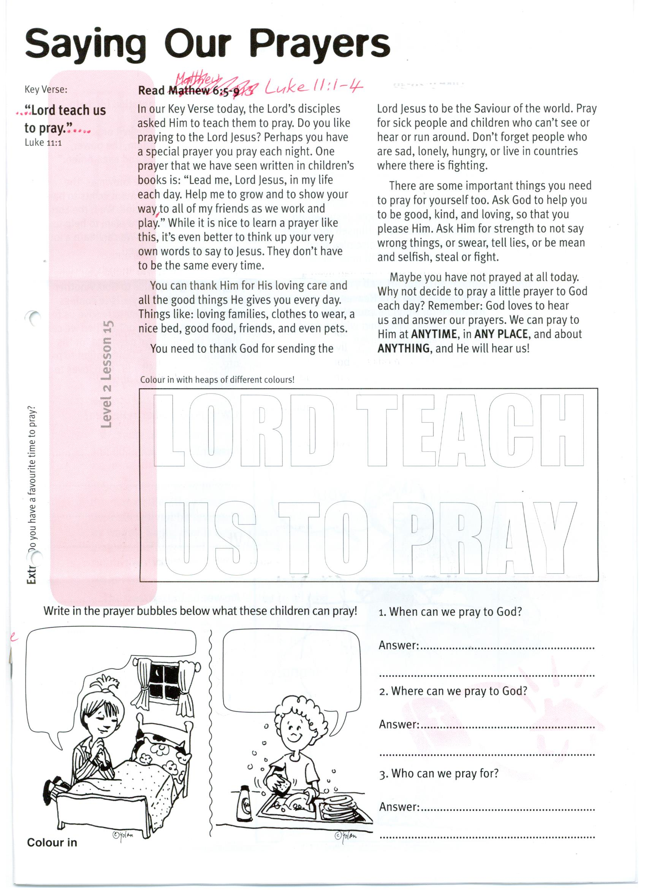

1. When can we pray to God?

**Answer:** _____________________

2. Where can we pray to God?

**Answer:** _____________________

3. Who can we pray for?

**Answer:** _____________________  
__________________________________________________________

**LORD TEACH US  
 TO PRAY**

**COLOUR IN:**

Write in the prayer bubbles below what these children could pray!

**Level 2 lesson 15**

**Extra:** Do you have a favourite time to pray?

**Level 2 lesson 39**

**Extra:** Find out all you can about the job that Joseph’s brothers did.

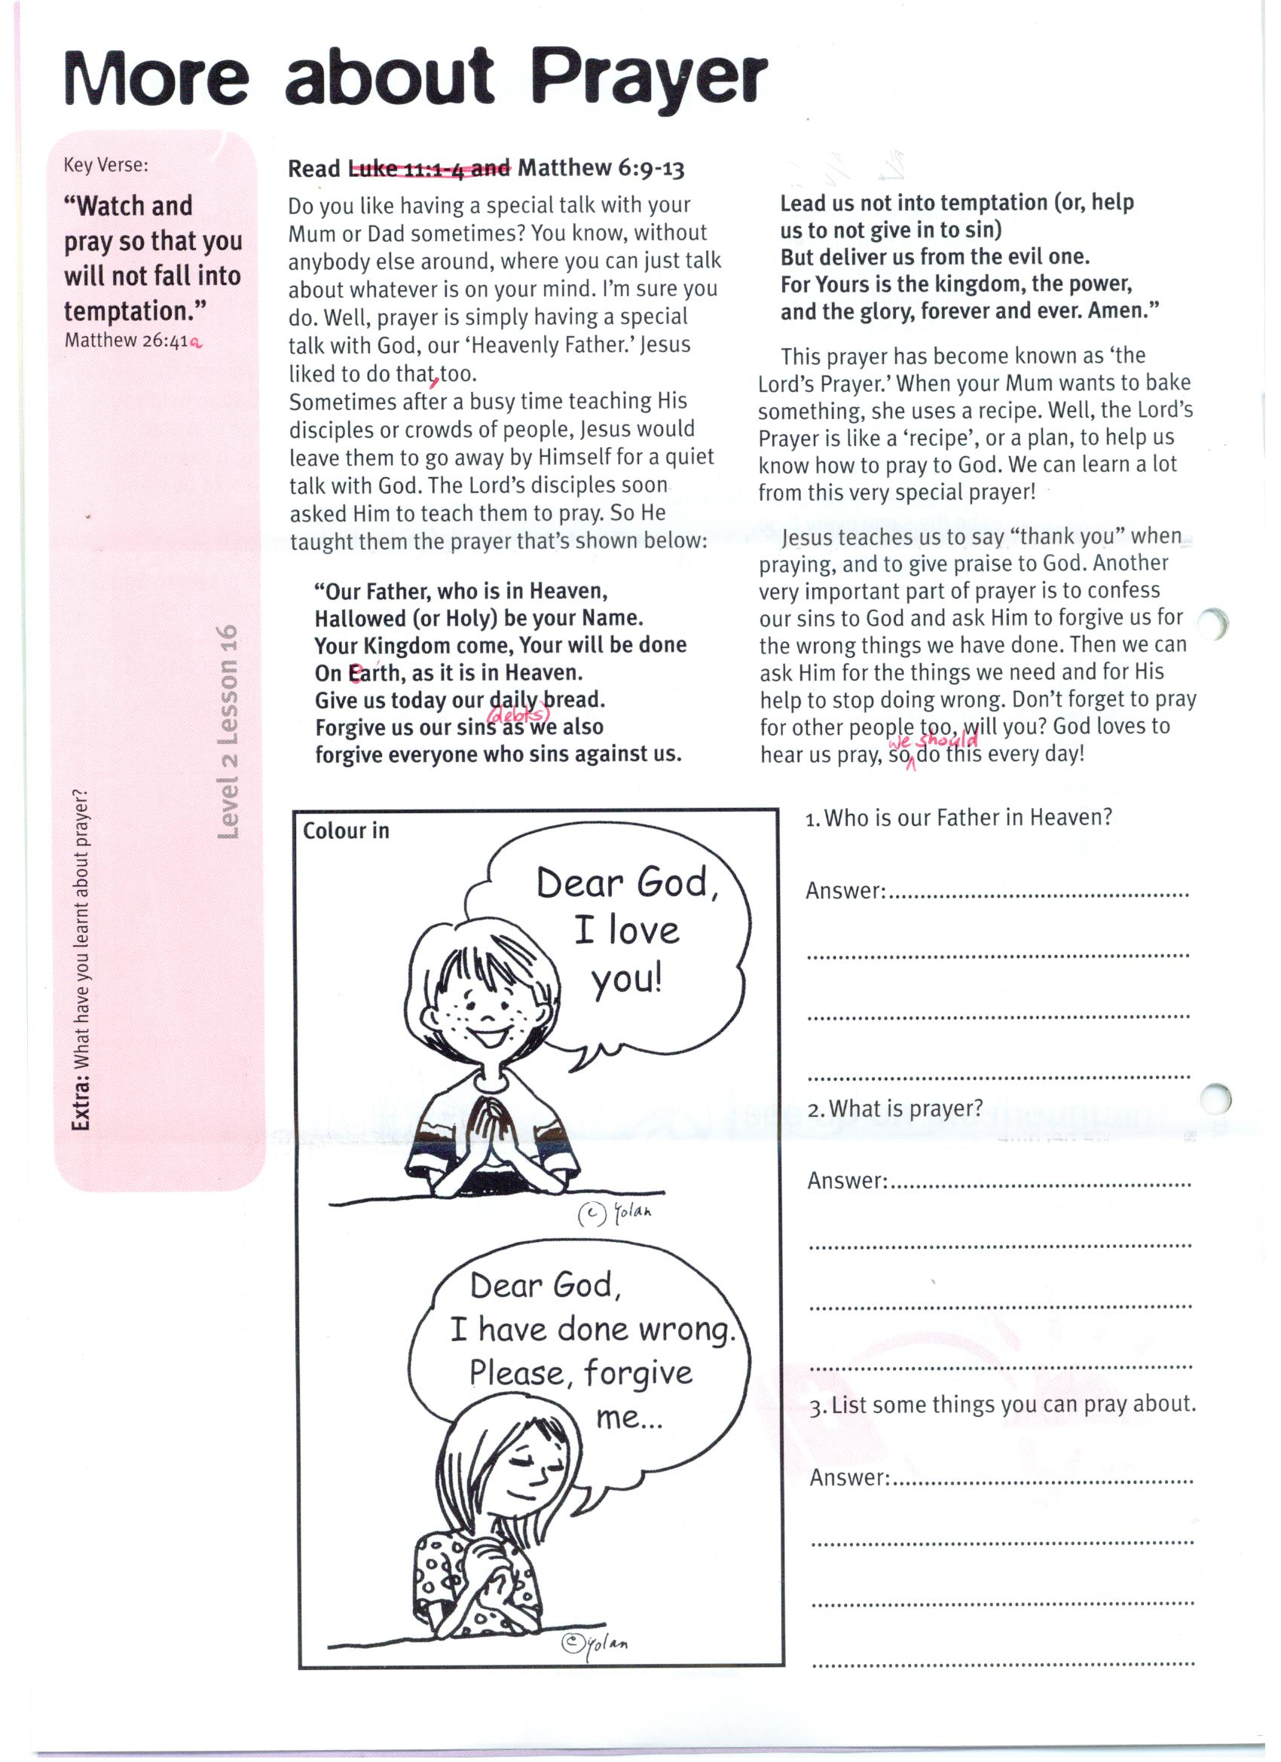

1. Who is our Father in Heaven?  
  
**Answer:** __________________

2. What is prayer?

**Answer:** __________________  
_________________________

3. List some things you can pray about:  
_________________________  
_________________________  
_________________________  
_________________________

Please complete and return by post to   
**PSSM Bible Discovery, 5/399 New North Rd, Kingsland, Auckland 1021** or scan & email to **info@biblediscovery.org.nz**

**Level 2 lesson 16**

**Extra:** What have you learnt about prayer?

So He taught them the prayer that’s shown below:

**“Our Father, who is in Heaven,  
Hallowed (or Holy) be your Name.  
Your Kingdom come, Your will be done  
On earth, as it is in Heaven.  
Give us today our daily bread.  
Forgive us our sins (or debts) as we also  
forgive everyone who sins against us.  
Lead us not into temptation (or, help  
us to not give in to sin)  
But deliver us from the evil one.  
For Yours is the kingdom, the power,  
and the glory, forever and ever. Amen.”**

This prayer has become known as ‘the Lord’s Prayer.’ When your Mum wants to bake something, she uses a recipe. Well, the Lord’s Prayer is like a ‘recipe’, or a plan, to help us know how to pray to God. We can learn a lot from this very special prayer!

Jesus teaches us to say “thank you” when praying, and to give praise to God. Another very important part of prayer is to confess our sins to God and ask Him to forgive us for the wrong things we have done. Then we can ask Him for the things we need and for His help to stop doing wrong. Don’t forget to pray for other people too, will you? God loves to hear us pray, so we should do this every day!

**Read Matthew 6:9-13**Do you like having a special talk with your Mum or Dad sometimes? You know, without anybody else around, where you can just talk about whatever is on your mind. I’m sure you do.   
Well, prayer is simply having a special talk with God, our ‘Heavenly Father.’ Jesus liked to do that, too.

Sometimes after a busy time teaching His disciples or crowds of people, Jesus would leave them to go away by Himself for a quiet talk with God. The Lord’s disciples soon asked Him to teach them to pray.

Key Verse: **“Watch and pray so that you will not fall into temptation.”**

Matthew 26:41a

**More about Prayer**