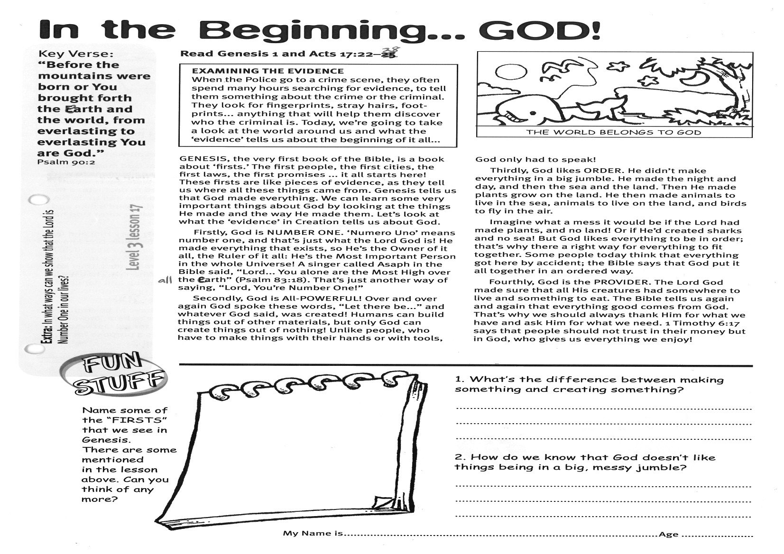

Key Verse:  
**“Before the mountains were born or You brought forth the earth and the world, from everlasting to everlasting You are God.”**

Psalm 90:2

**Read Genesis 1 and Acts 17:22-28**

**EXAMINING THE EVIDENCE: When the Police go to a crime scene, they often spend many hours searching for evidence, to tell them something about the crime or the criminal. They look for fingerprints, stray hairs, foot-prints... anything that will help them discover who the criminal is. Today, we’re going to take a look at the world around us and what the ‘evidence’ tells us about the beginning of it all...**

GENESIS, the very first book of the Bible, is a book about ‘firsts.’ The first people, the first cities, the first laws, the first promises ... it all starts here! These firsts are like pieces of evidence, as they tell us where all these things came from. Genesis tells us that God made everything. We can learn some very important things about God by looking at the things He made and the way He made them. Let’s look at what the ‘evidence’ in Creation tells us about God.

Firstly, God is NUMBER ONE. ‘Numero Uno’ means number one, and that’s just what the Lord God is! He made everything that exists, so He’s the Owner of it all, the Ruler of it all: He’s the Most Important Person in the whole Universe! A singer called Asaph in the Bible said, “Lord... You alone are the Most High over all the earth” (Psalm 83:18). That’s just another way of saying, “Lord, You’re Number One!”

Secondly, God is All-POWERFUL! Over and over again God spoke these words, “Let there be...” and whatever God said, was created! Humans can build things out of other materials, but only God can create things out of nothing!

**In the Beginning: GOD!**



**Extra:** In what ways can we show that the Lord is Number One in our lives?

Unlike people, who have to make things with their hands or with tools, God only had to speak!  
  
Thirdly, God likes ORDER. He didn’t make everything in a big jumble. He made the night and day, and then the sea and the land. Then He made plants grow on the land. He then made animals to live in the sea, animals to live on the land, and birds to fly in the air.  
Imagine what a mess it would be if the Lord had made plants, and no land! Or if He’d created sharks and no sea! But God likes everything to be in order; that’s why there a right way for everything to fit together. Some people today think that everything got here by accident; the Bible says that God put it all together in an ordered way.

Fourthly, God is the PROVIDER. The Lord God made sure that all His creatures had somewhere to live and something to eat. The Bible tells us again and again that everything good comes from God. That’s why we should always thank Him for what we have and ask Him for what we need. 1 Timothy 6:17 says that people should not trust in their money but in God, who gives us everything we enjoy!

1. What’s the difference between making something and creating something?

__________________________________________

____________________________________________________________________________________

2. How do we know that God doesn’t like things being in a big, messy jumble?

______________________________________________________________________________________________________________________________

My Name is ……………………………………………………… Age…………………

**Level 3 lesson 17**

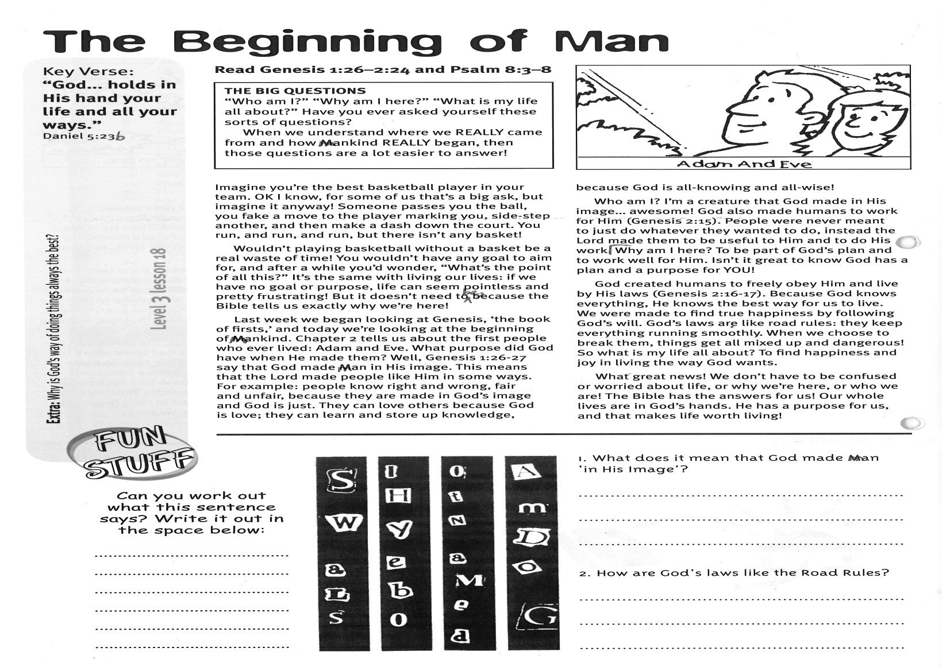

**Read Genesis 1:26 - 2:24  
and Psalm 8:3-8**

**THE BIG QUESTIONS: “Who am I?” “Why am I here?” “What is my life all about?” Have you ever asked yourself these sorts of questions? When we understand where we REALLY came from and how mankind REALLY began, then those questions are a lot easier to answer!**

Imagine you’re the best basketball player in your team. OK I know, for some of us that’s a big ask, but imagine it anyway! Someone passes you the ball, you fake a move to the player marking you, side-step another, and then make a dash down the court. You run, and run, and run, but there isn’t any basket!

Wouldn’t playing basketball without a basket be a real waste of time! You wouldn’t have any goal to aim for, and after a while you’d wonder, “What’s the point of all this?” It’s the same with living our lives: if we have no goal or purpose, life can seem pointless and pretty frustrating! But it doesn’t need to be, because the Bible tells us exactly why we’re here!

Last week we began looking at Genesis, ‘the book of firsts,’ and today we’re looking at the beginning of mankind. Chapter 2 tells us about the first people who ever lived: Adam and Eve. What purpose did God have when He made them?   
Well, Genesis 1:26-27 says that God made man in His image. This means that the Lord made people like Him in some ways. For example: people know right and wrong, fair and unfair, because they are made in God’s image and God is just. They can love others because God is love; they can learn and store up knowledge, because God is all-knowing and all-wise!

**The Beginning of Man**

Key Verse:  
**“God… holds in His hand your life and all your ways.”**

Daniel 5:23b



1. What does it mean that God made man ‘in His image’?

____________________________________________________________________________________________________________________________________

2. How are God’s laws like the Road Rules?

____________________________________________

________________________________________________________________________________________­­­­­­­­­­­­­­­­­­­

Who am I? I’m a creature that God made in His image… awesome! God also made humans to work for Him (Genesis 2:15). People were never meant to just do whatever they wanted to do, instead the Lord made them to be useful to Him and to do His work.  
  
Why am I here? To be part of God’s plan and to work well for Him. Isn’t it great to know God has a plan and a purpose for YOU!  
  
God created humans to freely obey Him and live by His laws (Genesis 2:16-17). Because God knows everything, He knows the best way for us to live. We were made to find true happiness by following God’s will. God’s laws are like road rules: they keep everything running smoothly. When we choose to break them, things get all mixed up and dangerous!   
So what is my life all about? To find happiness and joy in living the way God wants.

What great news! We don’t have to be confused or worried about life, or why we’re here, or who we are! The Bible has the answers for us! Our whole lives are in God’s hands. He has a purpose for us, and that makes life worth living!

**Level 3 lesson 18**

**Extra:** Why is God’s way of doing things always the best?

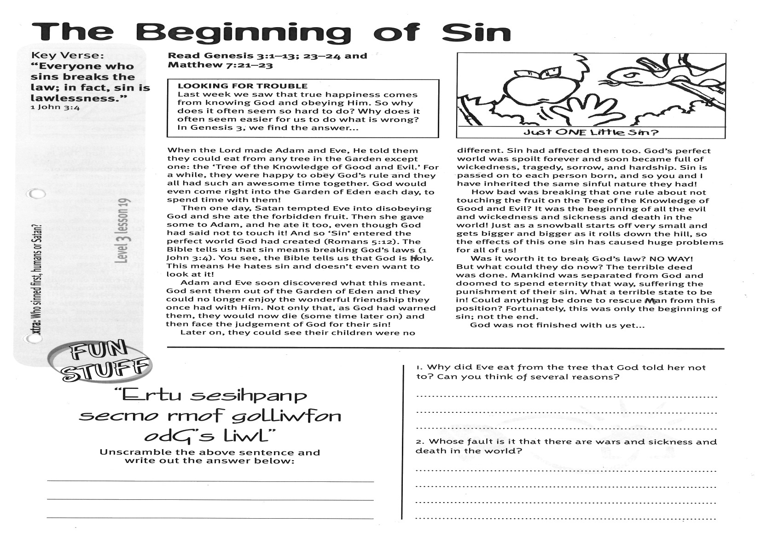

**Read Genesis 3:1-13; 23-24  
and Matthew 7:21-23**

**LOOKING FOR TROUBLE: Last week we saw that true happiness comes from knowing God and obeying Him. So why does it often seem so hard to do? Why does it often seem easier for us to do what is wrong? In Genesis 3, we find the answer...**

When the Lord made Adam and Eve, He told them they could eat from any tree in the Garden except one: the ‘Tree of the Knowledge of Good and Evil.’ For a while, they were happy to obey God’s rule and they all had such an awesome time together. God would even come right into the Garden of Eden each day, to spend time with them!

Then one day, Satan tempted Eve into disobeying God and she ate the forbidden fruit. Then she gave some to Adam, and he ate it too, even though God had said not to touch it! And so ‘Sin’ entered the perfect world God had created (Romans 5:12). The Bible tells us that sin means breaking God’s laws (1 John 3:4). You see, the Bible tells us that God is Holy. This means He hates sin and doesn’t even want to look at it.

Adam and Eve soon discovered what this meant. God sent them out of the Garden of Eden and they could no longer enjoy the wonderful friendship they once had with Him. Not only that, as God had warned them, they would now die (some time later on) and then face the judgement of God for their sin!

Key Verse:  
**“Everyone who sins breaks the law; in fact, sin is lawlessness.”**

1 John 3:4

**The Beginning of Sin**

Later on, they could see their children were no different. Sin had affected them, too. God’s perfect world was spoilt forever and soon became full of wickedness, tragedy, sorrow, and hardship. Sin is passed on to each person born, and so you and I have inherited the same sinful nature they had!

How bad was breaking that one rule about not touching the fruit on the Tree of the Knowledge of Good and Evil? It was the beginning of all the evil and wickedness and sickness and death in the world!   
Just as a snowball starts off very small and gets bigger and bigger as it rolls down the hill, so the effects of this one sin has caused huge problems for all of us!

Was it worth it to break God’s law? NO WAY! But what could they do now? The terrible deed was done. Mankind was separated from God and doomed to spend eternity that way, suffering the punishment of their sin. What a terrible state to be in! Could anything be done to rescue man from this position? Fortunately, this was only the beginning of sin; not the end.

God was not finished with us yet...



1. Why did Eve eat from the tree that God told her not to? Can you think of several reasons?

________________________________________________________________________________________________________________________________________________________________________

2. Whose fault is it that there are wars and sickness and death in the world?

______________________________________________________________________________________________________________________________

**Extra:** Who sinned first, humans or Satan?

**Level 3 lesson 19**

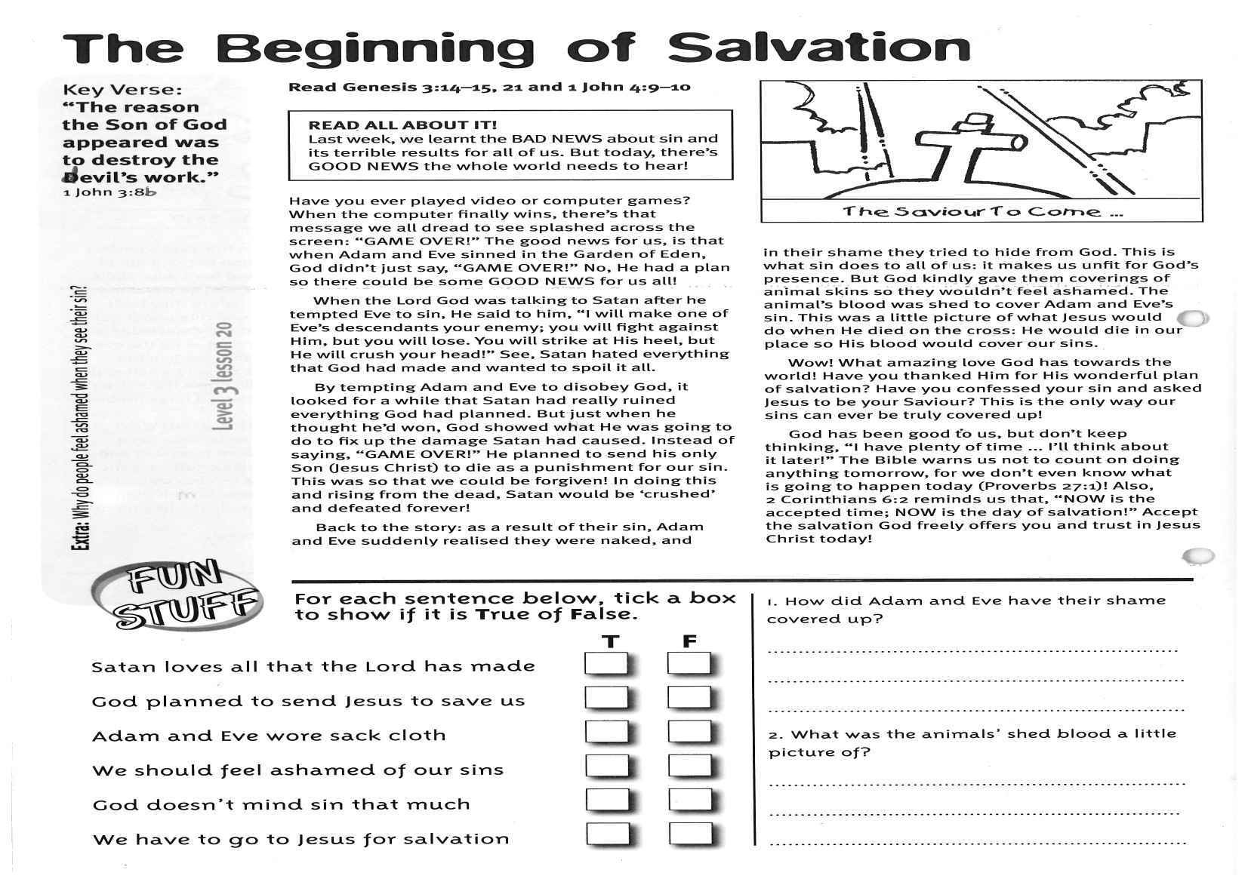

**Read Genesis 3:14-15; 21  
and 1 John 4:9-10  
  
READ ALL ABOUT IT!   
Last week, we learnt the BAD NEWS about sin and its terrible results for all of us. But today, there’s GOOD NEWS the whole world needs to hear!**

Have you ever played video or computer games? When the computer finally wins, there’s that message we all dread to see splashed across the screen: “GAME OVER!” The good news for us, is that when Adam and Eve sinned in the Garden of Eden, God didn’t just say, “GAME OVER!” No, He had a plan so there could be some GOOD NEWS for us all!  
  
When the Lord God was talking to Satan after he tempted Eve to sin, He said to him, “I will make one of Eve’s descendants your enemy; you will fight against Him, but you will lose. You will strike at His heel, but He will crush your head!” See, Satan hated everything that God had made and wanted to spoil it all.  
  
By tempting Adam and Eve to disobey God, it looked for a while that Satan had really ruined everything God had planned. But just when he thought he’d won, God showed what He was going to do to fix up the damage Satan had caused.   
Instead of saying, “GAME OVER!” He planned to send his only Son (Jesus Christ) to die as a punishment for our sin. This was so that we could be forgiven! In doing this and rising from the dead, Satan would be ‘crushed’ and defeated forever!

**The Beginning of Salvation!**

Key Verse:  
**“The reason the Son of God appeared was to destroy the devil’s work.”**

1 John 3:8b

**Answer:**

Back to the story: as a result of their sin, Adam and Eve suddenly realised they were naked, and in their shame they tried to hide from God. This is what sin does to all of us: it makes us unfit for God’s presence.   
But God kindly gave them coverings of animal skins so they wouldn’t feel ashamed. The animal’s blood was shed to cover Adam and Eve’s sin. This was a little picture of what Jesus would do when He died on the cross: He would die in our place so His blood would cover our sins.  
  
Wow! What amazing love God has towards the world! Have you thanked Him for His wonderful plan of salvation? Have you confessed your sin and asked Jesus to be your Saviour? This is the only way our sins can ever be truly covered up!  
  
God has been good to us, but don’t keep thinking, “I have plenty of time ... I’ll think about it later!” The Bible warns us not to count on doing anything tomorrow, for we don’t even know what is going to happen today! (Proverbs 27:1) Also, 2 Corinthians 6:2 reminds us that, “NOW is the time… NOW is the day of salvation!” Accept the salvation God freely offers you, and trust in Jesus Christ today!

**Level 3 lesson 20**

**Extra:** Why do people feel ashamed when they see their sin?



1. How did Adam and Eve have their shame covered up?

____________________________________________

____________________________________________

____________________________________________

2. What was the animal’s shed blood a little picture of?

____________________________________________  
____________________________________________  
________________________________________________________________________________________

Please complete and return by post to   
**PSSM Bible Discovery, 5/399 New North Rd, Kingsland, Auckland 1021** or scan & email to **info@biblediscovery.org.nz**