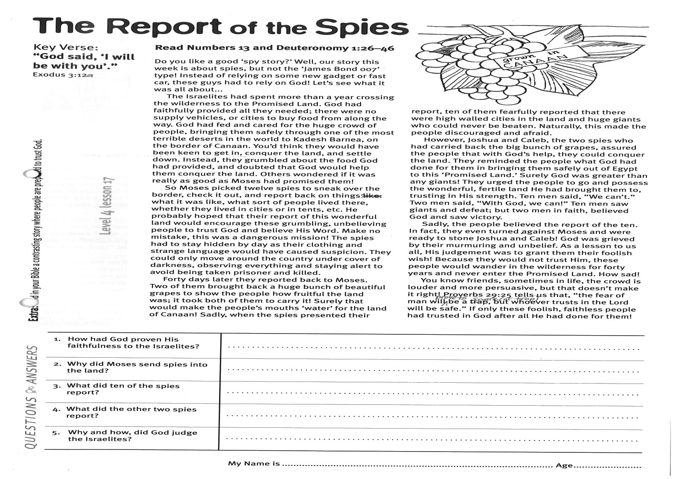
Key Verse:
“God said, “I will be with you’.”
Exodus 3:12a
Read Numbers 13
and Deuteronomy 1:26-46
Do you like a good ‘spy story?’ Well, our story this week is about spies, but not the ‘James Bond 007’ type! Instead of relying on some new gadget or fast car, these guys had to rely on God! Let’s see what it was all about...
The Israelites had spent more than a year crossing the wilderness to the Promised Land. God had faithfully provided all they needed; there were no supply vehicles, or cities to buy food from along the way. God had fed and cared for the huge crowd of people, bringing them safely through one of the most terrible deserts in the world to Kadesh Barnea, on the border of Canaan. You’d think they would have been keen to get in, conquer the land, and settle down. Instead, they grumbled about the food God had provided, and doubted that God would help them conquer the land. Others wondered if it was really as good as Moses had promised them!
So Moses picked twelve spies to sneak over the border, check it out, and report back on things: what it was like, what sort of people lived there, whether they lived in cities or in tents, etc. He probably hoped that their report of this wonderful land would encourage these grumbling, unbelieving people to trust God and believe His Word. Make no mistake, this was a dangerous mission! The spies had to stay hidden by day as their clothing and strange language would have caused suspicion. They could only move around the country under cover of darkness, observing everything and staying alert to avoid being taken prisoner and killed.
Forty days later they reported back to Moses. Two of them brought back a huge bunch of beautiful grapes to show the people how fruitful the land was; it took both of them to carry it!
The Report of the Spies
1. How had God proven His faithfulness to the Israelites?

2. Why did Moses send spies into the land?

3. What did ten of the spies report?
4. What did the other two spies report?
5. Why and how, did God judge the Israelites?
Level 3 lesson 1
Extra: Find in your Bible a contrasting story where people are prepared to trust God.

Level 4 lesson 17
QUESTIONS & ANSWERS
Surely that would make the people’s mouths ‘water’ for the land of Canaan! Sadly, when the spies presented their report, ten of them fearfully reported that there were high walled cities in the land and huge giants who could never be beaten. Naturally, this made the people discouraged and afraid.
However, Joshua and Caleb, the two spies who had carried back the big bunch of grapes, assured the people that with God’s help, they could conquer the land. They reminded the people what God had done for them in bringing them safely out of Egypt to this ‘Promised Land.’ Surely God was greater than any giants!
They urged the people to go and possess the wonderful, fertile land He had brought them to, trusting in His strength. Ten men said, “We can’t.” Two men said, “With God, we can!” Ten men saw giants and defeat; but two men in faith, believed God and saw victory.
Sadly, the people believed the report of the ten. In fact, they even turned against Moses and were ready to stone Joshua and Caleb! God was grieved by their murmuring and unbelief. As a lesson to us all, His judgement was to grant them their foolish wish! Because they would not trust Him, these people would wander in the wilderness for forty years and never enter the Promised Land. How sad!
You know friends, sometimes in life, the crowd is louder and more persuasive, but that doesn’t make it right! Proverbs 29:25 tells us that, “the fear of man will prove to be a snare (or trap), but whoever trusts in the Lord will be safe.” If only these foolish, faithless people had trusted in God after all He had done for them!
My Name is _____________________________________________ Age ___________
Key Verse:
“Jesus said, ‘I tell you the truth, unless a man is born again, he cannot see the kingdom of God.’”
John 3:3
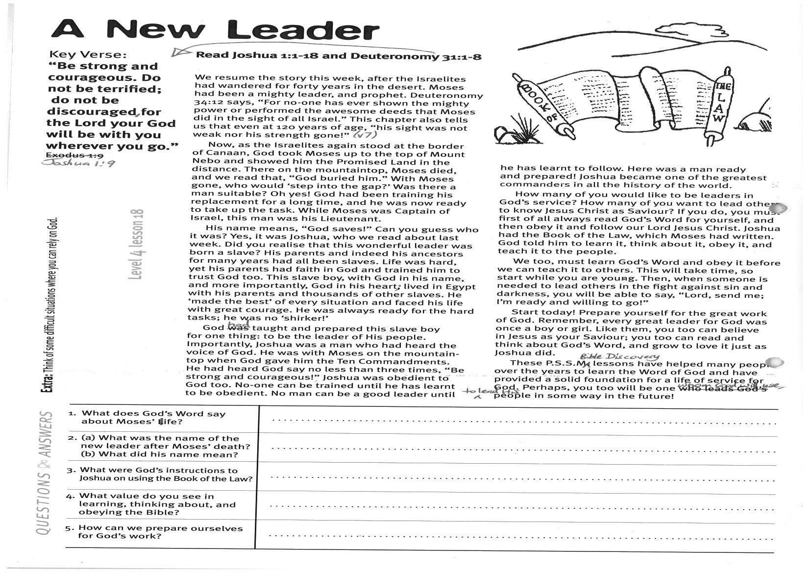
A New Leader
Key Verse:
“Be strong and courageous. Do not be terrified; do not be discouraged, for the Lord your God will be with you wherever you go.”
Joshua 1:9
Read Deuteronomy 31:1-8
and Joshua 1:1-18
We resume the story this week, after the Israelites had wandered for forty years in the desert. Moses had been a mighty leader, and prophet. Deuteronomy 34:12 says, “For no-one has ever shown the mighty power or performed the awesome deeds that Moses did in the sight of all Israel.” This chapter also tells us that even at 120 years of age, “his sight was not weak nor his strength gone!” (v7)
Now, as the Israelites again stood at the border of Canaan, God took Moses up to the top of Mount Nebo and showed him the Promised Land in the distance. There on the mountaintop, Moses died, and we read that, “God buried him.” With Moses gone, who would ‘step into the gap?’ Was there a man suitable? Oh yes! God had been training his replacement for a long time, and he was now ready to take up the task. While Moses was Captain of Israel, this man was his Lieutenant.
His name means, “God saves!” Can you guess who it was? Yes, it was Joshua, who we read about last week. Did you realise that this wonderful leader was born a slave? His parents and indeed his ancestors for many years had all been slaves. Life was hard, yet his parents had faith in God and trained him to trust God, too. This slave boy, with God in his name, and more importantly, God in his heart, lived in Egypt with his parents and thousands of other slaves. He ‘made the best’ of every situation and faced his life with great courage. He was always ready for the hard tasks; he was no ‘shirker!’
God had taught and prepared this slave boy for one thing: to be the leader of His people. Importantly, Joshua was a man who had heard the voice of God. He was with Moses on the mountain-top when God gave him the Ten Commandments.
1. What does God’s Word say about Moses’ life?
2. What was the name of the new leader after Moses’ death, and what did his name mean?
3. What were God’s instructions to Joshua on using the Book of the Law?
4. What value do you see in learning, thinking about, and obeying the Bible?
5. How can we prepare ourselves for God’s work?
___
Extra: Think of some difficult situations where you can rely on God.
Level 4 lesson 18
QUESTIONS & ANSWERS
He had heard God say no less than three times, “Be strong and courageous!” Joshua was obedient to God, too. No-one can be trained until he has learnt to be obedient. No man can be a good leader until he has learnt to follow. Here was a man ready and prepared! Joshua became one of the greatest commanders in all the history of the world.
How many of you would like to be leaders in God’s service? How many of you want to lead others to know Jesus Christ as Saviour? If you do, you must first of all always read God’s Word for yourself, and then obey it and follow our Lord Jesus Christ. Joshua had the Book of the Law, which Moses had written. God told him to learn it, think about it, obey it, and teach it to the people.
We too, must learn God’s Word and obey it before we can teach it to others. This will take time, so start while you are young. Then, when someone is needed to lead others in the fight against sin and darkness, you will be able to say, “Lord, send me; I’m ready and willing to go!”
Start today! Prepare yourself for the great work of God. Remember, every great leader for God was once a boy or girl. Like them, you too can believe in Jesus as your Saviour; you too can read and think about God’s Word, and grow to love it just as Joshua did.
These PSSM Bible Discovery lessons have helped many people over the years to learn the Word of God and have provided a solid foundation for a life of service for God. Perhaps, you too will be one whom God will use, to lead His people in some way in the future!

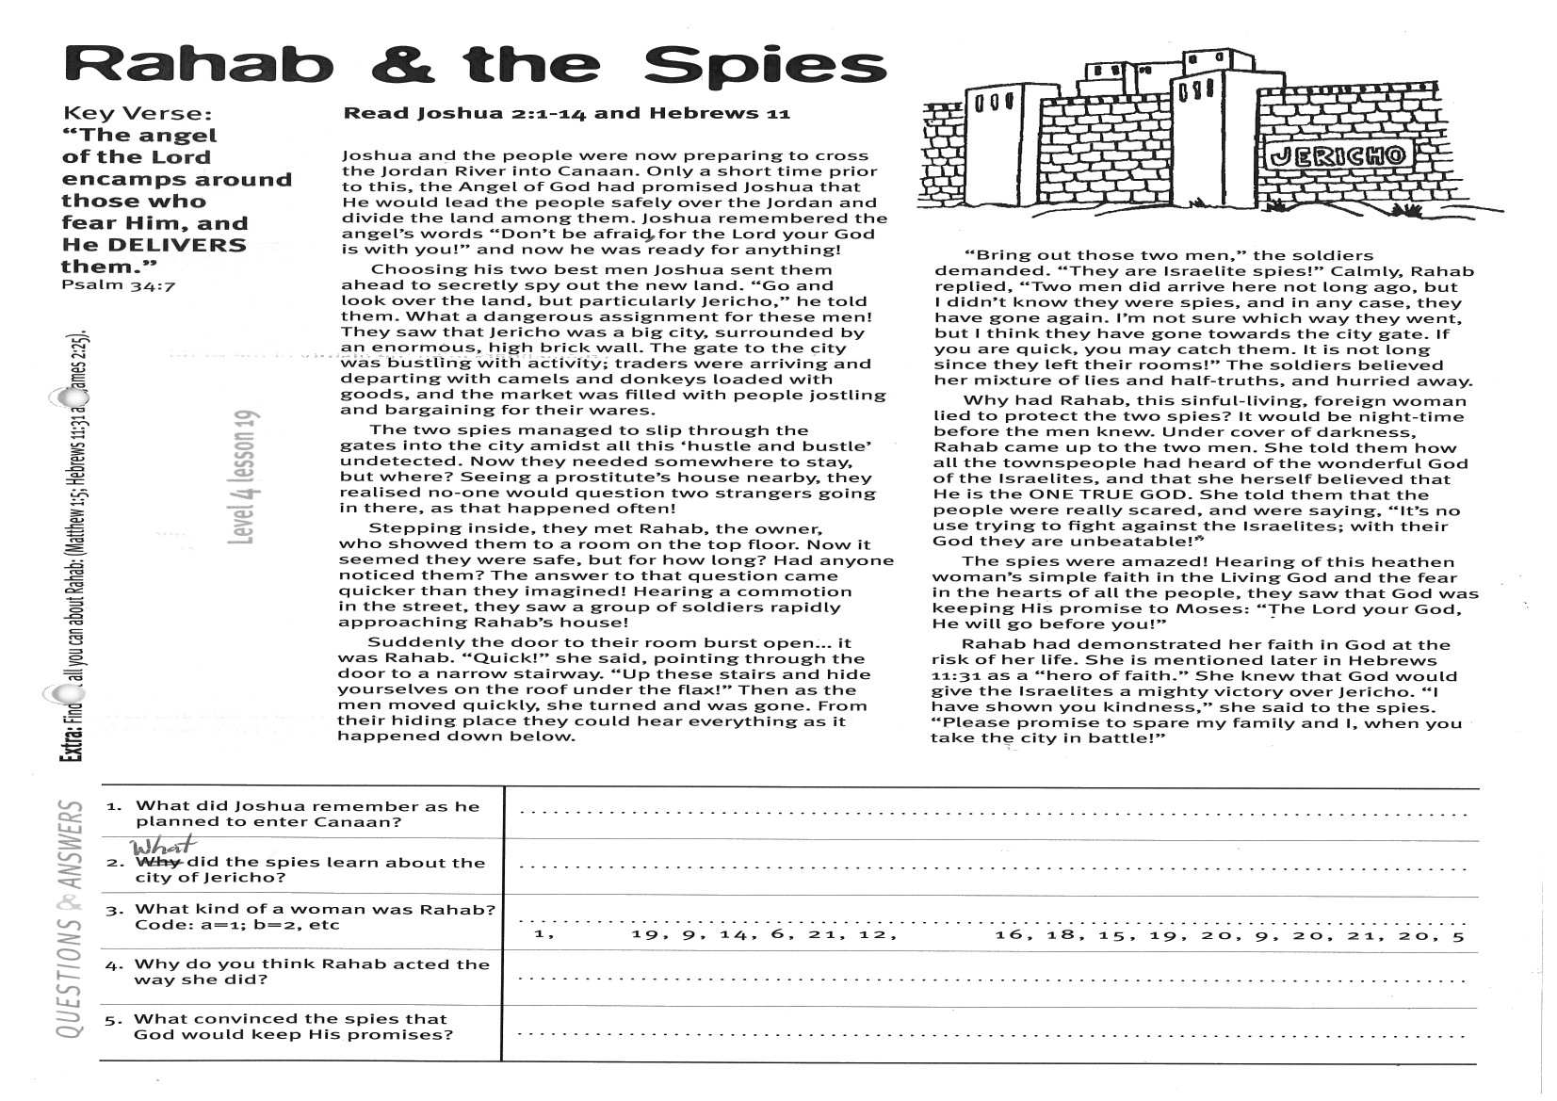
Key Verse:
“The angel of the Lord encamps around those who fear Him and He delivers them.”
Psalm 34:7
Read Joshua 2:1-14
and Hebrews 11
Joshua and the people were now preparing to cross the Jordan River into Canaan. Only a short time prior to this, the Angel of God had promised Joshua that He would lead the people safely over the Jordan and divide the land among them. Joshua remembered the angel’s words “Don’t be afraid, for the Lord your God is with you!” and now he was ready for anything!
Choosing his two best men, Joshua sent them ahead to secretly spy out the new land. “Go and look over the land, but particularly Jericho,” he told them. What a dangerous assignment for these men! They saw that Jericho was a big city, surrounded by an enormous, high brick wall. The gate to the city was bustling with activity; traders were arriving and departing with camels and donkeys loaded with goods, and the market was filled with people jostling and bargaining for their wares.
The two spies managed to slip through the gates into the city amidst all this ‘hustle and bustle’ undetected. Now they needed somewhere to stay, but where? Seeing a prostitute’s house nearby, they realised no-one would question two strangers going in there, as that happened often!
Stepping inside, they met Rahab, the owner, who showed them to a room on the top floor. Now it seemed they were safe, but for how long? Had anyone noticed them? The answer to that question came quicker than they imagined! Hearing a commotion in the street, they saw a group of soldiers rapidly approaching Rahab’s house!
Suddenly the door to their room burst open… it was Rahab. “Quick!” she said, pointing through the door to a narrow stairway. “Up these stairs and hide yourselves on the roof under the flax!”
Rahab & the Spies
1. What did Joshua remember as he planned to enter Canaan?
2. What did the spies learn about the city of Jericho?

3. What kind of woman was Rahab? Code: a=1, b=2, c=3, etc | __ __ __ __ __ __ __ __ __ __ __ __ __ __ __ __ __  1 19 9 14 6 21 12 16 18 15 19 20 9 20 21 20 5
4. Why do you think Rahab acted the way she did?

5. What convinced the spies that God would keep His promises?
Extra: Find out all you can about Rahab (Matthew 1:5, Hebrews 11:31 and James 2:25)

Level 4 lesson 19
QUESTIONS & ANSWERS
Then as the men moved quickly, she turned and was gone. From their hiding place they could hear everything as it happened down below.
“Bring out those two men,” the soldiers demanded. “They are Israelite spies!” Calmly, Rahab replied, “Two men did arrive here not long ago, but I didn’t know they were spies, and in any case, they have gone again. I’m not sure which way they went, but I think they have gone towards the city gate. If you are quick, you may catch them. It is not long since they left!” The soldiers believed her mixture of lies and half-truths, and hurried away.
Why had Rahab, this sinful-living, foreign woman lied to protect the two spies? It would be night-time before the men knew. Under cover of darkness, Rahab came up to the two men. She told them how all the townspeople had heard of the wonderful God of the Israelites, and that she herself believed that He is the ONE TRUE GOD. She told them that the people were really scared, and were saying, “It’s no use trying to fight against the Israelites; with their God they are unbeatable!”
The spies were amazed! Hearing of this heathen woman’s simple faith in the Living God and the fear in the hearts of all the people, they saw that God was keeping His promise to Moses: “The Lord your God, He will go before you!”
Rahab had demonstrated her faith in God at the risk of her life. She is mentioned later in Hebrews 11:31 as a “hero of faith.” She knew that God would give the Israelites a mighty victory over Jericho. “I have shown you kindness,” she said to the spies. “Please promise to spare me and my family, when you take the city in battle!”

Rahab’s Red Cord
Key Verse:
“The Lord is my helper; I will not be afraid. What can man do to me?”
Hebrews 13:6
Read Joshua 2:15-24
and James 2:14-26
Rahab’s earnest plea for her and her family to be spared when the Israelites captured the city of Jericho showed true faith in the God of Israel. You see, humanly speaking, Jericho seemed really safe behind its huge brick walls. Yet Rahab knew that the God of the Israelites was not like the idols her people worshipped; He was the REAL God!
She and her people had heard how God sent terrible plagues upon Egypt and delivered His people out of slavery. They’d heard how He parted the Red Sea for them, drowned Pharaoh and his army, crushed the powerful King of the Amorites in battle, and defeated Og the fearsome giant King, also! Now, as the people of Jericho looked across the river Jordan, they could see the great camp of the Israelites with its strange pillar of cloud by day and fire by night - and they were ‘scared stiff!’
The two spies promised Rahab that in return for sparing their lives, she and her family’s lives would be spared. However, there were two conditions: 1) she must hang a large, scarlet red cord from the window of her house to identify it to the Israelites when they attacked; and 2) she must bring all her family into her house. Only those people inside her house were guaranteed safety.
Does this sound familiar? Remember Noah’s Ark and The Passover in Egypt? In each case, complete obedience to God’s instructions was required to avoid judgement. People had to be in the Ark safe from the flood; or in their houses sheltering behind the blood on their door-posts. Those who didn’t believe or who chose to argue with God and do things their own way, were free to do so, but they suffered the judgement of God!

The spies made it clear that anyone outside Rahab’s house would not be spared. Friends, in the same way, we need to be ‘in’ Jesus Christ, sheltering behind His shed blood, God’s wonderful provision for our sin. Only then can we be SURE we are safe from His righteous wrath and judgement on sin (see 1 John 1:7 and Romans 10:9).
There are those today who say, “How arrogant and intolerant, to insist that Jesus is the ONLY way!” Friends, if Rahab had hung a green cord out her window, her house would have been levelled, and everyone in it killed, along with all the others! God’s instructions (via the two spies) were for a red cord to identify her house. What if Rahab’s father had perhaps insisted, “My house will do; I’m going to barricade myself in here. I’ll be alright!” Would he have survived? No!
Yet sadly, many people still want to come to God on their own terms instead of His. They want to be saved their way. The Bible makes it abundantly clear that we are in no position to argue with God! He has only promised to save those who obey His Word; and in simple, trusting faith, believe that Jesus died to pay for their sins! (1 Peter 1:18-19)
Reassured by the spies’ promise, Rahab helped the two men through her window on the city wall, and lowered them down with the scarlet cord. She told them where and how long to hide until the soldiers had stopped searching for them and returned to the city. They followed her instructions exactly and were able to return safely to Joshua and tell him all that had happened. This confirmed to Joshua that God would give them the city. He gladly agreed to spare Rahab and all in her house, just as the spies had promised her.
What an amazing book the Bible is! Full of interesting, true stories, and it is written so that we can know God and understand what He requires from us. Read your Bible carefully and learn to love it - it’s the best book of all!

1. What had the people of Jericho heard about Israel’s God?
2. What are the two conditions Rahab had to fulfil to be saved?
3. How can we be SURE we are safe from God’s judgement on sin?

4. Do you think it’s arrogant to claim that Jesus is the only way? Why or why not?
5. How did Rahab help the spies to escape from Jericho? (Fill in the consonants).  Please complete and return by post to  PSSM Bible Discovery, 5/399 New North Rd, Kingsland, Auckland 1021 or scan & email to info@biblediscovery.org.nz
   |  | E |  |  | O |  | E |  | E |  |  |  |  | E |  |  |  | O
   | I |  |  |  |  |  | E |  |  |  | A |  |  | E |  |  |  | O
Extra: Compare Rahab’s experience with God’s plan of salvation.

Level 4 lesson 20
QUESTIONS & ANSWERS

