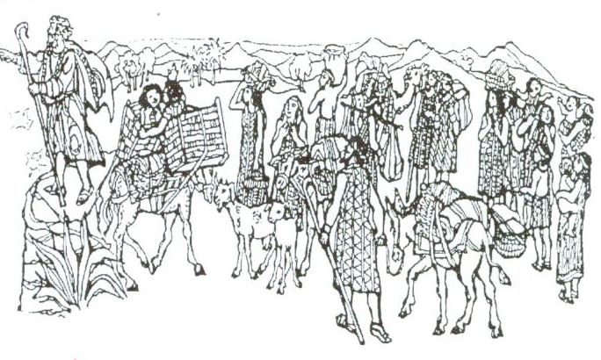
Bread from Heaven
Key Verse:
“…He satisfies the thirsty and fills the hungry with good things.”
Psalm 107:9
Read Exodus 16:1-26
After their amazing deliverance from the Egyptian army at the Red Sea, the Children of Israel had been led by God’s ‘Pillar of Cloud’ to a place called Elim. There they spent some delightful, refreshing days, enjoying the wells of cool, clear water, and the shade of the graceful palm trees. However, before long, the pillar of God’s presence began to move slowly onward.
So the tents were taken down, and the whole Israelite camp moved forward, following the pillar of cloud. Soon they arrived at the Desert of Sin (this was simply the Jewish name for it, and nothing to do with ‘sin’. i.e. doing bad things), which lay between the Israelites and the Promised Land. It was a barren and harsh place and the people began to grumble and murmur among themselves.
It’s hard to believe what these foolish, ungrateful people began saying: “Why did we ever leave Egypt?” they whined. “There, we had as much food as we wanted; here, Moses and Aaron have brought us into this desert to starve us to death!” How quickly people forget God’s goodness! True, the wilderness looked an unlikely spot to find food; but God had shown them clearly that He was with them and there was nothing to fear.
He had miraculously brought them safely out of Egypt and delivered them from Pharaoh at the Red Sea. By day they were aware of His presence with them in the Pillar of Cloud and at night by the Pillar of Fire. At Marah and at Elim, He had supplied fresh water for them. God was protecting and providing for them continually in so many ways. But had they learnt to trust Him? It seems not, as all we hear is grumbling!

1. What did the people grumble about in the Desert of Sin? Write ‘True’ or ‘False’ | a. Food _________________ b. Clouds _________________  c. Tents ____________ d. Moses & Aaron ____________
2. Why had they no need to fear?
3. How did God provide meat for the people?
4. How did He provide bread?
5. (a) What name was given to the Bread that God sent His people? (b) What did Moses say about it?
My Name is _____________________________________________ Age ___________
Level 3 lesson 1
Extra: Was it fair for the people to complain when they arrived at the Desert of Sin?
Level 4 lesson 13
QUESTIONS & ANSWERS
Key Verse:
“Jesus said, ‘I tell you the truth, unless a man is born again, he cannot see the kingdom of God.’”
John 3:3
God was listening and told Moses, “I have heard the murmuring of the Children of Israel.” Would we grumble so often if we remembered that God hears everything? But how kind God is! He said, “I will rain down bread from Heaven for you.” They had been longing for the bread of Egypt, and now they were to have ‘Bread from Heaven!’
Moses called the people together to encourage them with the good news, and the Glory of the Lord blazed from the Pillar of Cloud. What a wonderful way of saying to them all, “I am here; right here with you!” God then promised Moses to provide food for the people. “They will have flesh to eat this evening, and bread from Heaven every morning!” How would God do that?
It seemed impossible, but sure enough, towards evening dark clouds seemed to be blowing towards the camp. This turned out to be flocks of little brown birds called quails. God brought them right into the Israelite camp… thousands of them! This was God’s provision of the meat He had promised. In the morning, the Israelites discovered another miraculous thing had happened.
Heavy dew lay on the ground, but when this dried off the people found that all around them the ground was covered with small white grains like white frost crystals. “Man-hoa?” everyone asked (“What is it?”). And so it came to be called ‘Manna.’ “This is the bread which the Lord has given you to eat,” said Moses. Everyone gathered as much as they needed for the day, and the next day a fresh supply was there for them!
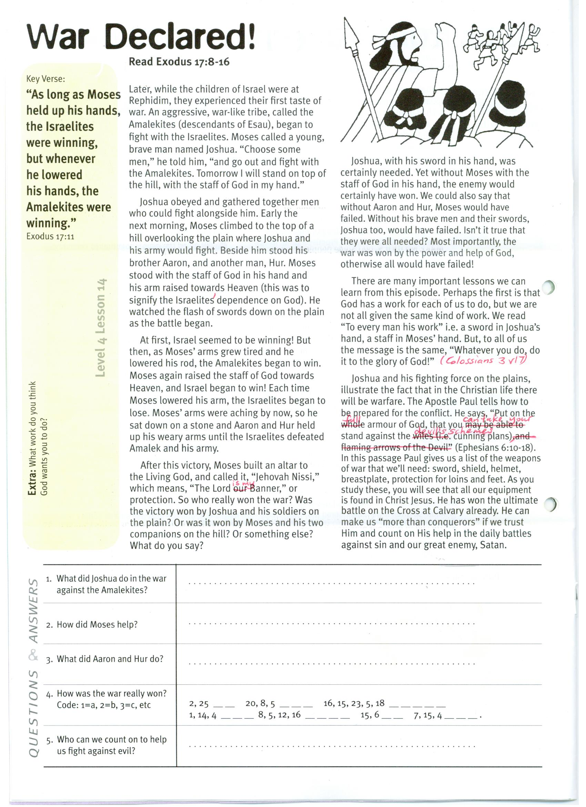
War Declared!
Key Verse:
“As long as Moses held up his hands, the Israelites were winning, but whenever he lowered his hands, the Amalekites were winning.”
Exodus 17:11

Read Exodus 17:8-16
Later, while the children of Israel were at Rephidim, they experienced their first taste of war. An aggressive, war-like tribe, called the Amalekites (descendants of Esau), began to fight with the Israelites. Moses called a young, brave man named Joshua. “Choose some men,” he told him, “and go out and fight with the Amalekites. Tomorrow I will stand on top of the hill, with the staff of God in my hand.”
Joshua obeyed and gathered together men who could fight alongside him. Early the next morning, Moses climbed to the top of a hill overlooking the plain where Joshua and his army would fight. Beside him stood his brother Aaron, and another man, Hur. Moses stood with the staff of God in his hand and his arm raised towards Heaven (this was to signify the Israelites’ dependence on God). He watched the flash of swords down on the plain as the battle began.
At first, Israel seemed to be winning! But then, as Moses’ arms grew tired and he lowered his rod, the Amalekites began to win. Moses again raised the staff of God towards Heaven, and Israel began to win! Each time Moses lowered his arm, the Israelites began to lose. Moses’ arms were aching by now, so he sat down on a stone and Aaron and Hur held up his weary arms until the Israelites defeated Amalek and his army.
After this victory, Moses built an altar to the Living God, and called it, “Jehovah Nissi,” which means, “The Lord is my banner,” or protection. So who really won the war? Was the victory won by Joshua and his soldiers on the plain? Or was it won by Moses and his two companions on the hill? Or something else? What do you say?
1. What did Joshua do in the war against the Amalekites?
2. How did Moses help?
3. What did Aaron and Hur do?
4. How was the war really won? Code: 1=a, 2=b, 3=c, etc | __ __ __ __ __ __ __ __ __ __ __ __ __ __ __ __ __ __ __ __ __ __  2 25 20 8 5 16 15 23 5 18 1 14 4 8 5 12 16 15 6 7 15 4
5. Who can we count on to help us fight against evil?
Extra: What work do you think God wants YOU to do?
Level 4 lesson 14
QUESTIONS & ANSWERS
Joshua, with his sword in his hand, was certainly needed. Yet, without Moses with the staff of God in his hand, the enemy would certainly have won. We could also say that without Aaron and Hur, Moses would have failed. Without his brave men and their swords, Joshua too, would have failed. Isn’t it true that they were all needed? Most importantly, the war was won by the power and help of God, otherwise all would have failed!
There are many important lessons we can learn from this episode. Perhaps the first is that God has a work for each of us to do, but we are not all given the same kind of work. We read “To every man his work” i.e. a sword in Joshua’s hand, a staff in Moses’ hand. But, to all of us the message is the same, “Whatever you do, do it to the glory of God!” (See Colossians 3:17)
Joshua and his fighting force on the plains, illustrate the fact that in the Christian life there will be warfare. The Apostle Paul tells how to be prepared for the conflict. He says, “Put on the full armour of God, so that you can take your stand against the devil’s schemes” (or cunning plans) - see Ephesians 6:10-18. In this passage Paul gives us a list of the weapons of war that we’ll need: sword, shield, helmet, breastplate, protection for loins and feet. As you study these, you will see that all our equipment is found in Christ Jesus. He has won the ultimate battle on the Cross at Calvary already. He can make us “more than conquerors” if we trust Him and count on His help in the daily battles against sin and our great enemy, Satan.

Key Verse:
“Your Word is a Lamp to my feet and a light for my path.”
Psalm 119:105
Read Exodus 20
and Matthew 22:34-40
In Exodus 20 we find the TEN COMMANDMENTS that God gave to Moses on Mt Sinai. They became part of what was known as ‘The Law.’ They were to set out God’s righteous standards of behaviour for His people. Much of our law today is based on them.
1. WORSHIP NO OTHER GODS. (v3) This comes first! Lots of people have other gods. Heathen people worship their own ‘gods.’ People today often live for money, or learning, or fame, or pleasure, or self. These are their ‘gods.’ They have first place and the true, living God is left out.
2. MAKE NO IDOLS. (v4) Some people actually make idols of wood, stone or metal and worship them! Even in some so called “churches” people pray to images of the Saviour, or even Mary and the old saints. God strictly forbids this!
3. DO NOT BLASPHEME GOD’S NAME. (v7) It’s a terrible thing to use the name of God or Jesus as swear words, or even disrespectfully. We should never do this. God will judge any who misuse His name in this way.
4. KEEP THE SABBATH. (v8) The Jews were to keep the seventh day of the week holy, (special to God). It was to be a day of rest from their daily work, just as God finished the work of creation in six days and rested on the seventh. Today as Christians, we keep Sunday as a day set apart to God; that is the day God finished the work of Redemption, when Christ rose from the dead. Do you keep Sunday special and different as God’s day?
5. HONOUR YOUR PARENTS. (v12) As children, we are commanded to obey our parents (Colossians 3:20). Even when we grow up and become adults, we are still to treat our parents with respect and honour.

God’s Law Given
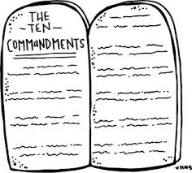
1. What is the meaning of the third commandment?
2. Unscramble the fifth commandment: | MOTHER YOUR HONOUR AND FATHER YOUR
3. Which is the hardest one for you to keep?
4. Why do you think these commandments are important?

5. Because we have failed to keep God’s commandments, what do we need now?
Extra: Is it possible for a sinful person to obey these laws?
Level 4 lesson 15
QUESTIONS & ANSWERS
6. DO NOT MURDER. (v13) God forbids anyone taking another’s life. 1 John 3:15 and Matthew 5:21-22 state that even to hate or have wicked intentions towards someone displays the same attitude as a murderer, so this will be punished.
7. NO ADULTERY. (v14) Jesus says, “The pure in heart shall see God” (Matthew 5:8). We are to keep our minds and hearts pure and wholesome, not misusing our bodies in sexual sins.
8. DO NOT STEAL. (v15) God forbids taking what belongs to someone else.
9. NO FALSE WITNESS. (v16) God forbids telling lies. We are to tell the truth and speak kindly to everyone. Beware of gossiping, slandering and backbiting.
10. DO NOT COVET. (v17) We are not to be envious, and want what others have. This can lead to stealing or cheating or worse (think of King David)! We are to be content with what we have.
All these commandments show GOD’S standard of right and wrong. He is the final authority as Almighty, Holy God. The first four teach us our duty to God; the last six, our duty to others. The Lord Jesus said that two commandments sum up all the others: (a) “Love the Lord your God, with all your heart, and with all your soul and with all your mind.” (b) “Love your neighbour as yourself” (see Matthew 22:37-39).
However, none of us can do this completely. We have all sinned and failed to meet this high standard (Romans 3:23). Praise God that through Christ’s death and resurrection, we can experience God’s gracious forgiveness of our sin and His power to help us live according to His standard. As we let the Holy Spirit have control of our lives and thoughts, He will guide and help us to do what is right and pleasing to God.

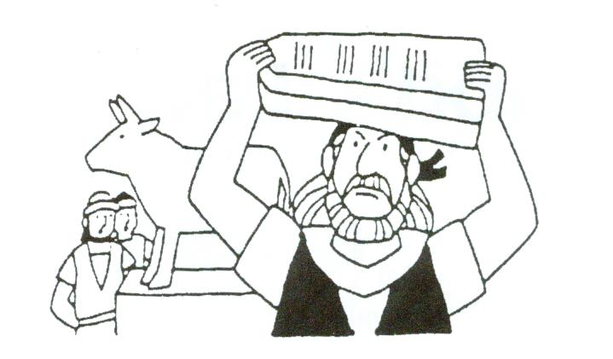
The Golden Calf
Key Verse:
“All have sinned and fall short of the glory of God, and are justified freely by His grace…”
Romans 3:23.24a
Read Exodus 24:12-18
and Exodus 32:1-26
Some time had passed since God had given Moses the Ten Commandments when He called him up to the top of Mt. Sinai. Moses took Joshua with him, the brave young soldier who’d led the people of Israel in battle against the Amalekites. Day after day passed by, and still Moses and Joshua did not return. The people began to wonder what had happened and became restless and discontented.
Finally, a large, angry crowd confronted Aaron, Moses’ brother. He’d been left in charge of the camp while Moses was away, but he was frightened when he saw how restless and upset the people were. “Make us a god to lead us!” they demanded angrily. “We don’t know what’s happened to Moses who brought us out of Egypt.” How sad that the Israelites should so quickly forget the Living God who had miraculously delivered and provided for them. He had brought them out of Egypt, but it was proving harder to get ‘Egypt’ out of them! Many years surrounded by idol worship had left its mark on them.
We need to be careful too about the company we keep; we will be affected by bad friends who do not love and respect God. Moses learned an important lesson too from Aaron’s behaviour. Remember when God called Moses to go and speak to Pharaoh? He promised to help Moses speak, but Moses wouldn’t go without Aaron. Aaron may have been a good speaker, but he was not a strong, faithful leader!
Despite knowing the second commandment, “You shall not make or worship idols!” Aaron gave in to the people. “Bring me all your golden ear-rings,” he said. The people did so, and Aaron melted them down and formed a golden calf, which he then set up before them.
1. (a) Who went up the mountain? (b) Who was left in charge of the camp?
2. Why were the people restless and worried?
3. What did Aaron make to keep the people peaceful?
   |  |  | O |  |  | E |  |  |  | A
4. What was wrong with what Aaron and the people did?
5. What was the challenge Moses put before the people, and the Lord puts before us today?
Please complete and return by post to
PSSM Bible Discovery, 5/399 New North Rd, Kingsland, Auckland 1021 or scan & email to info@biblediscovery.org.nz

Extra: How do you get on the Lord’s side?
Level 4 lesson 16
QUESTIONS & ANSWERS
When Aaron saw how pleased the people were, he built an altar and proclaimed a great feast. If Moses had relied on God instead of Aaron, this may not have happened.
Moses, of course, was unaware what was going on down in the Israelite camp. But God saw it and He was angry! He told Moses to take down the two stone tablets (flat stones) on which were written the Ten Commandments of God. As Moses and Joshua came near the camp, they heard the people having a party.
Joshua, who was a soldier, thought it was the noise of people rejoicing over a victory. But Moses said that it was not the shouts of men of war, but “the sound of singing that I hear.”
As Moses came into camp he saw the golden calf, and the people dancing round it. He could hardly believe his eyes, I’m sure! He was so angry that the people could forget and disobey God so quickly. He threw the stones on the ground, breaking them in pieces. You can imagine how quickly the singing stopped as the people saw the look on Moses’ face!
He turned to Aaron and rebuked him for leading the people into sin. Then Moses gave a loud challenge, “Who is on the Lord’s side? Let him come to me” (v26 NIV) Here was an opportunity for all to seek God’s forgiveness. Thousands of people heard the challenge that day.
Have you decided which side you are on in life? You may have never worshipped an idol, but have you given God His rightful place in your life? Perhaps you are conscious of wrong things in your life; the Bible says, “All have sinned.” God says, “Who will come over to My side and trust Me to forgive their sin?” Are you on the Lord’s side?

